A Journey into Weather
Grade Level: 8th grade
Subject(s):
Primary: Science
Integrated Activity: Reading
Reporting Category:
Earth and Space Systems
Lesson Summary and Connections:
Students will recognize different types of weather conditions and their characteristics.

Lesson Components Links

VESOL(s)  Complexity Continuum | Functional Skills | Assistive Technology | Materials
Vocabulary | Common Misconceptions | Student-Friendly Outcome(s) | Introductory Activity
Plan for Instruction | Differentiation | Reflection | Formative Assessment
Word Wall Cards | Supplemental Materials | Practice Items | Integrated Activity

VESOL(s):
S-8.6: Recognize different types of weather conditions and their characteristics.

Complexity Continuum:
- Recognizing simple weather conditions (e.g., rainy, cloudy, sunny, foggy, thunder and lightning) to
- Recognizing that changes in simple weather conditions are connected to decisions about everyday activities or actions to
- Connecting weather to characteristics of the atmosphere (e.g., temperature, cloudy versus clear, windy versus calm) and common weather tools and information (e.g., thermometers, weather forecasts).

Functional Skill(s):
- Students can identify weather conditions outside each day.
- Students can determine what to wear each day based on the weather conditions.
- Students can read a thermometer and determine if it is hot or cold outside.

Assistive Technology/AAC (Augmentative and Alternative Communication):
- Graphic organizer (mind map)
- Picture cards (visuals of types of weather)
- Laminated thermometer cards
- Folder in their AAC device with core words related to lesson

Materials:
- Types of Weather- Mind Map
- PowerPoint

Vocabulary:

Prior Knowledge What words will students need to know prior to starting the lesson?
- Rain | - Sunny | - Thunderstorm
- Cloudy | - Foggy | - Weather
Current Vocabulary What words will students learn during the lesson?
- Forecast
- Thermometer

Common Misconceptions:
- Some students may confuse what to wear in certain types of weather.
- Some students may miscount when telling the temperature or misread the thermometer.
- Some students may think that the weather/temperature outside is the same as the weather inside.

Student-Friendly Outcome(s):
- I know different types of weather.
- I know how to read a weather forecast and decide what to wear.
- I know how to read a thermometer and determine if it is hot or cold.
- I know how to plan my day for the weather.

Introductory Activity:
There are two levels for an introductory activity:
- Show students different pictures of weather and see if they can identify the different types of weather (can use a picture or a short video). Next, fill out the Mind map of different types of weather they remember.
- Show “Types of Weather” Mind map- have students share types of weather they already know. This can be done individually and printed out or as a group on a smart board.

Use the answers to these questions to determine each student’s level of understanding and starting point for instruction.

Plan for Instruction:
During this lesson, it is important to connect weather to students’ daily lives. While completing this lesson and continuing to learn about weather, try to address weather each day to discuss how the weather impacts their day. This lesson is planned to be in their workspace for whole group instruction.
**In the materials tab, there is a PowerPoint that will follow along with this lesson. Please adapt it to what works for your students, there are videos linked but a lot that go more in-depth on YouTube and you may need.
**This lesson can be done across multiple days/classes or during one class. If doing it across multiple days, here is the recommended break down:
Day 1: Types of weather
Day 2: Review types of weather & reading a forecast
Day 3: Review days 1 & 2, then introduce weather scenarios

Different Types of Weather
- With students in their workspace for whole group instruction, review the different types of weather. Slides 1 – 14 of the included PowerPoint, detail the different types of weather students will learn in this unit. (If your students need to be challenged more, you can add more to the definition.) Go through the slides with students and encourage them to create their own definition/meaning for each type. Additionally, students can come up to the board and point to/circle the answers on the slides with questions.

- Once students can recognize different types of weather, explain to students how the weather impacts their day. Use real-life situations (for example, the zoo.) It seemed like a nice day when we left for the zoo. We didn’t check the weather forecast. When we got there, it started to storm! We got soaking wet and they closed the zoo.
- Ask students, “Have you ever left your house not ready for the weather?”
  - Discuss how this could be dangerous: in a storm, hot temperatures, cold temperatures, snow, etc.
How to Read a Weather Forecast
- Next, introduce to students that we will learn how to read a weather forecast and how to plan for different types of weather. Use slides 15 – 31 in this introduction. Again, have students create their own definition/meaning for the different ways to forecast the weather.
- Show an example of a weekly forecast. This can be found easily on google. Then explain the different symbols and what they mean. Here is a video you can show of some of the symbols: https://www.youtube.com/watch?v=orbNx5S5RNU
Reading a Thermometer
- After the symbols, the next topic will be reading a thermometer. The leading question is, “What does a thermometer measure?” Use slides 32 – 42 for this part of the discussion.
- Next, there will be a few practice examples of how to read a thermometer as a class.
**This might require more time during the lesson- in the PowerPoint there are slides for students to independently show their understanding.
Weather Scenarios
- Practice scenarios of what students should wear during certain weather (Slides 42 to the end).
- The weather app is showing a sun with a temperature of 80°. What would you wear to go for a walk?
- The weather app is showing rain with a temperature of 50°. If you are going to the store, what should you wear?
- The weather app is showing snow. What should you wear?
- After talking about what to wear, introduce weather safety and what situations are safe vs not safe.
- The weather app is showing that it is windy. Is this a good day to fly a kite?
- The weather app is saying it is going to storm with lightening. Should you play outside? What is something else you could do?
- It is storming outside. You need to go to the store. Should you walk or get a ride?

Differentiation:
- If a student needs to be challenged, you can add more types of weather or more in-depth slides.

- In the slides, the activities can be done as a group or individually. For example, when reading the thermometer, there are some visual guides, these can be taken away if more of a challenge is needed. More visual guides can be added if needed.

- This lesson can be individualized or done in small groups depending on the needs of the class.

Reflection:
- What different types of weather are there?
- What parts of the weather should you check before going out for the day?
- What is the weather tool used to measure the temperature?
- What are some weather safety rules we should follow?

Formative Assessment:
- Matching different types of weather
- Give scenarios again and have students independently answer.
- Use questions from the slides and have students independently answer.
  - PowerPoint Assessment questions (slides 43-52)
- Online Games that can be played as a class or independently.
  - https://d3tt741pwxqwm0.cloudfront.net/KET/evlearnket/Dress-For-The-Season/index.html
  - https://pbskids.org/sid/games/weather-surprise
  - https://www.abcya.com/games/dress_for_the_weather

Integrated Activity:
Checking the weather-
Read the following passage to students:

Stacey would like to go to the park today with her sister. She checks the weather forecast app at 10:00 am. They are leaving for the park at 10:30. The forecast shows that it is 70° and sunny right now. It is supposed to warm up an additional 5°. It is also showing a 50% chance of rain at 3:00 pm.

Reading Questions:

- Where is Stacey planning on going?
  - Store
  - Park
  - Movies
- Who is Stacey going with?
  - Sister
  - Mom
  - Friend
- What time are they leaving for the park?
  - 12:00
  - 2:30
  - 10:30

Math Questions:

- If it is 70° right now, and supposed to warm up by 5°, what will the temperature be?
  - 60°
  - 55°
  - 75°
- If it is 10:00 am and they are leaving for the park at 10:30 am, how much time do they have before they leave?
  - 30 minutes
  - 1 hour
  - 5 minutes
- If they stay at the park for an hour, should she be worried about the 50% chance of rain at 3:00 pm?
  - Yes
  - No

Science Questions:

- What is the weather when Stacey checks the app?
- Is this good weather to go to the park?
- What should Stacey bring if there is a chance of rain?

Word Wall Cards:
Rain

liquid water falling from the sky

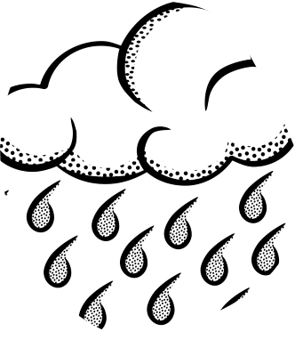
Sunny

bright sky with sun

Foggy

tiny water droplets,
a cloud close to the ground

Thunderstorm

a storm that involves thunder and lightening

Cloudy

The sky covered in clouds

Forecast

prediction of the weather

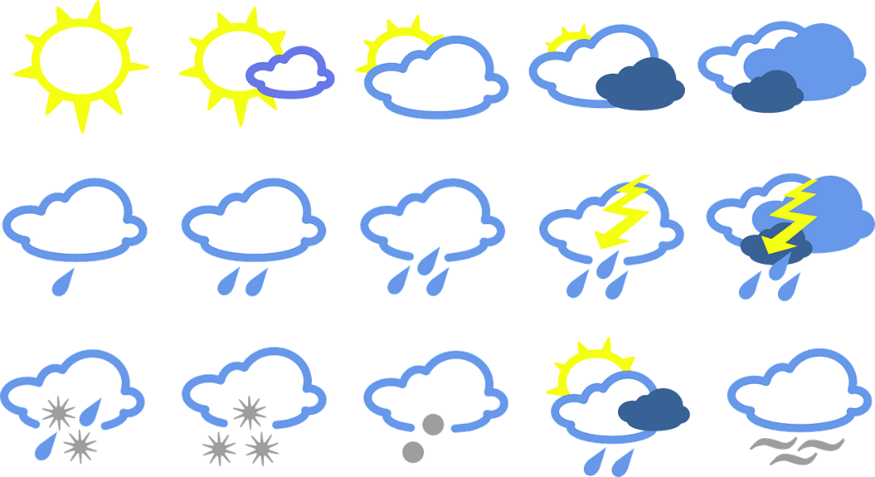

Weather

describes the sky and air outside

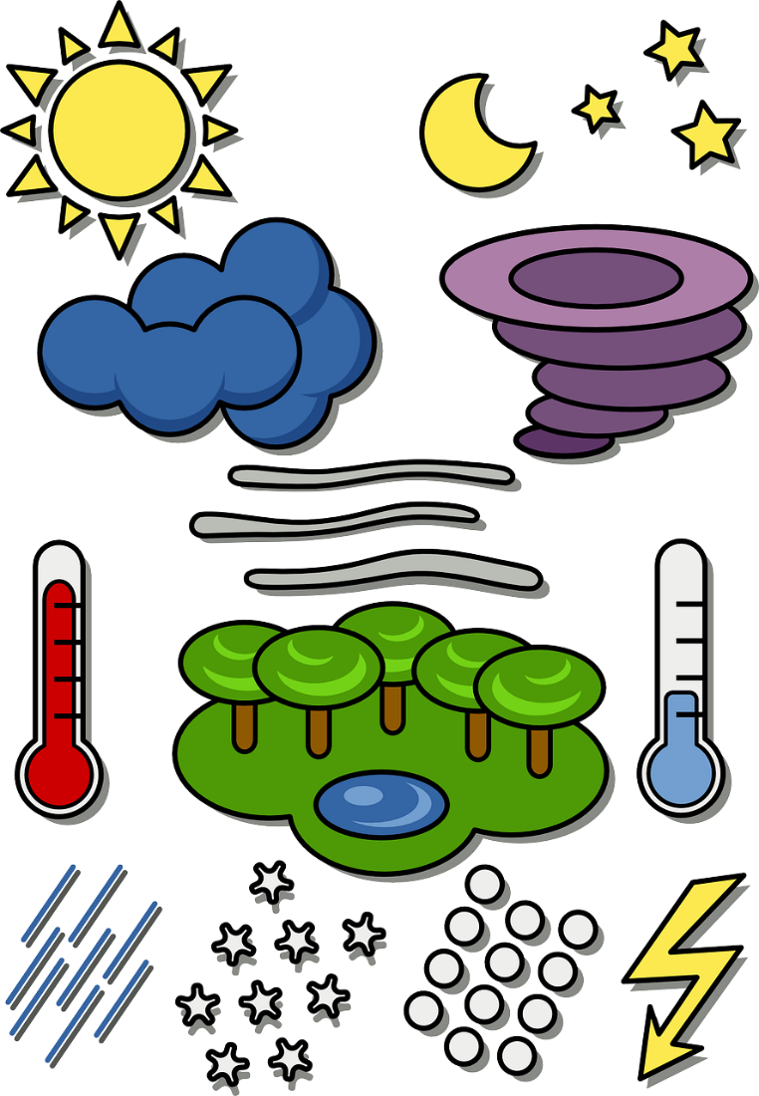

Thermometer

an instrument for measuring temperature
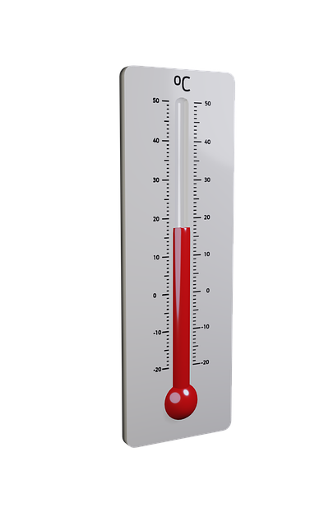

Mind Map

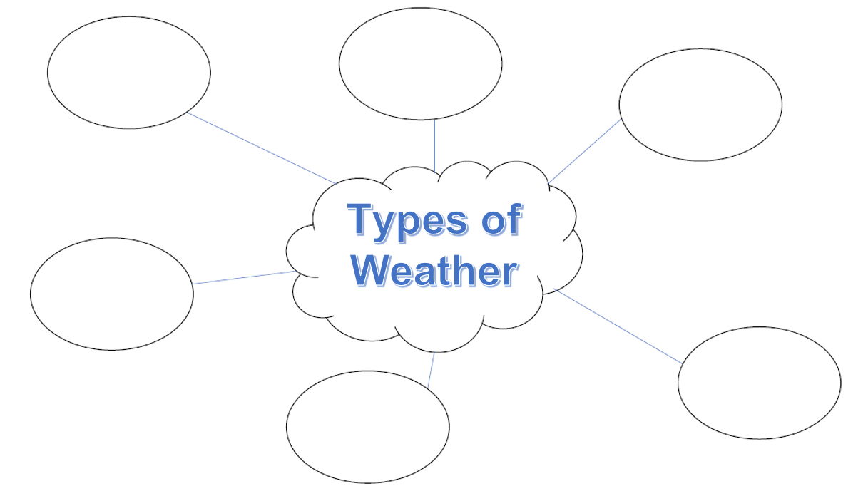

Addendum 1

Practice Items:

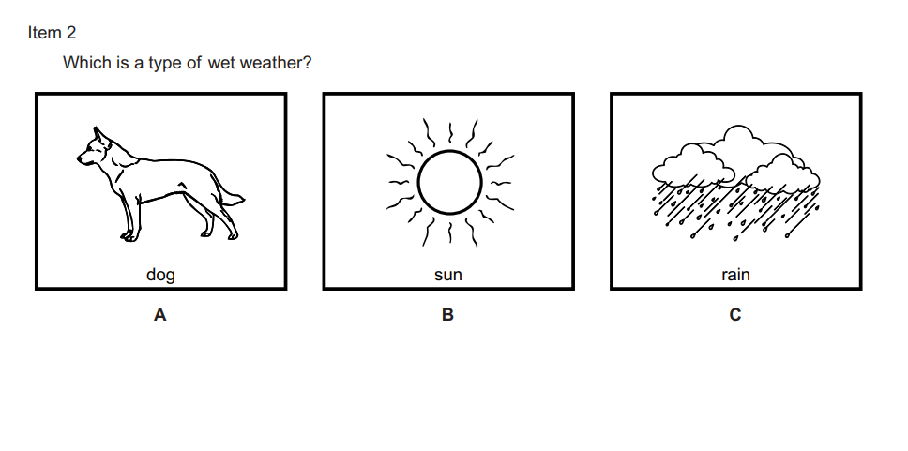
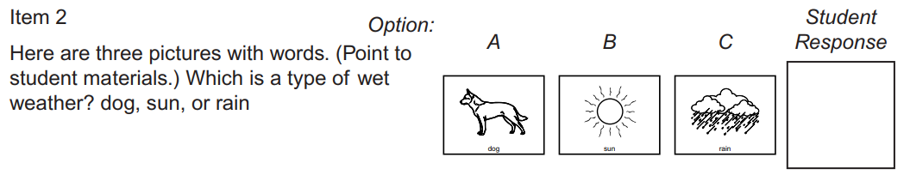

Power Point Presentation
The next 42 pages contain the slides for the PowerPoint presentation. Please feel free to transfer them to a PowerPoint, Google Slide, or leave them as they are.
Slide 1

Slide 2
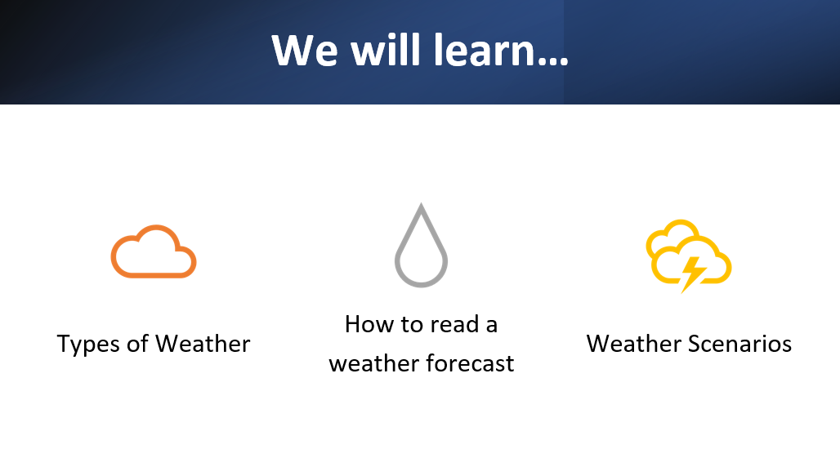

Slide 3

Slide 4

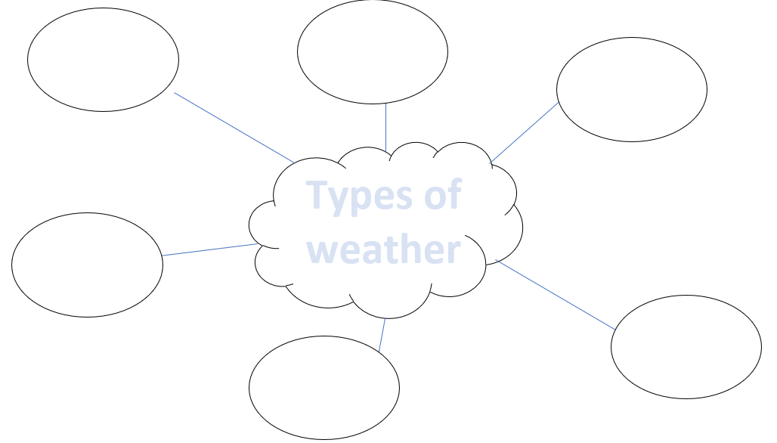

Slide 5

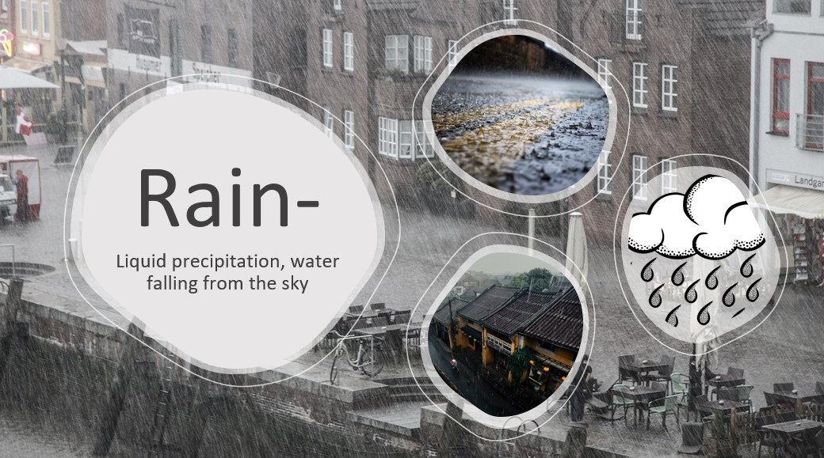

Slide 6

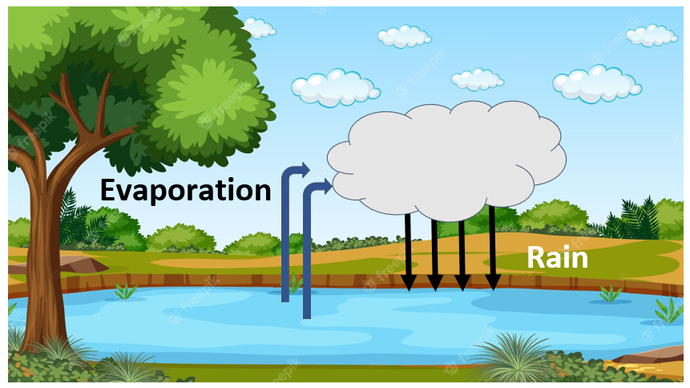

Slide 7

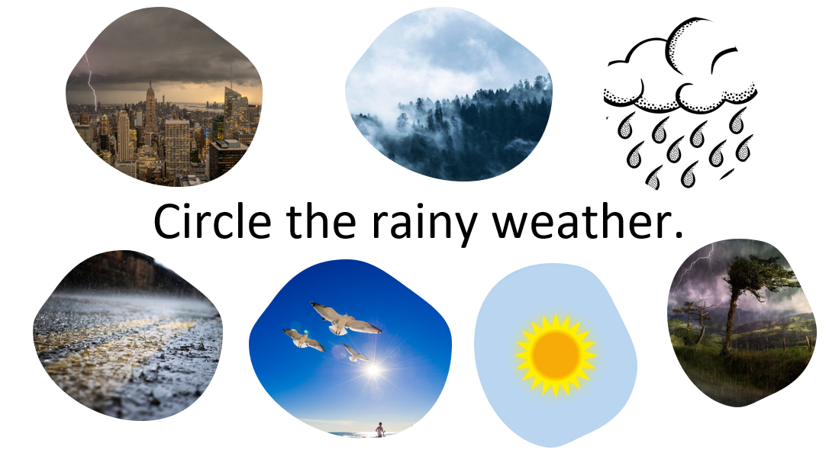

Slide 8
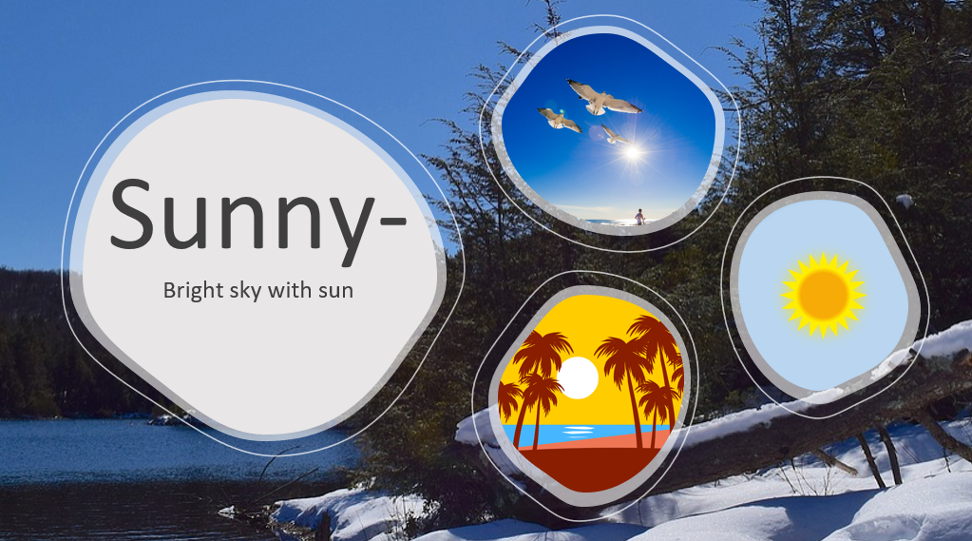

Slide 9

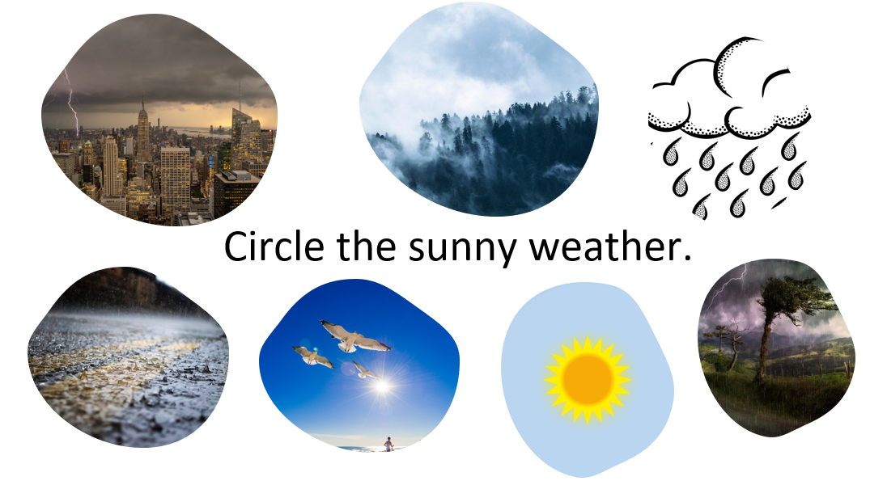

Slide 10

Slide 11

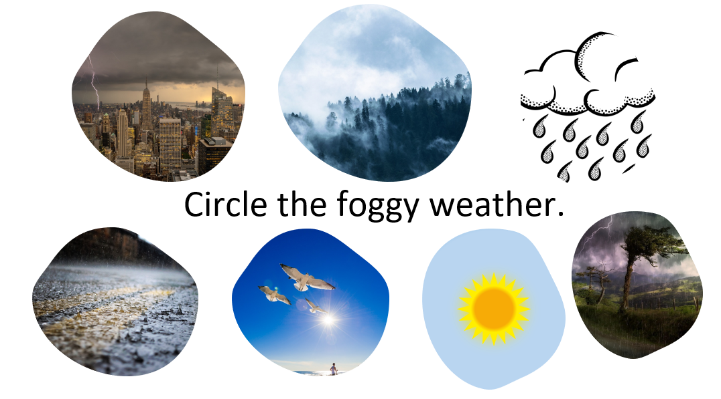

Slide 12
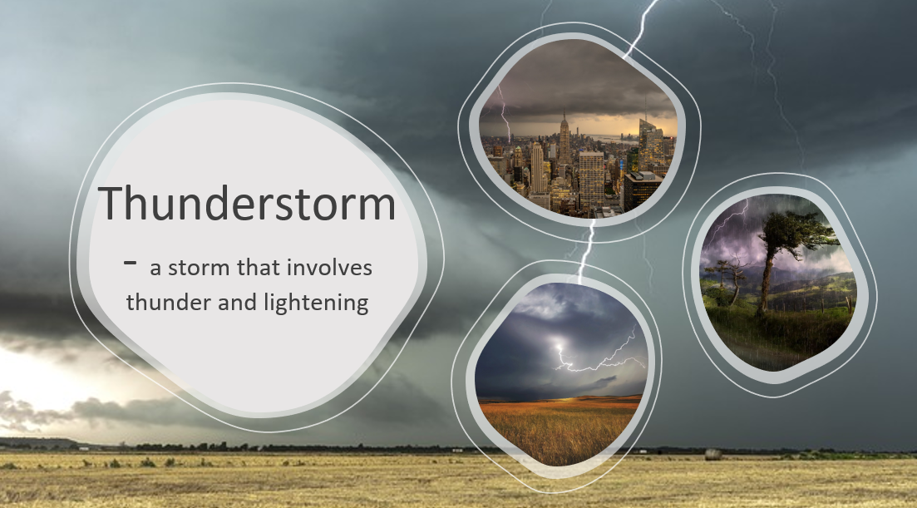

Slide 13

Slide 14

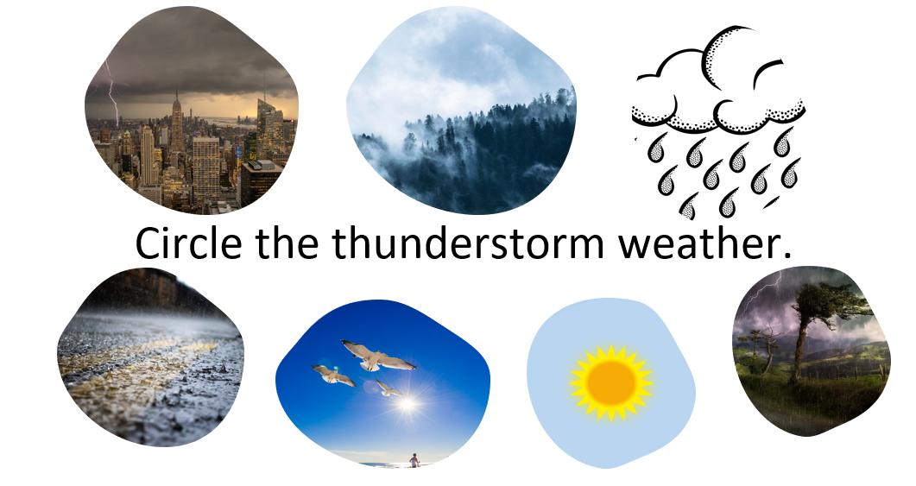

Slide 15

Slide 16

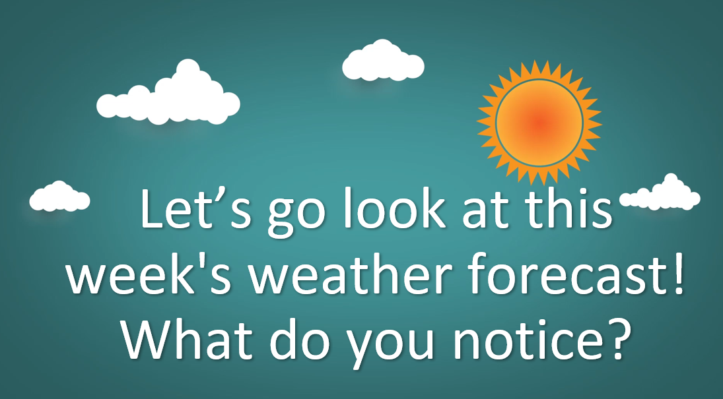

Slide 17

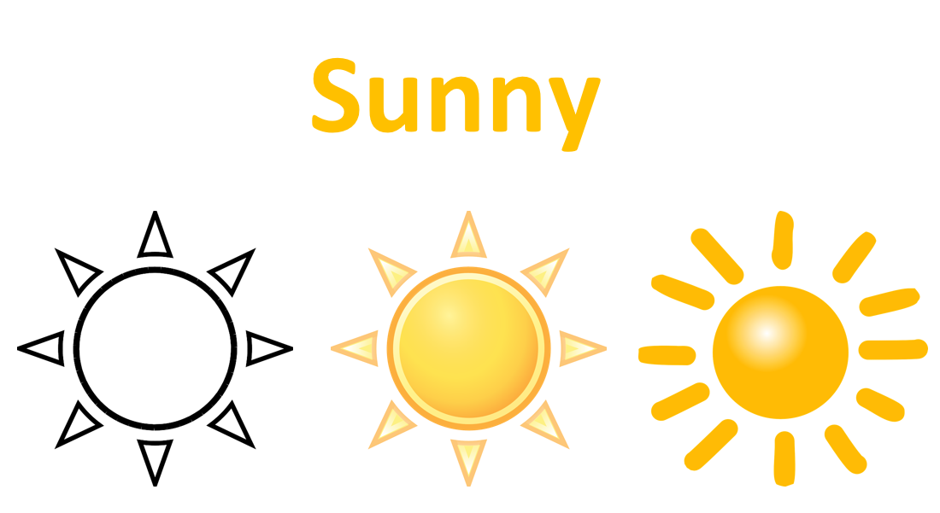

Slide 18

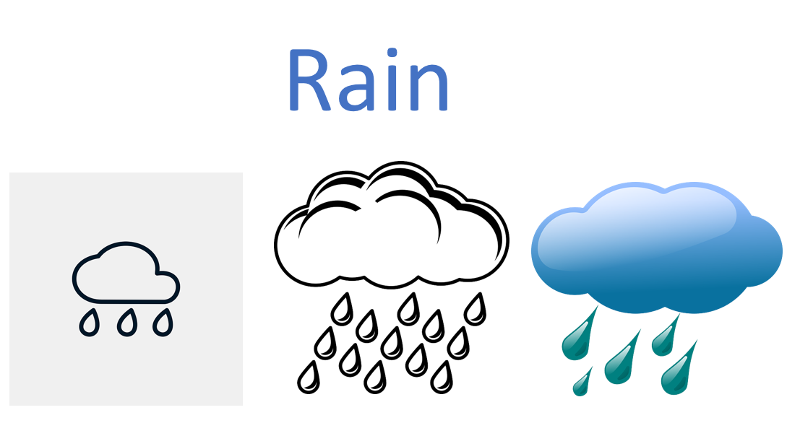

Slide 19

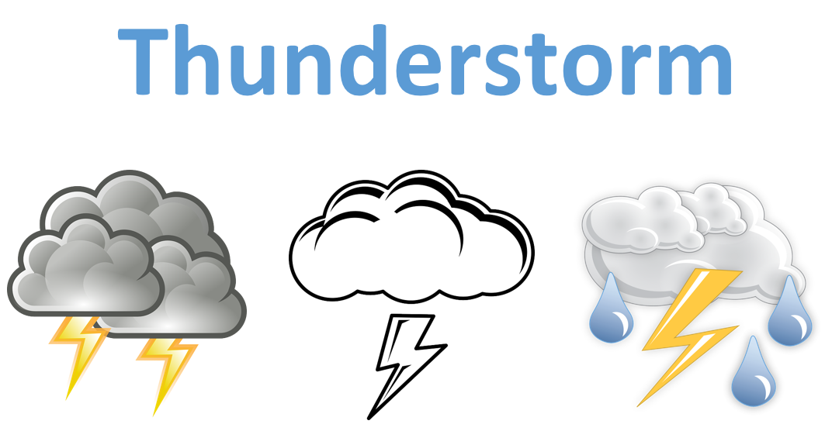

Slide 20

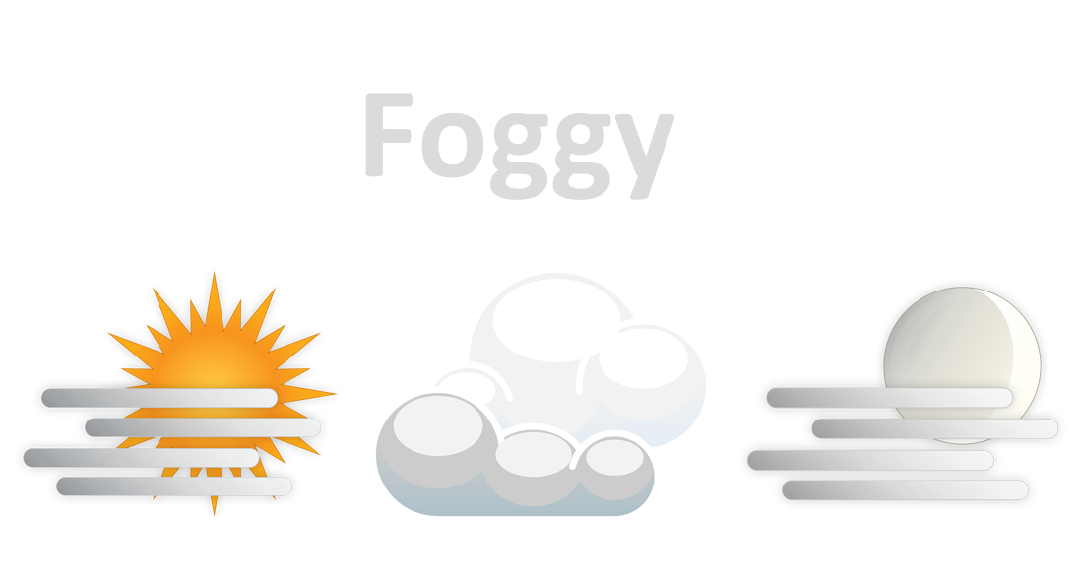

Slide 21

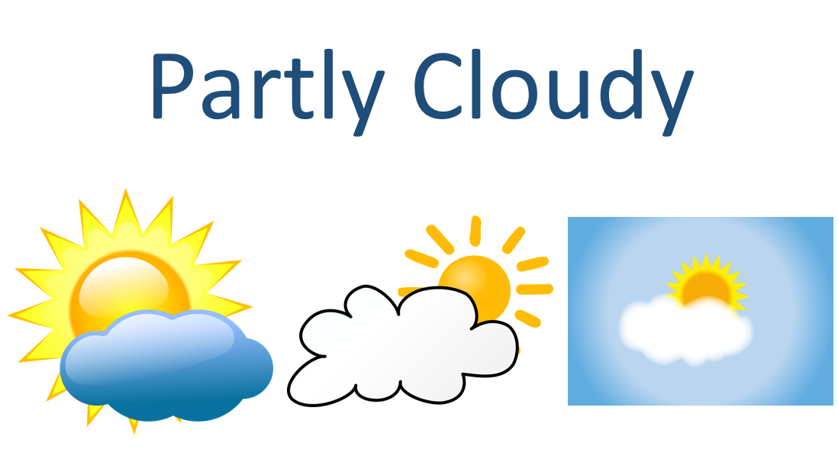

Slide 22

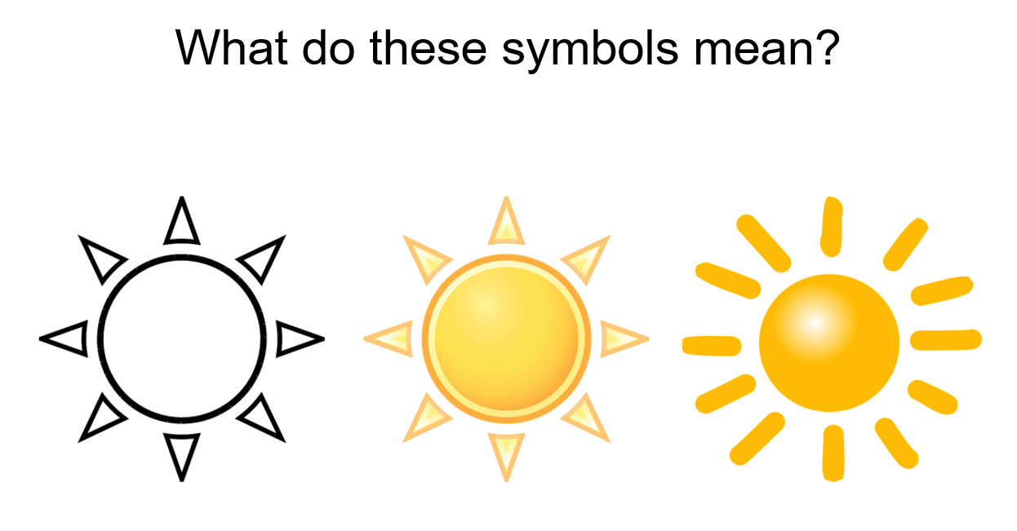

Slide 23

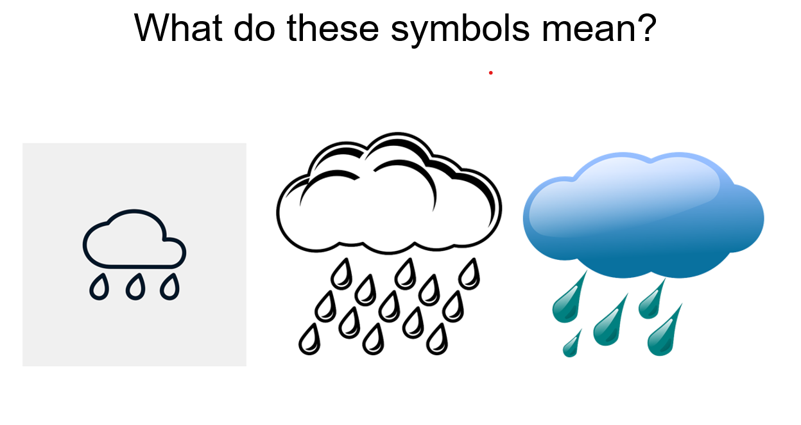

Slide 24
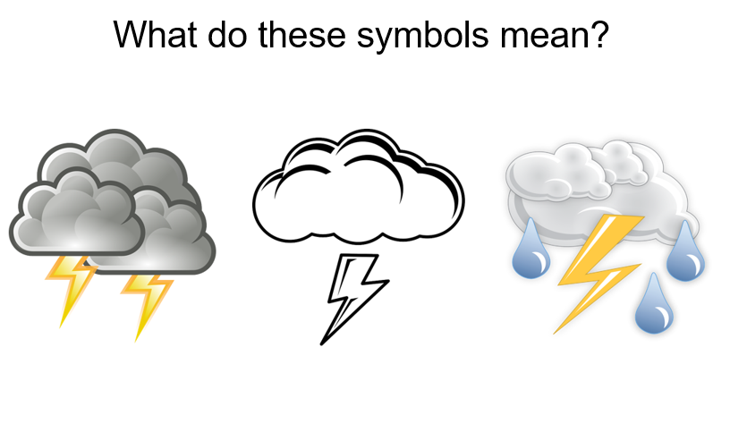

Slide 25

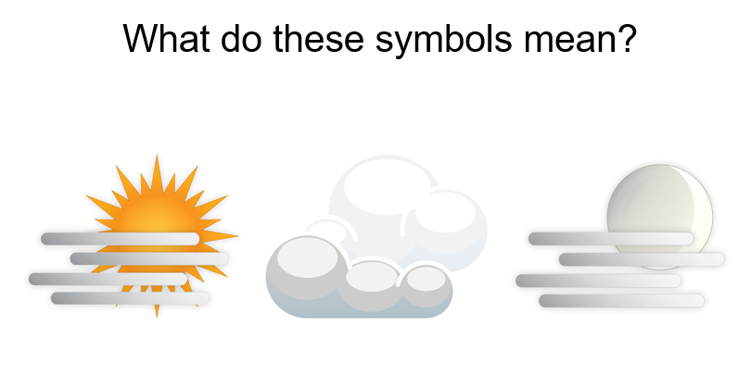

Slide 26

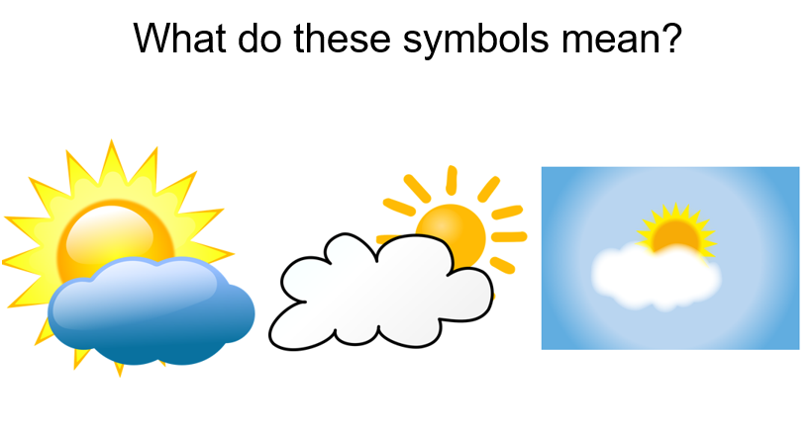

Slide 27

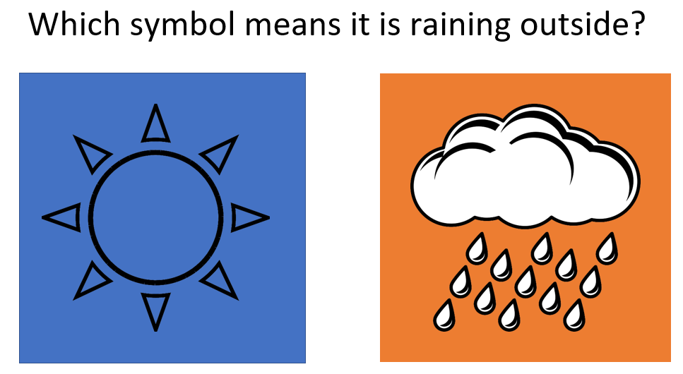

Slide 28

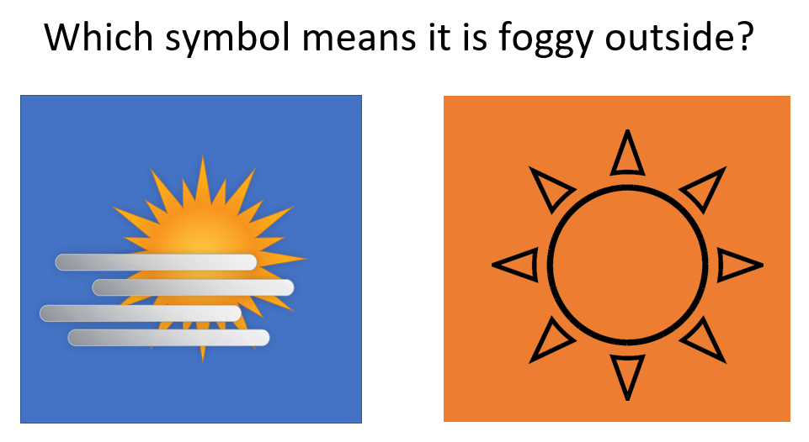

Slide 29

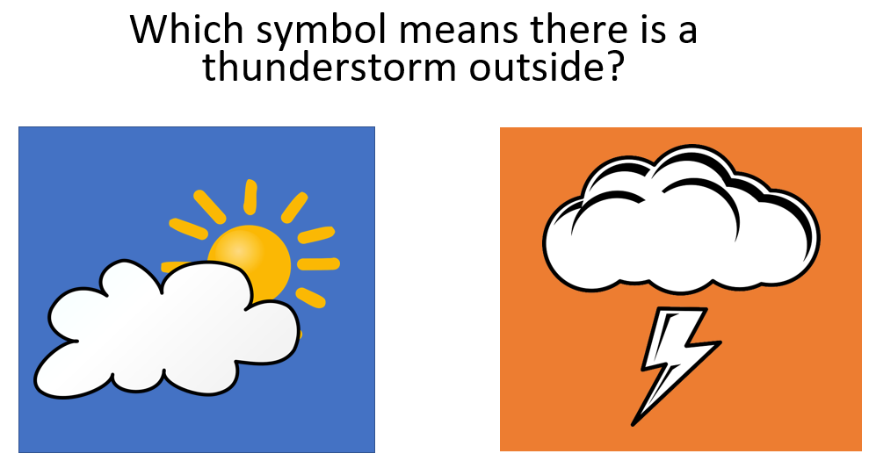

Slide 30

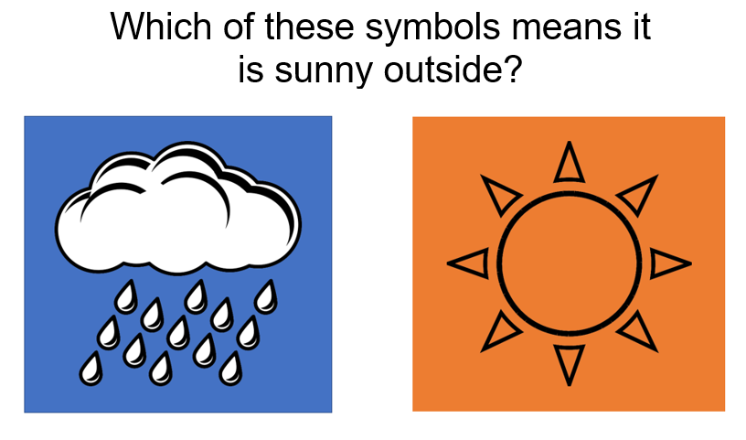

Slide 31

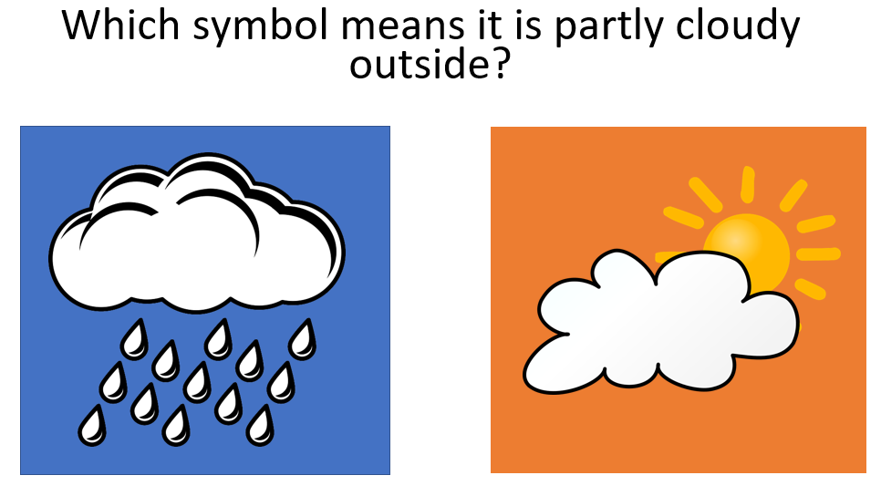

Slide 32

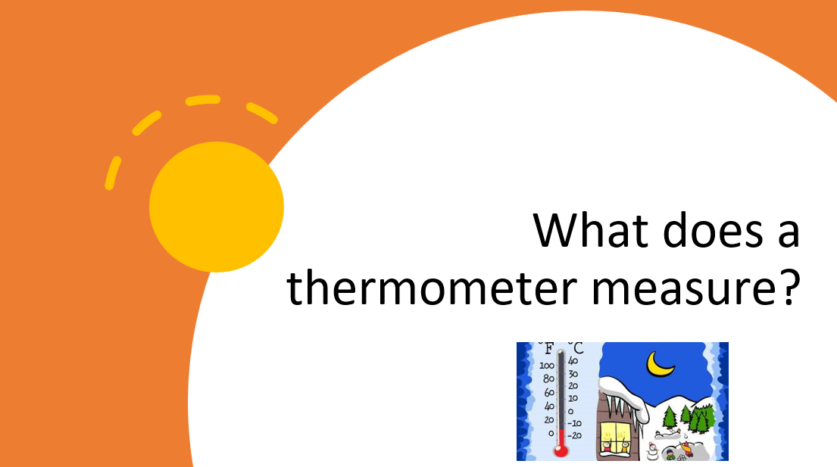

Slide 33

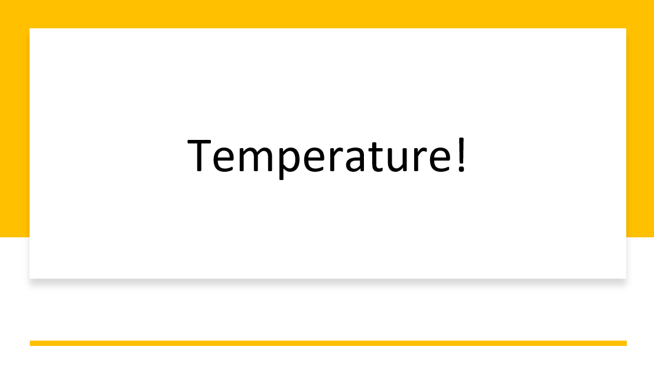

Slide 34

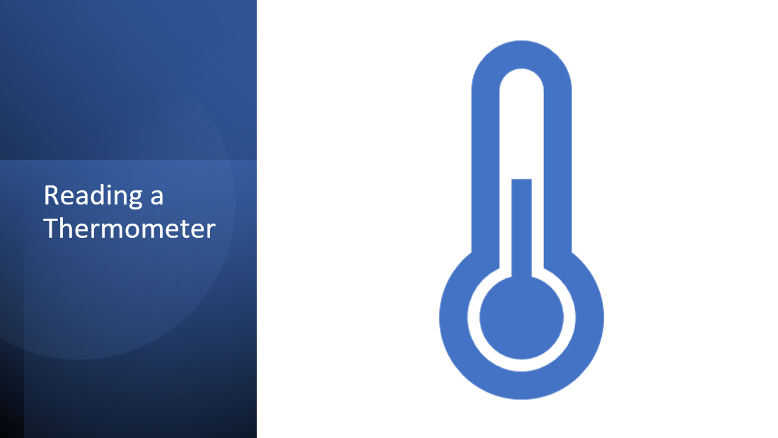

Slide 35
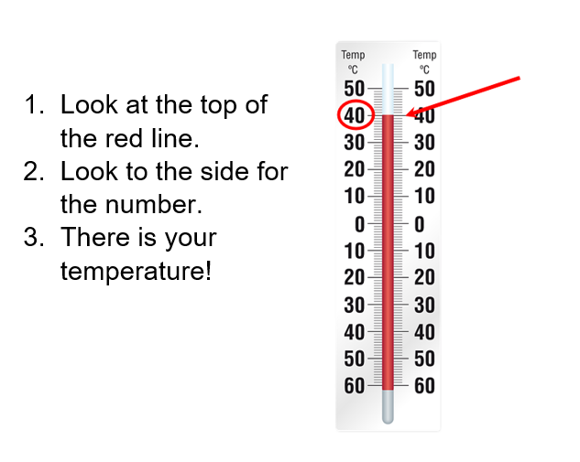

Slide 36

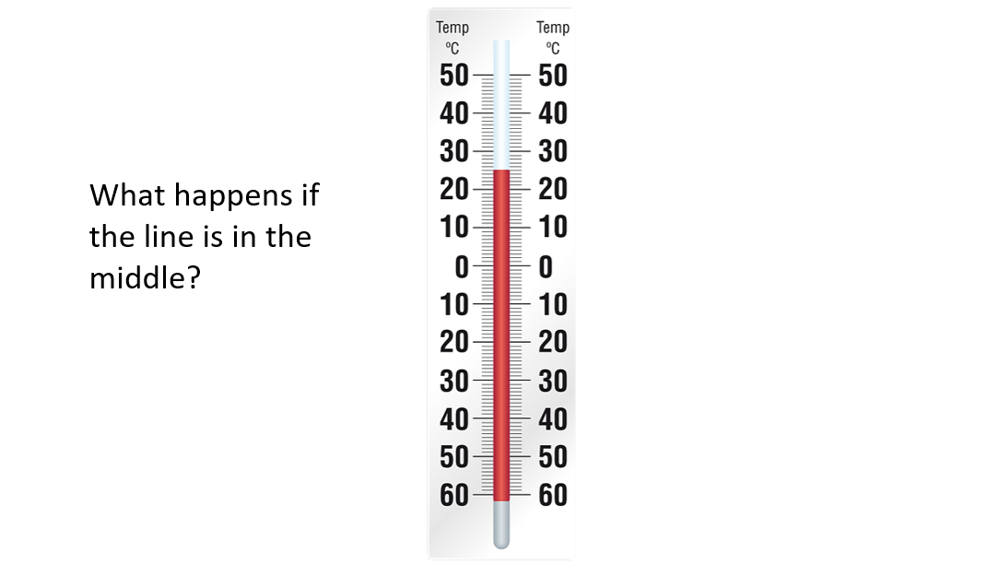

Slide 37

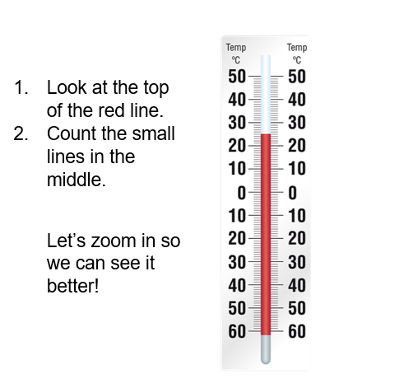

Slide 38

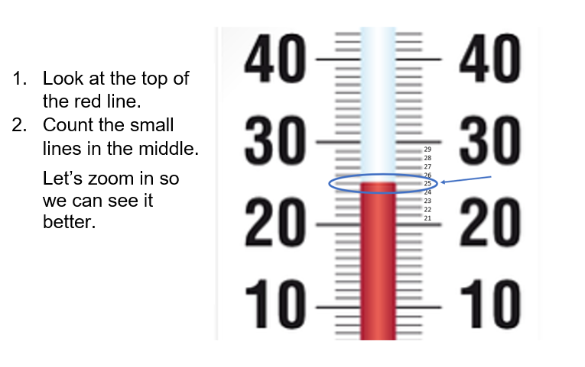

Slide 39

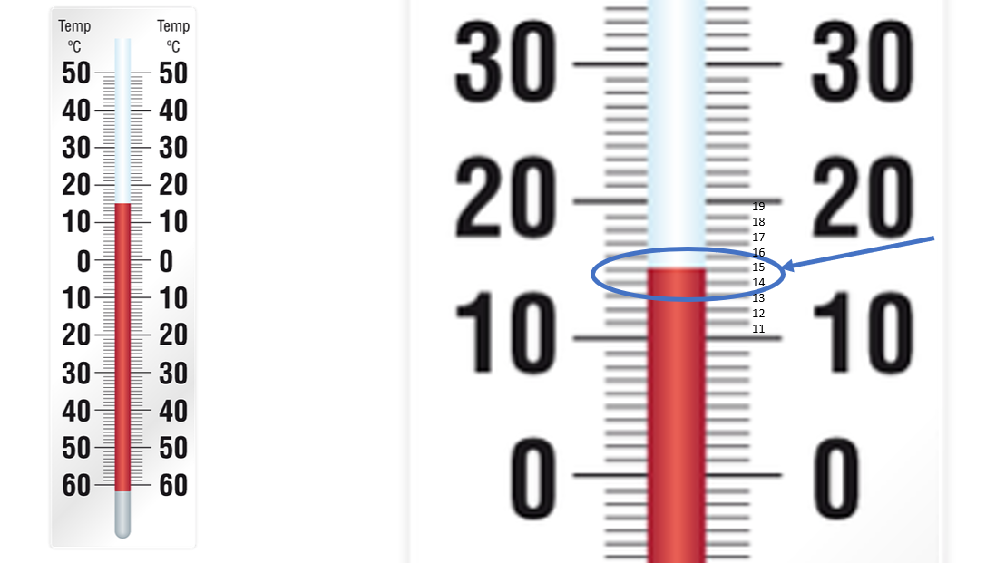

Slide 40

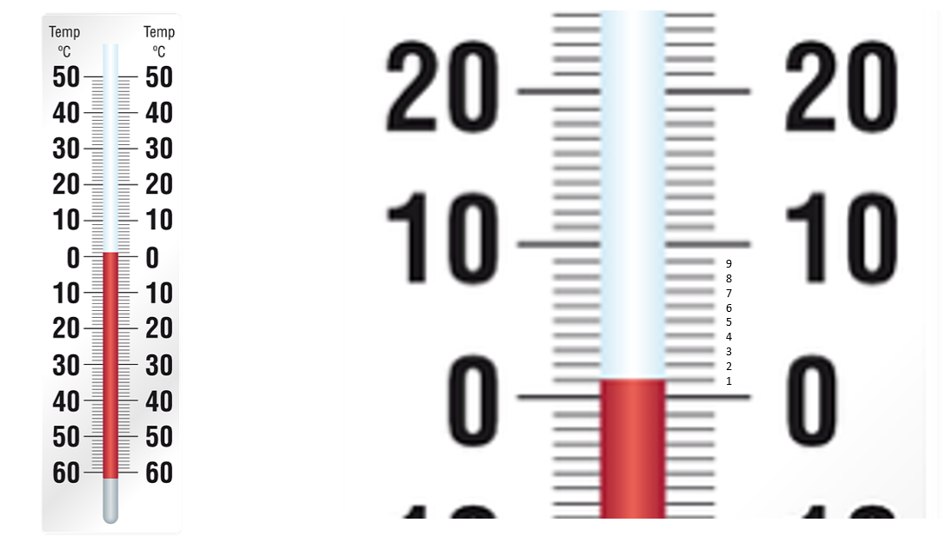

Slide 41

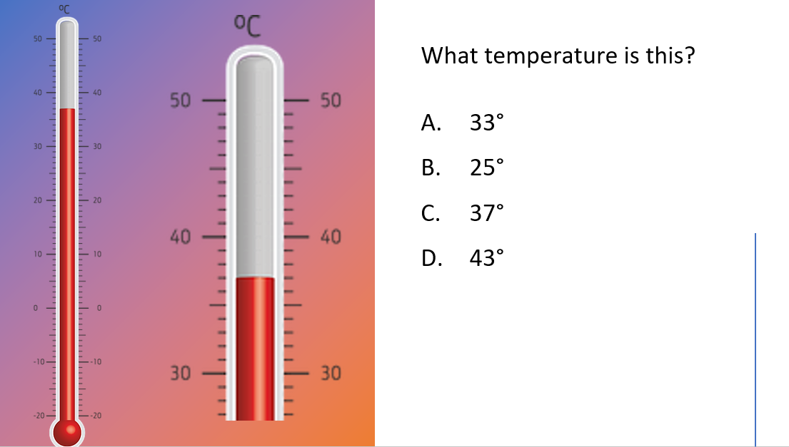

Slide 42

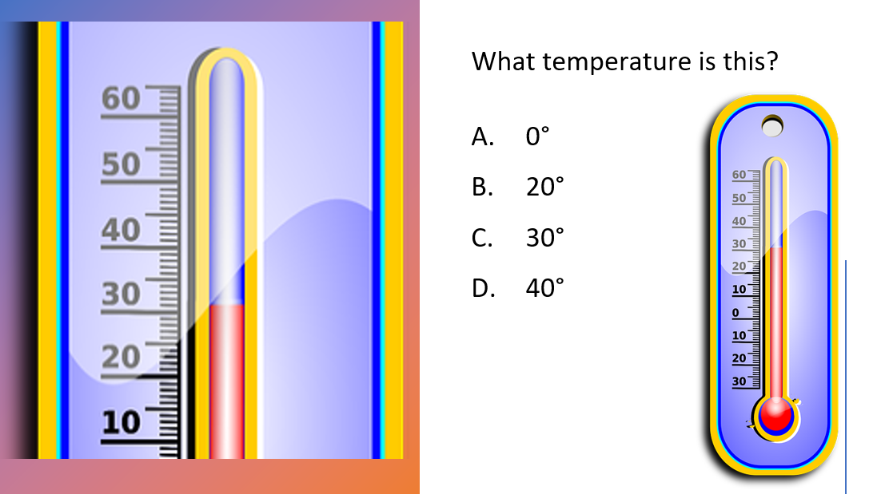

Slide 43

Slide 44

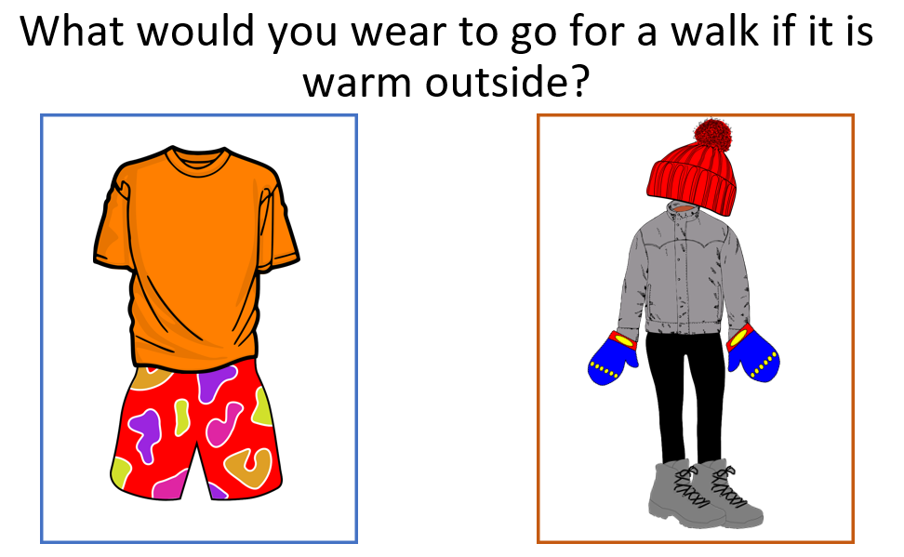

Slide 45

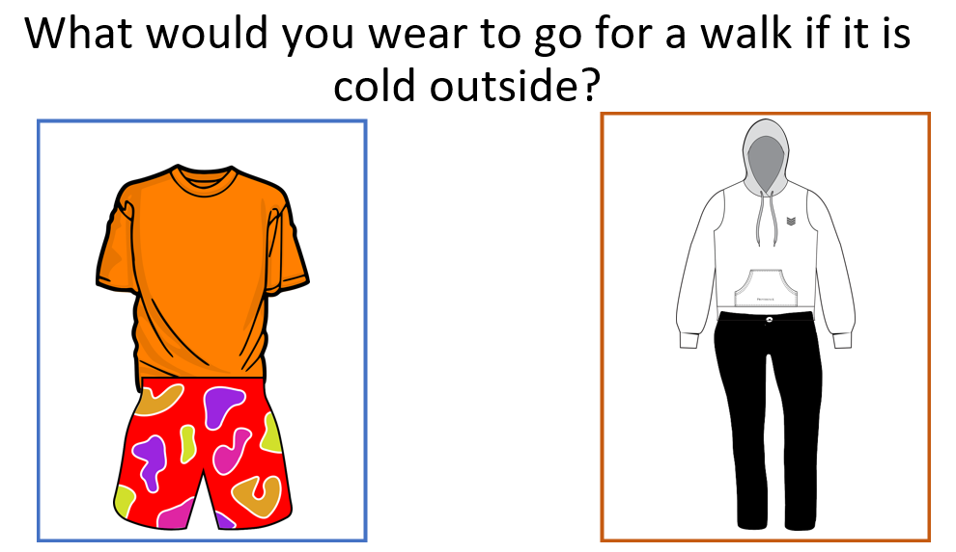

Slide 46

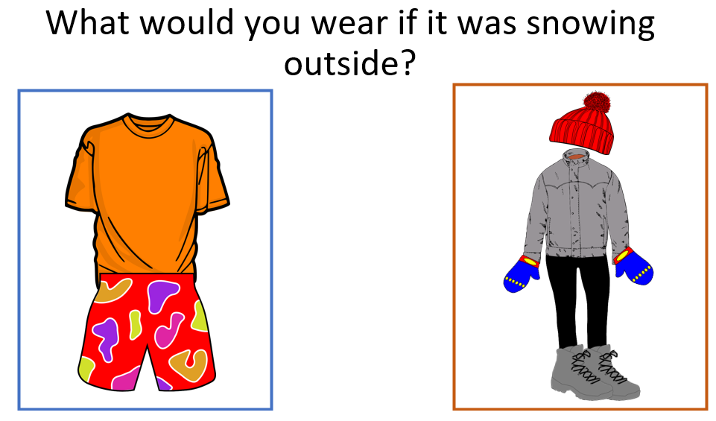

Slide 47

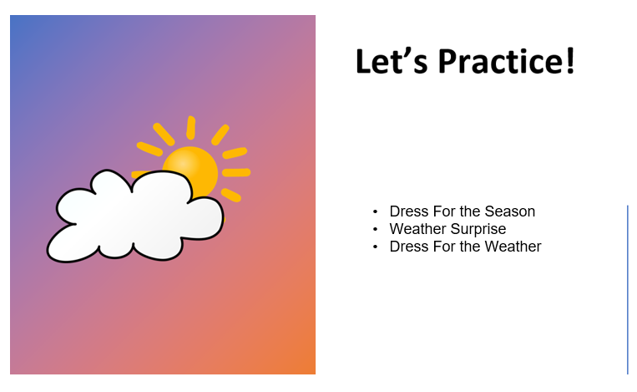

- Dress For The Season Weather Surprise Dress For The Weather

Slide 48

Slide 49

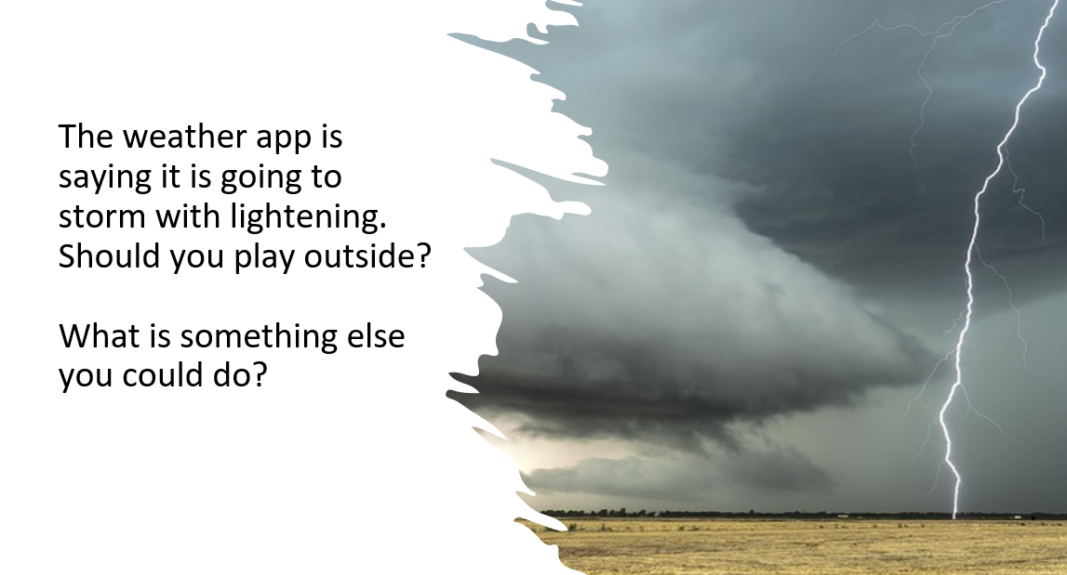

Slide 50

Slide 51

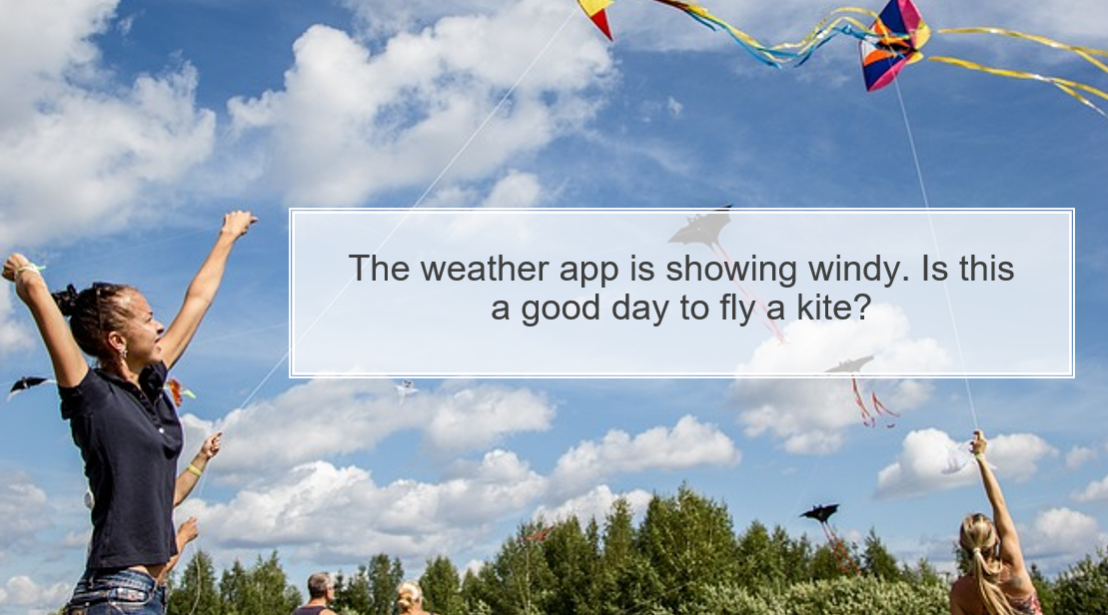

Slide 52

