Soapy Solutions

Help Us Stay Healthy
Grade Level: High School

Subject(s):
Primary: Reading, Science, and Math (This lesson can be taught as individual content lessons or integrated altogether.)

Reporting Category:
- Science: Life at the Molecular/Cellular and Systems/Organisms Levels
- Math: Algebra - Expressions and Operations
- Reading: Demonstrate comprehension of nonfiction texts and use word analysis strategies

Lesson Summary and Connections:
Students will listen to a story (or read a passage) and answer questions (reading), perform a simple experiment (science), and graph data (math) to develop an understanding of how washing hands (functional) can help minimize the number of bacteria and help slow the spread of illnesses such as the common cold or flu.
Lesson Components Links

VESOL(s)  Complexity Continuum | Functional Skills | Assistive Technology | Materials
Vocabulary | Common Misconceptions | Student-Friendly Outcome(s) | Introductory Activity
Plan for Instruction | Differentiation | Reflection | Formative Assessment
Word Wall Cards | Supplemental Materials | Practice Items

VESOL(s):
S-HS.3: Recognize that bacteria and viruses have an impact on human health and that people can take simple steps to support health and wellness.
Complexity Continuum:
- Recognizing simple steps that people can take to support their health (e.g., washing hands, brushing teeth, washing, and eating healthy food, getting regular sleep) to
- Recognizing that simple steps to support health can be framed as choices that people can make compared to other unrelated or poor choices to
- Recognizing that bacteria, viruses, and germs are too small to be seen with the naked eye and that they can cause illness/sickness if simple steps are not taken to support health and wellness.
M-HS.10: Interpret trends in data, including in real world applications.
Complexity Continuum:
Trends could include positive slopes of 1 through 10, negative slopes of -1 through -10, and slopes of 0.
R-HS.3: Answer questions about a nonfiction text that is read to the student or that the student reads.
Complexity Continuum:
The nonfiction text could range from four medium sentences with five to seven words up to two paragraphs with five to seven sentences each.

Functional Skill(s):
- Hand Washing: Sequencing, following directions, health, and safety

Assistive Technology/AAC (Augmentative and Alternative Communication):
- (TTS) Text-to-speech assistive technology that reads digital text aloud
- Student - (AAC) Augmentative and Alternative Communication devices

Materials:
- Supplemental Materials
- Word Wall Cards
- Markers
- Grid paper
- Chart paper
- Small bottle of baby oil or hand lotion
- Glitter - multiple colors
- Cup (or something else you can pick up, like a plate or silverware)

Vocabulary:
Prior Knowledge
Reading | Science | Math
- thoroughly | - cleanliness | - graph
- million | - germ | - positive
- habit | - healthy | - negative
- common cold | - impact

Current Vocabulary
Science and Math
- bacteria | - scatterplot | - negative linear relationship
- virus | - relationship | - no linear relationship
- trend | - positive linear relationship | - Slope 1 / Slope 2

Common Misconceptions:
Science:
- Students might think bacteria and viruses can not hurt them because they cannot be seen.
- Students might think their hands are clean if they do not look dirty.

Math:
- Students might get confused with positive and negative relationships (slopes) because the trend starts higher for a negative relationship/slope and lower for a positive relationship/slope.

Student-Friendly Outcome(s):
By listening to a story, conducting an experiment, and analyzing the data, I will be able to:
- Answer questions about a true story or event.
- Compare graphs and determine if a relationship is positive, negative, or has no relationship.
- Explain why it is important to wash my hands and other ways I can keep myself and my community healthy.

Introductory Activity:
- Choose one of the videos to play and only play it for about 30 seconds or to the end of one of the song clips. You can play the rest of the video throughout the lesson or on different days to keep students engaged in the lesson Hand Washing Video 1, Hand Washing Video 2
- After watching the video, ask students questions and record their responses. Sample questions:
  - When should you wash your hands?
  - How often should you wash your hands?
  - Why is washing your hands important?

Plan for Instruction:
Reading Section:
- Read (or have students read) the following passage all the way through one time:

About 22 million days of school are lost each year to the common cold. When students practice healthy habits, they miss fewer days of school. Thoroughly washing hands can keep you or other people from getting sick. Most people’s hands contain millions of good and bad germs. Most are harmless, but some may be bad germs that can cause you to get sick. Washing your hands for at least 20 seconds with soap is the best way to lift off bad germs and rinse them away.
- Re-read the passage but stop after each sentence to model how you process the information. For example: After reading the first sentence, say something like, “wow, 22 million is a lot of days missed. I know I’ve missed a few days from school from being sick with a cold, how about you guys?”… Continue through the passage modeling how you would take in the information. During this time, you could also model how to highlight key information or annotate/take notes on the side to help students who are at that level. Make sure to include the words bacteria and virus when discussing bad germs. Since the passage is short, you could make an anchor chart (A poster you create during the lesson to record and display important points) with your annotations. You can then refer to the passage throughout the lesson.
- Once you have gone through the passage again, Use the questions in Addendum 7 to review the information from the passage. With students who need assistance, model how you would attack each problem. For example, I would read question one and then restate it in my own words to make sure I understood what the question was asking. I would then reread the passage and stop where I thought the answer to the question was located. At this time, I would ask students what they thought or if they agreed with my answer. For the remainder of the problems, have students restate the question (if possible) and then have them try to locate the answer in the passage.
Science Section:
Lesson adapted from: Real Science: Glitter Germs
- Experiment Setup:
  - Pose the following questions (Hypotheses):
    - What do you think will happen to the good and bad germs on your hand when you shake someone else’s hand?
    - Does washing your hands affect the number of germs on your hands? Have students come up with ideas and write their ideas on the board or chart paper so they can see the different responses.
  - Explain to the students they will be conducting an experiment.
  - Have each student rub baby oil or lotion on their hands. Have one person sprinkle glitter onto their hands or if you have multiple colors of glitter, have several students put glitter on their hands. The glitter represents the germs.
  - Choose one or both scenarios, or create one of your own:
    - You have been sneezing and coughing and wiping your nose, or
    - It has been a while since you last washed your hands.
- Step 1:
  - Shake hands with everyone in the class. What happens to the germs? Record your findings on the Glitter Experiment Recording Sheet. (Addendum 8).
  - Pick up the cup (or another item you can pick up). What happens to the germs?
- Step 2:
  - Try washing your glittery hands in warm water without soap for 5 seconds. Did the germs go away? Record your findings on the Glitter Experiment Recording Sheet (Addendum 8).
- Step 3:
  - Wash your hands again. Use soap this time. Wash your hands for 20 seconds. Did the germs go away? Record your findings on the Glitter Experiment Recording Sheet.
- Conclusion:
  - What happened to the germs as you were shaking hands with your classmates?
  - What conclusion can you make about germs and washing your hands?
  - Record both of your conclusions on the Glitter Experiment Recording Sheet.
Math Section:
Part I
- Read and/or explain the following scenario to your students:
Mr. Scott’s Science class did an experiment on how hand washing effects hand cleanliness. They used lotion and glitter to help show germs and dirt on their hands. Students recorded their data in a chart using 0 to show completely clean through 10 showing extremely dirty. After putting the glitter on their hands, the students moved around the class and shook other students’ hands. After each handshake, the students would look at their hands and record how clean they were using the same scale. Once they shook 6 other students’ hands, they created a scatter plot with the data. (Addendum 9)
- Using the handout “Looking for Trends in Data”, have students make observations about the graph. Ask questions like: “What do you notice?” “What is being measured on the y-axis – (the axis that goes up and down) the x-axis (the axis that goes left and right)?”, “Does the data look like it is going up, going down or staying the same?”
Part II
- Using the same scenario, add the following information: After students conducted the first part of the experiment, they begin Part II where they wash their hands. The first trial they only used cold water to wash their hands and recorded the cleanliness of their hands in 5 second intervals up to 20 seconds. They rated the cleanliness of their hands using a scale from 0-5 where 0 represented completely clean hands and 5 represented very dirty hands. Their results are listed in the table and scatter plot. Depending on your students, you could show both (Addendum 10a) or just the scatter plot (Addendum 10b).
- Discuss what the data is showing. Ask students what they notice and what they wonder. (If students are struggling to come up with comments, model a few you notice. For example: I wonder why the dots look like they are going down. Or- I noticed that there were 3 different dots for 10 seconds and all others only had 1 or 2. Wonder why that is.)
- Once you have gathered all comments, ask students what the words Positive Relationship and Negative Relationship mean and how they might show it on a coordinate plane or graph. Students can use hand motions to indicate the direction each relationship would go on the graph. After the discussion, show these Word Wall cards: positive relationship, negative relationship, and no relationship. Have students compare the two graphs with the Word Wall cards and decide how they are alike and different. Hang the cards on the wall for future reference. Introduce the word slope and display the two Word Wall cards associated with slope. (Slope 1 / Slope 2) Discuss how you can use the relationships you previously discussed to help determine a line that would best fit the data and the slope that is associated with the line.
- After the discussion, have students use the graph to answer the questions located below the graph.
Part III
- Remind students of the scenario above then read the second part of the experiment.
The students reapplied the glitter to their hands and then washed their hands using warm water and soap and recorded the results the same way they did in the first part of the experiment.
- Using Addendum 11a/b, have students make connections between all three graphs making sure to refer to the type of relationship and the resulting slope. Continue to ask questions and model how you would interpret the information and then have students answer the questions below the graph.

Differentiation:
- Reading:
  - Model how to highlight or annotate text for students who need assistance.
  - Students who are able can read the passage and questions independently.
- Science:
  - Students who cannot participate in the experiment can watch this video.
  - Johns Hopkins Medicine – have students research or give them information on symptoms of the common cold. They can teach/tell the class what they learned.
- Math:
  - Students who did not master plotting points in the earlier grades, might need a little assistance or mini lesson on those VESOL (M.6.10 and M.7.9).
  - Have students record their own data for the experiment and use a graphing tool to create their own scatter plot.

Reflection:
- After reading the text, conducting the experiment, and analyzing the data, what can you say about germs (bacteria and viruses) and staying healthy? Use information from the text, experiment, and graphs to help you with your explanation.

Formative Assessment:
- Reading and Science:
  - Whenever you wash your hands, you should always use soap and warm water. Scrub all over your hands: your nails, the backs of your hands, in between your fingers, and even your wrists. You should wash for at least 20 seconds. A good way to judge the time is to sing the alphabet song to yourself.
    - What is this passage about?
    - How long should you wash your hands?
    - What should you use with warm water to wash your hands?
- Math:
  - Draw two graphs, one that represents a positive relationship (slope) and one that represents a negative relationship (slope) and explain why they represent these relationships.

Notes:
- Use this Hand Washing Data Tracking sheet with students to help them develop good hand washing habits.
- Display this Wash Your Hands for 20 Seconds near the sink as a visual for students.

Integrated Lesson: N/A

Word Wall Cards: Addendums 1 – 6

Scatterplot

shows the relationship between two sets of data
x
y

Addendum 1

Positive

Relationship

points slope from lower left to upper right

x
y

Addendum 2
Negative
Relationship

points slope from upper left to lower right

x
y

Addendum 3

No Relationship

No relationship exists

x
y

Addendum 4

Slope

rate of change or

the “steepness” of the line
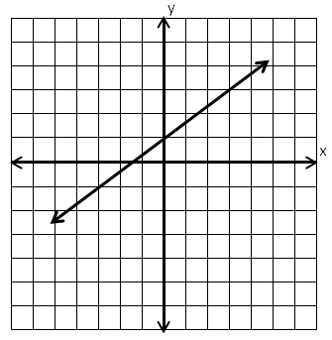
3
2
Slope = $\frac{\text{2}}{\text{3}}$

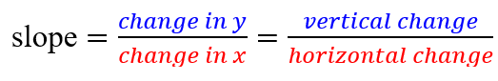

Addendum 5

Slope

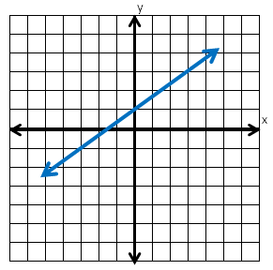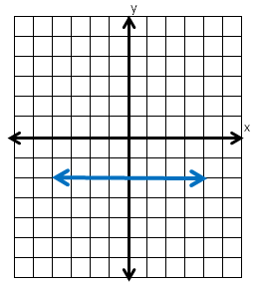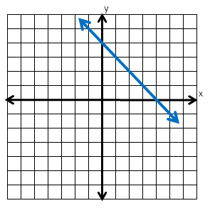
positive slope
negative slope
zero slope

Addendum 6

Supplemental Materials: Addendums 7 – 11b
Passage 1 Questions
Directions: Read the passage and answer the following questions.
- What is one thing a student can do not to get sick?
  - Eat cookies.
  - Play a game.
  - Wash your hands.

- How long should you wash your hands?
  - 5 minutes
  - 20 seconds
  - 1 hour

- What is this passage mostly about?
  - Why handwashing is important
  - What water is used for
  - Girls and boys in a school

Addendum 7
Glitter Experiment Recording Sheet

Color the hands below to show what they look like after each step of the experiment. For each step use words to describe how your hands look and feel.

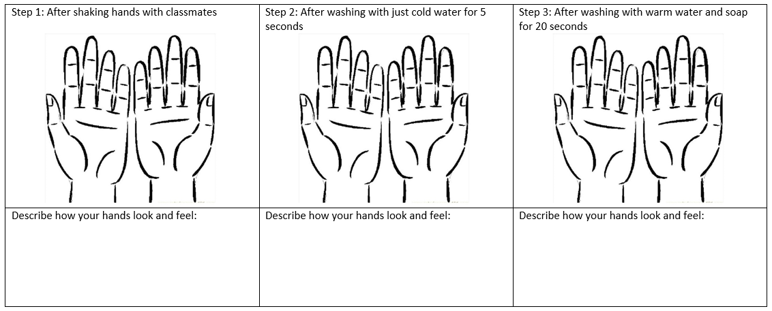
Conclusion:
1) Thinking about the experiment, what can you say about how germs are spread?

2) Thinking about the experiment, what can you say about how you can stop the spread of germs and live a healthy lifestyle?

Addendum 8

Looking for Trends in Data
Part 1
Mr. Scott’s Science class did an experiment on how hand washing effects hand cleanliness. They used lotion and glitter to help show germs and dirt on their hands. Students recorded their data in a chart using 0 to show completely clean through 10 showing extremely dirty. After putting the glitter on their hands, the students moved around the class and shook other students’ hands. After each handshake, the students would look at their hands and record how clean they were using the same scale. Once they shook 6 other students’ hands, they created a scatter plot with the data. Here are their results.

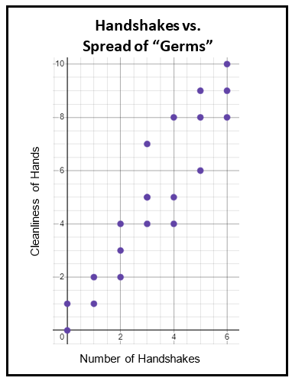

Directions: Read the scenario and review the data in the graph. Answer the following questions:

What do you wonder?

What do you notice?

Addendum 9
Looking for Trends in Data
Part 2

Block 4 Results Using only cold water

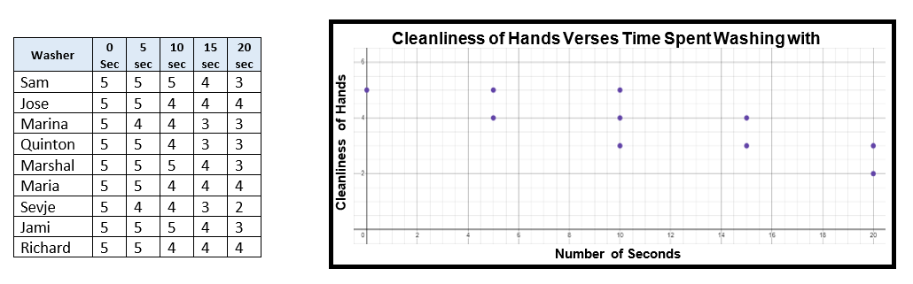

Directions: Use the data in the graph to answer the 3 questions below.

- What do you notice about the data in the scatter plot?

- Is there a relationship between the cleanliness of the student’s hands and the number of seconds they washed with cold water?

- How long do you think it would take for the students to have completely clean hands?

Addendum 10a

Looking for Trends in Data
Part 2

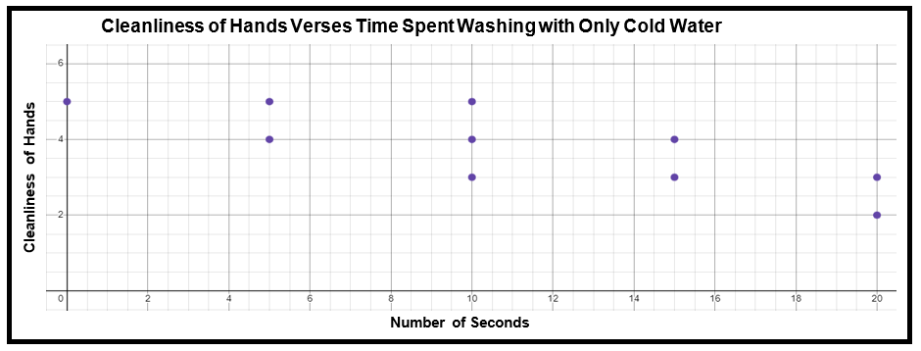

Directions: Use the data in the graph to answer the 3 questions below.

- What do you notice about the data in the scatter plot?

- Is there a relationship between the cleanliness of the student’s hands and the number of seconds they washed with cold water?

- How long do you think it would take for the students to have completely clean hands?

Addendum 10b

Looking for Trends in Data
Part 3

Block 4 Results Using warm water and soap

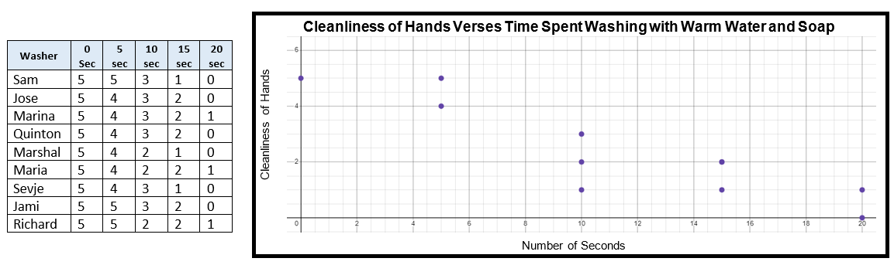

Directions: Use the data in the graph to answer the 3 questions below.

- What do you notice about the data in the scatter plot?

- Is there a positive or negative relationship between the cleanliness of the student’s hands and the number of seconds they washed with warm water and soap?

- How does this graph compare with the graphs in part 1 and 2?

Addendum 11a

Looking for Trends in Data
Part 3

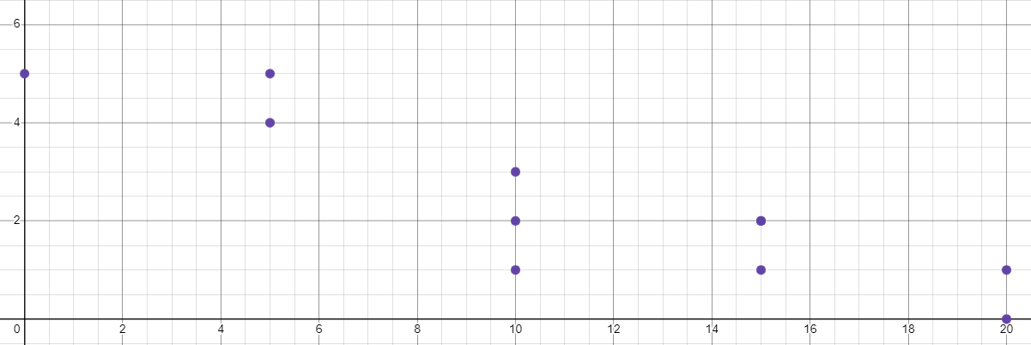
Cleanliness of Hands Verses Time Spent Washing with Warm Water and Soap
Cleanliness of Hands
Number of Seconds

Directions: Use the data in the graph to answer the 3 questions below.

- What do you notice about the data in the scatter plot?

- Is there a positive or negative relationship between the cleanliness of the student’s hands and the number of seconds they washed with warm water and soap?

- How does this graph compare with the graphs in part 1 and 2?

Addendum 11b
Reading Practice Item:

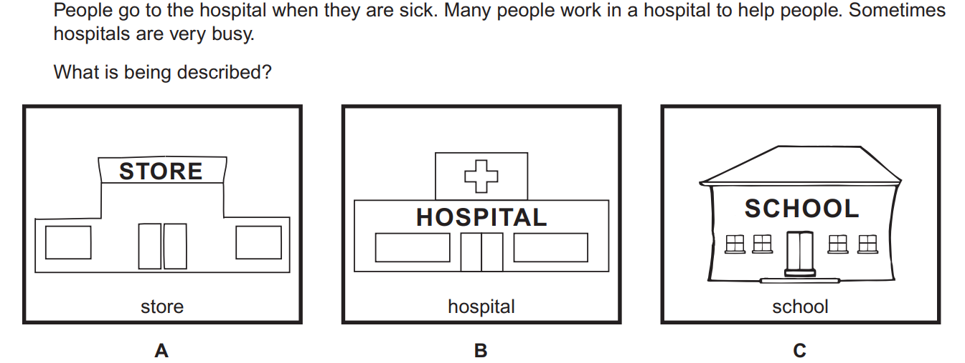

Addendum 12

Science Practice Item:

Kayla is sick with a cough. What should Kayla do to feel better and protect others?

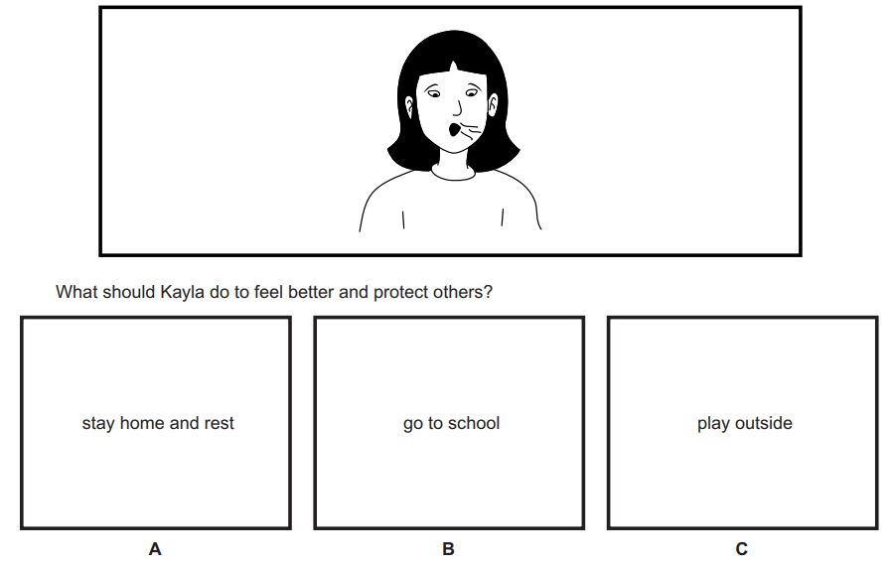

Addendum 13

Math Practice Item:

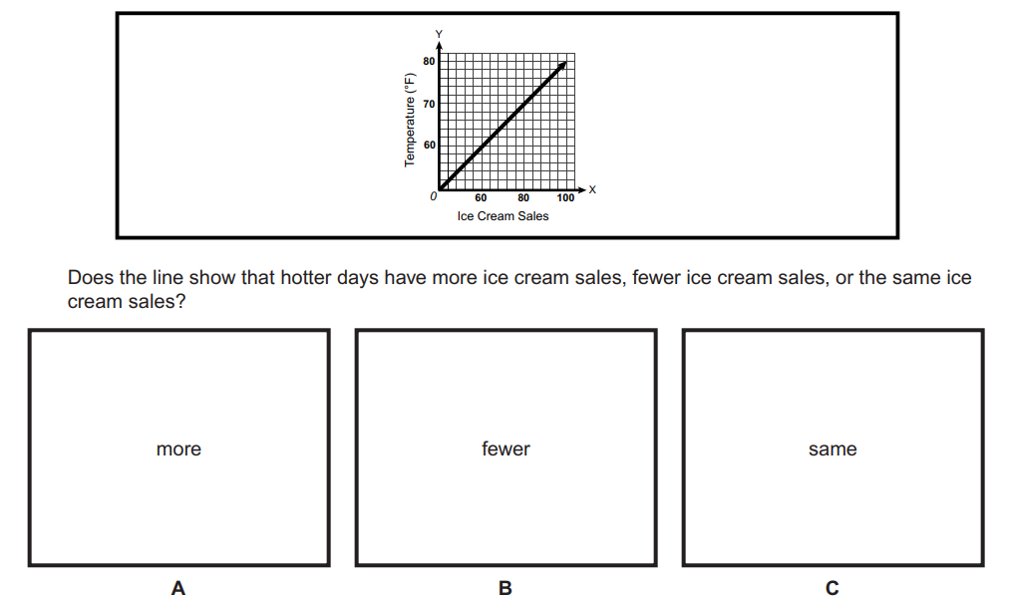
Addendum 14

