What could it cost?
Don’t let sales tax sneak up on you! It doesn’t have to be scary.

Grade Level: High School
Subject(s):
Primary: Mathematics
Integrated Activity: Mathematics, Reading
Reporting Category:
Algebra - Equations and Inequalities
Lesson Summary and Connections:
Students will find the amount of sales tax and total cost for a purchase.
Lesson Components Links
VESOL(s)  Complexity Continuum | Functional Skills | Assistive Technology | Materials
Vocabulary | Common Misconceptions | Student-Friendly Outcome(s) | Introductory Activity
Plan for Instruction | Differentiation | Reflection | Formative Assessment
Word Wall Cards | Supplemental Materials | Practice Items | Integrated Activity

VESOL(s):
M-HS.7: Find the amount of sales tax and total cost for a purchase.
Complexity Continuum:
Problems could include finding the total cost for a purchase when given the cost(s) of 1 to 3 items and the total sales tax or finding the amount of sales tax when given the cost(s) of 1 to 3 items and the total cost of the purchase.

Functional Skill(s):
- Recognizing total cost of a purchase such as at a store or restaurant
- Recognizing purchases without sales tax included will cost more.
- Recognizing purchase total (such as at a restaurant) will cost more than just the sum of the items (such as on a menu)

Assistive Technology/AAC (Augmentative and Alternative Communication):
- Students might need a communication device
- Students might need a calculator that reads the numbers and functions aloud or a calculator with larger buttons or larger screen.
- Students might need physical objects to select from.

Materials:
- Calculator
- Items from the classroom for a “store”
- Worksheets found under Supplemental Materials
- Dry erase boards & markers (optional)
- Fake money or electronic resource such as https://www.mathsisfun.com/money/money-master.html (optional for review)
- Addition worksheets such as from Math Drills https://www.math-drills.com/addition.php (optional for review)

Vocabulary:
Prior Knowledge
- coin | - penny | - nickel 1 | - nickel 2
- dime 1 | - dime 2 | - quarter 1 | - quarter 2
- dollar | - less | - more | - addition
- subtraction
Current Vocabulary
- sales tax

Common Misconceptions:
- Some students may have difficulty understanding that there will be an additional number to add on when calculating a purchase or that sales tax is not automatically included on all purchases.
- Some students may have difficulty understanding that sales tax is not an option.
- Some students might not understand that there are exceptions (such as prescription medicines, school lunches, etc.)

Student-Friendly Outcome(s):
- I can find the sales tax when given the price of an item(s) and the total price.
- I can find the total cost when given the price of the item(s) and the sales tax.

Introductory Activity:
- Pull up a weekly add from a local store on the computer or have hard copies. Give students time to look through the weekly ad and have them pick out items they might want to buy. Start a conversation about the items and prices they have found. Then move the conversation from the objects they want to buy to how things cost a little more than the price listed on the page. Sales tax is important because it helps give us community resources. But we need to be ready!

Plan for Instruction:
- Introductory Activity/Conversation
- Review prior vocabulary
  - Review money terms: dollars and cents. This can be done with cut-outs of or fake dollars and coins on the students’ desks or by using this free interactive tool (https://www.mathsisfun.com/money/money-master.html) on a shared screen (whole/small group) or individually. The goal in this review is to remind the students of how to read money when given in this format: $ _ . _ _ , especially in regard to prices seen in a store or restaurant.
  - Review computation terms: addition and subtraction. This can start off with simple math problems such as “2 + 1 =,” “1 + 1 + 1 =” and “2 + 1 = 3,” where the intention is to bridge to adding prices for more than one item.
    - This review can be done in a whole group where a student reads the problem on the board and asks a peer to solve it, then that peer solves that problem, reads a new problem, and asks a peer to solve the new problem.
    - The review can also be done with worksheets, such as Math Drill’s Addition Worksheets (https://www.math-drills.com/addition.php).
- Review putting it together
  - Have students practice simple money addition problems, including 2-4 addends. This can be done in the same review as above, where after students demonstrate competency with computation review, just start adding dollar signs. Some students may only be able to do whole dollar addition while others could select from answer choices or others could add change.
    - Remember to keep the ability level of the individual students in your class in mind when creating the review sets.
    - Also, encourage students to work problems with and without a calculator.
- Introduce & Define Sales Tax
  - The goal here is to let students know that when they pick out items in a store, the total cost will be different and always be more than just adding the price of the items together. This is a good thing because that money helps our community. This extra cost, the sales tax, can change if they buy things in different counties or states, or if they buy things like food versus clothes.
    - You can use this website to look up different county sales tax and possibly use with students.
    - Use the Word Wall card Sales tax to help facilitate the discussion further.
- Hands-on Activity:
  - Use a desk to set-up a “store” with some items from around the classroom such as a pencil, cup, stapler, book, or other items from home. Next to the items put cards (or write on the desk with a dry erase marker) with the prices for each item. Set a standard sales tax rate for the store such as 6%.
  - Give each student a set amount of money. This could be play-money or just the dollar amount. Have students select one to three items they can buy with the money they have been given.
  - Once they have selected their items and calculated their subtotal, have them come to you to “Checkout” At this time you calculate the tax, and they must calculate their total price and figure out if they have enough money to buy all of their items. During “checkout” conference with the student on how they got their subtotal, total price, and if they have enough money.
- Practice problems with sales tax (these can be put on your board, into different interactive programs, or as a worksheet found in the Supplemental Materials- Total Price, Sales Tax).
Finding Total Purchase
- Jose buys shoes for $70.00. The sales tax is $4.20. How much money does Jose need to buy the shoes?
A $70.00 B $65.80 C $74.20

- Terry buys a notebook for $9.99. The sales tax is $0.59. How much money does Terry need to buy the notebook?
A $10.58 B $25.00 C $12.50

- Raven wants a book that costs $8.75 and a book that costs $16.95. The sales tax for the books is $1.54. How much money will Raven spend buying the books?
A $31.54 B $27.24 C $40.00

- A new soccer ball costs $26.00. The sales tax is $1.82. How much will the coach spend to get the new soccer ball?
A $31.82 B $44.00 C $27.82

- Hamara is buying lunch. Nachos are $6.00 and a soda is $2.00. The sales tax will be $0.48. How much money does Hamara need to buy lunch?
A $8.48 B $7.52 C $6.10

Finding Sales Tax
- A pair of shoes costs $80.00. The total price including sales tax is $84.80. What is the sales tax for the shoes?
A $4.80 B $86.00 C $48.00

- A pack of notebooks costs $16.00. The total price including sales tax is $17.12. What is the sales tax?
A $1.11 B $12 C $1.93

- Bob wants two books that cost $8.00 and $7.00. The total price including sales tax is $15.90. What is the sales tax?
A $20.00 B $2.00 C $0.90

- Coach wants a pump for the soccer ball. The pump is $20.00. The total price including sales tax is $21.20. What is the sales tax?
A $0.01 B $1.20 C $23.00

- Sarah buys a taco for $9.00 and an iced tea for $1.00. The total price including sales tax is $10.55. How much will Sara spend on sales tax?
A $20.00 B $10.55 C $0.55

Differentiation:
- Some students may need more time reviewing money or addition before beginning the lesson.
- Make sure students have a calculator that is appropriate for them.
- Use cards with answer choices on them for students to select an answer.
- Some students might be ready to access this VESOL on a deeper level. If students are ready, do a mini lesson on how to calculate the tax on simple dollar amounts. Use 10% as a benchmark and then move to 5%. Use these benchmarks as a way to estimate the tax amount.

Reflection:
- Why is the total price more than the price of the items you buy?
- What is sales tax and why is it important?

Formative Assessment:

Questions
  - When a problem asks for a total, it means you need to use _______. (addition)
  - The extra amount that you pay over the cost of the items you purchase is called _________. (Sales Tax)
  - If you are asked how much money you have left, what operation do you need to use? (Subtraction)

Problems
  - Problem 1
    - STICKER PACKET: $12
    - SALES TAX (7%): $0.84
    - What is the total purchase price?
$15.00 $20.84 $12.84
  - Problem 2
    - CELL PHONE: $400
    - SALES TAX (7%): $28
    - What is the total purchase price?
$428 $450 $500
  - Problem 3
    - WATER BOTTLE: $28.58
    - SALES TAX (7%): $2.00
    - What is the total purchase price?
$35.00 $30.58 $22.84

Integrated Activity:
- Journal Activities:
  - Salvador has an amazing idea for a new invention. The materials cost $100 to make it. If the 7% sales tax is $7, what is the total price for the materials for the new invention? What invention do you think Salvador is going to make? Explain why you chose the invention.
  - You have won $10,000 in the lottery. You have to pay 15% tax on the money. How much would you have left after paying the tax of $1,500? Would you give any money away? Why or why not?
- Reading
  - Julia is working at the Phoebus High School Store. Her friends Monica and Hamza visited the school store during lunch and bought some items. Julia calculated the sales tax for her friends to finish their sales.
    - Monica
      - $2 pencil and $14 notebook
      - Sales tax (7%): $1.12
    - Hamza
      - $5 pencil case and $30 charger
      - Sales tax (7%): $2.45
  - Math Questions:
    - How much did Monica spend? How much did Hamza spend?
    - Who spent more money?
    - How many people visited the store?
    - How many people were working?
  - Reading Questions:
    - Where is the store?
    - When did Monica and Hamza go to the store?
    - Who didn’t buy anything?
    - What is the name of the school?
    - What did Monica buy? What did Hamza buy?
Word Wall Cards:

Penny

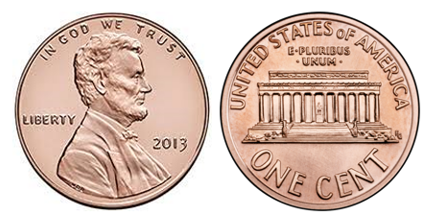

1¢

one cent

Nickel

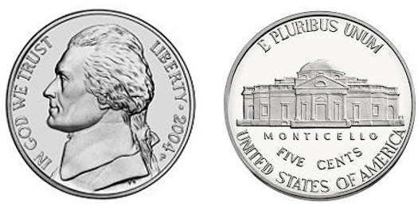

5¢

five cents
Nickel

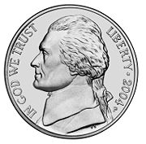

one nickel equals five pennies

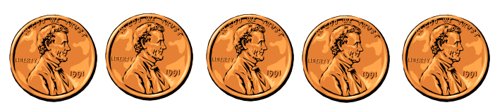
5¢
5 cents

Dime

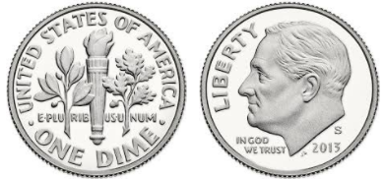

10¢
ten cents

Dime

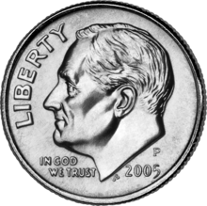

one dime equals ten pennies

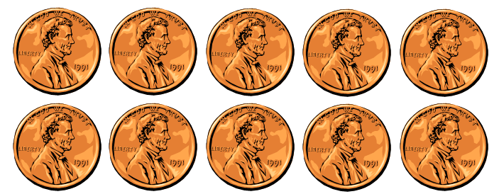

10¢
10 cents

Quarter

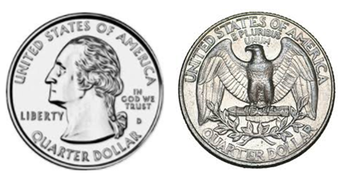

25¢
twenty-five
cents

Quarter

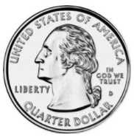

one quarter equals twenty-five pennies

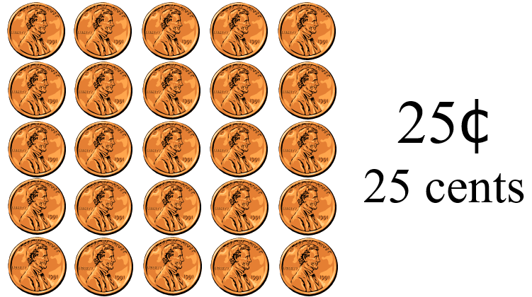

Dollar

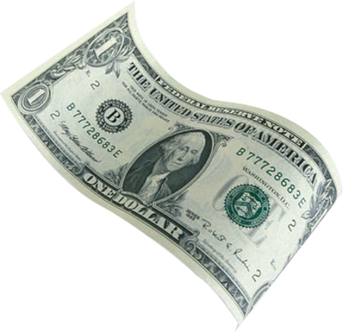

$1.00
one hundred cents

Addition

9 + 3 = 12
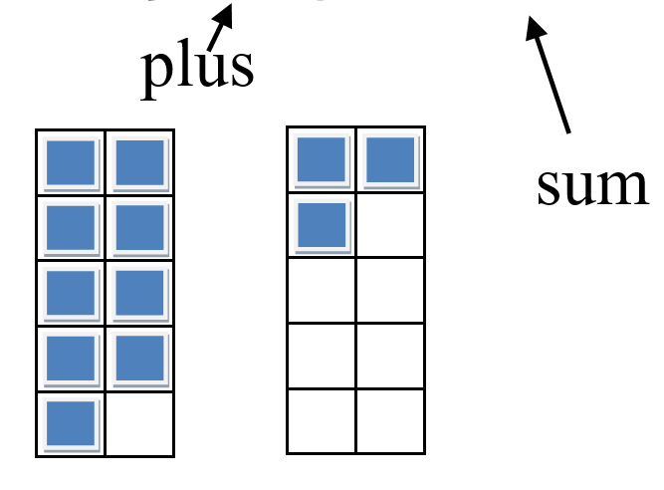

Subtraction

(subtract)
8 – 2 = 6
minus difference

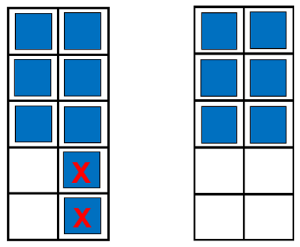

More Than

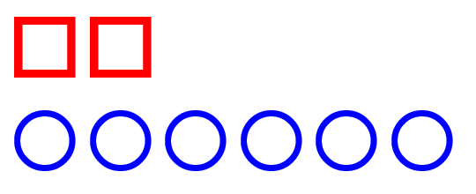

Less Than

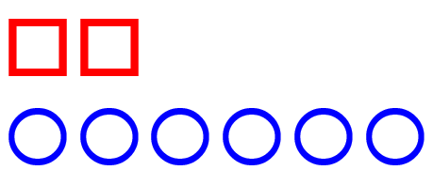

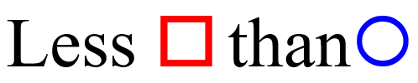
Sales Tax
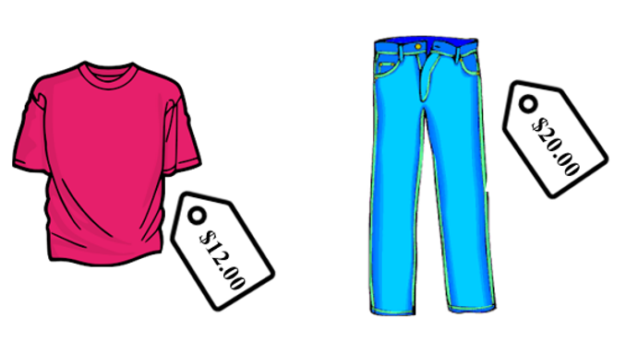

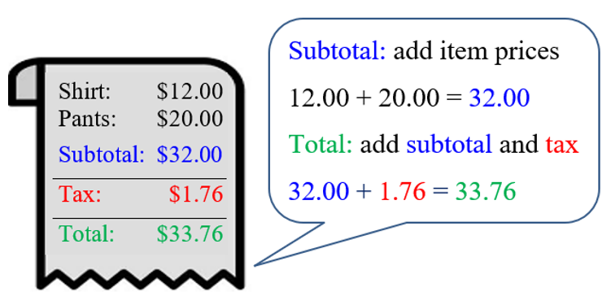

Name: __________________
Date: __________________
Finding Total Purchase
Directions: Circle the letter of the correct answer option.

- Jose buys shoes for $70.00. The sales tax is $4.20. How much money does Jose need to buy the shoes?

A $70.00 B $65.80 C $74.20

- Terry buys a notebook for $9.99. The sales tax is $0.59. How much money does Terry need to buy the notebook?

A $10.58 B $25.00 C $12.50

- Raven wants a book that costs $8.75 and a book that costs $16.95. The sales tax for the books is $1.54. How much money will Raven spend buying the books?

A $31.54 B $27.24 C $40.00

- A new soccer ball costs $26.00. The sales tax is $1.82. How much will the coach spend to get the new soccer ball?

A $31.82 B $44.00 C $27.82

- Hamara is buying lunch. Nachos are $6.00 and a soda is $2.00. The sales tax is $0.48. How much money does Hamara need to buy lunch?

A $8.48 B $7.52 C $6.10

Name: __________________
Date: __________________
Finding Sales Tax

Directions: Circle the letter of the correct answer option.

- A pair of shoes cost $80.00. The total price including sales tax is $84.80. What is the sales tax for the shoes?

A $4.80 B $86.00 C $48.00

- A pack of notebooks costs $16.00. The total price including sales tax is $17.12. What is the sales tax?

A $1.11 B $12.00 C $1.93

- Bob wants two books that cost $8.00 and $7.00. The total price including sales tax is $15.90. What is the sales tax?

A $20.00 B $2.00 C $0.90

- Coach wants a pump for the soccer ball. The pump is $20.00. The total price including sales tax is $21.20. What is the sales tax?

A $0.01 B $1.20 C $23.00

- Sarah buys a taco for $9.00 and an iced tea for $1.00. The total price including sales tax is $10.55. How much will Sara spend on sales tax?

A $20.00 B $10.55 C $0.55

Practice Items:
- 