# Can I Buy That?

**Grade Level:** 5

**Subject(s):**

Primary: Mathematics

Integrated Activity: Mathematics, Reading, Science

**Reporting Category:**

Number, Number Sense, Computation, and Estimation

**Lesson Summary and Connections:**

Students will find the value of coins up to $1.00 and make change for $1.00.

**Lesson Components Links**

|  |  |  |  |
| --- | --- | --- | --- |
| **[VESOL(s)](#_VESOL(s):)**  **[Complexity Continuum](#_VESOL(s):)** | **Functional Skills** | **Assistive Technology** | **Materials** |
| **Vocabulary** | **Common Misconceptions** | [**Student-Friendly Outcome(s)**](#_Student_Friendly_Outcome(s):_1) | **Introductory Activity** |
| **Plan for Instruction** | **Differentiation** | **Reflection** | **Formative Assessment** |
| **Word Wall Cards** | **Supplemental Materials** | **Practice Items** | **Integrated Activity** |

## 

## VESOL(s):

**M-5.6:** Use currency for problems up to $1.00.

**Complexity Continuum**:   
Problems could include determining whether a set of the same or different coins is sufficient to purchase an item priced up to $1.00 or making change for $1.00.

## Functional Skill(s):

* Students will identify coins as money and that money is used to buy things.
* Students will identify the values of a penny, nickel, dime, and quarter.
* Students will find the value of a set of coins and decide whether they have enough money to make a small purchase (up to $1.00) using coins.
* Students will identify whether they should get change back from a purchase.

## Assistive Technology/AAC (Augmentative and Alternative Communication):

* Students with weak fine motor skills may benefit from having the coins on a screen to manipulate virtually.

## Materials:

* A mix of pennies, nickels, dimes, quarters, one-dollar bill

## Vocabulary:

**Prior Knowledge**

|  |  |  |
| --- | --- | --- |
| * money | * penny | * nickel 2 |
| * coin | * dime 1 | * quarter 1 |
| * cents | * dime 2 | * quarter 2 |
| * value | * nickel 1 |  |

**Current Vocabulary**

|  |  |  |
| --- | --- | --- |
| * change | * dollar |  |

## 

## Common Misconceptions:

* Some students think smaller coins have a smaller value (size of coin determines value).
* Some students think the number of coins is more important than the value of the coin. For example, some students think they have more money if they have 3 nickels than if they have 1 quarter.

## Student-Friendly Outcome(s):

* I can name my coins and say their values.
* I know how much money I have because I can add the values of my coins.
* I know whether I have enough money to buy something I want that costs $1.00 or less.
* I know whether I should get change back when I buy something.

## Introductory Activity:

Show students an assortment of coins. Ask questions such as:

* Do you know the names of any of these coins?
* Do you know how much each one is worth?
* Which coin has the greatest value?
* Which coin has the least value?
* How many pennies does it take to be the same value as a nickel?
* How many quarters does it take to make a dollar?

Use the answers to these questions to determine each student’s level of understanding and starting point for instruction.

**Starting Point for Instruction (Level A, Level B, or Level C)**

**Level A - for students with some knowledge of money. [Refer to grade 3 lesson on money.]**

* + Students at this level know that money is used to buy things, recognize that the coins are different from each other, and coins have different values. They may not know the name and value of each coin.

**Level B – for students who know the name and value of each coin. [Refer to grade 4 lesson on money.]**

* + Students at this level can identify the name and value of each coin. They may not know how to find the value of a set of coins. This level should be the appropriate learning level for students who successfully learned the grade 3 VESOL.

**Level C – for students who can add the values of two coins (same or different) [Continue with grade 5 lesson on money].**

* + Students at this level can add coins to find the value up to 50 cents.

## Plan for Instruction:

**Level C**

* Find the value of a set of coins with a maximum value of 50 cents.  
  Students should begin by showing how many nickels are equal to 50 cents, how many dimes equals 50 cents, and how many quarters equals 50 cents. Counting the nickels reinforces counting by fives (M-3.17, M-4.22). Counting the dimes reinforces skip counting by tens (M-4.22) and multiples of ten (M-4.2, M-5.3).
* When students become comfortable with coins whose total value is 50 cents or less, they should begin finding the value of a set of coins up to $1.00.

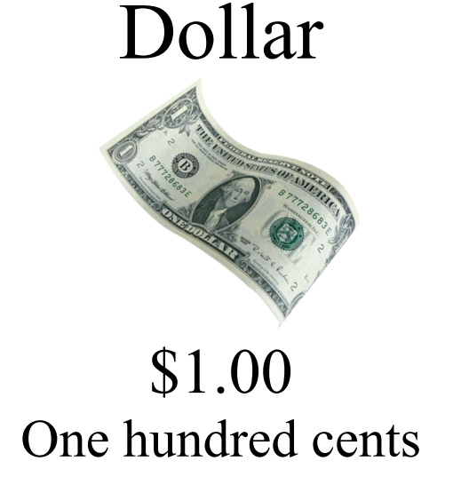

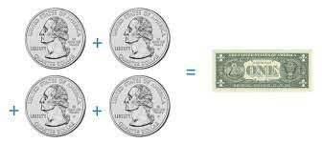

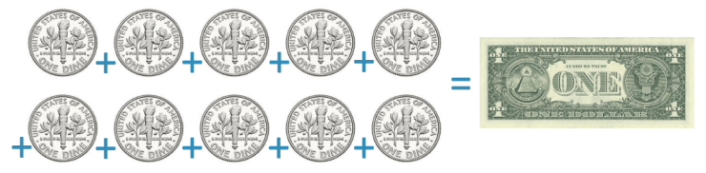

* Students should be shown that 4 quarters are equal to one dollar. Some students may be able to trade quarters for nickels to see that it takes more nickels to equal a dollar. Some students may be able to identify that 5 dimes are equal to 50 cents, so 10 dimes are equal to one dollar. Other students may rely on knowing the values of individual coins and using a calculator to add the value of a set of coins up to one dollar.
* For students to be able to identify whether they have enough money to make a purchase up to $1.00, they will need to be able to compare numbers to determine which one is greater. Many students benefit from using a number line to compare numbers and decide which number is greater. This technique will require a number line from 0 to 100 so that students can locate the number that represents the total value of their coins.
* Students should begin by finding the value of a small set of coins. For example:
  + Show students two quarters and a dime. Ask:
    - What is the value of one quarter?
    - What is the value of two quarters?
    - What is the value of one dime?
    - Can you tell me how much they are worth all together?
    - Show students how to begin with 50 cents and count on by ten. Then let them verify it with a calculator.
* Repeat this same process a few times with different coins and different numbers of coins whose value is $1.00 or less. Students may be more comfortable working in pairs or groups to add the coins.
  + Next give each group of students a different set of coins.
    - What is the value of your set of coins?
    - Which group has the set of coins with the greatest value?
    - Does any group have a set of coins equal to $1.00?
    - Have each group put a point on a number line to show the value of their coins. Then discuss how the sets of coins are arranged from least to greatest.
* Next, show students representations of items with price tags of $1.00 or less. One of the most visible ways that students can compare the cost of the item with the value of the money is to put a picture of the item on the number line to represent the cost. For example, if a comb is 75 cents, put a picture of a comb on the number 75.

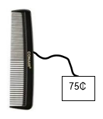

* At this point, they can think about which amounts of money are enough to buy the comb. This same comparison can be made with any objects with price tags up to one dollar. Suggestions include a pencil, eraser, keychain, etc.

Three items for sale as follows:

A sharpened pencil for 55 cents.
A pink eraser for 65 cents.
A keychain depicting a dog for 89 cents.

* Once students become comfortable with counting coins and comparing values of coins and objects, either on a number line or in other ways, they are ready to find the amount of change they should get from a dollar. They are also ready to determine how much more money they need to buy an object if they don’t have enough money.

## Differentiation:

* For students who show proficiency in adding coins with different values, ask them to show you two different sets of coins that make the same value. For example, show students a picture of an item with a price tag of 85₵. Ask students to show coins they could use to buy the item. If students show coins that equal more than 85₵, ask questions to determine whether they are aware their coins have a value greater than they need. They can also be asked to show the amount of change they would get if they paid for the item with a dollar bill.
* Students can also be shown a picture of an item with a price tag less than or equal to $1.00 and coins with a total value less than what they need. Students should be asked to identify which other coins they can combine with the given coins to have the correct amount of money for the item. For example, students can be given an item with a price tag of 93₵ and three quarters. They should choose coins to combine with the quarters to make 93₵.
* Students can also be shown two objects with different prices and be asked to determine whether they have enough money to buy both objects, one object, or neither object.

## Reflection:

* Activities with money can be included in daily routines. Students might “purchase” treats from a treat box, earn money by helping with classroom tasks, or play games such as “Who Has More?” with the group.

## Formative Assessment:

Give students a collection of mixed coins.

* Say: Show me coins that make 90 cents.
* Say: Now show me a different way to make 90 cents.
* Say: Here is a quarter. Show me which other coins can be put with the quarter to make one dollar.
* Say: This object costs 73 cents. Show me the correct coins to buy the object.
* Say: If you paid for the object with a dollar bill, how much change would you get?
* Say: Here are two sets of coins. (Give students coins.) What is the value of each set of coins? Which set of coins is closer to $1.00?

**Mastering the Skills**

A table can be used to keep a running record of student progress over time. Students may master these skills at different times, and that could be documented with the date the student demonstrated the skill. Skills can be added to the table over time.

|  |  |  |  |  |  |  |
| --- | --- | --- | --- | --- | --- | --- |
| **Skill** | **Student 1** | **Student 2** | **Student 3** | **Student 4** | **Student 5** | **Student 6** |
| Tell value of a set of coins less than 50 cents. |  |  |  |  |  |  |
| Tell value of a set of coins between 50 cents and $1.00. |  |  |  |  |  |  |
| Show correct coins to make a purchase up to $1.00. |  |  |  |  |  |  |
| Given coins, identify additional coins to combine with it to make a specific value. |  |  |  |  |  |  |
| Given two or more coins, identify other coins needed to make a total of $1.00. |  |  |  |  |  |  |
| Tell the amount of change that should be received when making a purchase up to $1.00. |  |  |  |  |  |  |
|  |  |  |  |  |  |  |
|  |  |  |  |  |  |  |

## Integrated Activity:

**Buying Plants**

Read this story to students. Have a set of coins and a number line available to the students.

Byron and Gabe want to plant a garden together. Byron and Gabe are going to The Happy Plant Store after school to buy plants for their garden. Byron’s mom said she would drive them to the store and help them with their garden, but the boys have to pay for the plants. Byron has a dollar bill and Gabe has two quarters and a dime. The store sells strawberry plants for 55 cents each, tomato plants for 40 cents each, and lettuce plants for 75 cents each.

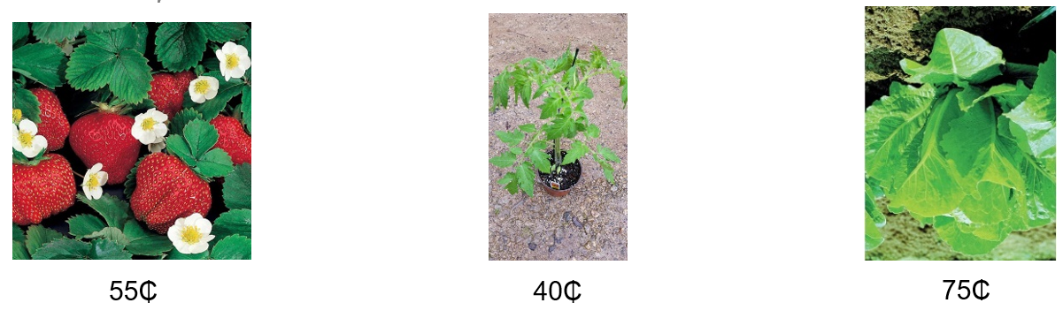

Reading Questions:

1. Where are Byron and Gabe going to buy plants?
2. Who has more money, Byron or Gabe?
3. Whose mom said she would drive them to the store?
4. When are Byron and Gabe going to the store?

Math Questions:

1. Show the coins that Gabe has (using a set of coins.)
2. Does Gabe have enough money for a strawberry plant?
3. If Byron buys a strawberry plant, how much change should he get?
4. If Gabe buys a tomato plant, how much change should he get?
5. Does Byron have enough money to buy a lettuce plant and a tomato plant?
6. How many tomato plants can Byron buy with his money?
7. If Byron and Gabe put their money together, do they have enough money to buy all three plants? Why or why not?

Science Questions:

1. Which of these is most important for the plants to grow?
   1. rocks b. sunlight c. salt
2. Which part of a plant is inside the ground?
   1. flowers b. leaves c. roots

Penny

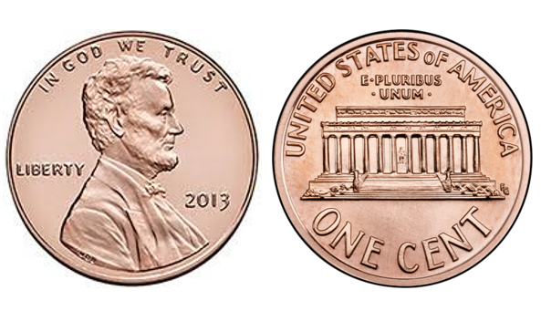

1¢

one cent

Nickel

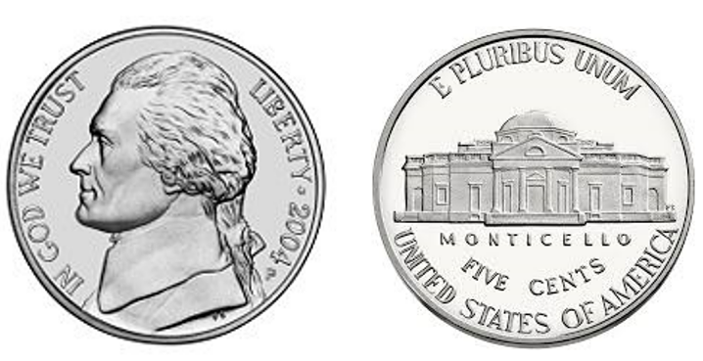

5¢

five cents

Nickel

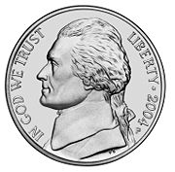

one nickel equals five pennies



5 cents

Dime

Image of the back of a dime.

Image of the front of a dime.

10¢

ten cents

Dime

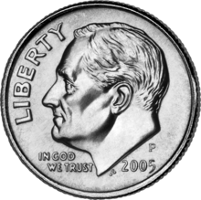

one dime equals ten pennies



10 cents

Quarter

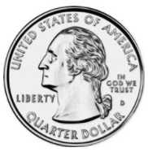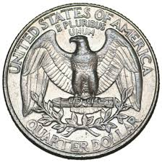

25¢

twenty-five

cents

Quarter



one quarter equals twenty-five pennies



25 cents

Dollar

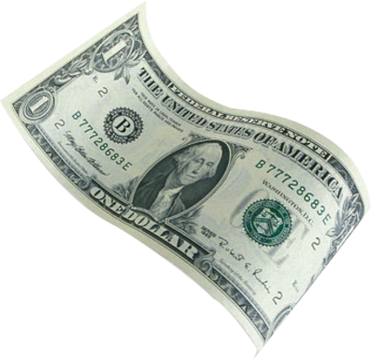

$1.00

one hundred cents

Practice VESOL question from 5th grade Math test.

Diagram: An apple costs 75 cents or three quarters. A dollar minus three quarters is equal to how many?

Question:  An apple costs 75 cents.  Beth paid one dollar for the apple.  How much should Beth get back?

A. one penny
B. one dime
C. one quarter

Practice VESOL question from 5th grade Science test.

Diagram: A boy standing next to a tomato plant holding a single tomato.

Question:  This is a tomato plant.  What would help the tomato plant grow?

A. watering (picture of a water pale)
B. swimming (picture of a boy swimming)
C. reading (picture of a boy reading a book)