Picture Graphs: More/Less/Same
Grade Level: 3rd grade
Subject(s):
Primary: Mathematics
Integrated Activity: Science
Reporting Category:
Probability, Statistics, Patterns, Functions, and Algebra
Lesson Summary and Connections:
Students will be learning how to compare information on a graph with the terms same, more, and less.
Lesson Components Links
VESOL(s)  Complexity Continuum | Functional Skills | Assistive Technology | Materials
Vocabulary | Common Misconceptions | Student-Friendly Outcome(s) | Introductory Activity
Plan for Instruction | Differentiation | Reflection | Formative Assessment
Word Wall Cards | Supplemental Materials | Practice Items | Integrated Activity

VESOL(s):
M-3.16: The student will: Compare categories represented in picture graphs using simple terms: same, more, less.

Complexity Continuum:

Categories could be presented for comparison that range from having the same amounts to having significantly different or slightly different amounts.

Functional Skill(s):
- Students will count with one-to-one correspondence.
- Students will develop analytical skills with interpreting/understanding data.

Assistive Technology/AAC (Augmentative and Alternative Communication):
- Yes/No communication cards or access to yes/no on AAC
- Access to communication cards or AAC devices with more, less, same
- Adapted scissors

Materials:
- Large cube (as many as you need for students to be grouped/paired/or independent)
  - If a large cube is not available, you can print out options, laminate if possible and pull at random from a hat or bag. Make sure to return picture to hat or bag during activity.
- Picture cards for cube (spider, butterfly, ant, ladybug, bee, dragonfly)
- Graphing worksheet
- Graphing worksheet for assessment
- Optional materials
  - Glue
  - Student scissors

Vocabulary:
Prior Knowledge What words will students need to know prior to starting the lesson?
- Compare
- Same
Current Vocabulary What words will students learn during the lesson?
- Picture Graph | - Less than
- More than

Common Misconceptions:
- Students may get confused with one-to-one correspondence and struggle to keep track of each item.
- Students who need to be challenged and can work on skip counting may struggle with understanding that the pictures represent more than one

Student-Friendly Outcome(s):
- I can compare pictures in a picture graph as same
- I can compare pictures in a picture graph as more, or less

Introductory Activity:
Begin the lesson with the question: “How do you get to school each day?” Use the organizer and cards (Addendum 1) to collect the data from students and make a picture graph. This can be created as an anchor chart, bulletin board, etc. Students who are able should be encouraged to bring their card to the organizer and place it where it belongs. (Extend the table and reproduce as many cards as you need for your class.) Follow the steps below the cards.
- Begin by asking students, “How do I get to school?”
  - Place your own picture card that shows how you get to school.
- Next, ask students one by one to come up and pick out the card that matches how they get to school.
- Allow them to add their card to the chart.
- Ask students follow-up questions about how the previous student gets to school.
  - This is where you can ask, “Do you think student A arrives to school the same way as student B?” or “Do they arrive the same time as me?”
- Once all students have placed their cards on the chart/board, ask students some of the following questions.
  - What can you tell me about what we see on the chart?
  - Is there one way of transportation that more students use to get to school?
  - Are there two ways of transportation that have the same number of students?
  - Is there one way of transportation that less students use to get to school?
- These questions can be used to review the vocabulary of same, more, and less.
  - This will help you determine if students understand the vocabulary, and whether you need to review it more during the lesson.

Plan for Instruction:
- Video –

  - YouTube: BrainPop (stop at 4:48): https://www.youtube.com/watch?v=Uz_CgWdUJ1Q – This video is about pictographs. Pictographs are very similar to picture graphs. The difference is a pictograph uses only one image for all categories and a picture graph uses different pictures for each category. The video:
    - Explains what a pictograph is.
    - Explains the different parts of a graph.
    - Explains how to read a pictograph.

- Activity 1: Students will complete an activity where they collect their own data to create a picture graph. They will follow the same concept as the introductory activity with every picture will counting as 1. The theme for this activity is bugs. Use a large cube and attach pictures (Addendum 2 and Addendum 3). For this activity, the pictures on the cube will be a spider, butterfly, ant, ladybug, bee, and dragonfly. Cut out enough of each picture (Addendum 5) for the students in your class to create a graph. If you have a large group of students, you could place students in pairs.
  - Explain to students that they will be rolling the cube and whatever is face up on the cube will be graphed.
  - Students will roll 20 times (or until one bug is rolled 10 times) and record their data on the picture graph handout (Addendum 3) using the cards (Addendum 4).
  - Once students finish the activity, they will compare their graph with a partner.
  - Ask the same type of questions you did in the introductory lesson.
    - What can you tell me about what we see on the chart?
    - Is there one type of bug that students rolled more of?
    - Are there two types of bugs that were rolled the same amount?
    - Is there one type of bug that was rolled less?

Differentiation:
- For students that need more of a challenge, you can have each bug equal 2 or 3 and students will work on skip counting.
- For students that need more help, work on using strategies to help them access the lesson (ex. Hand over hand assistance or AAC devices)

Reflection:
- Repeat the introductory activity process but use a different activity that might interest students. You can do favorite dessert, fast-food restaurants, physical activity (running, swimming, soccer, …), etc.. Addendum 7 provides an example using favorite ice cream. (Extend the table and reproduce as many cards as you need for your class.) Have students reflect on their understanding of how to read and interpret a picture graph.

Formative Assessment:
- Show students different picture graphs. (You can use the graphs on Addendum 6 or create your own. Each graph should be shown independently. You could cut them out or place one on a page.)
- Ask students questions about the picture graphs where the answers are same, more, less.
- Students can answer with picture cards, AAC devices, or you can provide whiteboards for them to write their answer on. Students can hold up their answer or press it when asked for a quick assessment.

Notes:
- Students can create their own picture graphs by choosing the topics they enjoy.
- Teachers and/or students can create more anchor charts with picture graph activities.
- Teachers can work on the concept of more/less with manipulatives like counters prior to beginning the picture graph lesson.
- Teachers can introduce tallies to students during picture graph lessons.

Integrated Activity:
Science: S-5.4 The student will: Recognize different types of weather conditions and their characteristics.
- Using the same concept as the introductory worksheet, you can work on collecting weather on a weekly/monthly basis.
- Students can determine characteristics of the weather as well (hot, cold, wet, windy, etc).
- Use Addendum 8 as a guide. (Extend the table and reproduce as many cards as you need for your class.)

Word Wall Cards:

Picture Graph

Our Favorite Pets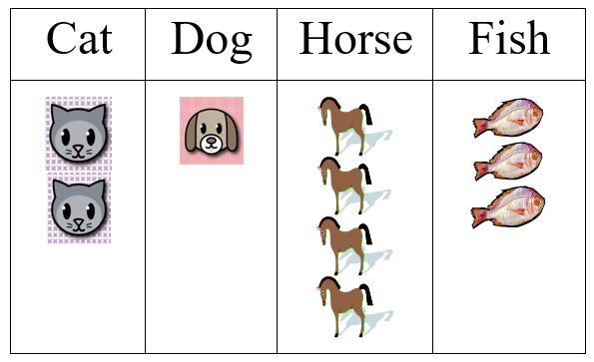

Compare

Ryan’s books Joe’s books

How many more books does Ryan have than Joe?

More Than

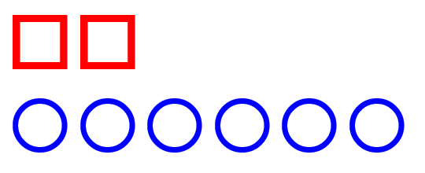

Less Than

Supplemental Materials: Introductory Pictograph
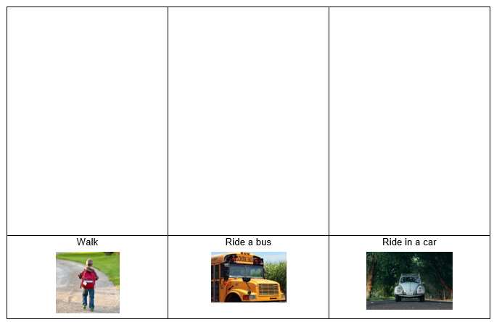
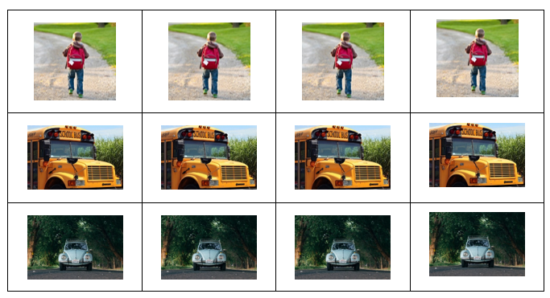
Addendum 1

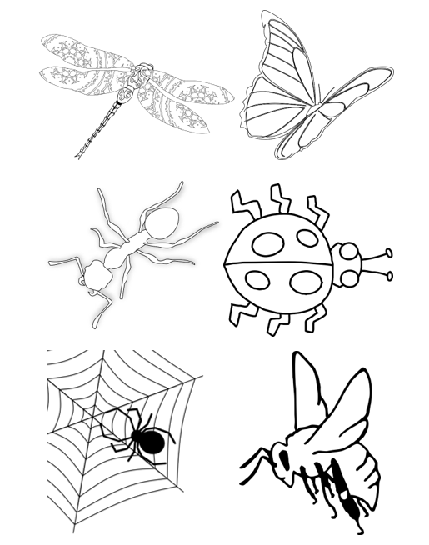

Addendum 2

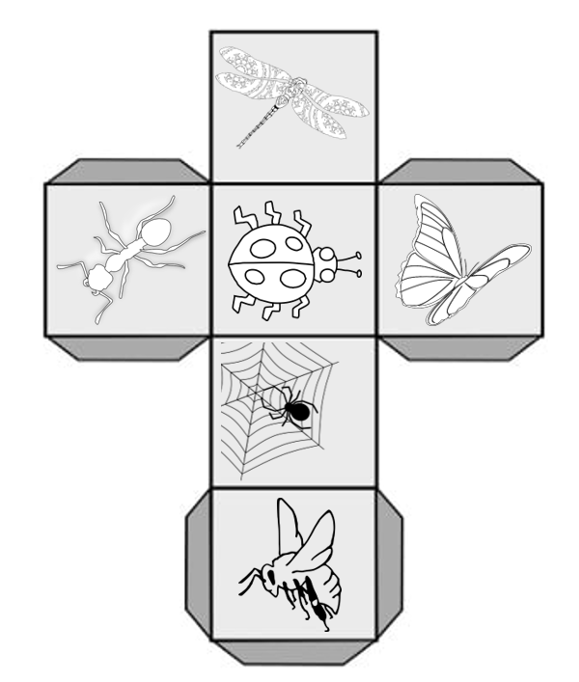

Addendum 3

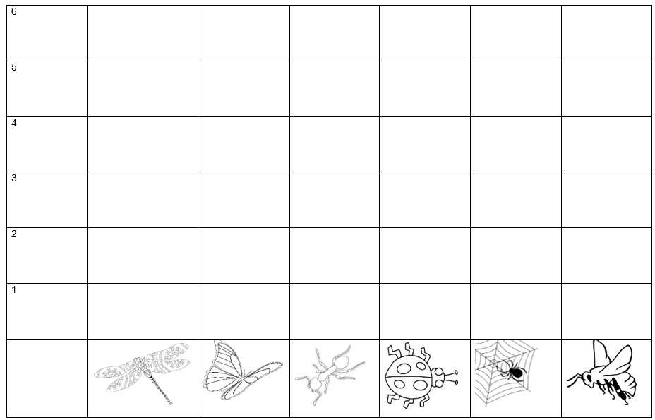
Addendum 4

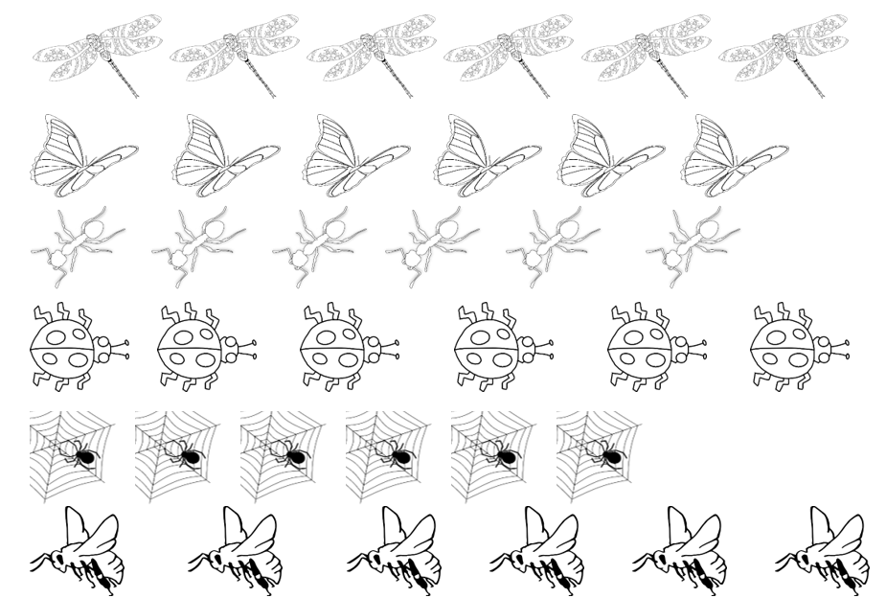
Addendum 5

Formative Assessment
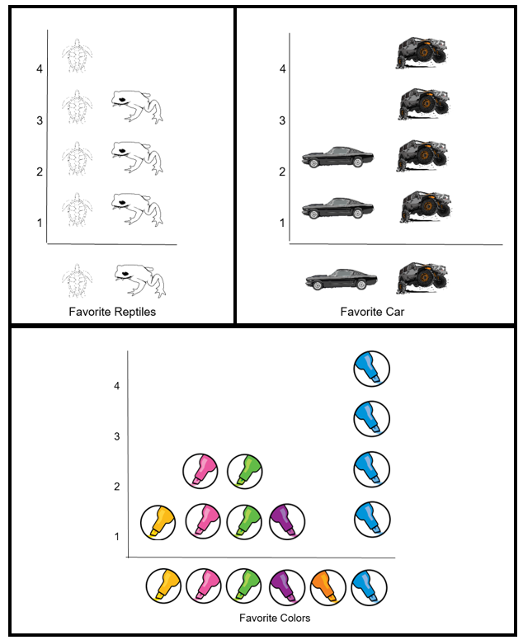
Addendum 6

Reflection Pictograph
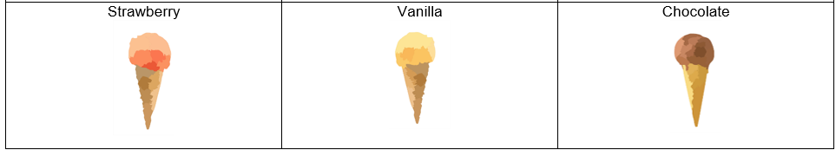

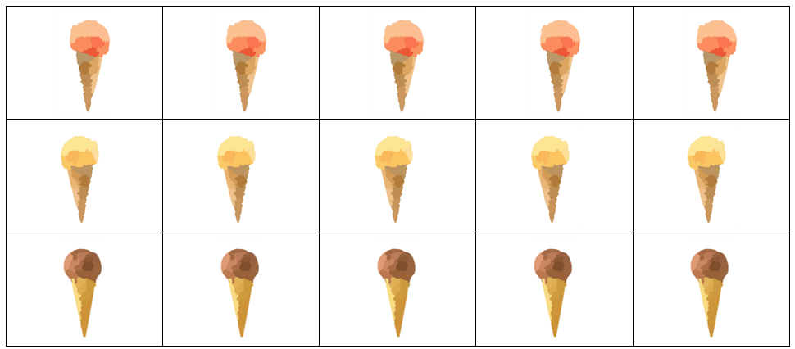
Addendum 7

Integrated Pictograph
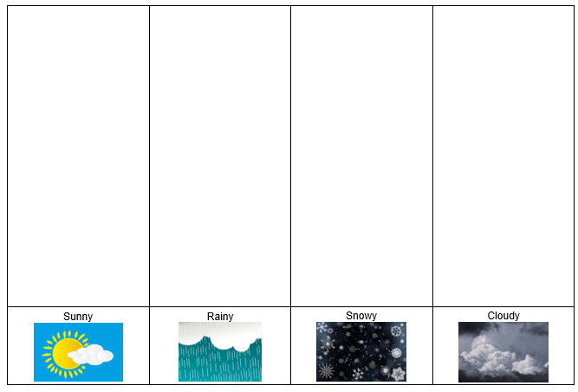

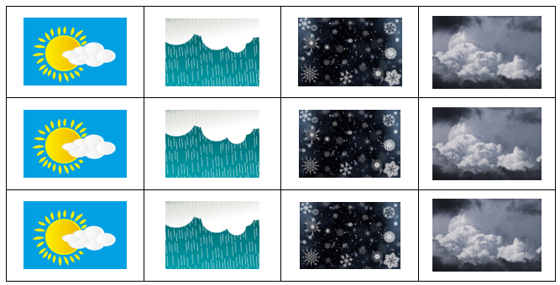
Addendum 8

Practice Items:

