# How Much Money Do I Have?

**Grade Level: 3**

**Subject(s):**

Primary: Mathematics

Integrated Activity: Mathematics, Reading, Science

**Reporting Category:**

Measurement and Geometry

**Lesson Summary and Connections:**

Students will learn about coins, their values, and how to use them to buy an object.

**Lesson Components Links**

|  |  |  |  |
| --- | --- | --- | --- |
| **[VESOL(s)](#_VESOL(s):)**  **[Complexity Continuum](#_VESOL(s):)** | [**Functional Skills**](#_Student_Friendly_Outcome(s):) | **Assistive Technology** | **Materials** |
| **Vocabulary** | **Common Misconceptions** | [**Student-Friendly Outcome(s)**](#_Student_Friendly_Outcome(s):_1) | **Introductory Activity** |
| **Plan for Instruction** | **Differentiation** | **Reflection** | **Formative Assessment** |
| **Word Wall Cards** | **Supplemental Materials** | **Practice Items** | **Integrated Activity** |

## VESOL(s):

**M-3.8 – Match and count coins through 25 cents.**

* **Complexity Continuum**: Complexity ranges from matching pennies, nickels, dimes, and quarters to their values to counting the value of a set of coins with a total value of 25 cents or less.

## Functional Skill(s):

* Students will identify coins as money and that money is used to buy things.
* Students will identify the values of a penny, nickel, dime, and quarter.
* Students will identify whether they have enough money to make a small purchase (up to 25 cents) using coins.

## Assistive Technology/ACC (Augmentative and Alternative Communication):

* Students with weak fine motor skills may benefit from having the coins on a screen to manipulate virtually.

## Materials:

* A mix of pennies, nickels, dimes, quarters, Word Wall cards

## Vocabulary:

**Prior Knowledge**

|  |  |  |
| --- | --- | --- |
| * money | * coin | * cents |

## Current Vocabulary

|  |  |  |
| --- | --- | --- |
| * penny | * nickel 1 | * nickel 2 |
| * dime 1 | * dime 2 | * quarter 1 |
| * quarter 2 | * value |  |

## Common Misconceptions:

* Some students think smaller coins have a smaller value (size of coin determines value).
* Some students think the number of coins is more important than the value of the coin. For example, some students think they have more money if they have 3 nickels than if they have 1 quarter.

## Student Friendly Outcome(s):

* I can name my coins and say their values.
* I know how much money I have.
* I know whether I have enough money to buy something I want.

## Introductory Activity:

* Show students an assortment of coins. Ask questions such as:
* What are these called?
* Do you know the names of any of them?
* What do we do with them?
* Do you know how much each one is worth?
* Which one has the greatest value?
* Which one has the least value?
* Use the answers to these questions to determine each student’s level of understanding and starting point for instruction.

**Starting Point for Instruction (Level A, Level B, or Level C)**

* **Level A -** **for students with very limited knowledge of money**
* Students at this level don’t know the names or values of the coins. They will begin by sorting the coins to determine how they are alike/the same and different.
* **Level B - for students with some knowledge of money**
* Students at this level know that money is used to buy things, recognize that the coins are different from each other, and coins have different values. They may not know the name and value of each coin.
* **Level C – for students who know the name and value of each coin**
* Students at this level can identify the name and value of each coin. They may not know how to find the value of a set of coins.

## Plan for Instruction:

**Level A**

* Give students one each of a penny, nickel, dime, and quarter. Talk about how the coins are different and the same. Students can identify the smallest one, identify the one that is a different color from the others, identify the largest one, match a coin to a picture of the coin, see how the two sides of a coin are different, etc.
* Next give students a mixed set of coins and 4 mats (boxes/bowls/etc.). Each mat should have one of the 4 coins (penny, nickel, dime, quarter) on it. Ask students to sort the coins onto the 4 mats so that all the coins that are the same are together. [This exercise also reinforces M-3.15 – Identify figures that are the same size and shape.]
* [A.T. – for students who are unable to physically move coins, the student can identify all coins that are the same as a given coin. For example, the teacher shows the student a nickel and asks the student to touch, look at, point to, or otherwise identify all other nickels in the set.]
* Once students recognize that the coins are different from each other and can sort them into different groups, they are ready to learn the names and values of the coins (Level B).

**Level B**

* Use the Word Wall Cards (WWC) to show students the picture of the front and back of each coin along with the name and value.

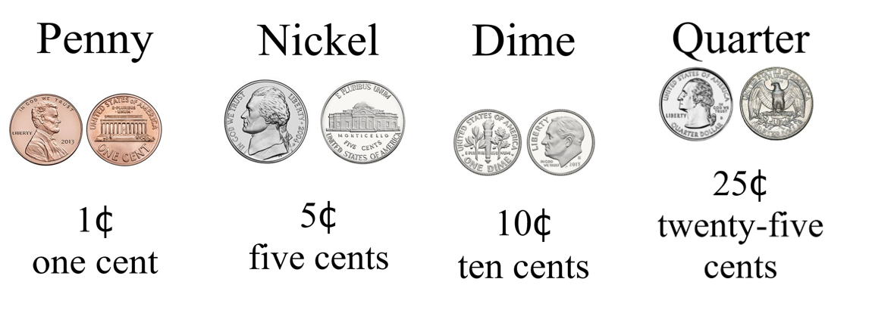

* Students should first use the WWC to practice looking at the coin and matching the name and value to the coin.
* Students should also be given the name or the value of a coin and be asked to identify which coin matches the name or value.
* Student Practice Activities:
* Point to a quarter.
* Point to the coin worth 10 cents.
* What is the coin worth 5 cents called?
* Which coins have a value less than 10 cents?
* Point to the coin with the greatest value.
* Point to the dime.
* After students have practiced matching the coins, words, and values using the WWC, they should practice the same skill without referring to the WWC. [Mix up the coins and the names each time they practice.]
* Once students can name and identify the value of each coin, they are ready to combine coins to find the value of two or more coins (Level C).

**Level C**

**Find the value of a set of coins that are all the same.**

* Students should first find the value of two or more of the same coin, beginning with pennies. This will reinforce one-to-one counting skills.
* Using only pennies, show the student how to count the pennies in a set. Then show them how to label the value of the set of pennies.
* Once students are comfortable with counting a set of pennies, the next step is to find the value of a set of nickels. Talk about the value of a nickel and practice counting by 5’s. Students will use and reinforce VESOL M-3.17 (skip counting by 5’s) to find the total value of their nickels up to 25 cents.
* Once students have become comfortable with counting pennies and then nickels, they should find the value of 2 dimes. [Since the set of coins at grade 3 has a maximum of 25 cents, only 2 dimes are required, but students who can count by 10’s can extend their learning by counting more than two dimes.]

**Find the value of a set of coins that are different.**

* Once students can count 5 pennies and know that the value is 5 cents, they can make the connection there is another coin that has a value of 5 cents.

Nickel
image of a nickel
one nickel equals five pennies
image of 5 pennies
5 cents

* Students can practice trading in pennies for nickels. Students can also practice trading in nickels for pennies.
* Students can then combine a nickel with pennies to find the total value. At first, some students may need to exchange the nickel for 5 pennies to find the value. This will help them develop the concept of equality. Students can also practice “counting on” by starting with the nickel, worth 5 cents, and then counting up to find the total value.
* For example, students can be given sets of money like the ones shown, with the nickel first and then the pennies. They can practice counting together starting with 5 and adding on the number of pennies.

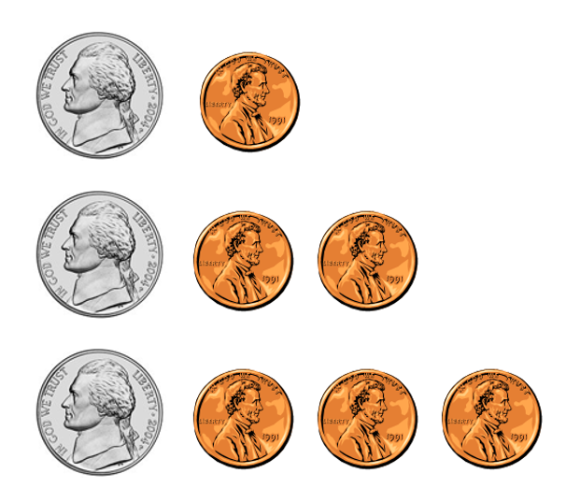

* Once students become more comfortable with adding these two different coins, they should be given nickels and pennies in random order and asked to count them.
* After students are familiar with nickels and pennies, the dime should be added to the set.

Dime
Image of a dime.
One dime equals ten pennies
image of 10 pennies
10 cents.

* The relationships between pennies, nickels, and dimes is more complex and may require frequent practice. One of the best ways to practice this concept is to have students gather coins that represent a given total. This will help the teacher to see which students use only one type of coin and which students mix the coins.
* For example: Ask students to show you coins that add up to 10 cents.
* Which students show a dime?
* Which students show two nickels?
* Which students show only pennies?
* Which students show a nickel and five pennies?
* Which students show the correct coins?
* Which students need more reinforcement?
* Next ask students if they can show you a different way to make 10 cents.
* Next, give students a nickel and ask them to find other coins to combine with the nickel to make 10 cents.
* Once students are comfortable with working with pennies, nickels, and dimes, they should be introduced to the relationship that these coins have with a quarter.

Quarter
image of a quarter
one quarter equals 25 cents
Image of 25 pennies,
25 cents

* [Repeat with similar activities as above.]

## Differentiation:

* If students can count by 5’s or by 10’s, they can practice finding the value of a set of coins greater than 25 cents. The value of the set should be a multiple of 5 or 10.

## Pulling It All Together (Reflection):

* Go back to the introductory activity and repeat the same questions. Compare the students answers from the beginning to the end.
  + Show students an assortment of coins. Ask questions, such as:
    - What are these called?
    - Do you know the names of any of them?
    - What do we do with them?
    - Do you know how much each one is worth?
    - Which one has the greatest value?
    - Which one has the least value?

## Formative Assessment:

* **Outcome Activity to Assess Learning (Level A):**

Give students a set of mixed coins and ask them to sort the coins into groups so that the same kind of coins are together.

* **Outcome Activity to Assess Learning (Level B):**

Give students a collection of mixed coins.

* Say: This word is **Dime**. (Show the word and point to it.) Can you find all of the dimes in the pile? How much is a dime worth?
* Say: This says **5 cents**. Can you find each coin that is worth 5 cents? What is this coin called?
* Say: Can you find all of the pennies in the set? Which word is **Penny**? How much is a penny worth?
* Say: This is a quarter. Show the quarter. Can you find all of the other quarters? Which word says quarter? [provide the words “penny,” “nickel,” “dime,” and “quarter.”] How much is a quarter is worth?
* **Outcome Activity to Assess Learning (Level C):**

Give students a collection of mixed coins.

* Say: Show me coins that make 20 cents.
* Say: Now show me a different way to make 20 cents.
* Say: Here is a nickel. Show me which other coins can be put with the nickel to make 20 cents.
* Say: This eraser (or any other object) costs 25 cents. Show me the correct coins to buy the eraser.
* Say: This pencil costs 18 cents. Show me the correct coins to buy the pencil.

**Mastering the Skills**

A table can be used to keep a running record of student progress over time. Students may master these skills at different times, and that could be documented with the date the student demonstrated the skill. Skills can be added to the table over time.

|  |  |  |  |  |  |  |
| --- | --- | --- | --- | --- | --- | --- |
| **Skill** | **Student 1** | **Student 2** | **Student 3** | **Student 4** | **Student 5** | **Student 6** |
| Identify a penny |  |  |  |  |  |  |
| Identify a nickel |  |  |  |  |  |  |
| Identify a dime |  |  |  |  |  |  |
| Identify a quarter |  |  |  |  |  |  |
| Tell value of a penny |  |  |  |  |  |  |
| Tell value of a nickel |  |  |  |  |  |  |
| Tell value of a dime |  |  |  |  |  |  |
| Tell value of a quarter |  |  |  |  |  |  |
| Tell value of two or more pennies |  |  |  |  |  |  |
| Tell value of two or more nickels |  |  |  |  |  |  |
| Tell value of two or more dimes |  |  |  |  |  |  |
| Tell value of two or more quarters |  |  |  |  |  |  |
| Tell value of mixed coins up to 25 cents |  |  |  |  |  |  |
| Show correct coins to make a purchase up to 25₵. |  |  |  |  |  |  |
|  |  |  |  |  |  |  |
|  |  |  |  |  |  |  |
|  |  |  |  |  |  |  |

## Integrated Activity:

**Let’s Go Shopping**

Read this story to students or have them read it. Have a set of coins available to the students.

*Kia, Antwon, and Jake are working on a project about ways to protect Earth. They need to buy some supplies. Kia will buy colored paper. Antwon will buy a bottle of glitter. Jake will buy a set of stickers. They are meeting at Antwon’s house on Tuesday afternoon to work on the project. Jake’s mom said she will send snacks for them to eat while they work.*

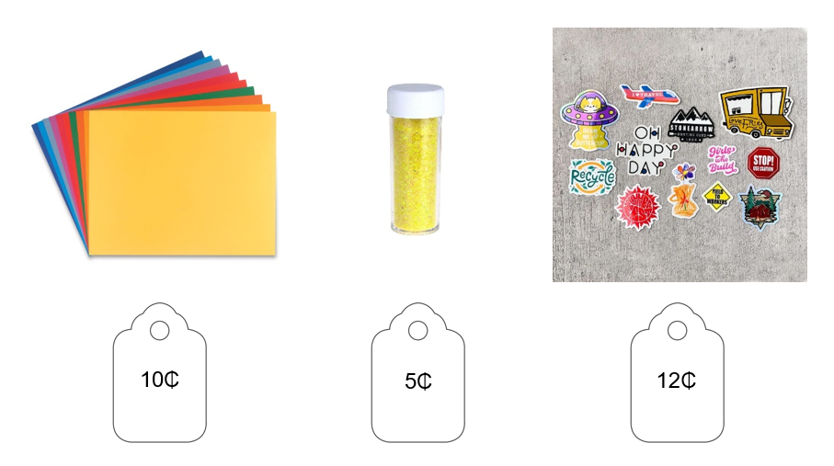

**Reading Questions:**

1. Who will buy the colored paper?
2. What is the project about?
3. Whose mom is sending snacks for them to eat?
4. When are the students working on this project?
5. Where are they meeting to work on the project?

**Math Questions:**

1. Show coins to buy the colored paper.
2. Show coins to buy the glitter.
3. Show coins to buy the stickers. Can you show a different set of coins to buy the stickers?
4. Who spent more money, Kia or Jake?
5. If you have a nickel and two dimes, do you have enough money to buy the colored paper, the glitter, and the stickers? Why or why not?

**Science Questions:**

1. Which of these are ways you can protect earth?
2. Eat more candy b. recycle c. go shopping

**Word Wall Cards:**

Penny

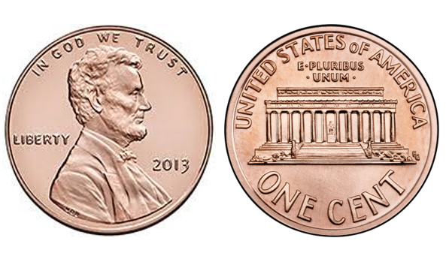

1¢

one cent

Nickel

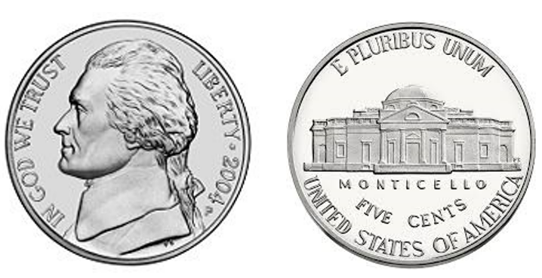

5¢

five cents

Nickel

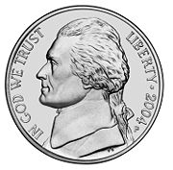

one nickel equals five pennies



5 cents

Dime

Image of the back of a dime.

Image of the front of a dime.

10¢

ten cents

Dime

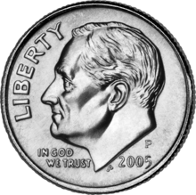

one dime equals ten pennies



10 cents

Quarter

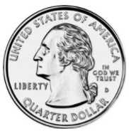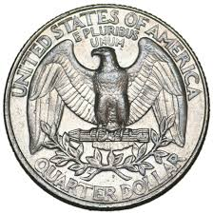

25¢

twenty-five

cents

Quarter



one quarter equals twenty-five pennies



25 cents

### Practice Items

### Here is a picture of 3 nickels. How much are three nickels altogether? 5 cents, 15 cents, or 30 cents.