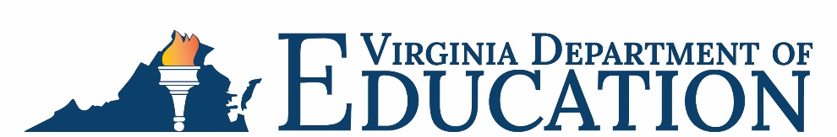

Office of School Nutrition Programs

Federal Program Administrative Review School Nutrition Program Summary
Section 207 of the Healthy Hunger Free Kids Act 2010, amended section 22 of the National School Lunch Act (42 U.S.C. 1769c) requires the Virginia Department of Education, Office of School Nutrition Programs (VDOE-SNP), to report the final results of the administrative review to the public in an accessible, easily understood manner in accordance with guidelines promulgated by the Secretary.
School Food Authority (SFA): Southampton County Public Schools
Date of Administrative Review: January 24-27, 2023
Review Month and Year: December 2022
Date review results were provided to the SFA: March 13, 2023
Date review summary was publicly posted: September 1, 2023
SFA participates in the following Child Nutrition Programs:
☒ School Breakfast Program
☒ National School Lunch Program
☐ Fresh Fruit & Vegetable Program
☐ Afterschool Snack
☐ Seamless Summer Option
SFA operates under the following Special Provisions:
☒ Community Eligibility Provision
☐ Provision 2

Review Findings
Review Area | Details
Program Access and Reimbursement  ☐ Certification and Benefit Issuance  ☐ Verification  ☒ Meal Counting and Claiming | Meal counting consolidation errors were observed.
Meal Patterns and Nutritional Quality  ☒ Meal Components and Quantities  ☒ Offer versus Serve  ☐ Dietary Specifications and Nutrient Analysis | Breakfast and lunch meal pattern violations were observed. These observations included insufficient quantities of foods, missing meal components, and vegetable subgroup violations.  Insufficient offer versus serve meal signage was posted in the cafeterias.
School Nutrition Environment and Civil Rights  ☒ Food Safety  ☒ Local Wellness Policy  ☐ Smart Snacks and Competitive Foods  ☒ Civil Rights | A copy of the most recent health inspection was not posted publicly.  The food safety plan did not meet all regulatory requirements.  Violations of the Buy American provision were observed.  The local wellness policy did not meet all regulatory requirements.  A public media release was not posted.  Annual civil rights training for staff was not completed.  The nondiscrimination statement was missing from program materials.
USDA is an equal opportunity provider, employer, and lender.

