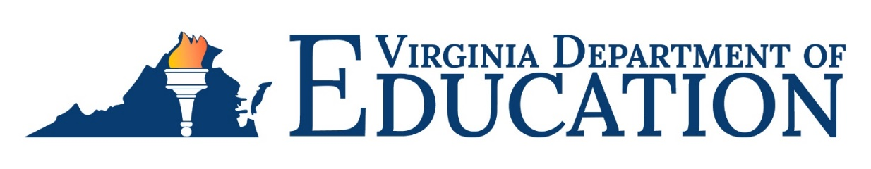

2023-2024 Title III, Part A, Allocations under Provisions of the Elementary and Secondary Education Act of 1965 (ESEA), as Amended
The Elementary and Secondary Education Act of 1965 (ESEA), as amended by the Every Student Succeeds Act of 2015 (ESSA), authorizes funding under the new Title III, Part A, Language Instruction for English Learners (EL) and Immigrant Students (IY) allocations for each eligible school division
EL Awards
The 2023-2024 Title III, Part A, federal allocations for each school division is based on the fall 2022 reported enrollment of ELs. The procedures and forms for applying for Title III, Part A, funds were previously provided to school division program coordinators. Applications were due on July 1, 2023.

Under Section 3201 of the ESEA, a school division with an EL award of less than $10,000
cannot access Title III, Part A, funds unless the division submits a joint application with one or
more divisions in a Title III consortium. The total allocation of all divisions participating in the
consortium must equal $10,000 or more. A school division may choose to join the Title III
Statewide Consortium to meet this requirement. The Department considers 2023-2024 Title III
consortium membership finalized as of September 15, 2023.

The EL awards represent the allocation to each division prior to adjustments that are applied based on participation in the 2023-2024 Title III Statewide Consortium. Divisions that
participate in the Title III Statewide Consortium should refer only to the Title III Statewide
Consortium adjusted federal award allocation.

IY Awards

The 2023-2024 Immigrant Children and Youth (IY) awards are for qualifying divisions. These funds are awarded to divisions that meet the state’s criteria for a significant increase of IY students as per Superintendent’s Memo 179-17. All divisions, including divisions that receive an EL award of less than $10,000, must submit an IY application through OMEGA.

Unclaimed Funds Under Title III, Part A

If the Department has not received an application for 2023-2024 Title III, Part A, EL or IY
funds from qualifying divisions by October 31, 2023, the unclaimed funds will be reallocated to eligible school divisions as required under Section 3114(c) of ESEA.

The following supporting documents, Additional Required Special Terms and Conditions for Grant Awards or Cooperative Agreements and Terms and Conditions of the grant award are provided on the Title III webpage.

For more information

Questions regarding the Title III, Part A, allocations should be addressed to Louise Marks, Title III Coordinator, at Louise.Marks@doe.virginia.gov or (804) 225-2901.

