History and Social Science

Standards of

Learning

for

Virginia

Public Schools

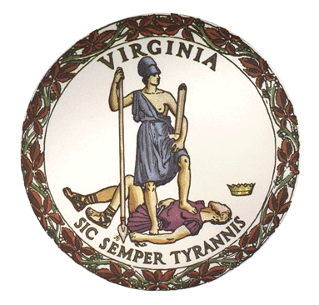

Board of Education
Commonwealth of Virginia

History and
Social Science

Standards of

Learning
for
Virginia
Public Schools

Adopted in April 2023 by the
Board of Education
Daniel A. Gecker, President
Dr. Tammy Mann, Vice President
Grace Turner Creasey, M. Ed.
Pamela Davis-Vaught
Bill Hansen
Anne B. Holton
Andy Rotherham
Dr. H. Alan Seibert
Dale Sturdifen

Superintendent of Public Instruction
Dr. Lisa Coons

Commonwealth of Virginia
Board of Education
Post Office Box 2120
Richmond, VA 23218-2120

Copyright © 2023
by the
Virginia Department of Education
P. O. Box 2120
Richmond, Virginia 23218-2120
Virginia Department of Education

All rights reserved. Reproduction of these materials for instructional purposes in public school classrooms in Virginia is permitted.

Statement of Non-Discrimination
The Virginia Department of Education does not discriminate on the basis of race, sex, color, national origin, religion, sexual orientation, gender identity, age, political affiliation, or against otherwise qualified persons with disabilities. The policy permits appropriate employment preferences for veterans and specifically prohibits discrimination against veterans.

Implementation Of Virginia’s History And Social Science Standards

Human history is complex and evolving as new technologies emerge and old stories are uncovered. We update our standards every seven years because we continue to learn more about the multiple facets of historical events through new discoveries and expanded research.

The virtues and flaws of Virginia, the United States and other world civilizations will be taught in an objective, factual and age-appropriate way by balancing fact and inquiry-based learning opportunities. These standards lay out the achievements and progress of our story and where Americans and Virginians have fallen short. Virginia’s History and Social Science education will highlight our shared humanity and the opportunity to work together in our constitutional republic to improve our own lives as well as the lives of our families and communities. The study of history and civics through these standards will provide the foundation for students to be engaged and deeply informed citizens who will continue to strengthen our communities, our economy and our republic.

The success of Virginia’s 2023 History and Social Science standards depends on the sound judgment and strong preparation of teachers and informed engagement by parents and communities. The standards and state-developed curriculum frameworks will serve as guides for best-in-class teaching and learning. While the immense responsibility of defining curriculum and texts used in classrooms across Virginia rests with local school boards, these standards should be implemented in the following ways:
- Students should be exposed to the facts of our past in a content rich and engaging way, even when those facts are uncomfortable.
- Teachers, whether they are new to the profession or are veteran educators, should utilize these standards in their classrooms as a mechanism to support their content knowledge and the important work they do each day in classrooms as they teach students across the Commonwealth.
- Every local school board has the responsibility to select and fully implement curricula that are aligned with the core history and social science standards for every grade level and course.
- The curriculum selected by local school boards should provide a level of guidance, consistency, high quality instructional materials, and professional development so that teachers, especially less experienced teachers, are not required to develop materials on their own.
- The Virginia Department of Education will provide our teachers with excellent instructional tools and training so they will be able to teach all of our history in an objective, fair, empathetic, nonjudgmental and developmentally appropriate manner in accordance with Title IV and Title VI of the Civil Rights Act of 1964.
- Teachers must facilitate open and balanced discussions on difficult topics, including discrimination and racism, and present learning opportunities without personal or political bias.
- Teachers should engage students in fact-based, non-ideological, and age-appropriate ways that do not imply students today are culpable for past events. Teachers should not intentionally expose students to embarrassment or disparagement or unreasonably restrict student access to varying points of view.
- Teachers, students, and parents should insist on dignity and respect for each other as part of civil society.
- Parents should have access to all instructional materials utilized in any Virginia public school. Division policies and practices should reflect this commitment.

