History and Social Science

Standards of

Learning

for

Virginia

Public Schools

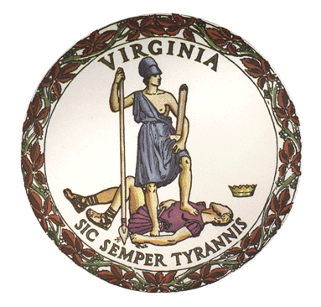

Board of Education
Commonwealth of Virginia

History and
Social Science

Standards of

Learning
for
Virginia
Public Schools

Adopted in April 2023 by the
Board of Education
Daniel A. Gecker, President
Dr. Tammy Mann, Vice President
Grace Turner Creasey, M. Ed.
Pamela Davis-Vaught
Bill Hansen
Anne B. Holton
Andy Rotherham
Dr. H. Alan Seibert
Dale Sturdifen

Superintendent of Public Instruction
Dr. Lisa Coons

Commonwealth of Virginia
Board of Education
Post Office Box 2120
Richmond, VA 23218-2120

Copyright © 2023
by the
Virginia Department of Education
P. O. Box 2120
Richmond, Virginia 23218-2120
Virginia Department of Education

All rights reserved. Reproduction of these materials for instructional purposes in public school classrooms in Virginia is permitted.

Statement of Non-Discrimination
The Virginia Department of Education does not discriminate on the basis of race, sex, color, national origin, religion, sexual orientation, gender identity, age, political affiliation, or against otherwise qualified persons with disabilities. The policy permits appropriate employment preferences for veterans and specifically prohibits discrimination against veterans.

Guiding Principles

Introduction

Virginia’s History and Social Sciences standards aim to raise our aspirations for history and social science instruction and restore excellence, curiosity and excitement around teaching and learning history. The teaching of history should illuminate insights from the past and inspire current and future generations to lead lives that are informed and inspired by those who walked this journey before them.

Expectations For Virginia’s Students

Every graduate from Virginia’s K-12 schools will possess a robust understanding of the places, people, events and ideas that comprise the history of Virginia, the United States and the world. Our students will learn from the rise and fall of civilizations across time, so that we may pursue and maintain government and economic systems that have led to human achievement. The Virginia standards are grounded in the foundational principles and actions of individuals and institutions so that we may learn from them as we strive to maintain our political liberties and personal freedoms and thrive as a nation.

The United States, whose founding history is rooted in Virginia’s history, has led the world in political, social and economic thought and action in ways that fundamentally changed the interactions and expectations of individual citizens with government. Students will know that the Declaration of Independence first stated that “all men are created equal, and that they are endowed by their Creator with certain unalienable Rights, that among these are Life, Liberty and the pursuit of Happiness.” The standards will recognize the world impact of America’s ongoing quest for a “more perfect Union” and the optimism, ideals and imagery captured by Ronald Reagan’s “shining city upon a hill” speech, Lincoln’s Second Inaugural Address, and Frederick Douglas’ complicated love for America. Students will know our nation’s exceptional strengths, including individual innovation, moral character, ingenuity and adventure, while learning from terrible periods and actions in direct conflict with these ideals.

Our students will also understand that our history encompasses a broad civilization beyond their neighborhood, Virginia and the United States. They will learn that humankind has spanned continents, ethnicities and religions, with common qualities that unite us and differences that enrich our society. The events of our history demonstrate that people have incredible ability to inspire, innovate and improve lives, and this human story also shows that evil exists and people are capable of destroying civilizations, communities and individual lives.

The standards provide an unflinching and fact-based coverage of world, United States and Virginia history. Students will study the horrors of wars and genocide including the Holocaust and the ethnic cleansing campaigns that have occurred throughout history and continue today. They will better understand the abhorrent treatment of Native Americans, the indelible stain of slavery, segregation and racism in the United States and around the world, and the inhumanity and deprivations of totalitarian and communist regimes. Students also will study inspirational moments including the achievements of Greek and Roman governments and advancements in engineering, architecture and art, the European Enlightenment, the American Revolution, the triumph of America’s Greatest Generation in World War II, the Marshall Plan, the Civil Rights Movement, the fall of the Berlin Wall, Project Apollo, progress against diseases, and the heroic sacrifice of Flight 93 passengers.

Students will have an in-depth understanding of the good and the bad in the world, United States and Virginia history. The Standards will include an appreciation of the attributes and actions that have made America the world’s exemplar of freedom, opportunity and democratic ideals. This comprehensive story of the United and the world will prepare every student for the rights, opportunities and responsibilities of Americans. As noted by George Santayana over 100 years ago, “those who cannot remember the past are condemned to repeat it.”

Principles

The foundational principles for these History and Social Sciences learning standards include:
- Individual liberty and representative government are cornerstones of the American way of life;
- The Declaration of Independence and the Constitution are remarkable documents that provide the freedoms and framework for our constitutional republic.
- We aspire to live up to the ideals expressed but not fully realized by the Founders for a society that recognizes all individuals are created equal.
- From thirteen diverse colonies to a unified nation, “E Pluribus Unum” – “Out of Many, One,” has always been our strength. Immigrants from around the world continue to come to the United States seeking freedom and opportunity to build a better life and have contributed to our communities and added to the rich history of the United States.
- Free enterprise, property rights and the rule of law enable an economic system that allocates assets through free markets and competition and fosters innovation, opportunity and efficiency.
- Centralized government planning in the form of socialism or communist political systems, as well as fascism, totalitarianism, and other forms of government that preference state power or control over individual liberty and consent of the governed, are incompatible with democracy.
- America is both exceptional and imperfect.
- The rights codified in the United States and Virginia constitutions and the Bill of Rights provide for individual freedoms that place a responsibility on current and future generations of Americans to engage in the political process with civility and fulfill their civic obligations.
- Through the ages, civilizations have grown, prospered and vanished. Every student should understand our Great American Experiment is not guaranteed forever. As Benjamin Franklin warned citizens over 200 years ago, “you have a republic… if you can keep it.”

Implementation Of Virginia’s History And Social Science Standards

Human history is complex and evolving as new technologies emerge and old stories are uncovered. We update our standards every seven years because we continue to learn more about the multiple facets of historical events through new discoveries and expanded research.

The virtues and flaws of Virginia, the United States and other world civilizations will be taught in an objective, factual and age-appropriate way by balancing fact and inquiry-based learning opportunities. These standards lay out the achievements and progress of our story and where Americans and Virginians have fallen short. Virginia’s History and Social Science education will highlight our shared humanity and the opportunity to work together in our constitutional republic to improve our own lives as well as the lives of our families and communities. The study of history and civics through these standards will provide the foundation for students to be engaged and deeply informed citizens who will continue to strengthen our communities, our economy and our republic.

The success of Virginia’s 2023 History and Social Science standards depends on the sound judgment and strong preparation of teachers and informed engagement by parents and communities. The standards and state-developed curriculum frameworks will serve as guides for best-in-class teaching and learning. While the immense responsibility of defining curriculum and texts used in classrooms across Virginia rests with local school boards, these standards should be implemented in the following ways:
- Students should be exposed to the facts of our past in a content rich and engaging way, even when those facts are uncomfortable.
- Teachers, whether they are new to the profession or are veteran educators, should utilize these standards in their classrooms as a mechanism to support their content knowledge and the important work they do each day in classrooms as they teach students across the Commonwealth.
- Every local school board has the responsibility to select and fully implement curricula that are aligned with the core history and social science standards for every grade level and course.
- The curriculum selected by local school boards should provide a level of guidance, consistency, high quality instructional materials, and professional development so that teachers, especially less experienced teachers, are not required to develop materials on their own.
- The Virginia Department of Education will provide our teachers with excellent instructional tools and training so they will be able to teach all of our history in an objective, fair, empathetic, nonjudgmental and developmentally appropriate manner in accordance with Title IV and Title VI of the Civil Rights Act of 1964.
- Teachers must facilitate open and balanced discussions on difficult topics, including discrimination and racism, and present learning opportunities without personal or political bias.
- Teachers should engage students in fact-based, non-ideological, and age-appropriate ways that do not imply students today are culpable for past events. Teachers should not intentionally expose students to embarrassment or disparagement or unreasonably restrict student access to varying points of view.
- Teachers, students, and parents should insist on dignity and respect for each other as part of civil society.
- Parents should have access to all instructional materials utilized in any Virginia public school. Division policies and practices should reflect this commitment.

Background and Context for the History and Social Science Standards Revisions

In 1995, the Virginia Board of Education published Standards of Learning in English, mathematics, science, and history and social science for kindergarten through grade 12. Subsequently, Standards of Learning were developed for all academic content areas. The Standards of Learning are designed to raise the academic achievement for all students in Virginia by providing clear and specific benchmarks at each grade level about what students should know and be able to do.

Pursuant to legislation from the 2000 Virginia General Assembly, the Board of Education established a seven-year cycle for review of the Standards of Learning. Thus, the 1995 History and Social Science Standards of Learning were reviewed in 2001, 2008, and 2015. The Virginia Department of Education convened review committees in 2021-2022 to review and revise the 2015 History and Social Science Standards of Learning. The feedback of the committees, exceptional work by department staff, and extensive public comment are reflected in these standards.

Curriculum, on the other hand, created at the division or local level, should prescribe a specific sequence of coherent “units” or “modules” that combine instructional strategies with resources and a sequence of student activities to help students meet the standards. A locally developed curriculum should specify how resources, instructional strategies, content vocabulary, student activities, formative and summative assessments, and evaluation procedures may be combined into those coherent units.

To assist school divisions with the creation of the local curricula, the Virginia Department of Education will separately issue Curriculum Frameworks for the HSS. The Curriculum Frameworks will suggest instructional resources (print and non-print), suggested students' activities, suggested formative and summative assessment and evaluation materials, and suggested pacing. They will also include scaffolding and differentiation suggestions to help curriculum developers address the needs of struggling learners and those who need challenges. The Frameworks will offer important instructional guidance to ensure that students are learning and applying the skills of historical analysis, such as being an active listener, looking at events and issues from various perspectives, analyzing primary and secondary sources, evaluating, and developing arguments, and citing evidence in support of one’s opinion both orally and in writing. Finally, the suggested student activities will encourage students to wrestle with complex texts and ideas, including the important and transcendent themes associated with the study of history, such as liberty, democracy, self-government, truth and citizenship. In short, Curriculum Frameworks will be issued to further enrich and clarify the concepts set forth in the Virginia Standards for History and Social Science.

Organization and Prescribed Order of History and Social Science Courses
Historically, Virginia has offered flexibility around the grades at which some of these “courses” are taught; in this configuration, the standards are presented in the Board of Education’s recommended grade level sequence. School divisions are strongly encouraged to adopt this sequence, but it is not required. Local School Boards that authorize alternative approaches must ensure that gaps in student learning are avoided and make accommodations for students who transfer from another division and ensure that students satisfy Board-prescribed graduation requirements.

Skills
Preceding the standards at each grade level is a skills standard. The development of these skills at each grade level is important as they develop academically in all content areas. Note: The skills will not be assessed in isolation; rather, they will be assessed as part of the content in the History and Social Science Standards of Learning.

Grades K-3
Standards are organized into the four core strands of social studies: history, geography, civics and economics:
- The history strand offers opportunities for students to read, hear, learn about, research, and explore the lives of people and events in the community, Virginia, the United States, and the world.
- The geography strand entails the study of both basic geographic skills and specific geography standards that align with and enhance students’ understanding of the history taught at each grade.
- The civics strand builds students’ knowledge of citizenship, patriotism, and the establishment of the U.S. Constitution. The strand includes specific expectations for students’ knowledge of how the U.S. government is structured (the three branches of government), and confirms a nascent understanding of the basic rights and responsibilities of U.S. citizenship.
- In the economics strand, students in K – 3 acquire an understanding of the most basic principles of economics on which the 6 – 12 standards will build.

Additionally, the students in K-3 are introduced to basic history and social science skills:
- Kindergarteners learn about their Community and focus on patriotism, citizenship, and history.
- First graders learn about the Commonwealth of Virginia through the lives of changemakers and events in Virginia history. They also learn more about patriotism, civics, and citizenship, map skills, and basic economics.
- Second graders are introduced to United States of America history through the lives of changemakers and historical events. They focus on civics education with an introduction to key aspects of America’s constitutional democracy, and learn more about citizenship, patriotism, geography, and economics.
- Third graders study the World by learning about ancient China, Egypt, Rome, Greece, and Mali. They also continue to develop skills and knowledge about maps, civics, and economics.

Standards for grades 6 – 12 proceed in an integrated way, focused on the following aspects of American history:

Grades 4-6
- Grade Four: Virginia Studies, chronological story of the history of Virginia
- Grade Five: United States History to 1865, America’s history from its earliest days to the Civil War
- Grade Six: United States History 1865 to the Present, the story of the America from the Civil War – present

Grades 7-8
Students in grades seven and eight refocus their attention on three strands of social studies content in preparation for a more in-depth look at world and American history in grades 9 – 12:
- Grade Seven: Civics and Economics
- Grade Eight: World Geography

Grades 9-12
In grades nine – twelve, students trace closely the causes, course of events, and effects of the most essential aspects of world and American history, culminating in one last immersion in American government, solidifying students’ knowledge of the rights and obligations of U.S. citizenship.
- Grade Nine: World History to 1500 CE
- Grade Ten: World History 1500 CE to the Present
- Grade Eleven: Virginia and U.S. History
- Grade Twelve: Virginia and United States Government
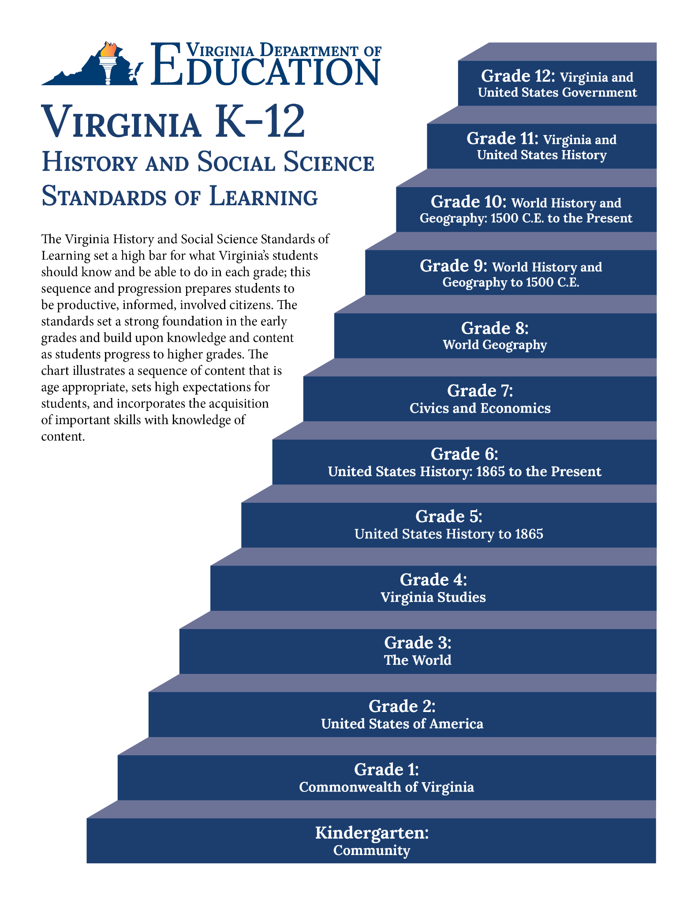

Grade 10: World History and Geography: 1500 A.D. to the Present
These standards enable students to examine history and geography from 1500 A.D. to the present, with emphasis on development of the modern world. The study of history rests on knowledge of dates, names, places, events, and ideas. Historical understanding, however, requires students to engage in historical thinking, raise questions, and marshal evidence in support of their answers. Students engaged in historical thinking draw upon chronological thinking, historical comprehension, historical analysis and interpretation, historical research, and decision making. These skills are developed through the study of significant historical substance from the era or society being studied.

Skills

Skills WHII The student will apply history and social science skills to the content by
- selecting and synthesizing evidence from information sources, including but not limited to artifacts, primary/secondary sources, charts, graphs, and diagrams in events in world history;
- applying geographic skills to determine and predict patterns and trends of people, places, or events;
- questioning to construct arguments using evidence from multiple sources;
- investigating and analyzing evidence from multiple sources to construct arguments and draw conclusions;
- comparing and contrasting historical, cultural, economic, and political perspectives;
- determining cause and effect to analyze connections;
- using decision-making models, including but not limited to T-charts and Venn diagrams to analyze and explain the incentives for and consequences of a specific choice;
- engaging and communicating as informed individuals with different perspectives;
- developing products that reflect an understanding of research and content to make real life connections; and
- contextualizing and corroborating sources for credibility, propaganda, and bias to determine patterns and trends to understand the modern world.

Emergence of a Global Age

WHII.1 The student will apply history and social science skills to analyze the political, cultural, geographic, and economic conditions in the world around 1500 (A.D.) by
- locating major states and empires;
- describing the beliefs, sacred writings, traditions, customs, and growth of major religions, including but not limited to Buddhism, Christianity, Hinduism, Islam, Judaism, and Sikhism; and
- analyzing major trade patterns, regional and global interactions, cultural exchanges, technological and scientific exchanges.

WHII.2 The student will apply history and social science skills to analyze the Renaissance and Protestant Reformation in terms of their impacts on Western civilization by
- explaining the effects of the theological, political, and economic differences that emerged, including the views and actions of Martin Luther, John Calvin, Henry VIII, and Elizabeth I;
- describing how the Renaissance and Reformation led to changing cultural values, traditions, and philosophies, and the role of the printing press in disseminating these changes; and
- describing the effect of religious conflicts on society and government actions, including but not limited to the Inquisition and the Catholic Reformation.

WHII.3 The student will apply history and social science skills to describe European exploration by
explaining the political, social, cultural, and economic goals of European exploration and colonization;
comparing and contrasting the social, political, economic, and cultural effects of European colonization and the responses of Indigenous peoples in Africa, Asia, and the Americas; and
analyzing how competition for colonies among Britain, France, and Spain changed the economic system of Europe.

Age of Revolutions

WHII.4 The student will apply history and social science skills to analyze the political, socio-cultural, geographic, religious, and economic conditions in Europe, Russia, and the Americas that led to political unrest and revolution from approximately 1500 (A.D.) to about 1800 (A.D.) by
- describing the series of wars in Europe, including but not limited to the French Wars of Religion, the Thirty Years War, the German Peasants’ War, the Tudor Rebellions, and the Dutch Revolt;
- defining and describing how the Scientific Revolution and Enlightenment influenced the European view of the world, including but not limited to Descartes, Hume, Kant, Locke, Montesquieu, Isaac Newton, Rousseau, and Voltaire;
- analyzing Enlightenment themes and how they influenced the political foundations of Virginia and the United States;
- describing the Age of Absolutism with emphasis on the development of France and Louis XIV and the Hapsburg empire and Charles V;
- describing the development of constitutional monarchy in Great Britain, with emphasis on the English Civil War and the Glorious Revolution and their impacts on democracy;
- explaining the influence of the American Revolution on the causes and effects of the French and Latin American Revolutions; and
- assessing the effect of Napoleon and the Congress of Vienna on political power in Europe.

Global Interactions

WHII.5 The student will apply history and social science skills to understand Asia from approximately 1500 A.D. approximately 1800 A.D. by
- describing the location and development of previously established trade routes, the economic success, the influence of religion, and the factors contributing to the longevity of the Ottoman Empire’s influence and power;
- describing the location and development of northern and southern empires in India, including but not limited to the major trading posts, the growth of Sikhism challenging the Mughal Empire, and cultural developments;
- describing the location, origins, and development of China, including but not limited to the expansion, development, and social and cultural patterns within the Ming and Qing (Manchu) dynasties; and
- describing the location, origins, and development of Japan, including but not limited to the incentives and consequences of the Tokugawa shogunate’s closed country policy, the roles of important figures in Japanese society such as the Emperor and the Shogun, and the importance of religion in Japanese society.

WHII.6 The student will apply history and social science skills to understand sub-Saharan Africa from approximately 1500 A.D. to approximately 1800 A.D. by
- describing the location and development of Eastern and Western Africa;
- explaining the influence of Askia Muhammad in the region;
- analyzing the role of religion in Eastern and Western Africa, including Islam in Songhai, Coptic Christianity in Ethiopia, and Animism in the Songhai and Asante (Ashanti) Empires;
- analyzing the role of the Ashanti and other powerful Western African Empires in the Transatlantic Slave Trade;
- examining the Swahili trade network and its impacts on Eastern Africa;
- comparing and contrasting the development of Central and Southern Africa, including but not limited to the political systems of the Songhai, Asante (Ashanti), Kongo, and Zulu empires;
- analyzing the adoption of African Christianity in Kongo and compare it to the practice of Indigenous religions in the Zulu Empire; and
- identifying trading partners, resources and products exchanged with major Central and Southern African empires.

WHII.7 The student will apply history and social science skills to analyze the global impact of changes in European nations between 1800 and 1900 by
- explaining the roles of resources, capital, and entrepreneurship in developing an industrial economy;
- analyzing the effects of the First and Second Industrial Revolution;
- evaluating responses to imperialism, including but not limited to the Sepoy Mutiny and Boxer Rebellion;
- explaining the events related to the unification of Italy and the role of Italian nationalism; and
- explaining the events related to the unification of Germany and the role of Bismarck.

Era of Global Wars

WHII.8 The student will apply history and social science skills to understand World War I by
- explaining economic and political causes and identifying major events and leaders of the war, including but not limited to the assassination of Archduke Franz Ferdinand, Georges Clemenceau, John J. Pershing, Kaiser Friedrich Wilhelm II, and Woodrow Wilson;
- identifying the changes to modern warfare used in battles along the Eastern and Western fronts;
- describing major battles, including but not limited to Gallipoli, Marne, Meuse-Argonne, Somme, and Verdun;
- analyzing and explaining the terms of the Treaty of Versailles and the actions of the League of Nations, and the mandate system;
- identifying the causes and consequences of the Russian Revolution;
- explaining the causes and effects of worldwide depression in the 1930s; and
- examining the rise of totalitarianism.

WHII.9 The student will apply history and social science skills to understand World War II by
- explaining economic and political causes and identifying major events and leaders of the war, including but not limited to Winston Churchill, Dwight Eisenhower, Adolf Hitler, Michinomiya Hirohito, Joseph Stalin, Douglas MacArthur, Franklin D. Roosevelt, Harry Truman, and Admiral Chester Nimitz;
- describing the major battles, including but not limited to Leningrad, Midway, Normandy, Okinawa, and Stalingrad;
- identifying the role of technology on the war, including but not limited to cavity magnetron, naval power, radar, computers—the Electronic Numerical Integrator and Computer (ENIAC), antibiotics, and the atomic bomb;
- describing key causes, events, victims, and impact of the Holocaust including antisemitism, the rise of the Nazi Party, Kristallnacht, the establishment of ghettos, concentration and death camps, mobile killing squads, rescue, Jewish resistance and liberation;
- examining the effects of the war, with emphasis on the terms of the peace, the war crimes trials, the division of Europe, plans to rebuild Germany and Japan, the creation of international cooperative organizations, the Universal Declaration of Human Rights (1948), and the creation and defense of the modern State of Israel; and
- describing the heroic aspects, including but not limited to D-Day, French Resistance, Dunkirk Evacuation, covert action, and Operation Jedburgh.

WHII.10 The student will apply history and social science skills to understand the significance of the Cold War during the second half of the twentieth century by
- explaining the causes, the domino theory, the role of containment, and the differences between the United States and Soviet Union’s economic and political systems;
- describing the events, conflicts, and revolutionary movements, including but not limited to the Berlin Blockade, Suez Canal Crisis, Hungarian Revolution, Bay of Pigs, Cuban Missile Crisis, and Prague Spring, and the impact of clandestine operations on the Cold War;
- describing conflicts, events, and major leaders in Asia, including Mao Zedong, Chiang Kai-shek, Deng Xiaoping, and Ho Chi Minh, and Tiananmen Square;
- explaining the collapse of communism in the Soviet Union and Eastern Europe and the end of the Cold War, including the actions of Mikhail Gorbachev, Pope John Paul II, Ronald Reagan, Margaret Thatcher, and Vaclav Havel;
- examining the political and economic causes and global consequences of the breakup of the Soviet Union; and
- analyzing how nations around the world developed a culture of global interdependence.

WHII.11 The student will apply history and social science skills to identify the political, economic, and socioeconomic aspects of independence movements and decolonization by
- describing the struggles for self-rule, including Gandhi’s leadership and the development of India’s democracy;
- describing African independence movements in Ghana, Algeria, Kenya, and South Africa, including but not limited to Jomo Kenyatta’s leadership of Kenya and Nelson Mandela’s role in South Africa;
- describing the end of the League of Nations’ mandate system and the creation of states in the Middle East, including the roles of Golda Meir and Gamal Abdel Nasser, and
- explaining the effects of decolonization and other methods of gaining independence.

WHII.12 The student will apply history and social science skills to explain global changes during the twenty-first century by
- identifying modern era genocides and crimes against humanity, including but not limited to Mao’s Cultural Revolution, Stalin Regime, Armenia, Cambodia, Fidel Castro’s Cuba, Darfur, Rwanda, and China’s minority Uyghur population;
- identifying contemporary economic and political issues and ethnic and religious conflicts resulting in the migrations of refugees;
- examine the development, role, and effects of technology, including social media and chemical and biological technologies;
- analyzing the increasing impact, events, and conditions that have given rise to international terrorism, including but not limited to the US Embassy bombing in Beirut, the Lockerbie Bombing/Pan AM Flight 103, the US Embassy bombings in Nairobi and Kenya, and 2011 Breivik shootings; and
- describing economic interdependence, including the rise of multinational corporations, international organizations, and trade agreements.

