History and Social Science

Standards of

Learning

for

Virginia

Public Schools

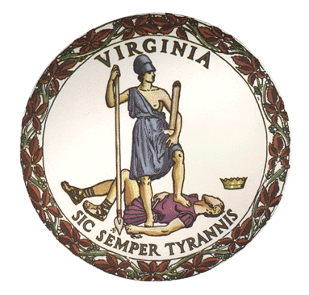

Board of Education
Commonwealth of Virginia

History and
Social Science

Standards of

Learning
for
Virginia
Public Schools

Adopted in April 2023 by the
Board of Education
Daniel A. Gecker, President
Dr. Tammy Mann, Vice President
Grace Turner Creasey, M. Ed.
Pamela Davis-Vaught
Bill Hansen
Anne B. Holton
Andy Rotherham
Dr. H. Alan Seibert
Dale Sturdifen

Superintendent of Public Instruction
Dr. Lisa Coons

Commonwealth of Virginia
Board of Education
Post Office Box 2120
Richmond, VA 23218-2120

Copyright © 2023
by the
Virginia Department of Education
P. O. Box 2120
Richmond, Virginia 23218-2120
Virginia Department of Education

All rights reserved. Reproduction of these materials for instructional purposes in public school classrooms in Virginia is permitted.

Statement of Non-Discrimination
The Virginia Department of Education does not discriminate on the basis of race, sex, color, national origin, religion, sexual orientation, gender identity, age, political affiliation, or against otherwise qualified persons with disabilities. The policy permits appropriate employment preferences for veterans and specifically prohibits discrimination against veterans.

Guiding Principles

Introduction

Virginia’s History and Social Sciences standards aim to raise our aspirations for history and social science instruction and restore excellence, curiosity and excitement around teaching and learning history. The teaching of history should illuminate insights from the past and inspire current and future generations to lead lives that are informed and inspired by those who walked this journey before them.

Expectations For Virginia’s Students

Every graduate from Virginia’s K-12 schools will possess a robust understanding of the places, people, events and ideas that comprise the history of Virginia, the United States and the world. Our students will learn from the rise and fall of civilizations across time, so that we may pursue and maintain government and economic systems that have led to human achievement. The Virginia standards are grounded in the foundational principles and actions of individuals and institutions so that we may learn from them as we strive to maintain our political liberties and personal freedoms and thrive as a nation.

The United States, whose founding history is rooted in Virginia’s history, has led the world in political, social and economic thought and action in ways that fundamentally changed the interactions and expectations of individual citizens with government. Students will know that the Declaration of Independence first stated that “all men are created equal, and that they are endowed by their Creator with certain unalienable Rights, that among these are Life, Liberty and the pursuit of Happiness.” The standards will recognize the world impact of America’s ongoing quest for a “more perfect Union” and the optimism, ideals and imagery captured by Ronald Reagan’s “shining city upon a hill” speech, Lincoln’s Second Inaugural Address, and Frederick Douglas’ complicated love for America. Students will know our nation’s exceptional strengths, including individual innovation, moral character, ingenuity and adventure, while learning from terrible periods and actions in direct conflict with these ideals.

Our students will also understand that our history encompasses a broad civilization beyond their neighborhood, Virginia and the United States. They will learn that humankind has spanned continents, ethnicities and religions, with common qualities that unite us and differences that enrich our society. The events of our history demonstrate that people have incredible ability to inspire, innovate and improve lives, and this human story also shows that evil exists and people are capable of destroying civilizations, communities and individual lives.

The standards provide an unflinching and fact-based coverage of world, United States and Virginia history. Students will study the horrors of wars and genocide including the Holocaust and the ethnic cleansing campaigns that have occurred throughout history and continue today. They will better understand the abhorrent treatment of Native Americans, the indelible stain of slavery, segregation and racism in the United States and around the world, and the inhumanity and deprivations of totalitarian and communist regimes. Students also will study inspirational moments including the achievements of Greek and Roman governments and advancements in engineering, architecture and art, the European Enlightenment, the American Revolution, the triumph of America’s Greatest Generation in World War II, the Marshall Plan, the Civil Rights Movement, the fall of the Berlin Wall, Project Apollo, progress against diseases, and the heroic sacrifice of Flight 93 passengers.

Students will have an in-depth understanding of the good and the bad in the world, United States and Virginia history. The Standards will include an appreciation of the attributes and actions that have made America the world’s exemplar of freedom, opportunity and democratic ideals. This comprehensive story of the United and the world will prepare every student for the rights, opportunities and responsibilities of Americans. As noted by George Santayana over 100 years ago, “those who cannot remember the past are condemned to repeat it.”

Principles

The foundational principles for these History and Social Sciences learning standards include:
- Individual liberty and representative government are cornerstones of the American way of life;
- The Declaration of Independence and the Constitution are remarkable documents that provide the freedoms and framework for our constitutional republic.
- We aspire to live up to the ideals expressed but not fully realized by the Founders for a society that recognizes all individuals are created equal.
- From thirteen diverse colonies to a unified nation, “E Pluribus Unum” – “Out of Many, One,” has always been our strength. Immigrants from around the world continue to come to the United States seeking freedom and opportunity to build a better life and have contributed to our communities and added to the rich history of the United States.
- Free enterprise, property rights and the rule of law enable an economic system that allocates assets through free markets and competition and fosters innovation, opportunity and efficiency.
- Centralized government planning in the form of socialism or communist political systems, as well as fascism, totalitarianism, and other forms of government that preference state power or control over individual liberty and consent of the governed, are incompatible with democracy.
- America is both exceptional and imperfect.
- The rights codified in the United States and Virginia constitutions and the Bill of Rights provide for individual freedoms that place a responsibility on current and future generations of Americans to engage in the political process with civility and fulfill their civic obligations.
- Through the ages, civilizations have grown, prospered and vanished. Every student should understand our Great American Experiment is not guaranteed forever. As Benjamin Franklin warned citizens over 200 years ago, “you have a republic… if you can keep it.”

Implementation Of Virginia’s History And Social Science Standards

Human history is complex and evolving as new technologies emerge and old stories are uncovered. We update our standards every seven years because we continue to learn more about the multiple facets of historical events through new discoveries and expanded research.

The virtues and flaws of Virginia, the United States and other world civilizations will be taught in an objective, factual and age-appropriate way by balancing fact and inquiry-based learning opportunities. These standards lay out the achievements and progress of our story and where Americans and Virginians have fallen short. Virginia’s History and Social Science education will highlight our shared humanity and the opportunity to work together in our constitutional republic to improve our own lives as well as the lives of our families and communities. The study of history and civics through these standards will provide the foundation for students to be engaged and deeply informed citizens who will continue to strengthen our communities, our economy and our republic.

The success of Virginia’s 2023 History and Social Science standards depends on the sound judgment and strong preparation of teachers and informed engagement by parents and communities. The standards and state-developed curriculum frameworks will serve as guides for best-in-class teaching and learning. While the immense responsibility of defining curriculum and texts used in classrooms across Virginia rests with local school boards, these standards should be implemented in the following ways:
- Students should be exposed to the facts of our past in a content rich and engaging way, even when those facts are uncomfortable.
- Teachers, whether they are new to the profession or are veteran educators, should utilize these standards in their classrooms as a mechanism to support their content knowledge and the important work they do each day in classrooms as they teach students across the Commonwealth.
- Every local school board has the responsibility to select and fully implement curricula that are aligned with the core history and social science standards for every grade level and course.
- The curriculum selected by local school boards should provide a level of guidance, consistency, high quality instructional materials, and professional development so that teachers, especially less experienced teachers, are not required to develop materials on their own.
- The Virginia Department of Education will provide our teachers with excellent instructional tools and training so they will be able to teach all of our history in an objective, fair, empathetic, nonjudgmental and developmentally appropriate manner in accordance with Title IV and Title VI of the Civil Rights Act of 1964.
- Teachers must facilitate open and balanced discussions on difficult topics, including discrimination and racism, and present learning opportunities without personal or political bias.
- Teachers should engage students in fact-based, non-ideological, and age-appropriate ways that do not imply students today are culpable for past events. Teachers should not intentionally expose students to embarrassment or disparagement or unreasonably restrict student access to varying points of view.
- Teachers, students, and parents should insist on dignity and respect for each other as part of civil society.
- Parents should have access to all instructional materials utilized in any Virginia public school. Division policies and practices should reflect this commitment.

Background and Context for the History and Social Science Standards Revisions

In 1995, the Virginia Board of Education published Standards of Learning in English, mathematics, science, and history and social science for kindergarten through grade 12. Subsequently, Standards of Learning were developed for all academic content areas. The Standards of Learning are designed to raise the academic achievement for all students in Virginia by providing clear and specific benchmarks at each grade level about what students should know and be able to do.

Pursuant to legislation from the 2000 Virginia General Assembly, the Board of Education established a seven-year cycle for review of the Standards of Learning. Thus, the 1995 History and Social Science Standards of Learning were reviewed in 2001, 2008, and 2015. The Virginia Department of Education convened review committees in 2021-2022 to review and revise the 2015 History and Social Science Standards of Learning. The feedback of the committees, exceptional work by department staff, and extensive public comment are reflected in these standards.

Curriculum, on the other hand, created at the division or local level, should prescribe a specific sequence of coherent “units” or “modules” that combine instructional strategies with resources and a sequence of student activities to help students meet the standards. A locally developed curriculum should specify how resources, instructional strategies, content vocabulary, student activities, formative and summative assessments, and evaluation procedures may be combined into those coherent units.

To assist school divisions with the creation of the local curricula, the Virginia Department of Education will separately issue Curriculum Frameworks for the HSS. The Curriculum Frameworks will suggest instructional resources (print and non-print), suggested students' activities, suggested formative and summative assessment and evaluation materials, and suggested pacing. They will also include scaffolding and differentiation suggestions to help curriculum developers address the needs of struggling learners and those who need challenges. The Frameworks will offer important instructional guidance to ensure that students are learning and applying the skills of historical analysis, such as being an active listener, looking at events and issues from various perspectives, analyzing primary and secondary sources, evaluating, and developing arguments, and citing evidence in support of one’s opinion both orally and in writing. Finally, the suggested student activities will encourage students to wrestle with complex texts and ideas, including the important and transcendent themes associated with the study of history, such as liberty, democracy, self-government, truth and citizenship. In short, Curriculum Frameworks will be issued to further enrich and clarify the concepts set forth in the Virginia Standards for History and Social Science.

Organization and Prescribed Order of History and Social Science Courses
Historically, Virginia has offered flexibility around the grades at which some of these “courses” are taught; in this configuration, the standards are presented in the Board of Education’s recommended grade level sequence. School divisions are strongly encouraged to adopt this sequence, but it is not required. Local School Boards that authorize alternative approaches must ensure that gaps in student learning are avoided and make accommodations for students who transfer from another division and ensure that students satisfy Board-prescribed graduation requirements.

Skills
Preceding the standards at each grade level is a skills standard. The development of these skills at each grade level is important as they develop academically in all content areas. Note: The skills will not be assessed in isolation; rather, they will be assessed as part of the content in the History and Social Science Standards of Learning.

Grades K-3
Standards are organized into the four core strands of social studies: history, geography, civics and economics:
- The history strand offers opportunities for students to read, hear, learn about, research, and explore the lives of people and events in the community, Virginia, the United States, and the world.
- The geography strand entails the study of both basic geographic skills and specific geography standards that align with and enhance students’ understanding of the history taught at each grade.
- The civics strand builds students’ knowledge of citizenship, patriotism, and the establishment of the U.S. Constitution. The strand includes specific expectations for students’ knowledge of how the U.S. government is structured (the three branches of government), and confirms a nascent understanding of the basic rights and responsibilities of U.S. citizenship.
- In the economics strand, students in K – 3 acquire an understanding of the most basic principles of economics on which the 6 – 12 standards will build.

Additionally, the students in K-3 are introduced to basic history and social science skills:
- Kindergarteners learn about their Community and focus on patriotism, citizenship, and history.
- First graders learn about the Commonwealth of Virginia through the lives of changemakers and events in Virginia history. They also learn more about patriotism, civics, and citizenship, map skills, and basic economics.
- Second graders are introduced to United States of America history through the lives of changemakers and historical events. They focus on civics education with an introduction to key aspects of America’s constitutional democracy, and learn more about citizenship, patriotism, geography, and economics.
- Third graders study the World by learning about ancient China, Egypt, Rome, Greece, and Mali. They also continue to develop skills and knowledge about maps, civics, and economics.

Standards for grades 6 – 12 proceed in an integrated way, focused on the following aspects of American history:

Grades 4-6
- Grade Four: Virginia Studies, chronological story of the history of Virginia
- Grade Five: United States History to 1865, America’s history from its earliest days to the Civil War
- Grade Six: United States History 1865 to the Present, the story of the America from the Civil War – present

Grades 7-8
Students in grades seven and eight refocus their attention on three strands of social studies content in preparation for a more in-depth look at world and American history in grades 9 – 12:
- Grade Seven: Civics and Economics
- Grade Eight: World Geography

Grades 9-12
In grades nine – twelve, students trace closely the causes, course of events, and effects of the most essential aspects of world and American history, culminating in one last immersion in American government, solidifying students’ knowledge of the rights and obligations of U.S. citizenship.
- Grade Nine: World History to 1500 CE
- Grade Ten: World History 1500 CE to the Present
- Grade Eleven: Virginia and U.S. History
- Grade Twelve: Virginia and United States Government
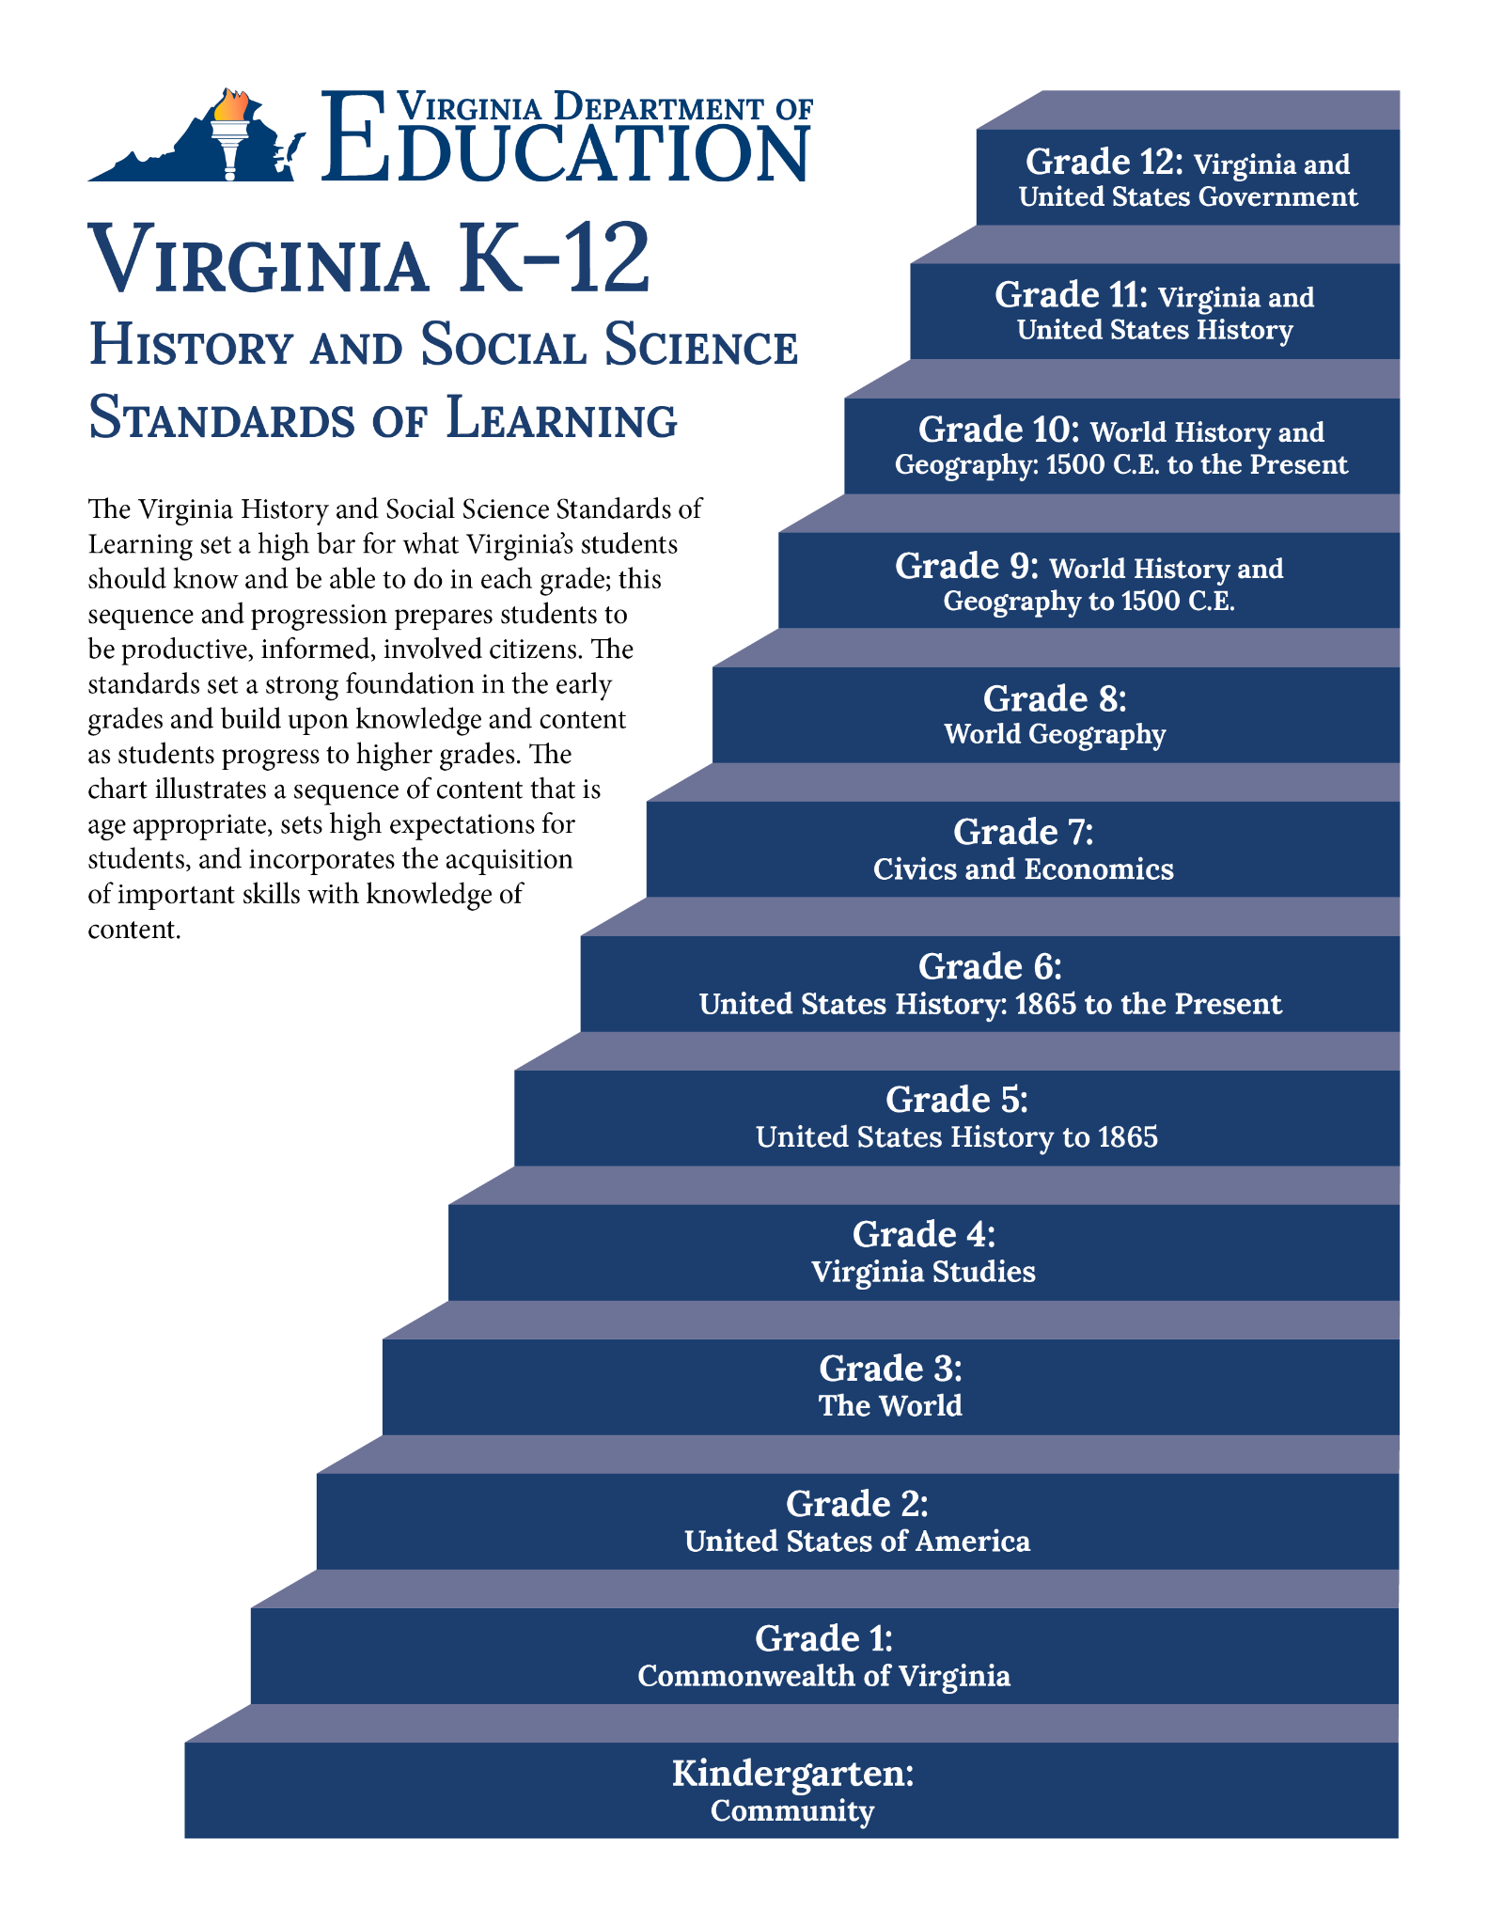

Grade 8: World Geography
The focus of this course is the study of the world’s people, places, and environments, with an emphasis on world regions. The knowledge, skills, and perspectives of the course are centered on the world’s peoples and their cultural characteristics, landforms and climates, economic development, and migration and settlement patterns. Spatial concepts of geography will be used as a framework for studying interactions between people and their environments. Using geographic resources, students will employ inquiry, research, and technology skills to ask and answer geographic questions. Particular emphasis will be placed on students understanding and applying geographic concepts and skills to their daily lives.

Skills

Skills WG The student will demonstrate skills for historical thinking, geographical analysis, economic decision making, and responsible citizenship by
- selecting and synthesizing evidence from information sources, including but not limited to artifacts, primary/secondary sources, charts, graphs, diagrams, and geospatial technologies including maps, GIS, and GPS imagery to understand the regions of the world;
- applying geographic skills to determine and predict patterns and movement of people, places, or events;
- developing questions, enhancing curiosity, and engaging in critical thinking and analysis;
- investigating and analyzing evidence from multiple sources to construct arguments;
- comparing and contrasting historical, cultural, economic, and political perspectives;
- determining and explaining cause and effect relationships;
- using economic decision-making models to analyze and explain the incentives for and consequences of a specific choice;
- engaging and communicating as civil and informed individuals with different perspectives;
- developing products that reflect an understanding of research, content, and world geography concepts; and
- contextualizing, corroborating, and evaluating sources for credibility, propaganda, and bias to determine patterns and trends to understand the world.

Introduction to Geography

WG.1 The student will apply history and social science skills to explain how geographic information and geospatial tools are used to make decisions by
- explaining how characteristics of regions have led to regional labels;
- describing how regional landscapes reflect the physical environment and the cultural characteristics of their inhabitants;
- analyzing how cultural characteristics including the world’s major languages, ethnicities, and religions, link or divide regions;
- explaining how cartography is used to reflect regional perspectives, point of view, and perceptions of an area and the creation of mental maps.

Resources and the Environment

WG.2 The student will apply social science skills to evaluate the significance of natural, human, and capital resources by
- comparing the distribution of major natural resources throughout world regions;
- showing the influence of resources on patterns of economic activity and land use; and
- evaluating perspectives regarding the use of resources.

Classifying and Identifying Regions

WG.3 The student will analyze the characteristics of the United States and Canadian regions by
- identifying and analyzing the location of major geographic regions and major cities on maps and globe;
- describing major physical and environmental features and how geography may change over time;
- analyzing cultural influences and landscapes; and
- explaining important economic characteristics including the distribution of economic activities and global trade.

WG.4 The student will analyze the characteristics of the Latin American and Caribbean regions by
- identifying and analyzing the location of major geographic regions and major cities on maps and globe;
- describing major physical and environmental features and how geography may change over time;
- analyzing cultural influences and landscapes; and
- explaining important economic characteristics including the distribution of economic activities and global trade.

WG.5 The students will analyze the characteristics of the European region by
- identifying and analyzing the location of major geographic regions and major cities on maps and globe;
- describing major physical and environmental features and how geography may change over time;
- analyzing cultural influences and landscapes; and
- explaining important economic characteristics including the distribution of economic activities and global trade.

WG.6 The student will analyze the characteristics of the Russian and Central Asian regions by
- identifying and analyzing the location of major geographic regions and major cities on maps and globe;
- describing major physical and environmental features and how geography may change over time;
- analyzing cultural influences and landscapes; and
- explaining important economic characteristics including the distribution of economic activities and global trade.

WG.7 The student will analyze the characteristics of the Sub-Saharan African region by
- identifying and analyzing the location of major geographic regions and major cities on maps and globe;
- describing major physical and environmental features and how geography may change over time;
- analyzing cultural influences and landscapes; and
- explaining important economic characteristics including the distribution of economic activities and global trade.

WG.8 The student will analyze the characteristics of the North African and Southwest Asian regions by
- identifying and analyzing the location of major geographic regions and major cities on maps and globe;
- describing major physical and environmental features and how geography may change over time;
- analyzing cultural influences and landscapes; and
- explaining important economic characteristics including the distribution of economic activities and global trade.

WG.9 The student will analyze the characteristics of the South Asian and Southeast Asian regions by
- identifying and analyzing the location of major geographic regions and major cities on maps and globe;
- describing major physical and environmental features and how geography may change over time;
- analyzing cultural influences and landscapes; and
- explaining important economic characteristics including the distribution of economic activities and global trade.

WG.10 The student will analyze the characteristics of the East Asian region by
- identifying and analyzing the location of major geographic regions and major cities on maps and globe;
- describing major physical and environmental features and how geography may change over time;
- analyzing cultural influences and landscapes; and
- explaining important economic characteristics including the distribution of economic activities and global trade.

WG.11 The student will analyze the characteristics of the Australian and Pacific Islands regions by
- identifying and analyzing the location of major geographic regions and major cities on maps and globe;
- describing major physical and environmental features and how geography may change over time;
- analyzing cultural influences and landscapes; and
- explaining important economic characteristics including the distribution of economic activities and global trade.

Population and Migration

WG.12 The student will apply social science skills to understand the distribution, growth rates, and characteristics of human population by
- examining the relationship between demographic data to determine the level of economic development;
- distinguishing between developed and developing countries; and
- comparing and contrasting the level of economic development to the standard of living, quality of life, form of government, and personal freedom and economic opportunity.

WG.13 The student will apply history and social science skills to understand population and migration by
- explaining how data is used to describe and compare populations; and
- analyzing the causes, impacts, and responses related to migration.

Culture

WG.14 The student will apply history and social science skills to determine cultural patterns and interactions across time and place by
- identifying and describing characteristics that contribute to cultural identity, cultural groups, and cultural landscapes and;
- explaining the intellectual exchanges among cultures, including but not limited to the areas of science, geography, mathematics, philosophy, medicine, art, and literature.

WG.15 The student will apply social science skills to analyze the patterns of rural and urban migration and development by
- applying the concepts of site and situation to major cities in each region; and
- explaining how the functions of towns and cities have changed over time.

Globalization

WG.16 The student will apply history and social science skills to understand the impact of the growing interdependence of the world by
- examining factors that influence the distribution of economic activities and trade; and
- analyzing global trade and communication networks.

Political Geography

WG.17 The student will apply social science skills to analyze strategic geographic features and resources by
- identifying and describing examples of disputed borders and explaining the reasons for the dispute;
- describing and explaining examples of the different types of conflicts that may erupt between and among nations; and
- analyzing the types of conflicts and cooperation that can occur over the use of rivers and bodies of water.

