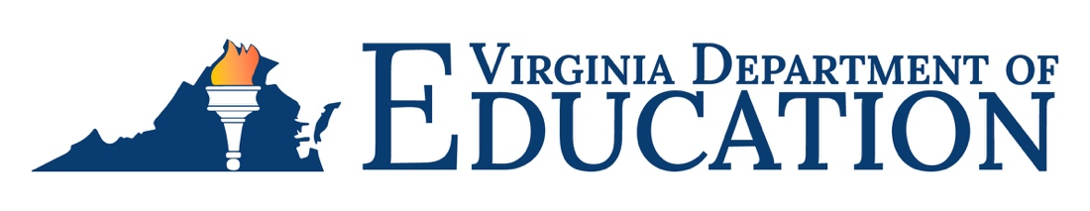
Subject: Recruitment Incentive for Public Education (RIPE)
The 2022 Special Session I of the General Assembly appropriated funding to support recruitment efforts for school divisions hiring to fill instructional positions between August 15, 2023, and November 30, 2023.
School divisions interested in this funding must submit data to the Virginia Department of Education via the Recruitment Incentive for Public Education (RIPE) Application on the Single Sign-on for Web Systems (SSWS) portal. The submitted application should be a snapshot of the school division’s vacancies on August 15, 2023 and include the number of hard-to-staff vacancies defined by the Critical Teaching Shortage Areas list and non-hard-to-staff vacancies for the 2023-2024 school year by school. Priority for distribution of these incentives shall be to school divisions experiencing the most acute difficulties in recruiting qualified teachers, defined for this initiative as the overall free and reduced lunch rate of 40 percent or greater on the 2022-2023 Free and Reduced Lunch Eligibility Report.
Eligible teachers must be hired in a reported instructional position vacancy in a Virginia public school division between August 15, 2023 and November 30, 2023. Individuals who are employed by a local school division in Virginia as of July 1, 2023, who accept an otherwise qualifying position in another local school division are not eligible for this incentive. Individuals employed by a local school division as of July 1, 2023, who transfer from a non-hard-to-staff school to a hard-to-staff school within the same division, are eligible for this incentive.
An eligible teacher will receive a $2,500 incentive award for filling a non-hard-to-staff position, or an incentive award of $5,000 for a hard-to-staff position. School divisions will provide half of the incentive payment to the individual no earlier than January 1, 2024 and provide the balance of the full amount to the individual no earlier than May 1, 2024, provided the individual receives a satisfactory performance evaluation and provides a written commitment to return to the same school for the 2024-2025 school year.
School divisions awarded RIPE funds will be provided funding on a cost reimbursement basis. Budget transfer requests and reimbursement requests will be processed through the Virginia Department of Education’s Online Management of Education Grant Awards system, OMEGA. The incentive awards are taxable to the recipient, and the school division is responsible for ensuring all taxes are remitted.
The RIPE vacancy data for school year 2023-2024 must be submitted between Monday, August 14, 2023 and Thursday, August 31, 2023, on the SSWS portal. Each school division has an SSWS account manager who can provide the school division staff member, designated to serve as the division RIPE contact, access to the RIPE Application. Instructions for entering and submitting the vacancies data are available online as part of the RIPE Application.
For more information
Name | Title | Email | Phone Number
Shawna LeBlond | Grants Manager | Shawna.LeBlond@doe.virginia.gov | (804) 692-0172

