**Dual Services Requirement**

Under federal civil rights law, special education and related services and Language Instruction Educational Program (LIEP) services are separate categories of support for ELs with disabilities. **Special education and related services cannot substitute for LIEP services**.

**Serving ELs with Disabilities**

* For ELs with disabilities, the Individualized Education Plan (IEP) team must include a staff member with expertise in second language acquisition.

LIEP services must be provided to all ELs at proficiency levels 1.0-4.3 including ELs with disabilities (except [”opt out”](https://ncela.ed.gov/files/english_learner_toolkit/7-OELA_2017_optout_508C.pdf)  ELs).

* School divisions must provide a qualified interpreter, if needed, to the parents of ELs with disabilities for IEP and other special education-related meetings. Students, siblings, family members, and untrained school staff are not considered qualified interpreters.

**Required Timeline**

ELs who may have a disability and need services under the Individuals with Disabilities Education Act (IDEA) must be located, identified, and evaluated for special education and disability-related services in a timely manner. The required timeline (65 business days) applies to all students including ELs.

**Under federal civil rights law, divisions are prohibited from:**

* Delaying or denying disability evaluations of ELs for special education and disability-related services based on EL status or English proficiency level; and
* Requiring ELs to be in the U.S. for a specified length of time or to receive LIEP services for a specified length of time before conducting a special education evaluation or providing services if the EL qualifies for services.

**[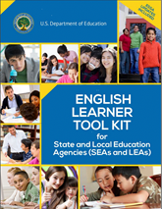](https://www2.ed.gov/about/offices/list/oela/english-learner-toolkit/index.html)**

[**EL Tool Kit Chapter 6:**](https://www2.ed.gov/about/offices/list/oela/english-learner-toolkit/chap6.pdf)

Tools and Resources for Addressing English Learners with Disabilities

**Determining Eligibility for Special Education and Related Services for ELs**

* English proficiency or EL status cannot be the basis for determining special education eligibility.
* The IDEA mandates that ELs must be evaluated in the student’s native language in the form most likely to yield accurate academic, developmental, and functional information on what the child knows and can do, unless it is clearly not feasible to provide or administer.

[34 CFR § 00.304(c)(1)(ii)]

* The eligibility team must include a staff member with second language acquisition expertise.

**English Learner Tool Kit**

The English Learner Tool Kit supports the 2015 [Dear Colleague Letter](https://www2.ed.gov/about/offices/list/ocr/letters/colleague-el-201501.pdf) jointly released by the U.S. Department of Education and the U.S. Department of Justice outlining the civil rights obligations of states and school divisions to identify and educate ELs.

The [English Leaner Tool Kit](https://www2.ed.gov/about/offices/list/oela/english-learner-toolkit/index.html) is intended to help states and school divisions understand the requirements in fulfilling these civil rights obligations and contains guidance, sample tools, and resources.

[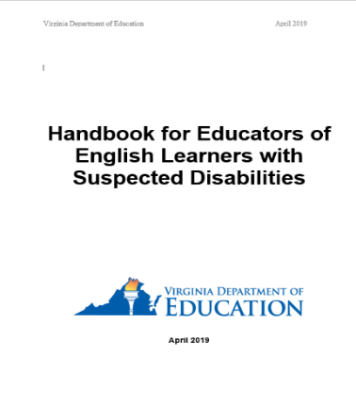](http://www.doe.virginia.gov/instruction/esl/resources/handbook_educators.pdf)[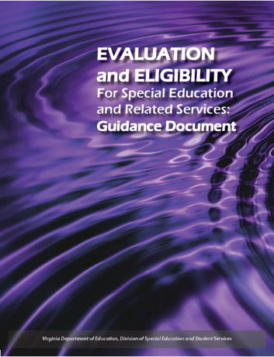](http://www.doe.virginia.gov/special_ed/disabilities/guidance_evaluation_eligibility.docx)

**USED Websites**

* [Office of Special Education Programs](https://www2.ed.gov/about/offices/list/osers/osep/index.html)

[USED Office for Civil Rights](https://www2.ed.gov/about/offices/list/ocr/index.html)

**VDOE Websites**

* [Office of Special Education Office and Student Services](https://www.doe.virginia.gov/programs-services/special-education)
* [Title III Office](https://www.doe.virginia.gov/programs-services/federal-programs/essa/title-iii)

[**Handbook for Educators of ELs with Suspected Disabilities**](https://www.doe.virginia.gov/home/showpublisheddocument/23291/638043748750800000)

* Provides school divisions with guidance on a multi-step process to appropriately identify and evaluate ELs who may

be suspected of having a disability for possible eligibility

for special education and related services.

* Assists divisions with ensuring compliance with state and federal regulations in serving ELs with disabilities.

[**Evaluation and Eligibility for Special Education and Related Services Guidance Document**](https://www.doe.virginia.gov/home/showpublisheddocument/876/637945623863270000)

* Assists school based teams and parents in navigating the referral, evaluation, and identification of students with disabilities.
* Assists IEP teams and related service providers in addressing the student needs related to referral, evaluation, and provision of related services.
* Provides information on regulatory requirements and provision of related services under IDEA of 2004.

**VDOE Technical Assistance Documents**

**Determining EL Status**

In Virginia, the EL status is based on the administration of a WIDA screening instrument to determine an English proficiency level for incoming students who may be ELs. All ELs exit the EL status solely by achieving a 4.4+ on the ACCESS for ELLs assessment.

**Federally Required English Language Proficiency (ELP) Assessment**

The English proficiency of ELs in Virginia, including ELs with disabilities, is annually assessed by the ACCESS for ELLs assessment or the Alternate ACCESS. An IEP plan shall not exempt an EL with disabilities from this assessment ([ESSA](https://www2.ed.gov/documents/essa-act-of-1965.pdf) Sec. 1111(b)(2)(G)(i).