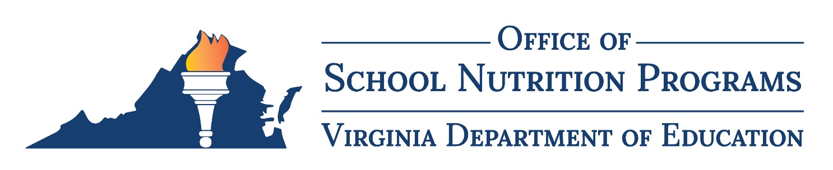

Income Eligibility Guidelines

Effective from July 1, 2023 to June 30, 2024

Table 1. Free Guidelines 130% Federal Poverty Line
Household Size | Yearly | Monthly | Twice per Month | Every Two Weeks | Weekly
1 | 18,954 | 1,580 | 790 | 729 | 365
2 | 25,636 | 2,137 | 1,069 | 986 | 493
3 | 32,318 | 2,694 | 1,347 | 1,243 | 622
4 | 39,000 | 3,250 | 1,625 | 1,500 | 750
5 | 45,682 | 3,807 | 1,904 | 1,757 | 879
6 | 52,364 | 4,364 | 2,182 | 2,014 | 1,007
7 | 59,046 | 4,921 | 2,461 | 2,271 | 1,136
8 | 65,728 | 5,478 | 2,739 | 2,528 | 1,264
For each add’l family member, add: | 6,682 | 557 | 279 | 257 | 129
Child Nutrition Programs: Income Eligibility Guidelines, 88 Fed. Reg. 8,397 (February 9, 2023)

Table 2. Reduced-Price Guidelines 185% Federal Poverty Line
Household Size | Yearly | Monthly | Twice per Month | Every Two Weeks | Weekly
1 | 26,973 | 2,248 | 1,124 | 1,038 | 519
2 | 36,482 | 3,041 | 1,521 | 1,404 | 702
3 | 45,991 | 3,833 | 1,917 | 1,769 | 885
4 | 55,500 | 4,625 | 2,313 | 2,135 | 1,068
5 | 65,009 | 5,418 | 2,709 | 2,501 | 1,251
6 | 74,518 | 6,210 | 3,105 | 2,867 | 1,434
7 | 84,027 | 7,003 | 3,502 | 3,232 | 1,616
8 | 93,536 | 7,795 | 3,898 | 3,598 | 1,799
For each add’l family member, add: | 9,509 | 793 | 397 | 366 | 183
Child Nutrition Programs: Income Eligibility Guidelines, 88 Fed. Reg. 8,397 (February 9, 2023)

