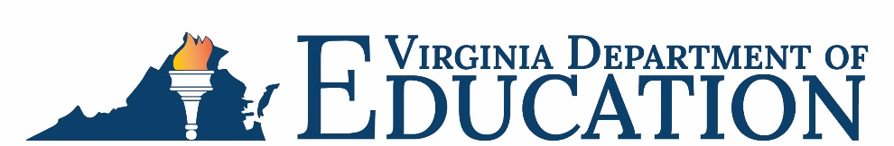

Office of School Nutrition Programs

Federal Program Administrative Review School Nutrition Program Summary
Section 207 of the Healthy Hunger Free Kids Act 2010, amended section 22 of the National School Lunch Act (42 U.S.C. 1769c) requires the Virginia Department of Education, Office of School Nutrition Programs (VDOE-SNP), to report the final results of the administrative review to the public in an accessible, easily understood manner in accordance with guidelines promulgated by the Secretary.
School Food Authority (SFA): Charlottesville City Public Schools
Date of Administrative Review: March 27, 2023
Review Month and Year: February 2023
Date review results were provided to the SFA: March 30, 2023
Date review summary was publicly posted: July 14, 2023
SFA participates in the following Child Nutrition Programs:
☒ School Breakfast Program
☒ National School Lunch Program
☒ Fresh Fruit & Vegetable Program
☐ Afterschool Snack
☐ Seamless Summer Option
SFA operates under the following Special Provisions:
☒ Community Eligibility Provision
☐ Provision 2

Review Findings
Review Area | Details
Program Access and Reimbursement  ☐ Certification and Benefit Issuance  ☐ Verification  ☐ Meal Counting and Claiming | No findings identified.
Meal Patterns and Nutritional Quality  ☐ Meal Components and Quantities  ☐ Offer versus Serve  ☐ Dietary Specifications and Nutrient Analysis | No findings identified.
School Nutrition Environment and Civil Rights  ☒ Food Safety  ☐ Local Wellness Policy  ☐ Smart Snacks and Competitive Foods  ☒ Civil Rights | Violations of the Buy American Provision were observed.  The most recent food safety inspection report was not posted in a publicly visible location.  The food safety plans did not meet all regulatory requirements.  The SFA’s procedures for receiving and processing complaints alleging Civil Rights discrimination within FNS School Meals Programs were insufficient.
USDA is an equal opportunity provider, employer, and lender.

