Virginia Compliance with Title III Requirements

Purpose of Program and General Use of Funds of Title III

The overarching purpose of Part A, of Title III, known as the English Language Acquisition, Language Enhancement, and Academic Achievement Act, is to ensure that English learners (ELs), including immigrant children and youth, attain English language proficiency and meet the same challenging academic content and achievement standards that other students are expected to meet. [ESSA, Section 3102(a)(1-2)]

Entrance Procedures for ELs
Initial identification of ELs is required as part of the enrollment process under Title VI of the Civil Rights Act of 1964.
The English Learner Toolkit created by the U.S. Department of Education (USED) states that LEAs must accurately identify EL students in a timely manner. The USED Office for Civil Rights in conjunction with the U.S. Department of Justice has approved the following questions to demonstrate minimal compliance with the requirement to identify possible EL students in need of language assistance:

- What is the primary language used in the home, regardless of the language spoken by the student?
- What is the language most often spoken by the student?
- What is the language that the student first acquired?
These identifying questions must be included verbatim on registration documents or on a separate home language survey provided to all students enrolling in a Virginia public school. If a parent or guardian responds with any language other than English for one or more questions, then the student should be progressed to the language screening process. Superintendent’s Memo 149-21

Timeframe for Completion
School divisions must develop a written protocol to ensure that incoming ELs are identified, screened, and placed in appropriate programs and services within thirty days of enrollment at the beginning of the school year, or within 2 weeks after the start of the school year. School divisions must ensure that all ELs enrolling in a school division are identified in a consistent and equitable manner.

Assessment of students who have been identified as potential ELs
School divisions may select from the following WIDA screening tools to identify potential ELs as stated in Superintendent’s Memo 189-22
Cut scores for the WIDA Screeners are also specified in this memo.
- WIDA Screener – Paper or Online
- WIDA Screener for Kindergarten - Paper
- WIDA MODEL (Grades 1-12) – Paper
- Kindergarten MODEL – Paper

Timeframe for Completion
School divisions must develop a written protocol to ensure that incoming ELs are identified, screened, and placed in appropriate programs and services within thirty days of enrollment, and must ensure that all ELs enrolling in a school division are identified in a consistent and equitable manner.

Placement of ELs in an effective English language instruction educational program (LIEP)

ELs initially identified using a WIDA Screener should be placed in an effective LIEP. ELs with an overall proficiency score of less than 4.4 on the ACCESS for ELLS® English language proficiency (ELP) assessment should be placed in an effective LIEP. Under Title VI and the EEOA LEAs must provide EL students with a language assistance program that is educationally sound and proven successful, consistent with Supreme Court decisions Castañeda v. Pickard and in Lau v. Nichols. For further in information on LIEP definitions please see: USED Title III Language Instruction Educational Programs Report
[ESSA, Section 3115 (c)(1)]

Timeframe for Completion
Ongoing as part of the enrollment process

Parent Notification
Inform parents annually regarding their child’s placement in a language instruction educational program within 30 days after the beginning of the school year, or within two weeks of the child’s placement within a program. The notification letter as required under Title I, Part A, or Title III, Part A, must include the following components:
- Level of English proficiency and how level was assessed;
- Method of instruction and other available methods of instruction;
- How the program will meet the educational needs of the student;
- Graduation requirements;
- Exit requirements;
- EL students and special education; and
- Parental right to remove student from program or refuse services.
[ESSA, Section 1112 (e)(3)(A)]

Timeframe for Completion
Parents must be notified within thirty days of enrollment at the beginning of the school year, or within 2 weeks after the start of the school year following placement in a LIEP.
The notification should be provided to parents in their native language or a language they understand. See Sample Notification Letter and Title I/III Parent Notification Requirements under Title III Parent, Family and Community Engagement heading.

Assessing the English Language Proficiency of ELs
The state-approved English language proficiency assessment in Virginia is the ACCESS for ELLs. The overall cut score to determine EL proficiency in Virginia is 4.4. Superintendent’s Memo #168-17

The Division Director of Testing (DDOT) will notify division personnel of the state-approved division-testing window.

Information on English Learner participation in state assessments can be found in the Procedures for Determining English Learner Participation in the Virginia Assessment Program [ESSA, Section 1111(b)(2)(G)]

Timeframe for Completion
January through March (state-approved testing window)

State Federal Program Monitoring

All federal programs out of the Office of ESEA Programs are monitored on a 5-year schedule. See the FPM Five-Year-Schedule 2020-2024 in Superintendent’s Memo 288-20

Timeframe for Completion
Every five years

Title III Funding
Apply for Title III grant funding. School divisions may qualify for two types of funding under Title III:
- EL subgrants; and/or
- Immigrant Children and Youth (IY) subgrants. Superintendent’s Memo #179-17

Divisions must receive $10,000 to apply for EL funds. School divisions that receive less than $10,000 must enter into a consortium to receive funds.
Funds must be used for supplemental:
- Language instruction educational programs that increase English language proficiency and student achievement in academic classes;
- Providing effective professional development to classroom teachers, principals, administrators, and other school personnel; and
- Parent, family and community engagement activities
[ESSA, Sections 3115(c)(1-3)]

Timeframe for Completion
Deadline to submit Title III federal application: July 1
Superintendent’s Memos announcing federal allocations and reallocations can be located under Title III Allocations.

Accountability through Monitoring Former ELs
Students classified as formerly EL must be monitored for two full academic years to ensure that they are able to participate meaningfully in the regular educational program. Under Title I, Part A, a state may include, for up to four years after exiting the English learner subgroup, the assessment results of such a student previously identified as an English learner in calculating the Academic Achievement indicator in reading/language arts and mathematics for the English learner subgroup in its statewide accountability system. Superintendent's Memo #210-17
[ESSA, Section 1111(b)(3)(B)]

Timeframe for Completion
Monitoring is ongoing as part of the instructional process

EL Proficiency Level Gains
Virginia ESSA State Plan: (See page 19) Virginia will use the WIDA ACCESS for ELLs 2.0 assessment to measure progress in achieving ELP.

To determine the EL exit criterion under the new scale, ACCESS for ELLs 2.0 data were used to identify the composite score that was most consistent with passing or failing the state reading assessment (consistency rate). This methodology indicated a composite score of 4.4, which was selected as Virginia’s ACCESS for ELLs 2.0 exit criterion.

To define ELP, 2015-2016 and 2016-2017 year ACCESS for ELLs 2.0 data were analyzed using the new scale. Several grade clusters and composite score groupings were compared to determine which could be combined. The data indicated three grade clusters (grades K-2, grades 3-5, and grades 6-12) and three composite score groupings (1.0-2.4, 2.5-3.4, and 3.5-4.4). For these groupings, average growth from 2015-2016 to 2016-2017 was calculated to identify the ELP requirements below.
Composite Proficiency Level Gains
Proficiency Level | Grades K-2 | Grades 3-5 | Grades 6-12
1.0-2.4 | 1.0 | 0.7 | 0.4
2.5-3.4 | 0.4 | 0.4 | 0.2
3.5-4.4 | 0.2 | 0.2 | 0.1

The school level baseline data, long-term goals, and interim measures of progress for the ELP indicator are described in section A.4.iii.c. and are provided in Attachment A.

EL Measurement of Interim Progress

EL baseline data and measures of interim progress toward meeting the long-term goals for academic achievement can be found in Virginia ESSA State Plan (See Appendix A)

Timeframe for Completion
Interim progress is measured annually. Long-term goals are set for 7 years.

English Language Proficiency (ELP) Progress Indicators
EL baseline ACCESS data and measures of interim progress toward meeting the long-term goals for ELP, can be found in Virginia ESSA State Plan (See Appendix C)

English Learner Progress Targets
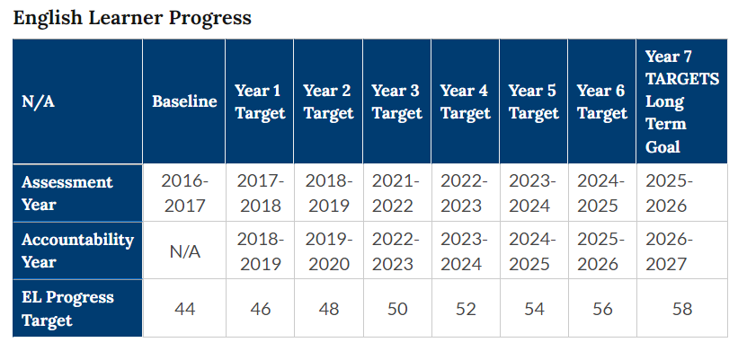
Accountability Years 2018-2019 through 2024-2025

https://www.doe.virginia.gov/data-policy-funding/data-reports/statistics-reports/accreditation-federal-reports/federal-accountability#:~:text=English%20Learner%20Progress,58)

Timeframe for Completion
Interim progress is measured annually. Long-term goals are set for 7 years.
*Accountability waiver for 2020-2021 and 2021-2022 due to COVID-19.

