Specifications for Completing the
Miscellaneous Web Collections
2023 – 2024
Revised July 2023

Fall Miscellaneous Data Collection

General Information
All the data on these forms is aggregate data that cannot be calculated or derived from the individual student records.

Number of Children Receiving Home Instruction
Required: Fall Format: numeric Maximum Length: 12 Level: Division
Enter the number of home-schooled students that reside within the school division. Aggregate totals are required for Elementary, Middle and High School Levels. Include all home-schooled students, not just those who attend the local school division on a part-time basis. Only include persons of school age that are subject to compulsory attendance requirements as defined in the Code of Virginia §22.1-254.

Number of Religious Exemptions
Required: Fall Format: numeric Maximum Length: 12 Level: Division
Enter the number of religious exemption students that reside within the school division. Aggregate totals are required for Elementary, Middle and High School Levels.
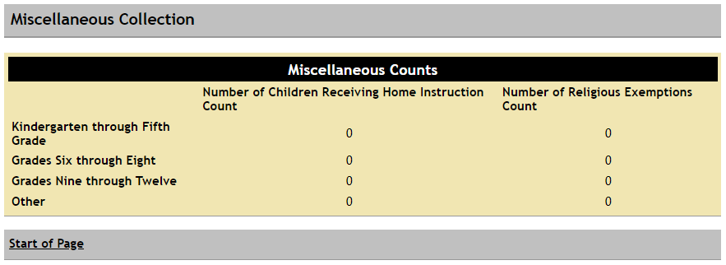

Days in Session
Required: Fall Format: numeric Maximum Length: 3 Level: School
Enter the number of days in session by school. It cannot exceed the number of days entered on the school calendar.
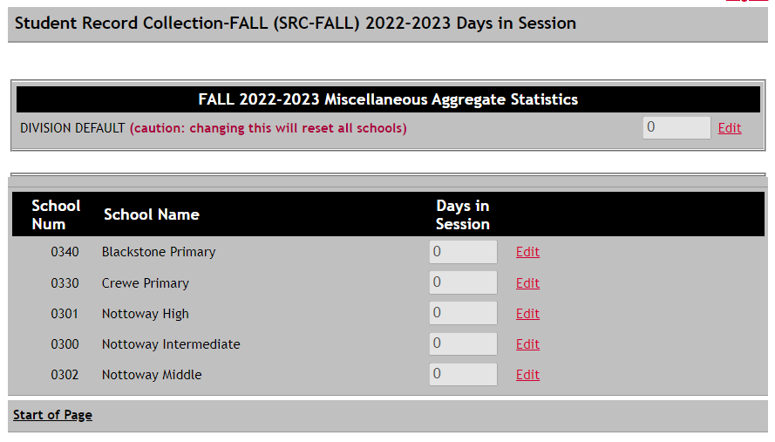

Starting Teacher Salary
Required: Fall Format: numeric Maximum Length: 12 Level: Division
For purposes of this data collection, only include licensed elementary and secondary classroom teachers (regardless of fund source). Include as classroom teachers art, music, physical education, technology, remedial, gifted, math, reading, special education, and ESL teachers. School divisions should not include teacher aides, guidance counselors or librarians in this report.
Report the starting salary (excluding fringe benefits) for a first year beginning teacher with Bachelors, Masters and Doctorate degrees. If your division pays supplements for advanced degrees separate from the base salary, please include the advanced degree supplements as part of the base salary for this data collection. If there is no separate salary scale for a teacher with a master's degree, enter the starting salary awarded to a teacher with a bachelor's degree.

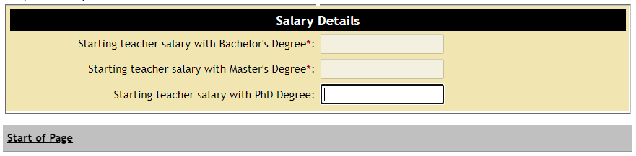

Average Teacher Salary
Required: Fall Format: numeric Maximum Length: 12 Level: School
This miscellaneous form is populated with each fall membership school within your division. Please enter the average teacher salary for each school.
For purposes of this data collection, only include licensed elementary and secondary classroom teachers (regardless of fund source). Include as classroom teachers art, music, physical education, technology, remedial, gifted, math, reading, special education, and ESL teachers. School divisions should not include teacher aides, guidance counselors or librarians in this report.
Report the average salary (excluding fringe benefits) for each school reported in fall membership. See the teacher definition above for additional guidance on which teachers to include. To calculate each school’s average salary, sum all the salaries of each teacher who works in the school and divide the sum by the FTE total of all teachers (full and part-time) in the school.
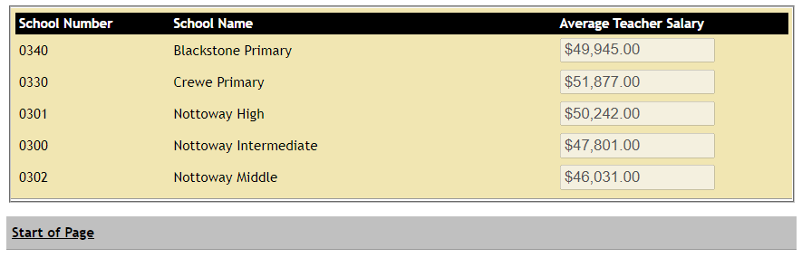

K - 3 Miscellaneous
Please refer to the specific instructions provided by the Budget Office through the K-3 Class Size Reduction Program application that is available through SSWS.

Spring Miscellaneous Data Collection

General Information
All the data on these forms is aggregate data that cannot be calculated or derived from the individual student records.

Days in Session
Required: Spring Format: numeric Maximum Length: 3 Level: School
Enter the number of days in session by school. This is required to calculate March 31 ADA and ADM. It cannot exceed the number of days entered on the school calendar.
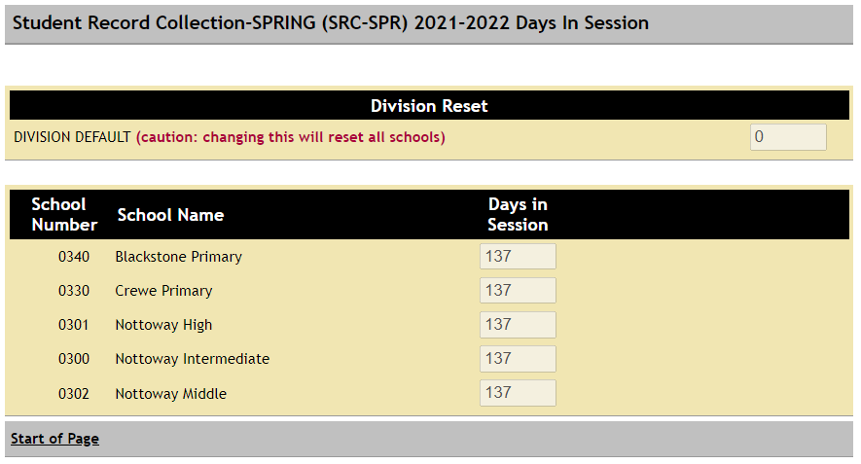

Report of March 31 Average Daily Membership (ADM) Kindergarten Adjustment
Required: Spring Format: numeric Maximum Length: 12 Level: Division
Only licensed teachers (regardless of fund source) can be included as instructional kindergarten positions for purposes of calculating Adjusted ADM. In addition, school divisions may only include resource teachers on an FTE basis using the percentage of time spent with kindergarten students. School divisions may not include teacher aides. Guidance Counselors and Librarians may not be counted as resource teachers. Resource teachers which may be counted include art, music, physical education, technology, remedial, gifted, math, reading, special education, and ESL resource teachers.
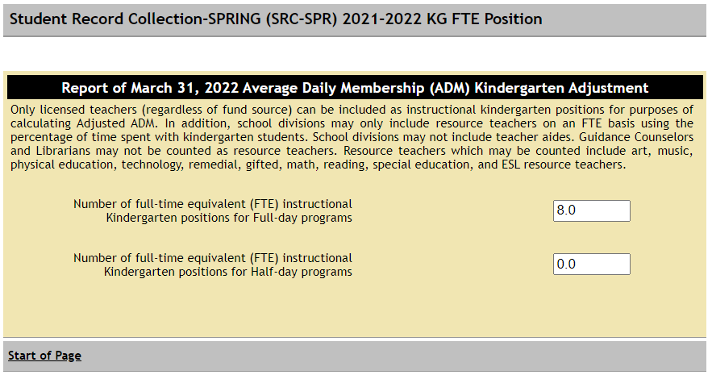

Projections for March 31 Average Daily Membership (ADM)
Required: Spring Format: numeric Maximum Length: 12 Level: Division
Once a successful file has been processed, Projections for March 31 are required. This form is populated with the current Unadjusted K-12 ADM Count. You are to enter the Unadjusted K-12 ADM Count for the years requested.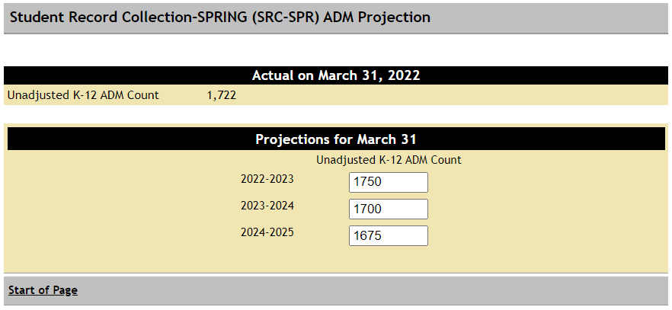

End of Year Miscellaneous Data Collection

General Information
All the data on these forms is aggregate data that cannot be calculated or derived from the individual student records.

Days in Session
Required: EOY Format: numeric Maximum Length: 3 Level: School
Enter the number of days in session by school. This is required to calculate End-of-Year ADA and ADM. It cannot exceed the number of days entered on the school calendar.
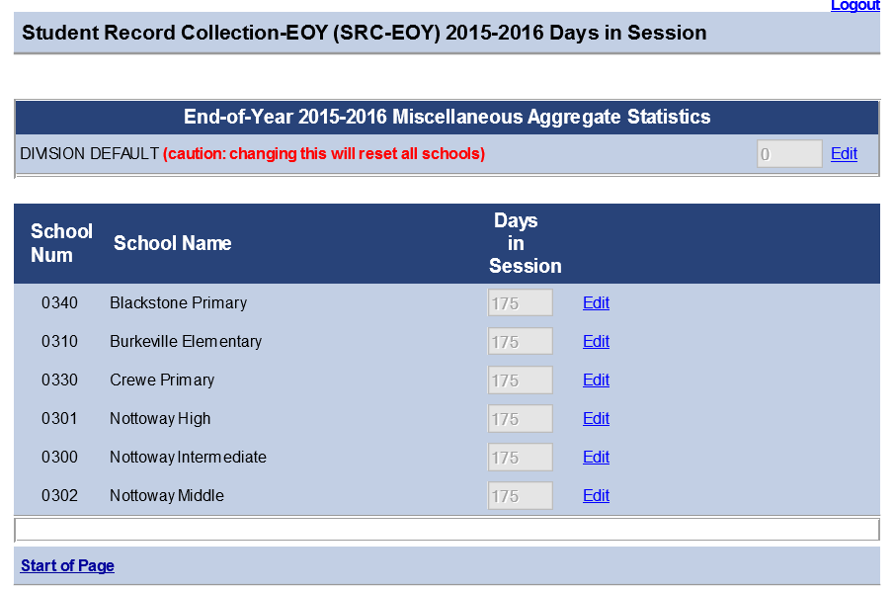

Number of Instructional Hours
Required: EOY Format: numeric Maximum Length: 4 Level: School
Section 22.1-98, Code of Virginia, paragraph J, requires that the division superintendent and local school board chairman certify the total number of teaching days and teaching hours in each school year. This certification information will be included in the Board of Education's annual report, as required by Section 22.1-81, Code of Virginia.
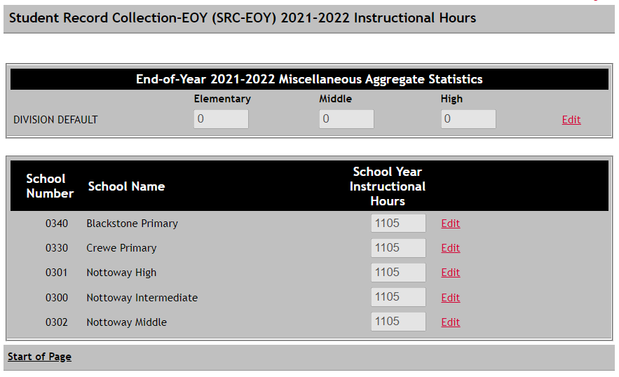

Summer Miscellaneous Data Collection

General Information
All the data on these forms is aggregate data that cannot be calculated or derived from the individual student records.

Aggregate days class attendance (day present) for summer term
Required: SUM Format: numeric Maximum Length: 12 Level: Division
Enter the summer school aggregate days attendance for the division. Count each student once for each session enrolled.

Average daily class attendance (ADA) for summer term
Required: SUM Format: numeric Maximum Length: 12 Level: Division
Enter the summer school ADA for the division.
Summer school average daily attendance (ADA) for the division is determined
by: 1.) calculating ADA for each class; 2.) summing ADA across all classes in each school; and 3.) summing ADA across all schools in the division. Class ADA is calculated by dividing the aggregate days attendance (total days present) by the number of days the class is in session. When a pupil is enrolled in more than one class, days present should be counted only in one class each day.
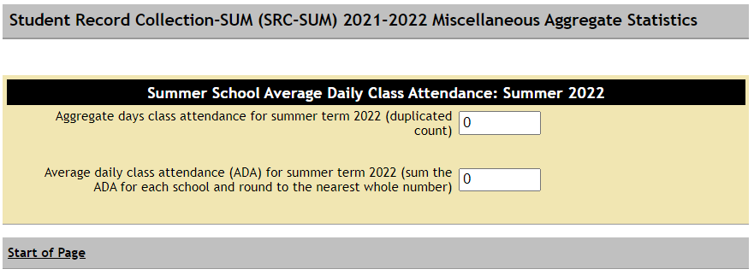

The Summer School ADA Report calculates an Average Days in Session.

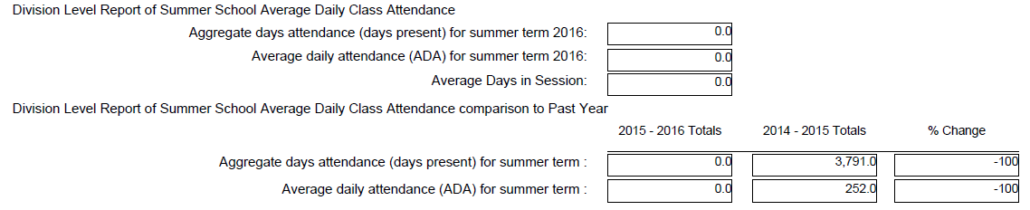

Remedial Summer School
Required: SUM Format: numeric Maximum Length: 12 Level: Division
Enter the summer school eligible student counts for the division.
State funding is provided in the 2020-2022 appropriation act (Chapter 1289, 2020 Acts of Assembly) for those divisions that offered a qualifying remedial summer school program in summer 2021 (fiscal year 2022) pursuant to Section 22.1-253.13:1 C., Code of Virginia.

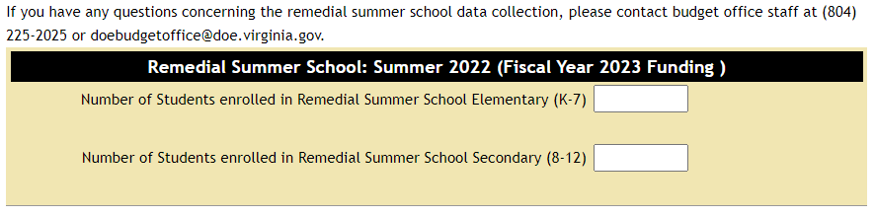

Qualifying Remedial Summer School Programs General Information
In reporting qualifying students for state remedial summer school funding in the Summer Student Record Collection (SRC), please note the following requirements:
- Each student may only be counted once. Students should be counted in this manner regardless of whether they were served in one or more subject areas or in single or multiple sessions during the 2021 remedial summer school program. The funded per pupil amount is based on the average cost of 30 days of instruction per student; there may have been some students who received more instruction and some who received less than 30 days but each student should be counted only once for state funding purposes.
- The minimum instruction hours and staffing requirements for remedial summer school programs per Board of Education regulation 8 VAC 20-630-60 are as follows:
  - Minimum of 20 hours of instruction per subject, exclusive of field trips, assemblies, recreational activities, lunch or post-program testing time
  - For grades K-5 that offer an integrated curriculum, a minimum of 40 hours of instruction shall be required
  - The pupil-teacher ratios for state-funded summer remedial programs shall not exceed 18:1

- Please note the following appropriation act provisions (contained in Item 145, Paragraph C.9.g.1 of Chapter 1289, 2020 Acts of Assembly) that govern remedial summer school funding and restrictions on charging tuition and awarding course credit:
“These funds are available to school divisions for the operation of programs designed to remediate students who are required to attend such programs during a summer school session or during an intersession in the case of year-round schools. These funds may be used in conjunction with other sources of state funding for remediation or intervention. School divisions shall have maximum flexibility with respect to the use of these funds and the types of remediation programs offered; however, in exercising this flexibility, students attending these programs shall not be charged tuition and no high school credit may be awarded to students who participate in this program.”
- “Eligible students” are defined as those students who meet either (i) the criteria identifying students who are educationally at risk that have been established by the local school board or (ii) the state criteria identifying students who are educationally at risk as specified in Section 22.1-253.13:1 of the Code of Virginia.
School divisions that operate year-round schools may include students who were remediated during intersession periods of the year-round school term in the collection. Students who were remediated during the intersession periods of year-round schools should be submitted for reimbursement in the reporting cycle that occurs in the subsequent fiscal year.
For example, students who were remediated during the intersession periods of 2020-2021 year-round school terms that occurred from July 2020 through June 2021 or September 2020 through August 2021 should be reported in the data collection for reimbursement from fiscal year 2022 remedial summer school funds. Just as with summer remediation programs, a student must be counted only once for the entire school year regardless of the number of intersession periods the student attended for remediation purposes.
Nonresident, foster care children described under Section 22.1-101.1, subsections A and B, Code of Virginia, that were served in the summer 2021 remedial program in your division may be included in the data collection for reimbursement from state remedial summer school funds. Like other students submitted for state reimbursement, these students must be counted only once in the collection.
After the actual remedial summer school program enrollments are received from school divisions through the completed Summer SRC and are approved by the department, the fiscal year 2021 remedial summer school entitlement will be paid in recurring payments to school divisions based on the availability of state funds. In the event the calculated payments exceed the available state appropriation for fiscal year 2022, and additional state funding is not obtained during the year, final payments to divisions will be prorated.
For divisions that request reimbursement for remedial summer school programs, state payments for fiscal year 2022 will be based on the state share of $545 per eligible pupil, subject to the availability of state funds. The state share of per pupil payments will be based on the composite index of local ability-to-pay for each school division.
School divisions that did not serve remedial summer school students in summer 2021 must complete the Remedial Summer School collection using zeros for both values.
If you have any questions concerning the remedial summer school data collection, please contact budget office staff at (804) 225-2025 or doebudgetoffice@doe.virginia.gov.

