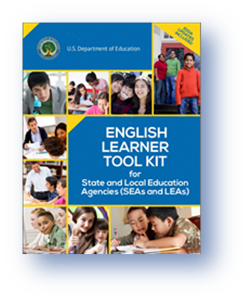

**Designing and Implementing an Effective Language Instruction Educational Program (LIEP)**

**Select the LIEP Model(s)**

* The model(s) must be effective in meeting the diverse needs of ELs
* The model(s) must have a reasonable chance of success within a reasonable timeframe
* The model(s) must provide the opportunity for ELs to acquire English proficiency
* The model(s) must provide ELs meaningful and equal access to the same appropriate grade-level curriculum as all students to allow an opportunity for on-time graduation

**Implement the LIEP Model(s)**

* The model(s) must be implemented with fidelity by qualified instructional staff
* Educators of ELs should be provided effective professional development focused on improving EL instructional practices and EL academic performance
* Sufficient resources, including staffing, must be provided to allow for a reasonable chance of success
* The model(s) must provide LIEP services to all ELs K-12 at proficiency levels 1.0-4.3 until they reach the state criterion for proficiency (4.4+ on the ACCESS for ELLs assessment)

**Evaluate the LIEP Model(s)**

* The evaluation process must include input from relevant stakeholders such as LIEP teachers, content and resource teachers, administrators, student support staff, and parents
* The evaluation process must include the collection and analysis of pertinent student testing and performance data
* The evaluation process should result in modifications to the LIEP model(s), as necessary, based on evaluation results

**Under federal law and the Code of Virginia, LIEP services are part of the required, core curriculum for ELs. Non-Federal funds must support the LIEP including materials and staffing. Title III funds must provide supplemental support.**

[**English Learner Tool Kit**](https://www2.ed.gov/about/offices/list/oela/english-learner-toolkit/index.html)

The English Learner Tool Kit supports the 2015 [Dear Colleague Letter](https://www2.ed.gov/about/offices/list/ocr/letters/colleague-el-201501.pdf) jointly released by the U.S. Department of Education and the U.S. Department of Justice outlining the civil rights obligations of states and school divisions to identify and educate ELs.

The English Leaner Tool Kit is intended to help states and school divisions understand the requirements for fulfilling these civil rights obligations and contains guidance, sample tools, and resources.

**Under federal civil rights law, programs to educate ELs must be:**

* Based on sound educational theory
* Adequately supported so the program has a reasonable chance of success
* Periodically evaluated and modified if necessary

**Elements of a Compliant Division Program**

**to Provide Services to ELs**

Identified ELs have meaningful and equitable access to the same appropriate grade-level curriculum as all students to allow an opportunity for on-time graduation.

Educators of ELs are provided effective, sustained professional development designed to increase EL English proficiency and academic achievement.

Special categories of ELs, such as "opt-out" ELs and ELs with disabilities, receive services to help them acquire English proficiency.

The same information provided to English-speaking parents is provided to the parents of ELs in a language they can understand.  The division must also provide outreach to the parents of ELs.

All identified ELs participate in the state assessment programs. The ACCESS for ELLs test should only be administered to ELs who have not reached 4.4+.

Identified ELs have access to the same student support services and specialized programs as all students.

All identified ELs are provided LIEP services consistent with the chosen LIEP model(s).  The necessary resources, including staffing, must be provided to effectively implement the LIEP model(s).

Each identified potential EL is assessed for an English language proficiency level.

All students potentially needing language instruction educational program (LIEP) services are accurately identified.