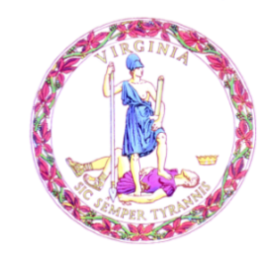

Commonwealth of Virginia

College Partnership Laboratory Schools Standing Committee Agenda

Date of Meeting: July 7, 2023 Time: 10:00 a.m.

Location: Board Room, 22nd Floor, James Monroe Building

10:00 a.m. STANDING COMMITTEE CONVENES

MOMENT OF SILENCE

PLEDGE OF ALLEGIANCE

APPROVAL OF THE AGENDA

APPROVAL OF MINUTES
PUBLIC COMMENT ON AGENDA ITEMS
ACTION/DISCUSSION ITEMS
- Final Review of College Partnership Laboratory School Application from Virginia Commonwealth University

- Final Review of College Partnership Laboratory School Application from Southside Virginia Community College

- Final Review of Revisions to the College Partnership Laboratory School Application
DISCUSSION OF CURRENT ISSUES
PUBLIC COMMENT ON NON-AGENDA ITEMS

ADJOURNMENT

