Instructions for Accessing the SNP Training Hub

Enrollment Instructions
- Go to https://vdoelearning.catalog.instructure.com/courses/vdoe-snp-training-hub.
- Click on Enroll.
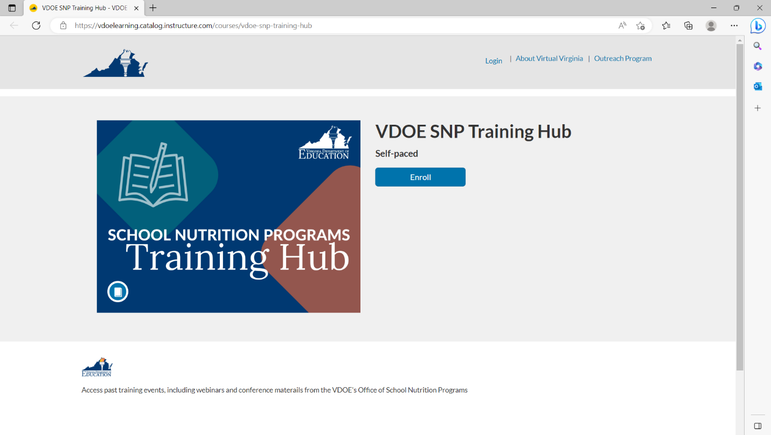
- Under Choose your program, select Virtual Virginia Professional Learning from the dropdown menu, and then click on Login.
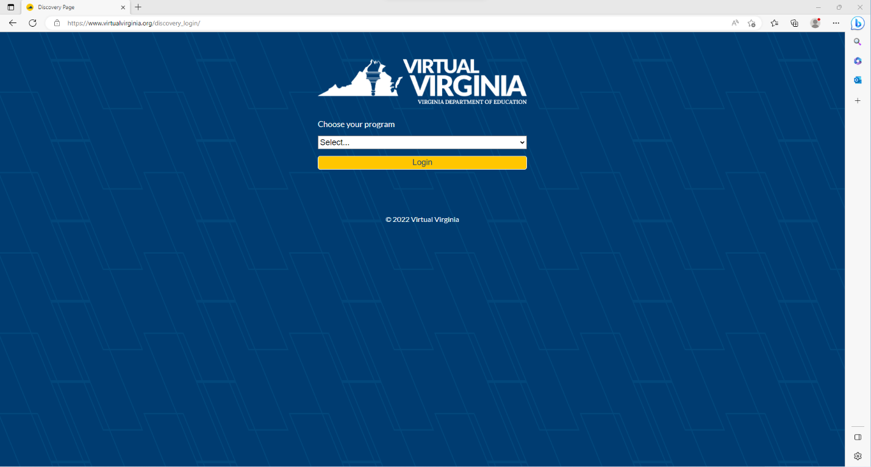
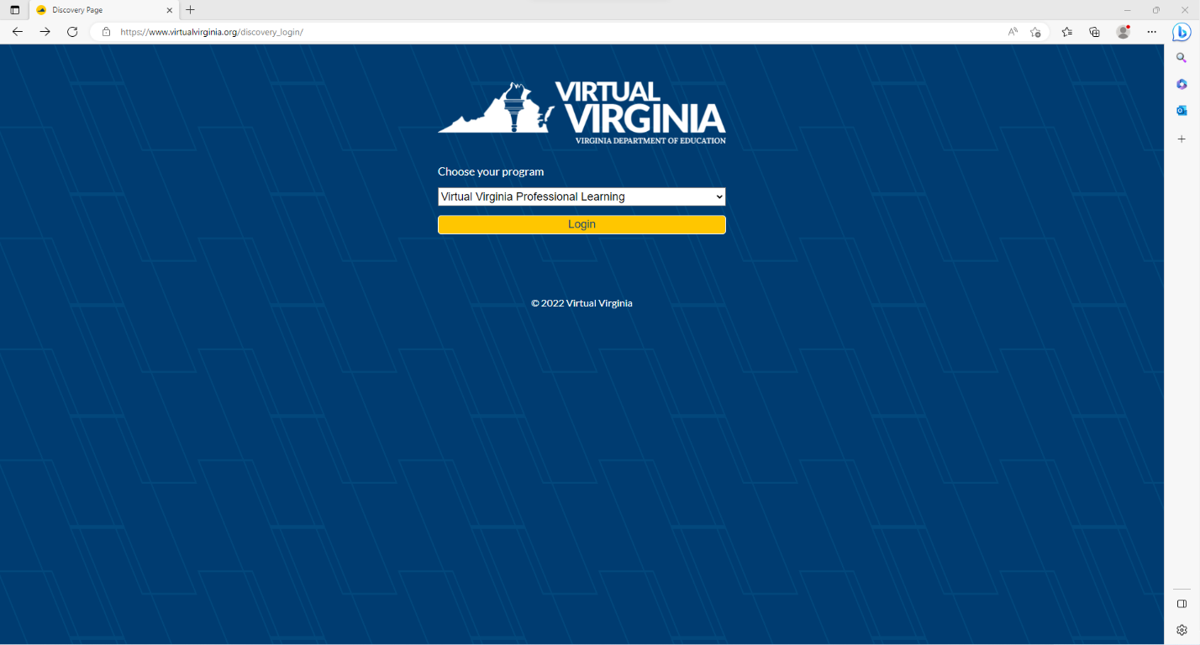
- If you already have a Virtual Virginia account, click on Sign in to Enroll. If you do not have an account, complete the initial registration information, and click on Register New Account.

Login Instructions
- To login to Canvas once you have an account, go to https://virtualvirginia.org/discovery_login/.
  - To reset your password, go to https://virtualvirginia.org/tech-support/.
- Under Choose your program, select Virtual Virginia Professional Learning from the dropdown menu, and then click on Login.
- You will now be on your Virtual Virginia Dashboard. This is where you can access all courses in which you are enrolled. Click on the VDOE SNP Training Hub course card.
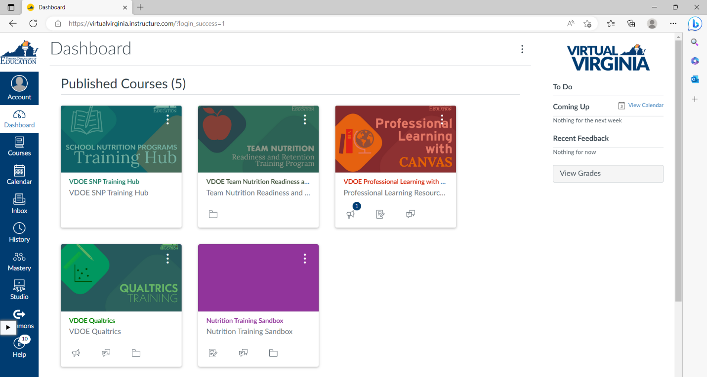
- You can also access the VDOE SNP Training Hub course by clicking on Courses in the lefthand panel of the Virtual Virginia Dashboard.
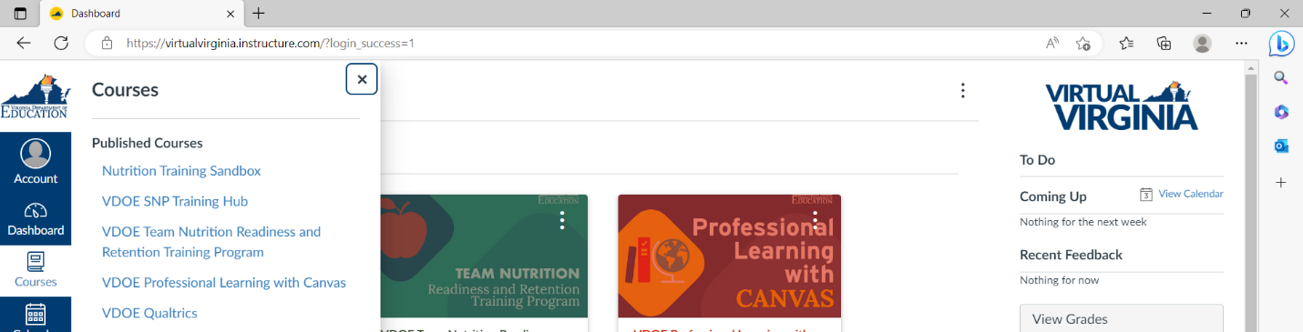

Course Navigation
- You will now be on the Home page for the VDOE SNP Training Hub course. Read the information on the Home page and then select Intake Questionnaire.
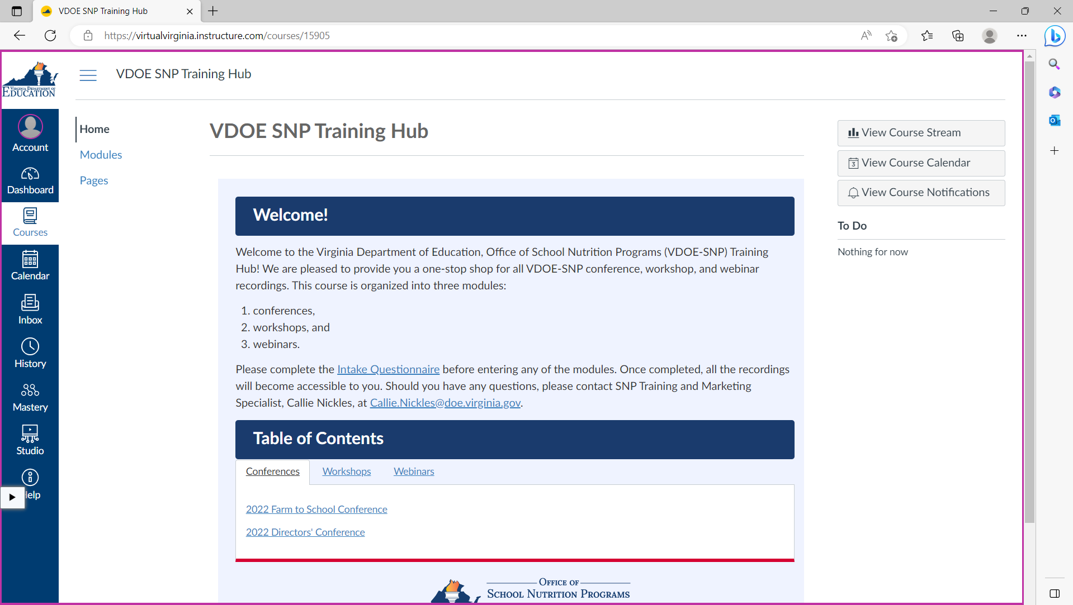
- Click on Take the Survey.
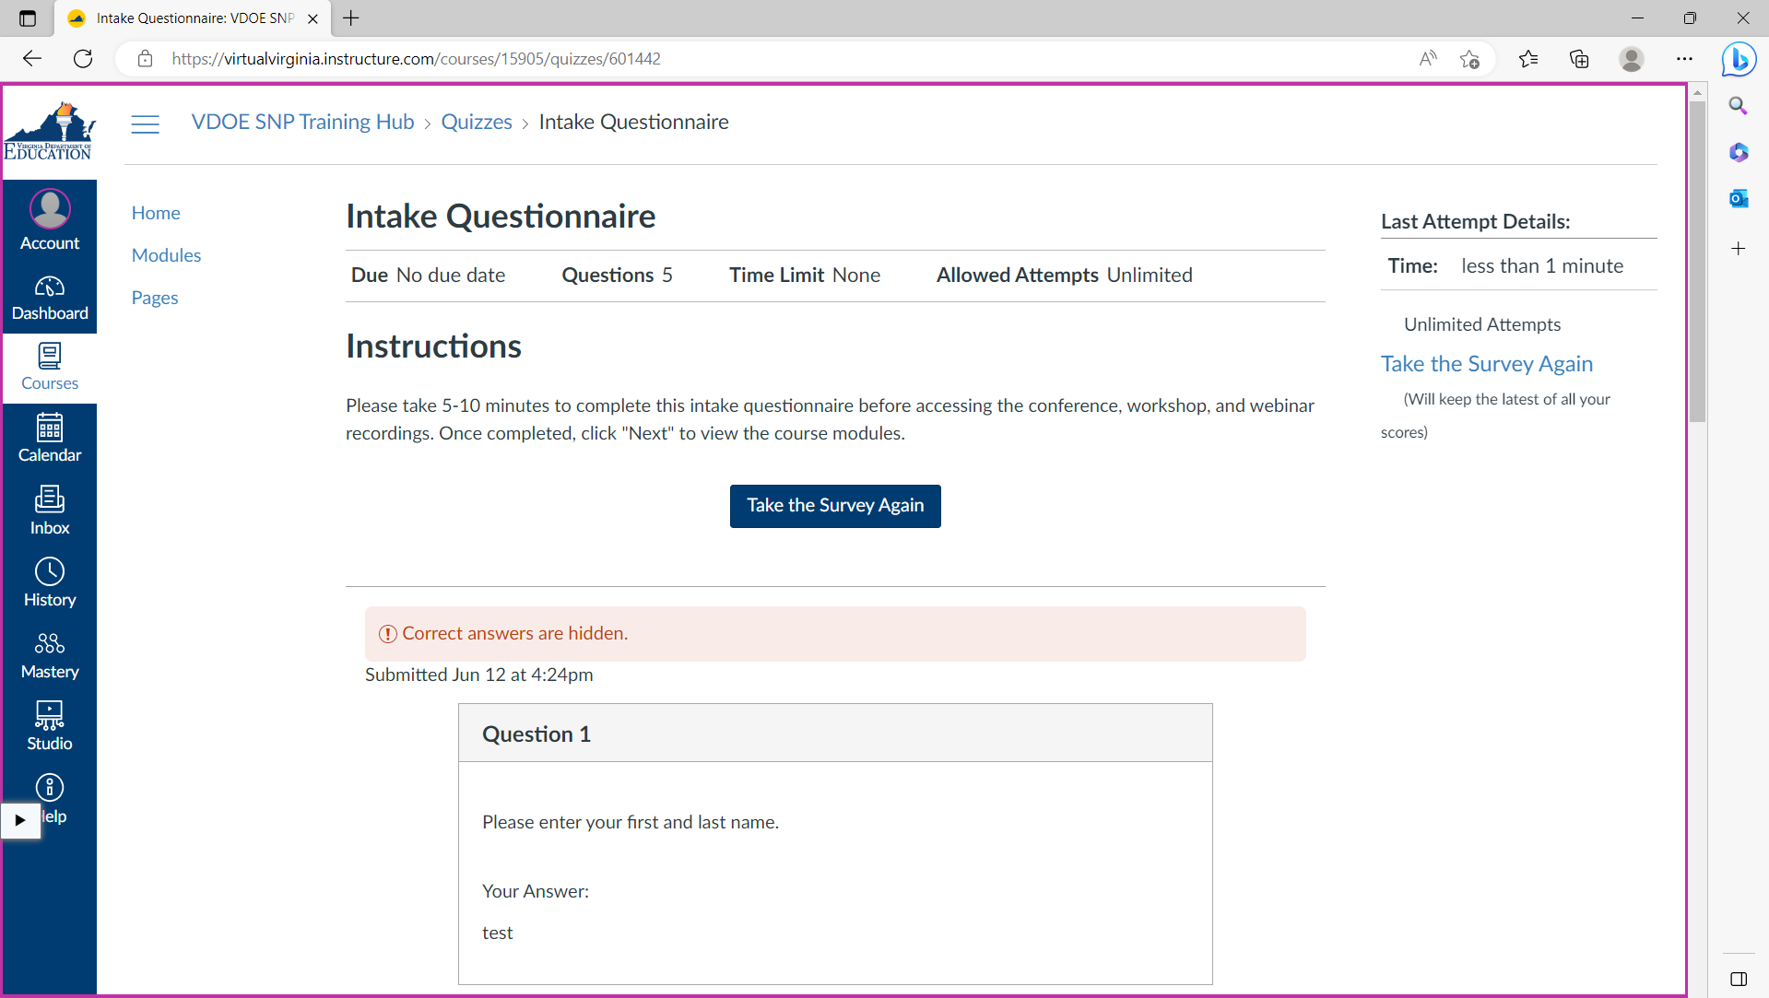
- Complete each question. Once you’ve completed the quiz, click on Submit Quiz.
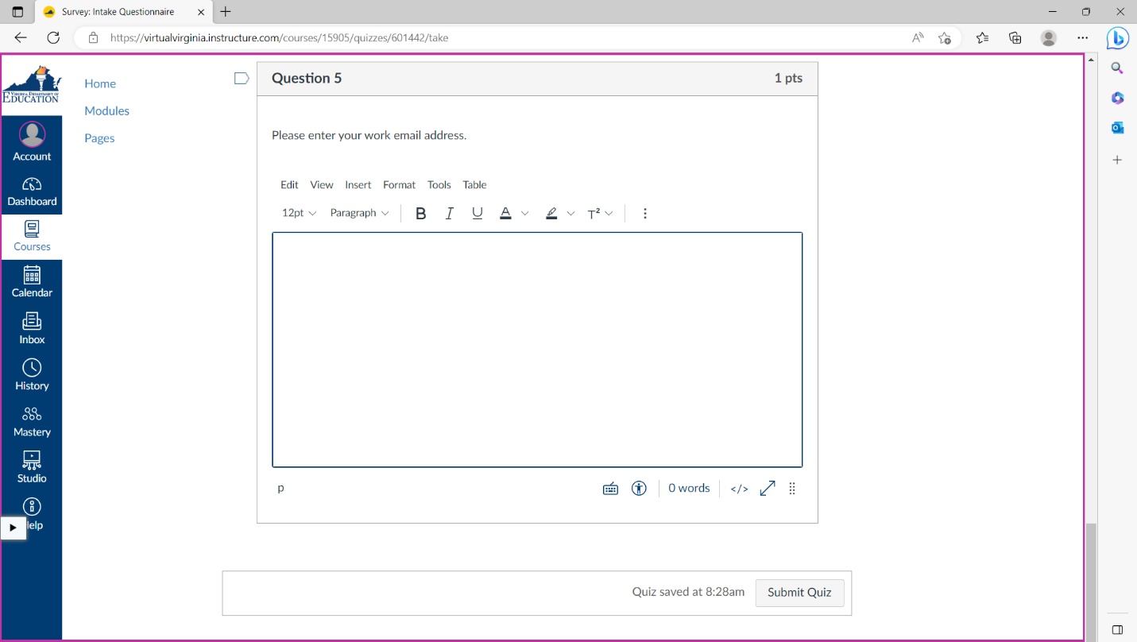
- Once your quiz is submitted, you will be brought to a page that has your responses. Scroll down and click on Next.
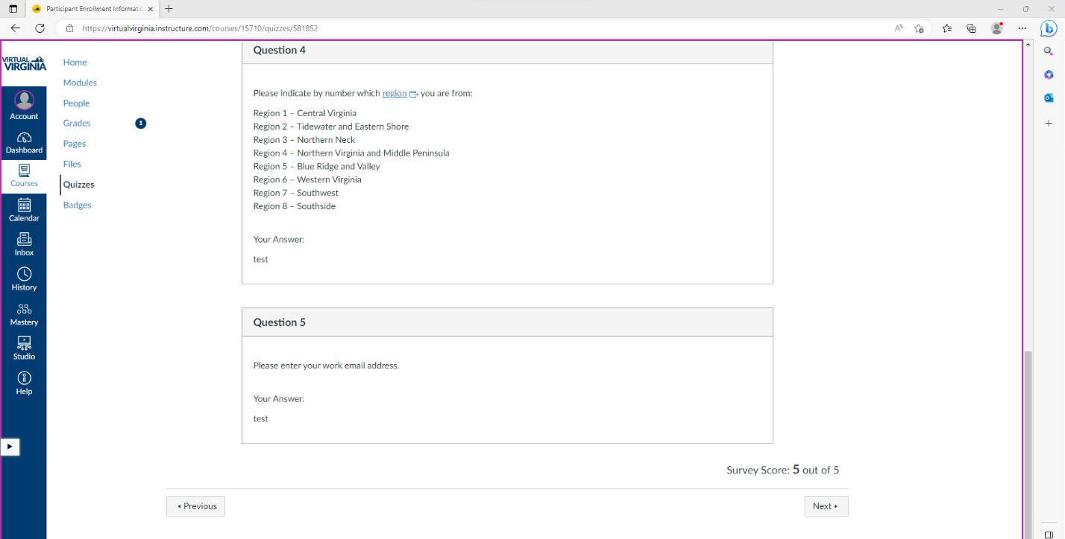
- On the Course Navigation page, select Return to Training Hub Home Page.
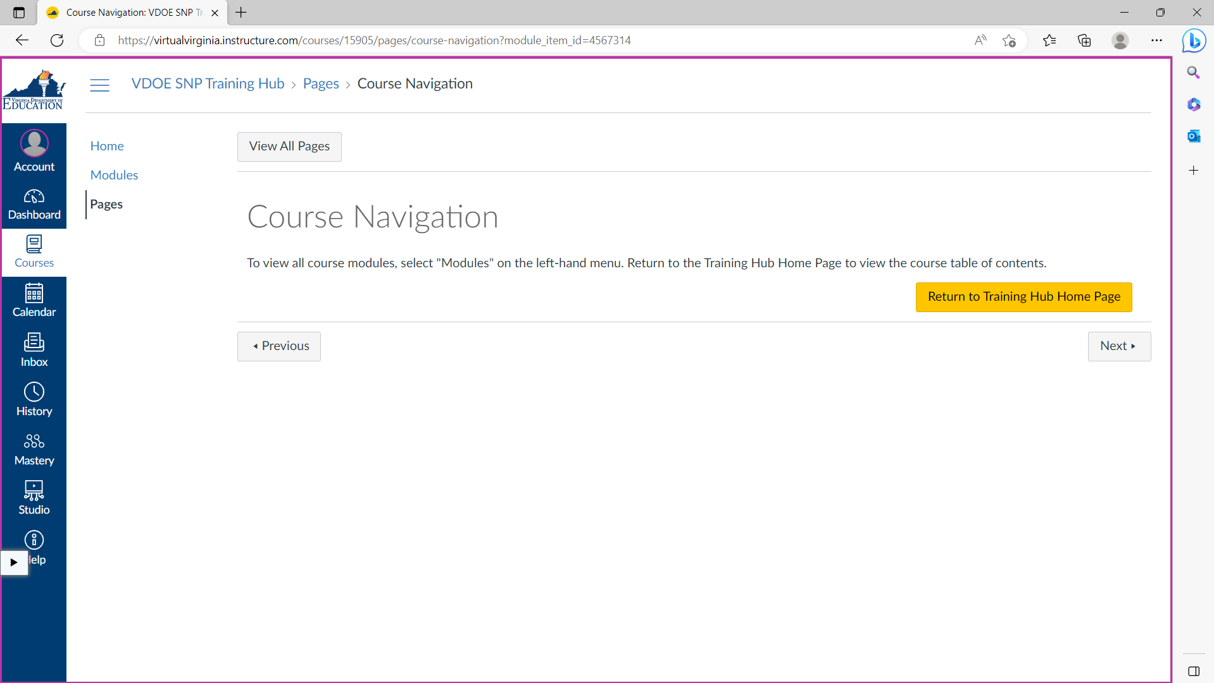
- On the Training Hub Home Page, you can now select the conference, workshop, or webinar recording you would like to view.
- You can also access these recordings by clicking on Modules in the lefthand panel.
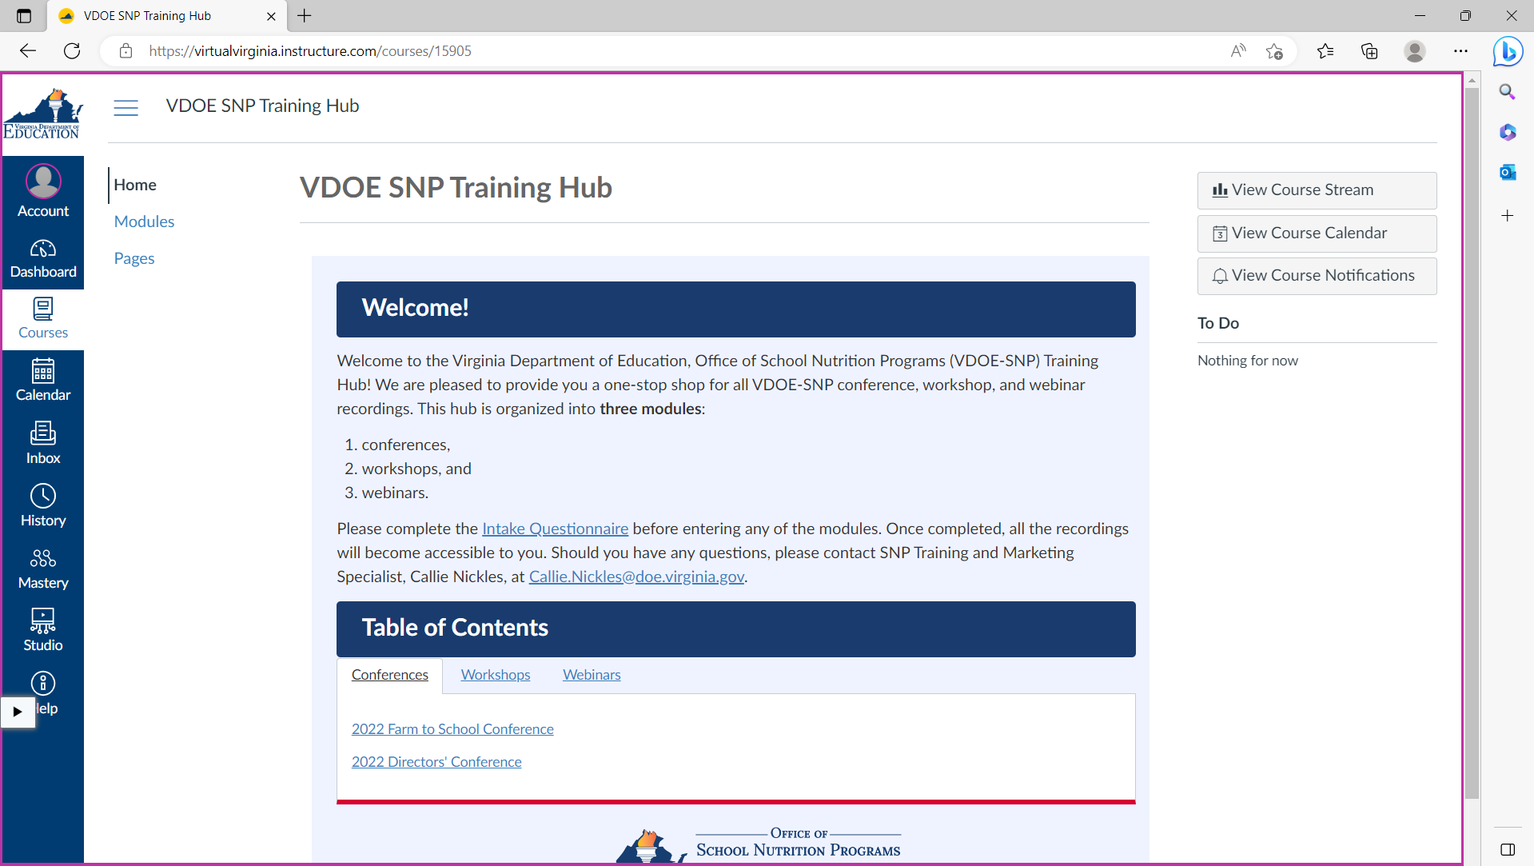
- Within the Modules page, you can navigate to the conference, workshop, or webinar recording you need to access.
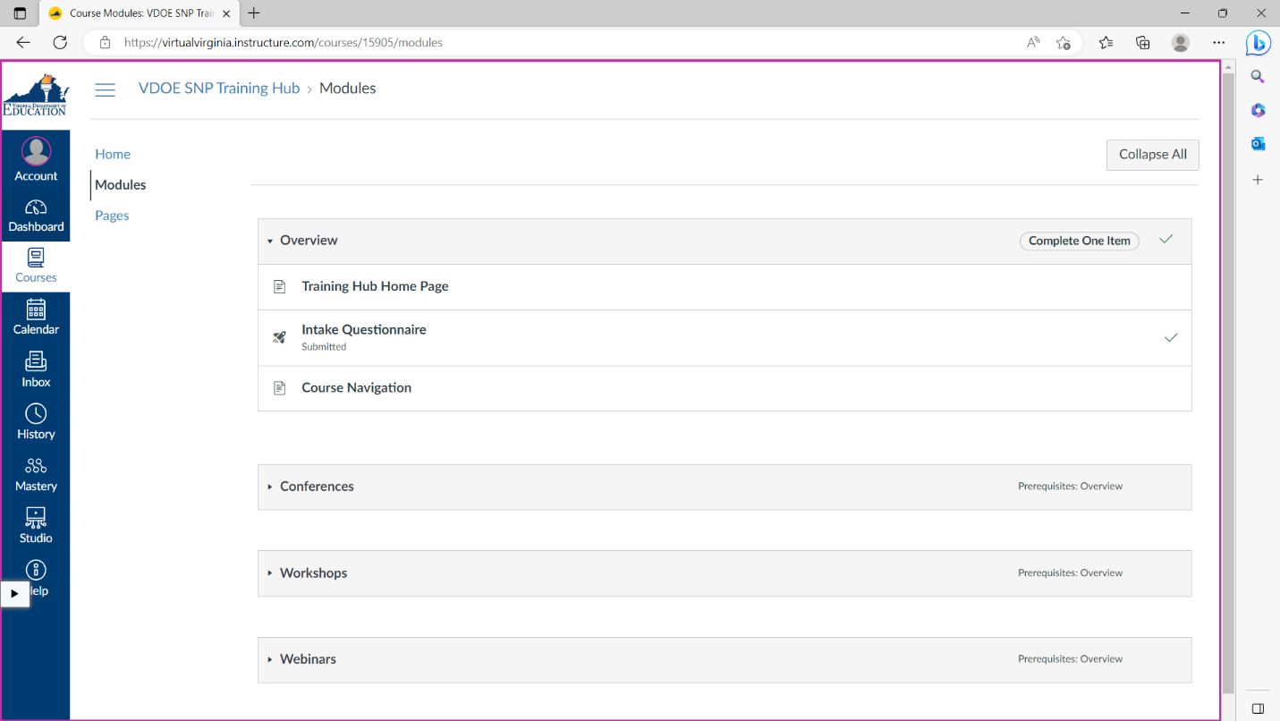
Should you have any questions about navigating Virtual Virginia for the VDOE SNP Training Hub, please contact Callie Nickles, SNP Training and Marketing Specialist, at Callie.Nickles@doe.virginia.gov.

