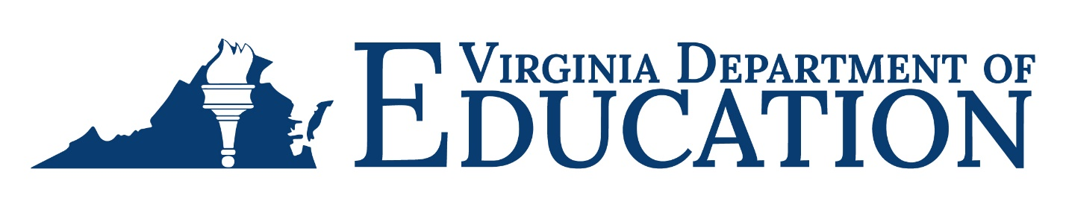

2023-2024 Adult Education Program Due Dates

Month | AEFLA/C&I/  IELCE | GAE | SLCA | Race to GED | PIVA
July
August
September
October | Quarterly Reimbursement,  Business Services,  Program Income, and Match Reports due 10/20/2023 | Quarterly Reimbursement,  Program Income Report due 10/20/2023 | Expenditure  Report or Quarterly Reimbursement due  10/20/2023
November
December
January | Quarterly Reimbursement,  Business Services,  Program Income, and Match Reports due 1/19/2024 | Quarterly Reimbursement,  Program Income Report due 1/19/2024 | Expenditure  Report or Quarterly Reimbursement due  1/19/2024
February |  |  |  | First  Reimbursement due 2/16/2024 | First Reimbursement due 2/16/2024
March
April | Quarterly Reimbursement,  Business Services,  Program Income, and Match Reports due 4/19/2024 | Quarterly Reimbursement,  Program Income Report due 4/19/2024 | Expenditure  Report or Quarterly Reimbursement due  4/19/2024
May |  | Final  Paper-based Reimbursement due 5/24/2024 | Final  Paper-based Reimbursement due 5/24/2024
June |  | Final OMEGA Reimbursement due 5/31/2024 |  | Final Reimbursement due 5/31/2024 | Final Reimbursement due 5/31/2024
July | Business Services,  Final Program Income, and Match Reports due 7/19/2024 | Final Program Income Report due 7/19/2024 | Final Expenditure Report due 7/19/2024
August | Final Reimbursement, One-Stop, and Career & Training Services Reports due 8/16/2024

