Guidance Documentation for Parentally-Placed Private School and Home-School Students Data Survey
2022-2023
Revised May 2023

Office of Special Education Data
Department of Special Education & Student Services
Division of School Quality, Instruction and Performance

Parentally-Placed Private School and Home-Schooled Students Data Process

General Information
Under the Individuals with Disabilities Education Act (IDEA) data collection requirement, Local Educational Agencies (LEAs) must gather and maintain data on children with disabilities enrolled by their parents in private schools and submit the data to the appropriate State Educational Agency (SEA). The LEAs must collect information per the requirements found in §300.132, provision of services for parentally-placed private school and Home Schooled children with disabilities. Collecting this data will provide valuable information regarding the extent and scope of the equitable services provision under IDEA and assist in ensuring that parentally placed children with disabilities are able to participate.

- The number of children evaluated;
- The number of children determined to be children with disabilities; and
- The number of children served.
- The number of eligible parentally placed students not currently receiving services.
The Virginia Department of Education (VDOE) is collecting this information. Collecting this data will provide valuable information regarding the extent and scope of the equitable services provision under IDEA and assist in ensuring that parentally placed children with disabilities are able to participate equitably in IDEA.

34 CFR 300.132 Provision of Services for Parentally-Placed Private School Child with Disabilities – Basic Requirement
(a) General. To the extent consistent with the number and location of children with disabilities who are enrolled by their parents in private, including religious, elementary schools and secondary schools located in the school district served by the LEA, provision is made for the participation of those children in the program assisted or carried out under Part B of the Act by providing them with special education and related services, including direct services determined in accordance with §300.137, unless the Secretary has arranged for services to those children under the by-pass provisions in §§300.190 through 300.198.
(b) Services plan for parentally-placed private school children with disabilities. In accordance with paragraph (a) of this section and §§300.137 through 300.139, a services plan must be developed and implemented for each private school child with a disability who has been designated by the LEA in which the private school is located to receive special education and related services under this part.
(c) Record keeping. Each LEA must maintain in its records, and provide to the SEA, the following information related to parentally-placed private school children covered under §§300.130 through 300.144:
(1) The number of children evaluated;
(2) The number of children determined to be children with disabilities; and
(3) The number of children served.
Note:
For the purposes of this survey, the term parentally-placed children means parentally-placed private school and home-schooled children.

Process for Completing the Parentally Placed and Home School Students Survey

Step 1
Navigate to the “Parentally-Placed” link found within the Special Ed December 1 Membership (December 1 Child Count) application via the Single Sign-on for Web Systems (SSWS) portal.
Note: This link will not be found on your main SSWS dashboard.
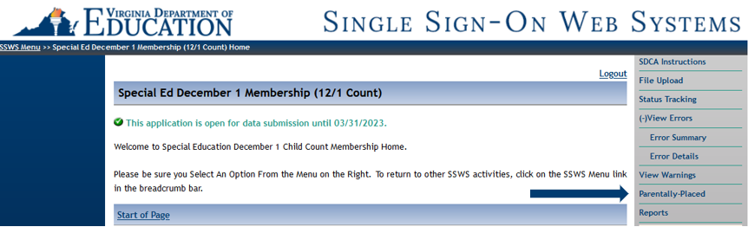

Step 2
Begin completing the survey questions.
Question 1:
- Enter the number of parentally-placed children that were evaluated in the preceding 12 months of the December 1 Child Count.
  - This includes students evaluated from December 2 of the previous school year through December 1 of the current school year.
  - This includes parentally-placed private school and home-schooled students
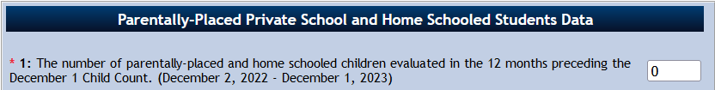

Question 2:
- Enter the number of parentally-placed children determined to be children with disabilities that were found eligible for special education in the preceding 12 months of the December 1 Child Count.
  - This includes students evaluated from December 2 of the previous school year through December 1 of the current school year.

Question 3:
- This number will be pre-populated based on information from the December 1 Child Count.
  - Make sure students are coded correctly using the Parentally-Placed Students Flag
Note:
- This number is also pre-populated into the Proportionate Set-Aside (Speced-PSA) application. Please reference Figure 7 of the Individuals with Disabilities Education Act (IDEA) proportionate Set-Aside Guidance Document.

Question 4:
- Enter the number of parentally-placed children determined to be children with disabilities that were found eligible for special education in the preceding 12 months of the December 1 Child Count.
  - This includes students evaluated from December 2 of the previous school year through December 1 of the current school year.

Step 3
Save information and Review Reports
- Once the survey is complete, select “Save” at the bottom of the Survey.
- Once the data has been saved, select “reports” from the right-hand menu in order to review your reports.
  - The Parentally-Placed data will be found in the report titled “Special Education Child Count Certification Report.”
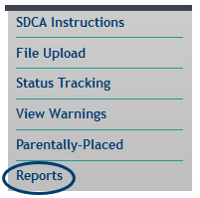

Step 4
Once the December 1 Child Count data has been submitted and the Parentally-Placed Survey has been completed, divisions will begin the review and verification process. Please refer to the Superintendent Data Collection Approval (SDCA) Instructions link located on the right hand menu of the December 1 Child Count application.

