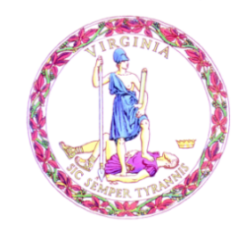

Commonwealth of Virginia

College Partnership Laboratory Schools Standing Committee Agenda

Date of Meeting: June 5, 2023 Time: 10:00 a.m.

Location: Board Room, 22nd Floor, James Monroe Building

10:00 a.m. STANDING COMMITTEE CONVENES

MOMENT OF SILENCE

PLEDGE OF ALLEGIANCE

APPROVAL OF THE AGENDA

APPROVAL OF MINUTES

Minutes from the April 2023 Meeting of the Standing Committee
PUBLIC COMMENT ON AGENDA ITEMS
ACTION/DISCUSSION ITEMS
- First Review of College Partnership Laboratory School Application from Southside Virginia Community College
- First Review of Revisions to the College Partnership Laboratory School Application
PRESENTATIONS & WRITTEN REPORTS
- Learning Pathways in Virginia: A Historical Perspective
- Update of May 3 Innovation Incubator
- Update on Approved College Partnership Laboratory School Planning Grants
DISCUSSION OF CURRENT ISSUES
PUBLIC COMMENT ON NON-AGENDA ITEMS

ADJOURNMENT

