Guidance Documentation for Completing the Coordinated Early Intervening Services Survey
(CEIS Survey)
2022-2023
Revised March 2023

Office of Special Education Data
Department of Special Education and Student Services
Division of School Quality, Instruction and Performance

Coordinated Early Intervening Services (CEIS) Survey Reporting Process

Background
The code of federal regulations (34 CFR §300.226 (d)) requires each Local Educational Agency (LEA) that implements CEIS to report to the state on the number of children who received CEIS and the number of those children who subsequently received special education and related services under Part B during the preceding two-year period (i.e., the two years after the child has received CEIS) (71 FR 46540, 46628 (Aug. 14, 2006)). States and LEAs must maintain these records for audit and monitoring purposes.

34 CFR 300.226 Early Intervening Services
(a) General. An LEA may not use more than 15 percent of the amount the LEA receives under Part B of the Act for any fiscal year, less any amount reduced by the LEA pursuant to §300.205, if any, in combination with other amounts (which may include amounts other than education funds), to develop and implement coordinated, early intervening services, which may include interagency financing structures, for students in kindergarten through grade 12 (with a particular emphasis on students in kindergarten through grade three) who are not currently identified as needing special education or related services, but who need additional academic and behavioral support to succeed in a general education environment. (Refer to Appendix D for examples of how §300.205(d), regarding local maintenance of effort, and §300.226(a) affect one another.)
(b) Activities. In implementing coordinated, early intervening services under this section, an LEA may carry out activities that include:
(1) Professional development (which may be provided by entities other than LEAs) for teachers and other school staff to enable such personnel to deliver scientifically based academic and behavioral interventions, including scientifically based literacy instruction, and, where appropriate, instruction on the use of adaptive and instructional software; and
(2) Providing educational and behavioral evaluations, services, and supports, including scientifically based literacy instruction.
(c) Construction. Nothing in this section shall be construed to either limit or create a right to FAPE under Part B of the Act or to delay appropriate evaluation of a child suspected of having a disability.
(d) Reporting. Each LEA that develops and maintains coordinated, early intervening services under this section must annually report to the SEA on:
(1) The number of children served under this section who received early intervening services; and
(2) The number of children served under this section who received early intervening services and subsequently receive special education and related services under Part B of the Act during the preceding two year period.
(e) Coordination with ESEA. Funds made available to carry out this section may be used to carry out coordinated, early intervening services aligned with activities funded by, and carried out under the ESEA if those funds are used to supplement, and not supplant, funds made available under the ESEA for the activities and services assisted under this section.

Additional Definitions
CEIS (Coordinated Early Intervening Services) Voluntary - LEA's can choose to use a portion of their IDEA Part B funds for services to a defined group of at-risk students.
CCEIS (Comprehensive Coordinated Early Intervening Services) Mandatory - LEA's identified as having significant disproportionality in identification, placement, and/or disciplinary removals must use IDEA Part B funds.

Process for Completing the CEIS Survey

Step 1
Navigate to the “Coordinated Early Intervening Services Survey (CEIS Survey)” application via the Single Sign-on for Web Systems (SSWS) portal.
Note: Your dashboard may be different from the example below.

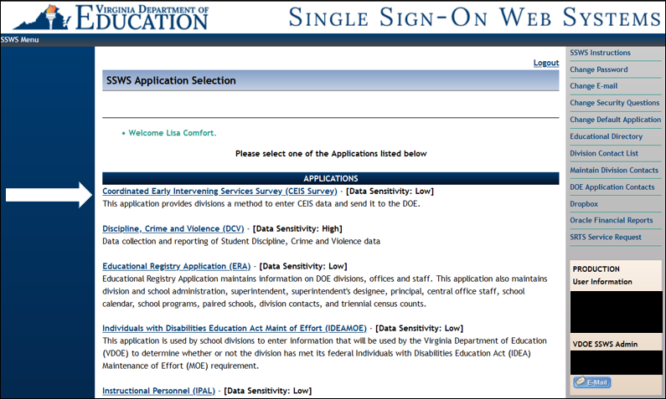

Step 2
After selecting the “Coordinated Early Intervening Services Survey (CEIS Survey)” link, the following screen will appear. Click the “Enter Survey” link.
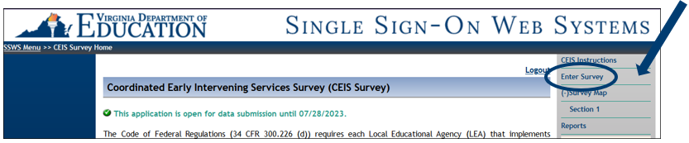

Step 3
Begin completing the survey questions.
Question 1:
- This flag will be prepopulated based on status. Please verify the information is correct.
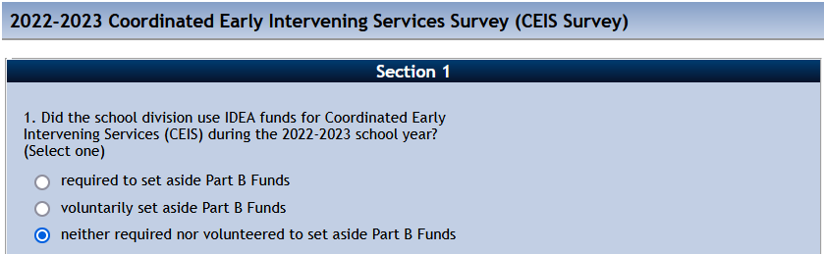

Question 2:
List the actual dollar amount spent on CEIS during the current school year.
- If divisions are required to or voluntarily set aside Part B Funds, enter the appropriate values.
  - Must be a whole number or valid dollar amount.
  - The only special character that is accepted is a period.
  - Will not accept a comma nor dollar sign.
- If divisions were neither required to nor voluntarily set aside Part B Funds, enter zero (0).

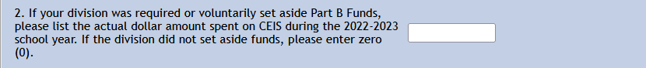
Question 3:
This is the total number of students served during the current school year.
- This is a prepopulated field derived from the Early Intervening Services Flag that is a data element in the End of Year Student Record Collection.
- Divisions are expected to verify this information. If incorrect, the divisions will work directly with the SRC contact within the division to have this information corrected.
- It is important that divisions track students throughout the school year.
- If divisions are not required to or voluntarily set aside funds, then a zero will prepopulate.

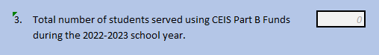

Question 4:
Of the students that were served using CEIS Funds, indicate the number of students that were found eligible for special education services.
- This question covers a three-year period.
- The numbers from previous years should match the data that was reported in previous years.
  - Use reports from previous years to assist with this
- If divisions were neither required to nor voluntarily set aside Part B Funds, enter zero (0).
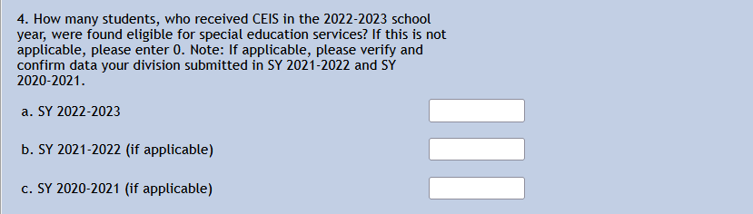
Question 5:
This question pertains to the upcoming school year. Divisions will need to indicate if funds are being voluntarily set aside for the following school year.
- If funds will be set aside for IDEA Part B Funds for the following school year, select “Yes” and enter a dollar amount.
  - The only special character that is acceptable is a period (.).
  - Do not use a comma (,) or dollar sign ($).
- If funds will not be set aside for IDEA Part B Funds for the following school year, select “No.” Move to Question 6.
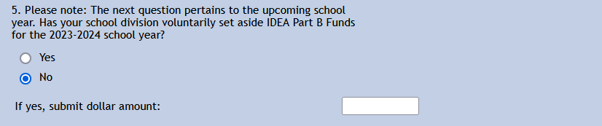

Question 6:
Enter a detailed description of each CEIS activity that was funded with the amount reserved for CEIS in the current school year. This includes, but is not limited to, things such as activities, programs, staff dollar amount spent, etc.
- If divisions are required to or voluntarily set aside Part B Funds, then a detailed explanation of each CEIS activity that was funded is required.
- If divisions were neither required to nor voluntarily set aside Part B Funds, enter “N/A.”
- Field cannot be blank.
- DO NOT indicate that this information was sent as a separate attachment. The attachment will not be accepted, and the division will be required to resubmit the CEIS Survey with the activity details included.
Note: Attachments will not be accepted. Please enter the information requested in the space provided under question 6.
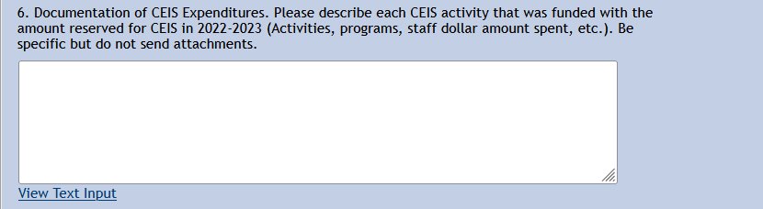

Step 4
Submit Report for Verification
- Once the survey is complete, select “reports” from the right-hand menu in order to review your reports.
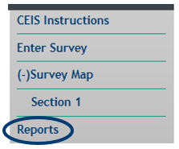
- Once reports have been reviewed and no additional changes are needed, select “Submit for Verification.”
- If errors are found, the following will appear at the top of the page with a list of errors below it.
  - Unable to Submit to DOE due to the following errors:

- If no errors are found, the following will appear at the top of the page and no additional changes will be able to be made.
  - This application is open for data submission until 07/28/2023. This division's data has been submitted and cannot be changed. It is waiting on superintendent verification.

Step 5
Report Verification and Signatures
- Once the data has been successfully submitted, the division’s Superintendent will receive an email indicating that the Coordinated Early Intervening Services Survey (CEIS Survey) data submission has been completed and is ready for review and approval.
- The Superintendent will then access the reports that need to be reviewed through the Superintendent Data Collection Approval (SDCA) from their SSWS dashboard.
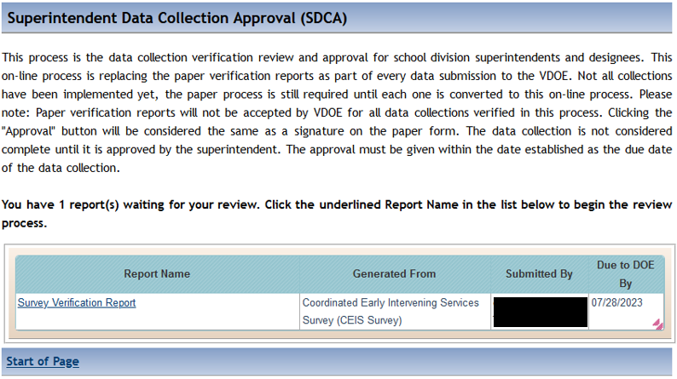
- Once the Superintendent clicks on the report name in the list, below is an example of what they will receive.
- At this time, they will review the information and then Approve or Disapprove the information.
  - If the report is disapproved, a Disapproval Comment will be required.
- Once the report has been approved or disapproved by the Superintendent, the Data Submitter will receive an email advising them of the outcome.

