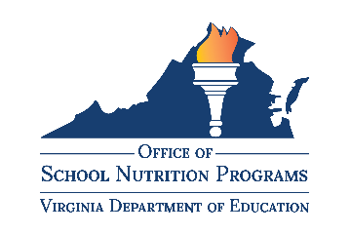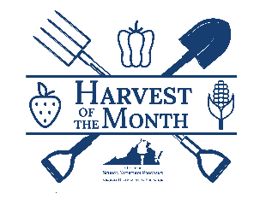

Harvest of the Month

Program Overview:
The Virginia Harvest of the Month program promotes seasonal eating, increased fruit and vegetable consumption, and supports local economies while providing ready-to-use materials for classrooms, cafeterias, nonprofits, farmers’ markets, and early care centers to educate children about the joys of eating seasonal, local foods.
The objective of the program is to increase consumption of seasonal, Virginia Grown fresh fruits and vegetables so children establish healthy eating habits to last a lifetime.

Harvest of the Month Featured Produce:
- January: Sweet Potatoes
- February: Butternut Squash
- March: Kale
- April: Lettuce
- May: Strawberries
- June: Cucumbers
- July: Zucchini
- August: Tomatoes
- September: Sweet Bell Peppers
- October: Apples
- November: Cabbage
- December: Spinach

Available Resources:
- Educational Posters
- Point of Service Signs
- Nutrition Education Lesson Plans
- For more information and to access resources, visit the Office of School Nutrition Programs Harvest of the Month webpage

