Summary Data
Students with Disabilities in Virginia
The Commonwealth serves students in several disabilities categories for students who range in age from 2-22. Students are identified for a disability through a multi-step process at the local division level. Once identified, a team of trained professionals work with families to develop an individualized education program (IEP)
There are currently 178,894 students with disabilities in Virginia (14%). This is in line with the national average. This year, there has been an increase in the number of students with disabilities, however, the number is less than 2019-2020.
Students with Disabilities in Virginia
Number of Students
School Year

The following chart outlines the number of students across the Commonwealth who have been identified in specific disability categories during the 2021-2022 academic year.
Disability Category
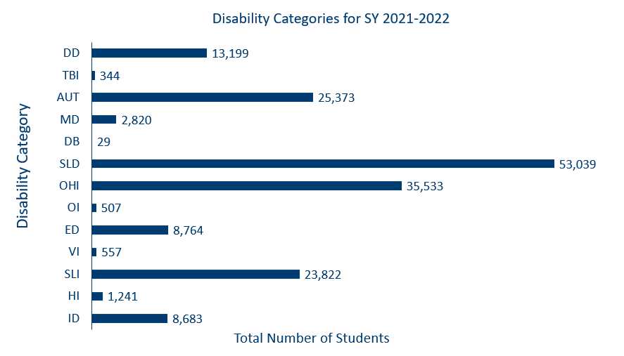
Disability categories noted above as well as the percentages of students per category for the 2021-2022 SY:
DD = Developmental Disability 7%
TBI = Traumatic Brain Injury Less than 1%
AUT= Autism 14%
MD = Multiple Disabilities 2%
DB = Deaf Blindness Less than 1%
SLD = Specific Learning Disabilities 30%
OHI = Other Health Impairments 20%
OI = Orthopedic Impairment Less than 1%
ED = Emotional Disability 5%
VI = Visual Impairments including Blindness Less than 1%
SLI = Speech Language Impairment 13%
HI = Hearing Impairments including Deafness 1%
ID = Intellectual Disabilities 5%
Local school divisions are responsible for providing a free and appropriate public education to children with disabilities from an early age through early adulthood (ages 2-22). As shown, the majority of students with disabilities receiving services with an individualized education program (IEP) are in preschool through grade 12.
Students with Disabilities by Age
