Agenda Item: H

Date: April 20, 2023

Title: Final Review of a Adoption of Special Provision to Suspend the Use of the Chronic Absenteeism Indicator for the Determination of Accreditation Status in Accreditation Year 2023-2024

Presenters: Ms. Amy Siepka, Director of Accountability
Ms. Rebecca Hall, Standards of Accreditation Coordinator

Ms. Shelley Loving-Ryder, Assistant Superintendent of Student Assessment, Accountability and ESEA Programs

Email: Amy.Siepka@doe.virginia.gov Phone: (804) 225-2102

Purpose of Presentation:
Action required by state or federal law or regulation

Executive Summary:
Chronic absenteeism is one of nine indicators in Virginia’s School Accreditation Model. Based in part on the relationship between school attendance and student achievement, chronic absenteeism was selected as a measure of student engagement in the 2017 revision to the Regulations Establishing Standards for Accrediting Public Schools in Virginia (SOA). Chronically absent students are defined as those who are absent 10% or more of their enrolled school days, typically 18 or more days. The performance level a school earns on the chronic absenteeism indicator is used in conjunction with the performance levels of the other indicators to determine a school’s accreditation status.

Due to the lingering impacts created by the COVID-19 pandemic, school division leaders continue to report increased absences despite the programs and procedures put in place to address chronic absenteeism. During the 2022-2023 school year, absences were exacerbated by contagious illnesses that were endemic during the same time period: COVID-19, respiratory syncytial virus (RSV) and the flu. Section 22.1-272 of the Code of Virginia indicates that students are not expected to attend school while contagious. Anecdotal accounts also suggest student mental health may negatively affect student attendance post-pandemic.

In April 2022, the Board adopted special provisions to suspend the use of the chronic absenteeism indicator for the determination of accreditation status in accreditation year 2022-2023 when there was a similar concern expressed by school divisions. At the time, a large number of absences caused by COVID-19, along with the quarantine and isolation practices that were in place during the 2021-2022 school year, suggested that the chronic absenteeism indicator may not have been an accurate reflection of the practices and programs in place to address attendance issues. For transparency, the performance level and the chronic absenteeism rate were still reported publicly.

In November 2022, the Board adopted special provisions to exclude the 2021-2022 school year data from being used in subsequent accreditation year calculations (i.e., the 2021-2022 school year data would not be used to demonstrate improvement, nor would it be used in the three-year rate). The result of the November review is that the performance levels for the 2023-2024 and 2024-2025 accreditation years are to be determined as shown in the following table:

 | Accreditation Year  2023-2024 | Accreditation Year  2024-2025
Level One | The performance level is determined using the current year rate. | The performance level is determined by using the best of the current or cumulative three-year rate* or, by using the current year rate if it is in the Level Two range, and the school demonstrated at least a 10% improvement in the chronic absenteeism rate from the previous year.
Level Two | The performance level is determined using the current year rate | The performance level is determined by using the best of the current or cumulative three-year rate* or, by using the current year rate if it is in the Level Three range, and the school demonstrated at least a 10% improvement in the chronic absenteeism rate from the previous year.
Level Three | The performance level is determined using the current year rate | The performance level is determined by using the best of the current or cumulative three-year rate* or, if the school has been a Level Two or Level Three through our consecutive years.
*Indicates the rate will be calculated with data from the 2022-2023 and 2023-2024 school years.

Because of the continued number of absences that school division leaders are reporting due to illness, the Board is again being asked to consider the adoption of special provisions (8VAC20-131-380 F 3) to suspend the chronic absenteeism indicator from the determination of school accreditation status for accreditation year 2023-2024 (based on 2022-2023 school year data). The proposal does not request that chronic absenteeism be removed from the accreditation model, as the other components and requirements in the SOA still apply to the chronic absenteeism indicator.
- All indicators, including chronic absenteeism, will have a rate and performance level calculated and reported on the School Quality Profiles for the school and division.
- The requirements of 8VAC20-131-400. Application of the school quality indicator performance levels to actions applies to all indicators, including the chronic absenteeism indicator.
  - If a school quality indicator is at Level Two, the school and its school division shall have primary responsibility to revise and implement its multi-year school improvement plan.
In developing such plan, the school and its school division shall determine the issues and conditions that are likely contributing to the school's performance on the indicator and plan and implement essential actions and research-based strategies designed to improve performance on the indicator to achieve the Level One standard.
  - If any school quality indicator is at Level Three, the school and school division shall work cooperatively and in consultation with the department to develop a corrective action plan, which shall be incorporated as a component of the school's comprehensive, unified, long-range plan.
In developing such plan, the school and school division, in consultation with the department, shall determine the issues and conditions that are likely contributing to the school's performance on the indicator and plan and implement essential actions and research-based strategies to achieve improvement to the Level One standard.

All schools with indicators at Level Three must undergo an academic or other review, as appropriate, conducted by the department, or under its guidance, to further identify required actions to improve student achievement and the school quality indicators that are at Level Three.

The proposal to suspend the use of the chronic absenteeism indicator from the determination of accreditation status does request that the accreditation status of a school will be determined using the performance levels of all indicators except chronic absenteeism.
- In the current accreditation system, if at least one indicator is a Level Three, the school is Accredited with Conditions.
- Suspending the use of the chronic absenteeism indicator results in a school being Accredited if the only indicator with a Level Three is chronic absenteeism.
Should the Board adopt the current proposal to suspend the use of the chronic absenteeism indicator in accreditation determination for the 2023-2024 accreditation year, the Board may need to pursue additional action at a later board meeting to determine how 2022-2023 school year data will be used in accountability years 2024-2025 and 2025-2026. This will be dependent upon what changes are made to the accreditation system in Phase I of the accountability transformation process.

In the background information section of this document, chronic absenteeism data requested by the Board at first review is displayed. It should be noted that chronic absenteeism data pre- and –post-pandemic is so different that the Board should consider whether the post-pandemic data is an accurate representation of the school’s efforts to engage students in school, as it was when first implemented in the accreditation model, given the varied influences the pandemic has had on students and families.

Action Requested:
- Approval of the proposal.

Superintendent’s Recommendation
The Superintendent of Public Instruction recommends that the Board of Education approve the proposal to adopt special provisions for accreditation year 2023-2024 to temporarily suspend the use of the chronic absenteeism indicator for the determination of accreditation status.

Previous Review or Action:
- First review
March 23, 2023

Background Information and Statutory Authority:
The Virginia Department of Education is requesting that the Board adopt special provisions related to chronic absenteeism as authorized in 8VAC20-131-380 F 3:

The board may adopt special provisions related to the measurement and use of a school quality indicator as prescribed by the board. The board may also alter the inclusions and exclusions from the performance level calculations by providing adequate notice to local school boards.

Chronic Absenteeism in the Accreditation Model
Chronic absenteeism is one of nine indicators in Virginia’s School Accreditation Model (8VAC20-131-380). Based on the relationship between school attendance and student achievement, chronic absenteeism was selected as a measure of student engagement in the 2017 revision to the SOA. Chronically absent students are defined as those who are absent 10% or more of their enrolled school days. The performance level a school earns on the chronic absenteeism indicator is used in conjunction with the performance levels of the other indicators to determine a school’s accreditation status.

Schools earn a Performance Level for each of the indicators:
- Level One: Indicator rate meets or exceeds state benchmark or shows sufficient improvement from the previous year.
- Level Two: Indicator rate is near the state standard or shows sufficient improvement from the previous year.
- Level Three: Indicator rate is below standard and does not meet the criteria for Level One or Level Two.

The combination of performance levels determines a school’s Accreditation status. If all indicators are Level One or Level Two, then the school is Accredited. If one or more indicators are a Level Three, then the school is Accredited with Conditions. A school that fails to adopt or fully implement required corrective actions to address Level Three school-quality indicators will receive a status of Accreditation Denied.

For Chronic Absenteeism, the performance levels are described as:
- Level One: Current or cumulative three-year chronic absenteeism rate is 15% or lower or Current year rate is in Level Two range and decreased chronic absenteeism rate by 10% (R10) from previous year.
- Level Two: Current year or cumulative three-year rate is greater than 15% but less than or equal to 25% or Current year rate within level three range decreased chronic absenteeism rate by 10% (R10) from previous year.
- Level Three: Current year or cumulative three-year rate is more than 25% or Current year rate has stayed at a Level Two or three through four consecutive years. (Level Three - 4 Years Rating).

The Chronic Absenteeism rate, used to determine a performance level, is calculated by dividing the number of students who are absent 10% or more days by all students whose end-of-year membership is greater than or equal to 50%. Excused and unexcused absences are counted in the rate.

Previous Board Items Pertaining to Chronic Absenteeism
In April 2022, the Board adopted special provisions to suspend the use of the chronic absenteeism indicator for the determination of accreditation status in accreditation year 2022-2023 due to the impact of COVID-19 on attendance. At the time, a large number of absences caused by COVID-19, along with the quarantine and isolation practices that were in place during the 2021-2022 school year, suggested that the chronic absenteeism indicator may not have necessarily been an accurate reflection of the practices and programs in place to proactively address attendance issues. For transparency, the performance level and the chronic absenteeism rate were still reported publicly.

In November 2022 the Board adopted special provisions to exclude the 2021-2022 school year data from being used in subsequent accreditation year calculations (i.e., the 2021-2022 school year data would not be used to demonstrate improvement, nor would it be used in the three-year rate.) The result of the November review is that the performance levels for the 2023-2024 and 2024-2025 accreditation years are to be determined as shown in the following table:

 | Accreditation Year  2023-2024 | Accreditation Year  2024-2025
Level One | The performance level is determined using the current year rate. | The performance level is determined by using the best of the current or cumulative three-year rate* or, by using the current year rate if it is in the Level Two range, and the school demonstrated at least a 10% improvement in the chronic absenteeism rate from the previous year.
Level Two | The performance level is determined using the current year rate | The performance level is determined by using the best of the current or cumulative three-year rate* or, by using the current year rate if it is in the Level Three range, and the school demonstrated at least a 10% improvement in the chronic absenteeism rate from the previous year.
Level Three | The performance level is determined using the current year rate | The performance level is determined by using the best of the current or cumulative three-year rate* or, if the school has been a Level Two or Level Three through our consecutive years.
*Indicates the rate will be calculated with data from the 2022-2023 and 2023-2024 school years.

Professional Learning Opportunities and Division Efforts to Address Chronic Absenteeism
School divisions have been actively participating in the professional learning opportunities and support provided by the Department to address chronic absenteeism post-pandemic.
- To assist school divisions, the Office of School Quality, in conjunction with the Office of Student Services, began a year-long collaborative learning cohort for principals and members of their attendance team to engage in a three-part E-learning series facilitated by Attendance Works. Following the E-learning series, principals and attendance team members participated in an in-person session, with follow-up support webinars scheduled for later in the school year. School leaders of schools that have a Level Two or Three performance rating in chronic absenteeism were invited to join the cohort. The first cohort reached capacity at 200 school principals and attendance team members. Due to the overwhelming response, an additional cohort began in January. The second cohort includes an additional 200 school principals and attendance team members who participated in the three-part E-Learning series facilitated by Attendance Works along with follow-up support webinars.
- The Department held a one-hour attendance overview webinar on February 2, 2023, as part of the Office of School Quality monthly “Quick Take” webinars. Approximately 250 school and division leaders attended.
- The Office of School Quality and Office of Student Services collaborated to design a Canvas course titled, Virginia’s One-Stop for Improving Attendance that contains curated resources on improving attendance. Currently there are 300 school and division leaders enrolled in the course.
- School divisions and families also have access to the ENGAGE Virginia program offered by Graduation Alliance, an education services provider specializing in providing student outreach and support services to students who are struggling with chronic absenteeism or are academically at risk.
    - Participating students and families are assigned an academic success coach to help them navigate the program and access online and in-person services, including academic resources, referrals for community services, 24/7 academic tutoring, homework assistance, motivational coaching, study and time-management skills coaching, test preparation, and feedback on resumes and cover letters.
    - Engage Virginia services are available to students, families, and schools at no cost through a partnership between the Department and Graduation Alliance. The 2022 General Assembly appropriated $3.5 million for the Department to create an online program to help school divisions provide support and coaching for disengaged, chronically absent and struggling students, and the Department contracted with Graduation Alliance to provide support for up to 18,500 students statewide.
    - School divisions who opt to participate in the program will be able to refer eligible students and parents in non-participating divisions may enroll their children by registering directly on the Engage Virginia website.
Chronic Absenteeism Data Analysis
At first review, the Board asked for information regarding historical chronic absenteeism data. Below are various representations of the data. It should be noted that chronic absenteeism data pre- and –post-pandemic is so different that the Board should consider whether the current data is an accurate representation of the school’s efforts to engage students in school, as it was when first implemented in the accreditation model, given the varied influences the pandemic has had on students and families.

Data Notes:
- The accreditation model based on the 2017 SOA was first implemented using
2017-2018 school year (SY) data.
- In school year 2020-2021, divisions used locally defined definitions of “meaningful engagement” to determine whether a student was counted as present.

Historical State Chronic Absenteeism Rates by Range

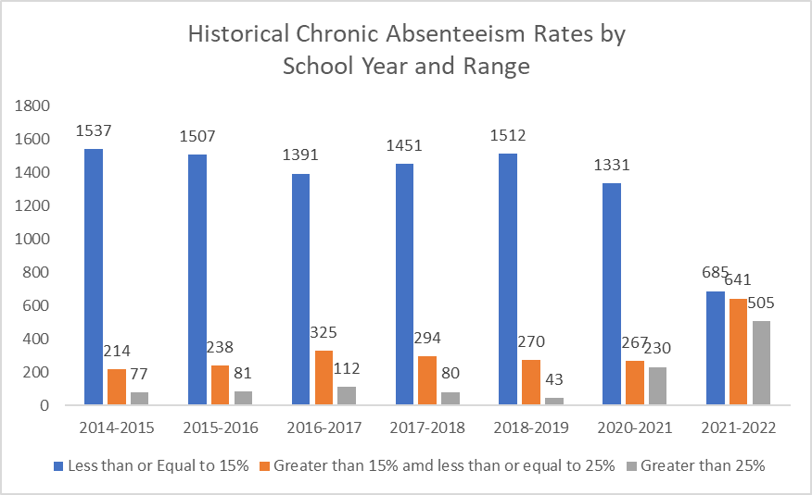

Historical State Chronic Absenteeism Rates by Student Groups

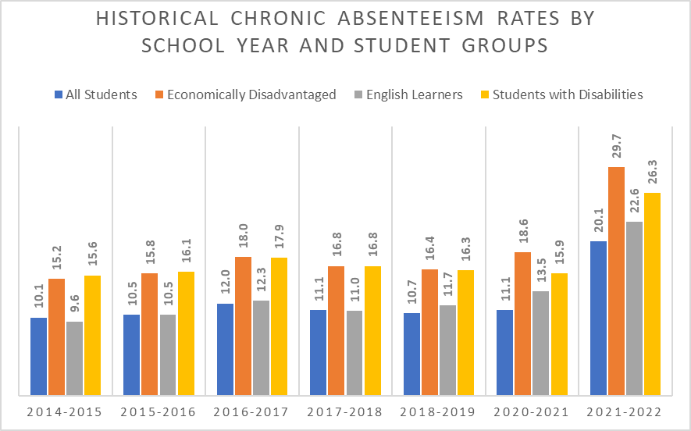

Distribution of Chronic Absenteeism Rates of Schools

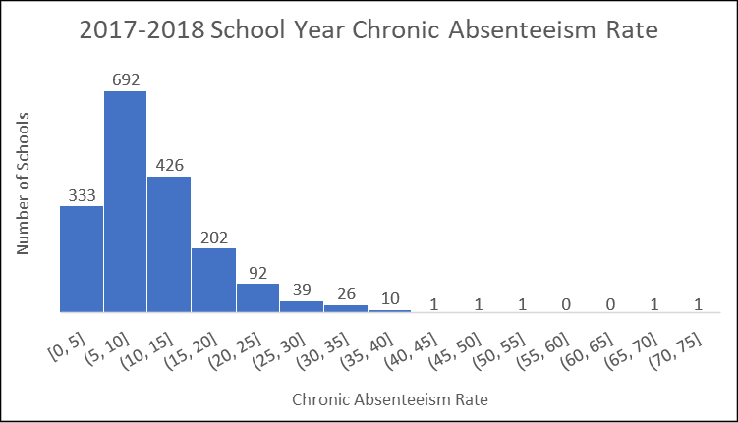

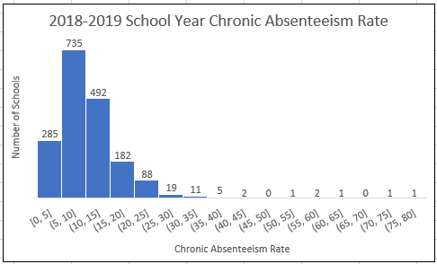

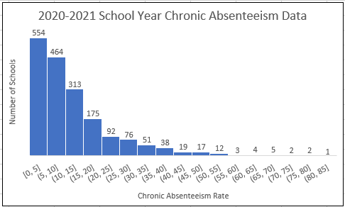

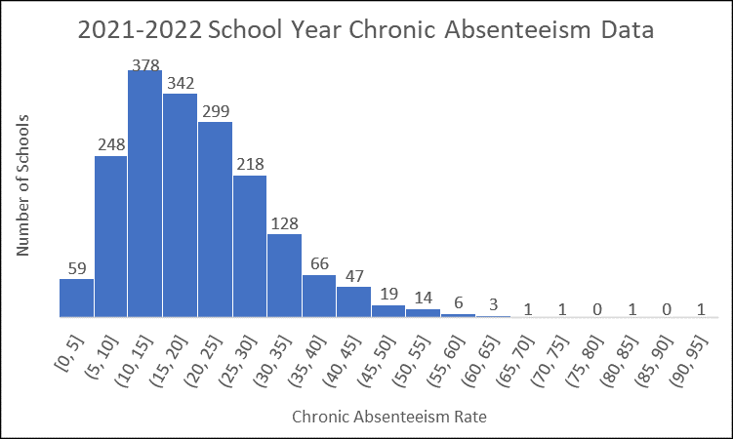

​ | 2017-2018​ | 2018-2019​ | 2020-2021​ | 2021-2022​
Mean​ | 10.69 | 10.43​ | 12.15​ | 19.99
Median​ | 8.96​ | 9.18 | 8.69​ | 18.19​

Mean: sum of the values of the data set divided by the number of values in the data set
Median: half of the values in the data set are above the value and half of the values in the data set are below the value

Impact on Fiscal and Human Resources:
There is no impact of the action on the VDOE’s resources (fiscal or human), nor on the resources of local school divisions.

