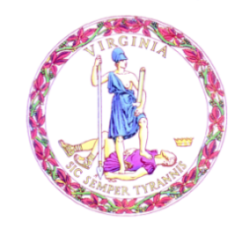

Commonwealth of Virginia

College Partnership Laboratory Schools Standing Committee Agenda

Date of Meeting: April 12, 2023 Time: 10:00 a.m.

Location: Board Room, 22nd Floor, James Monroe Building

10:00 a.m. STANDING COMMITTEE CONVENES

MOMENT OF SILENCE

PLEDGE OF ALLEGIANCE

APPROVAL OF THE AGENDA

APPROVAL OF MINUTES

Minutes from the March 8, 2023, Meeting of the Standing Committee
PUBLIC COMMENT ON AGENDA ITEMS
ACTION/DISCUSSION ITEMS
- Final Review of the College Partnership Laboratory Committee Application Process
- Update on Lab School Applications
- Preview of Revisions to the Lab School Application
- Other related documents pending update and revisions by VDOE; including:
  - Final Review of the College Partnership Laboratory School Evaluation Rubric (Attachment A)
  - Final Review of College Partnership Laboratory School Template Board Report (Attachment B)
  - First Review of VDOE Lab School Application Technical Review Process Flowchart (Attachment C)
  - First Review of VDOE Lab School Application Technical Review Process (Attachment D)
  - First Review of VDOE Lab School Application Technical Review for Completeness (Attachment E)
PRESENTATIONS & WRITTEN REPORTS
- Update on Approved College Partnership Laboratory School Planning Grants
DISCUSSION OF CURRENT ISSUES
PUBLIC COMMENT ON NON-AGENDA ITEMS

ADJOURNMENT

