Career and Technical Education Financial Report (CTEFR)

General Information

The state provides financial assistance to the school divisions and regional technical centers to support the operation, improvement, and expansion of career and technical education (CTE)
(Ref: 8VAC20-120-30). The state financial assistance provided through categorical entitlements shall be used to support the following:

- principals and assistant principals of technical education centers if at least 50 percent of their time is spent in career and technical education program administration or supervision;
- extended contracts of instructors for activities related to the coordination, development, or improvement of career and technical education programs; and
- adult occupational career and technical education programs to provide opportunities for adults to prepare for initial employment, retraining, or career advancement.

The data collected in the Career and Technical Education Financial Report (CTEFR) for school year (SY) 2021-2022 will be used to calculate the school divisions’ and regional technical centers’ fiscal year 2023 state categorical entitlements for career and technical occupational preparation and adult education programs.

The CTEFR for school year 2021-2022 will be collected through the Virginia Department of Education (VDOE) Single Sign-On for Web Systems (SSWS) data report entry application. The CTEFR data entry must be completed and submitted to VDOE through the SSWS. If you do not have access to the CTEFR web-based application, the CTE administrator or designee will need to request access from their division SSWS Account Manager.

The CTEFR web-based application will be open and accessible through the SSWS on March 31, 2023.

The CTEFR will collect the additional occupational adult education data by CTE program areas for the number of classes, the enrollment, and the number of full-time and part-time teachers.
The CTEFR data entry must be completed and submitted to DOE through SSWS.
After completing the CTEFR data entry, the division superintendent or an authorized designee must verify the report’s accuracy and approve the report electronically in the web-based application. After approval, reports are sent to VDOE. Reports must be submitted to VDOE by April 28, 2023.
If you have questions, please contact Office of Career, Technical, and Adult Education, at cte@doe.virginia.gov or by telephone at (804) 225-3349.

Instructions for CTEFR Data Completion

Collect the Data Required for the CTEFR
Collect the data for the following Items:
- State and local funds salary expenditures by category (Extended Contracts, CTE Center Principals and Assistant Principals, and Specialty CTE Center Principals and Assistant Principals) for SY 2021-2022 career and technical occupational preparation education programs.
- Local funds expenditures for SY 2021-2022 career and technical occupational adult education programs.
- Number of career and technical occupational adult education program classes, enrollment, and full-time and part-time teachers by CTE program areas.

Only salary expenditures are to be reported for the categories listed. Expenditures cannot include any fringe benefits costs.

Local CTE Administrators must check and verify the data for the CTEFR before starting and entering the data into the SSWS CTEFR application and submission to VDOE.

- Regional technical centers are required to enter into the CTEFR the individual financial data for each school division that participates in the regional technical center.
- If the regional technical center provides occupational adult education programs, the required additional data for the number of career and technical adult occupational education program classes, enrollment, and full-time and part-time teachers by CTE program areas need to be reported only on the first school division’s CTEFR.

The SSWS will immediately process the CTEFR data and generate error reports as necessary. All corrections must be made through SSWS.

Log in to SSWS and CTEFR Application Selection
- Log in to the SSWS at Link: https://p1pe.doe.virginia.gov/ssws/login.page.do.
- SELECT “CTE Financial Report (CTEFR)” from the list of available applications.

Please select one of the Applications listed below
APPLICATIONS
CTE Financial Report (CTEFR) - Online system to collect and report annual data related to state financial assistance provided for CTE Occupational Preparation and Adult Education Programs.

CTEFR Data Entry
You will see a menu on the upper right side of the screen with the following items listed:

- Enter Data
- Administration
- Reports

- SELECT “Enter Data” from the menu list on the upper right side of the screen.
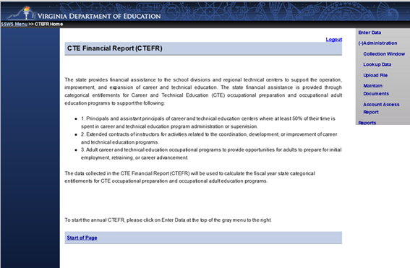

Career and Technical Occupational Preparation and Adult Education Programs Selection

- SELECT Yes or No from the radio buttons to answer the questions concerning if the school division/regional technical center operated a local program for occupational preparation or occupational adult education for school year 2021-2022.
- If “Yes” is selected for the question “Did the school division/regional technical center operate a local program for occupational preparation for school year 2021-2022?” then data entry will be required for Occupational Prep programs’ expenditures.
- If “Yes” is selected for the question “Did the school division/regional technical center operate a local program for adult education programs for school year 2021-2022?” then data entry will be required for Adult Education programs’ expenditures and Headcount.
- SELECT “No” to both questions if the school division/regional technical center did not operate any local program(s) for occupational preparation and adult education programs for school year 2021-2022, then you will be directed to the “Submit to DOE” screen and to complete the verification form.
- After you have selected “Yes” or “No” to answer the questions concerning if the school division/regional technical center operated a local program for occupational preparation or adult education for school year 2021-2022, SELECT the “Save & Next ->” button to proceed to the next screen.

Career and Technical Occupational Preparation Programs Data Entry

If “Yes” was selected for the question “Did the school division/regional technical center operate a local program for occupational preparation for school year 2021-2022?” then the following data entries are required for Occupational Prep programs expenditures:

- State funds salary expenditures by category (Extended Contracts, CTE Center Principals and Assistant Principals, and Specialty CTE Center Principals and Assistant Principals).
- Local funds salary expenditures by category (Extended Contracts, CTE Center Principals and Assistant Principals, and Specialty CTE Center Principals and Assistant Principals).

Report only salary expenditures in the categories listed. Expenditures cannot include any fringe benefits costs.

The Occupational Preparation Programs data entry screen is populated with the following data fields:

- School Year 2021-2022 State Funds Payment for Occupational Prep - Dollar figure shown is the Occupational Preparation payment provided in Supt’s Memo No. 131-22, dated
June 24, 2022, to the school division/regional technical center from the previous school year’s CTEFR reported local expenditures for Occupational Preparation programs.
- School Year 2020-2021 CTE Financial Report: Local Funds Spent for Occupational Prep Programs - Dollar figure shown is the total amount of Local Funds reported spent by the school division/regional technical center in the previous school year’s CTEFR for Occupational Preparation programs.

- Under the State Funds column, enter the salary expenditures distribution by category (Extended Contracts, CTE Center Principals and Assistant Principals, and Specialty CTE Center Principals and Assistant Principals) for SY 2021-2022 career and technical occupational preparation education programs. Enter only a WHOLE dollar figure (rounded to the nearest dollar) without any commas, decimals, or cents (i.e., 1200, not 1,200.25).
- Under the Local Funds column, enter the additional local funds salary expenditures by category (Extended Contracts, CTE Center Principals and Assistant Principals, and Specialty CTE Center Principals and Assistant Principals) for SY 2021-2022 career and technical occupational preparation education programs. Enter only a WHOLE dollar figure (rounded to the nearest dollar) without any commas, decimals, or cents (i.e., 1200, not 1,200.25).
- Expenditure data can only be entered into the open block cells populated with zeros.
- Report ONLY the salary expenditures in the categories listed. Do not include any Fringe benefits costs in the reported amounts.

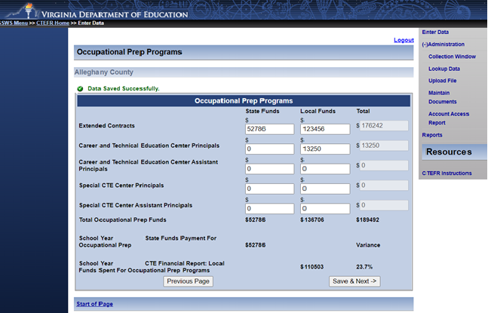

Total Occupational Prep Funds – State Funds amount under the State Funds column must EQUAL the School Year 2021-2022 State Funds Payment for Occupational Prep - Dollar figure for the Occupational Preparation payment provided in Supt’s Memo No. 131-22, dated June 24, 2022, to the school division/regional technical center.

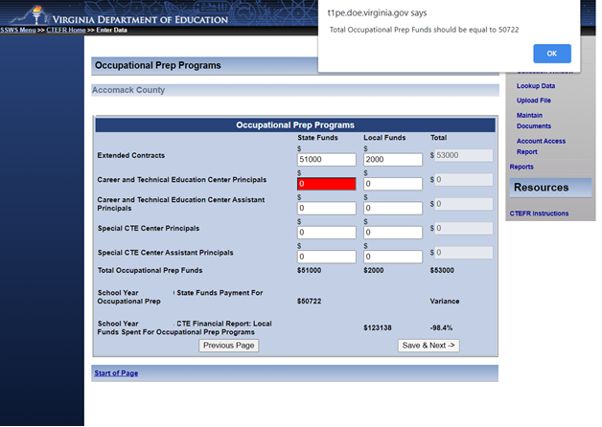
Each data entry block must have either a zero (0) or a dollar expenditure amount. If you remove the zero (0) entry, the cell block will turn RED and an error message will be displayed.
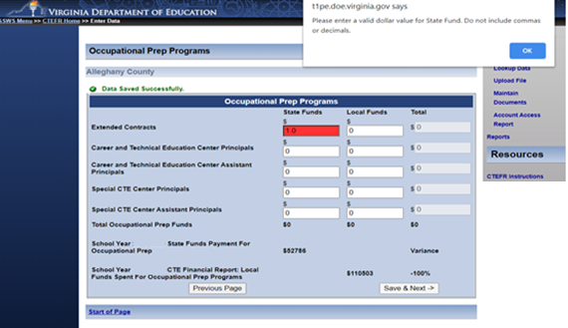
Total Occupational Prep Funds – Local Funds amount under the Local Funds column is compared with the School Year 2020-2021 CTE Financial Report: Local Funds Spent for Occupational Prep Programs amount reported spent by the school division/regional technical center in the previous school year’s CTEFR for Occupational Preparation programs.

Variance percentage displays the difference if the reported local expenditures from the data reported in previous school year’s CTEFR for Occupational Preparation programs.

- If the Variance exceeds 10 percent, you will be prompted to recheck your data entries.

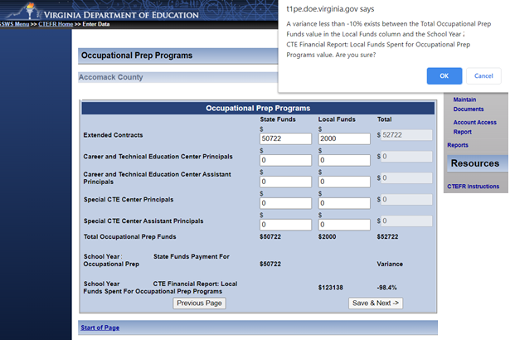

School division/regional technical center’s Fiscal Year 2023 entitlements for Occupational Preparation programs are based on the amounts reported for Local Funds additional salary expenditures by category (Extended Contracts, CTE Center Principals and Assistant Principals, and Specialty CTE Center Principals and Assistant Principals) for SY 2021-2022 career and technical Occupational Preparation programs.

- When the Occupational Preparation program expenditure amounts for State and Local funds have been entered for each category (Extended Contracts, CTE Center Principals and Assistant Principals, and Specialty CTE Center Principals and Assistant Principals) for SY 2021-2022 career and technical Occupational Preparation programs have been entered and checked, SELECT the “Save & Next ->” button.

Career and Technical Occupational Adult Education Programs Data Entry

If “Yes” was selected for the question “Did the school division/regional technical center operate a local program for adult education for school year 2021-2022?” then the following data entries are required for Occupational Adult Education programs expenditures:

- Local funds expenditures for SY 2021-2022 career and technical occupational adult education programs to provide opportunities for adults to prepare for initial employment, retraining, or career advancement.
- The number of career and technical occupational adult education program classes, enrollment, and full-time and part-time teachers by CTE program areas.

Report only the full-time and part-time teacher salaries or salary supplement expenditures in the categories listed. Expenditures cannot include any fringe benefits costs.

The Occupational Adult Education Programs data entry screen is populated with the following data fields:

- School Year 2021-2022 State Funds Payment for Adult Occupational - Dollar figure shown is the Adult Education payment provided in Supt’s Memo No. 131-22, dated June 24, 2022, to the school division/regional technical center from the previous school year’s CTEFR reported local expenditures for Occupational Adult Education programs.
- School Year 2020-2021 CTE Financial Report: Local Funds Spent for Adult Education Occupational Programs - Dollar figure shown is the total amount of Local Funds reported spent by the school division/regional technical center in the previous school year’s CTEFR for Occupational Adult Education programs.

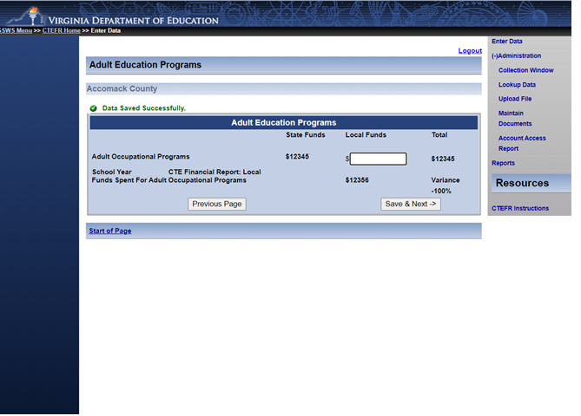
- Under the Local Funds column, enter the additional local funds expenditures for SY 2021-2022 career and technical adult occupational education programs to provide opportunities for adults to prepare for initial employment, retraining, or career advancement. Enter only a WHOLE dollar figure (rounded to the nearest dollar) without any commas, decimals, or cents (i.e., 1200, not 1,200.25).
- Expenditure data can only be entered into the open block cell populated with a zero.

Report only the full-time and part-time teacher salaries or salary supplement expenditures in the categories listed. Expenditures cannot include any fringe benefits costs.

Total Adult Occupational Education Funds – Local Funds amount under the Local Funds column is compared with the School Year 2020-2021 CTE Financial Report: Local Funds Spent for Adult Occupational Education Programs amount reported spent by the school division/regional technical center in the previous school year’s CTEFR for Occupational Adult Education programs.

Variance percentage displays the difference if the reported local expenditures from the data reported in previous school year’s CTEFR for Adult Education programs.

- If the Variance exceeds 10 percent, you will be prompted to recheck your data entries.

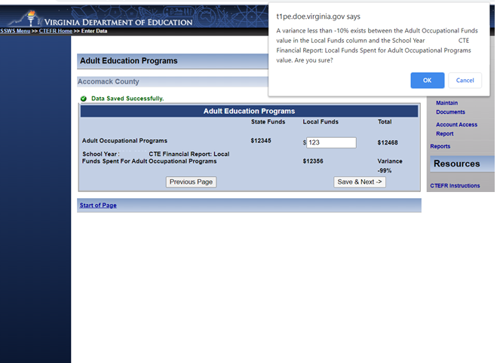

School division/regional technical center’s Fiscal Year 2023 entitlements for Occupational Adult Education programs is based on the amounts reported for Local Funds additional expenditures for SY 2021-2022 career and technical adult occupational education programs.

- When the Adult Education program expenditure amount for Local funds has been entered and verified for SY 2021-2022 career and technical Occupational Adult Education programs, SELECT the “Save & Next ->” button.

The SY 2021-2022 CTEFR collects additional Occupational Adult Education Program data by CTE Program Areas for:

- Number of Occupational Adult Education classes,
- Enrollment for Occupational Adult Education Classes, and
- Number of full-time and part-time Occupational Adult Education Teachers.

If the regional technical center provides occupational adult education programs, the required additional data needs to be reported only on the first school division’s CTEFR.

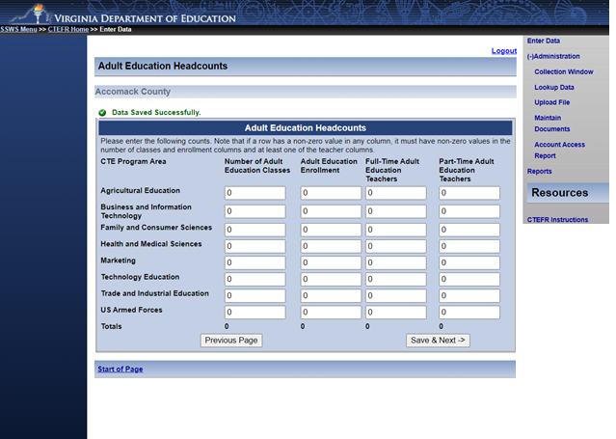

Fill in the correct counts for each category and program area. If a row has a non-zero value in any column, the row must have non-zero values in:

- Number of Occupational Adult Education classes,
- Enrollment for Occupational Adult Education Classes, and
- Number of full-time and part-time Occupational Adult Education Teachers.

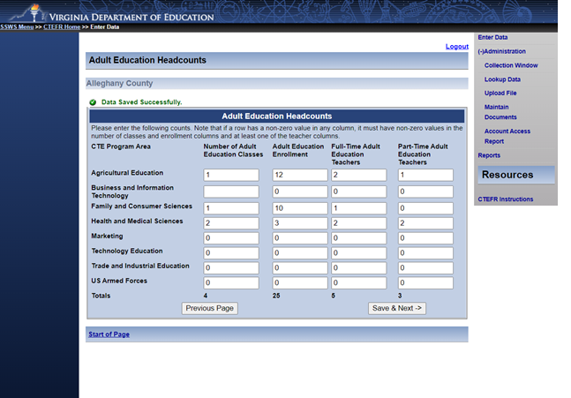

When the Occupational Adult Education Headcount program numbers have been entered and verified for SY 2021-2022 career and technical Occupational Adult Education programs, SELECT the “Save & Next ->” button.

CTEFR Data Submission to Virginia Department of Education

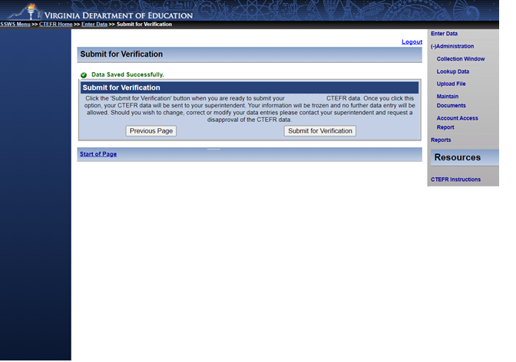

You may select the “Previous Page” button to review your data. When you are ready to finalize your CTEFR data, SELECT the “Submit for Verification” button. Once you click this option, your CTEFR data will be sent to your division superintendent.

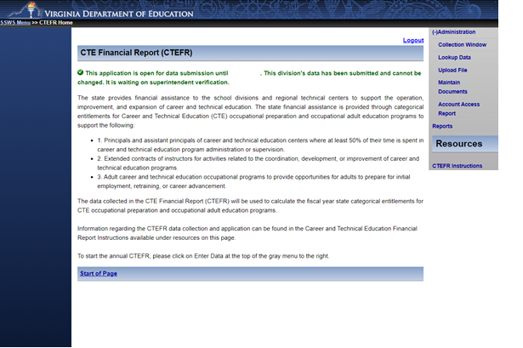

After the CTEFR has been approval electronically by the division superintendent or designee, the report is automatically submitted to DOE.

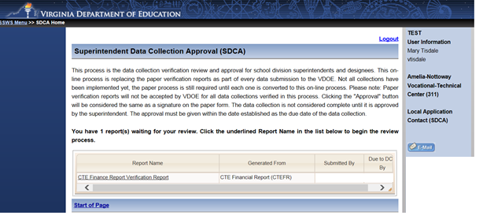

Your information will be frozen and no further data entry will be allowed. Should you wish to change, correct, or modify your data entries please contact your superintendent and request a disapproval of the CTEFR data.

The preparer of the report will receive an email when the approval is completed and the SY 2021-2022 collection window is locked for the school division or regional technical center.

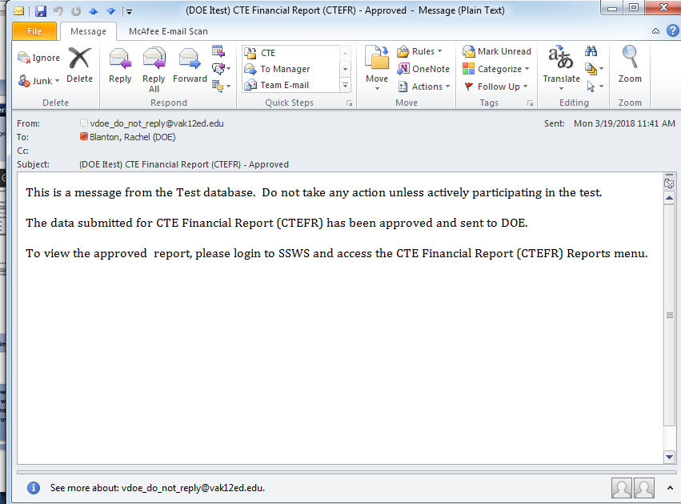

CTEFR Verification Report Submission to Virginia Department of Education

If the CTEFR for SY 2021-2022 needs to be corrected and/or the data revised after the report has been submitted to DOE and the collection window has been locked, the division superintendent or designee must contact the Office of Career, Technical, and Adult Education to request that the window be unlocked.
Reports must be submitted to VDOE by April 28, 2023.

If you have questions, please contact Office of Career, Technical, and Adult Education, at cte@doe.virginia.gov or by telephone at (804) 225-3349.

