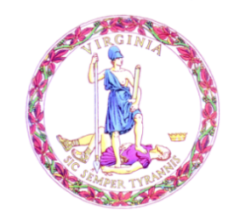

Commonwealth of Virginia

Board of Education Agenda

Date of Meeting: March 23, 2023 Time: 8:00 a.m.

Location: Board Room, 22nd Floor, James Monroe Building

8:00 a.m. FULL BOARD CONVENES

MOMENT OF SILENCE

PLEDGE OF ALLEGIANCE

APPROVAL OF MINUTES

PUBLIC COMMENT

CONSENT AGENDA

- Final Review to Certify a List of Qualified Persons for the Office of Division Superintendent of Schools

ACTION/DISCUSSION ITEMS

- Final Review of Arlington County Public Schools Alternate Route to Licensure for Certain Endorsements Pursuant to House Bill 2486 of the 2019 Virginia General Assembly
- First and Final Review of Request from Buena Vista City Public Schools to Discontinue a Local Graduation Requirement
- First Review of Alternative Accreditation Plans for 2023-2024 Accountability Year
- First Review of Adoption of Special Provision to Suspend the Use of the Chronic Absenteeism Indicator for the Determination of Accreditation Status for Accreditation Year 2023-2024
- First Review of Proposal to Approve Only a Year-to-Year Comparison of State Assessment Results to Determine Growth for Accountability Year 2023-2024
- First Review of Updates to the Board Approved Courses
- First Review of Recommendation to Approve New Education (Endorsement) Programs

PRESENTATIONS & WRITTEN REPORTS

- Update on College Partnership Laboratory Schools
- Written Report on Historical Cut-Scores for the SOL Reading and Mathematics Tests for Grades 3-8
- Written Report on the Implementation of MOUs with Identified Divisions
- Written Report on the Timeline for Revisions to the Computer Science Standards of Learning
- Written Report on the Educational Technology Plan for Virginia 2023-2028

DISCUSSION OF CURRENT ISSUES – by Board of Education Members and Superintendent of Public Instruction

ADJOURNMENT

