Office of School Quality
Richmond City Public Schools
VBOE Spring Report
March 2023

Division Information
Region: I
Chairperson of the Board: Stephanie Rizzi
Superintendent’s Name: Jason Kamras
Memorandum of Understanding (MOU) Date: September 7, 2017
Corrective Action Plan (CAP) Date: September 21, 2018

The Superintendent of Public Instruction shall assist local school boards in the implementation of action plans for increasing educational performance and individual student growth in those school divisions and schools that are identified as not meeting the approved criteria. The Superintendent of Public Instruction shall monitor the implementation of and report to the Board on the effectiveness of the corrective actions taken to improve the educational performance in such school divisions and schools. [§ 22.1-253.13:3.]

In fulfilling this requirement and the responsibilities of the Virginia Board of Education as stated in the Memorandum of Understanding with the Richmond City School Board, the Office of School Quality (OSQ) meets with the school division and reviews:
(1) artifacts that serve as evidence of the implementation of the required actions detailed in the corrective action plan; and
(2) quarterly data that serve as evidence of progress made towards the attainment of the goals of the corrective action plan.

Richmond City Public Schools will continue for 2022-2023 under the guidance of a Memorandum of Understanding (MOU) with the Board. This report aims to provide an update regarding Richmond's profile, profiles of schools in the division, and recent data associated with state accreditation and federal accountability. Additionally, this report provides an outline of the responsibilities of Richmond’s Superintendent and Local Board for the 2022-2023 school year. The Office of School Quality will provide details of various supports offered to Richmond and highlight the progress Richmond has made regarding the essential actions from its Corrective Action Plan. Lastly in this report, Richmond provides a summary of priority essential actions for the 2022-2023 in the areas of Academics and Student Success, Human Resources, and Leadership and Governance.
Report Index

- Division Characteristics
  - Division Profile
  - School Profiles
- Accountability Reporting
  - State Accreditation Ratings Summary for Division
  - Federal Identification Summary for Division
- Memorandum of Understanding Monitoring Process
  - Introduction
  - Superintendent and Board Responsibilities
  - OSQ Progress Monitoring
  - Essential Action (EA) Progress
  - OSQ Support - Technical Assistance Topics
- Data for 2022-2023 Accountability
  - School Quality Indicator Summary
  - Standards of Learning (SOL) Subject Pass Rates
  - Four-Year Graduation Rates
- Division Action Plan for 2022-2023
  - Student Reporting Data
    - Academic Achievement
    - Attendance
    - On-Time Graduation and Dropout
  - Staff
    - Retention, Evaluation, Recruitment
    - Professional Development

Report Details

- Division Characteristics

Division Profile
Division Website: https://www.rvaschools.net/

Vision: Dreams4RPS

Link to Richmond City Public Schools Strategic Plan
Location: Richmond is an urban school division located in the city of Richmond, VA.
Superintendent Profile: Superintendent’s Corner
Division Board of Education: Richmond City Public Schools Board of Education is composed of one Board representative from each of the city’s nine districts. The School Board meets the first and third Monday of each month.
School Quality Profiles of the Division: Richmond City Public Schools Quality Profile
Richmond City consists of five preschools, twenty-six elementary schools, seven middle schools, eight high schools, and three combined schools.
Student Enrollment: 2021-2022 (21,189 Full Time Students); 2020-2021 (28,240 Full Time Students)
2020-2021 enrollment numbers include Virtual Virginia
Educator Totals: 2021-2022 (1,793 Educators); 2020-2021 (1,831 Educators)
School Year Calendar: Opening Day-August 29, 2022; Closing Day-June 9, 2023

School Profiles
School Name | Principal | Grade Levels | Student Enrollment  (21/22)
Blackwell Preschool | Elaine Probst | Pre-K | 164
Martin Luther King Jr. Early Learning Center | Crystal Hartsfield | Pre-K | 145
Mary Scott Preschool | Lisa Hicks | Pre-K | 155
Maymont Pre-K Center | Victoria Hampton | Pre-K | 171
Summer Hill Preschool Center | Lee Doxey | Pre-K | 124
Barack Obama Elementary | Jennifer K. Moore | PreK-5 | 276
Bellevue Elementary | V Tanaia Hines | PreK-5 | 200
Blackwell Elementary | Ebony Davis | PreK-5 | 377
Broad Rock Elementary | Teya Brown-Green | PreK-5 | 655
Cardinal Elementary | Juvenal Abrego-Meneses | PreK-5 | 854
Chimborazo Elementary | Cordell Watkins | PreK-5 | 390
Elizabeth D. Redd Elementary | Sherry Wharton-Carey | PreK-5 | 381
Fairfield Court Elementary | Angela Wright | PreK-5 | 245
G.H. Reid Elementary | Angela Delaney | PreK-5 | 650
George W. Carver Elementary | Tiawana Giles | PreK-5 | 378
Ginter Park Elementary | Michelle Jones | PreK-5 | 276
Henry Marsh III Elementary | Kimberly Cook | PreK-5 | 474
J.B. Fisher Elementary | Duane Samuels | PreK-5 | 251
J.L. Francis Elementary | Kecia Ryan | PreK-5 | 534
John B. Cary Elementary | Michael Powell | PreK-5 | 220
Linwood Holton Elementary | Nikea Hurt | PreK-5 | 435
Mary Munford Elementary | Gregory P. Muzik | PreK-5 | 410
Miles Jones Elementary | Sonya Shaw | PreK-5 | 528
Oak Grove/Bellemeade Elementary | Fatima Smith | PreK-5 | 546
Overby-Sheppard Elementary | Shayla Holeman | PreK-5 | 265
Patrick Henry School Of Science And Arts | Tarnee Hudson | K-5 | 316
Southampton Elementary | Sheleta R. Crews | PreK-5 | 435
Swansboro Elementary | Theron Sampson | PreK-5 | 161
Westover Hills Elementary | Allison El Koubi | PreK-5 | 368
William Fox Elementary | Daniela Jacobs | PreK-5 | 358
Woodville Elementary | Rickeita Jones | PreK-5 | 265
Albert Hill Middle | Tashiana Ivy | 6-8 | 449
Binford Middle | Melissa Rickey | 6-8 | 412
Henderson Middle | Antoine London | 6-8 | 431
Lucille M. Brown Middle | Stacy Gaines | 6-8 | 584
Martin Luther King Jr. Middle | Inett Dabney | 6-8 | 514
River City Middle | Jacquelyn Murphy | 6-8 | 1,515
Thomas C. Boushall Middle | Latonya Waller | 6-8 | 455
Armstrong High | Willie Bell | 9-12 | 776
George Wythe High | Kevin Olds | 9-12 | 1,296
Huguenot High | Robert Gilstrap | 9-12 | 1,339
John Marshall High | Monica Murray | 9-12 | 542
Open High | Clary Carleton | 9-12 | 188
Richmond Career Education and Employment Academy | Maurice Burton | 9-12 | 22
Richmond Community High | Kenya Massenburg | 9-12 | 211
Thomas Jefferson High | Cherita Sears | 9-12 | 908
Amelia Street Special Education | Mark Phillips | PreK-12 | 18
Franklin Military Academy | David A. Hudson | 6-12 | 317
Richmond Alternative | Lamont Trotter | 6-12 | 142

- Accountability Reporting
Accreditation: The Virginia Board of Education accreditation standards provide a comprehensive view of school quality, encourage continuous improvement for all schools and emphasize closing achievement gaps. The accreditation standards measure performance on multiple school quality indicators, including student achievement, chronic absenteeism, graduation, drop-out, and participation rates.
State-Level Accountability: Schools are rated on each school quality indicator and also receive a summative rating of either “Accredited,” “Accredited with Conditions,” or in the case of a school that has not made a good faith effort to implement corrective actions, “Accreditation Denied.”
Accreditation Ratings - Under the current system, schools earn one of the following three accreditation ratings:
- Accredited — Schools with all school quality indicators at either Level One or Level Two;
- Accredited with Conditions — Schools with one or more school quality indicators at Level Three
- Accreditation Denied — Schools that fail to adopt or fully implement required corrective actions to address Level Three school quality indicators.
  - A school rated as Accreditation Denied may regain state accreditation by demonstrating to the Board of Education that it is fully implementing all required corrective action plans.

State Summary | Elementary | Middle | High | Combined | Total
Total Number of Schools in Division | 26 | 7 | 8 | 3 | 44
Accredited | 12 | - | 3 | 1 | 16
Accredited with Conditions | 14 | 7 | 5 | 2 | 28

Federal Level Accountability: Under the Every Student Succeeds Act (ESSA), schools are identified for support and improvement for federal support and improvement based on multiple performance indicators. These indicators include academic achievement measured by pass rates on the Standards of Learning reading and mathematics assessments, growth in reading and mathematics achievement for elementary and middle schools, high school graduation rates, progress in English Learners gaining proficiency in English, and chronic absenteeism. In addition, schools are reviewed using the most recent school year's data. There are four federal identifications:
- Comprehensive Support and Improvement (CSI): Title I schools that are performing in the bottom five (5) percent across the state or any ATSI Title I school that does not exit after three consecutive years of identification based on all students;
- Comprehensive Support and Improvement- Federal Graduation Indicator (CSI-FGI): Any school with a graduation class that has a graduation rate below 67%;
- Targeted Support and Improvement (TSI): Any school, Title I and non-Title I, with one or more consistently underperforming (two consecutive years) student group(s) and are identified annually;
- Additional Targeted Support and Improvement (ATSI) schools are identified every three years from among schools identified for targeted support and improvement, with one or more student groups performing below the level of the highest performing comprehensive support and improvement school.

Federal Summary | Elementary | Middle | High | Combined | Totals
Total Number of Schools in Division | 26 | 7 | 8 | 3 | 44
CSI | 9 | 6 | 1 | - | 16
CSI-FGI | - | - | 1 | 1 | 2
TSI | - | - | - | - | -
ATSI | 1 | 1 | 2 | 1 | 5

- Memorandum of Understanding (MOU) Monitoring Process
Per the Memorandum of Understanding (MOU):
The Richmond City School Board and the central office staff will adopt five key principles and implement corrective action plan essential actions to comply with the five key priorities and the Standards of Quality in order to improve student achievement.
1. Academics and Student Success
2. Leadership and Governance
3. Operations and Support Services
4. Human Resource Leadership
5. Community Relations and Communications [pg. 1]

OSQ staff will meet every two months with the Division Superintendent and appropriate staff to review progress in implementing the corrective action plan and to review quarterly data, which may include the following data points: student attendance, teacher attendance, student discipline reports, student transfer data, student intervention participation and progress by intervention type, number and quality of teacher observations and walkthroughs conducted per month, and local assessment data in English, math, history, and science. OSQ staff may request additional data. Feedback on the steps taken by Richmond City Public Schools to implement the essential actions in the corrective action plan will be communicated by OSQ staff via a written bi-monthly report provided to the Superintendent of Public Instruction, the Director of School Quality, the Division Superintendent and the Richmond City School Board. Specific next steps will be developed as needed. [pg. 2 Item 3]
The Richmond City School Board will direct the division superintendent and appropriate staff to meet every two months with the Office of School Quality to review (1) artifacts that serve as evidence of the implementation of the required actions detailed in the corrective action plan (CAP); and (2) quarterly data that serve as evidence of progress made towards the attainment of the goals of the CAP. Data points to be reviewed may include the following: student attendance, teacher attendance, student discipline reports, student transfer data, student intervention participation and progress by intervention type, number and quality of teacher observations and walkthroughs conducted per month, and local assessment data in English, mathematics, history, and science. OSQ staff may request additional data. Feedback on the steps taken by Richmond City Public Schools to implement the essential actions in the corrective action plan will be communicated by OSQ staff via a written bi-monthly report provided to the Superintendent of Public Instruction, the Director of School Quality, the Division Superintendent and the Richmond City School Board. Specific next steps will be developed as needed [pg. 3 Item 2]
Superintendent and Board Responsibilities
Per the MOU, “the State Superintendent of Public Instruction and the State Board President will meet with the Local Board Chair and any other interested Richmond School Board members at least twice per year to facilitate communication and regular updates. All meetings shall be conducted according to applicable Open Meeting Laws.” [pg 2, #2]
Meetings will be held in the fall and spring with the VDOE Superintendent of Public Instruction, VBOE President, the LEA, and the Division Superintendent. These meetings will provide Richmond City Public Schools the opportunity to update the Virginia Department of Education and the Virginia Board of Education on the progress of certain CAP elements. Additionally, consistent with requirements outlined in the MOU, the RCPS Board received training from the Virginia School Board Association (VSBA) on September 10, 2022. [pg 5, #10]

OSQ Progress Meetings
Corrective Action Plan (CAP) Meetings for 2022-2023 will occur in September, November, January, March, May, and July.
Additional meetings with division leadership and OSQ will occur for the following processes
- Fall Division Monitoring Meetings - Division leaders that have schools with Level 3 School Quality Indicators participated in a fall division level monitoring meeting to discuss systems and processes the division utilizes to support continuous school improvement, including data analysis, comprehensive school improvement plan development, and monitoring the comprehensive school improvement plan for implementation and impact.
- Spring School Monitoring Meetings - Schools with Level 3 school quality indicators will participate in a spring virtual monitoring meeting with OSQ. The purpose of these reflective conversations between building principals and OSQ is to discuss evidence provided by the school of the implementation and impact of the comprehensive school improvement plan and consider next steps. Division leaders will attend these meetings to observe and will follow up with OSQ after the school meetings to reflect on trends, support, and next steps.

Essential Action Progress
Per the MOU, the Richmond City School Board and the central office staff will adopt five key priorities and implement corrective action plan essential actions to comply with the five key priorities and the Standards of Quality in order to improve student achievement.

- Academics and Student Success
- Leadership and Governance
- Operations and Support Services
- Human Resource Leadership
- Community Relations and Communications

The Office of School Quality (OSQ) monitors Richmond City’s progress on the essential actions in each priority area identified in the Corrective Action Plan (CAP) on a bi-monthly basis, and provides feedback. At these meetings, OSQ monitors the implementation of the CAP to ensure the division is making progress toward improving systems and processes that influence student achievement. Below is a limited highlight of areas of progress and improvement that OSQ provides at these meetings.
Notable areas of progress include, but are not limited to:
- The following RPS schools are fully accredited for the 2022-2023 school year:
  - Elementary Schools: Broad Rock Elementary School, Elizabeth D. Redd Elementary School, Fairfield Court Elementary School, J.B. Fisher Elementary School, J.L. Frances Elementary School, John B. Cary Elementary School, Linwood Holton Elementary School, Mary Munford Elementary School, Southampton Elementary School, William Fox Elementary School
  - High Schools: Open High School, Richmond Career Education and Employment Academy, Richmond Community High School, Franklin Military Academy
- Based on preliminary data for federal identification (2022) and the established exit criteria outlined in the State Plan under ESSA, Westover Hills Elementary and Chimborazo Elementary exited identification as a Comprehensive Support and Improvement School (CSI), Huguenot High School exited as a school identified for its federal graduation indicator (CSI-FGI) based on its FGI above 67%. (P1; Academics and Student Success)
- Division superintendent reported transportation improvements and RPS is 100% staffed with bus drivers. Recruitment and retention of bus drivers have resulted in no need for double-backs of routes. Efforts have also led to a positive impact on student attendance and engagement at the start of the school year. (P3; Operations and Support Services)
- In September of 2021, VDOE acknowledged and celebrated the closure of Richmond’s Results Driven Accountability (RDA) CAP. A report with findings of noncompliance with regulations governing special education was issued on September 24, 2015. Noncompliance findings were corrected by RPS and closed within one year as required. In January 2016, the RDA CAP for program improvement was developed and implemented. Revisions to the plan occurred in May 2019. Based on VDOE’s review, the RDA CAP is closed. This closure reflects significant improvements in the division’s policies, procedures, and practices for the education of students with disabilities. (P1; Academics and Student Success)
- On February 6 and March 13, 2018, the Virginia Department of Education conducted monitoring to ensure that certain federally-funded programs and activities under the Elementary and Secondary Education Act of 1965 (ESEA), as amended, were implemented as stipulated by law. Specifically, the Title I, Part A, and Title III, Part A, programs were reviewed as operated by Richmond City Public Schools. As a result of the federal program monitoring review, additional information was requested in the form of a corrective action plan to ensure compliance with federal requirements. In May 2022, VDOE informed Richmond City Public Schools’ that the corrective action plan has been fully implemented and the findings from that program year have been resolved. (P3; Operations and Support Services)
Notable focus areas for improvement include, but are not limited to:
- Reduce the number of schools not fully accredited. (P1; Academics and Students Success)
- Reduce the number of federally identified schools. Based on current preliminary data (2022), five additional schools have been identified as Comprehensive Support and Improvement (CSI); one additional school for Comprehensive Support and Improvement-Federal Graduation Index (CSI-FGI), and two additional schools have been identified as Additional Targeted Support and Improvement (ATSI). (P1; Academics and Students Success)
- RPS division leaders are encouraged to work to fill executive division-level vacancies.
- As part of leadership development efforts, continue to review processes and refine systems that allow work to continue when changes occur in leadership.
- Develop and implement a process to systematically review, revise, and monitor early interventions and supports to increase student attendance and reduce the chronic absenteeism rate. Although the use of the chronic absenteeism indicator was waived for the accreditation year of the 2022-2023 school year, 57% of schools in RCPS have a level 2 or level 3 school quality indicator rating in Chronic absenteeism. (P1; Academics and Student Success)
- Continue to refine and monitor the implementation of professional development and Tier I instructional practices in the classroom setting and the impact on student progress. (P1; Academics and Students Success)
- Develop tracking processes and supports for graduation cohorts of students for early identification of students at-risk to improve student graduation and drop-out rates. (P1; Academic and Student Success)

OSQ remains committed to supporting the continuous improvement efforts of Richmond City Public Schools.

Technical Assistance Topics
The Director of the Office of School Quality (OSQ), formerly Office of School Improvement (OSI), will coordinate with OSQ staff, division staff, and other VDOE offices to provide technical assistance in support of the MOU and corrective action plan. [pg.2, #1]

The Division Superintendent will direct appropriate division staff to participate in OSQ (formerly OSI)-required technical assistance and other professional development identified by the Office of School Quality, when invited, to support the implementation of strategies for improving student achievement in low-performing schools. The Division Superintendent will ensure that the appropriate division staff implement with fidelity actions/next steps resulting from all technical assistance provided as a result of the MOU. [pg.4, #8]
Overview of Technical Assistance Offerings
The OSQ has coordinated various technical assistance for the 2022-2023 school year. The listing of technical assistance offerings (see Appendix) is not intended to be exhaustive; instead, it provides a brief overview of scheduled technical assistance and other professional development opportunities to support the implementation of strategies for improving student outcomes. Richmond City Public Schools is currently operating under a MOU with the Virginia Board of Education has a total of 49 schools.

- Data for 2022-2023 Accountability
School Quality Indicators: Schools earn accreditation ratings (Section B) based on performance on school quality indicators.
The [current] accreditation standards measure performance on multiple school quality indicators, not just on overall student achievement on state tests.
Elementary and middle schools are evaluated on the following indicators: Overall proficiency and growth in English reading/writing achievement (including progress of English learners toward English-language proficiency); Overall proficiency and growth in mathematics; Overall proficiency in science; English achievement gaps among student groups; Mathematics achievement gaps among student groups; and [chronic]absenteeism
High schools are evaluated on the following school quality indicators: Overall proficiency in English reading/ writing and progress of English learners toward English-language proficiency; Overall proficiency in mathematics; Overall proficiency in science; English achievement gaps among student groups; Mathematics achievement gaps among student groups; Graduation and completion; Dropout rate; [chronic] absenteeism; and College, career and civic readiness.
Performance on each school quality indicator is rated at one of three levels:
- Level One: Meets or exceeds standard or sufficient improvement
- Level Two: Near standard or making sufficient improvement
- Level Three: Below standard
The table below provides a summary of the division counts of school quality indicators for each indicator and each performance level. Totals for the current year and previous years appear at the bottom of the table. There is no data for 2020-2021 and 2021-2022 since accreditation was waived.
School Quality Indicator  Distribution | Level One | Level Two | Level Three | Totals
Academic Achievement - English | 22 | 8 | 13 | 43
Achievement Gap - English | 13 | 16 | 14 | 43
Academic Achievement - Math | 26 | 3 | 15 | 44
Achievement Gap - Math | 12 | 12 | 20 | 44
Academic Achievement - Science | 11 | 5 | 27 | 43
Chronic Absenteeism | 19 | 17 | 8 | 44
Graduation and Completion Index | 7 | - | 3 | 10
Dropout Rate | 6 | 2 | 2 | 10
Totals (Accred. Yr: 2022-2023) | 116 | 63 | 102 | 281
Totals (Accred. Yr: 2019-2020) | 145 | 55 | 84 | 284
Totals (Accred. Yr: 2018-2019) | 138 | 51 | 86 | 275

Standards of Learning (SOL) Division Subject Pass Rates: As referenced in Superintendent Balow’s August 18, 2022 News Release, the impact of the pandemic was seen in Richmond City Public Schools. The table below represents Richmond’s subject level pass rates from SOL test administration for all students. Data represents the 2021-2022 test administration and pre-pandemic SOL administration for 2018-2019 and 2017-2018. For comparison purposes, State subject level pass rates in 2021-2022 for all students were 73% in English Reading; 65% in English Writing; 66% in Mathematics; 65% in Science; and 66% in History and Social Sciences. Previous State Pass rates for 2018-2019 for all students were 78% in English Reading; 76% in English Writing; 82% in Mathematics; 81% in Science; and 80% in History and Social Sciences.

Subject Area | 2021/2022  (Assessment Year) | 2018/2019  (Assessment Year) | 2017/2018  (Assessment Year)
English: Reading | 47.2 | 56.31 | 58.87
English: Writing | 35.58 | 51.54 | 50
Mathematics | 36.99 | 55.82 | 52.25
Science | 32.06 | 59.73 | 59.34
History and Social Sciences | 34.18 | 54.74 | 62.29

Cohort Data: The data reported below represent the division’s four-year graduation and dropout rates which show the percentage of all students who earn diplomas or drop out within four years of entering high school for the first time. Additionally, the Division’s Federal Graduation Indicator provided represents the number of diplomas earned with no flexibility for limited-English proficient students and students with disabilities. Details on the graduation calculator can be found in this document. Any school failing to meet the federal four-year adjusted cohort graduation rate of 67% may be identified for comprehensive support and improvement (CSI).

Rate Type | 2022 | 2021 | 2020 | 2019 | 2018
Virginia On-Time Graduation Rate | 74.32 | 78.50 | 71.51 | 70.80 | 75.44
Drop Out Rate | 19.97 | 15.08 | 23.24 | 24.13 | 20.15
Federal Graduation Indicator | 67.51 | 73.96 | 67.13 | 63.38 | 66.22

- Division Action Plan for 2022-2023

For the 2022-2023 school year, the division identified essential actions and goals to address each of the following areas:
- Student Academic Achievement (Academics and Student Success)
- Student Attendance (Academics and Student Success)
- Graduation Rate and Drop Outs (Academics and Student Success)
- Retention, Evaluation and Recruitment of Staff in all areas (i.e. Administrators, Teachers, Counselors, Bus Drivers, etc.) (Human Resources)
- Professional Development for School Leadership (Leadership and Governance)

Area 1: Student Academic Achievement (Academics and Student Success)

Goal 1: Increase the number of accredited schools from 16 to 22
- Key Action: Manage against accreditation dashboards – One of the challenges with the current accreditation system is that it is extremely complex. Until recently, many of our principals did not have a comprehensive understanding of exactly what data points needed to change – and by how much – to achieve accreditation. Given this, we created a dashboard for each school that clearly lays out the requirements. (See below for the dashboard for Chimborazo Elementary School). This year, we will be tightly managing accreditation using these dashboards and interim data (particularly from the beginning and mid-year Virginia Growth Assessment (VGA)) to guide decisions at the school and division level.

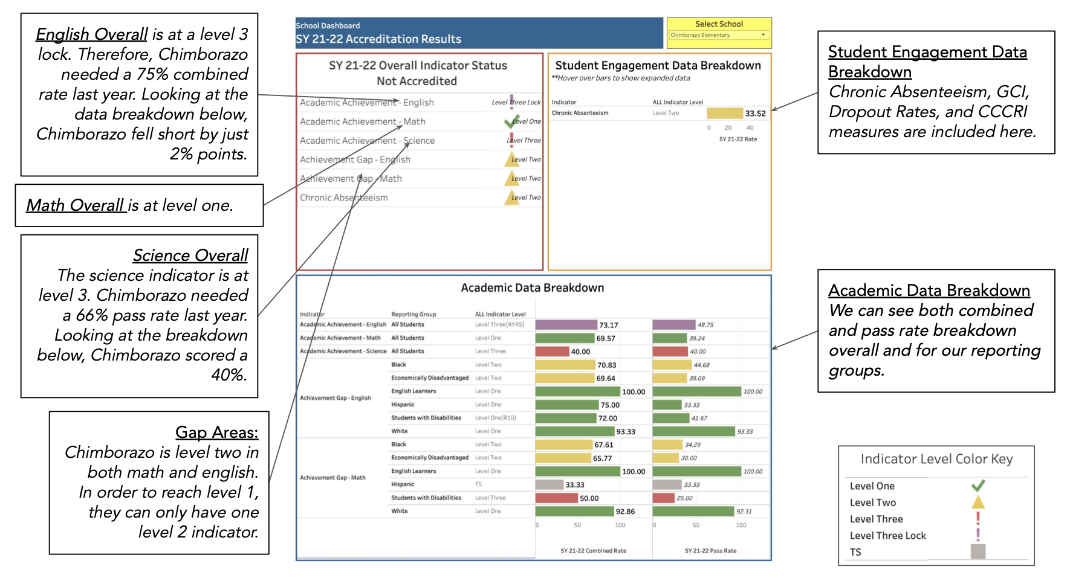
- Key Action: Focus on science instruction – We saw significant growth in both reading and math last year (from fall VGA to spring SOL), but our science scores lagged. Given that the accreditation framework requires 70% proficiency in science (and does not take into account growth), science instruction must be a key focus this year. Towards that end, we have updated our elementary schedule to include daily science instruction (as opposed to alternating days with social studies), added an elementary science specialist to work directly with teachers (we only have one other science specialist), focused our division-level professional learning for elementary teachers on science, and provided schools with ARP funds to develop site-specific extended learning plans with a focus on science.

Goal 2: Increase overall reading proficiency from 47% to 52%
- Key Action: Provide additional training on the science of teaching reading – In 2020, we adopted an ELA curriculum (EL Education) based on the science of teaching reading (and fully aligned to the requirements of the Virginia Literacy Act). To support our teachers in utilizing this curriculum, we have paid for cohorts of educators to become certified in LETRS (Language Essentials for Teachers of Reading and Spelling). We are expanding that work this year and aim to have all elementary teachers certified within three years.
- Key Action: Increase the number of reading interventionists and reading coaches – We have added 30 reading interventionists and reading coaches to provide intensive small group support to students (interventionists) and training for teachers to utilize our science-based reading curriculum (coaches). One challenge we continue to have is filling all of these positions. We are exploring financial incentives and more targeted recruitment to address this.

Area 2: Student Attendance (Academics and Student Success)

Goal 1: Reduce overall chronic absenteeism from 27.7% to 22%
- Key Action: Bring coherence and coordination to our attendance work – We have a significant number of school and central personnel working on attendance, but their efforts have not always been coordinated. For example, a teacher, social worker, and principal may have all been reaching out to the same family about a student but may have not known about each other’s efforts. We cannot afford that level of inefficiency given the challenge at hand. In response, we have created an “outreach dashboard” (see below) that tracks all outreach efforts for every student in jeopardy of being chronically absent. We have also created “attendance trios” in each school (social worker, family liaison, and Communities in Schools site coordinator) who work as a coordinated team with a caseload of students.

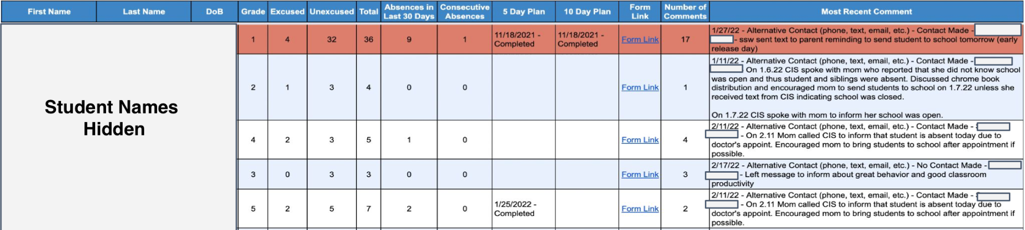
Area 3: Graduation Rate and Dropout Rate (Academics and Student Success)

Goal 1: Increase overall graduation rate from 74.4% to 80%
- Key Action: Bring coherence to dropout prevention work – Similar to our attendance work, we have many staff members working to prevent students from dropping out and to re-enroll those who already have. But those efforts have not been particularly coordinated or successful in the past. To address this, we have created a “dropout dashboard” (see below) to track all dropout prevention and recovery actions (and the outcome of those actions). Not only has this helped us become more coordinated in our approach, but it has also helped us identify individuals and activities that are having the biggest impact on dropout prevention and recovery. This, in turn, is aiding us in refining job expectations for each role, and highlighting best practices and top performers.

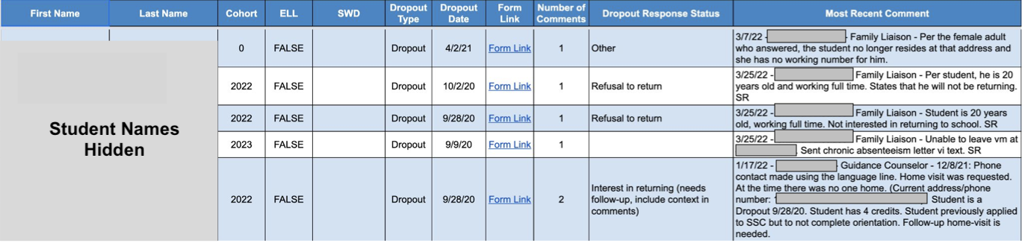
Goal 2: Increase Hispanic/Latino subgroup graduation rate from 44.2% to 55%
- Key Action: Expand and refine our Newcomer Academy – We recently started a Newcomer Academy to serve recent immigrant high school students who do not speak English proficiently. The vast majority of these students are Hispanic/Latino, coming from Central America. Longitudinal dropout data suggests the Newcomer Academy is having a positive impact. The graph below shows the dropout rates of our Hispanic/Latino students over the past several years (different colored lines) by the year of high school that students drop out. The bottom green line represents the 2024 cohort. It is noticeably less steep, meaning a far lower percentage of students are dropping out early in their high school career, as compared to similar students in prior cohorts (the other colored lines). Given this, we believe further investment and refinement of the Newcomer Academy this year will make a significant difference for our Hispanic/Latino graduation rate.

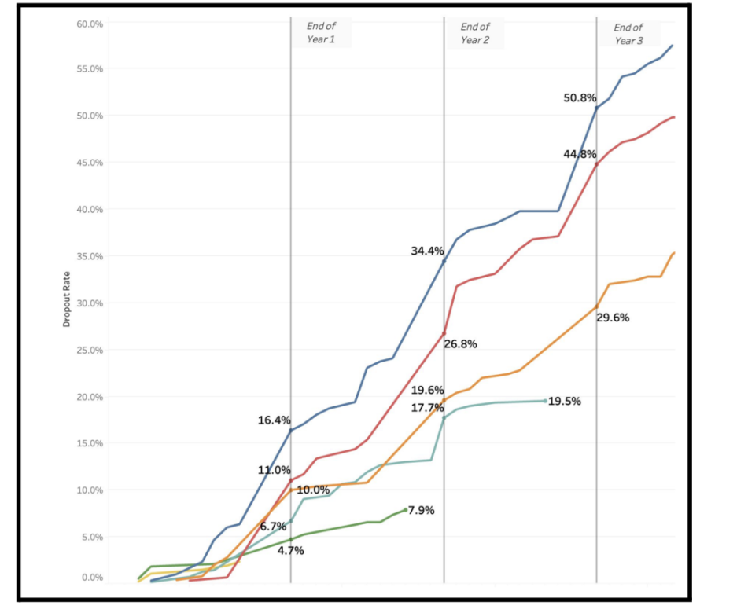

Area 4: Retention, Evaluation, and Recruitment of Staff (Human Resources)

Goal 1: Increase our teacher retention rate to 80%
- Key Action: Conduct 360 degree evaluations of school leaders – Teacher retention is influenced by a myriad of factors, from working conditions to pay to family obligations. That said, school leaders with effective people management skills tend to excel at retaining the most expert teachers. Given this, we will be conducting 360 degree evaluations for all principals this year to help us develop coaching plans with a special emphasis on people management.

Goal 2: Increase number of teacher applications by 15%
- Key Action: Launch major recruitment campaign – We are working with a local marketing firm to launch a major digital and print recruitment campaign this year. We will be highlighting our division’s diversity and commitment to social justice, as well as the Richmond region’s livability, as compared to DC and other East Coast cities.
- Key Action: Launch “grow our own” program – We are working with several local universities to develop “grow our own” programs, focused on helping our top instructional assistants and long-term substitute teachers earn their license.

Area 5: Professional Development for School Leadership (Leadership and Governance)

Goal 1: Ensure 100% of elementary principals become trained in the key elements of the science
of teaching reading
- Key Action: Incorporate science of teaching reading training in elementary cluster meetings – Given our “do whatever it takes” focus on early literacy, we need to ensure that our elementary principals have a solid understanding of the science of teaching reading (STR). Towards that end, our academic team, in collaboration with external partners, will train our elementary school leaders in the foundational elements of STR. This will occur during our cluster meetings, with follow up coaching from our principal managers, academic team, and external partners, as necessary.

Data Source: Fall Membership Reports
Data Source: Virginia Educator Data
Data Source: Education Directories (Calendar 2022-2023)
Data Source: School List with Principal Contact Information (csv)
Data Source: School Accreditation Report 2022-2023
Data Source: School Quality Profile
Data Source:School Accreditation Reports
Data Source: SOL Test Results
Data Source: Virginia Cohort Reports; Cohort years 2021 and 2020 are italicized because the State allowed flexibility in graduation criteria since accreditation was waived.

