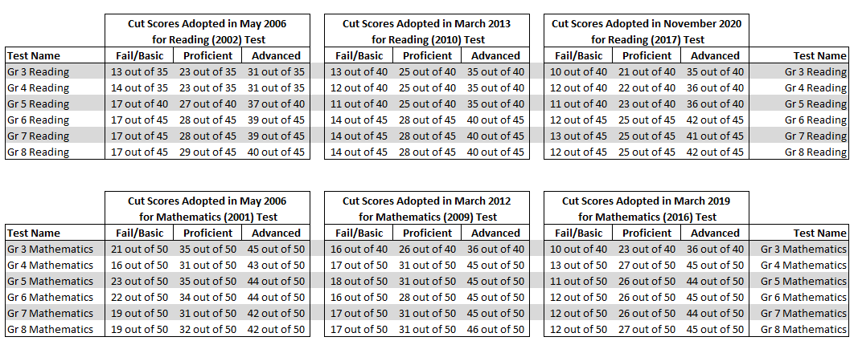
Historical Summary of Standards of Learning (SOL) Test Cut Scores: Grades 3-8 Reading and Mathematics

As context, the Standards of Learning (SOL) tests are "named" based on the adoption date of the SOL they measure. For example, the grade 5 SOL mathematics test currently being administered is referred to as the SOL grade 5 mathematics (2016) test because it is based on the mathematics SOL adopted by the Virginia Board of Education in 2016. The cut score information presented in this document begins with 2006. While the SOL tests were first administered in 1998, prior to the No Child Left Behind requirements for annual testing in grade 3-8 reading and mathematics, the SOL tests were administered at grade 3, grade 5, and grade 8 and were cumulative in nature. The cut score adoption in 2006 was the first for the grade-specific 3-8 reading and mathematics tests.

In reviewing the history of the cut scores on the SOL tests, it is important to be aware that cut scores must be interpreted in light of the difficulty of the test. For example, in 2012 the cut score adopted for "proficient" for the grade 5 mathematics test measuring the 2009 mathematics SOL was 31 out of 50 items correct. The cut score for the previous grade 5 mathematics tests based on the 2001 SOL was 35 out of 50 items correct. On the surface the cut score adopted in 2012 may appear to be a reduction in the expectations for proficiency in grade 5 mathematics. However, the 2009 mathematics SOL represented a significant increase in expectations for students as compared to the previous 2001 SOL. In some cases, content moved down as much as four grade levels from where it had been located in 2001 and significant new content was added. Because of this increase in content rigor of the SOL, the tests which measured the SOL were also more rigorous. To provide the board with context regarding the difficulty of the tests measuring the 2009 mathematics SOL, in 2012 Department staff provided a statistical estimate of what the cut scores on the new mathematics tests would be to maintain the same level of rigor as was required on the test measuring the 2001 SOL. As an example, the estimated cut score to maintain the same level of rigor to be considered proficient on the grade 5 mathematics SOL test (2009) as was required to be proficient on the grade 5 mathematics test measuring the 2001 SOL was 22 out of 50 items correct. Therefore, while the cut score of 31 out of 50 items on the grade 5 SOL mathematics adopted by the board in 2012 may on the surface appear to be a reduction in expectations from what was required on the test measuring the 2001 SOL, it was in fact an increase.

