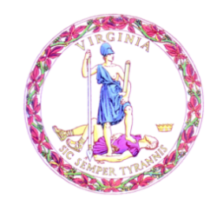

Commonwealth of Virginia

College Partnership Laboratory Schools Standing Committee Agenda

Date of Meeting: March 8, 2023 Time: 10:00 a.m.

Location: Board Room, 22nd Floor, James Monroe Building

10:00 a.m. STANDING COMMITTEE CONVENES

Election of Committee Leadership

Approval of the Agenda

Approval of Minutes from the December 2022 and February 2023 Meetings of the Standing Committee
ACTION/INFORMATION ITEMS
- Public Comment on Agenda Items
- Review and Approval of Standing Committee Schedule for 2023
- First review of the College Partnership Laboratory Committee Application Process
- Discussion on Updates to the Application, FAQs, and Website
- First review of the College Partnership Laboratory School Evaluation Rubric
- First review of College Partnership Laboratory School Template Board Report
PRESENTATIONS & WRITTEN REPORTS
- Update on Approved College Partnership Laboratory School Planning Grants
- Administrative Update
  - State emails
  - SharePoint
DISCUSSION OF CURRENT ISSUES
PUBLIC COMMENT ON NON-AGENDA ITEMS

ADJOURNMENT

