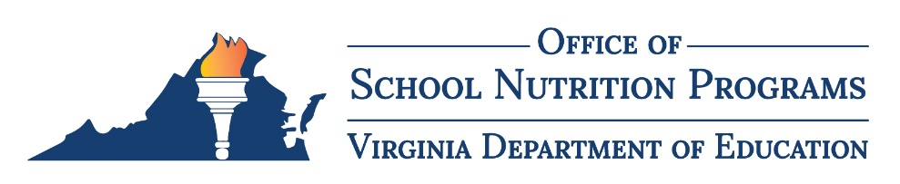

Data Request Form
The Virginia Department of Education, Office of School Nutrition Programs (VDOE-SNP) requires submission of this data request form prior to providing program data. The requestor must complete the form and return it to the VDOE-SNP via email at SNPPolicy@doe.virginia.gov.
Please allow 1-2 weeks for processing data requests.

Contact Information
Date of request: Click or tap to add date of submission
Organization/division name: Click or tap to add organization/division name
Point of contact first and last name: Click or tap to add first and last name
Address: Click or tap to add organization/division address
Email address: Click or tap to add email address
Phone number: Click or tap to add phone number

Details About the Data Request

Organization Type:
☐ Federal Agency
☐ State Agency
☐ School Division
☐ Nonprofit Organization
☐ Other: Click or tap to add the purospoe of request

Program:
☐ NSLP - National School Lunch Program
☐ SBP - School Breakfast Program
☐ SMP - Special Milk Program
☐ SFSP - Summer Food Service Program
☐ CACFP – At-Risk Component of the Child & Adult Care Food Program
☐ SSO – Seamless Summer Option
☐ Other: Click or tap to add other programs

Frequency of request:
☐ Once
☐ Bi - Weekly
☐ Monthly
☐ Quarterly
☐ Annually
☐ Other: Click or tap to if the frequency is different from above

Purpose of data:
☐ Audit
☐ Research or analysis
☐ Reporting
☐ Other: Click or tap to add the intended purpose of requested data

Program Year(s):
☐ 2017-2018
☐ 2018-2019
☐ 2019-2020
☐ 2020-2021
☐ 2021-2022
☐ 2022-2023
☐ Other: Click or tap to add another timeframe

Data Points Requested:
☐ Meal Counts
☐ Claim Earnings
☐ Program Statistics (number of program sponsors and/or sites)
☐ Geographical Data
☐ Other: Click or tap to add other data points needed

Requested deadline: Click or tap to add requested deadline

Please submit data request forms to VDOE-SNP via email to SNPPolicy@doe.virginia.gov.

Internal Use Only
Person Responsible: Click or tap to add name
Date completed: Click or tap to add the completion date
Status of this Request: Click or tap to add the status of the report

