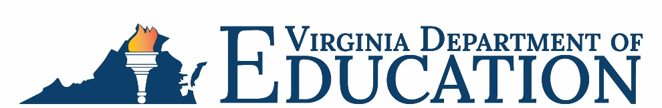

Office of School Nutrition Programs

Federal Program Administrative Review School Nutrition Program Summary
Section 207 of the Healthy Hunger Free Kids Act 2010, amended section 22 of the National School Lunch Act (42 U.S.C. 1769c) requires the Virginia Department of Education, Office of School Nutrition Programs (VDOE-SNP), to report the final results of the administrative review to the public in an accessible, easily understood manner in accordance with guidelines promulgated by the Secretary.
School Food Authority (SFA): Fredericksburg City Public Schools
Date of Administrative Review: October 12-14, 2022
Review Month and Year: September 2022
Date review results were provided to the SFA: October 17, 2022
Date review summary was publicly posted: February 9, 2023
SFA participates in the following Child Nutrition Programs:
☒ School Breakfast Program
☒ National School Lunch Program
☐ Fresh Fruit & Vegetable Program
☐ Afterschool Snack
☐ Seamless Summer Option
SFA operates under the following Special Provisions:
☒ Community Eligibility Provision
☐ Provision 2

Review Findings
Review Area | Details
Program Access and Reimbursement  ☐ Certification and Benefit Issuance  ☐ Verification  ☒ Meal Counting and Claiming | Meals were not counted and recorded at the point of service.
Meal Patterns and Nutritional Quality  ☒ Meal Components and Quantities  ☐ Offer versus Serve  ☐ Dietary Specifications and Nutrient Analysis | The signage explaining what constitutes a reimbursable meal to students was not displayed.
School Nutrition Environment and Civil Rights  ☐ Food Safety  ☒ Local Wellness Policy  ☐ Smart Snacks and Competitive Foods  ☒ Civil Rights | The Local School Wellness Policy did not contain all required components.  The USDA “And Justice for All” poster was not displayed in a prominent location and visible to recipients of benefits.
USDA is an equal opportunity provider, employer, and lender.

