EXPERIENCE WORKS 2023
HIGH-QUALITY WORK-BASED LEARNING (HQWBL) CONFERENCE
LOGO DESIGN GUIDELINES
Deadline for Submission: March 1, 2023

Introduction

Career and Technical Education (CTE) High-Quality Work-Based Learning (HQWBL) comprises school-coordinated workplace experiences related to students’ career goals and/or interests, integrated with instruction and performed in partnership with local businesses and organizations. CTE HQWBL assists students with the transition from the classroom to the workplace and/or college. Experience Works is the professional development conference for all stakeholders in CTE HQWBL. These stakeholders include administrators, WBL coordinators/points-of-contact, teachers, counselors, career coaches and others.

Purpose of the Experience Works logo

The logo’s purpose is to make Experience Works recognizable and promote the conference to all stakeholders. The Experience Works 2023 theme is “Pathways for the Future.” The conference dates are June 28 - 29, 2023. Please include the conference name, theme, and dates in the logo design.

Characteristics of the logo:
The logo must consist of the following parts:
- A pictographic part (picture).
- A logotype part - create a logo so it can be utilized on a webpage,
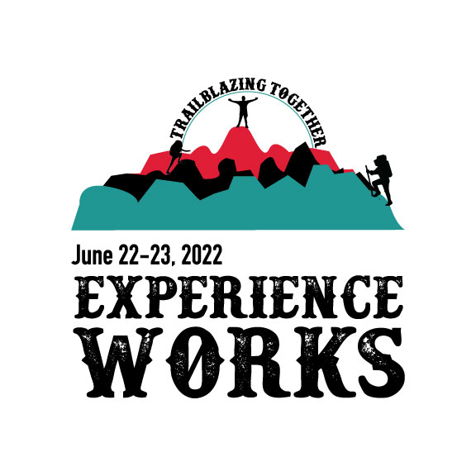
brochure, guides, etc.
- Include the theme in the logo design.
- Include the following colors: The right logo color choices can immediately create feelings of happiness and well-being whereas darker colors might make the same logo feel gloomy and edgy.
- At right is the logo created by Lindsay Santos, Graphics II student at Blacksburg High School, for last year’s Experience Works 2022 conference themed “Trailblazing Together.”

The characteristics of the logo must adhere to the following:
- Not infringe or violate the rights of third parties; including copyright, logos, trademarks, patents, and any other intellectual property rights.
- Not contain images or photographs or other identifying elements without express authorization.
- Not contain "clip art" and/or "artwork" symbols of other creations.
The specific elements of the logo must consider the following:
- Simplicity: Simple logos are those people can recognize as soon as they see them; remember that unnecessary elements must be minimized.
- Narrative: The logo tells the story of “Experience Works” and its purposes in an illustrative way.
- Versatility: The logo is reproducible, maintaining its effectiveness in any size, format, and type of print when reproduced in color and in black and white.
- Uniqueness: the pictographic version of the logo contains a single graphic idea and the presence of at least one clear, unique, and identifiable element that characterizes Experience Works and includes the theme.
- Memorable/Impactful: A great logo should be impactful and capture your viewer’s attention.
- Timelessness: It’s not enough that a logo is good today—it has to stay good for years to come.

Submission Guidelines:
- Each school division can submit a MAXIMUM of 6 logos for consideration.
- Logo designs may be developed by individual students or groups of students.
- Image Formats: jpeg, png; EPS file without raster layers will be required.
- Logo colors and RGB information to utilize are shown below.
- All submissions must be approved by the supervising teacher and include a signed submission form.
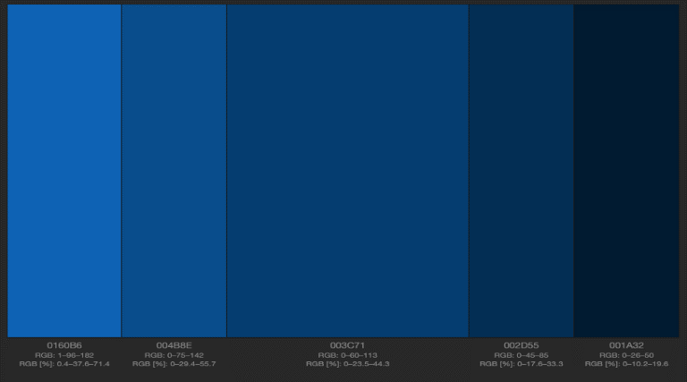
- SUBMISSIONS DUE: March 1, 2023, to cte@doe.virginia.gov

