Procedures for the Read-Aloud Accommodation:
Growth Assessments and Standards of Learning (SOL) Tests

Revised June 2022

Table of Contents

Introduction………………………………………………………………………………………....2

Responsibilities for Administering the Read-Aloud Accommodation……………………...……...3

Eligibility Guidelines for the Read-Aloud Accommodation……………………………………….4

General Guidelines for Administering the Read-Aloud Accommodation…………………………5

Read-Aloud Guidelines for SOL Reading Assessments…………………………………………...6

Read-Aloud Guidelines for SOL Writing Assessments…………………………………………...19

Read-Aloud Guidelines for SOL Mathematics Assessments……………………………………...24

Read-Aloud Guidelines for SOL Science Assessments……………………………………………50

Read-Aloud Guidelines for SOL History/Social Science Assessments……………………………60

Read-Aloud Guidelines for Technology Enhanced Items (TEI)…………………………………...67

Questions or comments related to this document may be directed to the Virginia Department of Education by email at student_assessment@doe.virginia.gov or by telephone at (804) 225-2102.
Property of the Virginia Department of Education
© 2021by the Commonwealth of Virginia Department of Education, P.O. Box 2120, Richmond, Virginia, 23218-2120. All rights reserved. Except as permitted by law, this material may not be reproduced or used in any form or by any means, electronic or mechanical, including photocopying or recording, or by any information storage or retrieval system, without written permission from the copyright owner.
Commonwealth of Virginia public school educators may photocopy or print any portion of these procedures for the administration of the read-aloud accommodation for educational purposes without requesting permission. All others should direct their written requests to the Virginia Department of Education at the above address or by email to student_assessment@doe.virginia.gov.

Introduction
This document is a resource for educators and parents regarding the administration of the read-aloud accommodation to eligible students participating in Growth Assessments and Standards of Learning (SOL) tests. This document includes:
- responsibilities of school personnel administering the read-aloud accommodation
- procedures for read-aloud accommodation test administration, and
- examples of how test items must be read aloud in each of the content areas.

Only students with disabilities identified under the Individuals with Disabilities Education Improvement Act of 2004 or Section 504 of the Rehabilitation Act of 1973 and students identified as English Learners (EL) are eligible for the read-aloud accommodation. Decisions regarding assessment participation and testing accommodations must be made by the Individualized Education Program (IEP) team, 504 committee, and/or the EL committee, and must be documented in the respective IEP, 504 Plan, and/or EL Student Assessment Participation Plan.

Before providing eligible students with any accommodation for state assessments, IEP teams, 504 committees, and EL committees should read and understand the documents related to assessment participation and test accommodations. These documents are available on the Virginia Department of Education website at Participation and Inclusion:

- Participation in the Virginia Assessment Program: A Resource for Educators and Parents of Students with Disabilities
- Testing Accommodations for Students with Disabilities: Growth Assessments and Standards of Learning Tests
- Guidelines for English Learner Participation in the Virginia Assessment Program

Responsibilities of School Personnel for Administering the Read-Aloud Accommodation
School Divisions
School divisions are responsible for ensuring teachers receive the proper training to administer the read-aloud accommodation to eligible students participating in statewide assessments. Staff responsible for administering the read-aloud accommodation must follow all security procedures for the administration of Growth Assessments and SOL tests and the additional security procedures for the administration of the read-aloud accommodation.
Division Directors of Testing and School Test Coordinators
Division Directors of Testing (DDOT) and School Test Coordinators (STC) must ensure that all read-aloud administrations are recorded and/or proctored. If recorded, the audio recording of the entire read-aloud testing session must be retained on file and secured in the office of the DDOT until scores are received and verified and Authorization to Report (ATR) is approved for that test administration.
If proctored, the Examiner and Proctor must verify in writing that the test administration was conducted according to standardized procedures. This written verification must be retained on file in the office of the DDOT until scores are received and verified and Authorization to Report (ATR) is approved for that test administration.
The Test Implementation Manuals for each test administration include details about the read-aloud accommodation. DDOTs and STCs must be familiar with the information in the manual for the current test administration.
Test Examiners
Test Examiners (Examiners) have the responsibility of ensuring that test security and validity are maintained at all times. The Examiner must administer the read-aloud accommodation without leading the student, through voice inflection or by repeating any part of the test that is not specifically requested by the student. Prior to reading a test item aloud, Examiners should take a moment to review the item so that an answer is not inadvertently given to the student when the item is read.
Examiners may use the audio version of SOL Practice Items in the TestNav 8 application to hear examples of how SOL tests should be read aloud and to practice reading SOL test items. The Writing and Non-Writing Examiner’s Manuals for each Growth Assessment and SOL test include details about the read-aloud accommodation. Examiners must be familiar with information in the manual for the specific SOL test they are administering.

Eligibility Guidelines for the Read-Aloud Accommodation
Read-Aloud Accommodation on Mathematics, Science, History/Social Science, and Writing Assessments
The read-aloud accommodation for Mathematics, Science, History/Social Science, and Writing assessments is allowed for students with disabilities and EL students as specified in the student’s IEP, 504 Plan, or EL Student Assessment Participation Plan.

Read-Aloud on the Reading Assessment
The read-aloud accommodation on the statewide Reading assessments is allowed only for students with a visual impairment, including blindness, and those students with a specific disability that severely limits or prevents them from decoding text at any level of difficulty as determined by a diagnostic tool or instrument administered by a qualified professional. Students with disabilities who are having difficulty reading text and/or are reading below grade-level are not allowed the read-aloud accommodation on the statewide Reading assessments. Additional information on eligibility requirements for the read-aloud accommodation of the statewide Reading test is provided in Supt. Memo No. 235 dated October 27, 2006, and in the SOL Non-Writing Test Implementation Manual.
Note: For the EOC Reading test, under certain circumstances, students with disabilities may receive the read-aloud accommodation (accommodation 14) even though the student has not been determined as eligible by the school division according to the criteria required for the read-aloud accommodation on the Reading assessment. To qualify, the student must meet all of the following criteria:
- the student is retaking the EOC Reading test, having failed the previous attempt(s) without using the read-aloud accommodation; and
- the student’s IEP/504 Plan lists the read-aloud accommodation or audio accommodation for other tests; and
- the student receives the read-aloud or audio accommodation in the classroom.
The read-aloud accommodation on the EOC Reading test will be considered a non-standard accommodation (accommodation code B). In addition to marking the student’s test with accommodation codes 14 and B, the test must be marked as retest on the Student Test Details screen in PearsonAcess^{next}.
Note: Special attention must be given to the student’s IEP, 504 Plan, or EL Student Assessment Participation Plan regarding the use of the read –aloud accommodation. For example, the IEP, 504 Plan, or EL Student Assessment Participation Plan may require the entire test to be read aloud or may require having words, questions, or sentences read aloud only when requested by the student.

General Procedures for Administering the Read-Aloud Accommodation
The following procedures should be used when administering the read-aloud accommodation to an individual student on all Growth Assessments and SOL tests. If reading content beyond the procedures outlined in this document would clue students or violate the construct of the test items being measured, the content must not be read.

The Examiner must:
- administer the read-aloud accommodation only in English.
- read text exactly as written using a natural tone.
- read the test question first, followed by the multiple-choice answer options or
the related text for technology-enhanced items.
- stop reading aloud if the text is misread. The Examiner should stop and say, “No that is wrong. I must read it to you again.” Then re-read the text.
- adapt the pace of reading to the needs of the student(s).
- be aware of specific accommodations identified in a student’s IEP, 504 Plan,
or EL Student Assessment Participation Plan. For example, an IEP may require
the entire test to be read aloud to a student, or it may require that words,
questions, or sentences are read aloud only when requested by the student.

The Examiner must NOT:
- use voice inflection, word emphasis, or other reading styles, that can lead students toward a response or make the test content confusing.
- read the test question and insert the answer options or any related text for technology-enhanced items into the test question.
- explain, translate, or verbally interpret any portion of the test items or answer options. No assistance (e.g., defining words, substituting words, attempting to clarify the intent of test items, etc.) may be provided to students.
- read any part of an item would clue the student or violate the construct being measured. The examiner must say, “Please refer to the ___ on your screen”

Read-Aloud Guidance for Reading

Growth Assessments and Standards of Learning (SOL) Tests
Students who are determined eligible for the read-aloud accommodation may have test items read aloud to them. Guidelines for administering the read-aloud accommodation for Reading tests are provided below.
The Examiner must:
- read all passages exactly as written
- read the question first, then the multiple-choice answer options or related text for technology-enhanced items as it pertains to items that ask a question about a specific sentence or sentences within a reading passage

The Examiner must NOT:
- emphasize underlined individual words or phrases as part of the item or answer options.
- explain, translate, or verbally interpret any portion of the test items or answer options. No assistance (e.g., defining words, substituting words, attempting to clarify the intent of test items, etc.) may be provided to students.
- read the test question and insert the answer options or any related text for technology-enhanced items into the test question.
- use voice inflection, word emphasis, or other reading styles, that can lead students toward a response or make the test content confusing.
- read numbers at the beginning of paragraphs in fiction or nonfiction text nor lines in poems.
- describe any pictures that accompany the passage.

Note: At the student’s request, the Examiner may go back and reread any sentences or paragraph(s) referenced in a test item, or any part of the text. If a mistake is made in reading a test item, the Examiner should stop and say, “No that is wrong. I must read it to you again.” Then re-read the test item.

Read-Aloud Examples for Reading
The examples below are intended to assist examiners in reading various reading test items. Some examples have explanations as to why certain test items are read in a particular way and notes of issues that could arise when reading a specific item type. All test items are to be read exactly as written using a natural tone and manner.
Item Contains: | Examples/Read as:
Ellipses: An ellipsis is a row of three periods after a word and is used to signify missing text in a sentence. When ellipses are present in test items, the Examiner should pause briefly and then continue the rest of the statement.  The Examiner does not read “dot, dot, dot,” in the passage or sentence, regardless of the location of the ellipsis. | Example:  "After school I went to her house…and then came home."  Read as:  "After school I went to her house (pause) and then came home."
Copyright: A copyright is the collection of rights that automatically are entrusted to someone who creates an original work. When copyrights are present in test passages or items, the Examiner does not read the copyright text. | Example:  “On D Street” from Wickett’s Remedy by Myla Goldberg, copyright© 2005 by Myla Goldberg.  Read as:  “On D Street” from Wickett’s Remedy by Myla Goldberg.
Item Contains: | Examples/Read as:
Homophones: Homophones are words with the same pronunciation but different meanings. When homophones appear in the answer options of a test item, the Examiner does not read the options as this could lead to clueing of the test item assessed. | Example:  Which word in paragraph 1 has a homophone?  - long  - one  - darkness  - another  Read as:  Which word in paragraph 1 has a homophone?  Please refer to the answer options on your screen.  or  Please refer to the answer options in your test booklet.
Paragraph Numbers: Paragraph numbers will appear in reading passages of the SOL tests. When paragraph numbers appear, the Examiner does not read the paragraph numbers in fiction or nonfiction text, nor in lines of poems. | Example:  ¹ Alice groaned  Read as:  Alice groaned
Permissions: Permissions will appear at the end of reading passages. When permissions are present, the Examiner does not read permissions at the end of the passages. | Example:  “On D Street” from Wickett’s Remedy by Myla Goldberg, copyright© 2005 by Myla Goldberg. Used by permission of Doubleday, a division of Random House.  Read as:  The Examiner does not read permissions at the end of the passages.
Trademark Statements and Symbols: Trademark statements and symbols will appear at the end of the reading passage. When trademark statements and symbols appear at the end of a reading passage, the Examiner does not read that information. | Example: 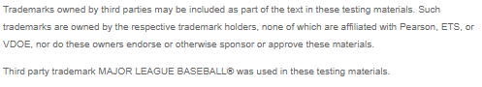  Read as:  The Examiner does not read trademark statements or trademark symbols in the reading passages.
Boxed Text: When text appears in a box, the Examiner will read it as, “A box.” | Example: 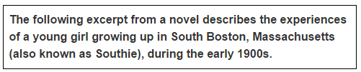  Read as:  A box, the following excerpt from a novel describes the experiences of a young girl growing up in South Boston, Massachusetts (short pause) (also known as Southie) (short pause), during the early nineteen hundreds.
Item Contains: | Examples/Read as:
Commas: A comma is a punctuation mark that separates words, clauses, or ideas within a sentence. The Examiner will read test items with commas using a short pause. | Example:  We had coffee, cheese and crackers, and grapes.  Read as:  We had coffee (short pause) cheese and crackers (short pause) and grapes.
Headers: Headers are subtitles or phrases that briefly describe a section of a passage. When headers appear between paragraphs in reading passages, the Examiner should read the headers with the same pause used for titles. | Example: 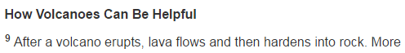  Read as:  How Volcanoes Can Be Helpful. (pause) After a volcano erupts, (short pause) lava flows and then hardens into rock.
Parentheses: Parentheses are used to enclose additional information, such as a comment, an example, or a brief explanation. When parentheses appear in test items, the Examiner does not read the parentheses. The Examiner will have a short pause before and after each parenthesis. | Example:  Read as:  A box, the following excerpt from a novel describes the experiences of a young girl growing up in South Boston, Massachusetts (short pause) (also known as Southie) (short pause), during the early nineteen hundreds.
Underlines: The Examiners should not emphasize the underlined individual words, sentences, or phrases within a test item. Underlines are read the same across items. In all grades and content areas, the Examiner will read “underline…stop underline.  An underline should not be read when it designates a prefix/suffix. The prefix or suffix should be read as separate letters. The Examiner should read the options exactly as written, using a natural tone, and without emphasizing the prefix/suffix in any word. | Example:  Read as:  …her words as Mrs. Watson continued to stare at her with an almost, underline, belligerent, stop underline, gaze.  Example:  Which word from the story uses –ing the same way it is used in enduring?  A. string  B. marching  C. anything  D. bring  Read as:  Which word from the story uses i-n-g the same way it is used in enduring?  - string  - marching  - anything  - bring

Reading Passages
All reading passages are read exactly as written. Examiners should not describe any pictures that accompany the passage. The following are examples of how reading passages must be read by the Examiner.
Note: The example provided is a set of paired reading passages, where students are presented with two reading selections and a set of test items based on each passage separately and test items based on both passages. Paired passages are one type of reading passage and only available on the Grades 5 through End-of-Course Reading tests.
Example 1: Paired Reading Passages
When reading paired passages, the Examiner should read the tab, the title, and the associated passage, and then read the next tab, title, and associated passage. Then read the test items that follow.
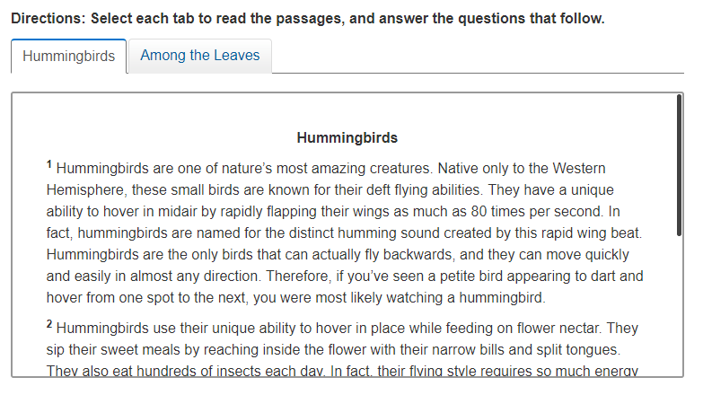

Directions:
- Directions for split passages will appear above the passage and should be read first.
- When paragraph numbers appear, the Examiner does not read the paragraph numbers in fiction or nonfiction text, nor in lines of poems.
Read as:
Directions: Select each tab to read the passages, and answer the questions that follow.
Hummingbirds (pause) Hummingbirds (pause) Hummingbirds are one of nature’s most amazing creatures. Native only to the Western Hemisphere, these small birds are known for their deft flying abilities. They have a unique ability to hover in midair by rapidly flapping their wings as much as 80 times per second. In fact, (pause) hummingbirds are named for the distinct humming sound created by this rapid wing beat. Hummingbirds are the only birds that can actually fly backwards, (pause) and they can move quickly and easily in almost any direction. Therefore, (pause) if you’ve seen a petite bird appearing to dart and hover from on spot to the next, (pause) you were most likely watching a hummingbird…

Note: Examiner should only re-read paragraph 1 if requested by the student.

Example 2: Authors and Footnotes
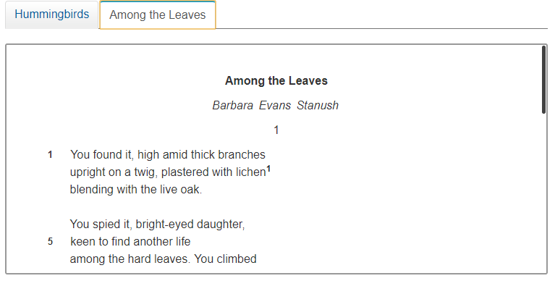
Authors
- If the author is listed under the title, the name will be in italics and read as “By…”

Read as:
Among the Leaves by Barbara Evans Stanush (pause).
You found it, high amid thick branches upright on a twig, plastered with lichen, One (pause) blending with the live oak…

Footnotes
Some reading passages contain footnote numbers in the passage. The text associated with the footnote number appears at the end of the passage. The Examiner should read the footnote text exactly as it appears when the Examiner arrives to the end of the text.

Read as:
One, lichen, a type of moss that grows on tree
Example 3: Cause-and-Effect Chart
Cause-and-Effect Chart:
- Read the direction of the chart (i.e. left to right, top to bottom) then read the cause-and-effect chart starting with cause, then moving through the effects.
- Arrows are NOT read in any reading items, including When/Then or summary items that do not have titles or labels that have arrows.

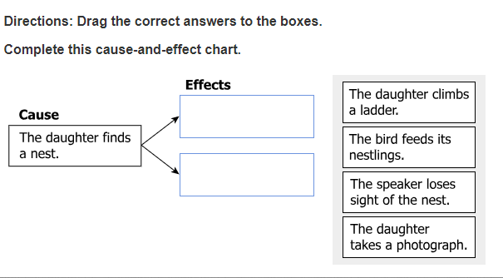

Read as:
Directions: Drag the correct answers to the boxes. Complete this cause-and-
effect chart.

At Left, Cause (pause) The daughter finds a nest. At right, Effects (pause) empty box, empty box.
Grey box, from top to bottom.
The daughter climbs a ladder.
The bird feeds its nestlings.
The speaker loses sight of the nest.
The daughter takes a photograph.

Example 4: Venn Diagram
Venn diagram
- Read the diagram starting with the title of the diagram then from the left circle. “At Left…” Read the title first then read the information inside the circle.
- Next, read the right circle, “At right…” Read the title first then the information inside the circle.
- Last, read the overlapping circle contents. “In overlap…”

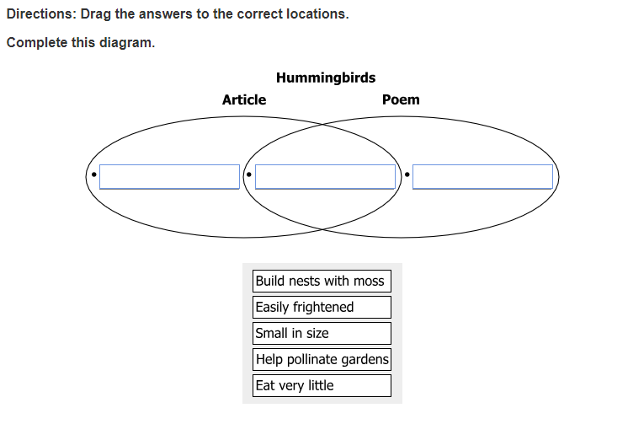

Read as:
Directions: Drag the answers to the correct locations. Complete this diagram.

A diagram titled Hummingbirds. At left, Article, bullet, empty box. At right, Poem, bullet, empty box. In overlap, bullet, empty box.

Grey box, from top to bottom. Build nests with moss, Easily frightened, Small in size, Help pollinate gardens, Eat very little.

Example 5: Boxes
All boxes are read when present in test items. This includes multiple-choice test items and technology-enhanced items (TEI).
- Empty boxes are referred to as “empty box.”
- All “empty boxes,” references should be preceded with a pause.
- For online tests, the dragger bay will be referred to as grey box.

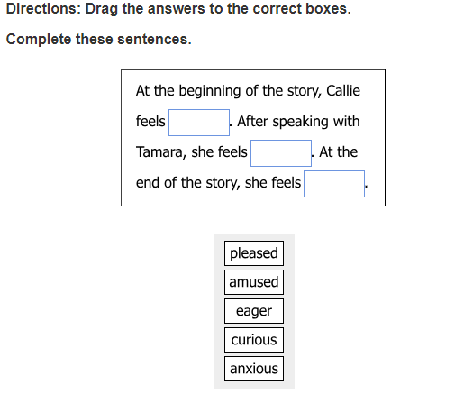

Read as:
Directions: Drag the answers to the correct boxes. Complete these sentences.

A box. At the beginning of the story, Callie feels, empty box. After speaking with Tamara, she feels, empty box. At the end of the story, she feels, empty box.

Grey box, from top to bottom. Pleased, amused, eager, curious, anxious.

Example 6: Boxes (continued)
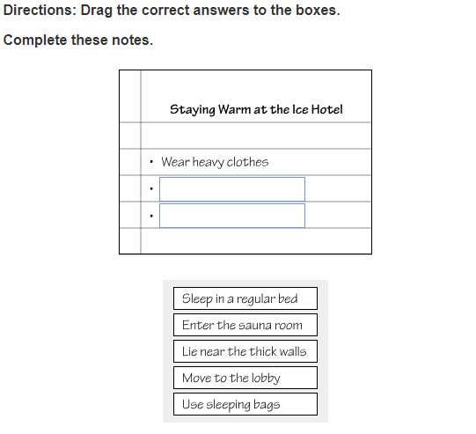

Read as:
Directions: Drag the correct answers to the boxes. Complete these notes.

Staying Warm at the Ice Hotel. Bullet, wear heavy clothes. Bullet, empty box. Bullet, empty
box.

Gray box, from top to bottom. Sleep in a regular bed, Enter the sauna room, Lie near the thick walls, Move to the lobby, Use sleeping bags.

Example 7: Tables
Tables
Tables in reading are generally referred to as charts. Below is an example.

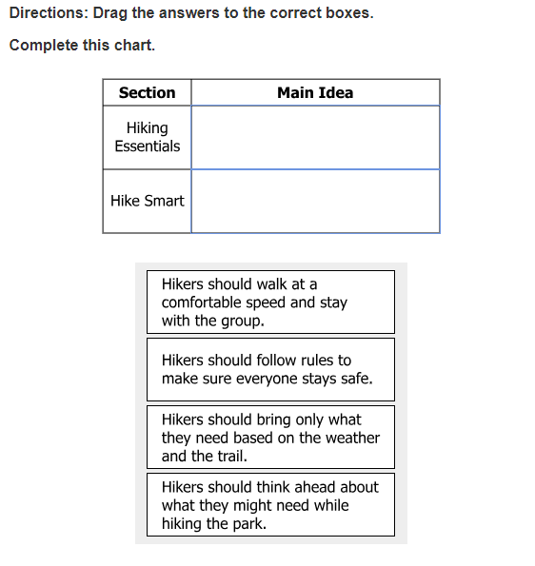

Read as:
Directions: Drag the answers to the correct boxes. Complete this chart.

A two-column chart, read left to right, top to bottom.

Section, Main Idea, Hiking Essentials, empty box, Hike Smart, empty box

Gray box, from top to bottom.
Hikers should walk at a comfortable speed and stay with the group.
Hikers should follow rules to make sure everyone stays safe.
Hikers should bring only what they need based on the weather and the trail.
Hikers should think ahead about what they might need while hiking the park.

Example 7: Tables Cont.
Match Table Grids like the one shown above should be read in the following manner, from left to right, top to bottom.

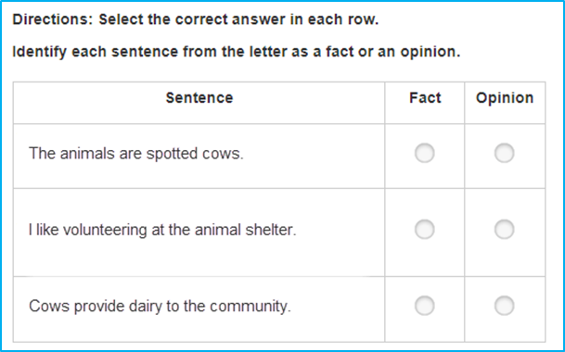
Note: In the online tests, text-to-speech will highlight what is reflected in the first column and drops the highlighting on the last two column headers. This type of highlighting does not occur in other Technology Enhanced Items (TEI) for reading.

Read as:
Directions: Select the correct answer in each row.
Identify each sentence from the letter as a factor an opinion.
A 3 column table.
Read left to right, top to bottom.
Sentence. Fact. Opinion.
The animas are spotted cows. Empty box, empty box.
I like volunteering at the animal shelter. Empty box, empty box.
Cows provide dairy to the community. Empty box, empty box.

Example 8: Dictionary Entry
The pronunciation key for dictionary items should NOT be read.
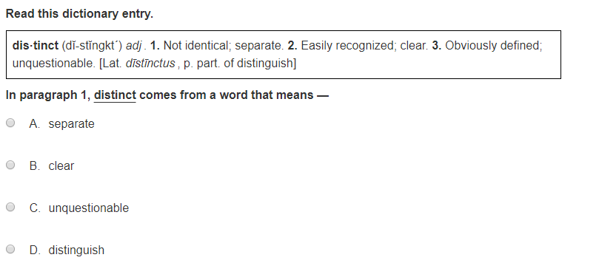

Read as:
Read this dictionary entry.
A box (pause) distinct, (pause) adjective (pause) One, Not identical; separate (pause) Two, Easily recognized; clear. (pause) Three, Obviously defined; unquestionable. Latin, distinctus, past participle of distinguish.
In paragraph one, underline, distinct, stop underline, comes from a word that means
A separate
B clear
C unquestionable
D distinguish

Example 9: Photographs
If a photograph has a title or caption, it should be read as, “A photograph titled…” or as “A photograph captioned….” The Examiner will direct the student: “Please refer to the photograph on your screen/in your test booklet.”
If the photograph does not have a title or caption, the Examiner should be read: “A photograph. Please refer to the photograph on your screen/in your test booklet.”

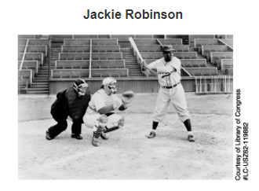
Read as:
A photograph titled Jackie Robinson. Please refer to the photograph on your screen.

Read-Aloud Guidance for SOL Writing Tests
Students who are determined eligible for the read-aloud accommodation on writing assessments may have test items read aloud to them for the multiple-choice/TEI and short-paper components of the SOL Writing tests. When providing the read-aloud accommodation on the multiple-choice/technology-enhanced item component, the following guidance is provided below.
The Examiner must:
- read all writing drafts (passages) exactly as written
- read sentence numbers as they appear in writing drafts before each sentence
- read the question first, then the multiple-choice answer options or related text for technology-enhanced items that ask a question specifically about a sentence or sentences within a writing draft

The Examiner must NOT:

- describe any pictures that accompany the passage.
- emphasize individual words or phrases that are underlined as part of test item or answer option.
- use voice inflection, word emphasis, or other reading styles, that can lead students toward a response or make the test content confusing.
- read the test question and insert the answer options or any related text for technology-enhanced items into the test question.
- explain, translate, or verbally interpret any portion of the test items or answer options. No assistance (e.g., defining words, substituting words, attempting to clarify the intent of test items, etc.) may be provided to students.
Note: At the student’s request, the Examiner may go back and re-read the sentences or paragraph(s) referenced in the test item, or may re-read any part of the text.

When providing the read-aloud accommodation on the short-paper component of the SOL Writing test, the Examiner must:
- go to the individual student’s work area and quietly read the prompt aloud to that student from the student’s test.
- follow the directions for the short-paper component located in the appropriate Examiner’s Manual for that test administration.
Note: The examiner is allowed to read-aloud the Checklist for Writers from the student’s test for online and paper.

The Examiner must NOT:
- answer questions pertaining to the prompt or assist with interpreting the prompt,
- engage in any discussion about the prompt or potential responses.

Read-Aloud Item Examples for Writing
The examples below are intended to assist Examiners in reading various writing items. Some items will have an explanation as to why the items are read a particular way and the possible issues that could arise when reading a specific type of item.
Text must be read exactly as written using a natural tone and manner. Other text is information for the Examiner and should not be read to students. If a mistake is made in reading a test item, the Examiner should stop and say, “No that is wrong. I must read it to you again.” Then re-read the test item.

Example 1: Writing Draft

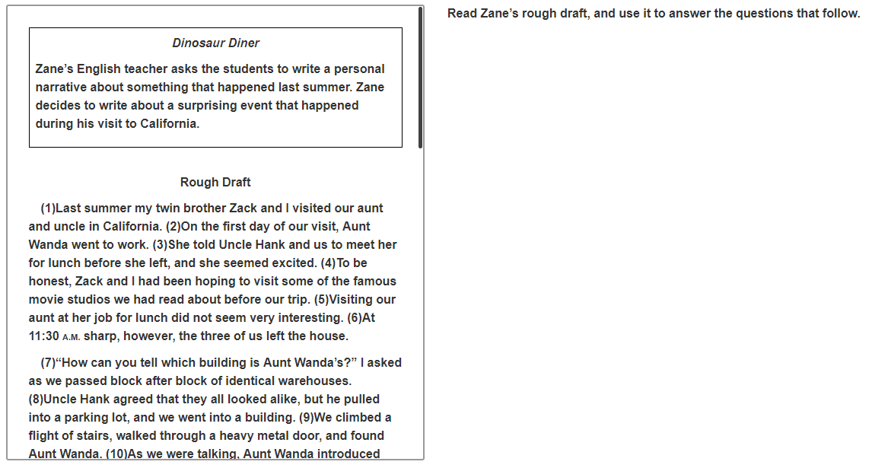
Note: The Examiner should read sentence numbers as they appear in passages before each sentence.
Read as:
Read Zane’s rough draft, and use it to answer the questions that follow.
A box (pause) Dinosaur Diner, (pause) Zane’s English teacher asks the students to write a personal narrative about something that happened last summer. Zane decides to write about a surprising event that happened during his visit to California.

Rough Draft, (pause) One (pause) Last summer my twin brother Zack and I visited our aunt and uncle in California. Two (pause) On the first day of our visit, Aunt Wanda went to work. Three (pause) She told Uncle Hank and us to meet her for lunch before she left, and she seemed excited…

Example 2: Underlined Text

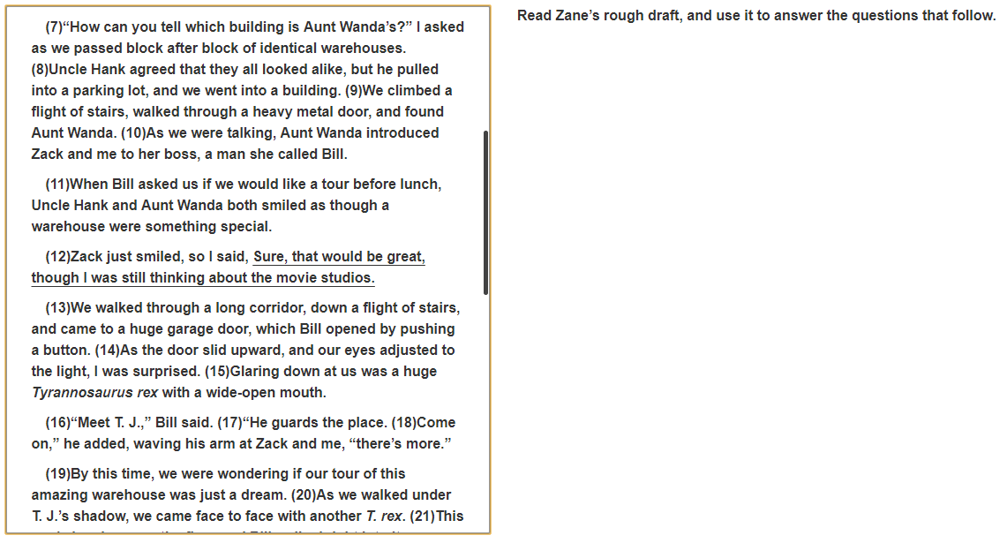

Note: the Examiner should not emphasize the underlined words, phrases, or sentences.

Sentence twelve in this example includes underlined text.

Read as:
…Twelve (pause) Zack just smiled, so I said, underline, Sure, that would be great, though I was still thinking about the movie studios, stop underline,…

Example 3: Text Boxes

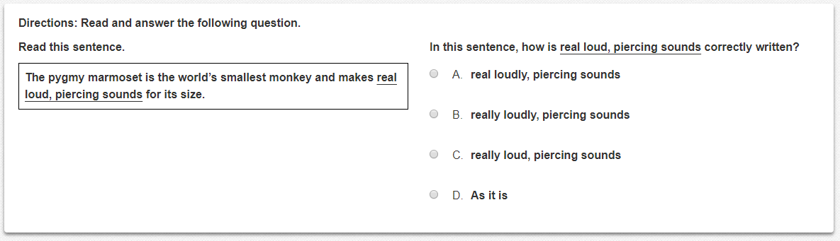

Read as:
Directions: Read and answer the following question.

Read this sentence. A box. The pygmy marmoset is the world’s smallest monkey and makes, underline, real loud (pause) piercing sounds, stop underline, for its size.

In this sentence (pause) how is, underline, real loud (pause) piercing sounds, stop underline, correctly written?

A real loudly (pause) piercing sounds
B really loudly (pause) piercing sounds
C really loud (pause) piercing sounds
D As it is

Read-Aloud Guidance for Mathematics

Growth Assessments and Standards of Learning (SOL) Tests
Students who are determined eligible for the read-aloud accommodation in mathematics may have test items read aloud to them. Mathematics tests can present unique challenges to examiners providing the read-aloud accommodation due to the use of numbers, symbols, and mathematical terminology in test items. The procedures for administering the read-aloud accommodation on mathematics tests are provided below.
The Examiner must
- understand what the test item is measuring to avoid clueing the student by reading the numbers in a specific way.
- In some many instances, refer the reader to a figure or drawing. It is appropriate for the Examiner to refer the student to the same figure or drawing immediately after reading the section of the test item that directs the student.
- Although many mathematics operations, tables, charts, graphs and signs are present in test items, the Examiner should ensure that reading information aloud does not clue the student to a response. When in doubt, the Examiner should use the statement, "Please refer to the ______ in your test book.” or “Please refer to the _____ on your screen.”

The Examiner must NOT:
- use voice inflection, word emphasis, or other reading styles, that can lead students toward a response or make the test content confusing.
- read the test question and insert the answer options or any related text for technology-enhanced items into the test question.
- explain, translate, or verbally interpret any portion of the test items or answer options. No assistance (e.g., defining words, substituting words, attempting to clarify the intent of test items, etc.) may be provided to students.
- read any part of an item would clue the student or violate the construct being measured. The examiner must say, “Please refer to the ___ on your screen”

Read-Aloud Guidance for Mathematics

Growth Assessments and Standards of Learning (SOL) Tests
The examples below are intended to assist examiners in reading various mathematics test items. Some examples have explanations as to why certain test items are read in a particular way and notes of issues that could arise when reading a specific item type. All test items are to be read exactly as written using a natural tone and manner.
Numbers
- Whole numbers should be read according to their common English usage as long as place value is not part of the test question.

- For example, the number 1,234 would be read as “one thousand two hundred thirty-four” if the test item was not assessing place value. The number 1,234 would be read as “one comma two three four” if the test item is assessing place value (i.e., “What is the value of the 2 in the number 1,234”).
Whole Numbers  (not assessing place value) |  |  |  |  |  | Whole Numbers  (assessing place value)
16 | Read as: Sixteen |  |  |  |  | 16 | Read as: one six
56 | Read as: Fifty- Six |  |  |  |  | 56 | Read as: five six
465 | Read as: Four Hundred Sixty Five |  |  |  |  | 465 | Read as: four six five
1,310 | Read as: One Thousand Three Hundred Ten |  |  |  |  | 1,310 | Read as: one comma three one zero
Large Whole Numbers
- Large whole numbers are read by referencing all of the number place values.
Large Whole Numbers  (all of the number’s place values) |  |  |  |  | Large Whole Numbers  (digit by digit)
123,456 |  | Read as: One hundred twenty-three thousand, four hundred fifty-six |  |  | 789,101 |  | Read as: Seven, eight, nine, comma, one, zero, one
Note: If reading the number as a whole number violates the construct being measured, read the number digit by digit.
Positive Numbers  If a positive sign precedes a number and is not a part of an operation, then read as “positive.” |  |  | Negative Numbers  Negative numbers should be read as “negative.” Do NOT read the negative sign as a minus sign.
+8 | Read as: positive eight |  | -5 |  |  |  | Read as: negative five
 |  |  | -4.31 |  |  |  | Read as: negative four point three one
Decimals
- Decimal numbers should be read using the word “point” for the decimal point. For example, the number 1.23 would be read as “one point two three.”
Decimal Numbers |  |  |  | Read as:
0.5 |  |  |  | zero point five
36.7 |  |  |  | thirty-six point seven
25.16 |  |  |  | twenty-five point one six
Repeating Zeros
- Six repeating zeroes or numbers before or after the decimal point, are read as “zero and three repeating.”

- More than six repeating zeroes or numbers after the decimal point (beyond millionths), the examiner will say, “point” and read the digits in order from left to right.

- Read “repeating” where “…” represents the number of group of numbers that repeats.
Repeating Zeros |  |  |  | Read as:
4.221 |  |  |  | Four point two two one
0.100000 |  |  |  | Zero point one zero zero zero zero zero
0.333… |  |  |  | Zero point three three three repeating
0.3 |  |  |  | Zero point three repeating
Percentages
- Percentages should be read as “percent.”
Percentages |  |  |  | Read as:
75% |  |  |  | seventy-five percent
2.5% |  |  |  | two point five percent
0.24% |  |  |  | zero point two four percent
Fractions
- Fractions should be read according to their common English usage.
- For example, the fraction ¾ should be read as “three fourths.”
Fractions |  |  |  | Read as:
$$\frac{1}{2}$$ |  |  |  | one-half
$$\frac{13}{28}$$ |  |  |  | thirteen twenty-eighths
$$3_{4}^{1}$$ |  |  |  | three and one-fourth
$${63}_{4}^{3}$$ |  |  |  | sixty-three and three-fourths
Currency (Money):
- Currency should be read as dollars and cents if there is a decimal point. Do NOT read shortcuts for numbers. For example, $0.25 should be read as “twenty-five cents” instead of “a quarter.”
- If the amount is less than a dollar, do NOT read the zero. For example, $0.45 cents is read as “forty-five cents” NOT “zero dollars and forty-five cents.”
Currency |  |  |  | Read as:
$3.25 |  |  |  | three dollars and twenty-five cents
$0.45 |  |  |  | forty-five cents
$5,325 |  |  |  | five thousand three hundred twenty-five dollars

Dates and Years:
- Read years in plain English, and read months as the full name, even if abbreviations are presented in text.
- Read days as you would when reading a date instead of reading the day as number. For example, read “second” instead of “two” and “third” instead of “three.”
Dates and Years | Read as:
1945 | nineteen forty-five
2008 | two thousand eight
Dec. 6, 2015 | December sixth, two thousand fifteen
Time:
- Read time without using shortcuts or reading the time in reference to a different version of time. For example, read “five forty-five” instead of “quarter of six,” and “five ten” instead of “ten after five.”
- Read a.m. and p.m. without adding language about the time of day. For example, read “8:00 a.m.” instead of “8 a.m. in the morning” and “10:00 p.m.” instead of “10:00 p.m. at night.”
Time | Read as:
9:00 a.m. | nine a.m.
6:30 p.m. | six thirty p.m.
Symbols and Operations
- Symbols and operations should be read according to their common English usage. For example, “>” should be read as “greater than” and “+” should be read as “plus.”
Symbols/Operations | Read as:
= | equals
≠ | not equal to
$$<$$ | less than
$$>$$ | greater than
≤ | less than or equal to
≥ | greater than or equal to
$$℉$$ | degrees Fahrenheit
$$℃$$ | degrees Celsius
$$π$$ | pi
$$\%$$ | percent
$$!$$ | factorial
$$∞$$ | infinity
$$μ$$ | mu
$$σ$$ | sigma
′ | prime
+ | plus
− | minus
÷ or ∕ | divided by
X or • | times
$$±$$ | plus or minus

Probability:
- Read as: “Probability of” (word in parentheses) “is” (remaining text).
- Do NOT read open parentheses/close parentheses.
Probability | Read as:
P (orange) = $\frac{1}{6}$ | Probability of orange is one-sixth
Exponents and Radicals:
- Read the base first. The base can be either a number or a variable.
- If the exponent has a value of 2, it is read as “squared” if applied to an integer or number.
- If the exponent has a value of 3, it is read as “cubed” if applied to an integer or number.
- If the exponent does not have a value of 2 or 3 and is used in an equation it is read as “to the power of.”
- Read all negative exponents as “y to the power of negative…”
- Radicals with an implied radical index of two are read as “the square root of x.”
- If the radical is part of a larger expression read “close square/cube root.”
- Read “log” followed by the base, the word “of,” and then the number or variable.
- If the log is shown without an explicit base, then read as “log” and the number or variable.
Exponents and Radicals | Read as:
4² | four squared or four to the second power
9³ | nine cubed or nine to the third power
5⁴ | five to power of four
√2 | the square root of two
3$\sqrt{2x-4}$ + 6 =3 | three times the square root of two x minus 4 close square root, plus six equals three
f (x) = 9 log ($\frac{2}{5 }$ x) +5 | f of x equals nine log of, left parenthesis, two fifths x, right parenthesis, plus five
Ratios:
- Read ratios as “the ratio x to y.”
Ratios | Read as:
3:5 | the ratio three to five
Absolute Value:
- Read as “the absolute value.”
- If the absolute value is part of a larger expression read “close absolute value.”
Absolute Value | Read as:
$$\left|5\right|$$ | the absolute value of five
$$\left|-16\right|$$ | the absolute value of negative sixteen
$$\left|2+7\right|$$ | the absolute value of two plus seven, close absolute value
Ordered Pairs:
- Read coordinate pairs as “ordered pair x, y.”
- If a list of ordered pairs is provided, “ordered pairs” will only be read once before the first ordered pair.
- A pause should be used between each ordered pair read.
Ordered Pair | Read as:
(4,2) | ordered pair four, two
(-2,4) | ordered pair negative two, four
{(2,3) (3,4) (4,5)} | The set or ordered pairs two, three. three, four. four, five.
Given: Circle W  W (-4,6) | Given circle W. Point W represented by the ordered pair negative four, six
The line y=x+3 passes through (2,4) | The line y equals x plus three passes through the point represented by the ordered pair two, four
Function Notation:
- Read the first letter shown, then the word “of” followed by the variable and/or number in parentheses.
- When the expression inside the parentheses is more complex or includes another function, use the same rule of reading the letter first, then the word “of” followed by the variable or expression in parentheses.
- When the inverse of function is presented, read it as “f inverse of x.”
Function Notation | Read as:
f (x) | f of x
f (g (x)) | f of g of x
f (x+1) | f of left parenthesis x plus one right parenthesis
f ⁻¹ (x) = -$\frac{2}{3}$x – 2 | f inverse of x equals negative two-thirds x minus two
Interval Notation:
- Read as “interval xxyy.”
- When union and intersection symbols appear in items, it should be read as “Please refer to the symbolic notation on your screen.”
- If the notation is in the multiple-choice answer options, do NOT read the symbolic notation.
Interval Notation | Read as:
[0,2) | Interval zero two
A. (-∞, -3]  B. [-3,0]  C. [0,2)  D. (2, ∞) | A. Interval negative infinity negative three  B. Interval negative three zero  C. Interval zero two  D. Interval two infinity
Logical Arguments:
Logical Arguments | Read as:
Implies ($→$) | p$→$ q Read as: if p then q
Equivalent ($↔$) | p$↔$ q Read as: p if and only if q
Therefore ($∴$) | $∴$ p $⋀$ q Read as: therefore p and q
Caret ($⋀$) | p $⋀$ q Read as: p and q
Reversed Caret ($⋁$) | p $⋁$ q Read as: p or q
Note: If reading the symbols as noted violates the construct tested, they should NOT be read.
Geometric Symbols:
- Geometric symbols should be read according to their common English usage.
Geometric Symbols | Read as:
$$\overset{⃡}{AB}$$ | line AB
$$\vec{AB}$$ | ray AB
$$\overline{AB}$$ | line segment AB
AB | the length of line segment AB or the distance from A to B
$$∠ ABC$$ | angle ABC
m$∠ABC$ | the measure of angle ABC
$$\hat{AB}$$ | arc AB
m$\hat{AB}$ | the measure of arc AB
$$△$$ | triangle
$$≅$$ | is congruent to
$$∥$$ | is parallel to
$$⊥$$ | is perpendicular to

Measurements:
- Read measurements by speaking the whole word the symbol represents.
Length (Metric) | Read as:
mm | millimeter
cm | centimeter
dm | decimeter
m | meter
dam | decameter
hm | hectometer
km | kilometer
Mass (Metric) | Read as:
mg | milligram
cg | centigram
dg | decigram
g | gram
dag | decagram
hg | hectogram
kg | kilogram
Volume (Metric) | Read as:
ml | milliliter
cl | centiliter
dl | deciliter
l | liter
dkl | dekaliter
hl | hectoliter
kl | kiloliter
Length ( US Customary) | Read as:
in | inch
ft | foot
yd | yard
mi | mile
Weight ( US Customary) | Read as:
oz | ounce
lb | pound
Volume (US Customary) | Read as:
oz | ounce
c | cup
pt | pint
qt | quart
gal | gallon

Volume and Area | Read as:
in3 | cubic inches or inches cubed
cm2 | square centimeters or centimeters squared

Tables, Graphs, Diagrams, and Plots
A read-aloud accommodation should not provide additional assistance with diagrams, charts, or tables by explaining them to students.
When reading an item with a complex diagram, the Examiner must only read the text contained in the diagram.
Tables:
There is more than one correct way to read tables, below are acceptable ways of reading tables:
- The Examiner may state rows in transition, for example: Header Row…Next Row…
- The Examiner may count the rows, for example: Row One…Row Two…
- The Examiner must pay attention to how tables are organized when determining how information is read. If there is a more logical manner to read a table due to its orientation, the Examiner may do so.
- Blank cells in a table should be read as “blank,” if this information is essential to answering the item.
- Cells with an underlined question mark should be read as “question mark.”

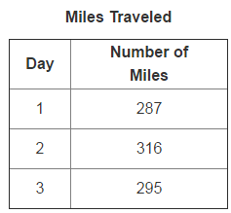

Read as:
A two column table titled Miles Traveled. Read left to right, top to bottom.
Day, Number of Miles
One, two hundred eighty-seven
Two, three hundred sixteen
Three, two hundred ninety-five

Graphs:
- When reading graphs, read the title first followed by the vertical axis and horizontal axis.
- If the x and y axis are present and labeled, they should be read as “vertical” and “horizontal” for consistency.
- Labels should be read from left to right or bottom to top when needed.
- Scale breaks should be read as “interrupted.” For example, “From zero interrupted to….”
- Circle graphs should be read as “A circle graph titled… Clockwise from top….”

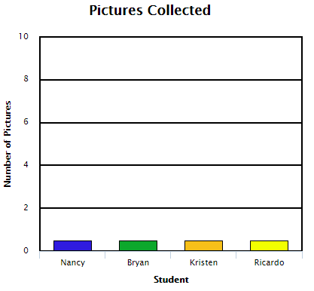
Read as:
A graph titled, Pictures Collected.
The vertical axis is number of pictures from zero to ten in labeled increments of
two.
The horizontal axis is student. From left to right, Nancy, Bryan, Kristen, Ricardo.

Histograms:
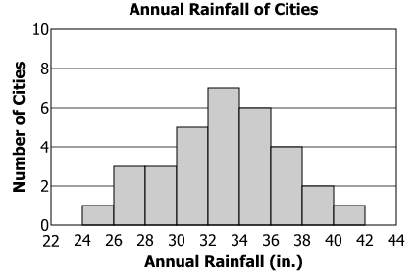
Read as:
A histogram titled, Annual Rainfall of Cities.
The vertical axis is number of cities from zero to ten in labeled increment of two.
The horizontal axis is annual rainfall (inches), from twenty-two to forty-four in labeled increments of two.
Scatterplots:
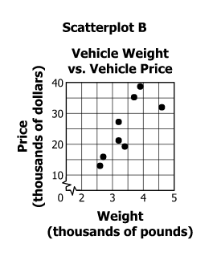
Read as:
Scatterplot B titled, Vehicle Weight versus Vehicle Price.
The vertical axis is price (thousands of dollars) from zero interrupted to ten and ten to forty in labeled increments of ten.
The horizontal axis is weight (thousands of pounds) from zero interrupted to two and two to five in labeled increments of one.
Pictographs:
- Read the title of the pictograph and then the key.
- Read the pictograph title then columns from left to right, followed by rows from top to bottom.
- When referencing the picture in the key use the term “represents.”
- If the stem says “pictograph,” refer to pictograph versus “graph.”
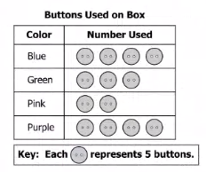
Read as:
A graph titled Buttons Used on Box.
Key. Each button represents five buttons.
A two column table from left to right. Color, Number Used.
Colors, from top to bottom, Blue, Green, Pink, Purple.

Spinners:
- Read the title of the spinner and reference it as a spinner.
- Words, numbers, or letters, within the spinner should NOT be read.
- Do NOT read the location of the arrow.
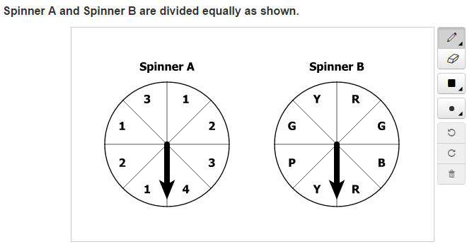
Read as:
At left, spinner A. At right, spinner B.
Graphs as Answer Options:
- If reading the answer options violates the construct tested, they should NOT be read.
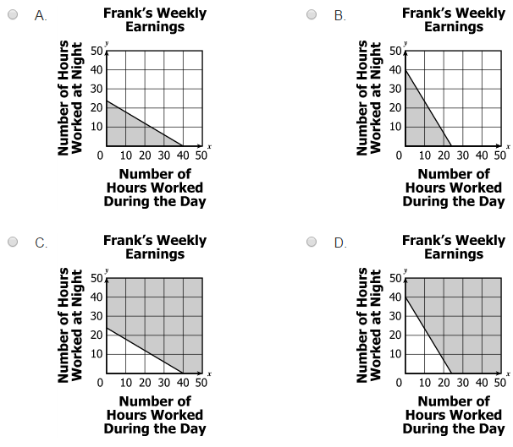
Read as:
Each graph is titled Frank’s Weekly Earnings.
The vertical axis is number of hours worked at night from zero to fifty in labeled increments of ten.
The horizontal axis is number of hours worked during the day from zero to fifty in labeled increments of 10.
Please refer to the graphs on your screen A, B, C, D or Please refer to the graphs in your test book A, B, C, D.

Boxplots:
- Read the title, and then read the labels of boxes.
- Always read as “boxplot,” NOT box and whisker plot.
- Read the range of the number line followed by the labeled increments.

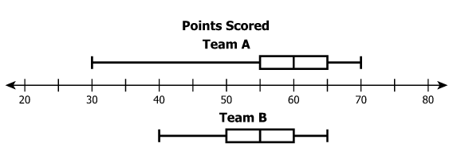
Read as:
Boxplot titled Points Scored.
First boxplot, Team A.
Last boxplot, Team B.
A number line from twenty to eighty in labeled increments of ten.

Line plots:
- Read the title, and then read the key.
- Read the range of the number line followed by the labeled increments.

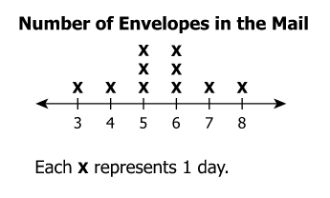
Read as:
Line plot titled Number of Envelopes in the Mail.
Key, each x represents one day.
A number line from three to eight in labeled increments of one.

Stem and Leaf Plot:
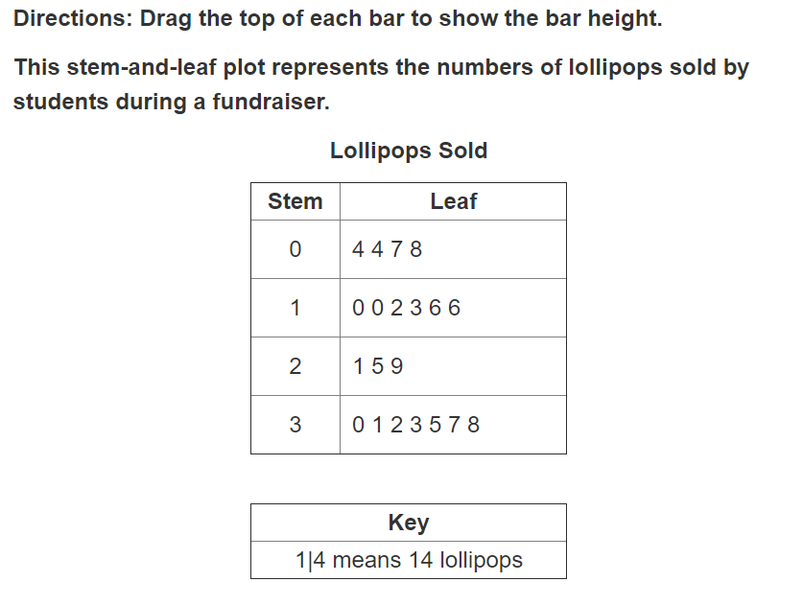
Read as:
Directions: Drag the top of each bar to show the bar height.
This stem-and-leaf plot represents the numbers of lollipops sold by students during a
fundraiser.

A stem-and-leaf plot title Lollipops Sold

(Read from left to right, top to bottom)

Row 1 Stem Leaf
Row 2 zero four four seven eight
Row 3 one zero zero two three six six
Row 4 two one five nine
Row 5 three zero one two three five seven eight

Key
Stem one means fourteen lollipops

Number Lines:
- Read the title of the number line, if present.
- Number lines are read as “number lines,” unless the stem refers to the number line as a graph.
- Read the range of numbers on the bottom of the number lines along with the increments. Only labeled increments should be referenced.
Note: Number lines that are not consistently labeled in specific increments will have the labels read from left to right.

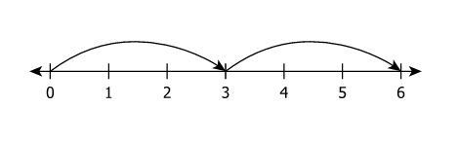
Read as:
A number line from zero to six in labeled increments of one.

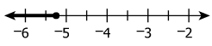
Read as:
A number line from negative six to negative two in labeled increments of one.
Read as:
A number line labeled from left to right, negative five, negative four, negative two.

Coordinate Grids:
- Coordinate grids are read as “graphs.”
- When reading coordinate grids, do NOT reference any lines or points unless they are labeled.
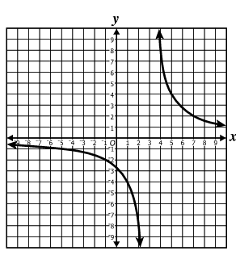
Read as:
A graph. Please refer to the graph on your screen.

Models:
- In models, titles should be read only if they are not referenced in the stem or in the answer options.
- If a key is present, the key should be read first.
- If no description is provided in the stem, the Examiner should state, “Please refer to the figure on your screen,” or “Please refer to the figure in your test book.”

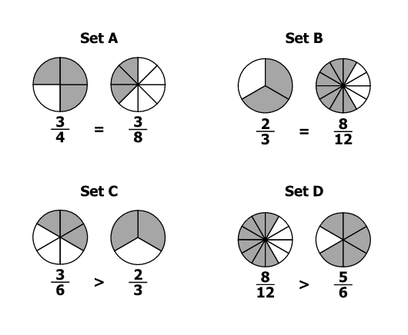
Read as:
Please refer to the sets on your screen.

Models (continued):
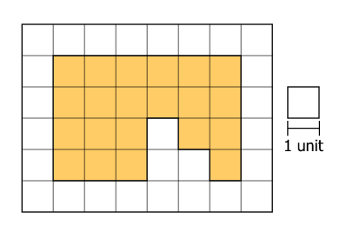
Read as:
Key, the scale equals one unit.

Keys and Legends:
- Keys and legends should be read after the title of a graph/diagram
- Keys should be read first regardless of where they appear in the item.
- Graphs, diagrams, and equations should NOT be read using key symbols.
- Keys are read last in Stem and Leaf plots to highlight when the stem and leaf plot is in text.

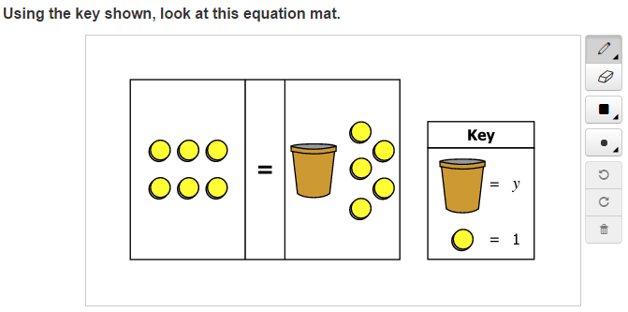

Read as:
Key, Cup equals y. Circle equals one.
Keys and Legends (continued):
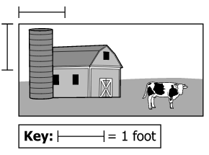
Read as:
Key, scale equals one foot.

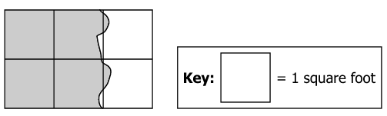
Read as:
Key, one unit square equals one square foot.

Thermometer:
- Read as “thermometer,” indicating degrees Fahrenheit or degrees Celsius depending on the item.
- Read the range from bottom to top. Only labeled increments should be referenced.

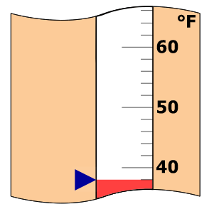
Read as:
A thermometer in degrees Fahrenheit from forty at bottom to sixty at top, in labeled increments of ten.

Summation:
- Read as “the sum of (equation below symbol) to (number above symbol).”
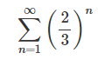
Read as:
The sum of n equals one to infinity, left parenthesis two-thirds right parenthesis, to the power of n.

Illustrations with Labels:
- If no description is provided in the stem, the Examiner should say, “Please refer to the figure on your screen,” or “Please refer to the figure in your test book.”
- If the figure is named in the stem with three or more letters, a pause should be included between each letter.

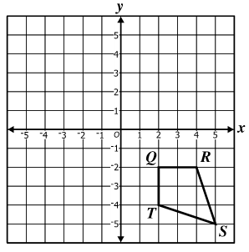
Read as:
A graph. Please refer to the figure on your screen.

Currency
Describe money using standard language (penny, dime, quarter, or dollar).
- read each currency symbol as a symbol and not interpret the value. (e.g., two quarters instead of fifty cents, or three dimes instead of thirty cents).
- If reading the currency symbols violates the construct being measured, they should not be read.

- 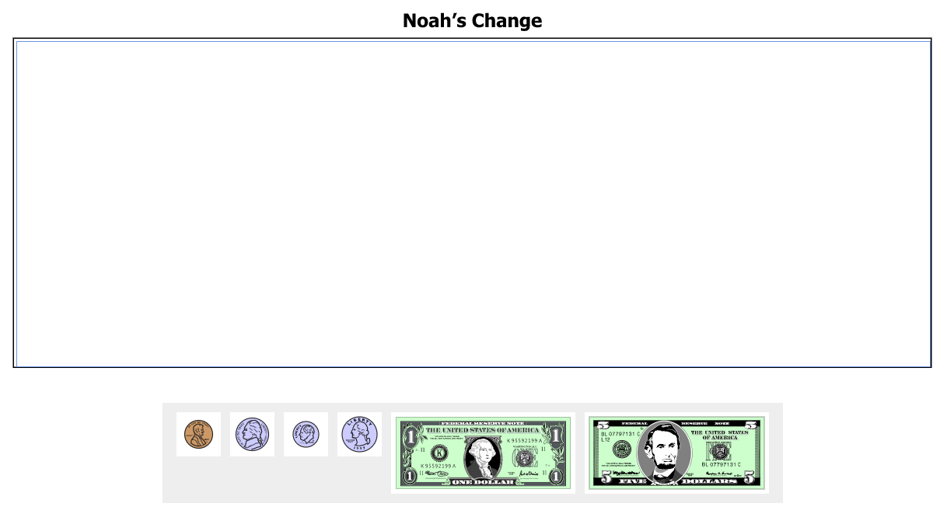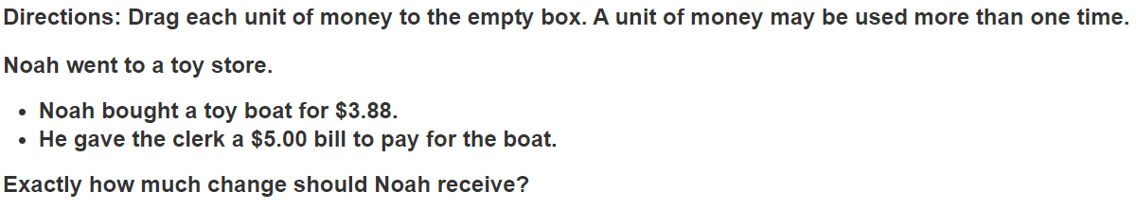Read as:
Directions: Drag each unit of money to the empty box. A unit of money may be used more than one time.
Noah went to a toy store.
Bullet: Noah bought a toy boat for $3.88.
Bullet: He gave the clerk a $5.00 bill to pay for that boat.
Exactly how much change should Noah receive?
Noah’s Change Empty Box
Grey box. Please refer to the money on your screen.

Mathematics Read-Aloud Item Examples:
The examples on the following pages are test items from released test forms and practice items and are intended to assist Examiners in reading various mathematics items. Some items have an explanation as to why the items are read a particular way and the possible issues that could arise when reading a specific type of item.
Text must be read exactly as written using a natural tone and manner. Other text is information for the Examiner and should NOT be read to students. If a mistake is made in reading a test item, the Examiner should stop and say, “No, that is wrong. I must read it to you again.” Then re-read the test item.

Example 1: Sets
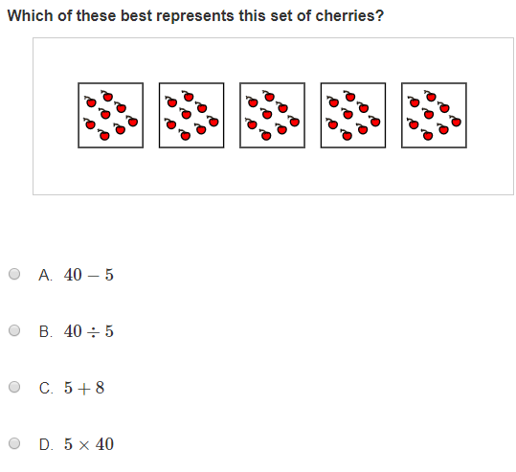

Read as:
Which of these best represents this set of cherries?

A. Forty minus five
B. Forty divided by five
C. Five plus eight
D. Five times forty

Example 2: Patterns
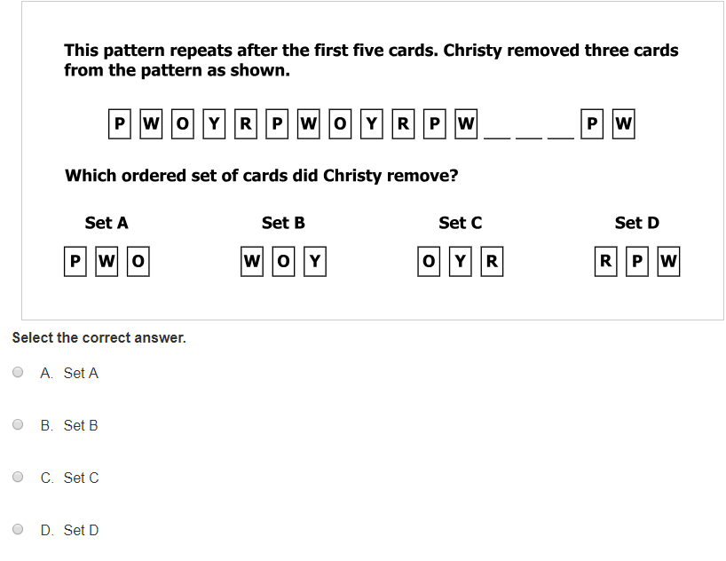
Read as:
This pattern repeats after the first five cards. Christy removed three cards from the
pattern as shown.
Which ordered set of cards did Christy remove?
Please refer to the sets on your screen or Please refer to the sets in your test book.
Select the correct answer

A Set A
B Set B
C Set C
D Set D

Example 3: Expressions
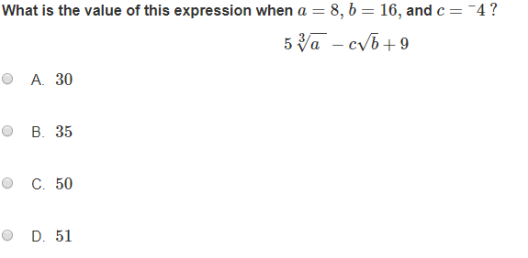

Read as:
What is the value of this expression when a equals eight, b equals 16, and c
equals negative four?

Five times the cube root of a, close cube root, minus c times the square root of b, close square root, plus 9

A 30
B 35
C 50
D 51

Example 4: Solution Set

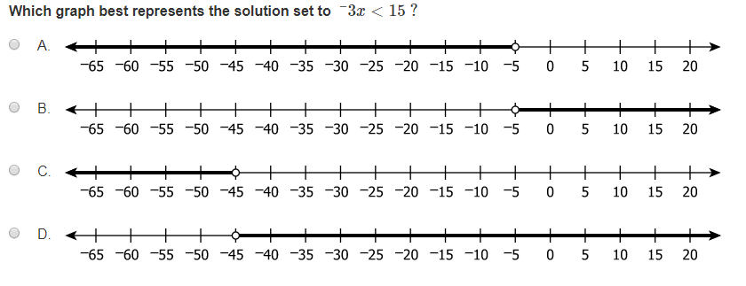
Read as:
Which graph best represents the solution set to negative three x is less than fifteen?
Each number line is from negative sixty-five to twenty in labeled increments of five.
A, B, C, D

Example 5: Triangles

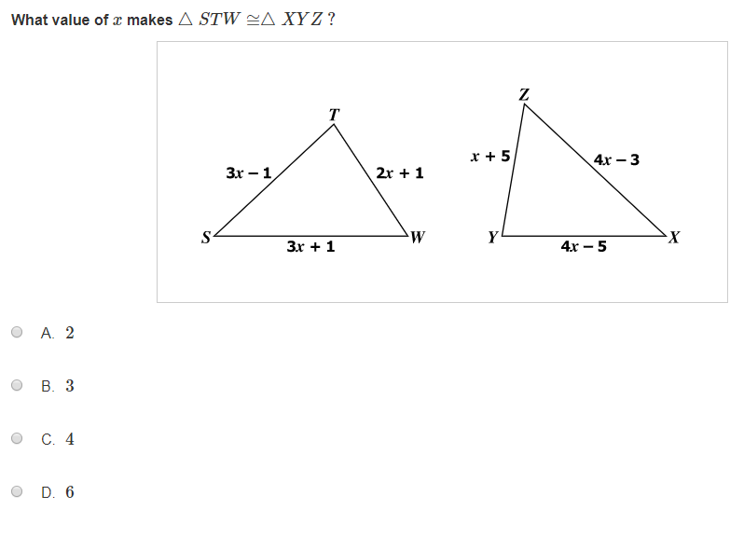
Read as:
What value of x makes triangle STW congruent to triangle XYZ?
A 2
B 3
C 4
D 6

Example 6: Vertices

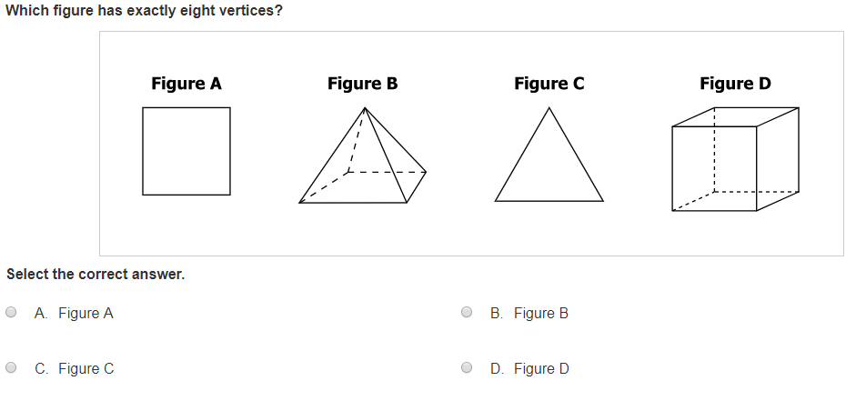

Read as:
Which figure has exactly eight vertices?
Please refer to the figures on your screen or Please refer to the figures in your test book.
Select the correct answer.
A Figure A
B Figure B
C Figure C
D Figure D

Read-Aloud Guidelines for SOL Science Assessments
Students who are determined eligible for the read-aloud accommodation on Science assessments may have test items read aloud to them. Science test can present unique challenges to examiners providing the read-aloud accommodation due to the use of abbreviations and scientific symbols in test items, guidance and examples are provided.
Some test items may contain graphic representations as part of the item or as answer options. In these instances, it is always safer to simply refer the student to the graphics or art contained in the item or answer options.
The Examiner must:
- read symbols or processes that will not lead the student to an answer.
- read quantity abbreviations as words unless the item specifically asks which abbreviation means the word. For example, L is read as liter and m\s is read as meters per second.
- read symbols of elements as printed.
- read a unit of quantity that is one or fewer, as a singular quantity. For example, liter, milligram, meter, and gram.
- only read text contained in the diagram. For items containing complex maps, it may be impossible to accurately read the contents of the map aloud without making the question too complex to understand. In these cases, use the statement, "Please refer to the ______on your screen."

The Examiner must NOT:
- read the name of the element unless it is spelled out.
- refer to the "beginning and ending" or "starting at" and "ending with" when reading
time charts or timelines. These terms may clue an answer. The Examiner should read
the question silently first and make a judgment on the best way to read the question
without clueing an answer.
- interpret or describe the graphics or art contained within an item.
- provide additional assistance with diagrams, charts, or tables by having them
explained.
- emphasize underlined individual words or phrases as part of the item or answer
options
- explain, translate, or verbally interpret any portion of the test items or answer
options. No assistance (e.g., defining words, substituting words, attempting to clarify
the intent of test items, etc.) may be provided to students.
- read the test question and insert the answer options or any related text for
technology-enhanced items into the test question.
- use voice inflection, word emphasis, or other reading styles, that can lead students
toward a response or make the test content confusing.

Read-Aloud Guidance for Science
The examples on the following pages are test items from released test forms and practice items, and are intended to assist Examiners in reading various science items. Some items will have an explanation as to why the items are read a particular way and the possible issues that could arise when reading a specific type of item.
All statements that the Examiner must read aloud to the students must be read exactly as written using a natural tone and manner. If a mistake is made in reading a test item, the Examiner should stop and say, “No that is wrong. I must read it to you again.” Then re-read the test item.
Measurements:
- Read measurements by speaking the whole word the symbol represents.
Length (Metric) | Read as:
mm | millimeter
cm | centimeter
dm | decimeter
m | meter
dam | decameter
hm | hectometer
km | kilometer

Mass (Metric) | Read as:
mg | milligram
cg | centigram
dg | decigram
g | gram
dag | decagram
hg | hectogram
kg | kilogram

Volume (Metric) | Read as:
ml | milliliter
cl | centiliter
dl | deciliter
l | liter
dkl | dekaliter
hl | hectoliter
kl | kiloliter

Length ( US Customary) | Read as:
in | inch
ft | foot
yd | yard
mi | mile

Weight ( US Customary) | Read as:
oz | ounce
lb | pound

Volume (US Customary) | Read as:
oz | ounce
c | cup
pt | pint
qt | quart
gal | gallon

Volume and Area Measurements | Read as:
in³ | cubic inches or inches cubed
cm² | square centimeters or centimeters squared

Speed | Read as:
rpm | revolutions per minute
mph | miles per hour

Temperature | Read as:
$$℃$$ | degrees Celsius
$$℉$$ | degrees Fahrenheit
K | Kelvin
T | absolute temperature

Pressure | Read as:
psi | pounds per square inch
atm | atmospheres
kpa | kilopascals

Time | Read as:
msec | millisecond
sec | second
mya | millions of years ago

Miscellaneous | Read as:
ac | alternating current
dc | direct current
bp | boiling point
mp | melting point
v | volt
w | watt
kw | kilowatt
kwh | kilowatt hour
mol wt | molecular weight
sd | standard deviation
Db | decibel
Hz | hertz
ppm | parts per million
STP | standard temperature and pressure

Example 1: Paired Passages
The example provided is a paired reading passages, where students are presented with two reading selections and a set of test items based on each passage separately and test items based on both passages.
Example 1: Paired Reading Passages
When reading paired passages, the Examiner should read the tab, the title, and the associated passage, and then read the next tab, title, and associated passage. Then read the test items that follow.
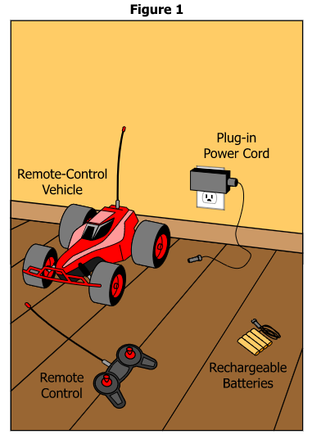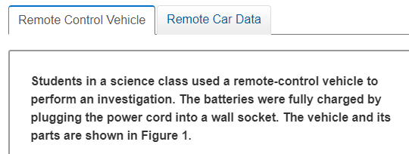

Read as:
Remote- Control Vehicle
Students in a science class used a remote-control vehicle to perform an investigation. The batteries were fully charged by plugging the power cord into a wall socket. The vehicle and its parts are shown in Figure 1.
A diagram title Figure 1 (read clockwise from top)
Plug-in Power Cord, Rechargeable Batteries, Remote Control, Remote-Control Vehicle
Please refer to the figure on your screen.

Example 1: Paired Passages (continued)
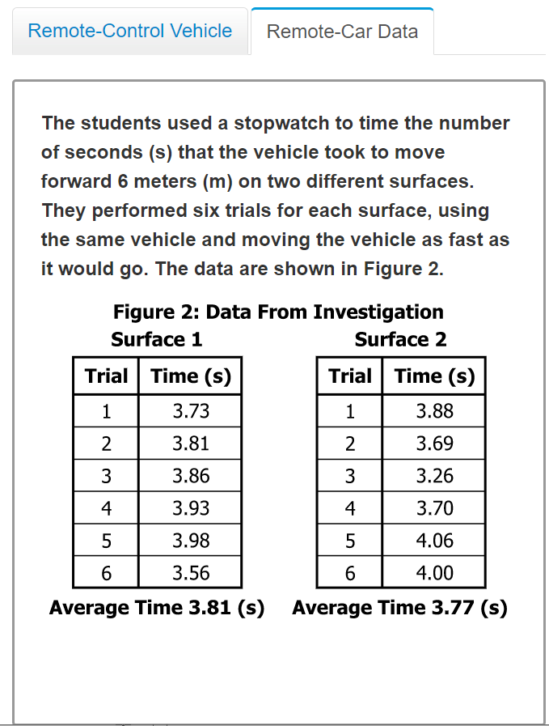

Read as:
Remote-Car Data
The students used as stopwatch to time the number of second(s) that the vehicle took to move forward 6 meters (m) on two different surfaces. They performed six trials for each surface, using the same vehicle and moving the vehicle as fast it would go. The data are shown in Figure 2.
Two table titled Figure 2: Data From Investigation
At left a two-column table titled, Surface 1
(Read the table from left to right, top to bottom)
Trial, Time, seconds,; One, three point three seven; Two, three point eight one; Three, three point eight six; Four, three point nine three; Five, three point nine eight; Six, three point five six
Average Time three point eight one seconds
At right a two-column table titled, Surface 2
(Read the table from left to right, top to bottom)
Trial, Time, seconds; One, three point eight eight; Two, three point six nine; Three, three point two six; Four, three point seven zero; Five, four point six; Six, four point zero zero
Average Time three point seven seven
Please refer to the figure on your screen.

Example 3: Drop down
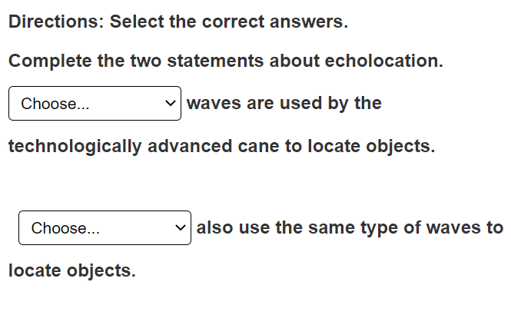
Read as:
Directions: Select the correct answers
Complete the two statements about echolocation.

Choose… (the drop down is read Electromagnetic, Compression, Seismic) waves are used by the technologically advanced cane to locate objects.

Choose… (the drop down is read Radios, Microwave Ovens, Submarines) also use the same type of waves to locate objects.

Example 4: Diagram

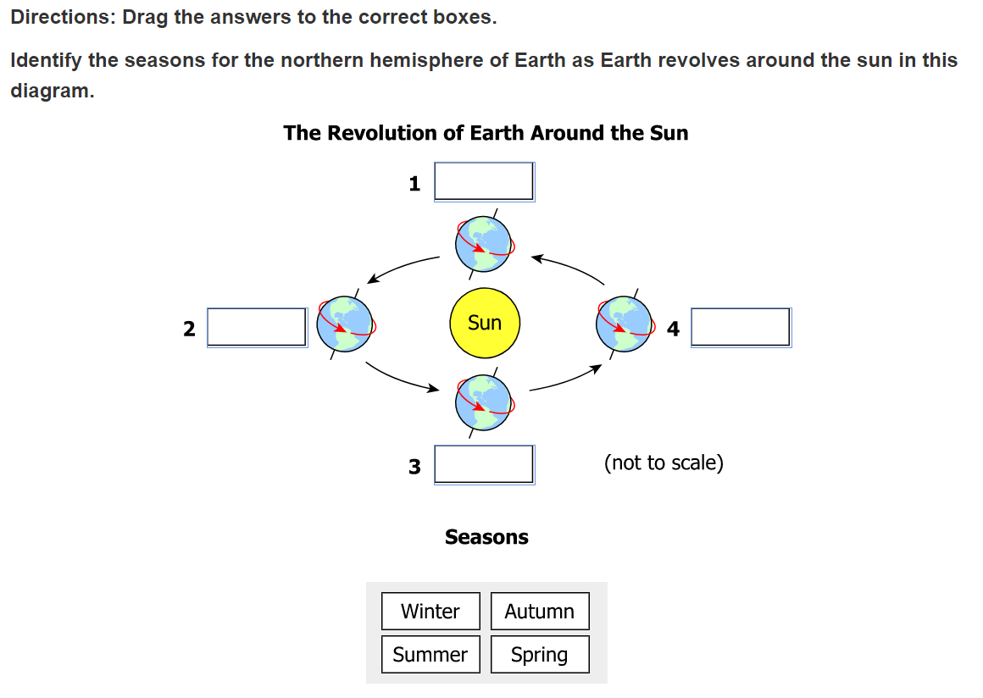
Read as:
Directions: Drag the answers to the correct boxes.
Identify the seasons for the northern hemisphere of Earth as Earth revolves around the sun in this diagram.
A diagram titled, The Revolution of Earth Around the Sun
(Read clockwise from left to right, top to bottom)
One, empty box, four empty box, open parenthesis not to scale close parenthesis, three, empty box, two empty box

A grey box titled seasons (read left to right, top to bottom)
Winter, Autumn, Summer, Spring
Please refer to the diagram on your screen.

Example 5: Illustration
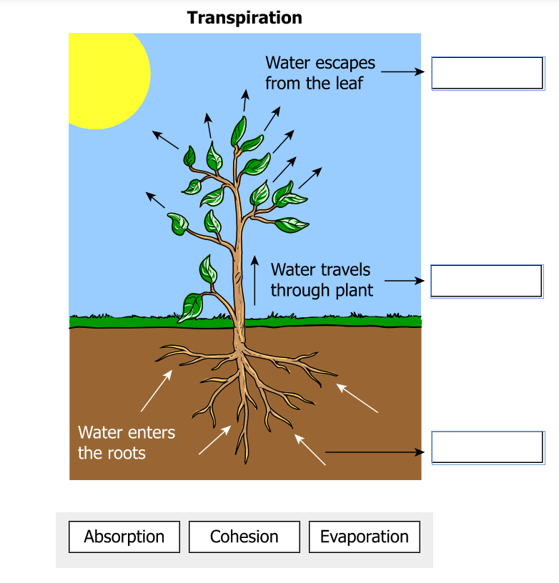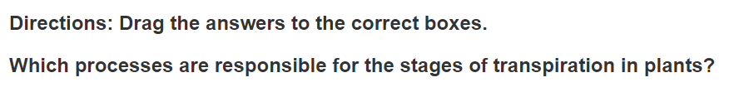

Read as:
Directions: Drag the answers to the correct boxes.
Which processes are responsible for the stages of transpiration in plants?
A diagram titled transpiration from bottom to top.
Water enters the roots, empty box.
Water travels through the plant, empty box.
Water escapes from the leaf, empty box.
Please refer to the illustration on your screen.

Read-Aloud Guidance for SOL History/Social Science Assessments
Students who are determined eligible for the read-aloud accommodation on History/Social Science assessments may have test items read aloud to them. History/Social Science test items can include a variety of maps, charts, diagrams, and tables. These items require attention from the Examiner prior to being read aloud to the student. Guidelines are provided below.

The Examiner Must:
- be familiar with all symbols that are included in a specific type of test question.
- read text in maps, charts, diagrams, and tables. Maps, charts, diagrams and tables should be read in the order that is most relevant for that individual item.
- ensure that reading information aloud does not clue the student to a response.

The Examiner must NOT:
- describe or interpret information contained in maps, charts, diagrams, and tables in any way.
- describe or interpret information contained in a photograph. An attempt to describe or interpret information in a photograph could clue the student to a response.
- use voice inflection, word emphasis, or other reading styles, that can lead students toward a response or make the test content confusing.
- read the test question and insert the answer options or any related text for technology-enhanced items into the test question.
- explain, translate, or verbally interpret any portion of the test items or answer options. No assistance (e.g., defining words, substituting words, attempting to clarify the intent of test items, etc.) may be provided to students.
- read any part of an item would clue the student or violate the construct being measured. The examiner must say, “Please refer to the ___ on your screen”

History/Social Science Read-Aloud Item Examples
The examples on the following pages are test items from released test forms and practice items and are intended to assist teachers, administrators, and other school personnel in reading various history/social science items. Some items will have an explanation as to why the items are read a particular way and the possible issues that could arise when reading a specific type of item.
This text must be read exactly as written using a natural tone and manner. Other text is information for the Examiner and should not be read to students. If a mistake is made in reading a test item, the Examiner should stop and say, “No that is wrong. I must read it to you again.” Then re-read the test item.

Example 1: Timelines
- Timelines should be read “A timeline entitled…” from left to right.
- The year label will be read first, followed by the description of the event for each entry on the timeline.
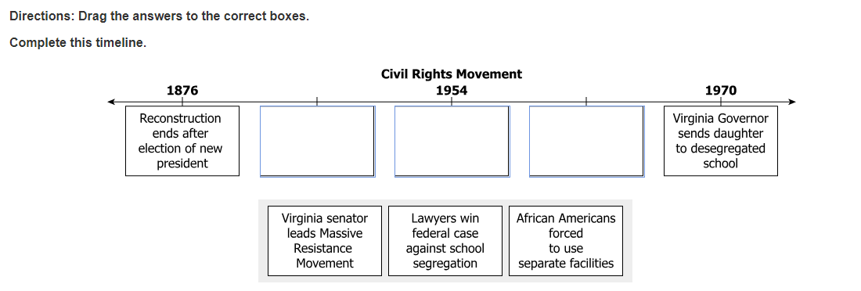
Read as:
Directions: Drag the answers to the correct boxes. Complete this timeline.
A timeline entitled Civil Rights Movement.
From left to right. Eighteen-seventy-six, Reconstruction ends after election of new president. Empty box, Nineteen fifty-four, empty box. Empty box, Nineteen-seventy, Virginia Governor sends daughter to desegregated school.
A gray box from left to right.
Virginia senator leads Massive Resistance Movement.
Lawyers win federal case against school segregation.
African Americans forced to use separate facilities

Example 2: Headlines
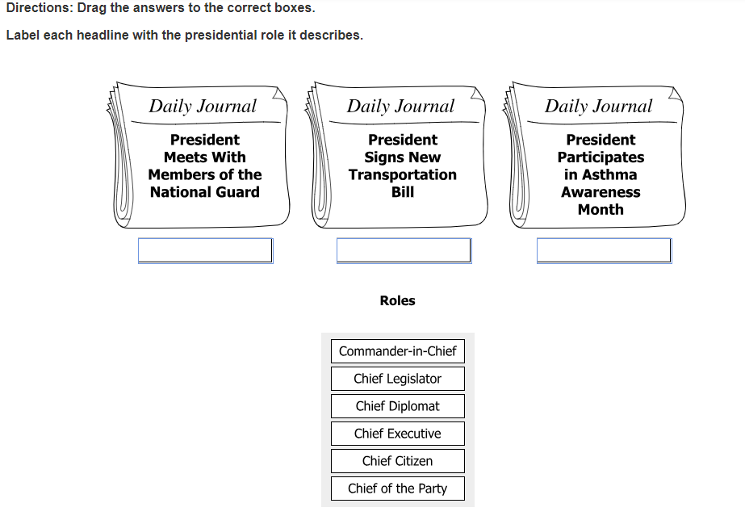
Read as:
Directions: Drag the answers to the correct boxes. Label each headline with the presidential role it describes.
From left to right. At left, Daily Journal, President Meets With Members of the National Guard, empty box. At Center, Daily Journal, President Signs New Transportation Bill, empty box. At right, Daily Journal, President Participates in Asthma Awareness Month, empty box.
Roles
Gray box, from top to bottom.
Commander-in-Chief
Chief Legislator
Chief Diplomat
Chief Executive
Chief Citizen
Chief of the Party

Example 3: Drawings
Drawings, illustrations, and pictures with labels should be read from left to right, top to bottom.

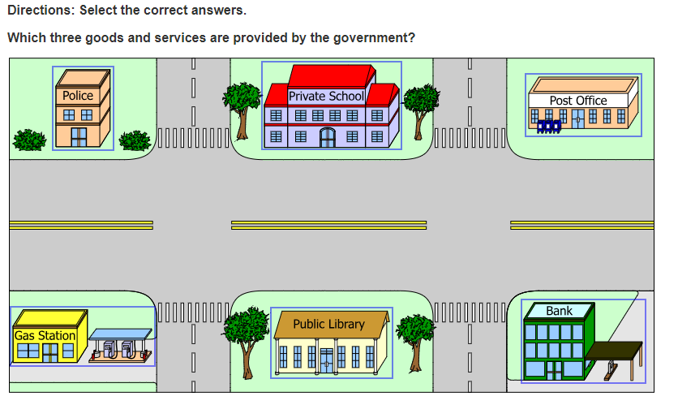
Read as:
Directions: Select the correct answers
Which three goods and services are provided by the government?
A drawing. At top, from left to right, Police, Private School, Post Office.
At bottom, from left to right, Gas Station, Public Library, Bank.

Example 4: Diagrams
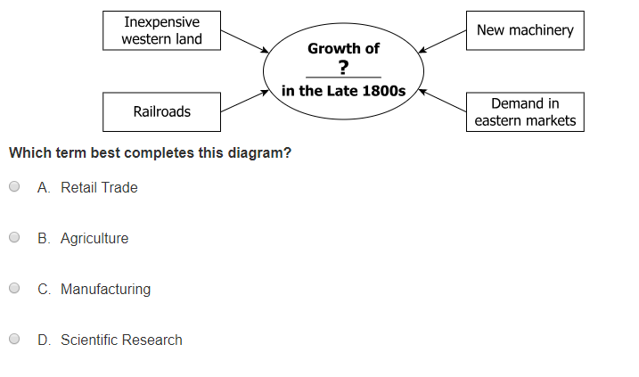
Read as:
A diagram, at left, Inexpensive western land, Railroads. At center, Growth of, question mark, in the Late 1800s.
At right, New machinery, Demand in eastern markets.
Which term best completes this diagram?
A Retail Trade
B Agriculture
C Manufacturing
D Scientific Research

Example 5: Chart

Charts:
- Charts are read from top “at top,” to bottom, “at bottom.”

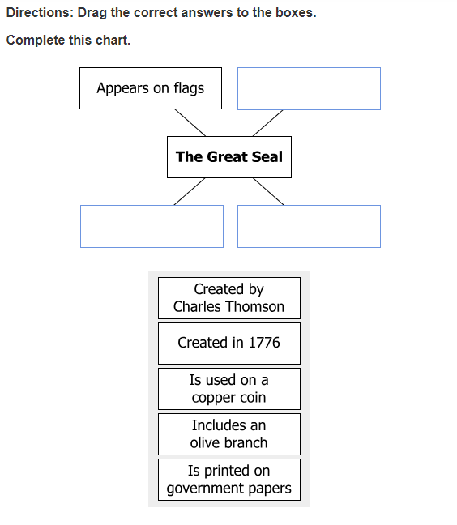

Read as:
Directions: Drag the correct answers to the boxes. Complete this chart.
At top, from left to right, Appears on flags, empty box. At center, The Great Seal. At bottom from left to right, empty box, empty box.
Gray box, from top to bottom.
Created by Charles Thomson
Created in 1776
Is used on a copper coin
Includes an olive branch
Is printed on government papers

Example 6: Maps

- Art, illustrations, and landmarks on maps should NOT be read.
- Map legends should NOT be read.
- For many items containing complex maps, it may be impossible to accurately read aloud the contents of the map without making the question too complex for the student to understand. In these cases, use the statement, "Please refer to the map in your test book,” or “on your screen.”

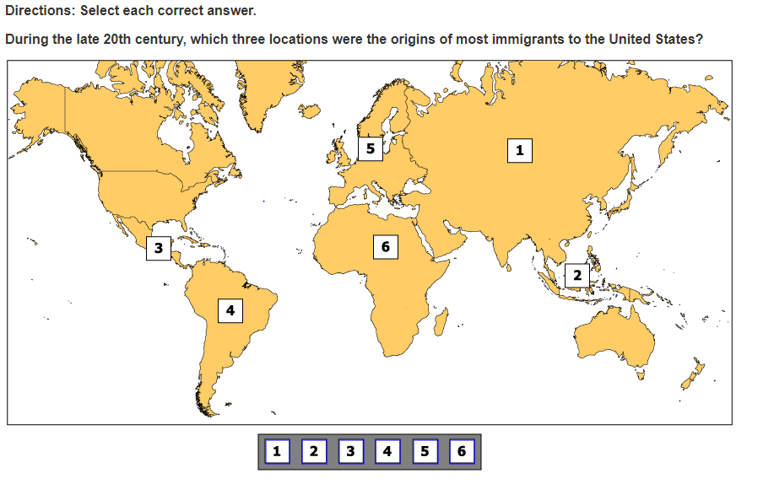
Read as:

Directions: Select each correct answer.
During the late 20th century, which three locations were the origins of the most immigrants to the United States?
A map with labels one through six. Gray box, from left to right, one, two, three, four, five, six.

Example 7: Maps

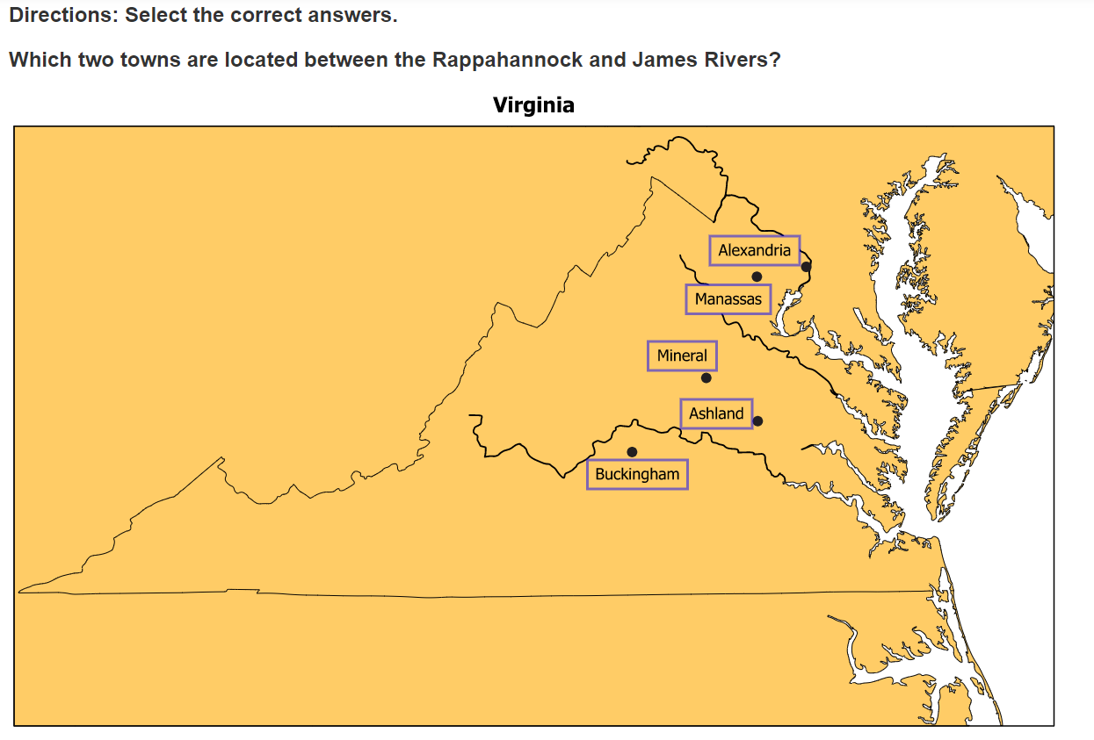

Read as:
Directions:
Select the correct answers.
Which two towns are located between the Rappahannock and James Rivers?
A map titled, Virginia
Labels read from top to bottom
Alexandria
Manassas
Mineral
Ashland
Buckingham
Please refer to the map on your screen.

Read-Aloud Guidelines for Technology-Enhanced Items (TEI)
Technology-enhanced items (TEI) are computer delivered items that allow students to indicate their responses in ways other than multiple-choice formats. TEI types include formats such as drag-and-drop, hot text, hot spot, bar graph or histogram, and fill-in-the-blank. These types of items are used in all content area Standards of Learning (SOL) assessments. Guidelines for administering the read-aloud accommodation for the TEIs are provided on the following pages.
Some items contain directions that appear on the top of the screen. If directions are provided, they must be read by the Examiner.
- In items that contain highlighting or underlining, the Examiner must state highlighting or underlining before and after each word(s) that contains highlighting or underlining.
- Examiners must not describe any pictures that accompany the item. Students should be referred to the screen.

The following items are intended to assist Examiners with how to read the various TEI types found in the SOL tests. Some items include an explanation of why the items are read a particular way and possible issues that could arise when reading a specific type of item.

Example 1: Hot Text
Hot text should be read like all other words in the selection.
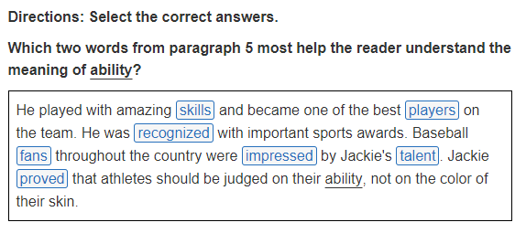
Read as:
Directions: Select the correct answers.
Which two words from paragraph 5 most help the reader understand the meaning of, underline, ability, stop underline?
A box, He played with amazing skills and became one of the best players on the team. He was recognized with important sports awards. Baseball fans throughout the country were impressed by Jackie’s talent. Jackie proved that athletes should be judged on their, underline, ability, stop underline, not on the color of their skin.

Example 2: Hot Spot (Complex)

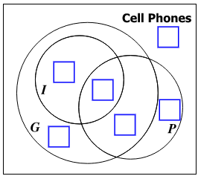

Read as:
Refer to the empty boxes in the diagram.

Example 3: Number Line
- Read number line per the number line entry.
- Read “a box” and the number of rays for the answer options.

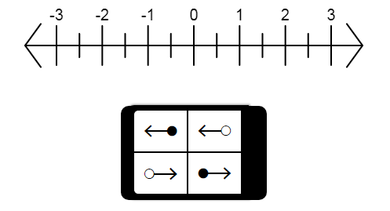

Read as:
A number line from negative three to three in labeled increments of one.
A box, four rays

Example 4: Drag-and-Drop
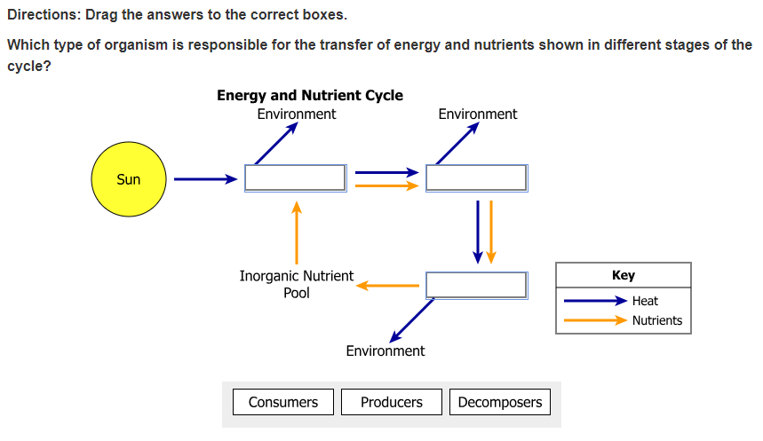
Read as:
Directions: Drag the answers to the correct boxes.
Which type of organism is responsible for the transfer of energy and nutrients shown in different stages of the cycle?
A diagram titled, Energy and Nutrient Cycle.
At top, from left to right. Sun, Environment, Environment.
At bottom from left to right, Inorganic Nutrient Pool, Environment.
Key (pause) navy arrow, heat (pause) orange arrow, nutrients.
Please refer to the diagram on your screen.
Gray box from left to right, Consumers, Producers, Decomposers.

Item 5: Bar Graph

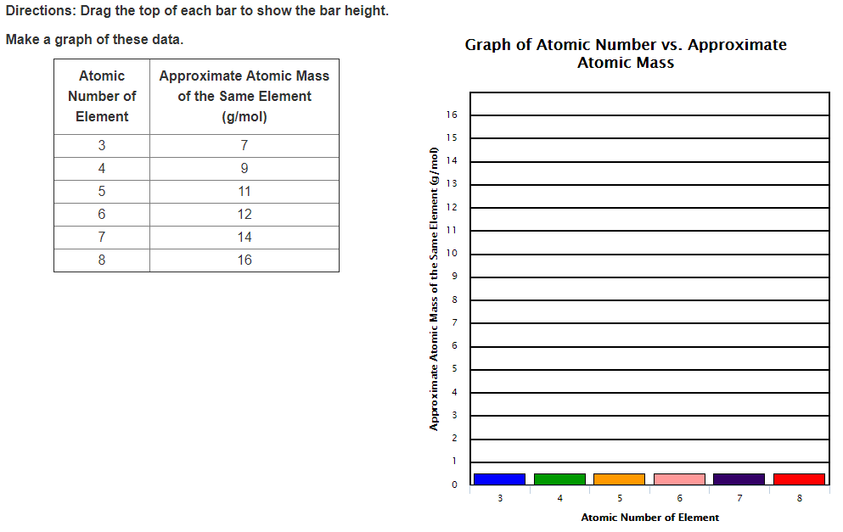
Read as:

Directions: Drag the top of each bar to show the bar height. Make a graph of these data.
A two-column table.
Heading row, Atomic Number of Element, Approximate Atomic Mass of the Same Element, grams per mol.
Next row, three, seven; next row, four, nine; next row, five, eleven; next row, six, twelve; next row, seven, fourteen; last row, eight, sixteen.
A graph titled, Graph of Atomic Number versus Approximate Atomic Mass.
The vertical axis is Approximate Atomic Mass of the Same Element, grams per mol from zero to sixteen in increments of one.
The horizontal axis is Atomic Number of Element, from three to eight in increments of one.
Please refer to the graph on your screen.

Item 6: Fill-in-the-Blank

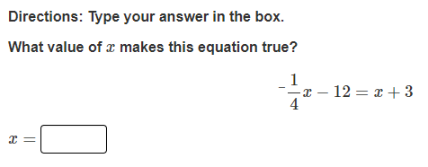

Read as:
Directions: Type your answer in the box.
What value of x makes this equation true?
Negative one-fourth x, minus twelve equals x plus three.
x equals empty box.

Item 7: Matching Figures

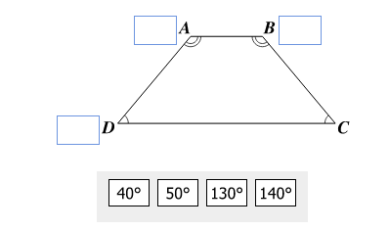
Read as:
A figure clockwise from top. Empty box A, B, Empty box, C, Empty box D.
Gray box from left to right. Forty degrees, fifty degrees, one hundred thirty degrees, one hundred forty degrees.

Example 8: Diagram

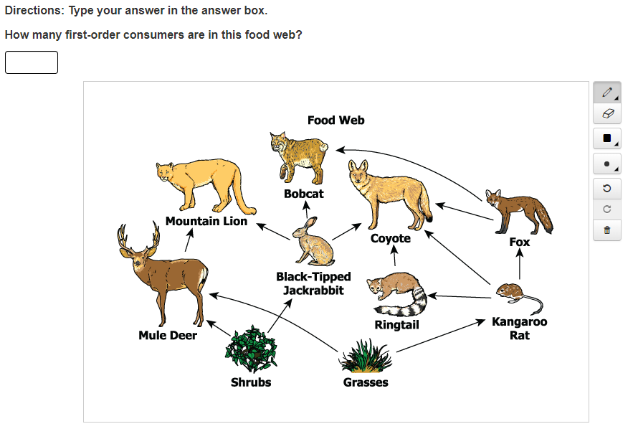
Read as:
Directions: Type your answer in the answer box.
How many first-order consumers are in this food web?
An empty box.
A food web titled Food Web.
From bottom to top Shrubs, Grasses, Mule Deer, Black-Tipped Jackrabbit, Ringtail, Kangaroo Rat, Mountain Lion, Bobcat, Coyote, Fox.
Please refer to the food web on your screen.

