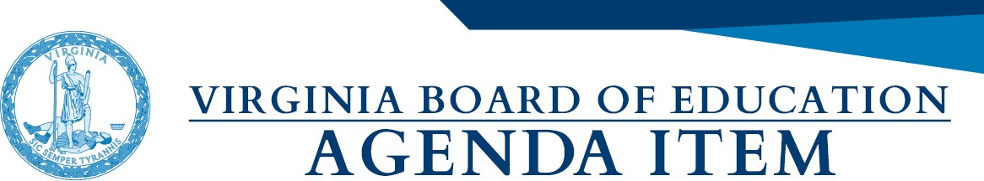

Agenda Item: F

Date: February 2, 2023

Title: First Review of the Proposed Revised 2022 History and Social Science Standards of Learning

Presenter: Christonya Brown, History Coordinator
Andrea Emerson, Secondary History Specialist
Brandi McCracken, Elementary History Specialist
Dr. Christine Harris, Director, Office of Humanities

Email: Christonya.Brown@doe.virginia.gov Phone: 804-225-2893

Purpose of Presentation:
Action required by state or federal law or regulation.

Executive Summary
The proposed, revised 2022 History and Social Science Standards of Learning describe the Commonwealth's broad goals for student learning and achievement in grades K-12 history, civics, geography, and economics. Section 22.1-253.13:1 of the Code of Virginia requires a review of each Standards of Learning subject area at least once every seven years. Pursuant to legislation from the 2000 Virginia General Assembly, the Board established a seven-year cycle for review of the Standards of Learning. Thus, the History and Social Science Standards of Learning originally adopted by the Board in 1995 were reviewed and revised in 2001, 2008, and 2015.

In August 2022 the Board received a presentation from VDOE about the process used to review and revise the standards to date. In November 2022, the Board received a follow up presentation from VDOE providing a revision to the standards to date. At the November Board of Education meeting, VDOE was directed to use the November draft as a baseline document and to correct omissions, errors, consider public and board member comments, and to incorporate elements from the August draft and 2015 Standards. From November to January, the VDOE revised the draft standards and fulfilled all directives of the Board. Conversations were held with various cultural groups to address concerns, corrections, and omissions. VDOE content staff provided instructional guidance to the document arbiters regarding historical accuracy, timelines, and content appropriateness. Using the November Standards document as the baseline for the revisions, changes were made to broaden and clarify the content in history, civics, economics, and geography. The draft incorporates content from earlier drafts and new content to tell a more complete story about how the past has shaped the Commonwealth, the nation, and the world.

Action Requested:
Action will be requested at a future meeting.

Superintendent’s Recommendation:
The Superintendent of Public Instruction recommends that the Board of Education accept the draft of the 2022 History and Social Science Standards of Learning for First Review.

Previous Review or Action:
Previous review or action. Specify date and action taken below:
Date: August 17, 2022
Action: No Board Action on Proposed Standards and Curriculum Framework

Date: September 15, 2022
Action: No Board Action on Work Session on Updated Timeline

Date: November 17, 2022
Action: No Board Action on Proposed Standards

Background Information and Statutory Authority:
Section 22.1-253.13:1 of the Code of Virginia requires the Board to establish educational objectives to form the core of Virginia’s educational program and require that the Standards be reviewed every seven years. It states, in part:

  - The General Assembly and the Board of Education believe that the fundamental goal of the public schools of the Commonwealth must be to enable each student to develop the skills that are necessary for success in school, preparation for life, and reaching their full potential. The General Assembly and the Board of Education find that the quality of education is dependent upon the provision of (i) the appropriate working environment, benefits, and salaries necessary to ensure the availability of high-quality instructional personnel; (ii) the appropriate learning environment designed to promote student achievement; (iii) quality instruction that enables each student to become a productive and educated citizen of Virginia and the United States of America; and (iv) the adequate commitment of other resources. In keeping with this goal, the General Assembly shall provide for the support of public education as set forth in Article VIII, Section 1 of the Constitution of Virginia.
  - The Board of Education shall establish educational objectives known as the Standards of Learning, which shall form the core of Virginia's educational program, and other educational objectives, which together are designed to ensure the development of the skills that are necessary for success in school and for preparation for life in the years beyond. At a minimum, the Board shall establish Standards of Learning for English, mathematics, science, and history and social science. The Standards of Learning shall not be construed to be regulations as defined in § 2.2-4001.
The Board shall seek to ensure that the Standards of Learning are consistent with a high-quality foundation educational program. The Standards of Learning shall include, but not be limited to, the basic skills of communication (listening, speaking, reading, and writing); computation and critical reasoning, including problem solving and decision making; proficiency in the use of computers and related technology; computer science and computational thinking, including computer coding; and the skills to manage personal finances and to make sound financial decisions.
The English Standards of Learning for reading in kindergarten through grade three shall be based on components of effective reading instruction, to include, at a minimum, phonemic awareness, systematic phonics, fluency, vocabulary development, and text comprehension.
The Standards of Learning in all subject areas shall be subject to regular review and revision to maintain rigor and to reflect a balance between content knowledge and the application of knowledge in preparation for eventual employment and lifelong learning. The Board of Education shall establish a regular schedule, in a manner it deems appropriate, for the review, and revision as may be necessary, of the Standards of Learning in all subject areas. Such review of each subject area shall occur at least once every seven years. Nothing in this section shall be construed to prohibit the Board from conducting such review and revision on a more frequent basis.
To provide appropriate opportunity for input from the general public, teachers, and local school boards, the Board of Education shall conduct public hearings prior to establishing revised Standards of Learning. Thirty days prior to conducting such hearings, the Board shall give notice of the date, time, and place of the hearings to all local school boards and any other persons requesting to be notified of the hearings and publish notice of its intention to revise the Standards of Learning in the Virginia Register of Regulations. Interested parties shall be given reasonable opportunity to be heard and present information prior to final adoption of any revisions of the Standards of Learning.

Timetable for Further Review/Action:
In anticipation of the Board’s acceptance of the standards for first review, the following timeline is proposed for next steps and actions:

- February 2, 2023: First Review of standards document
- March 13-21, 2023: Public hearings with the Board of Education
- March: Review of public comments and incorporate warranted edits
- April 20, 2023: Proposed Final Review and adoption by the Board.

