Professional Development Resource List for Child Care Providers

What is Effective Professional Development?

Effective professional development focuses on ensuring that children experience:
- High quality teacher-child interactions
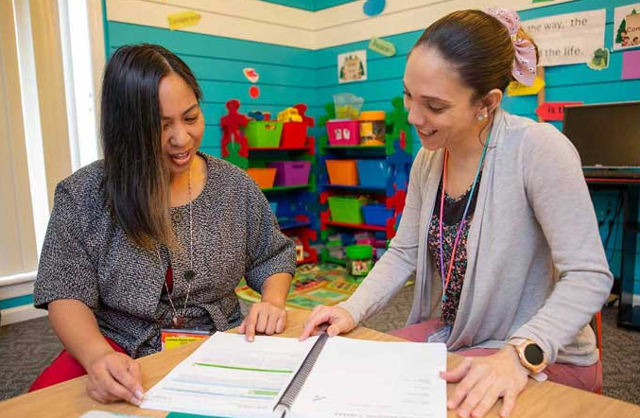
- Well-implemented curricula
- Developmentally appropriate instruction
The Elements of Effective Professional Development: PD Rubric provides a
framework for a data-driven, individualized approach that is targeted towards the needs of teachers and children.

A skilled and well-trained workforce is essential to providing high-quality early care and out-of-school time services to children and their families. Through professional development, child care providers acquire knowledge and skills needed to plan and implement quality early learning experiences.

If you are a child care provider looking for professional development opportunities, the Virginia Department of Education collaborates with partners to provide training opportunities throughout the state in both classroom-based and distance learning formats.

Professional Development Resource List

Child Development Associates Credential
- Council for Professional Recognition

College and University Courses and Degrees (Certificates, Associates, Bachelors, Masters, Doctorate)
- Center for Advanced Study of Teaching and Learning (CASTL – University of Virginia)
- Virginia Colleges and Universities
- Virginia Community College System

General Training for Early Care and Out-of-School Time Entities
- Better Kid Care Penn State Extension
- Virginia Pre-Service Training for Child Care Providers
- Health and Safety Training Update
- Child Abuse and Neglect Training – Online Mandated Reporter Course

Online Child Care Courses
- Community College Workforce Alliance
- Daily Health Observation Training
- Child Abuse and Neglect

Professional Associations (Workshops and Conferences)
- Northern Virginia Association for Early Childhood Education
- Virginia Alliance of Family Child Care Associations

Professional Development Resource List (cont’d)

- Virginia Association for Early Childhood Education
- Virginia Partnership for Out-Of-School Time
- Virginia Child Care Association
- Virginia Head Start Association

Quality and Improvement Programs (Workshops, Director’s Groups, Mentoring, Conferences)
- Center on the Social Emotional Foundations for Early Learning (CSEFEL)
- Teachstone (CLASS Training)
- Virginia Infant & Toddler Specialist Network (programs serving children birth-36 months)
- Infant and Toddler Endorsement Courses
- Virginia Quality Training Modules (programs serving birth-5 years)

Scholarship Opportunities for Community College and University Level Courses
- Project Pathfinders Scholarship Program (Virginia Early Childhood Foundation)
- Virginia Association for Early Childhood Education Annual Scholarship
- Virginia Child Care Provider Scholarship Program

State Resource and Referral (Workshops and Conferences)
- Child Care Aware of Virginia

Training for Trainers (Adult Learning Principles, Planning Training and Coaching)
- Virginia Cross-Sector Professional Development
- VCPD 101 - Becoming an Effective Early Childhood Professional Development Provider
- VCPD 102 - Planning Professional Development
- VCPD 103 – Virtual Training the VCPD Way!
- Practice-based Coaching

Virginia Department of Education, Office for Early Childhood
- Early Childhood Professional Development

The Professional Development Resource List is updated on an annual basis and can be found on the childcareva.com website. This list is comprehensive, but not inclusive of all professional development opportunities across the Commonwealth.
Updated July 2021

