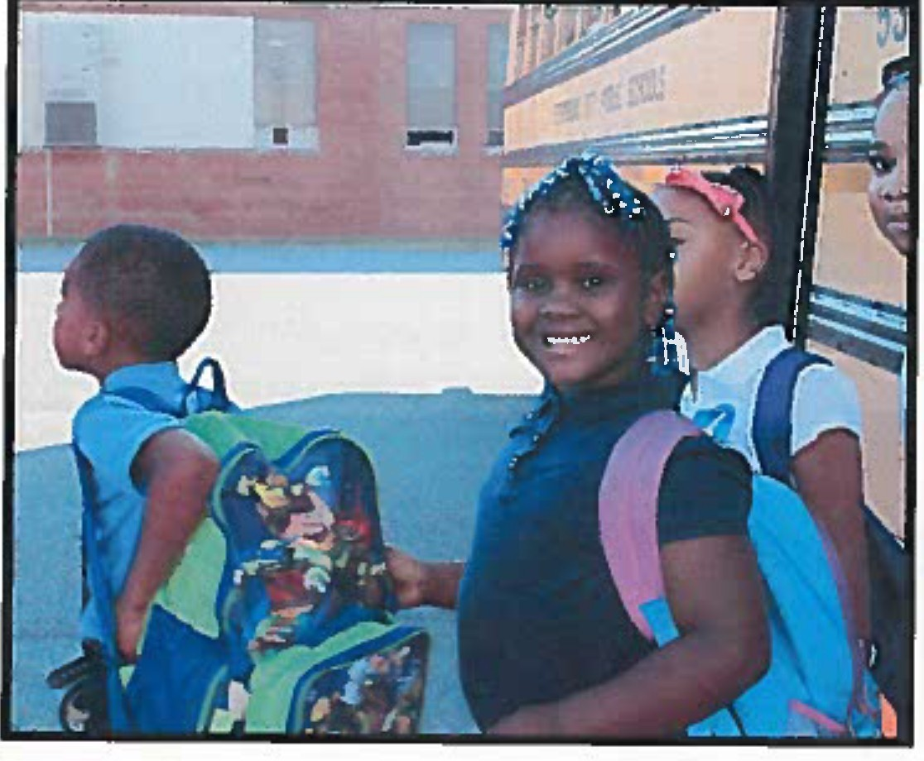
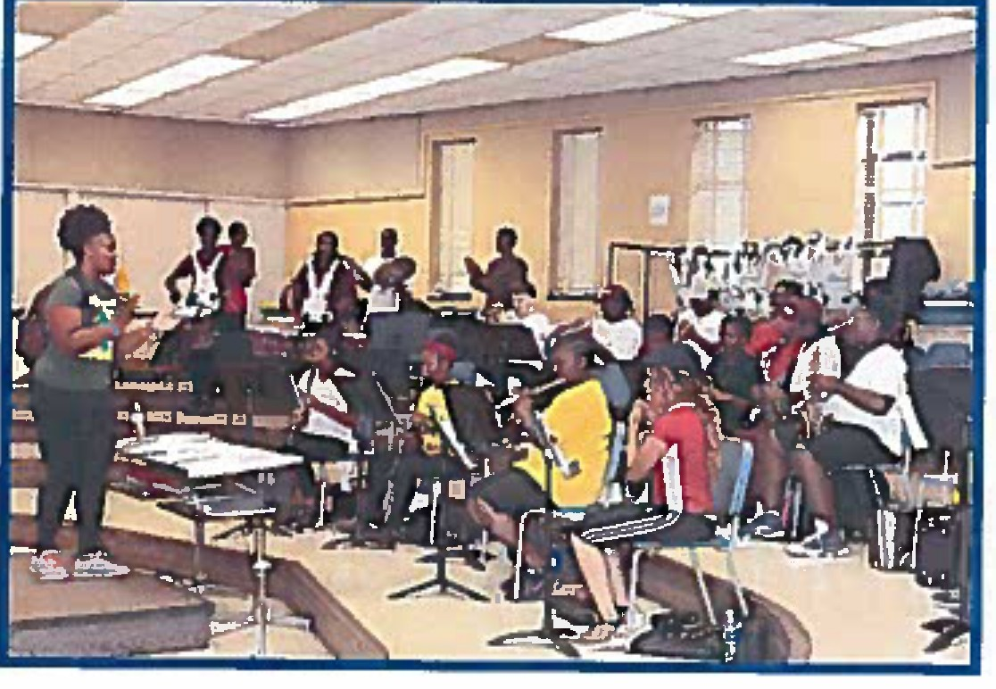
Petersburg City public Schools
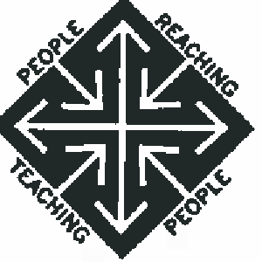
Corrective Action Plan 2016-2021
Dr. Marcus J. Newsome, Superintendent
255 South Boulevard East Petersburg, VA 23805
804-732-0510

I believe■
Petersburg City Public Schools
Mission Statement
Petersburg City Public Schools will provide a quality education to all students that will meet or exceed local, state and national standards. We commit to challenge and provide the necessary support so that each student will achieve at his or her highest potential in a safe, secure and nurturing environment. We will provide experiences for our students to become lifelong learners and contributing members in a global society.

Petersburg City Public Schools
Corrective Action Plan 2016.2021
developed with feedback from
- teachers
- building administrators
- central office administrators
- parents
- community members
- business partners

Table of Contents
Goals 4
Implement Quality Instruction and Curricula Alignment 5
Monitor Human Resource Management System and Retain, Hire, and Develop Quality Leadership Staff and Teachers 9
Develop, Adopt, and Implement a Unified Strategic Plan/Purpose and Direction 14
Maintain a Safe and Supportive Environment 17
Develop and Implement a Parental Engagement Plan 20
Authorizations 23

3(Page Petersburg City Public Schools Division Corrective Action Plan

Goals

Petersburg City Public Schools will

Engage students in challenging and relevant learning experiences that foster creativity, critical thinking, collaboration, and communication.
- Recruit, hire, and retain quality leaders and teachers who believe their talent and investment of time make a difference.
- Establish purpose and direction for the division through the development of a strategic plan.
- Create environments conducive to teaching and learning by strengthening relationships within schools.
- Strategically engage parents in the academic success of their children by collaborating with community partners.

- 41Page P e t e r s b u r g C i t y P u b I i c S c h o o I s D i v i s i o.n C o r r e c t i v e A c t i o n P I a n

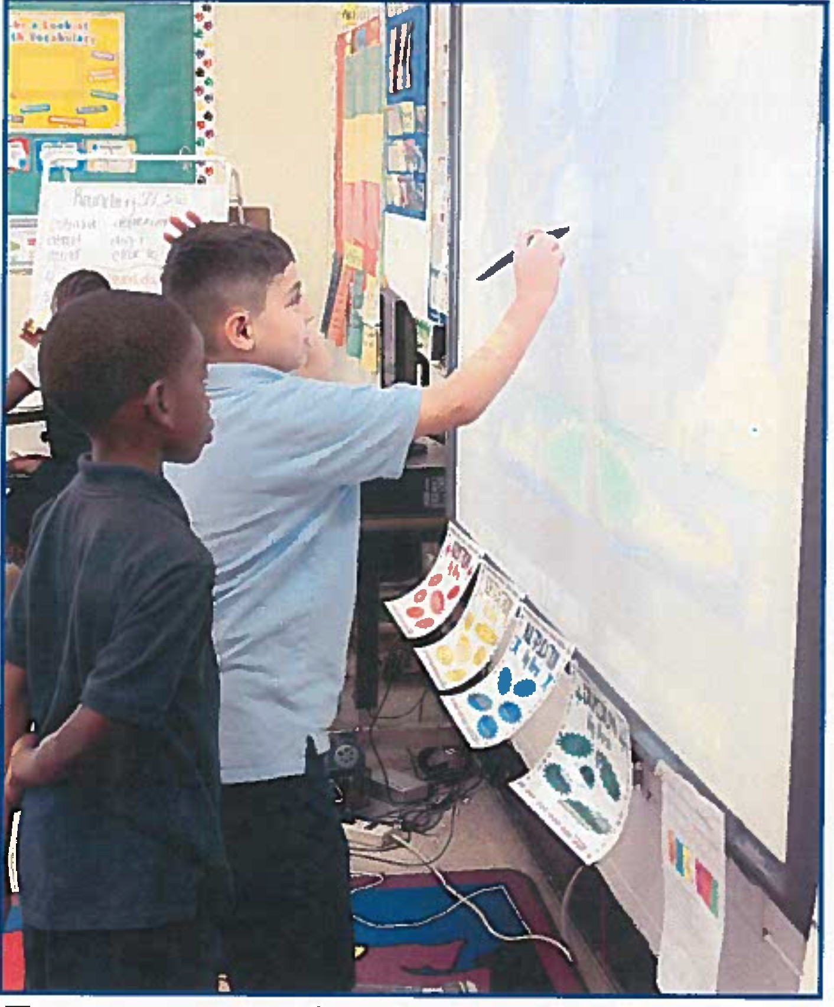
Goal Engage students in challenging and relevant learning experiences that foster creativity, critical thinking, collaboration and communication

Implement Quality Instruction and Curricula Alignment

Essential Action | Title of Person(s) Responsible for Essential Action | Title of Person(s) Monitoring | Dates (Timeframe) | Documentation Required to Support Evidence of Progress/Completion
Provide guidance to appropriate division level leaders regarding explicit expectations for monitoring the written and taught curriculum. | Superintendent  Chief Academic Officer | PCPS School Board  Superintendent | Completed by September 30,  2016 | Written expectations for all division leaders, including details about roles and responsibilities for each appropriate division leader; specific expectations for warned content areas; meeting agendas and minutes with explicit next steps; professional development on monitoring expectations with agendas, materials,  and written next steps
Monitor implementation of the written and taught curriculum and provide written feedback to appropriate division leaders. | Chief Academic Officer | Superintendent | October 2016-  June 2020 | Monitoring documents; artifacts of division leaders' feedback provided to principals on written and taught curriculum; next steps for division  leaders
Develop and provide procedures to monitor issues of compliance related to the provision of special education services and supports at  the division and school level. | Director of Student Support Services | Executive Director for Student Success | Completed by September 30,  2016 | Written procedures, including details about roles and responsibilities for each appropriate division leader; monitorin documents
Provide guidance to principals regarding explicit expectations for staff designated to serve as the LEA Representative for Special Education Processes at each school. | Director of Student Support Services  Supervisor of Special Education | Executive Director for Student Success | Completed by September 30,  2016 | Written expectations for all principals; specific expectations for participation in eligibility/lEP Meetings; completion of the Results Driven Accountability Action Plan
Provide guidance to principals regarding explicit expectations for monitoring the written and taught curriculum. | Chief Academic Officer | Superintendent | Completed by June 2017 | Written expectations for all principals; specific expectations for warned content areas; meeting agendas and minutes with explicit next steps;  professional development for

6IPage Petersburg City Public Schools Division Corrective Action Plan

Implement Quality Instruction and Curricula Alignment

Essential Action | Title of Person(s) Responsible for Essential Action | Title of Person(s) Monitoring | Dates (Timeframe) | Documentation Required to Support Evidence of Progress/Completion  .
principals on monitoring expectations
with agendas, materials, and written next steps
Monitor implementation of the written and taught curriculum and provide written feedback to principals . | Chief Academic Officer | Superintendent | July 2017-June 2020 | Monitoring documents; artifacts of principals' feedback provided to teachers on written and taught  curriculum; next steps for principals
Develop, implement and monitor principal training on how to use a variety of student formative and summative data to make inferences as to why questions were missed, why students fall into established categories, and how to create plans for future  instruction. | Curriculum Specialist  Director of Testing | Chief Academic Officer | July 1, 2017-  June 30, 2018 | Professional development materials/ presentations; next steps; sign-in roster; agenda; written plan for monitoring next steps; student data; data analysis tools; template for student plans based on data analysis
Develop a process to ensure that formative and summative assessment items are aligned with the Standards of Learning in content and cognitive levels. | Director of Testing  Curriculum Specialist | Chief Academic Officer | Completed by June 2018 | Written process for assessment development using Tables of Specification; evidence of unpacking the Standards of Learning and Curriculum Framework in content and cognitive levels; evidence of alignment to the test Blueprints; formative and  summative assessment samples
Develop and implement aligned curricula that include suggested learning activities which facilitate students' use of higher level thinking skills, utilize aligned curriculum resources, and provide sample formative and summative assessments. | Development: Curriculum Specialist  Implementation: Teachers and Principals | Development: Chief Academic Officer  Implementation: Teachers: Principals  Principals: | March 2018-  June 2020 | Established guidelines; samples of expectations; timeline for curriculum development in all content areas and grade levels; curricula documents and supporting documents

71Page Petersburg City Public S c h o o l s Division Corrective Action Plan

Implement Quality Instruction and Curricula Alignment

Essential Action | Title of Person(s) Responsible for Essential Action | Title of Person(s) Monitoring | Dates (Tlmeframe} | Documentation Required to Support Evidence of Progress/Completion
 |  | Chief Academic Officer
Provide explicit professional development to | Curriculum | Chief Academic | Completed in | Written expectations for teachers;
teachers and principals on the use of | Specialist | Officer | stages from | professional development agendas and
curriculum documents and suggested |  |  | June 2018- | materials with explicit next steps;
learning activities, resources, and |  |  | June 2021 | lesson plans
assessments.
Provide training to teachers and principals on the process used to develop classroom assessments which are aligned to the Standards of Learning and the taught  curriculum. | Curriculum Specialist  Director of Testing | Chief Academic Officer | June 2018-  August 2018 | Professional development agendas and materials with explicit next steps for principals and teachers; classroom assessment samples
Implement and monitor a process to develop classroom summative and formative assessments which are aligned to the Standards of Learning in content and cognition and contain a sufficient number of items to assess mastery of the taught  standards in a given time period. | Development: Curriculum Specialist  Director of Testing | Chief Academic Officer | August 2018-  June 2021 | Written process for alignment; written expectations of teachers; assessment samples aligned to SOLs and blueprints; samples of completed Tables of Specification
 | Implementation: Teachers and Principals | Implementation: Teachers: Principals Principals:  Chief Academic  Officer

Bl Page Petersburg City Public Schools Division Corrective Action Plan

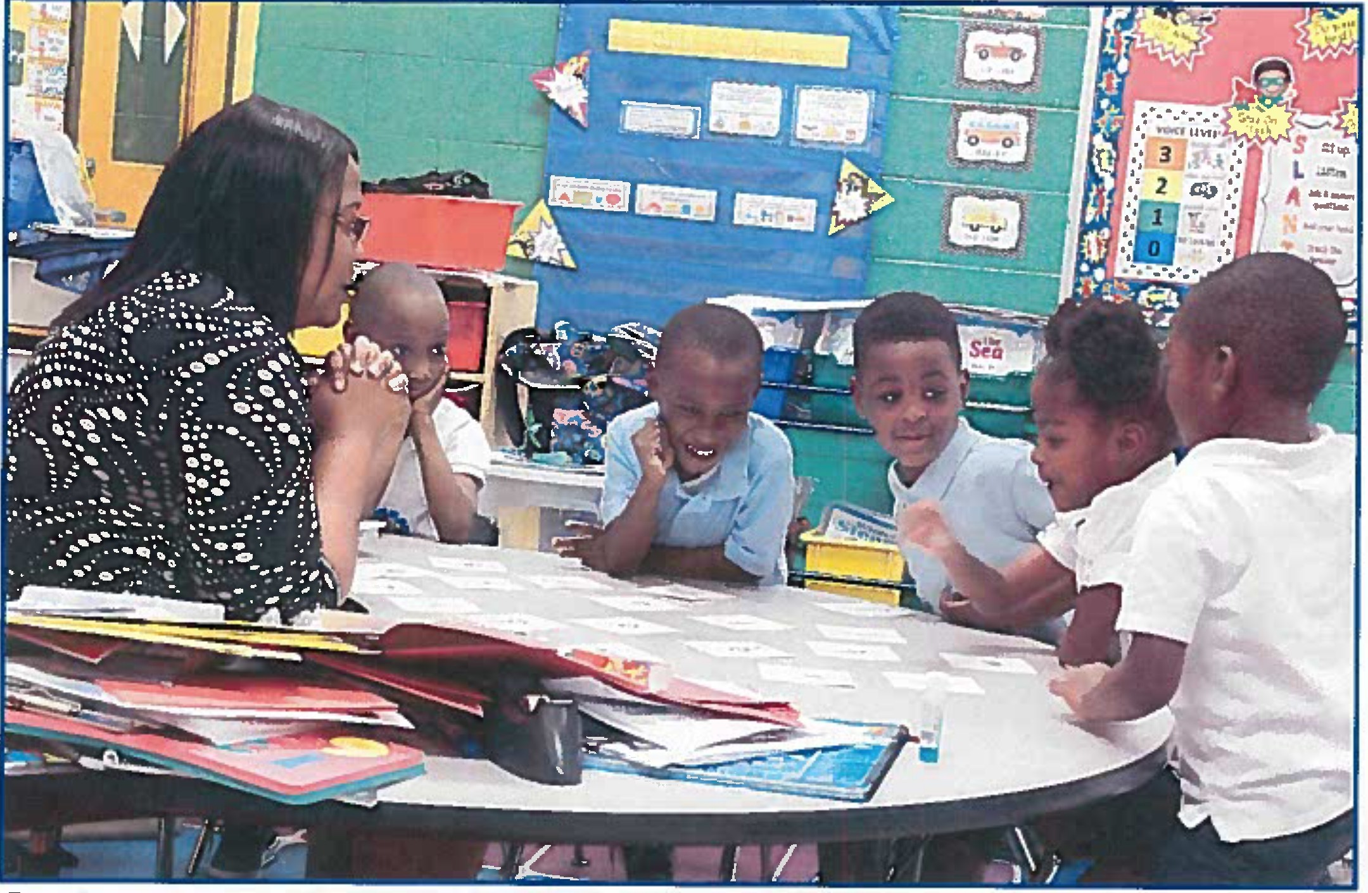

Goal Recruit, hire and retain quality leaders and teachers who believe their talent and investment of time make a difference

Monitor Human Resource Management System and Retain, Hire, and Develop Quality Leadership Staff and Teachers

Essential Action | Title of Person(s} Responsible for Essential Action | Title of Person(s) Monitoring | Dates (Timeframe) | Documentation Required to Support Evidence of Progress/Completion
Develop division level leadership roles/responsibilities. | Revised Organizational chart: Superintendent | Petersburg City School Board | Completed by June 30, 2016 | Organizational chart; job descriptions of division positions; artifacts from organizational chart and job description professional development
 | Job Descriptions: Director of Human Resources; VDOE Office of School Improvement (OSI) | Executive Director for HR and Operations | Completed by September 30,  2016
Establish written policies, procedures and practices. | Policy Manual: Director of Student Support Services | Executive Director for HR and Operations | Framed: Completed by July 1, 2016 | Policy manual including regulations and procedures
 |  |  | Procedures: July 1,2017
Implement and monitor policies, procedures and practices at the division and school level. | Policy and Regulations: Superintendent's Cabinet  Revised Organizational Chart/Job Descriptions:  Superintendent | Superintendent  PCPS School  Board | Initial implementation: Completed by October 31, 2016  Training and Monitoring Process: November 30,  2016 {process is | Written process for monitoring implementation of policies; artifacts from policy manual; professional development with specific attention to: awarding of credit accommodations for eligible standard diploma students with disabilities, homeless children, attendance, student conduct, discipline/referral  process, outside agencies, Petersburg

10 I Page Petersburg City Public Schools Division Corrective Action Plan

Monitor Human Resource Management System and Retain, Hire.and Develop Quality Leadership Staff and Teachers

Essential Action | Title of Person(s) Responsible for Essential Action | Title of Person(s) Monitoring | Oates  {Timeframe) | Documentation Required to Support Evidence of Progress/Completion
 | Superintendent's Cabinet | Superintendent | followed by continuous monitoring) | City Public Schools' Rights and Responsibilities Handbook; timeline for regular policy revisions/updates
Create a division plan for professional development based on the division and school needs. | Superintendent's Cabinet  Chief Academic Officer  Executive Director for HR and Operations Executive Director for Student Success | Superintendent | Completed by June 2017 | Written division process for determining professional development needs; division professional development plan, including expected outcomes, aligned to needs assessment
 | Curriculum Specialist
 | Principals
 | Superintendent's Advisory Council (teachers)
Provide support and opportunities for | Chief Academic | Superintendent | September 2017- | Written guidance on professional
division leaders, including principals, to | Officer |  | June 30, 2019 | development opportunities;
effectively implement and monitor learning | Executive Director |  |  | monitoring protocol for the selection
from professional development. | for HR and |  |  | and implementation of opportunities;
 | Operations |  |  | written feedback and/or next steps as
 | Executive Director |  |  | needed
 | for Student

111Page Petersburg City Public Schools Division Corrective Action Plan

Monitor Human Resource Management System and Retain, Hire.and Develop Quality Leadership Staff and Teachers

Essential Action | Title of Person(s) Responsible for Essential Action | Title of Person(s) Monitoring | Dates  {Tlmeframe) | Documentation Required to Support Evidence of Progress/Completion
 | Success
Monitor implementation and outcomes of professional learning at the division level and provide feedback to division leaders, including principals, on their use of professional learning with an explicit focus  on identified outcomes. | Superintendent | PCPS School  Board | October 1, 2017-  June 30, 2019 | Monitoring protocol for implementation, including identified outcomes, of professional development opportunities; written feedback and/or next steps as needed
Establish guidelines for the expectations for principals to develop professional development plans for the needs specific to  each school. | Chief Academic Officer | Superintendent | Completed by June 30, 2018 | Written expectations; written school process for determining professional development needs aligned to needs assessment
Create a school plan for professional development based on school needs. | Principals | Chief Academic Officer | September 2018-  June 30, 2020 | School professional development  plan, including expected outcomes, aligned to needs assessment
Monitor implementation and outcomes of professional learning at the school level and provide feedback to teachers on their use of professional learning with an explicit focus  on identified outcom es. | Principals | Chief Academic Officer | October 1, 2018-  June 30, 2020 | Monitoring protocol for implementation, including identified outcomes, of professional development opportunities; written  feedback and/or next steps as needed
Provide support and opportunities for teachers to effectively implement and monitor learning from professional development. | Curriculum Specialist  Principals | Chief Academic Officer | September 30,  2018-June 30,  2020 | Written guidance on professional development opportunities; monitoring protocol for the selection and implementation of opportunities; written feedback and/or next steps as needed
Monitor implementation and outcomes of  professional learning in schools and provide feedback to teachers on their use of | Principals | Chief Academic Officer | October 1, 2018-  June 30, 2020 | Monitoring protocol for  implementation, including identified outcomes, of professional
121Page Petersburg City Public Schools Division Corrective Action Plan

Monitor Human Resource Management System and Retain, Hire.and Develop Quality Leadership Staff and Teachers

Essential Action | Title of Person(s) Responsible for Essential Action | Title of Person(s) Monitoring | Dates (Timeframe) | Documentation Required to Support Evidence of Progress/Completion
professional learning with an explicit focus on student outcomes. | Assistant Principals | Principals |  | development opportunities; written feedback and/or next steps as needed
 | Curriculum Specialist | Chief Academic Officer

13 I Page Petersburg City Public Schools Division Corrective Action Plan

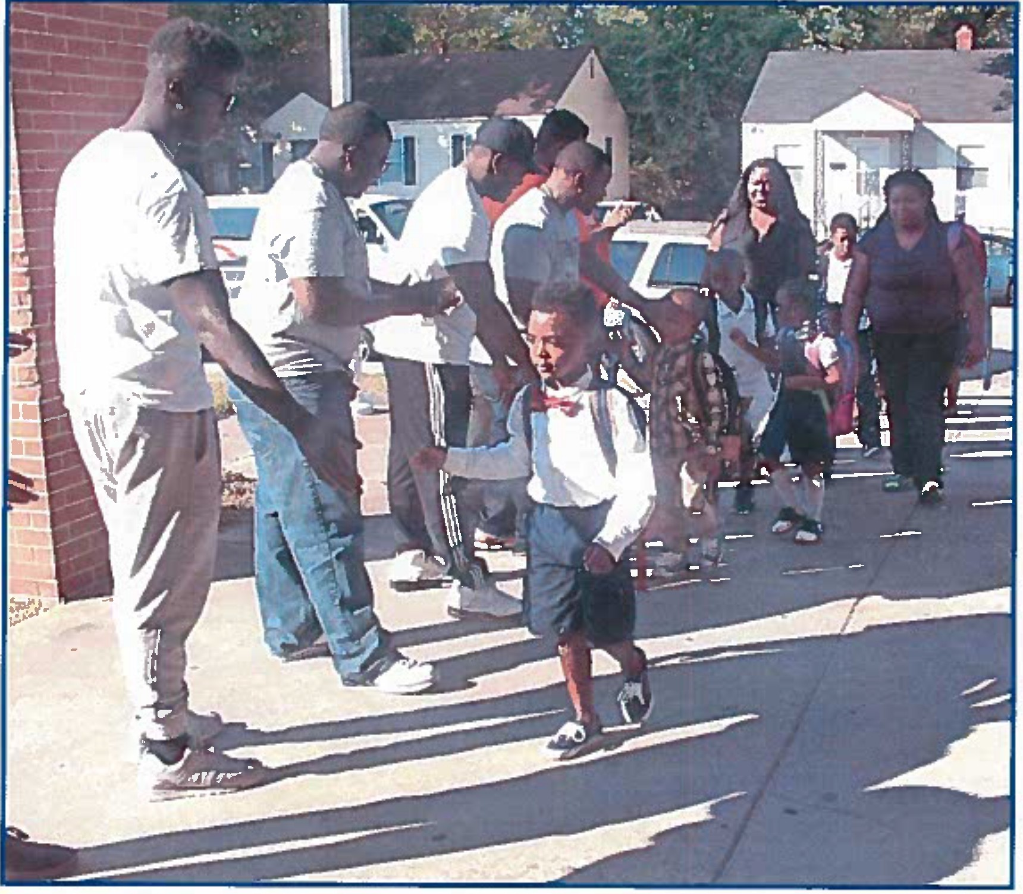
Goal Establish purpose and direction for the division through the development of a strategic plan

Develop, Adopt, and Implement a Unified Strategic Plan/Purpose and Direction

Essential Action | Title of Person(s) Responsible for Essential Action | Title of Person(s) Monitoring | Dates (Timeframe) | Documentation Required to Support Evidence of Progress/Completion
Develop, implement and monitor data- informed decision making process for division and building leaders in order to establish  sh ort - and long-term goals and objectives. | Chief Academic Officer | Superintendent | Develop by October 31,  2016  Implement November 1,  2016-June 30,  2018  Monitor July 1,  2017-June 30,  2018 | Data; data analysis tools; professional development agenda, materials and next steps; written artifacts for implementation and monitoring next steps
Conduct asset mapping in each school to make informed decisions regarding resources. | Virginia Department of Education/Office of School Improvement | VDOE Assistant Superintendent of Student Assessment and School Improvement  Chief Academic Officer | April 2016-  June 30, 2017 | Completed asset mapping tool for each school; written protocol for monitoring next steps
Participate in community school partnership strategic planning process to define collaborative roles in supporting schools. | Superintendent | PCPS School Board | November 2015-June 2018 | Agency and division partnership expectations and communications pathways document; minutes from meetings with Petersburg City Partnership with Schools, including committees.such as Housing Stability, Enhanced Access to Healthcare, Improved Nutrition and Access to Meals, Transformed School Climate, Holiday Planning; strategic plan for the  partnership; committee reports; data:

- IP age Petersburg City Public Schools Division Corrective Action Plan

Develop, Adopt, and Implement a Unified Strategic Plan/Purpose, and Direction

Essential Action | Title of Person(s) Responsible for  Essential Action | Title of Person(s) Monitoring | Oates (Timeframe) | Documentation Required to Support Evidence of Progress/Completion
housing, attendance, health, nutrition, discipline; presentations to School Board and City Council; committee rosters and attendance; data from
school climate survey

I Page Petersburg City Public Schools Division Corrective Action Plan

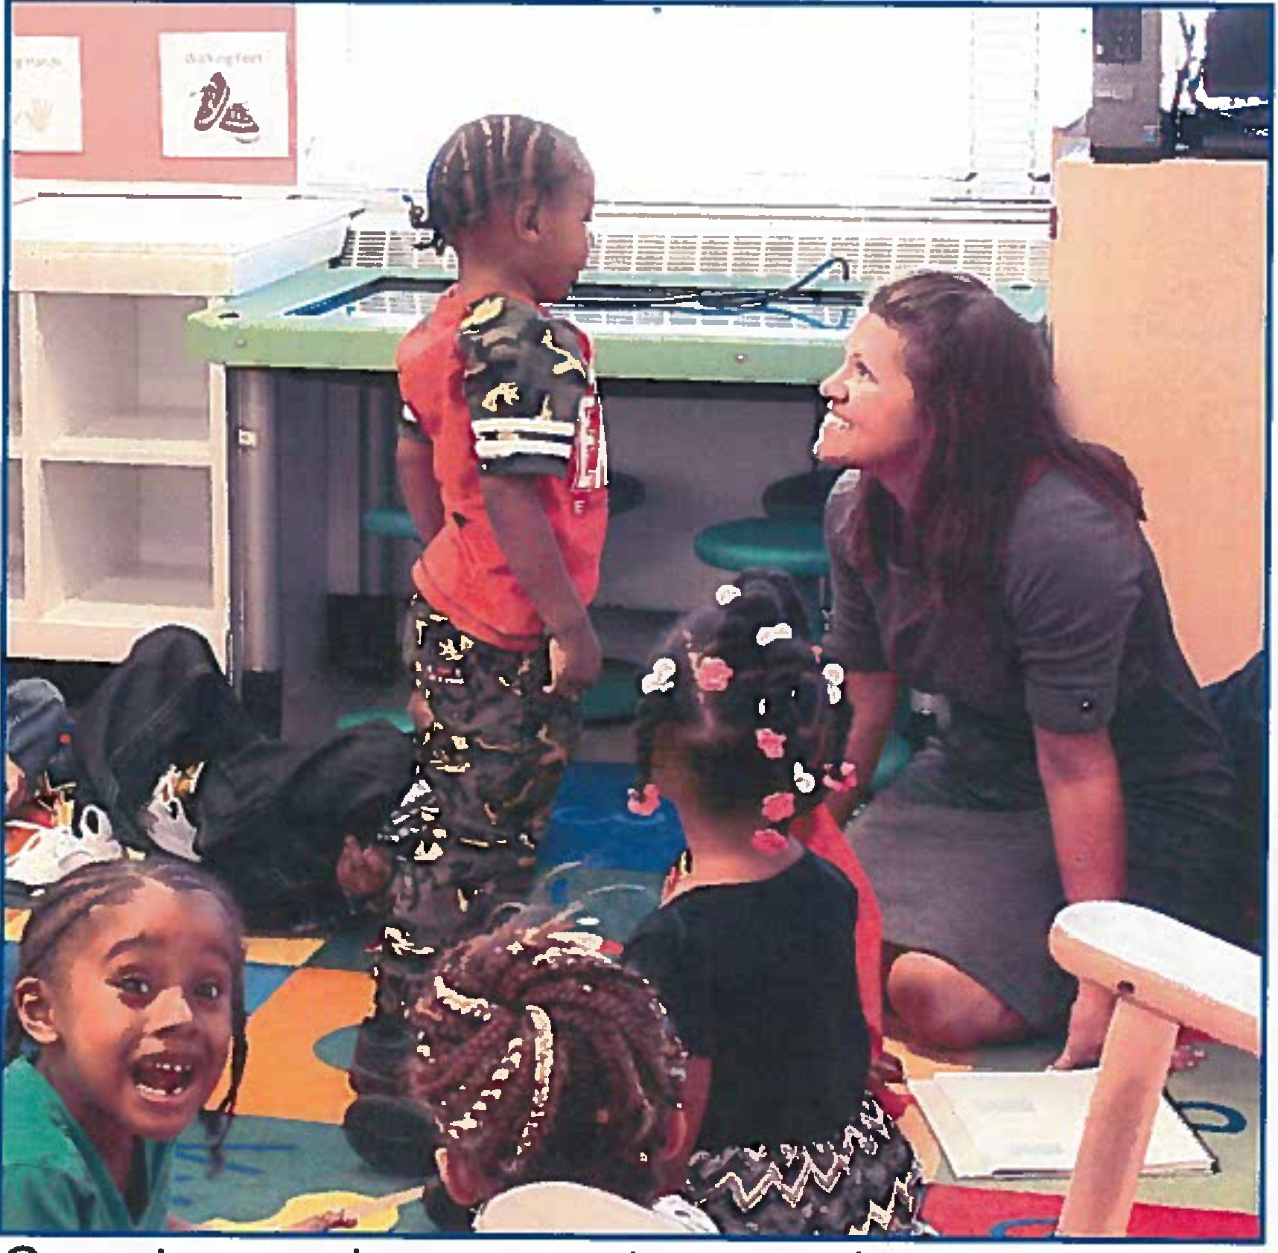
Goal Create environments conducive to teaching and learning by strengthening relationships within schools

Maintain a Safe and Supportive Environment

Essential Action | Title of Person(s} Responsible for Essential Action | Title of Person(s) Monitoring | Dates  {Timeframe) | Documentation Required to Support Evidence of Progress/Completion
Develop, implement, and monitor division student behavior and support plans. | Develop division plan:  Division-level Virginia Tiered System of Supports-Positive Behavioral Interventions Supports (VTSS- PBIS) Leadership Team  Implement and monitor division plan:  Division-level  VTSS-PBIS  Leadership Team | Develop division plan:  Executive Director for Student Success  Implement and monitor division plan:  Executive Director for Student Success VTSSCoach | Develop division-level plan: Completed by January 30,  2017  Implement and monitor division-level plan: January 2017- June  2019 | Infrastructure plan for VTSS supports; action plan; decision-making model document; communication plan; completed District Capacity Assessment Tool; meeting minutes with next steps; designated division level coordinator; Professional development on VTSS-PBIS (including appropriate division staff and bus drivers): sign-in sheets, training agendas, materials, and next steps  Division-level plan; division VTSS-PBIS team meeting agendas/minutes with next steps; threat assessment team roster
Develop an infrastructure for the Office of Student Services that addresses attendance, social, emotional, behavioral, physical and mental health of students. | Director for Student Support Services | Executive Director for Student Success | January 1,  2017- June 30,  2017 | Tiered mapping document of evidence based programs and gaps; internal communications flow chart
- IP age Petersburg City Public Schools Division Corrective Action Plan

Maintain a Safe and Supportive Environment

Essential Action | Title of Person(s) Responsible for Essential Action | Title of Person(s) Monitoring | Oates (Timeframe) | Documentation Required to Support Evidence of Progress/Completion
Develop, implement, and monitor school student behavior and support plans. | Develop school plan:  Selected Division- level VTSS-PBIS team members, Principals, School- level VTSS-PBIS team  Implement and monitor school level plan: Principals and teachers | Develop school plan:  Director for Student Support Services  VTSS Coach  Implement and monitor school level plan: Division-level VTSS-PBIS team;  VTSS Coach | Develop school-level plans: Completed by June 30, 2017  Implement and monitor  school-level plans: September 2017- June  2019 | Infrastructure plan for VTSS supports; action plan; decision-making model document; communication plan; completed Tiered Inventory Fidelity Assessment Tool; meeting minutes with next steps; designated division level coordinator; professional development on VTSS-PBIS (including teachers, cafeteria workers, custodians, and other support staff as applicable): sign-in sheets, training agendas, materials, and next steps; school-level plan; school VTSS-PBIS team meeting agendas/minutes with next steps: threat assessment team roster
Conduct school counseling program audit at | VOOE Office of | VOOE Office of | September | Audit report; next steps; technical
division and school level. | Student Services | School | 2017-June | assistance/professional development
 | (OSS) | Improvement | 2018 | defined by the audit report; Corrective
 |  | {OSI) |  | Action Plan essential actions as
 |  |  |  | appropriate

- IP age Petersburg City Public Schools Division Corrective Action Plan

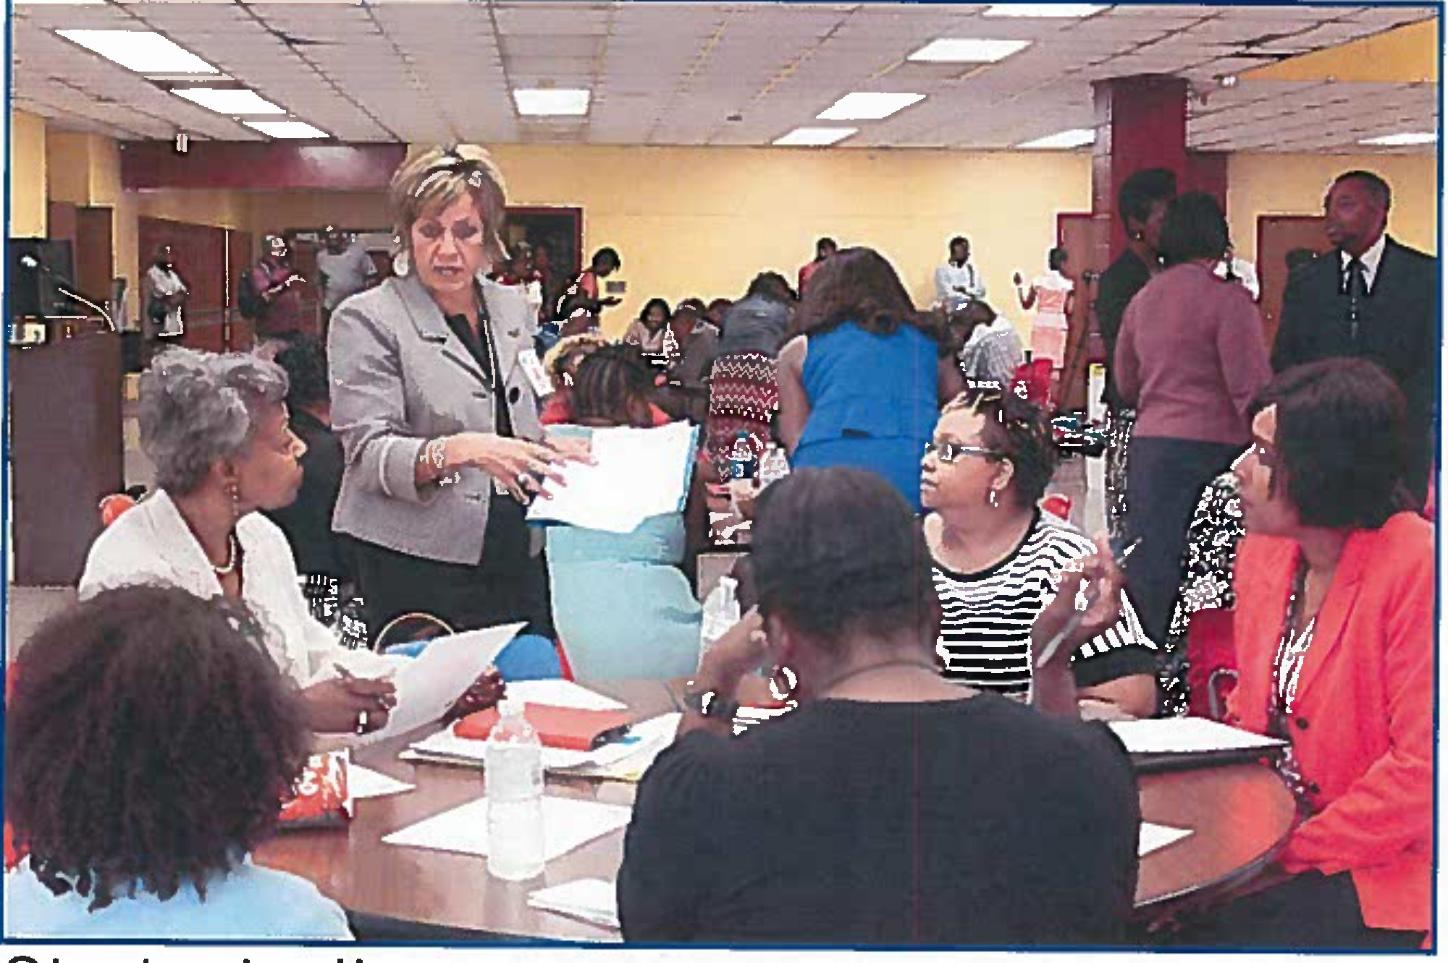
Goal Strategically engage parents in the academic success of their children
by collaborating with community partners

Develop and Implement a Parental Engagement Plan

Essential Action | Title of Person(s) Responsible for  Essential Action | Title of Person(s) Monitoring | Dates (Timeframe) | Documentation Required to Support Evidence of Progress/Completion
Build strategies and programs for connecting/supporting parents in the education of their children with the Petersburg City School Partnership. | Superintendent | PCPS School Board | November 2015-June 2018 | Community School Partnership Strategic Plan; meeting minutes with next steps
Develop and implement alternative methods of connecting with parents. {ex. communications through faith-based community, neighborhood organizations, early childhood centers, cell phone applications) | Executive Director for Student Success  Public Information Officer (PIO) | Superintendent | September 2017-June 2020 | List of alternative methods of communications; communication documentation; meeting minutes from non-school groups with next steps  .
Division-level
VTSS-PBIS
Leadership Team; School -level VTSS- PBIS Leadership Team; Petersburg City School
Partnership
Develop, implement, and monitor division- and school-level parental engagement plans. | Develop division plan:  Executive Director for Student Success  Division-level VTSS-PBIS  Leadership Team | Develop division plan: Superintendent | Develop division-level plan: Completed by September 2018 | Profession development on cultural responsiveness to economically disadvantaged students and parents, examination of explicit and implicit biases, and trauma-informed staff practices: sign-in sheets, training agendas, materials, and next steps; professional development on VTSS-  PBIS: sign-in sheets, training agendas,
 | Implement and  monitor division | Implement and  monitor division | Implement and  monitor | materials, and next steps; division-  level plan with evidence of cultural
- IP age Petersburg City Public Schools Division Corrective Action Plan

Develop and Implement a Parental Engagement Plan

Essential Action | Title of Person(s} Responsible for Essential Action | Title of Person(s) Monitoring | Dates (Timeframe) | Documentation Required to Support Evidence of Progress/Completion
 | plan: Division-level VTSS-PBIS  Leadership Team  Develop school plan:  Selected Division- level VTSS-PBIS team member, Principals, School- level VTSS-PBIS team  Implement and monitor school level plan: Principals and teachers | plan: Executive Director for  Student Success  Develop school plan:  Director of Student Support Services  Implement and monitor school level plan: Division-level VTSS-PBIS team | division-level plan: October 2018-June 2020  Develop school-level plans: Completed by September 2018  Implement and monitor  school-level plans: October 2018-June  2020 | responsiveness to the impacts of poverty and explicit/implicit biases; individual school-level plans with evidence of cultural responsiveness to the Impacts of poverty and explicit/implicit biases; division and school VTSS-PBIS team meeting agendas/minutes with next steps

- IP age Petersburg City Public Schools Division Corrective Action Plan

Authorizations

I (We) have reviewed and understand the work required to Implement the essential actions required in the Corrective Action Plan for the purposes of Improving student achievement in Petersburg City Public Schools.

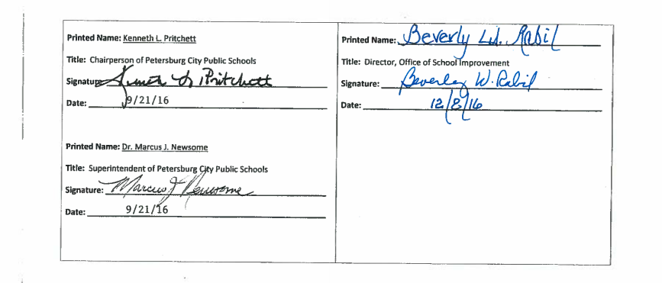

231Pagc Petersburg City Public Schools Division Corrective Action Plan

