**virginia board of education**

**Presented to the Governor**

**and General Assembly**

**November XX, 2018**

**Virginia Board of Education**

**2018 Annual Report**



**2018 Annual Report on**

**the Condition and Needs of**

**Public Schools in Virginia**

**Members of the Virginia Board of Education**

**As of November XX, 2018**

Mr. Daniel A. Gecker, President

Chesterfield, VA

Mrs. Diane T. Atkinson, Vice President

Ashland, VA

Ms. Kim E. Adkins

Martinsville, VA

Dr. Francisco Durán

Alexandria, VA

Ms. Anne B. Holton

Richmond, VA

Mrs. Elizabeth V. Lodal

McLean, VA

Dr. Keisha Pexton

Norfolk, VA

Dr. Tamara K. Wallace

Christiansburg, VA

Dr. Jamelle S. Wilson

Ashland, VA

**Superintendent of Public Instruction**

Dr. James F. Lane

Virginia Department of Education

**TABLE OF CONTENTS**

**Statutory Requirements** ……………….................................................................. Page

**Report**

1. Public Education in Virginia ……………………………………….. Page
2. Board of Education Priorities ……………………………………….. Page

**Appendices** …………………………………………………………………………. Page

*Standards of Quality (SOQ)*

* 1. Summary of Compliance and Non-Compliance with the SOQ for 2017-2018
  2. School Divisions Reporting Full Compliance with the SOQ for 2017-2018
  3. School Divisions Reporting Noncompliance with One or More Provisions of the SOQ for 2017-2018
  4. Current SOQ

*Parent and Student Options*

* 1. Charter School Report and Information on Parent and Student Options

*School Division Reporting Requirements*

* 1. Analysis of School Division Reporting Requirements

*Online Learning*

* 1. Status Report Regarding Multidivision Online Learning
  2. Virtual Virginia Brief

**Statutory Requirements**

## The following sections of the *Code of Virginia* outline the statutory requirements for the Virginia Board of Education’s *Annual Report on the Condition and Needs of Public Schools in Virginia* presented to the Governor and General Assembly:

## § 22.1-18. Report on education and standards of quality for school divisions; when submitted and effective.

By December 1 of each year, the Board of Education shall submit to the Governor and the General Assembly a report on the condition and needs of public education in the Commonwealth and shall identify any school divisions and the specific schools therein that have failed to establish and maintain schools meeting the existing prescribed standards of quality. Such standards of quality shall be subject to revision only by the General Assembly, pursuant to Article VIII, Section 2 of the Constitution of Virginia. Such report shall include:

1. A complete listing of the current standards of quality for the Commonwealth's public schools, together with a justification for each particular standard, how long each such standard has been in its current form, and whether the Board recommends any change or addition to the standards of quality;

2. Information regarding parent and student choice within each school division and any plans of such school divisions to increase school choice;

3. A complete listing of each report that local school divisions are required to submit to the Board or any other state agency, including name, frequency, and an indication of whether the report contains information that the local school division is also required to submit to the federal government;

4. An explanation of the need to retain or maintain the frequency of any report identified pursuant to subdivision 3; any recommendation for the elimination, reduction in frequency, or consolidation of reports identified pursuant to subdivision 3 when such elimination, reduction in frequency, or consolidation would require an amendment to the laws of the Commonwealth; and a description of any other report identified pursuant to subdivision 3 that the Board has eliminated, reduced in frequency, or consolidated; and

5. A complete listing of each report pertaining to public education that local school divisions are required to submit to the federal government, including name and frequency.

§ 22.1-212.15. Report of public charter schools.

The Board shall report the number of public charter schools established in the Commonwealth, as well as the number of charters denied, in its annual report to the Governor and the General Assembly pursuant to § 22.1-18.

§ 22.1-212.25. Information regarding online courses and virtual programs; report.

… C. Beginning November 1, 2011, and annually thereafter, the Board of Education shall include in its annual report to the Governor and the General Assembly information regarding multidivision online learning during the previous school year. The information shall include but not be limited to student demographics, course enrollment data, parental satisfaction, aggregated student course completion and passing rates, and activities and outcomes of course and provider approval reviews. The November 1, 2011, report shall be an interim progress report and include information on the criteria and processes adopted by the Board and outcomes of provider applications…

§ 22.1-253.13:3. Standard 3. Accreditation, other standards, assessments, and releases from state regulations.

1. ...The superintendent and the school board chairman shall certify to the Board of Education, as a part of certifying compliance with the Standards of Quality, that there is a justification in the Individual Education Program for every student who takes the Virginia Grade Level Alternative. Compliance with this requirement shall be monitored as a part of the special education monitoring process conducted by the Department of Education. The Board shall report to the Governor and General Assembly in its annual reports pursuant to § 22.1-18 any school division that is not in compliance with this requirement.

§ 22.1-253.13:6. Standard 6. Planning and public involvement.

1. …In the annual report required by § 22.1-18, the Board shall include an analysis of the extent to which these Standards of Quality have been achieved and the objectives of the statewide comprehensive plan have been met….

§ 22.1-253.13:8. Compliance.

Noncompliance with the Standards of Quality shall be included in the Board of Education's annual report to the Governor and the General Assembly as required by § 22.1-18.

**For Additional Copies**

Additional copies of the report are available by contacting the Office of Board Relations at the Virginia Department of Education, P.O. Box 2120, Richmond, VA 23218; phone: 804- 225-2540; or e-mail [BOE@doe.virginia.gov](mailto:BOE@doe.virginia.gov).

The report may be viewed online at: [www.doe.virginia.gov/boe/reports](http://www.doe.virginia.gov/boe/reports)

**2018 Annual Report on the Condition and Needs**

**of Public Schools in Virginia**

Education plays a vital role in determining how someone will spend their adult life and creates opportunities that can lead to higher earnings, better health, and a longer life. By the same token, the long-term social and financial cost of educational failure is high. A fair and inclusive system that makes the advantages of education available to all is one of the most powerful levers to achieve equity in our society. Every student deserves an equitable education that prepares them to succeed in a fast-paced, ever-changing global society.

The *2018 Annual Report on the Condition and Needs of the Public Schools in Virginia* presents:

* An update on the Board’s work;
* A summary of achievement of students and schools;
* The condition of public education; and
* The priorities and goals of the Board of Education.

The Board’s three priorities outlined in the *Comprehensive Plan: 2018-2023* are to:

* Provide high-quality, effective learning environments for all students;
* Advance policies that increase the number of candidates entering the teaching profession and encourage and support the recruitment, development, and retention of well-prepared and skilled teachers and school leaders;
* Ensure successful implementation of the *Profile of a Virginia Graduate* and the accountability system for school quality as embodied in the revisions to the *Standards of Accreditation.*

Since adopting the *Comprehensive Plan: 2018-2023*, the Board has dedicated their time and focus to equity and teachers and school leaders. During the past year, the Board has met with a growing number of experts and researchers in the field to learn about best practices in equity and teacher attraction and retention. Further, the Board continues to analyze Virginia-specific data in these areas. Through a work session with Education Resource Strategies, a national non-profit that partners with education leaders to transform how they use resources, the Board prioritized levers for action which include advocacy, regulatory, and engagement strategies. Building on this work, the Board intends to develop a comprehensive set of recommendations over the next several months to connect policies with outcomes and action steps.

**Equity**

Over the past 10 years, student enrollment in Virginia has shifted from majority-minority student enrollment to minority-majority student enrollment. Schools with high concentrations of students of color and low-income families face substantial challenges in attracting high-quality teachers and providing necessary resources for student success.

**Student Enrollment by Race**

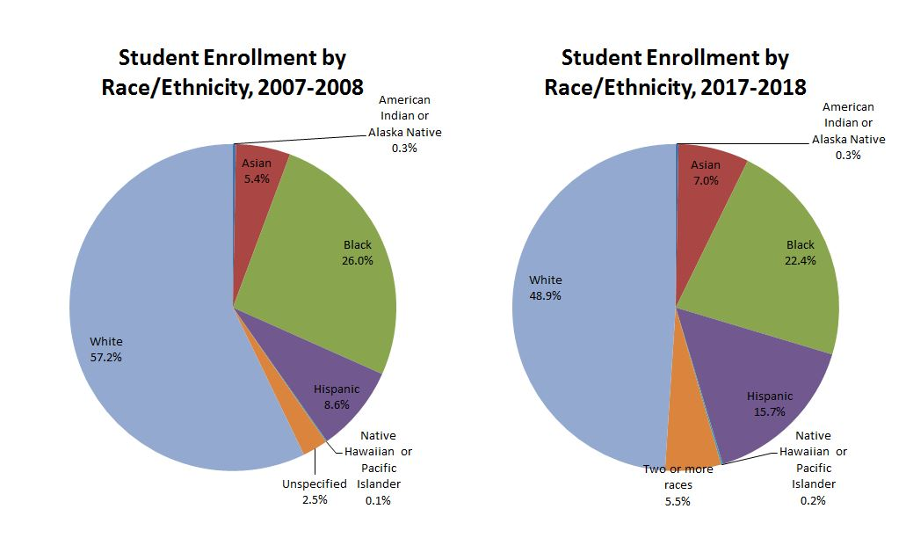

*Source: VDOE Fall Membership*

In 2017, 25 school divisions had at least one school isolated by race and income, which is defined as a school with more than 75 percent of students receiving free and reduced lunch and 75 percent of students are black or Hispanic. More than 82,000 students attend these schools isolated by poverty and race.

**Virginia Schools Isolated by Poverty and Race**

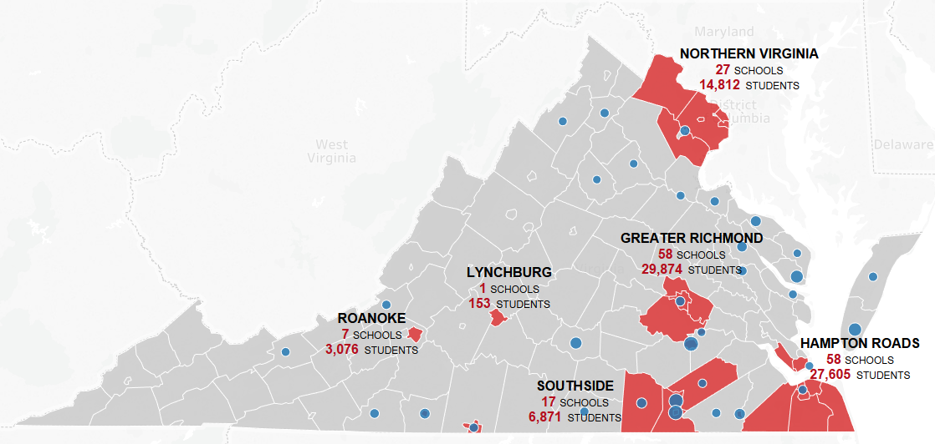

**At least one school in the division isolated by race and income**

**No isolated school**

**Provisionally licensed teachers greater than 10%**

*Source: VDOE Staff Analysis*

While our schools are becoming more diverse, our current educator workforce lacks diversity. Currently, non-white students make up 50.3 percent of Virginia’s student population, but only 21.4 percent (working on an updated figure) of the state’s teachers are non-white. Virginia’s challenges with teacher diversity are not unique but rather reflect broader national trends and a disproportionate racial composition of the teacher pipeline.

Research illustrates the importance of greater teacher diversity because of the substantial benefits teachers of color provide to all students and to students of color in particular. More teachers of color are being recruited than in years past, however their turnover rates are higher due to inadequate preparation and mentoring, poor teaching conditions, and displacement from the high-need schools in which they teach.

Studies have found that teachers of color boost the academic performance of students of color. Teachers’ influences include improved reading and mathematics test scores, improved graduation rates, and increased aspirations to attend college. Students of color also experience social-emotional and nonacademic benefits to having teachers of color, such as fewer unexcused absences and lower likelihoods of chronic absenteeism and suspension. Students of color and white students also report having positive perceptions of their teachers of color, including feeling cared for and academically challenged.

**Virginia’s License Instructional Personnel and Students by Race, 2017-2018**

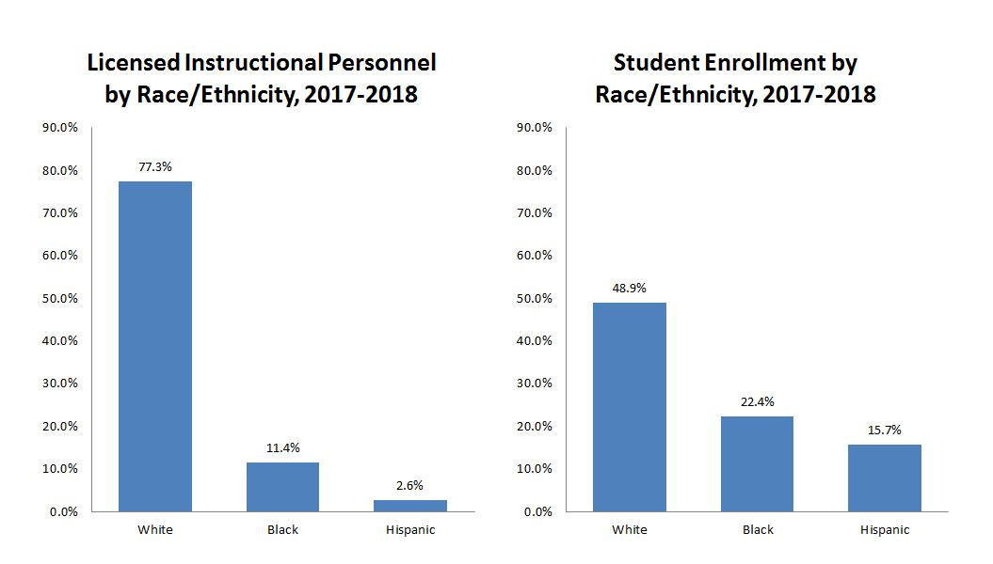

*Source: VDOE Staff Analysis*

The result of this data is that far too many students don’t receive as high-quality an education as others causing greater educational inequity, which often leads to decreased educational and occupational attainments, stunted career earnings, and poorer health in adulthood.

**Education Funding as Compared to Other States**According to the Joint Legislative Audit and Review Commission’s report *Virginia Compared to the Other States: 2018 Edition*, Virginia ranks 24th of 50 for state and local per pupil funding for Pre K-12 education, and 40th of 50 for state per pupil funding. These figures demonstrate the gap between state and local funding of public education. The majority of public school funding in Virginia, 51 percent, is from localities. The state contributes 42 percent of public school funding, with seven percent from federal sources. Some students from historically disadvantaged backgrounds are starting with less than their peers, and require more targeted resources and wrap-around services, based on individual needs, to achieve the same level of success as their peers. Virginia’s high poverty divisions get 89 cents for every dollar in low poverty divisions.[1]

**Teacher Attraction and Retention**

In Virginia, and in states across the country, teacher shortages have been a central concern for education leaders and policymakers. What we know is that teacher shortages are often confined to certain subject areas such as math, science, and special education. Urban, rural, high-poverty, high-minority, and low-achieving schools face persistent staffing challenges. Teacher vacancies are not distributed evenly across Virginia as challenged school divisions are more likely to have vacancies.

**Percent of Positions Unfilled by Region**

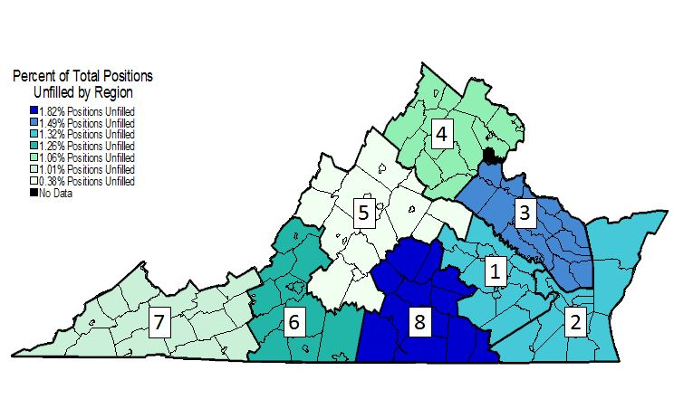

*Source: Dr. Luke Miller. October 24, 2017. Presentation to the Advisory Committee on Teacher Shortages (ACTS). University of Virginia*

While there are more unfilled positions in special education and elementary education, the magnitude of the teacher shortage varies across assignment area. As a percent of positions unfilled by teacher assignment area, math specialist and school psychologist are most in demand.

**Number of Positions Unfilled by Teacher Assignment Area, 2016-2017**

Graph shows number of unfilled positions by teaching assisgnment area 

*Source: Dr. Luke Miller. October 24, 2017. Presentation to the Advisory Committee on Teacher Shortages (ACTS). University of Virginia*

**Percent of Position Unfilled by Teacher Assignment Area, 2016-2017** Graph shows percent of unfilled positions by teaching assisgnment area; math specialists represent the greatest shortage area by percent 

*Source: Dr. Luke Miller. October 24, 2017. Presentation to the Advisory Committee on Teacher Shortages (ACTS). University of Virginia*

Teacher production is cyclical and often responsive to the state of the economy. According to one recent study, college students exposed to higher unemployment during their school tenure “select majors that earn higher wages.” As a result, poor economies tend to drive students away from teaching to careers that are more lucrative. It is notable that enrollment drops in teacher preparation programs were less steep in 2013-2014 than they were in 2010 and 2011. However, teacher production has grown steadily since 1985 and is projected to continue to grow.

While teacher production is one piece of the teacher shortage puzzle, teacher attrition and teacher turnover are major factors. Since 2004-2005, teacher turnover has been fairly stable but national data indicates that five year teacher turnover rates are 17 percent and teacher attrition rates account for about eight percent annually. Much of the demand for teachers is caused by attrition. Recently, it has accounted for more than 95 percent of demand, and in years to come, it will continue to account for at least 85 percent of annual demand. About a third of teacher attrition is due to retirement but pre-retirement attrition accounts for the largest share of turnover. Another 8 percent of teachers shift to different schools each year. For the past three years in Virginia, teacher turnover rates have been above 10.5 percent. While the specific reasons for departure are not collected, nationally we know that the majority reasons for teacher turnover include lack of administrative support, poor teaching conditions and accountability pressures.

**Ten-Year Trend in Teacher Turnover for Virginia**

*Source: Virginia Department of Education Instructional Personnel Data Collection System*

Higher teacher turnover negatively effects student achievement, hard to staff schools suffer from diminished collegial relationships, a lack of institutional knowledge, and the expense of training new teachers who, oftentimes, will not stay long-term.

Teacher indiction and mentorship programs are a strategy that can help address early teacher attrition. New teachers who are poorly supported or underprepared are more likely to leave the profession within the first five years. Comprehensive induction programs can improve teacher retention and accelerate the professional growth of a teacher, providing a positive return on investment and improve student learning.

As expected, salary and earning potential play a role in career choice selection. Virginia ranked 29th out of 50 for average salary of K-12 teachers and earn about 30 percent less than their non-teaching counterparts. According to the National Education Association’s *Rankings of States 2017* report, the average teacher salary in Virginia is $51,049 while the national average is $59,660. According to the U.S. Department of Education Beginning Teacher Longitudinal Study (BTLS), the percentage of beginning teachers who continued to teach after the first year varied by first-year salary level. For example, 97 percent of beginning teachers whose first-year base salary was $40,000 or more were teaching in 2008-2009 versus, 87 percent of beginning teachers whose first-year base salary was less than $40,000. In Virginia, the average starting salary for a teacher with a bachelor’s degree is $40,473 with a range from $30,407 to $49,600.

In addition to salary and earning potential, the shape of the salary schedule matters. The impact of salary on teacher turnover is largest among less experienced teachers and begins to decrease rapidly after seven to eight years of experience. Increasing salaries for teachers with three or more years on experience differentially retains high-ability teachers compared to increasing salaries for teachers with zero to two years experience. Local school divisions may improve student achievement growth at no cost by simply reshaping their salary structure.

**Average Shape of Salary Schedule in Virginia**

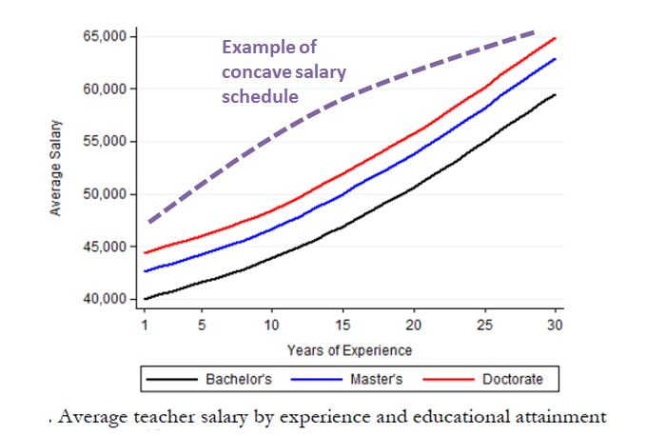

In Virginia, only four local school divisions front-load their teacher salary schedules while 13 divisions pay first through fifth year teachers the same amount. Thirty-one school divisions pay first and second year teachers the same amount and 46 school divisions have salary schedules that do not distinguish between some level of experience.

**Percent of Divisions Allocating the Largest Raises in Salary to Early, Middle and Late Career Teachers**

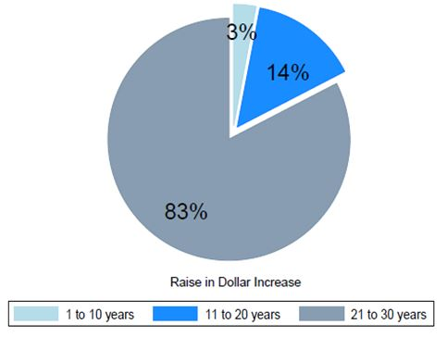

*Source: Source: Miller, LC & D’Costa, D. (2017). An analysis of Virginia’s 2016-17 teacher salary schedules. UVA EdPolicyWorks Report No. 6 .* [*https://curry.virginia.edu/sites/default/files/files/EdPolicyWorks_files/EdPolicyWorks_Report_6_VA_Teacher_Salaries2.pdf*](https://curry.virginia.edu/sites/default/files/files/EdPolicyWorks_files/EdPolicyWorks_Report_6_VA_Teacher_Salaries2.pdf)

Financial incentives can impact teacher recuitment and retention. Research shows that state financial incentive programs have potential to direct teachers to shortage areas but those incentive programs will lose their appeal they are not sufficient, sustainable, and paired with improvements to working conditions.

1. **Public Education in Virginia**

By nearly every national and state measure, Virginia’s public K-12 schools, students, and educators continue to improve and lead the way in academic achievement and accountability:

* Virginia students outperform their peers nationwide on the ACT by 18 or more points. Virginia public school 2017 graduates achieved gains on all four portions of the ACT (English, mathematics, reading and science) compared with the average scores in 2016.
* The average math and reading scores of Virginia fourth-grade and eighth-grade students on the 2017 National Assessment of Educational Progress (NAEP) – also known as "The Nation’s Report Card" – were significantly higher than the averages of their national peers.
* Virginia’s on-time graduation rate rose to 91.6 percent in 2018. Fifty-two percent of students in the class of 2018 graduated with an advanced diploma.
* Virginia students performed at least 21 points higher than the national average in math, and 31 points higher in reading and writing on the SAT college-admissions test. Sixty-three percent of Virginia’s 2017 public school graduates took the SAT.
* During the 2016-2017 school year, students earned at total of 157,490 Career and Technical Education (CTE) credentials, and 126,113 students earned one or more CTE credential, an increase of 15 percent and 16 percent, respectively, over the 2015-2016 school year.

**Student Demographics and Enrollment Trends**

Virginia schools continue to grow in diversity, representing every-changing communities. During the last ten years, the total student population has increased five percent   
(59,595 students), from 1,231,987 students in 2007-2008 to 1,291,582 students in 2017-2018; however the number of economically disadvantaged students, English Learners, and students with certain disabilities has increased dramatically. The number of economically disadvantaged students has increased by 44 percent (162,151 students), from 367,771 students in 2007-2008 to 529,922 students in 2017-2018. Economically disadvantaged students are students who: (1) are eligible for Free/Reduced Meals; (2) receive Temporary Assistance for Needy Families (TANF); (3) are eligible for Medicaid; or (4) identify as either migrant or experiencing homelessness. The number of English Learners has increased by 69 percent (64,784 students), from 94,364 students in 2007-2008 to 159,148 students, currently representing 12 percent of the student population. In addition, during that same period, the number of students identified with autism has increased by 178 percent (13,526 students), from 7,580 students in 2007-2008 to 21,106 in 2017-2018, and the number of students identified in the other health impairments disability category has increased by 29 percent (7,684 students), from 26,947 students in 2007-2008 to 34,631 students in 2017-2018. The changing makeup of our schools has an impact on resources and supports needed for students, as well as the additional costs to educate some of our most vulnerable student populations. Research supports what intuition tells us: schools serving more economically disadvantaged children, more English Learners, and more children with challenging conditions need more resources than their more advantaged counterparts to yield successful student outcomes.

|  |  |  |  |  |
| --- | --- | --- | --- | --- |
|  | **2007** | **2017** | **Students Change** | **Change Pct** |
| All Students | 1,231,987 | 1,291,582 | 59,595 | 5% |
| Economically Disadvantaged | 367,771 | 529,922 | 162,151 | 44% |
| English Learners | 94,364 | 159,148 | 64,784 | 69% |

|  |  |  |  |  |
| --- | --- | --- | --- | --- |
|  | **2007** | **2017** | **Students Change** | **Change Pct** |
| Autism | 7,580 | 21,106 | 13,526 | 178% |
| Other health impairments | 26,947 | 34,631 | 7,684 | 29% |

**Accreditation Status**

In September, the Virginia Department of Education reported the first school ratings under the new state accreditation standards, which were approved by the Board last November. The new accreditation standards are designed to promote continuous achievement in all schools, close achievement gaps and expand accountability beyond overall performance on Standards of Learning assessments. Additionally, the new standards recognize the academic growth of students making significant annual progress toward meeting grade-level expectations in English and mathematics.

Under the Board’s revised *Standards of Accreditations*, schools are evaluated on school quality indicators grouped in three categories: academic achievement, achievement gaps, and student engagement and outcomes. Performance on each indicator is rated at one of the following levels:

* Level One: Meets or exceeds state standard or sufficient improvement
* Level Two: Near state standard or sufficient improvement
* Level Three: Below state standard
* Too Small: Too few students in school or group to evaluate

The following tables summarize how Virginia’s 1,813 schools open during 2017-2018 performed on each applicable school quality indicator.

**Academic Achievement Summary**

|  |  |  |  |  |
| --- | --- | --- | --- | --- |
| Indicator | Schools at Level One | Schools at Level Two | Schools at Level Three | Too Small |
| English | 1,700 | 62 | 50 | 1 |
| Mathematics | 1,725 | 42 | 45 | 1 |
| Science | 1,661 | 36 | 64 | 1 |

**Achievement Gaps Summary**

|  |  |  |  |  |
| --- | --- | --- | --- | --- |
| Indicator | Schools at Level One | Schools at Level Two | Schools at Level Three | Too Small |
| English | 1,057 | 644 | 112 | 0 |
| Mathematics | 982 | 654 | 176 | 1 |

**Student Engagement and Outcomes Summary**

|  |  |  |  |  |
| --- | --- | --- | --- | --- |
| Indicator | Schools at  Level One | Schools at  Level Two | Schools at  Level Three | Too Small |
| Chronic Absenteeism | 1,600 | 169 | 44 | 1 |
| Dropout Rate (High Schools) | 270 | 30 | 30 | 0 |
| Graduation & Completion (High Schools) | 302 | 18 | 9 | 1 |

For 2018-2019, 92 percent, or 1,683, of Virginia’s 1,821 public schools are rated as accredited and seven percent are rated accredited with conditions. Three hundred twenty-two schools will undergo academic reviews or implement corrective action plans. This compares with 250 schools identified for similar state-directed or state-guided interventions last year under the previous accountability standards.

**Performance on School Quality Indicators**

Under the revised *Standards of Accreditation*, school quality indicators for English and mathematics include the academic growth of students making significant progress toward meeting state benchmarks. Schools are also evaluated on progress in closing achievement gaps in English and mathematics, raising overall achievement in science and reducing chronic absenteeism. High schools are evaluated on their success in raising graduation rates and reducing dropout rates. State-wide performance on these indicators is outlined below:

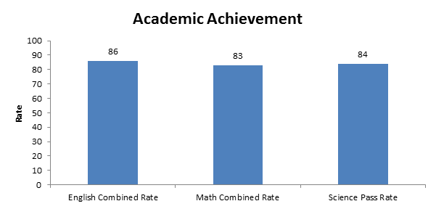

The state-level academic achievement combined rate for English is 86 percent. The state-level academic achievement combined rate for math is 83 percent. The state-level academic achievement pass rate for science is 84 percent.

The all students combined rate for academic achievement in English is 86 percent. Black and economically disadvantaged students fall below the all students combined rate in English at 75 and 78 percent, respectively. There is also a significant achievement gap for students with disabilities.

The all students combined rate for academic achievement in math is 83 percent. Black and economically disadvantaged students fall below the all students combined rate in math at 72 and 75 percent, respectively. There is also a significant achievement gap for students with disabilities.

The state-level chronic absenteeism rates dropped slightly from 11.8 percent in 2016-2017 to 11 percent in 2017-2018.

The state-level dropout rates from 2017 to 2018 dropped slightly from 5.8 to 5.5 percent.

The state-level Graduation and Completion Index rose slightly from 92.4 percent for the Class of 2017 to 92.8 percent for the Class of 2018.

**Standards of Learning (SOL) Assessment Performance**

Student achievement on SOL assessments during 2017-2018 remained relatively unchanged compared with performance during the previous school year.

Overall, 79 percent of students achieved proficient or advanced scores in reading, and 77 percent passed tests in mathematics, compared with 80 percent and 79 percent in 2016-2017. Eighty-one percent passed grade-level or end-of-course SOL tests in science, compared with 82 percent previously.

Student achievement in English writing declined by one point, with 78 percent passing compared with 79 percent during 2016-2017. Overall achievement in history/social science declined slightly, with 84 percent of students passing SOL tests in the subject.

However, the performance of demographic groups presents significant differences in pass rates on academic subjects, as shown by the following tables:

* Calculations for annual pass rates were modified to reflect new federal reporting requirements.

The pass rate benchmark for English reading is 75 percent. Hispanic, Black and economically disadvantaged students are below the state average of 79 percent. There is also a significant achievement gap for students with disabilities.

* Calculations for annual pass rates were modified to reflect new federal reporting requirements.

The pass rate benchmark for English writing is 75 percent. Black, economically disadvantaged, and Hispanic students and English Learners are below the state average of 78 percent. There is also a significant achievement gap for English Learners and students with disabilities.

* Calculations for annual pass rates were modified to reflect new federal reporting requirements.

The pass rate benchmark for history and social sciences is 70 percent. Black, economically disadvantaged, and Hispanic students are below the state average of 84 percent but meet or exceed the benchmark. There is also a significant achievement gap for students with disabilities.

* Calculations for annual pass rates were modified to reflect new federal reporting requirements.

The pass rate benchmark for mathematics is 70 percent. Black, Hispanic, and economically disadvantaged students and English Learners are below the state average of 77 percent but are close to the benchmark. There is also a significant achievement gap for students with disabilities.

* Calculations for annual pass rates were modified to reflect new federal reporting requirements.

The pass rate benchmark for science is 70 percent. Black and economically disadvantaged students are below the state average of 81 percent but are close to the benchmark. There is also a significant achievement gap for English Learners and students with disabilities.

**Graduation and Dropout Rates**

Virginia’s on-time graduation rate rose to 91.6 percent, an increase from 91.1 percent, for the class of 2018. While more than nine out of ten students who entered the ninth grade in 2014 earned a diploma within four years, there are still gaps in graduation and dropout rates among groups of students:

* English Learners displayed the largest gaps from their peers, with a graduation rate of   
  72.5 percent - 19 percentage points below the average – and almost one out of four students dropping out.
* Hispanic students also exhibited concerning levels of graduation and dropout, at   
  80.9 percent and 16 percent.
* Differences in graduation rates and dropout rates for Black students, students with disabilities, and economically disadvantaged students still persist as well.

**Suspension Rates among Demographic Groups**

According to Virginia Department of Education statistics, the number of students expelled in Virginia remains stable since 2015-2016. Additionally, the number of short-term and long-term suspensions for all students has remained stable since 2015-2016. However, the number of short-term suspensions among all students and among minority students in particular remains high. Although Black students made up 22 percent of the student population in 2017, they accounted for 52 percent of the short-term suspensions, 59 percent of long-term suspensions, and 42 percent of expulsions.

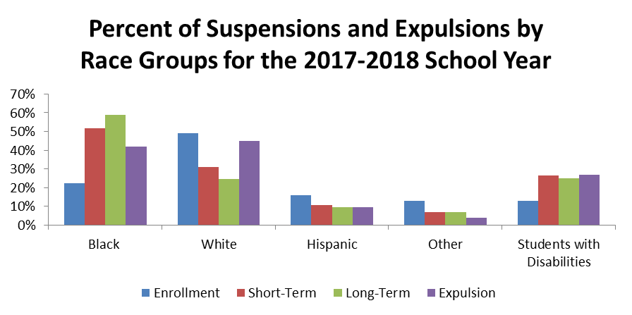

The Board is committed to creating a more equitable public education system which supports a high-quality, diverse teacher workforce, utilizing its authority provided in the *Virginia Constitution* and *Code of Virginia*. Addressing conditions that affect student learning and well-being requires a continued investment of resources. Addressing these needs will also require partnerships between the Board of Education, the General Assembly, the Governor, local school boards and divisions, educators, families, community organizations, institutions of higher education, and business industries.

1. **Board of Education Priorities and Goals** *(as outlined in the Board of Education’s Comprehensive Plan: 2018-2023)*

The Board of Education reaffirms the priorities and goals outlined in their comprehensive plan. These priorities and goals are the foundation for providing high-quality educational opportunities for all public school students in Virginia. In identifying these priorities and goals, the Board has reached out to families, students, educators, administrators, community members, business leaders, higher education institutions, and the public through hundreds of comments provided during Board public hearings, presentations, and through correspondence. To ensure that all children in the Commonwealth have access to a high-quality education that prepares them for a successful, healthy, and fulfilling life, the Board has developed the following priorities and goals:

**Priority 1: Provide high-quality, effective learning environments for all students**

Consistent with the constitutional mandate, the Board seeks to provide a high-quality, effective learning environment for all students. The current standards have not resulted in educational equity. There is a persistent achievement gap.[2] The Board of Education will focus on the factors that may be causal.

Students in high poverty schools have less experienced instructors, less access to high level science, math, and advanced placement courses, and lower levels of state and local spending on instructors and instructional materials.[3] High poverty divisions in Virginia get 86 cents for every dollar compared to low poverty divisions.[4] Additionally, the average teacher salary during the 2013-2014 school year in high poverty schools was over $11,000 less than in low poverty schools. [5] Currently, 32.46 percent of Virginia public school students are at-risk. Among schools that have been denied accreditation, the median percentage of at-risk students is 64.89 percent. Among schools that have been fully accredited for the past five years, the median percentage of at-risk students is 27.06 percent. Through the work in school improvement over the past decade, the Board has learned that our children in poverty oftentimes need additional services to be able to benefit from educational opportunity. Our schools in high poverty areas do not have access to the same funding that schools in low-poverty areas do, and they have greater numbers of students that may require access to additional services in order to receive the full benefit of the education being offered. Many challenges will need to be addressed to close the achievement and opportunity gap including access to healthy food, school infrastructure, advanced courses and technology, and the need for wrap-around services, in addition to great teachers and school leaders.

To promote educational equity, the Board will:

* Develop Standards of Quality, policies, and guidelines to reflect its understanding of the diverse nature of the modern student body.
* Advance policies that expand equitable learning opportunities with access to a variety of learning platforms, courses and programs and reduce barriers to technology access.
* Advocate for the resources required to fully support a system of quality education for all students, regardless of background, including tools for collaborative oversight and support at the Virginia Department of Education for schools that are not yet meeting standards.
* Actively foster equitable, supportive, and safe academic, disciplinary, and physical environments and encourage the engagement of all families in the academic lives of their children.
* Support and promote wrap-around services and mental and physical wellness and intervention programs to increase opportunities for all students to achieve.

**Priority 2: Advance policies that increase the number of candidates entering the teaching profession and encourage and support the recruitment, development, and retention of well-prepared and skilled teachers and school leaders**

Like much of the nation, Virginia is facing a growing shortage of high-quality educators entering and remaining in Virginia’s public schools. This decline is correlated with low teacher salaries and lack of commitment to tap the financial resources to correct this crucial situation. Virginia’s teacher shortage is due in significant part to a shrinking pool of candidates entering the teaching profession. Nationally, the number of individuals enrolling in teacher preparation programs has declined by 30 percent since 2008. According to the enrollment data from the State Council of Higher Education for Virginia (SCHEV), Virginia has seen a similar decline in teacher preparation program enrollment. Over the same time period, student enrollment in Virginia has grown by five percent. These trends are of particular concern in a state like Virginia with an increasingly diverse population. Currently, non-white students made up 48.7 percent of Virginia’s student population, but only 21.4 percent of the state’s educators are non-white. Diversity within the teacher workforce should reflect diversity in the classroom. Evidence suggests that students perform better when taught by teachers from diverse backgrounds.

The number of unfilled teacher positions across the Commonwealth has increased by 42 percent over the past 10 years, from 760 to 1,080, and has become an emergency in many high poverty school divisions. For example, two months before the beginning of the 2017 school year, Petersburg City Public Schools had 142 unfilled teaching positions out of a total of 400 positions, over one-third of their teaching positions. Another example is in Middlesex County Public Schools, where one month into the 2016 school year, over 20 percent of their teaching positions were unfilled. Although shortages occur in every region of the Commonwealth, divisions with the highest concentrations of poverty – both urban and rural – tend to have the hardest time attracting and retaining high-quality teachers.

In addition to attracting teachers, curbing teacher turnover is important. Teacher attrition in the United States has increased steeply since the 1990s.[6] Currently, the annual teacher attrition is about eight percent and accounts for roughly 90 percent of the demand for new teachers.[7] Another eight percent of teachers shift to different schools each year, bringing the total annual teacher turnover rate close to 16 percent.[8] These figures are even worse in high poverty schools. Multiple factors influence teachers to leave the professional for reasons other than retirement including: (1) concerns about over-testing and accountability, which creates stress and stifles creativity; (2) unhappiness with school administration and school climate; and (3) career dissatisfaction, which is often linked to a lack of adequate preparation for the challenges of a classroom.[9]

Part of the discussion on teacher recruitment, development, and retention must focus on teacher salaries. When compared to similarly educated professions across the country, Virginia teacher wages are less competitive, earning about 27 percent less than similarly educated professions.[10]

The Board recognizes the importance of recruiting, retaining, and appropriately training a well-prepared and diverse educator workforce. To support educator recruitment, development, and retention, the Board will:

* Promote instructional and support personnel capacity building through teacher preparation programs and ongoing professional development that supports a culture of continuous growth.
* Advocate for adequate resources for educator salaries.
* Promote equitable allocation of resources, including an equitable distribution of high-quality school personnel, that enable all school divisions to fund the necessary staff and infrastructure required to provide a quality education for all students.
* Advocate for new teacher mentorship programs to be implemented in local school divisions to support the development and retention of instructional personnel.
* Encourage respectful, caring relationships among staff and students for a positive school climate and life experience of teachers.
* Support policies for attracting top students into the education profession, including revisions as necessary to Board policies that might hinder entry into or retention in the teaching profession.
* Guide and support teacher preparation programs that address classroom instructional skills that support implementation of the *Profile of a Virginia Graduate*, understanding of student behavior, and cultural competencies for working with diverse and economically disadvantaged students, families, and communities as part of the curriculum.

**Priority 3: Ensure successful implementation of the *Profile of a Virginia Graduate* and the accountability system for school quality as embodied in the revisions to the *Standards of Accreditation***

The Board, with the support of the General Assembly and vigorous engagement of education leaders and the public across the Commonwealth, has adopted significant changes to the *Standards of Accreditation*, including the development of the *Profile of a Virginia Graduate* and reforms to school accreditation. The *Profile* outlines the knowledge, skills, competencies, and experiences students should attain during their K-12 education to make them “life-ready,” to be on a path to successful citizenship and participation in the evolving global economy. The *Profile* further articulates the importance of the 5 C’s – critical thinking, creative thinking, collaboration, communication, and citizenship and provides more flexibility for student choice of courses and reduces Standards of Learning (SOL) testing.

Virginia’s new accountability system provides a comprehensive picture of school quality, drives continuous improvement for all schools, and informs areas of technical assistance and school improvement resources from the Virginia Department of Education. Each school will be held accountable for attainment on multiple school quality indicators adopted by the Board for accreditation, based on performance benchmarks. Performance benchmarks measure actual performance or improvement or decline in performance over time, or a combination of the two, for each school quality indicator. Based on achievement and school improvement, schools and divisions will receive differential levels of oversight and support from the Virginia Department of Education to ensure continuous improvement toward the goal of a quality education for all students.

Successful implementation of the *Profile* and new accountability system will require support from the Board, Virginia Department of Education, General Assembly, Governor, and local school divisions. Additionally, it will require hard work and collaboration with local school boards, teachers, education and community leaders, parents, and students. In the coming years, the Board will continue to look at the impact of accreditation in the accountability system and increased student achievement and other societal impacts.

To foster continuous improvement in schools benefitting all students, the Board will:

* Support statewide systems that track achievement and improvement for all students.
* Oversee successful implementation of the revisions to the *Standards of Accreditation* to ensure they are meeting intended goals.
* Advocate for the resources required to fully support a system of continuous improvement for all students.
* Use evaluative data to identify additional measures impacting student achievement or school quality appropriate for public information and accountability
* Ensure rigorous standards to promote college, career, and civic readiness.
* Promote closer alignment and continuity with higher education and workforce needs.
* Review and identify best practices, and promising approaches that would benefit local school divisions.

**APPENDICES**

Appendix A: Accreditation Maps

Appendix B: Summary of Compliance and Non-Compliance with the Standards of Quality (SOQ) for 2017-2018

Appendix C: School Divisions Reporting Full Compliance with the Standards of Quality (SOQ) for 2017-2018

Appendix D: School Divisions Reporting Noncompliance with One or More Provisions of the Standards of Quality (SOQ) for 2017-2018

Appendix E: Current Standards of Quality (SOQ)

Appendix F: Charter School Report and Information on Parent and Student Options

Appendix G: Analysis of School Division Reporting Requirements

Appendix H: Status Report Regarding Multidivision Online Learning

Appendix I: Virtual Virginia Brief

1. Baker, Farrie, Sciarra. (2018) *Is School Funding Fair? A National Report Card (Seventh Edition).* Newark, NJ:Education Law Center and Rutgers Graduate School of Education. <http://www.edlawcenter.org/assets/files/pdfs/publications/Is_School_Funding_Fair_7th_Editi.pdf>.
2. Bohrnstedt, G., Kitmitto, S., Ogut, B., Sherman, D., and Chan, D. (2015). *School Composition and the Black–White Achievement Gap*. U.S. Department of Education, Washington, DC: National Center for Education Statistics. <https://nces.ed.gov/nationsreportcard/subject/studies/pdf/school_composition_and_the_bw_achievement_gap_2015.pdf>
3. Duncombe, Chris. (2017) *Unequal Opportunities: Fewer Resources, Worse Outcome for Students in Schools with Concentrated Poverty*. Richmond, VA: The Commonwealth Institute. <http://www.thecommonwealthinstitute.org/wp-content/uploads/2017/10/unequal_opportunities.pdf>.
4. Baker, Farrie, Johnson, Luhm, Sciarra. (2017) *Is School Funding Fair? A National Report Card (Sixth Edition).* Newark, NJ:Education Law Center and Rutgers Graduate School of Education. <https://drive.google.com/file/d/0BxtYmwryVI00VDhjRGlDOUh3VE0/view>.
5. Duncombe, *Unequal Opportunities: Fewer Resources, Worse Outcome for Students in Schools with Concentrated Poverty*. Richmond, VA: The Commonwealth Institute. <http://www.thecommonwealthinstitute.org/wp-content/uploads/2017/10/unequal_opportunities.pdf>.
6. Carver-Thomas, D. & Darling-Hammond, L. (2017) *Teacher turnover: Why it matters and what we can do about it.* Palo Alto:Learning Policy Institute. <https://learningpolicyinstitute.org/product/teacher-turnover>.
7. Ibid.
8. Ibid.
9. Advisory Committee on Teacher Shortages. (October 2017) *Preliminary Report*. Richmond, VA. <https://www.dropbox.com/sh/mrfi003udnhr9su/AAC6FiZdaxTWKecyXFn7z_nIa?dl=0&preview=Final+ACTS+Report.pdf>.
10. Baker, Farrie, Johnson, Luhm, Sciarra. (2017) *Is School Funding Fair? A National Report Card (Sixth Edition)*. Newark, NJ: Education Law Center and Rutgers Graduate School of Education. <https://drive.google.com/file/d/0BxtYmwryVI00VDhjRGlDOUh3VE0/view>