virginia board of education

Presented to the Governor
and General Assembly

December 1, 2019

Virginia Board of Education
2019 Annual Report

2019 Annual Report on
the Condition and Needs of
Public Schools in Virginia
Members of the Virginia Board of Education
As of November 14, 2019

Mr. Daniel A. Gecker, President
Chesterfield, VA

Mrs. Diane T. Atkinson, Vice President
Ashland, VA

Ms. Kim E. Adkins
Martinsville, VA

Ms. Pamela Davis-Vaught
Bristol, VA

Dr. Francisco Durán
Alexandria, VA

Ms. Anne B. Holton
Richmond, VA

Dr. Tammy Mann
Fairfax, VA

Dr. Keisha Pexton
Hampton, VA

Dr. Jamelle S. Wilson
Ashland, VA

Superintendent of Public Instruction
Dr. James F. Lane
Virginia Department of Education

Staff for this Report
Ms. Emily V. Webb, Director of Board Relations
Virginia Department of Education

TABLE OF CONTENTS

Executive Summary………………………………………………………………………Page 4
Report
- The Needs of Public Education in Virginia...……………………………...Page 5

- The Board’s Work…………………………………………………………..Page 7

- Summary of Achievement………...………………………..………………Page 16

Appendices ………………………………………………………………………………..Page 20
Appendix A: Statutory Requirements

Appendix B: 2019 Revisions to the Standards of Quality

Appendix C: Accreditation Maps

Appendix D: Summary of Compliance and Non-Compliance with the Standards of Quality (SOQ) for 2017-2018

Appendix E: School Divisions Reporting Full Compliance with the Standards of Quality (SOQ) for 2017-2018

Appendix F: School Divisions Reporting Noncompliance with One or More Provisions of the Standards of Quality (SOQ) for 2017-2018

Appendix G: Current Standards of Quality (SOQ)

Appendix H: Charter School Report and Information on Parent and Student Options

Appendix I: Analysis of School Division Reporting Requirements

Appendix J: Status Report Regarding Multidivision Online Learning

Appendix K: Virtual Virginia Brief

Executive Summary

As outlined in §22.1-18, by December 1 of each year, the Board of Education must submit to the Governor and General Assembly a report on the condition and needs of public education in the Commonwealth.

Through the 2019 Annual Report on the Condition and Needs of Public Schools in Virginia, the Board of Education reaffirms the priorities and goals outlined in its comprehensive plan, adopted November 2017. The priorities outlined in the comprehensive plan are to:
- Provide high-quality, effective learning environments for all students;
- Advance policies that increase the number of candidates entering the teaching profession and encourage and support the recruitment, development, and retention of well-prepared and skilled teachers and school leaders;
- Ensure successful implementation of the Profile of a Virginia Graduate and the accountability system for school quality as embodied in the revisions to the Standards of Accreditation.

The Board is committed to creating a more equitable public education system that supports a high-quality, diverse teacher workforce, utilizing its authority provided in the Virginia Constitution and Code of Virginia. Addressing conditions that affect student learning and well-being requires a continued investment of resources. Further, addressing these needs will require partnerships between the Board of Education, the General Assembly, the Governor, local school boards and divisions, educators, families, community organizations, institutions of higher education, and business industries. The comprehensive Standards of Quality issued by the Board, founded in research and best practice, make progress toward creating a more equitable public education system for Virginia’s students.
2019 Annual Report on the Condition and Needs
of Public Schools in Virginia

Education plays an essential role in determining how someone will spend his or her adult life and creates opportunities that can lead to higher earnings, better health, and a longer life. By the same token, the long-term social and financial cost of educational failure is high. A fair and inclusive system that makes the advantages of education available to all is one of the most powerful levers to achieve equity in our society. Every student deserves an equitable education that prepares him or her to succeed in life.

The 2019 Annual Report on the Condition and Needs of the Public Schools in Virginia presents the needs of public education, an update on the Board’s work, the 2019 revisions to the Standards of Quality, a summary of achievement, and an appendix of reports required by the Code of Virginia.

- The Needs of Public Education in Virginia

The Board of Education reaffirms the priorities and goals outlined in its comprehensive plan, adopted November 2017. The priorities outlined in the comprehensive plan are to:
- Provide high-quality, effective learning environments for all students;
- Advance policies that increase the number of candidates entering the teaching profession and encourage and support the recruitment, development, and retention of well-prepared and skilled teachers and school leaders;
- Ensure successful implementation of the Profile of a Virginia Graduate and the accountability system for school quality as embodied in the revisions to the Standards of Accreditation.

In 2018, the Board created the Special Committee on Evidence-Based Policymaking to begin addressing the priorities outlined in the comprehensive plan. The special committee met with a growing number of experts and researchers in the field to learn about best practices in equity and teacher attraction and retention. Since then, the Board as a whole has focused much their work on revisions to the Standards of Quality.

Many of the conclusions from the 2018 Annual Report remain true.
- By nearly every national and state measure, Virginia’s public schools, students, and educators continue to improve and lead the way in academic achievement and accountability. However, persistent achievement gaps remain for certain student groups.
- Virginia schools are underfunded. According to the Joint Legislative Audit and Review Commission’s report Virginia Compared to the Other States: 2019 Edition, Virginia ranks 26th of 50 for state and local per pupil funding for Pre K-12 education, and 42nd of 50 for state per pupil funding. Adjusting for inflation, state direct aid has fallen eight percent per student for K-12 public schools in Virginia since 2009.
- Local governments continue to take on a larger share of funding. In 2018-2019, Virginia localities invested $4.2 billion above the required local effort for SOQ programs. However, not all localities have the capacity to provide additional investments causing inequitable resources and learning opportunities for students.
- While student enrollment continues to increase, overall staffing levels for Virginia public schools have decreased compared to the 2008-2009 school year. Currently, there are 379 fewer staff in Virginia schools and over 55,000 more students enrolled, many requiring additional supports and services.
- Virginia continues to face a growing shortage of high-quality educators entering and remaining in the classroom. The number of unfilled teacher positions across the Commonwealth has increased by 83 percent since 2013. The number of teacher shortages increased from 479 during the 2013-2014 school year to a height of 1,081 in the 2016-2017 school year, then dropped slightly to 878 in the 2018-2019 school year. The percent of provisionally licensed and inexperienced teachers has similarly climbed.
- For the past six years in Virginia, teacher turnover rates have been above ten percent. While the specific reasons for departure are not collected, nationally we know that the major reasons for teacher turnover include lack of administrative support, poor teaching conditions and accountability pressures.
- Virginia ranked 32nd out of 50 for average salary of public K-12 teachers, based on 2017-2018 salary data.
- Comprehensive induction programs can improve teacher retention and accelerate the professional growth of a teacher, providing a positive return on investment and improve student achievement.
- Financial incentives impact teacher recruitment and retention. Research shows that state financial incentive programs have potential to direct teachers to shortage areas but those incentive programs will lose their appeal if they are not sufficient, sustainable, and paired with improvements to working conditions.

The Board’s Work

Article VIII, § 2 of the Constitution of Virginia requires the Board of Education to determine and prescribe Standards of Quality for the public schools in Virginia:
“Standards of quality for the several school divisions shall be determined and prescribed from time to time by the Board of Education, subject to revision only by the General Assembly. The General Assembly shall determine the manner in which funds are to be provided for the cost of maintaining an educational program meeting the prescribed standards of quality, and shall provide for the apportionment of the cost of such program between the Commonwealth and the local units of government comprising such school divisions. Each unit of local government shall provide its portion of such cost by local taxes or from other available funds.”

Section 22.1-18.01(A) of the Code of Virginia requires the Board of Education to review the Standards of Quality every two years:

“A. To ensure the integrity of the standards of quality, the Board of Education shall, in odd-numbered years, exercise its constitutional authority to determine and prescribe the standards, subject to revision only by the General Assembly, by reviewing the standards and either (i) proposing amendments to the standards or (ii) making a determination that no changes are necessary…”

In addition, § 22.1-18 of the Code requires the Board’s annual report to the Governor and General Assembly to include any recommendations for revisions to the Standards of Quality. Section 22.1-18 states, in part:

“…[T]he Board of Education shall submit to the Governor and the General Assembly a report on the condition and needs of public education in the Commonwealth and shall identify any school divisions and the specific schools therein that have failed to establish and maintain schools meeting the existing prescribed standards of quality. Such standards of quality shall be subject to revision only by the General Assembly, pursuant to Article VIII, Section 2 of the Constitution of Virginia. Such report shall include…[a] complete listing of the current standards of quality for the Commonwealth's public schools, together with a justification for each particular standard, how long each such standard has been in its current form, and whether the Board recommends any change or addition to the standards of quality…”

The 2019 review of the SOQ’s addresses all three of the Board’s priorities as identified in the Comprehensive Plan: 2018-2023. These SOQ’s promote educational equity (Priority 1) by establishing the resources required to fully support a system of quality education for all students, regardless of background, including wrap-around services and other programs to increase opportunities for all students to succeed. Additionally, these standards support educator recruitment, development and retention (Priority 2) by promoting the equitable allocation of resources and high-quality personnel and the implementation of teacher mentorship programs. Finally, the revisions support the implementation of the Profile of a Virginia Graduate and the revised school accountability system (Priority 3) by deploying resources necessary to support continuous improvement and alignment with higher education and workforce needs.

Following a nearly two-year process, including public hearings and significant engagement from an array of education, business and community stakeholders, on October XX, 2019, the Board of Education adopted revisions/issued revised/made recommendations…to the Standards of Quality.

Priority 1: Provide high-quality, effective learning environments for all students

Consistent with the constitutional mandate, the Board seeks to provide a high-quality, effective learning environment for all students. The current Standards of Quality have not resulted in educational equity or equity of opportunity. Despite progress, there is a persistent gap in student achievement.
Virginia ranks as one of the wealthiest states in the country, but is one of seventeen states with “regressive” school funding, meaning less funding is provided to high-poverty divisions than wealthier divisions, and is among the most inequitable. Based on a 2018 analysis, high poverty divisions in Virginia get 89 cents for every dollar compared to low poverty divisions. Through the work of school improvement over the past decade, the Board has seen firsthand that our children in poverty need additional services to be able to benefit from educational opportunity. Too often our schools in high poverty areas do not have access to the same funding that schools in low-poverty areas do, and they have greater numbers of students that require access to additional services in order to receive the full benefit of the education being offered.
Many challenges must be addressed to close the achievement and opportunity gap. The current funding system, increasingly reliant on local funding is inherently inequitable. Some students from historically disadvantaged backgrounds are starting with less than their peers, and require more targeted resources and wrap-around services, based on individual needs, to achieve the same level of success as their peers. State funding must work to ensure equity among divisions. For Virginia students, it’s not about funding, but rather about access and equity of opportunity to succeed in school and in life.

Education Funding
According to the Joint Legislative Audit and Review Commission’s report Virginia Compared to the Other States: 2019 Edition, Virginia ranks 26th of 50 for state and local per pupil funding for Pre K-12 education, and 42nd of 50 for state per pupil funding. These figures demonstrate the gap between state and local funding of public education. The majority of public school funding in Virginia, 51 percent, is from localities. The state contributes 42 percent of public school funding, with seven percent from federal sources. Despite recent progress by the legislature, state support is still down 8 percent per student for the 2018-2019 school year in real dollars compared to 2009-2010. Local governments continue to provide a greater share of funding. In 2017-2018, Virginia localities invested $4.2 billion above the required local effort for SOQ programs. However, not all localities have the capacity to provide additional investments causing inequitable resources and opportunities for students.

Changing Student Enrollment
Over the past ten years, student enrollment in Virginia has shifted from majority-minority student enrollment to minority-majority student enrollment (Chart I), growing in diversity, representing ever-changing communities.

Chart I: Student Enrollment by Race

Source: VDOE Fall Membership
The total student population has increased five percent (54,114 students), from 1,235,062 students in 2008-2009 to 1,289,176 students in 2018-2019; however the number of economically disadvantaged students, English Learners, and students with certain disabilities has increased dramatically. The number of economically disadvantaged students has increased by 31 percent (121,684 students), from 398,963 students in 2008-2009 to 520,647 students in 2018-2019. Economically disadvantaged students are students who: (1) are eligible for Free/Reduced Meals; (2) receive Temporary Assistance for Needy Families (TANF); (3) are eligible for Medicaid; or (4) identify as either migrant or experiencing homelessness. The number of English Learners has increased by 23 percent (20,138 students), from 87,019 students in 2008-2009 to 107,157 students in 2018-2019, currently representing eight percent of the student population. In addition, during that same period, the number of students identified with autism has increased by 164 percent (13,636 students), from 8,301 students in 2008-2009 to 21,937 in 2018-2019, and the number of students identified in the other health impairments disability category has increased by 34 percent (8,862 students), from 25,931 students in 2008-2009 to 34,793 students in 2018-2019.

The changing makeup of our schools has an impact on resources and supports needed for students, as well as the additional costs to educate some of our most vulnerable student populations. Research supports what intuition tells us: schools serving more economically disadvantaged children, more English Learners, and more children with challenging conditions need more resources than their more advantaged counterparts to yield successful student outcomes.

To provide high-quality effective learning environments for all students, the Board’s Standards of Quality revisions:
- Consolidate the At-Risk Add On and Prevention, Intervention, and Remediation funds into a single, expanded Equity Fund within the SOQ to distribute resources based on the divisionwide free lunch rate. School divisions would be able to use the funds to (1) provide for additional instructional or specialized student support positions; (2) support programs for students who are educationally at-risk or need prevention, intervention, and remediation; or (3) provide targeted compensation adjustments to assist in recruiting and retaining experienced teachers in high poverty schools;
- Amend the staffing requirements for English Learner teachers to differentiate the distribution of positions based on the proficiency level of students in each school divisions, while maintaining local flexibility in deploying those positions;
- Remove the school nurse, school social worker, and school psychologist position from the SOQ support position category, creating a new staffing category for specialized student support personnel with specified ratios for the positions; and
- Provide reading specialists positions for students in grades K-5, based upon the number of students failing third-grade Standards of Learning reading assessments, shifting the Early Reading Intervention Program into the SOQ’s.

Priority 2: Advance policies that increase the number of candidates entering the teaching profession and encourage and support the recruitment, development, and retention of well-prepared and skilled teachers and school leaders

Like much of the nation, Virginia continues to face a shortage of quality educators entering and remaining in Virginia’s public schools. This decline is correlated with low teacher salaries and lack of commitment to tap the financial resources to correct this crucial situation. Teacher vacancies are found in every region of the Commonwealth, but are not distributed evenly. The number of unfilled teacher positions across the Commonwealth has increased by 83 percent since 2013. The number of teacher shortages increased from 479 during the 2013-2014 school year to a height of 1,081 in the 2016-2017 school year, then dropped slightly to 878 in the 2018-2019 school year (Chart II). The percent of provisionally licensed and inexperienced teachers has similarly climbed. This shortage has reached emergency situations in many high poverty school divisions that do not have the resources to compete with other school divisions. Teachers are more likely to leave poor, urban schools and those who leave are likely to have greater skills than those who stay. This has led to inequitable teacher distribution across Virginia.
New and provisionally licensed teachers are concentrated in Virginia’s high poverty schools:
- High poverty schools (over 75% of its students in poverty) have an average of 13.5% new teachers (in their first or second year of teaching) and 9.3% provisionally licensed teachers.
- Low poverty schools (fewer than 25% of students in poverty) have an average of 6.9% new teachers and 7.2% provisionally licensed teachers.
- In Virginia, 9% of schools are staffed with 15% or more first year teachers, while 71% of schools have less than 5% first year teachers.
Research has shown that investments in instruction, especially quality teachers, leverage the largest gains in student performance. Up to 25% of the variance in test scores can be attributed to differences in teacher quality. Research indicates that being taught by a teacher in the top quartile of effectiveness for four consecutive years would eliminate achievement gaps between black and white students. This is concerning as black students are nearly two times more likely to be assigned an ineffective teacher, and half as likely to be assigned to the most effective teacher. These inequities are reflected within different schools in single school divisions and across school divisions.

Chart II: Number of Teacher Vacancies by Year Since 2013

Source: Virginia Department of Education Instructional Personnel Data Collection System

Financial incentives can impact teacher recruitment and retention. Research shows that state financial incentive programs have the potential to direct teachers to shortage areas, but these incentive programs lose their appeal if they are not sufficient, sustainable, and paired with improvements to working conditions. The Brookings Institution states most effective teachers are willing to teach in high-poverty schools if provided at least $15,000 in supplemental compensation.

In addition to attracting teachers, curbing teacher turnover is important. Teacher attrition in the United States has increased steeply since the 1990s. Since 2004-2005, teacher turnover has been fairly stable but national data indicates that five year teacher turnover rates are 17 percent and teacher attrition rates account for about eight percent annually. Much of the demand for teachers is caused by attrition. Recently, attrition has accounted for more than 95 percent of demand, and in years to come, it will continue to account for at least 85 percent of annual demand. About a third of teacher attrition is due to retirement but pre-retirement attrition accounts for the largest share of turnover. Another eight percent of teachers shift to different schools each year. For the past seven years in Virginia, teacher turnover rates have been above ten percent (Chart III). While the specific reasons for departure are not collected, nationally the majority reasons for teacher turnover include lack of administrative support, poor teaching conditions and accountability pressures.

Chart III: Ten-Year Trend in Teacher Turnover for Virginia

Source: Virginia Department of Education Instructional Personnel Data Collection System
Teacher induction and mentorship programs are a strategy that can help address early teacher attrition. New teachers who are poorly supported or underprepared are more likely to leave the profession within the first five years. Comparitively, teachers who are assigned a mentor during their first year in the classroom are more likely to teach for at least five years. Comprehensive mentorship and induction programs can improve teacher retention and accelerate the professional growth of a teacher, providing a positive return on investment and improve student learning. Currently, the Appropriation Act allocates $1 million annually to fund teacher mentor programs, providing $206 per teacher mentor to school divisions. This level of funding is insufficient to attract experienced teachers to provide thoughtful and holistic mentoring to new teachers.

In addition to teacher mentorship, principal leadership and support are among the most important factors in teachers’ decisions about whether to stay in a schools or in the profession. Principal turnover negatively affects teacher retention, teacher quality, and student achievement. Principal stability is needed to develop strong, trusting relationships with students, teachers and the community and more positive working conditions. A 2009 study by New Leaders, found that more than half of a school’s impact on student gains can be attributed to both principal and teacher effectiveness – with principals accounting for 25 percent and teachers 33 percent of the effect.

To increase the number of candidates entering the teaching profession and support the recruitment, development and retention of well-prepared and skilled teachers and school leaders, the Board’s Standards of Quality revisions:
- Establish a new Teacher Leader program, and expand the existing Teacher Mentor program, whereby additional compensation and additional time is provided during the instructional day for locally-designated staff to serve in leadership and mentorship program roles;
- Establish a statewide principal mentorship program to strengthen and foster the expanding role of quality school leaders that support teacher retention and student achievement; and
- Move the K-3 Class Size Reduction program into the Standards of Quality, and incorporate flexibility to allow larger class sizes for experienced teachers that are provided compensation adjustments.

While the Board does not offer specific recommendations, part of the discussion on teacher recruitment, development, and retention must focus on teacher salaries. When compared to similarly educated professions across the country, Virginia teacher wages are less competitive, earning about 30 percent less than similarly educated professions.

As expected, salary and earning potential play a role in career choice selection. As of 2016, Virginia ranked 32nd out of 50 for average salary of K-12 teachers. According to the National Education Association’s Rankings of States 2018 report, the average teacher salary in Virginia is $51,994 while the national average is $60,477. According to the U.S. Department of Education Beginning Teacher Longitudinal Study (BTLS), the percentage of beginning teachers who continued to teach after the first year varied by first-year salary level. For example, 97 percent of beginning teachers whose first-year base salary was $40,000 or more were teaching in 2008-2009 versus, 87 percent of beginning teachers whose first-year base salary was less than $40,000. In Virginia, the average starting salary for a teacher with a bachelor’s degree is $40,473 with a range from $30,407 to $49,600.

Priority 3: Ensure successful implementation of the Profile of a Virginia Graduate and the accountability system for school quality as embodied in the revisions to the Standards of Accreditation

The Board, with the support of the General Assembly and substantial engagement of education leaders and the public across the Commonwealth, adopted significant changes to the Standards of Accreditation, including the development of the Profile of a Virginia Graduate and reforms to school accreditation, in November 2017. On January 11, 2018, the revisions became effective and the Virginia Department of Education began implementing the changes.

The Profile describes the knowledge, skills, competencies, and experiences students should attain during their K-12 education to make them “life-ready,” and prepared to succeed in the evolving economy. The Profile articulates four broad areas that are key to preparing students for life after high school – content knowledge, workplace skills, community engagement and civic responsibility, and career exploration. It also includes increased career exposure, exploration, and planning beginning in the elementary grades. In the high school grades, there is an emphasis on increased opportunities for internships, and work and service-based learning experiences to achieve workplace and citizenship skills. As part of the Profile, the Board changed Virginia’s graduation requirements to provide more flexibility for student choice of courses and reduced Standards of Learning (SOL) testing. The new graduation requirements went into effect for the entering ninth grade class of 2018-2019.

Virginia’s new accountability system provides a more comprehensive picture of school quality that drives continuous improvement for all schools and informs areas of technical assistance and school improvement resources from the Virginia Department of Education. Through multiple indicators, each school is held accountable for attainment based on performance benchmarks. Performance benchmarks measure actual performance or improvement or decline in performance over time, or a combination of the two, for each school quality indicator. Based on achievement and school improvement, schools and divisions receive differential levels of oversight and support from the Virginia Department of Education to ensure continuous improvement toward the goal of a quality education for all students. A summary of the 2018-2019 accreditation results is provided later in the report.

To ensure successful implementation of the Profile of a Virginia Graduate and the accountability system, the Board’s Standards of Quality revisions:
- Establish state-level and regional work-based learning coordinators to foster connections between school divisions and the business community to advance work-based learning opportunities in each division.

In additional to the new revisions to the Standards of Quality, the Board reaffirms the following revisions recommended by the Board in 2016:
- To provide one full-time school counselor for every 250 students;
- To provide one full-time principal in every school;
- To provide one full-time assistant principal for each 400 students; and
- To eliminate the measures that were implemented during the recession - the “support position cap” and the temporary flexibility language waiving certain staffing requirements.

- Summary of Achievement

By nearly every national and state measure, Virginia’s public K-12 schools, students, and educators continue to improve and lead the way in academic achievement and accountability:

- Education Week’s Quality Counts 2019 report ranked Virginia third in the nation in student achievement based on the performance of students on national assessments in reading and mathematics, graduation rates and achievement on Advanced Placements examinations. K-12 achievement comprises one-third of Education Week’s three-part Quality Counts rating system. Virginia was awarded a B on its “Chance for Success Index” and a C for school finance.

- Virginia’s 2019 public school seniors achieved an average combined score of 1113 on the SAT, which represent a three-point improvement over the performance of 2018 graduates, and is 74 points higher than the national average for public school seniors. Sixty-four percent of Virginia’s 2019 public school graduates took the SAT, making it the most popular college admissions test in the Commonwealth.

- During the 2018-2019 school year, students earned a total of 158,452 Career and Technical Education (CTE) credentials, and 126,041 students earned one or more CTE credential, remaining stable from the 2017-2018 school year.

- The percentage of 2018 graduating seniors in Virginia public high schools who met the ACT’s college-readiness benchmark in each content area (English, reading, mathematics and science) was 22 or more points higher than the percentages for public graduates nationwide.

- Virginia’s on-time graduation rate remained stable at 91.5 percent in 2019. The majority of students in the class of 2019, 51.5 percent, earned an advanced diploma.

Accreditation Status
In September, the Virginia Department of Education reported school ratings under the revised state accreditation standards, which were approved by the Board in November 2017. The accreditation standards are designed to promote continuous achievement in all schools, close achievement gaps and expand accountability beyond overall performance on Standards of Learning assessments. Additionally, the standards recognize the academic growth of students making significant annual progress toward meeting grade-level expectations in English and mathematics.

Under the Board’s revised Standards of Accreditations, schools are evaluated on school quality indicators grouped in three categories: academic achievement, achievement gaps, and student engagement and outcomes. The school quality indicators are:
- Academic Achievement – English
- Academic Achievement – Mathematics
- Academic Achievement – Science
- Achievement Gaps – English
- Achievement Gaps – Mathematics
- Chronic Absenteeism
- Dropout Rate (high schools)
- Graduation and Completion Index (high schools)

Performance on each indicator is rated at one of the following levels:
- Level One: Meets or exceeds state standard or sufficient improvement
- Level Two: Near state standard or sufficient improvement
- Level Three: Below state standard
- Too Small: Too few students in school or group to evaluate

Every school under the accreditation regulations — regardless of performance — must develop a multi-year plan to support continuous improvement on each school quality indicator. The revised accreditation standards also require specific local and state actions to improve performance on each indicator, as follows:
- Level One – School and division continue to monitor the indicator and the school's multi-year plan for continuous improvement.
- Level Two – School and division implement essential actions and research-based strategies to improve performance on the indicator to Level One. If at Level Two for overall performance in English, mathematics or science, school must also undergo an academic review conducted by VDOE or under department guidance.
- Level Three – School undergoes an academic review conducted by VDOE or under its guidance. School and school division – in consultation with VDOE – develop and implement a corrective action plan.

School divisions that do not demonstrate evidence of progress in adopting or implementing corrective action plans for a school or schools with indicators at Level Three will be required to enter into a memorandum of understanding between the local school board and the state Board of Education, defining responsibilities and essential actions to improve performance.

The following tables summarize how Virginia’s 1,825 schools open during 2018-2019 performed on each applicable school quality indicator.

Academic Achievement Summary
Indicator | Schools at Level One | Schools at Level Two | Schools at Level Three
English | 1,689 | 81 | 49
Mathematics | 1,769 | 23 | 27
Science | 1,649 | 51 | 60

Achievement Gaps Summary
Indicator | Schools at Level One | Schools at Level Two | Schools at Level Three
English | 975 | 719 | 125
Mathematics | 1,406 | 352 | 61

Student Engagement and Outcomes Summary
Indicator | Schools at  Level One | Schools at  Level Two | Schools at  Level Three
Chronic Absenteeism | 1,663 | 133 | 23
Dropout Rate (High Schools) | 256 | 43 | 31
Graduation & Completion (High Schools) | 302 | 17 | 9

Schools earn one of the following three accreditation ratings based on performance on school quality indicators:
- Accredited – Schools with all school quality indicators at either Level One or Level Two. In addition, high-performing schools with waivers from annual accreditation authorized by the General Assembly are rated as Accredited. Schools meeting the previous standard for full state accreditation are also rated as Accredited for 2018-2019.
- Accredited with Conditions – Schools with one or more school quality indicators at Level Three
- Accreditation Denied – Schools that fail to adopt or fully implement required corrective actions to address Level Three school-quality indicators.

For 2018-2019, 92 percent, or 1,682, of Virginia’s 1,825 public schools are rated as accredited and seven percent are rated accredited with conditions. Two hundred fifty-two schools will undergo academic reviews or implement corrective action plans.
Suspension Rates among Demographic Groups
According to Virginia Department of Education statistics, the number of students expelled in Virginia remains stable since 2015-2016. Additionally, the number of short-term and long-term suspensions for all students has remained stable since 2015-2016. However, the number of short-term suspensions among all students, and among minority students in particular, remains high. Although Black students made up 22 percent of the student population in 2018, they accounted for 51 percent of the short-term suspensions, 55 percent of long-term suspensions, and 41 percent of expulsions.

Conclusion
The Board is committed to creating a more equitable public education system that supports a high-quality, diverse teacher workforce, utilizing its authority provided in the Virginia Constitution and Code of Virginia. Addressing conditions that affect student learning and well-being requires additional investments of resources – financial and human capital. Further, addressing these needs require partnerships between the Board, General Assembly, the Governor, local school boards and divisions, educators, families, community organizations, institutions of higher education, and business industries. The comprehensive Standards of Quality issued by the Board, founded in research and best practice, make progress toward creating a more equitable public education system for Virginia’s students and should be fully embraced and funded through the 2020-2021 biennial budget.

APPENDICES

Appendix A: Statutory Requirements

Appendix B: 2019 Revisions to the Standards of Quality

Appendix C: Accreditation Maps

Appendix D: Summary of Compliance and Non-Compliance with the Standards of Quality (SOQ) for 2017-2018

Appendix E: School Divisions Reporting Full Compliance with the Standards of Quality (SOQ) for 2017-2018

Appendix F: School Divisions Reporting Noncompliance with One or More Provisions of the Standards of Quality (SOQ) for 2017-2018

Appendix G: Current Standards of Quality (SOQ)

Appendix H: Charter School Report and Information on Parent and Student Options

Appendix I: Analysis of School Division Reporting Requirements

Appendix J: Status Report Regarding Multidivision Online Learning

Appendix K: Virtual Virginia Brief

Appendix A – Statutory Requirements

The following sections of the Code of Virginia outline the statutory requirements for the Virginia Board of Education’s Annual Report on the Condition and Needs of Public Schools in Virginia presented to the Governor and General Assembly:

§ 22.1-18. Report on education and standards of quality for school divisions; when submitted and effective.

By December 1 of each year, the Board of Education shall submit to the Governor and the General Assembly a report on the condition and needs of public education in the Commonwealth and shall identify any school divisions and the specific schools therein that have failed to establish and maintain schools meeting the existing prescribed standards of quality. Such standards of quality shall be subject to revision only by the General Assembly, pursuant to Article VIII, Section 2 of the Constitution of Virginia. Such report shall include:
1. A complete listing of the current standards of quality for the Commonwealth's public schools, together with a justification for each particular standard, how long each such standard has been in its current form, and whether the Board recommends any change or addition to the standards of quality;
2. Information regarding parent and student choice within each school division and any plans of such school divisions to increase school choice;
3. A complete listing of each report that local school divisions are required to submit to the Board or any other state agency, including name, frequency, and an indication of whether the report contains information that the local school division is also required to submit to the federal government;
4. An explanation of the need to retain or maintain the frequency of any report identified pursuant to subdivision 3; any recommendation for the elimination, reduction in frequency, or consolidation of reports identified pursuant to subdivision 3 when such elimination, reduction in frequency, or consolidation would require an amendment to the laws of the Commonwealth; and a description of any other report identified pursuant to subdivision 3 that the Board has eliminated, reduced in frequency, or consolidated; and
5. A complete listing of each report pertaining to public education that local school divisions are required to submit to the federal government, including name and frequency.
§ 22.1-212.15. Report of public charter schools.
The Board shall report the number of public charter schools established in the Commonwealth, as well as the number of charters denied, in its annual report to the Governor and the General Assembly pursuant to § 22.1-18.

§ 22.1-212.25. Information regarding online courses and virtual programs; report.
… C. Beginning November 1, 2011, and annually thereafter, the Board of Education shall include in its annual report to the Governor and the General Assembly information regarding multidivision online learning during the previous school year. The information shall include but not be limited to student demographics, course enrollment data, parental satisfaction, aggregated student course completion and passing rates, and activities and outcomes of course and provider approval reviews. The November 1, 2011, report shall be an interim progress report and include information on the criteria and processes adopted by the Board and outcomes of provider applications…

§ 22.1-253.13:3. Standard 3. Accreditation, other standards, assessments, and releases from state regulations.
- ...The superintendent and the school board chairman shall certify to the Board of Education, as a part of certifying compliance with the Standards of Quality, that there is a justification in the Individual Education Program for every student who takes the Virginia Grade Level Alternative. Compliance with this requirement shall be monitored as a part of the special education monitoring process conducted by the Department of Education. The Board shall report to the Governor and General Assembly in its annual reports pursuant to § 22.1-18 any school division that is not in compliance with this requirement.

§ 22.1-253.13:6. Standard 6. Planning and public involvement.
- …In the annual report required by § 22.1-18, the Board shall include an analysis of the extent to which these Standards of Quality have been achieved and the objectives of the statewide comprehensive plan have been met….

§ 22.1-253.13:8. Compliance.
Noncompliance with the Standards of Quality shall be included in the Board of Education's annual report to the Governor and the General Assembly as required by § 22.1-18.

For Additional Copies

Additional copies of the report are available by contacting the Office of Board Relations at the Virginia Department of Education, P.O. Box 2120, Richmond, VA 23218; phone: 804-225-2540; or e-mail BOE@doe.virginia.gov.

The report may be viewed online at: www.doe.virginia.gov/boe/reports

Appendix B – Accreditation Maps

2018-2019 SOL Reading Pass Rate
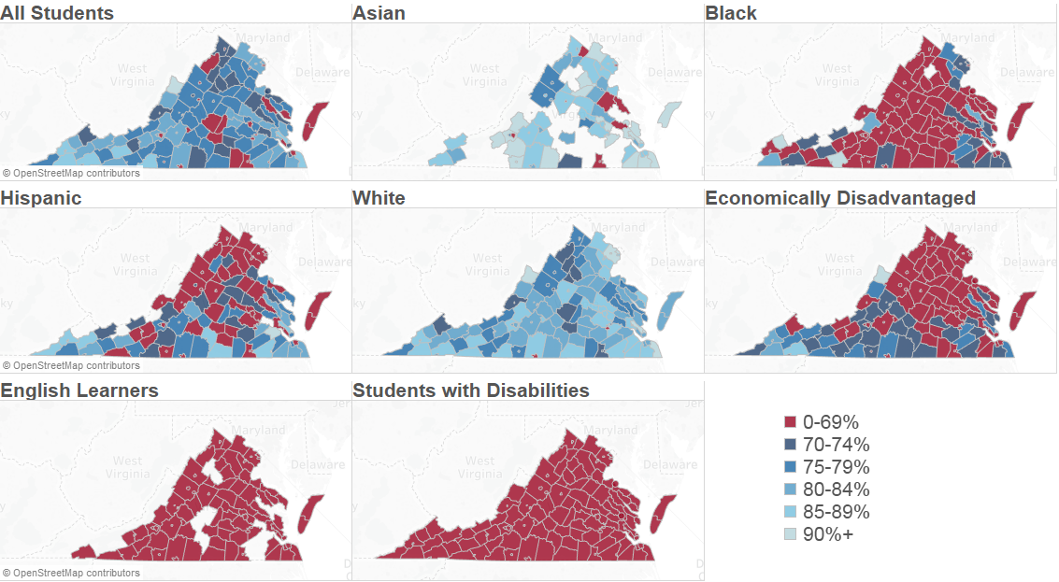
Note: Pass rates are calculated as the number of students passing the assessment divided by the number of students tested.

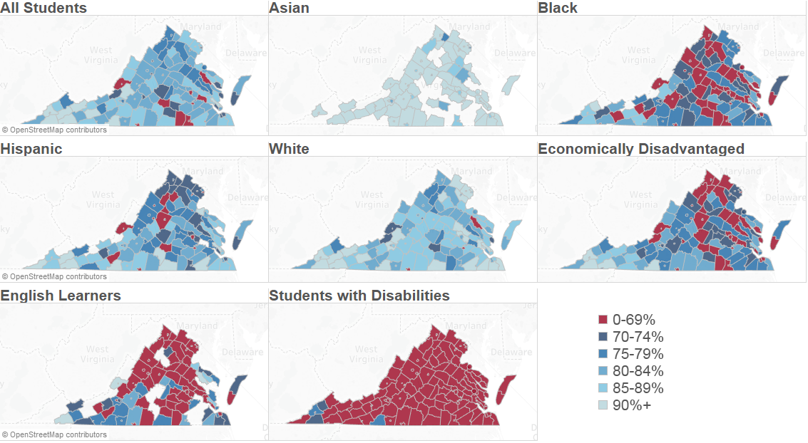
2018-2019 SOL Mathematics Pass Rate
Note: Pass rates are calculated as the number of students passing the assessment divided by the number of students tested.

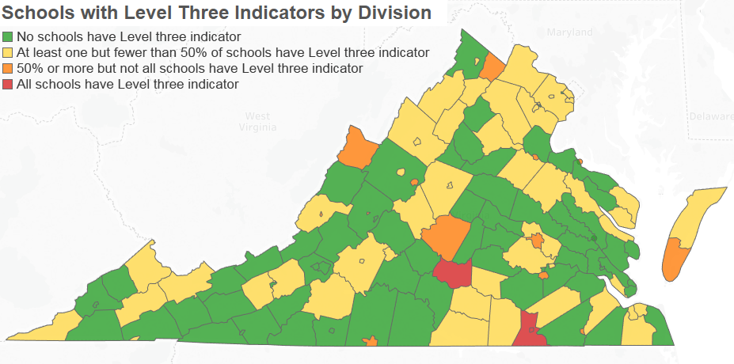

The Commonwealth Institute for Fiscal Analysis, (2019) K-12 Funding Trends At-a-Glance: Data for Statewide and All 132 School Divisions (2019-2020). Richmond, VA. https://www.thecommonwealthinstitute.org/2019/09/23/k-12-funding-trends-at-a-glance-data-for-statewide-and-all-132-school-divisions-2019-2020
Ibid
National Education Association, (2019) Rankings of the States 2018 and Estimates of the States 2019. Washington, DC.
de Brey, C., Musu, L., McFarland, J., Wilkinson-Flicker, S., Diliberti, M., Zhang, A., Branstetter, C., and Wang, X. (2019). Status and Trends in the Education of Racial and Ethnic Groups 2018 (NCES 2019-038). U.S. Department of Education. Washington, DC: National Center for Education Statistics. Retrieved 9/24/19 from https://nces.ed.gov/pubsearch
Darling-Hammond (2019) Investing for Student Success: Lessons from State School Finance Reforms. Palo Alto, CA: The Learning Policy Institute. https://learningpolicyinstitute.org/product/investing-student-success-school-finance-reforms-report
Baker, Farrie, Sciarra. (2018) Is School Funding Fair? A National Report Card (Seventh Edition). Newark, NJ: Education Law Center and Rutgers Graduate School of Education. http://www.edlawcenter.org/assets/files/pdfs/publications/Is_School_Funding_Fair_7th_Editi.pdf.
The Commonwealth Institute for Fiscal Analysis, (2019) K-12 Funding Trends At-a-Glance: Data for Statewide and All 132 School Divisions (2019-2020). Richmond, VA. https://www.thecommonwealthinstitute.org/2019/09/23/k-12-funding-trends-at-a-glance-data-for-statewide-and-all-132-school-divisions-2019-2020
VDOE Fall Membership Reports and IPAL, 2017
VDOE Fall Membership Reports and IPAL, 2017
VDOE Fall Membership Reports and IPAL, 2017
Darling-Hammond (2019) Investing for Student Success: Lessons from State School Finance Reforms. Palo Alto, CA: The Learning Policy Institute. https://learningpolicyinstitute.org/product/investing-student-success-school-finance-reforms-report
Rockoff, J. E. (2004). The impact of individual teachers on student achievement: Evidence from panel data. American Economic Review, 94(2), 247-252Nye, B., Hedges, L. V., & Konstantopoulos, S. (2000). The effects of small classes on academic achievement: The results of the Tennessee Class Size Experiment. American Educational Research Journal, 37(1), 123-151.)
Gordon, R., Kane, T. J., & Staiger, D. O. (2006). Identifying effective teachers using performance on the job. Hamilton project discussion paper. Washington, DC: Brookings Institution
Sanders, W. L., & Rivers, J. C. (1996). Cumulative and residual effects of teachers on future student academic achievement. University of Tennessee Value-Added Research and Assessment Center.
Carver-Thomas, D. & Darling-Hammond, L. (2017) Teacher turnover: Why it matters and what we can do about it. Palo Alto, CA: Learning Policy Institute. https://learningpolicyinstitute.org/product/teacher-turnover.
Aragon, S. (2016). Teacher shortages: What we know. Education Commission of the States.
Podolsky, A., Kini, T., Bishop, J., & Darling-Hammond, L. (2016). Solving the Teacher Shortage: How to Attract and Retain Excellent Educators (research brief). Palo Alto, CA: Learning Policy Institute.
Baker, Farrie, Sciarra. (2018) Is School Funding Fair? A National Report Card (Seventh Edition). Newark, NJ: Education Law Center and Rutgers Graduate School of Education. http://www.edlawcenter.org/assets/files/pdfs/publications/Is_School_Funding_Fair_7th_Editi.pdf

