Virginia Civics Education Survey for
High School Students: Report of Results

September 17, 2021

Prepared for:
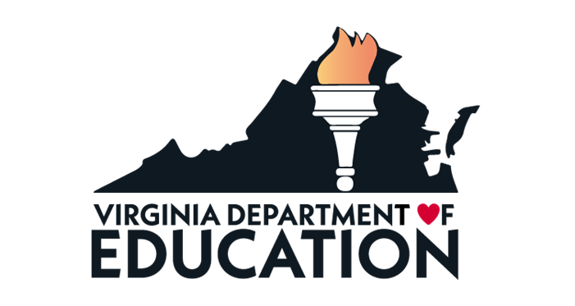

Prepared by:
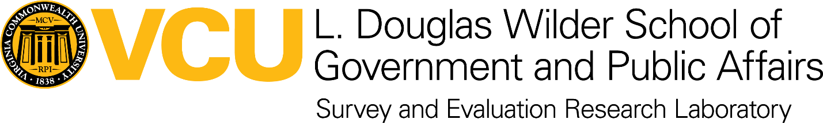

Survey and Evaluation Research Laboratory
L. Douglas Wilder School of Government and Public Affairs
Virginia Commonwealth University
Richmond, VA

SERL Project 0118

Acknowledgements
VCU’s Survey and Evaluation Laboratory would like to thank the Virginia Department of Education (VDOE) for the opportunity to contribute to this research effort. Special thanks are due particularly to Dr. Jennifer Piver-Renna and Ms. Christonya Brown, with whom SERL frequently consulted regarding survey content and administration. SERL is likewise grateful to the staff of VCU’s Institutional Review Board (IRB), who offered expert guidance as this study unfolded. Gratitude is also offered to several schools who pilot tested the survey prior to fielding.
At SERL, Dr. Jim Ellis served as the VCU principal investigator, helped conceptualize the project operations, and contributed to the report. Anne Buford provided project management and contributed to the report. Daniel Davis programmed the survey in Qualtrics. Dr. Cydney Lowenstein performed data analysis, reviewed open-ended responses and contributed to the report. Tanushree Banerjee, SERL intern, performed data analysis, reviewed open-ended responses and contributed to the report. Krista McDonald, SERL research assistant, contributed to the report.
Finally, our thanks go especially to students, survey administrators, school staff and faculty who participated in this study or facilitated its deployment.

IRB Citation
This study proceeded under VCU Institutional Review Board protocol HM20020863.

This page is intentionally left blank.

Table of Contents

Acknowledgements i
IRB Citation i
Table of Contents iii
List of Tables iv
List of Figures iv
Executive Summary vii
Background and purpose vii
Summary of results vii
Summary of methods ix
Sampling and recruitment ix
Response x
Demographic profile of the survey respondents x
Report of Results 1
Meaning of “civic engagement” 1
Satisfaction with information presented in civics and government courses 1
Self-reported understanding of civics and government 2
Actions occurring in any civics or government courses taken in Virginia 5
Impacts of civics or government courses taken in Virginia 6
Change in interest about politics and current events due to civics and government courses in Virginia 7
Beliefs about the word “politics” 8
Current events, sources of news, and discussions about current events or politics 9
Community engagement activities participated in within the past 12 months 12
Hours spent on community engagement activities in the past 12 months 14
Reasons for community engagement 15
Impact of COVID-19 on participation in community engagement 15
Estimated statewide total of community engagement hours in the past 12 months 16
Employment 16
Suggestions from respondents for improvements to civics and government courses 16
Voter registration status and relationships to other survey items 17
Race/Ethnicity and relationships to other survey items 20
Gender and relationships to other survey items 23
Locality type and relationships to other survey items 23
Conclusions 25
Appendix A: Methods A-1
Methods A-3
Background and purpose A-3
Instrument development: Content benchmarks A-3
Instrument refinement: Review and consultation A-4
VCU Institutional Review Board A-4
Sampling preparations A-4
Noteworthy survey characteristics A-5
Fielding: Survey administration and timeline A-5
Response A-6
Demographic profile of the survey respondents A-6
Appendix B: Survey Questionnaire B-1

List of Tables
Table 1: Average Self-Reported Understanding of Civics and Government Topics 3
Table 2: Frequency of Actions in Civics and Government Classes 5
Table 3: Impact of experiences in civics and government courses in Virginia 6
Table 4: How Closely Do You Follow Each of These Subjects Through News or Social Media? 9
Table 5: In the past 12 months, how often have you discussed current events or politics with people from the following groups? 11
Table 6: Demographic Profile of the Survey Respondents A-7

List of Figures
Figure 1: Satisfaction with Information from Virginia Civics and Government Courses by Voter Registration Status 2
Figure 2: Overall Understanding of Civics Education by Voter Registration Status 4
Figure 3: Change in Interest in Politics and Current Events Due to Experiences in Virginia Civics and Government Courses by Voter Registration Status 7
Figure 4: Beliefs about the Word “Politics” 8
Figure 5: Most Common Way to Get News 10
Figure 6: Community Engagement Activities Participated in (Past 12 Months) 13
Figure 7: Total Hours Spent on Community Engagement Activities in the Past 12 Months 14
Figure 8: Reasons for Doing Community-Engaged Services and Activities 15
Figure 9: Understanding, Interest, Satisfaction and Engagement by Voter Registration Status 19
Figure 10: Satisfaction with Information Presented in Virginia Civics and Government Courses by Race/Ethnicity 20
Figure 11: Self-reported Overall Understanding of Citizen Rights and Duties and How Government Works by Race/Ethnicity 21
Figure 12: Change in Interest in Politics and Current Events Due to Experiences in Virginia Civics and Government Courses by Race/Ethnicity 22
Figure 13: Civics Education on Gender Differences 23
Figure 14: Satisfaction with Information Presented in Virginia Civics and Government Courses by Locality Type 24
Figure 15: Self-reported Overall Understanding of Citizen Rights and Duties and How Government Works by Locality Type 24

This page is intentionally left blank.

Executive Summary

Background and purpose
In response to a legislative requirement from the Virginia General Assembly to survey high school seniors about their civics and government education, the Virginia Department of Education (VDOE) chose to collaborate with the Survey and Evaluation Research Laboratory (SERL) at Virginia Commonwealth University to develop and disseminate a Civics Education Survey to a sample of Virginia public high school seniors. The purpose of the survey was to understand how a representative statewide sample of seniors in public high schools felt about their civics and government education as well as their community engagement.
VDOE led the development of the survey questionnaire, with input from SERL and stakeholders consulted by VDOE, including the Commission on Civic Education. VDOE developed guidance documents about the survey for participating school divisions and communicated with selected school divisions about the survey.
SERL programmed and hosted the web-based survey. There were 682 usable responses from 28 high schools across Virginia. SERL analyzed the results and produced this report with input from VDOE.
Results from the survey are being shared with the General Assembly’s Commission on Civic Education and via this report. Results are intended to aid improvements in instructional content and practice.

Summary of results
A majority of the survey respondents (59.1%) were satisfied with the information presented in the civics and government courses they have taken in Virginia. Just over half of the respondents (51.8%) said that their interest in politics and current events had increased based on their experiences in their civics and government courses in Virginia, while 36.3% said it had stayed the same and 11.9% said it had decreased.
Suggestions for improvements in civics and government education, which were provided by students on the survey, included:
- make the experience more interactive (include hands-on, real-life activities; engage in the community; go on field trips)
- have guest lectures from government officials
- emphasize state and local government more
- have less repetition of subjects and cover broader topics
- focus more on:
  - modern politics
  - Black history
  - voter suppression
  - international politics
- have teachers be more engaged and open-minded, but leave their personal perspectives out of the classroom
Social media was by far the source for news most frequently mentioned by respondents, cited by 54.7%. No other source of news—including news websites or apps, local or network television, and cable television—was mentioned by more than 16.4% of respondents. Printed media (newspapers and magazines) and radio were each mentioned by fewer than two percent of respondents.
The topics that respondents followed most closely through news or social media were entertainment, health and technology. Then came the topic of politics and elections, which respondents said they followed more closely than sports, domestic affairs, business, international affairs, and religion, in that order.
Respondents’ self-reported understanding of 15 different civics and government topics averaged from somewhere between “poor” and “fair” for campaign finance laws (the least understood topic), up to “good” for national elections (the most understood topic). The respondents’ average reported understanding of state elections was about midway between “fair” and “good.” Their reported understanding of local elections was closer to “fair.”
Students were asked about their voter registration status: 22.5% were currently registered to vote, 70.4% were not registered but planned to register, and 7.0% were not registered and do not plan to register. Students who were not registered to vote and do not plan to register were a small group, but they consistently reported less understanding of civics and government topics; lower levels of satisfaction with their civics and government education; less interest in politics, domestic affairs and international affairs; and less interaction about politics and current events with various types of people including their own families. Their community engagement, however, matched or exceeded that of students who were currently registered to vote or who were not registered but planned to do so—except when it came to voting or participating in a protest to bring about societal change. Male students were more likely to say they were not registered to vote and do not plan to register.
When presented with eight pairs of adjectives that might describe their beliefs when they hear the word “politics,” respondents characterized politics as “interesting,” “deceptive,” “necessary,” “confusing,” “for the privileged,” “helpful,” “corrupt” and “difficult.” (The opposing word choices were, respectively, “boring,” “honest,” “irrelevant,” “clear,” “for the disadvantaged,” “unhelpful,” “fair,” and “easy.”)
The survey estimates that Virginia public high school seniors averaged 11.3 hours each of community engagement activities in the 12 months prior to the survey. Therefore, the full population of 57,437 seniors enrolled in government courses represented by the study contributed a total of 661,847 hours of community service in the 12 months prior to the survey. This figure was pushed downward by the COVID-19 pandemic, which reduced the number of opportunities for community engagement.
The most frequently mentioned community engagement activities were giving food or money to friends or people in their community who needed it (62.0%); volunteering with, or giving money to a community service organization (41.0%); and participating in a community service activity or community event (39.4%).
A majority of respondents said they participated in community activities because they “wanted to be the kind of person who helps others” (51.9%). Other frequently mentioned reasons were “I wanted to act on my beliefs” (31.6%), “I became upset by something I saw happening” (28.9%), “To do something about an issue I care about” (27.9%), and “I’ve been given a lot; I want to give back” (22.9%). The reason that was selected least often was “It is required at school” (10.3%).
Respondents said that teachers generally respect students’ opinions, encourage students to make up their own minds, present several sides of issues, make students feel free to express their opinions even when they differ from other opinions, and encourage students to evaluate the quality and validity of information discussed in class. The percentages of students saying that these actions occurred “a moderate amount” or “a great deal” in any of the civics or government courses they have taken in Virginia ranged from 63.2% to 86.7%.
In general, respondents from suburbs and cities reported somewhat higher levels of understanding and occurrences of some favorable activities or practices in the classroom. Students in towns reported higher understanding of local elections. Students in rural areas did not show major differences from students in other areas, but when they did, they tended to report slightly lower levels of understanding and lower frequencies of some activities or practices in the classroom. The small number of respondents from towns were more likely to say they participated in community engagement activities because they were required for school.

Summary of methods
Some important aspects of the project methods are summarized below. See Appendix A for more details. See Appendix B for the survey questionnaire.

Sampling and recruitment
Using school-level data provided by VDOE, SERL designed a probability sample of 36 public high schools in Virginia that was representative of the variety of schools and high school seniors found in Virginia’s rural areas, small towns, suburbs and cities. VDOE asked each selected school to communicate survey invitations to seniors and contribute 30 completed surveys, if possible. Schools were asked to invite seniors from a variety of backgrounds and levels of academic achievement.

Response
Of the 36 schools invited to participate, 28 did so. After removing cases with incomplete data, there were 682 completed surveys available for the analysis in this report.

Demographic profile of the survey respondents
Most of the respondents (82.8%) reported being enrolled in Virginia public schools in grades 6, 7 and 8, and 94.0% reported being enrolled in Virginia public schools in grades 9, 10 and 11. Therefore, the survey results are very applicable to experiences in Virginia public schools.
Most of the respondents (88.8%) were currently enrolled in a government course when they took the survey, including Virginia and U.S government (58.9%), Advanced Placement (24.0%), dual enrollment (12.8%), International Baccalaureate (1.5%) and all others (2.7%). This provides a variety of experiences and perspectives.
The demographics of the survey respondents parallel the known demographics of all high school seniors in Virginia reasonably well. This provides confidence that the survey results are representative of the opinions of all high school seniors around Virginia. See Appendix A for more details.

Report of Results
Results for the full range of survey questions are discussed here.

Meaning of “civic engagement”
At the start of the survey, respondents were asked to provide an open-ended response to the prompt: “What does ‘civic engagement’ mean to you? There are no right or wrong answers.” One common theme that was mentioned in the responses was political participation and engagement—some specific activities mentioned included voting, advocating, and protesting. Some example responses are:
- “Being involved in any level of governance such as listening to debates, asking questions at public forums, or voting”
- “I would say just engaging in democratic society to try to influence government policy. It could be voting, joining an interest group, or donating to a campaign.”
- “Being aware and contributing to civil society such as voting, protesting, and lobbying.”
Similarly, many respondents mentioned “duties” as citizens—particularly voting.
- “Participating in your civic duties and responsibilities such as voting, writing to your government representatives, etc.”
- “Getting involved with the community and attending civic duties.”
- “Engaging in your duties as a citizen and a participant in your community.”
Another frequently mentioned theme in the responses, not specifically mentioning the duties of citizenship, was being active or engaged in their community. Some activities that were mentioned were volunteering, addressing concerns within their community, and working together with community members. Some examples of this theme include:
- “Civic engagement to me means people taking part in the community around them; whether that be an event or in government, people have an involvement making a decision or helping.”
- “Engaging with the community through social organizations, activism, community aid and volunteer work”
- “Meaning when communities or people come together and work as a whole to change their city or community.”

Satisfaction with information presented in civics and government courses
Respondents were asked how satisfied they are with the information presented in the civics and government courses they have taken in Virginia. A majority (59.2%) said they were either “very satisfied” (16.1%) or “satisfied” (43.1%). Students who said they were not registered to vote and do not plan to register were less satisfied than others. See Figure 1.
Figure 1: Satisfaction with Information from Virginia Civics and Government Courses by Voter Registration Status
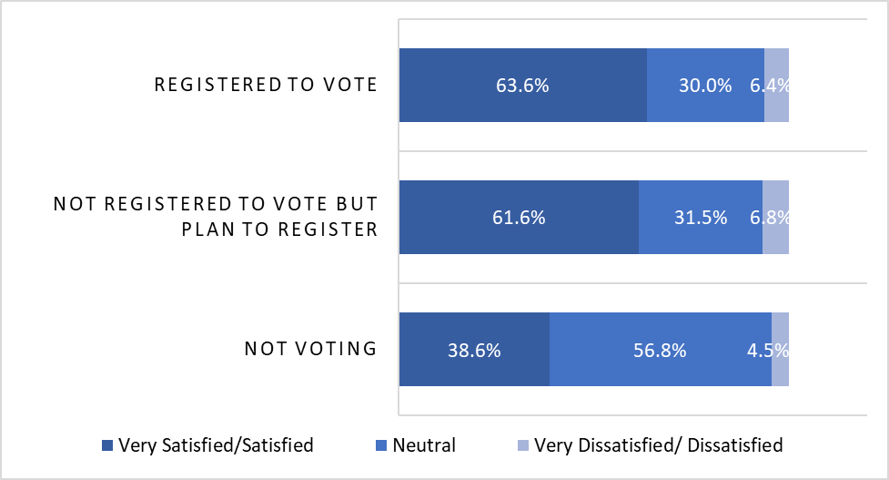
Also, African-American students were less satisfied than others, as were students in rural areas.

Self-reported understanding of civics and government
Respondents were asked to describe their current overall understanding of the rights and duties of citizens and how governments work. About two-thirds (64.4%) gave favorable responses, saying their understanding was either “excellent” (13.1%) or “good” (51.3%). Almost all others rated their understanding as “fair” (30.1%) with very few reporting their understanding as “poor” (4.3%) or “very poor” (1.2%). Students who were less likely to give favorable responses included those who said they were not registered to vote and do not plan to register, students who self-identified as Hispanic/Latino, and those living in rural areas.
In addition to this overall question, respondents were presented with two survey items listing a combined total of 15 civics and government topic areas. Respondents were asked to rate their understanding of each topic area on the same five-point scale ranging from “very poor” to “excellent.” The responses to all 15 topics were averaged together, assigning one point for responses of “very poor” up to five points for responses of “excellent.” The responses for each individual item were also averaged for comparison. The following key findings emerged:
- The combined average self-reported understanding across the 15 topics was 3.52, about midway between “fair” and “good.”
- The two highest-rated individual topics were:
  - national elections (4.04, “good”)
  - the Constitution of the United States (4.0, “good”)
- The two lowest-rated individual items were:
  - the Constitution of Virginia (2.99, “fair”)
  - campaign finance laws (2.75, between “poor” and “fair”)
- Average understanding for state elections was 3.47 (about midway between “fair” and “good”) and for local elections it was 3.31 (closer to “fair”).
See Table 1.
Table 1: Average Self-Reported Understanding of Civics and Government Topics
Topic Area | Mean
National elections | 4.04
The Constitution of the United States | 4.00
Civil rights and civil liberties | 3.84
History of certain groups deprived of rights or liberties and actions taken by those groups for inclusion | 3.84
Federalism and the federal system of government | 3.73
Political principles, philosophies and documents that shaped the development of the United States government | 3.72
Overall, how would you describe your current understanding of the rights and duties of citizens and how governments work? | 3.71
Organization and powers of local, state, and national governments | 3.64
State elections | 3.47
Civic engagement | 3.44
Organization, jurisdiction, and proceedings of the judiciary | 3.38
Process by which public policy is made | 3.36
Political principles, philosophies and documents that shaped the development of Virginia’s government | 3.32
Local elections | 3.31
The Constitution of Virginia | 2.99
Campaign finance laws | 2.75
Average of ratings from national elections to campaign finance laws | 2.59
Scale: 1=very poor, 2=poor, 3=fair, 4=good, 5=excellent.

Respondents who said they were not registered to vote and do not plan to register were more likely to report lower understanding—11.4% of them reported poor or very poor understanding, while 45.5% of them reported fair understanding and 43.2% of them reported good or excellent understanding. Among respondents who were not registered to vote but intended to register, 64.3% reported good or excellent understanding. Among respondents who were already registered to vote, 69.3% reported good or excellent understanding. See Figure 2.
Figure 2: Overall Understanding of Civics Education by Voter Registration Status
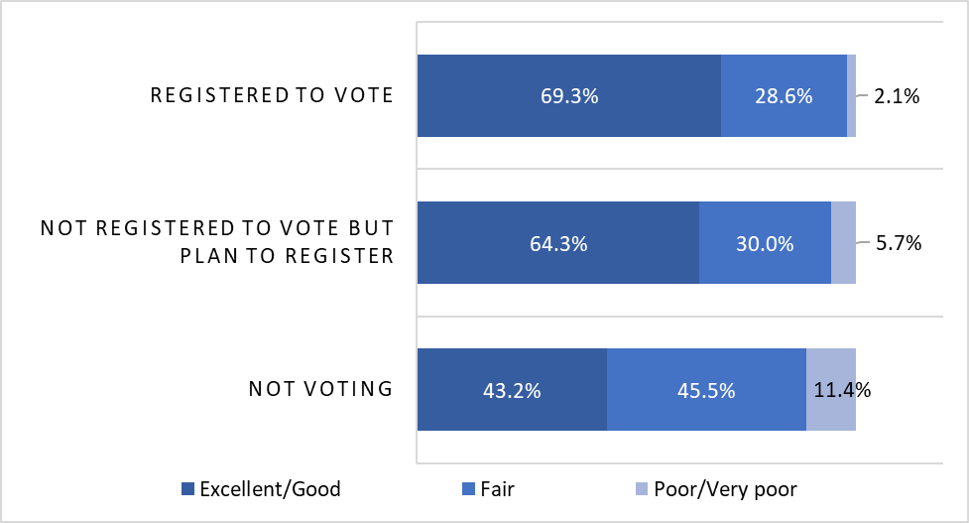

Actions occurring in any civics or government courses taken in Virginia
Respondents were presented with two survey items asking how often various actions occurred in any of the civics or government courses they have taken in Virginia. Respondents rated the frequency of these things on a five-point scale ranging from “never” to “a great deal.” When the responses to each of the 11 actions were averaged, assigning one point for responses of “never” up to five points for responses of “a great deal,” the following key findings emerged:
- the most frequently occurring action was “Teachers respect students’ opinions about political and social issues discussed during class” (4.47, about midway between “a moderate amount” and “a great deal”
- the two least frequently occurring actions were:
  - “I met people who work to make society better” (2.59, about midway between “rarely” and “occasionally”)
  - “I worked on a service learning or school project to improve my community” (2.50, also about midway between “rarely” and “occasionally”)
See Table 2.
Table 2: Frequency of Actions in Civics and Government Classes
Actions | Mean
Teachers respect students’ opinions about political and social issues discussed during class | 4.47
Students are encouraged to make up their own minds about issues | 4.19
Teachers present several sides of an issue when explaining it in class | 4.19
Students feel free to express opinions in class, even when their opinions are different from others | 4.11
Teachers encourage students to evaluate the quality and validity of information discussed in class | 4.10
I learned about things in society that need to be changed | 3.77
Teachers focus on issues students care about | 3.77
I learned about ways to improve my community | 3.41
I was required to keep up with politics or government, either by reading a newspaper, watching television or going on the internet | 3.27
I met people who work to make society better | 2.59
I worked on a service learning or school project to improve my community | 2.50
Scale: 1=never, 2=rarely, 3=occasionally, 4=a moderate amount, 5=a great deal.

Impacts of civics or government courses taken in Virginia
Respondents were also asked to rate how much their experiences in civics and government courses in Virginia contributed to their knowledge, skills, and personal development in five different areas. Respondents rated the contribution of their civics and government courses on a five-point scale ranging from “no impact at all” to “extreme impact.” When the responses to each of the five actions were averaged, assigning one point for responses of “no impact at all” up to five points for responses of “extreme impact,” the following key findings emerged:
- the two most impacted areas were:
  - “understanding people of diverse backgrounds (economic, racial, ethnic, political, religious, national origin)” (3.45, about midway between “a moderate impact” and “significant impact”
  - “being an informed and active citizen” (3.38, a little closer to “a moderate impact”)
- the least impacted area was “solving complex real-world problems” (3.09, “a moderate impact”)
All impacts were rated between “moderate” and midway between “moderate” and “significant.” See Table 3.
Table 3: Impact of experiences in civics and government courses in Virginia
Areas of knowledge, skills, and personal development potentially impacted | Mean
Understanding people of diverse backgrounds (economic, racial, ethnic, political, religious, national origin)? | 3.45
Being an informed and active citizen? | 3.38
Working effectively with others? | 3.22
Creating or clarifying a personal code of values and ethics? | 3.15
Solving complex real-world problems? | 3.09
Scale: 1= No impact at all, 2=Slight impact, 3=Moderate impact, 4=Significant impact, 5=Extreme impact

Change in interest about politics and current events due to civics and government courses in Virginia
In total, just over half of the respondents (51.8%) said that their interest in politics and current events had increased based on their experiences in their civics and government courses in Virginia, while 36.3% said it had stayed the same and 11.9% said it had decreased.
As Figure 3 shows, students who are not registered to vote and do not plan to register were more likely to report decreased interest in politics and current events due to their experiences in their civics and government courses in Virginia—20.9% of them reported decreased interest, compared to 11.2% and 10.4% for the other two groups of students.
Figure 3: Change in Interest in Politics and Current Events Due to Experiences in Virginia Civics and Government Courses by Voter Registration Status
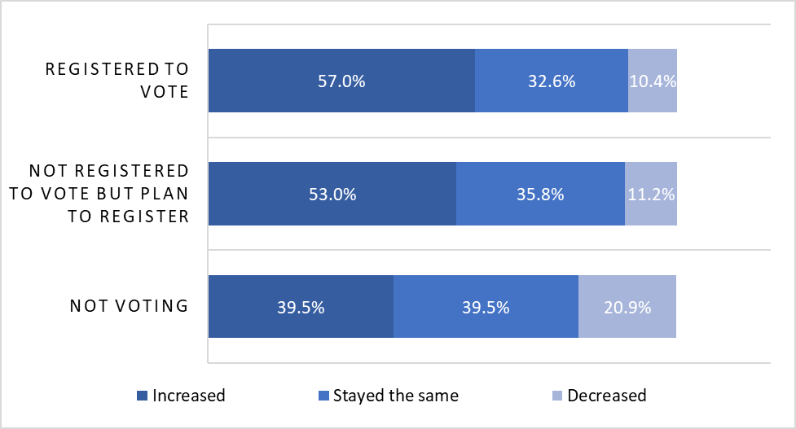
Also, males, Black/African-American students and students at schools in cities were more likely to say their interest in politics and current events had decreased based on their experiences in their civics and government courses in Virginia. Suburban students were more likely to say it had increased.

Beliefs about the word “politics”
Respondents were presented with eight pairs of adjectives that might describe their beliefs when they hear the word “politics.” They were asked to choose which word came closest to their beliefs. Majorities of respondents chose “interesting,” “deceptive,” “necessary,” “confusing,” “for the privileged,” “helpful,” “corrupt” and “difficult.” See Figure 4.
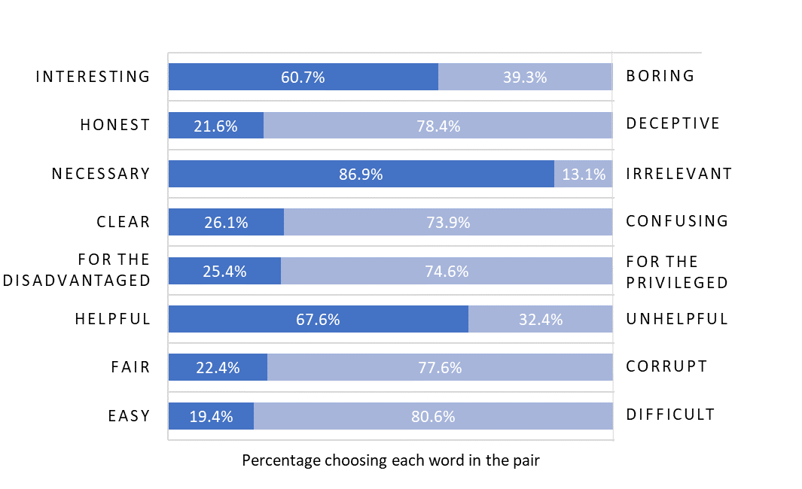
Figure 4: Beliefs about the Word “Politics”

Current events, sources of news, and discussions about current events or politics
Respondents were presented with a list of nine topics and asked how closely they follow each of those subjects through news or social media. The answer choices ranged from “not at all closely” to “extremely closely.” Entertainment (3.58, about midway between “moderately” and “very” closely) and health (3.31, closer to “moderately”) were the most closely followed topics. Technology (3.08, “moderately”) and politics/elections (3.04, “moderately”) came next. Then came sports (2.74, closer to “moderately” than “slightly”), domestic affairs (2.71, closer to “moderately” than “slightly”), business (2.67, closer to “moderately” than “slightly”), international affairs (2.62, closer to “moderately” than “slightly”), and religion (2.43, closer to “slightly” than “moderately”). See Table 4.
Table 4: How Closely Do You Follow Each of These Subjects Through News or Social Media?
Subjects | Mean
Entertainment | 3.58
Health | 3.31
Technology | 3.08
Politics/Elections | 3.04
Sports | 2.74
Domestic Affairs | 2.71
Business | 2.67
International Affairs | 2.62
Religion | 2.35
Scale: 1=not at all closely, 2=slightly closely, 3=moderately closely, 4=very closely, 5=extremely closely

Respondents were presented with seven different sources for news and asked to select the one that they most commonly used. Social media was by far the most frequently mentioned source for news, cited by 54.7%. No other news source—including news websites or apps (16.4%); local or network television (11.6%); family, friends or other social acquaintances (9.1%); and cable television (5.5%)—was mentioned by more than 16.4% of respondents. Printed media (newspapers and magazines) and radio were each mentioned by fewer than two percent of respondents (1.4% each). See Figure 5.
Figure 5: Most Common Way to Get News
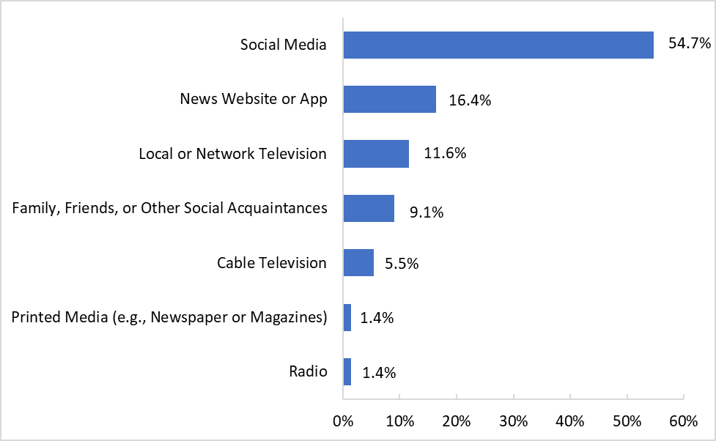

Respondents were asked how often they discussed current events or politics with people in six different groups. The group of family and friends was mentioned most often, followed by people of a different race or ethnicity, and people with different political views. The groups that respondents least frequently engaged in these discussions were people of different religious beliefs and people from a different economic background. See Table 5.
Table 5: In the past 12 months, how often have you discussed current events or politics with people from the following groups?
Groups | Mean
My family | 3.69
My friends | 3.47
People of a race or ethnicity other than my own | 3.10
People with political views other than my own | 3.04
People with religious beliefs other than my own | 2.96
People from an economic background other than my own | 2.73
Scale: 1=never, 2=rarely, 3=occasionally, 4=a moderate amount, 5=a great deal

Community engagement activities participated in within the past 12 months
Respondents were presented with a list of 14 community engagement and service activities (including earning money to support their family or providing care for others in their family who needed it). They were asked to select all of the activities they had participated in within the past 12 months. The top three most frequently selected activities were giving food or money to friends or people in their community who needed it (62.0%); volunteering with, or giving money to, a community service organization (41.0%); and participating in a community service activity or community event (39.4%). Conversely, the three least frequently selected activities chosen by respondents were voting in a local election (6.5%) and voting in a state election (7.2%), neither of which would be open to many students due to age restrictions; and presenting an issue at a city council or school board meeting or contacting an elected or appointed representative (10.2%). See Figure 6.

Figure 6: Community Engagement Activities Participated in (Past 12 Months)
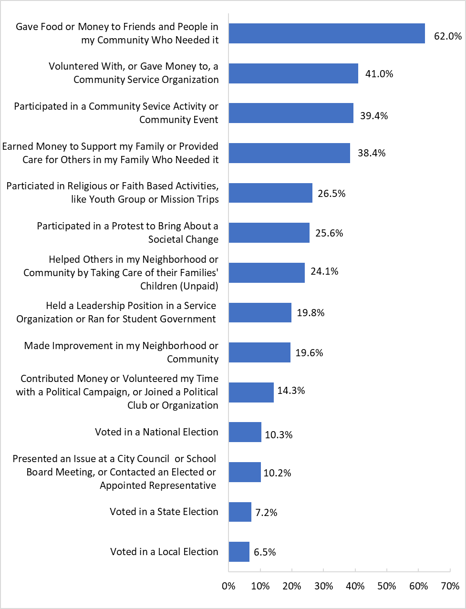

Hours spent on community engagement activities in the past 12 months
In addition to choosing from among 14 different types of community engagement activities they did in the 12 months prior to the survey, respondents were also asked how many total hours they spent participating in those activities within the past 12 months. The choices available to them were “Less than 1 hour,” “1 to 5 hours,” “6 to 10 hours,” “11 to 15 hours,” “16 to 20 hours,” and “More than 20 hours.” Respondents most commonly chose the options “1 to 5 hours” (25.3%) followed and “More than 20 hours” (22.1%). See Figure 7.
Figure 7: Total Hours Spent on Community Engagement Activities in the Past 12 Months
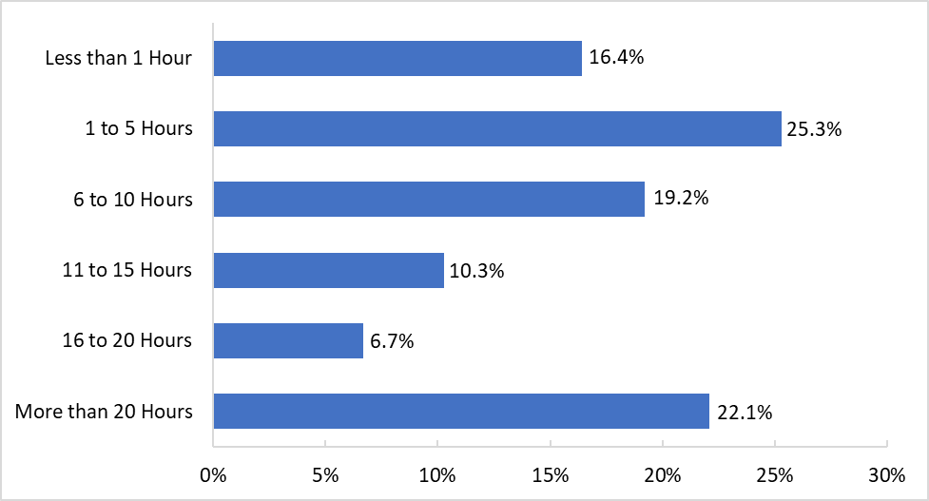

Reasons for community engagement
Respondents were also asked to choose up to three of the most important reasons that they participated in the community engagement activities they had mentioned. Twelve reasons were available to choose from. A majority of respondents selected “I wanted to be the kind of person who helps others” (51.9%). The next four most selected reasons were “I wanted to act on my beliefs” (31.6%), “I became upset by something I saw happening” (28.9%), “To do something about an issue I care about” (27.9%), and “I’ve been given a lot; I want to give back” (22.9%). The reason that was selected by the least respondents was “It is required at school” (10.3%). See Figure 8.
Figure 8: Reasons for Doing Community-Engaged Services and Activities
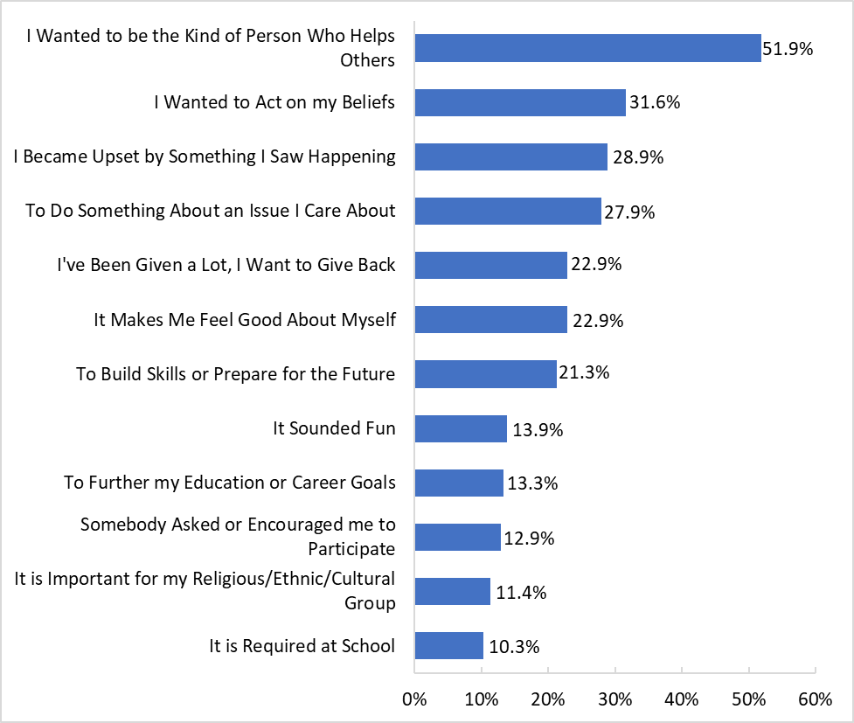

Impact of COVID-19 on participation in community engagement
Respondents were asked for an open-ended response about how COVID-19 affected their participation in civic engagement activities. One of the most commonly mentioned ways that COVID-19 affected their civic engagement was the limiting of opportunities that were available for civic engagement whether by cancellations of activities or due to the respondents staying at home. Some example responses included:
- “A lot because I was supposed to volunteer for a community organization this summer and wasn’t able to because of COVID.”
- “It makes participation very hard because with the limited amount of people there are less people allowed and less things are open.”
- “I am not going out as much so there isn’t a chance to engage in these activities.”
Many respondents mentioned specifically that COVID-19 safety restrictions limited their ability to participate, particularly that social distancing requirements limited the number of people that could participate in a group.

Estimated statewide total of community engagement hours in the past 12 months
Using the mid-points of these categories and assuming an average value of 30 for the top category of “more than 20 hours,” the students responding to the survey each contributed an average of 11.5 hours of community service in the past 12 months (in a year in which community service was greatly reduced due to the COVID-19 pandemic). Projecting this average to the full population of 57,437 seniors enrolled in government courses represented by the study, the survey estimates that Virginia public high school seniors contributed a total of 661,847 hours of community service in the past 12 months.

Employment
Overall, 63.2% of respondents said they had been employed (earning wages or salary) at some time in the past 12 months. Asian students were less likely to be employed than other races/ethnicities. Employed students reported more hours of community engagement activities, but one of those activities was “Earned money to support my family or provided care for others in my family who needed it.”

Suggestions from respondents for improvements to civics and government courses
Respondents were provided with an open-ended response item for them to suggest how civics and government education in Virginia could be improved. Many of the responses mentioned that classes should be more interactive, hands-on, or involving more real-life activities such as field trips or guest speakers. Some example responses are included below:
- “Hands on experience, seeing the principles in action at local levels”
- “More outside world experiences visiting important government/city places”
- “By engaging their students in actual civic activities instead of just teaching from a textbook.”
Another common theme in the responses was concerning curriculum—many respondents mentioned that courses should focus on current information or relate historical content to current events. Some responses include:
- “Speaking more about current events and including them in the lecture to give a first hand example of specific government terms”
- “by relating lessons more to current events rather than only focusing on the past”
- “Increased focus on modern policy instead of past policy.”
Respondents also offered suggestions for specific curriculum changes such as more focus on local and state government, international politics, voter suppression, and Black history. Some examples of comments from respondents are:
- “More coverage of the people of color that helped form and change our government.”
- “Definitely teach heavily on the constitution and amendments. We deserve to know what our rights are and how our government should be run.”
- “The curriculum should be centered around promoting civic engagement. Specifically speaking on learning about Virginia’s government, I have never been taught about the opportunities I have to engage in the concerns of my state and local community. In addition, it is very repetitive. We should learn about the progression of minority communities more. I know there is some effort to teach this topic, but, again, it’s very repetitive and minimal.”
Some respondents also mentioned avoiding political bias or discussions of political affiliation during lessons. For example:
- “Civics and government education could be improved by giving the students an educator who they feel like is unbiased.”
- “They could get rid of the political bias that the course/ teachers have.”

Voter registration status and relationships to other survey items
Respondents were asked to choose among three options to describe their voter registration status: “I am currently registered to vote,” “I am not registered to vote but plan to register,” and “I am not registered to vote and do not plan to register.” The majority of respondents were either currently registered to vote (22.5%) or were not registered but plan to register (70.4%). Only a small proportion of respondents responded that they were not registered to vote and did not plan to register (7.0%). Male students were more likely to say they were not registered to vote and do not plan to register.
This third group is small, but respondents who were not registered to vote and did not plan to register consistently reported less understanding of civics and government topics; lower levels of satisfaction with their civics and government education; less interest in politics, domestic affairs and international affairs; and less interaction about politics and current events with various types of people including their own families. Their community engagement, however, matched or exceeded that of students who were currently registered to vote or who were not registered but planned to do so—except when it came to voting or participating in a protest to bring about societal change.
To help illustrate these patterns, six summary scale variables were used which averaged responses across multiple related survey questions that all used five-point response choices. The scale variables were:
- Civics Understanding – created from the 15 items in Table 1.
- Activities in Virginia Civics and Government Courses – created from the 11 items in Table 2.
- Impacts of Virginia Civics and Government Course – created from the five items in Table 3.
- Engagement Level in Civics Activities – created from the 14 items in Figure 6.
- Attention to News and Social Media – created from the nine items in Table 4.
- Level of Current Events/Politics Discussion - created from the six items in Table 5.
Figure 9 shows how the mean ratings for these six scale variables plus four single items from the survey differ by voter registration status. Not all of the differences are statistically significant, but the pattern is fairly clear—students who are currently registered to vote generally gave more favorable responses on the 10 items examined, meaning that compared to those who are not registered and do not plan to register they reported higher understanding, increase in interest levels, more satisfaction, greater frequency of observing certain actions in their courses, more community engagement (mainly due to voting or participating in a protest to bring about societal change), greater attention to news and social media, and more frequent discussion of current events and politics. Students who were not registered to vote but planned to do so generally fell in between these two groups.

Figure 9: Understanding, Interest, Satisfaction and Engagement by Voter Registration Status
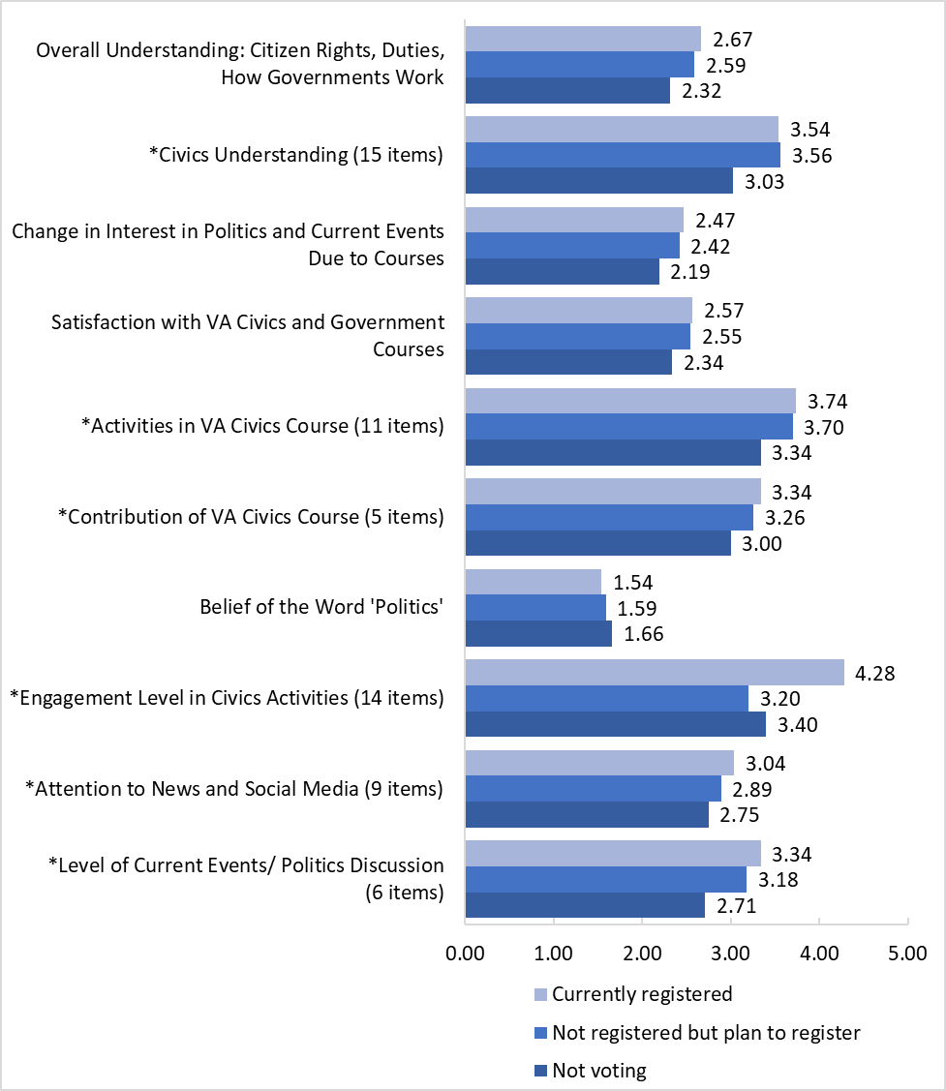
* = scales averaging multiple items
Mean ratings on 5-point scales

Race/Ethnicity and relationships to other survey items
In general, Asian and white respondents gave more favorable answers than other students, although differences were usually not major. In the case of satisfaction with information presented in Virginia civics and government courses, Hispanic/Latino students were actually the most satisfied. See Figure 10.
Figure 10: Satisfaction with Information Presented in Virginia Civics and Government Courses by Race/Ethnicity
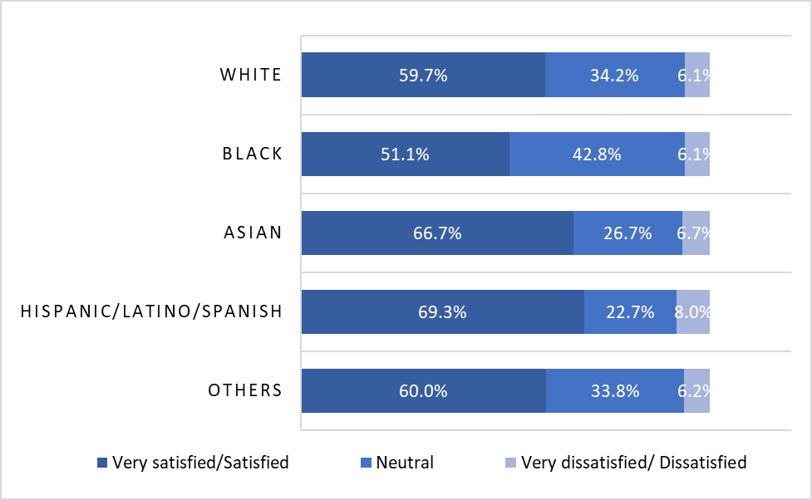

Self-reported overall understanding of citizen rights and duties and how government works was favorable among all racial/ethnic groups in the survey. Asian and white students were more likely to report favorable understanding than were Hispanic/Latino students. See Figure 11.
Figure 11: Self-reported Overall Understanding of Citizen Rights and Duties and How Government Works by Race/Ethnicity
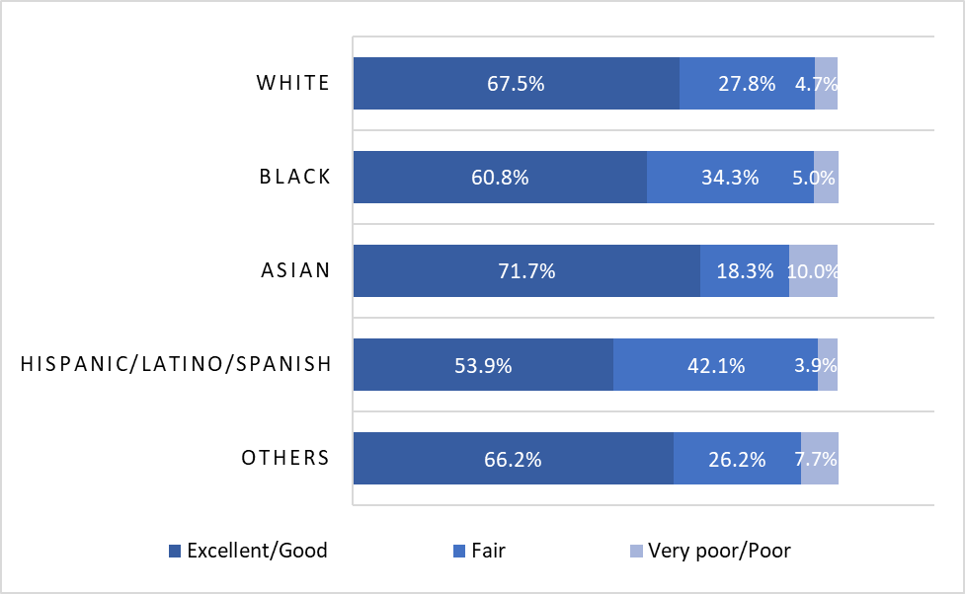

Changes in students’ interest in politics and current events, based on their experiences in civics and government courses in Virginia, increased the most for Asian students. See Figure 12.
Figure 12: Change in Interest in Politics and Current Events Due to Experiences in Virginia Civics and Government Courses by Race/Ethnicity
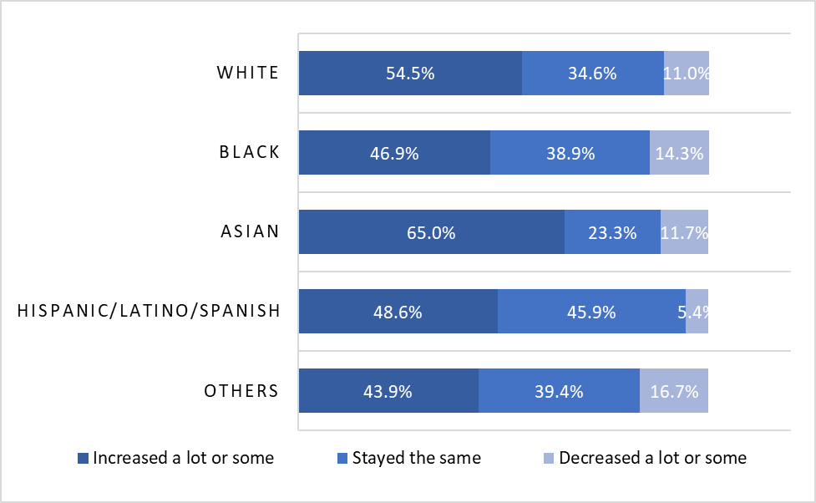

Gender and relationships to other survey items
Using some of the scaled variables described earlier, female respondents showed greater increased interest in politics and current events based on their experiences in Virginia civics and government courses. Females reported greater frequencies of favorable practices and activities in Virginia civics courses, as well as greater frequencies of political discussions and more engagement in civics activities than male respondents See Figure 13.
Figure 13: Civics Education on Gender Differences
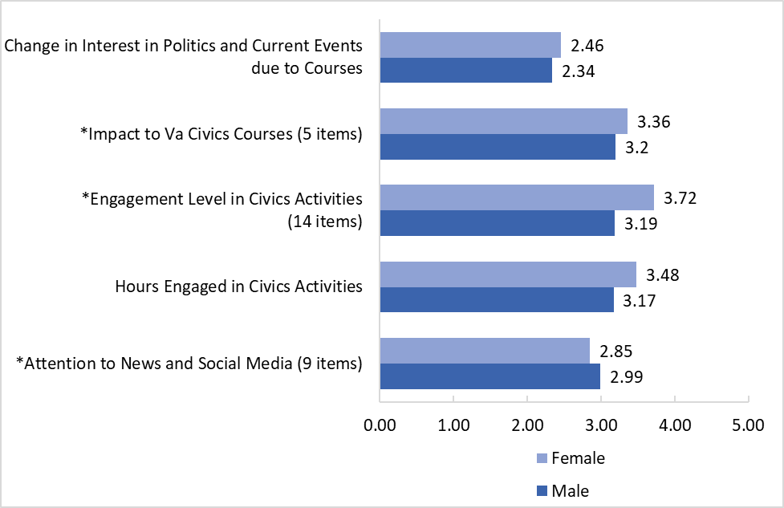
Mean ratings on 5-point scales
* = scales averaging multiple items

Locality type and relationships to other survey items
In general, respondents from suburbs and cities reported somewhat higher levels of understanding and occurrences of some favorable activities or practices in the classroom. Students in towns reported higher understanding of local elections. Students in rural areas did not show major differences from students in other areas, but when they did they tended to report slightly lower levels of satisfaction and understanding of civics and government topics, as well as lower frequencies of some activities or practices in the classroom. The small number of respondents from towns were more likely to say they participated in community engagement activities because they were required for school. Some of the comparisons involving students in towns and rural areas, even though showing statistical significance, are based on small numbers of respondents and should be viewed with caution. See Figure 14 and Figure 15 below.
Figure 14: Satisfaction with Information Presented in Virginia Civics and Government Courses by Locality Type
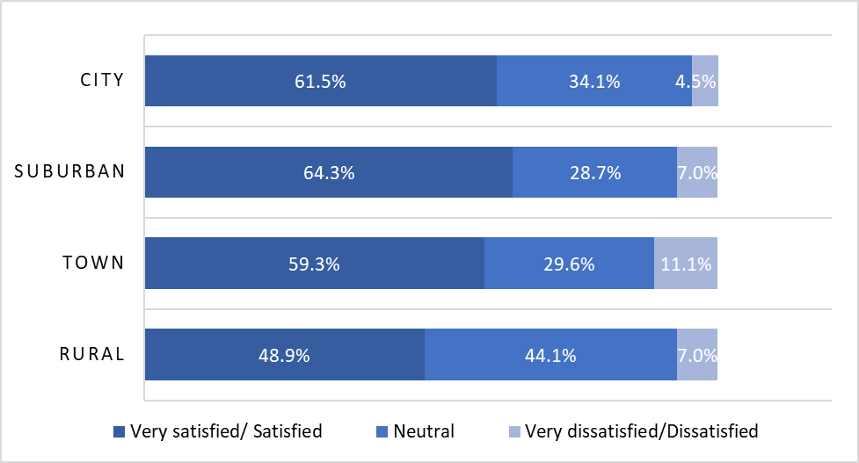
Figure 15: Self-reported Overall Understanding of Citizen Rights and Duties and How Government Works by Locality Type
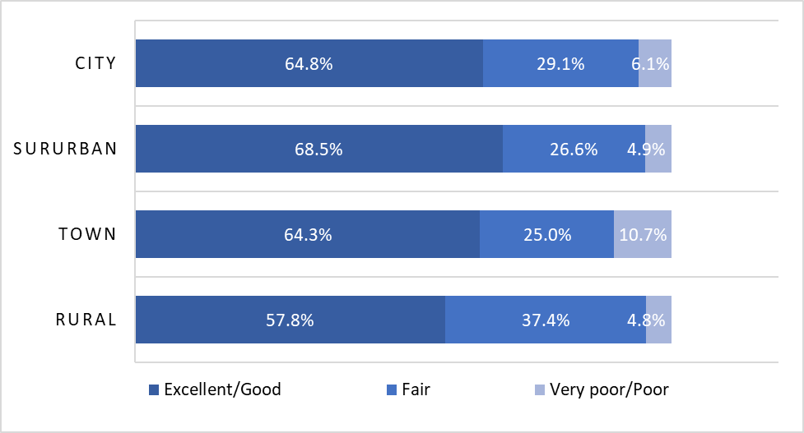

Conclusions

The 2021 Virginia Civics Education Survey for High School Students provides feedback directly from 682 high school seniors comprising a representative cross-section of seniors at Virginia’s public high schools.
Students give generally positive ratings for their satisfaction with the information presented to them in Virginia civics and government courses, their understanding of civics and government topics, and the frequency with which several desirable actions and practices occur in their classrooms.
However, self-reported understanding of local and state civics issues is likely to be lower than desired. At the same time, suggestions from students indicate that they would like to have more knowledge about local and state civics and government issues; would prefer more hands-on and experiential activities such as field trips, visits from government officials and real-world experience.
The survey supports a rough estimate that Virginia high school seniors in spring 2020 to spring 2021 provided more than 660,000 hours of community engagement, work and service—in a year when the COVID-19 pandemic significantly limited such opportunities.
Engaging students directly in this discussion is an important and enlightened step in understanding and further strengthening civics and government education in Virginia public education.

This page is intentionally left blank.

Appendix A: Methods

This page is intentionally left blank.

Methods

Background and purpose
In response to a legislative requirement from the Virginia General Assembly to survey high school seniors about their civics and government education, the Virginia Department of Education (VDOE) chose to collaborate with the Survey and Evaluation Research Laboratory (SERL) at Virginia Commonwealth University to develop and disseminate a Civics Education Survey to a sample of Virginia public high school seniors. (See Item 134.I. of the 2019 Appropriation Act; https://budget.lis.virginia.gov/get/budget/3929/ page 143.) The purpose of the survey was to understand how a representative statewide sample of seniors in public high schools felt about their civics and government education as well as their community engagement.
VDOE led the development of the survey questionnaire, with input from SERL and stakeholders consulted by VDOE. VDOE developed guidance documents about the survey for participating school divisions and communicated with selected school divisions about the survey.
SERL programmed and hosted the web-based survey. There were 682 usable responses from 28 high schools across Virginia. SERL analyzed the results and produced this report with input from VDOE.
Results from the survey are being shared with the General Assembly’s Commission on Civic Education and via this report. Results are intended to aid improvements in instructional content and practice.

Instrument development: Content benchmarks
The VDOE Civics Survey development and data collection process unfolded from May 2020 to May 2021. Throughout the summer and fall of 2020, VDOE and SERL met to discuss the survey instrument and related fielding plan. As it began to build the questionnaire, VDOE looked to several publicly-available civics-oriented surveys including:
- Achieve’s The Millenial Impact Report (2012)
- Indiana University Center for Postsecondary Research’s National Survey of Student Engagement (various dates)
- Kahne, J.E. & Sporte, S.E. (2008-2009). Developing citizens: The impact of civic learning opportunities on students’ commitment to civic participation. American Educational Research Journal, 45(3), 738-766. https://doi.org/10.3102/0002831208316951
- Malin, H., Han, H., & Liauw, I. (2017). Civic purpose in late adolescence: Factors that prevent decline in civic engagement after high school. Developmental Psychology, 53(7), 1384-1397. https://doi.org/10.1037/dev0000322
- Moely, B.E., McFarland, M., Miron, D., Mercer, S., & Ilustre, V. (2002). Changes in college students’ attitudes and intentions for civic involvement as a function of service-learning experiences. Michigan Journal of Community Service Learning, 9, 18-26. http://hdl.handle.net/2027/spo.3239521.0009.102
- National Assessment of Educational Progress’ Civics Student Questionnaire, Grade 8 (2018) and Grade 12 (2010)
- Saavedra, A.R. (2016). Academic civic mindedness and model citizenship in the International Baccalaureate programme. The Social Studies, 107(1), 1-13. https://doi.org/10.1080/00377996.2015.1094722
- Torney-Purta, J., Lehmann, R., Oswald, H. & Schulz, W. (2001). Citizenship and education in twenty-eight countries: Civic knowledge and engagement at age fourteen. International Association for the Evaluation of Educational Achievement.
- Wang, Y. & Rodgers, R. (2006). Impact of service-learning and social justice education on college students’ cognitive development. NASPA Journal, 43(2).
- Zukin, C., Keeter, S., Andolina, M.W., Jenkins, K., & Delli Carpini, M. X. The civic and political health of the nation, [United States]. (2019). Ann Arbor, MI: Inter-university Consortium for Political and Social Research. https://doi.org/10.3886/ICPSR37047.v2

Instrument refinement: Review and consultation
After studying these resources, VDOE and SERL worked together to customize survey content to project needs. From there, VDOE sought further revision/refinement from multiple stakeholders. In particular, in the fall of 2020, VDOE staff presented the draft survey for review to Virginia’s Commission on Civics Education, which is composed of more than a dozen General Assembly, non-legislative, and ex-officio members serving varying terms (https://www.doe.virginia.gov/instruction/history/everyday-civics/civics-commission/index.shtml). Staff likewise invited input from the VDOE cabinet, the Virginia Secretary of Education, and the Commonwealth’s Superintendent of Public Instruction.

VCU Institutional Review Board
Ahead of deployment, in October 2020, SERL submitted a draft Civics Education Survey, as well as related recruitment and administration materials, to VCU’s Institutional Review Board (IRB). The study was determined to be exempt under protocol number HM20020863 in early December 2020. A summary of important research ethics – such as the voluntary nature of the survey – was provided in a survey orientation webinar designed and conducted by VDOE (see additional reference below).

Sampling preparations
Prior to survey deployment, VDOE and SERL developed a sampling plan. They agreed that selecting 36 high schools and requesting completed surveys from 30 students per school was sufficient to represent feedback from the variety of schools (n = 319) and students enrolled in government courses in Spring 2021 (estimated n = 57,437) across the state.
SERL used VDOE data to categorize schools by four locality types (city, suburb, town, rural) and eight regions (VDOE regions I through VIII). Three of the 36 schools in the sample were allocated to the town category to ensure representation in that relatively small category (n = 24 total schools statewide). The remaining 33 schools in the sample were allocated to each of the eight regions, with at least two schools allocated to each region. Highly populated regions were allocated more schools. No explicit controls for locality type were exerted for this portion of the sampling.
In all cases, schools were selected in proportion to the estimated number of students enrolled in government classes at the school. Larger schools were more likely to be selected (there were fewer of those schools), but smaller schools were also represented (there were more of those schools). Chances of selection for individual students tended to even out with this “probability proportional to size (PPS)” method because at the second stage of selection—within schools—students in the smaller schools had higher chances of selection within the school than did students at the larger schools.

Noteworthy survey characteristics
The survey itself had several key features. It was presented as optional, and not part of any grading or extra credit exercise. No incentives were offered for survey completion, and students could skip or choose not to answer individual questions. The survey was only offered via web, using Qualtrics software. The survey was also designed to be anonymous – no teacher, staff member, administrator, parent/guardian, or research team member knew which students completed the survey. They could not connect answers to individual students.
SERL used one Qualtrics survey link for all schools in the sample, with a unique survey code for each school which was made available to the schools by through VDOE. Passwords were not shared across schools. SERL programmed Qualtrics to allow for more responses than necessary from each school—this was to plan ahead for potential discarded cases that would not pass SERL’s quality control tests. SERL also created Qualtrics dashboard reports that allowed individual schools to track their survey progress. VDOE was also able to see all schools’ progress in a separate master dashboard and reach out, if needed, to encourage responses.

Fielding: Survey administration and timeline
In the summer and fall of 2020, VDOE sent numerous communications—in the form of Superintendent memos and emails – to local education divisions, introducing the upcoming survey. Points of contact for survey administration were identified within each sampled division. VDOE subsequently conducted a survey orientation webinar in December 2020.
Schools began planning for survey administration throughout January-February 2021. SERL, VDOE and a few select schools participated in pilot testing in early March 2021. The survey went “live” in mid-late March 2021, and the data collection window remained open for about a month, until late April 2021. SERL regularly monitored Qualtrics to assess survey traffic and also to troubleshoot access or data collection problems.
There was one technical problem reported in the first hours after the survey went fully live. Due to an error at SERL in conceptualizing how Qualtrics would use the school-level passwords, there were data conflicts when multiple students from the same school were doing the survey at the same time. This situation had not been part of the pilot testing. The problem was discovered thanks to reports from a school where students were asked to do the survey as an in-class activity and they noticed unusual behavior from the survey. SERL corrected the error, VDOE communicated with the small number of schools that had started right away, and any affected cases were removed from the data.

Response
Of the 36 schools in the sample that were invited to participate, 28 did so. A raw total of 1,122 responses were received. When schools contributed more than 30 completed surveys, a random sample of 30 was selected from that school to be part of the analysis. After that sampling step, 715 completed surveys remained. SERL assessed the completeness of the sampled cases and removed 33 cases because of incomplete data, resulting in 682 usable responses available for analysis.
Although the sampling for the first stage (at the school level) was probability-based, the recruitment method at the second stage (individual students) was not. Therefore, we do not offer a response rate calculation. However, there were 7,174 students enrolled in a civics or government course at the sampled schools (including those that did not participate), so the 682 seniors in the analysis represent 9.5% of all students targeted for the survey.

Demographic profile of the survey respondents
Most of the respondents (82.8%) reported being enrolled in Virginia public schools in grades 6, 7 and 8, and 94.0% reported being enrolled in Virginia public schools in grades 9, 10 and 11. Therefore, the survey results are very applicable to experiences in Virginia public schools.
Most of the respondents (88.8%) were currently enrolled in a government course when they took the survey, including: Virginia and U.S government (58.9%), Advanced Placement (24.0%), dual enrollment (12.8%), International Baccalaureate (1.5%) and all others (2.7%). This provides a variety of experiences and perspectives.
The demographics of the survey respondents parallel the known demographics of all high school seniors in Virginia reasonably well. This provides confidence that the survey results are representative of the opinions of all high school seniors around Virginia. See Table 6 below.

Table 6: Demographic Profile of the Survey Respondents
 | Survey Respondents | Total Population
Race/Ethnicityª
White (non-Hispanic) | 43.6% | 49.6%
Black/African American (non-Hispanic) | 26.7% | 22.1%
Asian (non-Hispanic) | 8.8% | 7.4%
Hispanic/Latino/Spanish origin | 11.2% | 17.5%
Other (non-Hispanic) | 9.7% | 6.6%
Gender^{b}
Male | 49.4% | 51.5%
Female | 49.5% | 48.5%
Self-describe/non-binary | 1.1% | Not available
Locality Type^{c}
City | 26.4% | 19.1%
Suburb | 41.9% | 51.4%
Town | 4.1% | 3.2%
Rural | 27.6% | 26.3%
ª – VDOE 2019-202 Fall Membership Report (https://p1pe.doe.virginia.gov/buildatable/fallmembership)
^{b} – VDOE Cohort Report, cohort year 2020 (https://p1pe.doe.virginia.gov/buildatable/cohortgraduation)
^{c} – VDOE sampling frame data

Appendix B: Survey Questionnaire

This page is intentionally left blank.

