History and Social Science Standards of Learning

ENHANCED Curriculum Map

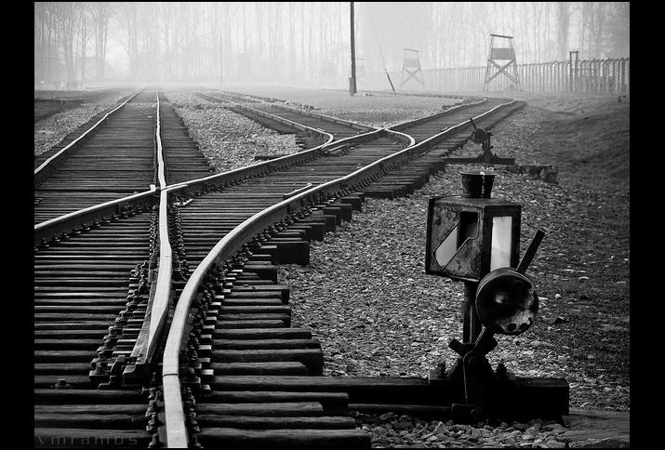

RESOURCES FOR TEACHING

The Holocaust and other World Genocides

2021
Commonwealth of Virginia
Department of Education
2010
Copyright © 2021
by the
Virginia Department of Education
P.O. Box 2120
Richmond, Virginia 23218-2120
www.doe.virginia.gov

All rights reserved. Reproduction of these materials for instructional
purposes in public school classrooms in Virginia is permitted.

Superintendent of Public Instruction
James Lane, Ph.D

Assistant Superintendent for Learning and Innovation
Michael Bolling

Office of Humanities
Christine Harris, Ph.D, Director
Andrea Emerson, Secondary History and Social Science Specialist
Brandi McCracken, Elementary History and Social Science Specialist
Christonya Brown, History and Social Science Coordinator

NOTICE
The Virginia Department of Education does not discriminate on the basis of race, sex, color, national origin, religion, age, political affiliation, veteran status, or against otherwise qualified persons with disabilities in its programs and activities.

Table of Contents
Acknowledgments 11
Organizations: 11
Writers and Collaborators 11
Introduction 12
SECTION I: Instructional Resources for Teaching History and Social Science 13
Holocaust and Genocide Studies Resources 13
Best Practices in Holocaust Education 13
Pedagogical Principles for Effective Holocaust Education 14
Students In Every Grade Will Experience A New Approach To Instruction That Focuses On Key Skills For Success In A Modern World 16
2015 History and Social Science Standards of Learning Skills Progression by Grade or Course 17
Key for Progression Chart 17
Progression Chart 17
Scaffolding 19
The Inquiry Design Model (IDM) 21
SECTION II: Division-level Curriculum Map for Teaching the Holocaust in United States History 1865 to Present 22
Learning In Place 23
Organizing Topic: The Holocaust Related Standard(s) of Learning 24
Essential Understandings 24
Sample Resources 25
Learning Experience: Political and economic conditions in Europe following World War I 26
Materials: 26
Instructional Activity: 26
Checking for Understanding: 26
Attachment A: Biography of Alfred Caro 27
Attachment B: Biography of Frank Shurman 28
Attachment C: The Rise of the Nazi Party 29
Learning Experience: Antisemitism - What is it and how did it impact the lives of those in Nazi Germany & Nazi-occupied Europe? 31
Materials 31
Instructional Activities – Part I 31
Instructional Activities – Part II 32
Checking for Understanding 32
Attachment A: Map of Pre-World War II Jewish Life 33
Attachment B: Biography of Margaret Lambert 35
Attachment C: Definition of Antisemitism 36
Attachment D: USHMM Holocaust Encyclopedia Article on Antisemitism 37
Origin and Meaning of the Term 37
Antisemitism in History 37
The Beginnings of Nazi Antisemitism 37
Attachment E: Pyramid of Hate 39
An Inquiry Approach: Performance Tasks, Assessment and Taking Action 40
Inquiry Description 40
Structure of the Inquiry 40
What conditions and ideas made the Holocaust Possible? 41
Supporting Questions 41
Supporting Question 1 43
Supporting Question 2 44
Supporting Question 3 44
Supporting Question 4 46
SECTION III: Division-level Curriculum Map for Teaching the Holocaust in World History 1500 to Present 48
Learning In Place 49
Organizing Topic 50
World History & Geography: 1500 to Present 50
Related Standard(s) of Learning 50
Essential Understandings 51
Sample Resources 52
Learning Experience: The Seeds of the Second World War 53
Materials 53
Instructional Activities 53
Learning Experience: Examining the Holocaust - Focus on Concentration Camps 54
Materials 54
Instructional Activities – Part I 54
Checking for Understanding 54
Learning Experience: America & the Holocaust 55
Materials 55
Instructional Activities 55
Learning Experience: Examining Genocide: Genocide in the 20th Century 56
Materials 56
Instructional Activities – Part I 56
Checking for Understanding 57
Attachment A: USHMM Holocaust Encyclopedia Article on the Armenian Genocide 57
Attachment B: USHMM Holocaust Encyclopedia Article on the Rwandan Genocide 58
Attachment C: Handout on the Genocide in the Ukraine 59
Holodomor 59
The Ukrainian Genocide 59
An Introduction 59
Ukraine Before the Holodomor 59
The Holodomor 60
The Holodomor as Genocide 61
Holodomor Denial 62
Legacy and Aftermath 62
Attachment D: USHMM Encyclopedia Entry on Darfur 64
Introduction 64
Violence 64
International Intervention 64
An Inquiry Approach: Performance Tasks, Assessment and Taking Action 65
Inquiry Description 65
Structure of the Inquiry 65
Are there common circumstances underlying genocides? 67
Supporting Questions 67
Inquiry Standard 68
Staging the Compelling Question 68
Staging the Compelling Question 69
Compelling Question 69
Staging the Compelling Question 69
Supporting Question 1 69
Overview 69
Supporting Question 69
Formative Performance Task 69
Featured Sources 69
Supporting Question 1 69
Formative Performance Task 69
Featured Sources 70
Featured Source A: Past Genocides and Mass Atrocities 70
Featured Source B: Late Ottoman Population and its Ethnic Distribution 70
Featured Source C: Jewish Population of Europe in 1933 70
Featured Source D: Ethnic Groups of Cambodia (1967) 71
Featured Source E: Genocide in Rwanda 72
Featured Source F: Ethnic Groups in Yugoslavia (1991) 72
Supporting Question 2 73
Overview 73
Supporting Question 73
Formative Performance Task 73
Featured Sources 73
Formative Performance Task 73
Featured Sources 74
Featured Source A: GDP Graphs of the Five Countries Where Genocide Occurred in the 20th Century 74
Supporting Question 3 79
Overview 79
Formative Performance Task 79
Featured Source A 79
Featured Source B 80
Featured Source C 80
Featured Source D 80
Featured Source E 80
Summative Performance Task 81
Taking Informed Action 83
SECTION IV: Division-level Curriculum Map for Teaching the Holocaust in Virginia & United States History 84
Learning In Place 85
Organizing Topic 86
Session 1: Establishing a Context for the Holocaust 88
Materials 88
Instructional Activities Part I 88
Instructional Activities Part II 88
Attachment A: Starburst Identity Worksheet 89
Attachment B: Considering the Path to Nazi Genocide 90
Session 2: The Rise of the Nazi Party 92
Materials 92
Instructional Activities - Part I 92
Instructional Activities - Part II 92
Session 3: The Final Solution to the Jewish Question 92
Materials 93
Instructional Activities 93
Attachment A: K-W-L Chart 94
Session 4: America & the Holocaust 94
Materials 95
Instructional Activities 95
An Inquiry Approach: Performance Tasks, Assessment and Taking Action 96
Inquiry Description 96
Content Background 96
The Superior Orders Defense 97
Why teach the “soldier’s dilemma” of superior orders? 97
A Note on Terminology 98
“I was only following orders!”Is this an acceptable defense? 99
Supporting Questions 99
Standards and Practices 100
Staging the Question 100
Staging the Compelling Question - Overview for the Teacher 101
Featured Source A 102
Featured Source B 103
Supporting Question 1 - Overview for the Teacher 104
Supporting Question 1 - Featured Source B 107
SQ1: Graphic Organizer 112
Supporting Question 2 - Overview for the Teacher 116
SQ2: Graphic Organizer 123
Supporting Question 3 - Overview for the Teacher 125
SQ3: Graphic Organizer 131
Supporting Question 3: 131
Formative Performance Task: 131
Instructions: 131
Featured Source A 131
According to General Walter Schellenberg, was a moral choice available to men who were ordered to murder? 131
What did Schellenberg say would happen to a man who “couldn’t go along with this type of an order”? 131
Why? 131
According to Albert Hartel, what would happen to those who were “too soft” to carry out orders to murder? 132
What happened when S.S. Colonel Gustav Nosske objected to an order to murder Jews? 132
According to S.S. General Erich von dem Bach Zelewski, how many men were killed for refusing to take part in shooting? 132
Featured Source B 132
According to Musmanno, was there a moral choice available to Eichmann? 132
How could Eichmann have been released from his role in the Holocaust? 132
According to Musmanno, why didn’t Eichmann and every Nazi official refuse to fulfill Hitler’s programme? 132
What was the “additional reason” that Einsatzgruppen officers preferred to keep their assignments as murderers? 133
Featured Source C 134
What extraordinary offer did Major Trapp make for his battalion? 134
How did Major Trapp feel about the orders the battalion had received? 134
What statements support your conclusion? 134
According to their testimony years later, why didn’t more men take Major Trapp’s offer? 134
What other reasons may explain the soldiers’ choice to kill the Jews they had been told to kill? 134
Featured Source D 135
What did Werner Schwenker say he was afraid might happen to him if he refused to murder Jews? 135
According to Schwenker, how often were men sentenced to death for refusing to murder Jews? 135
Based on Schwenker’s testimony, did perpetrators have a “moral choice” available to them? Explain. 135
SQ3: Summary 136
Supporting Question 3: 136
Formative Performance Task: 136
Supporting Question 4 - Overview for the Teacher 137
Supporting Question 137
Formative Performance Task 137
Featured Sources 137
Featured Source A: 139
Principle I 139
Principle II 139
Principle III 139
Principle IV 140
Principle V 140
Principle VI 140
Principle VII 140
Featured Source B: 141
Featured Source C: 142
WHEN CAN A SOLDIER DISOBEY AN ORDER? 142
Featured Source D: 145
Why German Soldiers Don’t Have to Obey Orders 145
Summative Performance Task - Overview for the Teacher 147
Summative Performance Task 147
ARGUMENT 147
EXTENSION 147
Constructing an Argument 147
Extension 147
Taking Informed Action 149
Overview for the Teacher 149
UNDERSTAND 149
ASSESS 149
ACT 149
Practicing the Historian Skill of “Sourcing” 149
Assessing the Case 150
Featured Source 152
Appendix A: Definitions of “Genocide” and “Crimes Against Humanity” from the Rome Statute of the International Criminal Court. 155
Article 6 155
Genocide 155
Article 7 155
Sample Resources 157
Other Compelling Questions to Consider . . . . 158

Acknowledgments

The Virginia Department of Education would like to acknowledge and show appreciation to the following individuals for their support and contributions to this project:

Organizations:
C3 Teachers
Echoes & Reflections
Facing History & Ourselves
Holocaust Commission of the United Jewish Federation of Tidewater
United States Holocaust Memorial Museum
USC-Shoah Foundation
University of Minnesota - Holocaust & Genocide Studies Program
Virginia Holocaust Museum

Writers and Collaborators
Hashim Davis, Teacher - Albemarle County Schools
Zachary Dobrin, Teacher - Staunton City Schools
Megan Ferenczy, Director of Education - Virginia Holocaust Museum
Jennifer Goss, Teacher - Staunton City Schools
Jennifer Madden, Teacher - Suffolk Public Schools
India Meissel, Teacher - Suffolk Public Schools
Patti Winch, History and Social Science Specialist (Retired) - Fairfax County Schools

Introduction
In March 2009, the Virginia General Assembly passed HB2409. This law required the State Superintendent of Public Instruction to select and distribute a teacher's manual that emphasizes the causes and ramifications of the Holocaust and genocide to all school divisions. Local school divisions must provide grade-appropriate portions of such manual to each history and literature teacher. As an update to previous materials provided in 2009, the history and social science program at the Virginia Department of Education worked with a team of teachers, organizations, and Virginia museums to provide such support for Virginia educators to meet the required instruction of the Holocaust and other world genocides. This document includes recommended practices; however, the Virginia Department of Education encourages each school division to utilize selected resources and seek additional training to further educator ability to teach about this difficult history.

The History and Social Science Standards of Learning Enhanced Curriculum Map for the Holocaust and other World Genocides is intended to help teachers align their classroom instruction with the History and Social Science Standards of Learning. The document is organized by topics and provides teachers with learning experiences and formative assessments aligned with the essential knowledge and skills in the Curriculum Framework.

School divisions and teachers may use the History and Social Science Standards of Learning Enhanced Curriculum Map for the Holocaust and other World Genocides as a resource for developing sound curricular, instructional and assessment programs. These materials are intended as examples of how the knowledge and skills might be presented to students and have been aligned with the Standards of Learning. Teachers who use the Enhanced Curriculum Map should correlate the essential knowledge and skills with available instructional resources as noted in the materials and determine the pacing of instruction as appropriate. This resource is not a complete curriculum and is neither required nor prescriptive, but it can be a useful instructional tool.

Each organizing topic contains the following:
- related History and Social Science Standard(s) of Learning;
- essential understandings and skills that define the designated Standard(s) of Learning, as presented in the History and Social Science Standards of Learning Curriculum Framework 2015;
- inquiries that support deeper learning;
- related information sources and sample resources. and
- sample formative and summative assessment items covering the organizing topic.

SECTION I: Instructional Resources for Teaching History and Social Science

Holocaust and Genocide Studies Resources

The study of history must emphasize the intellectual skills required for responsible citizenship. The Holocaust and Genocide Studies Resources contained within provide students an opportunity to practice historical thinking skills as they extend their understanding of the essential knowledge defined by all of the standards for history and social science.

Through the use of historical and geographical analysis, students explore the Holocaust and other genocides that have occurred in the twentieth and twenty-first centuries. These topics stretch across various courses and levels: United States History: 1865 to the Present, World History & Geography: 1500 to Present and Virginia and United States History. Although there is a topical focus, students will continue to learn fundamental concepts in civics, economics, and geography as they study these topics in chronological sequence and learn about change and continuity in our history through the use of primary and secondary sources.

As teachers explore the content, there are four compelling questions that transcend each unit, each lesson:

- How and why did the Holocaust happen?
- Why do we study the Holocaust?
- How is the Holocaust relevant today?
- What does the Holocaust teach us about the process of genocide?
Careful attention was paid to assure that the materials met the highest criteria, but the nature of the subject and the possible emotional impact means that teachers must take special care to preview all materials. School divisions, schools, and teachers are encouraged to preview all materials and consider the student readiness when delivering instruction to students. According to the United States Holocaust Memorial Museum, students in grades six and above demonstrate the ability to empathize with individual eyewitness accounts and to attempt to understand the complexities of Holocaust history, including the scope and scale of the events. While elementary age students are able to empathize with individual accounts, they often have difficulty placing them in a larger historical context. Elementary school can be an ideal place to begin discussing the value of diversity and the danger of bias and prejudice. These critical themes can be addressed through local and national historical events and can be reinforced during later study of the Holocaust.
Teachers should use the following Best Practices when teaching about the Holocaust and other world genocides:

Best Practices in Holocaust Education
A resource for Holocaust pedagogy and content is Echoes & Reflections — a collaboration between the ADL, the USC Shoah Foundation, and Yad Vashem. The Echoes & Reflections website provides teachers with a free, comprehensive Holocaust education curriculum using video testimony from survivors. Echoes & Reflections recommends the following best practices:

Pedagogical Principles for Effective Holocaust Education
In order for students to understand the importance of the Holocaust as a historical event and as part of our shared human story, it is critical for teachers to have a sound pedagogy for instruction. Echoes & Reflections recommends the following “pedagogy-in-practice” principles for teachers to apply to their planning and implementation of a comprehensive Holocaust education program, allowing students to study this complex topic in a meaningful way and to ultimately apply what they have learned to their daily lives.

- Define terms
In addition to key terms like antisemitism, Holocaust, and genocide, review key terms and phrases necessary to fully understand the content being studied. For an audio visual glossary from Echoes & Reflections, please visit this site.

- Provide background on the history of antisemitism
Ensure students understand the role that antisemitism played in allowing the Holocaust to occur.

- Contextualize the history
Help students understand what happened before and after a specific event, who was involved, where the event took place, etc. This helps to reinforce the fact that the Holocaust wasn’t inevitable, but rather was the result of choices and decisions made by individuals, institutions, and nations over years.

- Teach the human story
While connecting people and events to the larger story, educators should:
- Translate statistics into personal stories; use survivor and witness testimony whenever possible; emphasizing, however, that survivor voices are the exception.
- Highlight examples of how victims attempted to retain their humanity in the face of dehumanization (efforts to maintain identity and continuity of life, expression of values/beliefs, forms of resistance).
- Stress the “choice-less choices” of the victims with limited or no power to escape.
- Introduce victims’ prewar life/return to life to provide context for their choices, dilemmas, and actions.
- Focus on small and large decisions made by individuals who had the ability and the opportunity to choose between morally right and morally wrong decisions prior to, during, and after the Holocaust, including bystanders, collaborators, perpetrators, and rescuers.

- Use primary source materials
Enrich students’ understanding of the Holocaust by providing an abundance of print and digital resources from a variety of perspectives.

- Make the Holocaust relevant
Connect what students are learning to contemporary events, while distinguishing between the unique history of the Holocaust and what can be learned from its history and applied to our reality.

- Encourage inquiry-based learning and critical thinking
Support students’ sharing of ideas and asking questions of themselves and others.

- Foster empathy
Challenge students to understand people and their attitudes and actions in a historical context using sound approaches and strategies, refraining from the use of simulation activities.

- Ensure a supportive learning environment
Guide students “safely in and safely out” of this study; use age-appropriate materials and always be mindful of the social and emotional needs of individual students.

For additional exploration of effective teaching approaches, please visit the Echoes & Reflections Video Toolbox and watch the 11-minute film “Teaching about the Holocaust in Today’s World.”

We would sincerely appreciate your feedback on this resource guide.
Please click here to take a short survey.

Students In Every Grade Will Experience A New Approach To Instruction That Focuses On Key Skills For Success In A Modern World

The Profile of a Virginia Graduate establishes a new set of expectations – known as the 5 C’s: critical thinking, creative thinking, communication, collaboration, and citizenship skills.

This approach will prepare every student with the content knowledge they need and the skills they need to apply them successfully after graduation. A successful Virginia Graduate will:

- Achieve and apply academic & technical knowledge;
- Demonstrate workplace skills, qualities, & behaviors;
- Build connections and value interactions with others as a responsible & responsive citizen; and
- Align knowledge, skills, & personal interests with interests with career opportunities.

2015 History and Social Science Standards of Learning Skills Progression by Grade or Course

Key for Progression Chart
Standard Introduction Level | Symbol
Conceptual Understanding: The student is first introduced to the skill and applies the skill appropriately in varied situations. | C
Scaffolding the Understanding: The student continues to develop the skill and integrate the skill appropriately across new concepts. | S
Analyzing the Understanding: The student is knowledgeable about the skill from previous instruction, applies the skill to new concepts, and analyzes outcomes. | A

Progression Chart
Social Science Skill and Description of Skill | K | 1 | 2 | 3 | VS | USI | USII | CE | WG | WHI | WHII | VUS | GOVT
.1a Using information sources to view artifacts, primary and secondary sources | C | S | S | A | A | A | A | A | A | A | A | A | A
.1a Using information sources to use artifacts, primary and secondary sources | - | C | S | A | A | A | A | A | A | A | A | A | A
.1a Using information sources to identify artifacts, primary and secondary sources | - | - | C | S | S | S | S | A | A | A | A | A | A
.1a Using information sources to analyze and interpret artifacts, primary and secondary sources | - | - | - | - | C | S | S | S | A | A | A | A | A
.1a Using information sources to synthesize evidence from primary and secondary sources | - | - | - | - | - | - | - | - | C | C | C | S | S
.1a Applying geographic skills to use basic map skills | C | S | S | S | S | A | A | A | A | A | A | A | A
.1b Applying geographic skills to use geographic information | - | - | - | C | S | S | S | S | A | A | A | A | A
.1b Applying geographic skills to analyze the impact of geographic features | - | - | - | - | C | S | S | S | A | A | A | A | A
.1b Analyzing geographic skills to use geographic information to determine patterns and trends | - | - | - | - | - | C | C | C | S | S | S | A | A
.1c Organizing information to gather and classify information, sequence events, and separate fact from fiction | C | S | S | S | A | A | A | A | A | A | A | A | A
.1c Organizing information to use and create charts, graphs, diagrams, and pictures to determine characteristics of people, places or events | - | C | S | S | S | A | A | A | A | A | A | A | A
.1c Organizing information to interpret charts, graphs, diagrams, and pictures to determine characteristics of people, places or events | - | - | - | C | S | S | S | S | A | A | A | A | A
.1d Questioning and using critical thinking skills to ask appropriate questions to solve a problem | C | S | S | S | S | A | A | A | A | A | A | A | A
.1d Questioning and using critical thinking skills to summarize points and evidence to answer a question | - | - | - | C | S | A | A | A | A | A | A | A | A
.1d Questioning and using critical thinking skills to recognize points of view and historical perspective | - | - | - | - | C | S | S | S | A | A | A | A | A
.1d Questioning and using critical thinking skills to use evidence to draw conclusions and make generalizations | - | - | - | - | - | C | C | C | S | S | S | A | A
.1d Questioning and using critical thinking skills to evaluate sources for accuracy, credibility, bias, and propaganda | - | - | - | - | - | - | - | - | C | C | C | S | S
.1d Questioning and using critical thinking skills to construct arguments using evidence from multiple sources | - | - | - | - | - | - | - | - | - | - | - | C | C
.1e Comparing and contrasting to compare and contrast people, places, or events | C | S | S | S | A | A | A | A | A | A | A | A | A
.1e Comparing and contrasting to compare and contrast ideas and perspectives | - | - | - | C | S | S | S | S | A | A | A | A | A
.1e Comparing and contrasting to compare and contrast historical, cultural, and political perspectives | - | - | - | - | C | C | C | C | S | S | S | A | A
.1f Determining cause-and-effect to recognize direct cause-and-effect relationships | C | S | S | S | A | A | A | A | A | A | A | A | A
.1f Determining cause-and-effect to determine relationships with many causes or effects | - | - | - | C | S | S | S | S | A | A | A | A | A
.1f Determining cause-and-effect to explain indirect cause-and-effect relationships | - | - | - | - | - | - | - | - | C | C | C | S | S
.1g Making connections to make connections between past and present | C | S | S | S | A | A | A | A | A | A | A | A | A
.1g Making connections to explain connections across time and place | - | - | - | C | C | S | S | S | A | A | A | A | A
.1g Making connections to analyze multiple connections across time and place | - | - | - | - | - | - | - | - | C | C | C | S | S
.1h Making economic decisions to use a decision-making model to make informed decisions | - | C | C | C | S | S | S | S | A | A | A | A | A
.1h Making economic decisions to use a decision-making model to identify costs and benefits of a specific choice made | - | - | - | - | C | C | C | C | S | S | S | A | A
.1h Making economic decisions to use a decision-making model to analyze and explain the incentives and consequences of a specific choice made | - | - | - | - | - | - | - | - | C | C | C | S | S
.1i Exercising civic responsibility to practice good citizenship skills while collaborating, compromising, and participating in classroom activities | C | S | S | S | S | S | S | S | A | A | A | A | A
.1i Exercising civic responsibility to demonstrate respect for rules and laws | - | C | S | S | S | S | S | S | A | A | A | A | A
.1i Exercising civic responsibility to identify the rights and responsibilities of citizenship | - | - | - | - | - | C | C | C | S | S | S | S | S
.1i Exercising civic responsibility to identify ethical use of material or intellectual property | - | - | - | - | - | C | C | C | S | S | S | S | S
.1j Demonstrating comprehension to develop fluency in content vocabulary, and comprehension of verbal, written, and visual sources | C | C | S | S | S | S | S | S | A | A | A | A | A
.1j Demonstrating comprehension to defend positions using content vocabulary | - | - | C | S | S | S | S | S | S | S | S | A | A
.1j Demonstrating comprehension to access a variety of media, including online resources | - | - | - | C | S | S | S | S | A | A | A | A | A
.1j Demonstrating comprehension to investigate and research to develop products orally and in writing | - | - | - | - | C | S | S | S | A | A | A | A | A

Scaffolding

Instructional scaffolding is a process through which a teacher adds supports for students in order to enhance learning and aid in the mastery of tasks. The teacher does this by systematically building on students' experiences and knowledge as they are learning new skills.

Student Type | Strategies | Resources
Students with Disabilities | - When introducing new content, build background knowledge by making connections to the students’ lives  - Support content with visuals and pictures. When possible, introduce new content with visuals before text.  - Emphasize content and academic vocabulary throughout instruction  - Provide sentence frames for written work to assist students with fluency  - Provide opportunities for pair/share before students speak to a larger group  - Use graphic organizers to record information  - Check for understanding throughout lessons.  - Offer multiple ways/choice for students to demonstrate their understanding | I Do, We Do, You Do: Scaffolding Reading Comprehension in Social Studies
English Learners | - When introducing new content, build background knowledge by making connections to the students’ lives  - Support content with visuals and pictures. When possible, introduce new content with visuals before text.  - Support content with audio. When possible, introduce new content with videos and slow and clear articulated models. Emphasize content and academic vocabulary throughout instruction  - Provide sentence frames for written work to assist students with fluency (sentence frames can be simple for ELs with beginning proficiency and literacy)  - Provide model paragraphs when students are expected to write longer texts  - Provide opportunities for supported pair/share before students speak to a larger group  - Use graphic organizers to present and record information  - Check for understanding throughout lessons  - Offer multiple ways/choice for students to demonstrate their understanding, including drawings or manipulatives  - See this resource for additional ideas: History and Social Sciences Strategies for Supporting English Leaners Infographic | Supporting English Language Learners through the Curriculum and Beyond
Extension Instruction | - Pre-assess your students. Find out their areas of strength as well as those areas you may need to address before students move on.  - Consider grouping gifted students together for at least part of the school day.  - Plan for differentiation. Consider pre-assessments, extension activities, and compacting the curriculum.  - Use phrases like "You've shown you don't need more practice" or "You need more practice" instead of words like "qualify" or "eligible" when referring to extension work.  - Encourage high-ability students to take on challenges. Because they're often used to getting good grades, gifted students may be risk averse. | Gifted and Talented Students: Teaching Strategies

Differentiating Instruction: It’s Not as Hard as You Think - When some teachers think of differentiation, they imagine having to create a different lesson for every student in the room. In this video, teacher and author Larry Ferlazzo explains that differentiating instruction is really about getting to know your students and making decisions, often in the moment, based on what they need. He offers some low-lift strategies he’s learned over the years for making activities accessible for students with all types of gifts and challenges.

The Inquiry Design Model (IDM)
IDM is a distinctive approach to creating instructional materials that honors teachers’ knowledge and expertise, avoids over-prescription, and focuses on the key elements envisioned in the C3 Inquiry Arc. Unique to the IDM is the blueprint based on these key C3 elements—a one-page presentation of the questions, tasks, and sources that define a curricular inquiry. The blueprint offers a visual snapshot of an entire inquiry such that the individual components and the relationship among the components can all be seen at once.
—Swan, John Lee, and S.G. Grant, “The New York State Toolkit and the Inquiry Design Model: Anatomy of an Inquiry,” Social Education 79(5). (2015): 316–322.

Within many of the lessons, students are presented with compelling questions, supporting questions, sources, and tasks. In addressing a compelling question, students will work through a series of supporting questions, formative performance tasks, and featured sources in order to construct an argument with evidence.

SECTION II: Division-level Curriculum Map for Teaching the Holocaust in United States History 1865 to Present
The Virginia Department of Education does not provide or prescribe content for this chart. The Division-level Curriculum Map should be aligned to the History and Social Science Standards of Learning and reflect the division pacing and needs of students and teachers.

Topic and/or Unit Title | Skills and Content Standard(s) | Pacing | Assessment Title and Type | Local Connections | Necessary Professional Development

Learning In Place
Instruction Type | Description
Schoolhouse Instruction | Traditional (Face-to-Face) teaching (also known as in-person, F2F) focuses on several elements, including lectures, capstones, team projects, labs, studios, and so forth. Teaching is conducted synchronously in a physical learning environment (utilizing appropriate safety measures), meaning that “traditionally,” the students are in the same place simultaneously. The traditional classroom has the significant advantage of face-to-face interaction between the student and educator and the students themselves. Students derive motivation from the teacher as well as from the other students.
Interdisciplinary Instruction | Interdisciplinary teaching is an approach that integrates different aspects of more than one academic discipline to examine a theme, issue, question, or topic.  Interdisciplinary learning empowers students to explore different perspectives and views.  And research shows that interdisciplinary approaches to teaching help students learn how to solve problems and answer questions by:  - Recognizing biases  - Thinking critically  - Embracing ambiguity  Analyzing ethical concerns
Home-based Instruction | - The asynchronous modality affords students time to work on their learning on their own schedule. The teacher has designed a sequence of activities for students to work independently, and therefore this work may not be completed in tandem with other students. Asynchronous learning is often completed outside of regular class time. Examples of asynchronous assignments might include reading, watching videos, taking assessments, completing projects, completing homework, or answering questions. Students may need extra support in how to structure their time to complete work within the parameters set by the teacher. Students may also be given options to make choices about how they prioritize their time, which can provide practice in time management. Considerations for instructors include the student’s age, maturity, and evidence of prior success in working on asynchronous assignments, as well as the types of support available at home.
Online Instruction | Virtual learning has become an integral part of our educational system. Virtual learning can aid in:  - Increasing student engagement and choice,  - Supporting personalized learning experiences for students, and  - Increasing equity in access to high quality learning experiences.  Virtual learning programs offer flexibility to students while providing instruction aligned with the Standards of Learning. A number of Virginia school divisions provide opportunities for their students to take online courses as a part of their regular course offerings.

Organizing Topic: The Holocaust Related Standard(s) of Learning
USII.1 The student will demonstrate skills for historical thinking, geographical analysis, economic decision making, and responsible citizenship by
- analyzing and interpreting artifacts and primary and secondary sources to understand events in United States history;
b) analyzing and interpreting geographic information to determine patterns and trends in United States history;
c) interpreting charts, graphs, and pictures to determine characteristics of people, places, or events in United States history;
d) using evidence to draw conclusions and make generalizations;
e) comparing and contrasting historical, cultural, and political perspectives in United States history;
f) determining relationships with multiple causes or effects in United States history;
g) explaining connections across time and place;
h) using a decision-making model to identify the costs and benefits of a specific choice made;
i) identifying the rights and responsibilities of citizenship and the ethical use of material or intellectual property; and
j) investigating and researching to develop products orally and in writing.

USII.7 The student will apply social science skills to understand the major causes and effects
of American involvement in World War II by
a) explaining the causes and events that led to American involvement in the war, including the
attack on Pearl Harbor;
b) locating and describing the major events and turning points of the war in Europe and the
Pacific; and
c) explaining and evaluating the impact of the war on the home front.

Essential Understandings
- Political and economic conditions in Europe following World War I led to the rise of fascism and to World War II.
- The rise of fascism threatened peace in Europe and Asia.
- As conflict grew in Europe and Asia, American foreign policy evolved from neutrality to direct involvement.
- The Holocaust is an example of prejudice, discrimination, and genocide taken to the extreme.

Sample Resources
Below is an annotated list of Internet resources for this organizing topic. Copyright restrictions may exist for the material on some Web sites. Please note and abide by any such restrictions.
“Holocaust Encyclopedia.” United States Holocaust Memorial Museum
“Echoes & Reflections” Echoes & Reflections. This site offers lesson plans and correlated primary and secondary sources to teach this topic to secondary students.
“Teach” United States Holocaust Memorial Museum. This site offers lesson plans to educators across a variety of interconnected topics.
“Facing History and Ourselves.” Facing History. This site offers lesson plans to educators across a variety of interconnected topics
“What We Carry” The Holocaust Commission of the United Jewish Federation of Tidewater. These developed lessons allow students to learn from a Virginia-affiliated witness to the Holocaust. Lessons are aligned to specific Virginia Social Studies Standards of Learning Outcomes and include ideas for differentiation.
“Resources for Teachers” Virginia Holocaust Museum. This site contains a variety of resources to aid teachers in instructing about the Holocaust and other world genocides including connections to Virginia survivors of these atrocities.

Other collections, series, and links in eMediaVASM that you might find helpful:

Holocaust:
- Echoes and Reflections (A Series of 22 assets)
- What We Carry Collection | The Holocaust Commission
- Primary Source Set: Elie Wiesel’s Night and the Holocaust
- You Have to Speak Up: Lessons from the Holocaust | PBS NewsHour

Cambodian Genocide:
- Cambodia Teaches New Generation about Khmer Rouge Atrocities
- Khmer Rouge Leaders Found Guilty | NPR (Article)

Rwanda:
- Clinton: Crises in Somalia and Rwanda

Learning Experience: Political and economic conditions in Europe following World War I
Awareness of the political and economic conditions in Europe following World War I enables us to understand the rise in fascism and World War II.

The rise of fascism had a direct impact on the lives of people in Germany. Fascism can be defined as, “A social and political ideology that has as its primary guiding principle that the state or nation is the highest priority, rather than personal or individual freedoms.”

Materials:
- Paper or Word/Docs Access
- The Path to Nazi Genocide
- Attachment A: Biography of Alfred Caro
- Testimony of Alfred Caro
- Attachment B: Biography of Frank Shurman
- Testimony of Frank Shurman
- Attachment C: The Rise of the Nazi Party (USHMM Encyclopedia)

Instructional Activity:
- Ask students to describe the impact of the Treaty of Versailles. Have students write then share out loud how they feel that citizens of Germany may have felt about the Treaty of Versailles. What other impacts might World War I have had on Germany and its new democracy?
  - For ELs, providing sentence frames that focus on cause and effect language, e.g. “One impact of WWI on Germany was ____.”
- Share the Introduction and Chapter 1 of The Path to Nazi Genocide from USHMM. How does this clip help you add to your list? What piece of information learned was most surprising to you?
  - For ELs, after working through the text, rephrase/summarize the main points as needed.
- Next, share the testimonies of Alfred Caro and Frank Shurman. Before showing each clip, introduce the students to Alfred and Frank via their biographies. Following the clips ask students the following analysis questions:
  - In his testimony, how does Alfred Caro characterize the Weimar Republic?
  - What example does Frank Shurman share to illustrate the “insecure situation” that Germany was facing in the early 1920s? How does Frank indicate that Hitler took advantage of the situation?
  - Based on what you heard from Alfred and Frank, how confident do you think the German people were with the status of the government?
- Direct students to read the Attachment C: Rise of the Nazi Party or read this segment out loud with students. Following their reading, ask each student to generate one reflection item and one question they would like to explore further related to this topic.
- Ask students to share their reflections and questions with the class.
  - This could be done in pairs before the full group as needed for ELs.

Checking for Understanding:
- Note students’ initial comparisons between the secondary source film and primary source testimony.
- Identify student takeaways from The Rise of the Nazi Party handout. Generate a list of questions students have to circle back to during additional activities when possible.

Attachment A: Biography of Alfred Caro
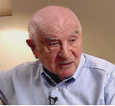
ALFRED CARO Alfred Caro was born July 27, 1911, to Sally and Frida Caro in Samter, Germany (today Szamotuly, Poland). The family then moved to Berlin, Germany, where Sally, a decorated veteran of World War I, bought a butcher shop. Alfred had three sisters, Cecila, Jenna, and Nora and two brothers, Alex and Siegbert. Alfred had fond memories of his childhood in Berlin, where he was raised in a conservative Jewish home.

In public school, Alfred was one of the only Jewish students. He participated in a number of local sports clubs and particularly enjoyed boxing. After Alfred completed his compulsory education, he studied to be a butcher in Halberstadt, Germany, for three years, returning to Berlin in 1928. Alfred recalled that shortly thereafter, the depression hit Germany hard, and the Nazi party rose to prominence.

Once Hitler came to power in 1933, Alfred noticed changes taking place around him, including anti-Semitic legislation. About this time, Alfred’s father’s business failed when his non-Jewish clientele dwindled. In 1935, after the Nuremberg Laws stripped the Caro family of its citizenship and rights, they became Zionists and tried to find ways to flee Germany, but it was too expensive to leave. In 1938, while being falsely sought as a political opponent, Alfred turned himself in to Nazi authorities, hoping his actions would protect his brothers.

Upon arrival in Sachsenhausen concentration camp, Alfred was forced to do hard labor amid primitive conditions and brutal treatment, all the while witnessing the arrival of new transports from all over Germany. After six weeks of appealing to the police in Berlin, his mother managed to orchestrate his release from Sachsenhausen in July of 1938.

HICEM, a large aid organization in Berlin, helped Alfred get a visa to immigrate to France where he lived in Paris with other refugees until he and about 500 other German and Austrian refugees were granted permission to live and work in Colombia. After two weeks aboard a ship called Cuba, Alfred arrived in Colombia with no money, possessions, nor the ability to speak Spanish. Until he caught malaria, Alfred worked in the gold mines deep in the Colombian jungle. Later Alfred moved to Bogota, where he became very successful, eventually owning a restaurant and butcher shop with an affluent clientele.

In 1952, Alfred decided to join his sister, Norma, who had earlier immigrated to America, settling in New York and learning English while working as a butcher for a German-owned delicatessen. Around this time, while on vacation, Alfred met his future wife, Helen, a divorcee living with her son, Allen, in Alabama. After a quick courtship, Alfred joined his new family in Anniston, Alabama, where he opened Caro’s Restaurant. Alfred and Helen had a daughter, Alice. Helen passed away in 1967. At the time of his interview in 1997, Alfred still lived in Anniston, enjoying the warmth of the local people and donating to many local causes, particularly the YMCA.

Attachment B: Biography of Frank Shurman
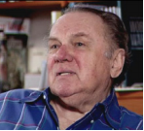
Frank Shurman was born Fritz Shurmann on January 8, 1915, in Hildesheim, Germany, to Willy and Alma Schurmann. He had two sisters, Edith and HanneLore. His father owned a men’s fashion business. In 1921, Frank started school in a two-room Jewish primary school. Before the Nazis came to power, Frank experienced enough antisemitism that he joined a boxing club to learn self-defense. Frank later attended the Gymnasium, a European secondary school to prepare students for the university. In 1932, as heir apparent to his father’s company, Frank became an apprentice tailor.

On April 1, 1933, on the day of the Nazi-organized nationwide boycott of Jewish-owned businesses, Frank traveled to the European Fashion Academy in Dresden, Germany, to complete his tailor training. That same year, Willy, a proud German Jew, won a prestigious fashion design award in Berlin, contributing to his belief that Nazism wouldn’t last. In contrast, many of Frank’s Zionist friends were leaving Germany for Palestine or South America.

In August 1934, Frank was hired as a tailor in Hamburg. Frank’s father continued his tailoring business until May 1938 when the Gestapo forced its liquidation. While Willy continued to operate a small-scale business from home, Frank explored emigration opportunities. In Berlin, he met with an American customer of Willy’s, Mrs. Augusta Hamilton, who agreed to sponsor Frank’s family once she returned to the United States. However, on November 9, 1938, the Gestapo arrested Frank and his father during the Kristallnacht Pogrom. After suffering abuse and public humiliation, they were sent to Buchenwald concentration camp with thousands of other Jewish men.

Amid abysmal conditions, Frank maintained hope that through aid from Mrs. Hamilton, he and his father would be freed. After several months, first Willy and then Frank were released after signing papers stating they had been well treated and wouldn’t speak of their imprisonment. In June 1939, while awaiting an emigration visa, Frank, with help from the British government, immigrated to England. In spring 1940, Frank immigrated to the United States. While living in New Jersey with an old friend from Hamburg, Frank quickly found a job as a tailor and soon thereafter obtained a loan from Mrs. Hamilton to pay for his family’s passage to America, forging a lifelong friendship between the two families.

While pursuing U.S. citizenship so he could join the army, Frank worked at a department store where he met his future wife, Margery. Frank completed basic training around November 11, 1942, keenly aware that five years earlier he had arrived at Buchenwald. Frank first was stationed at a POW camp and was later trained as an interrogator. In the post-war years, Frank helped to financially support some non-Jewish German friends who had earlier risked their own safety to help him and his family. At the time of Frank’s interview in 1996, he and Margery lived in Deerfield, Illinois, and had two children, Beverly and Daniel, and three grandchildren: Adam, Deborah, and Amanda.

Attachment C: The Rise of the Nazi Party

The Nazi Party was one of a number of right-wing extremist political groups that emerged in Germany following World War I. Beginning with the onset of the Great Depression it rose rapidly from obscurity to political prominence, becoming the largest party in the German parliament in 1932.

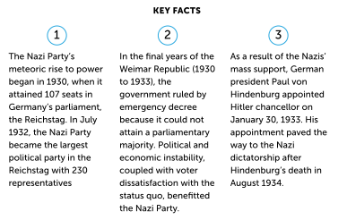
Before the onset of the Great Depression in Germany in 1929–1930, the National Socialist German Workers' Party (or Nazi Party for short) was a small party on the radical right of the German political spectrum. In the Reichstag (parliament) elections of May 2, 1928, the Nazis received only 2.6 percent of the national vote, a proportionate decline from 1924, when the Nazis received 3 percent of the vote. As a result of the election, a "Grand Coalition" of Germany's Social Democratic, Catholic Center, German Democratic, and German People's parties governed Weimar Germany into the first six months of the economic downturn.

During 1930–1933, the mood in Germany was grim. The worldwide economic depression had hit the country hard, and millions of people were out of work. The unemployed were joined by millions of others who linked the Depression to Germany's national humiliation after defeat in World War 1. Many Germans perceived the parliamentary government coalition as weak and unable to alleviate the economic crisis. Widespread economic misery, fear, and perception of worse times to come, as well as anger and impatience with the apparent failure of the government to manage the crisis, offered fertile ground for the rise of Adolf Hitler and his Nazi Party.

Hitler was a powerful and spellbinding orator who, by tapping into the anger and helplessness felt by a large number of voters, attracted a wide following of Germans desperate for change. Nazi electoral propaganda promised to pull Germany out of the Depression. The Nazis pledged to restore German cultural values, reverse the provisions of the Treaty of Versailles, turn back the perceived threat of a Communist uprising, put the German people back to work, and restore Germany to its "rightful position" as a world power. Hitler and other Nazi propagandists were highly successful in directing the population's anger and fear against the Jews; against the Marxists (Communists and Social Democrats); and against those the Nazis held responsible for signing both the armistice of November 1918 and the Versailles treaty, and for establishing the parliamentary republic. Hitler and the Nazis often referred to the latter as "November criminals."

Hitler and other Nazi speakers carefully tailored their speeches to each audience. For example, when speaking to businessmen, the Nazis downplayed antisemitism and instead emphasized anti-communism and the return of German colonies lost through the Treaty of Versailles. When addressed to soldiers, veterans, or other nationalist interest groups, Nazi propaganda emphasized military buildup and return of other territories lost after Versailles. Nazi speakers assured farmers in the northern state of Schleswig-Holstein that a Nazi government would prop up falling agricultural prices. Pensioners all over Germany were told that both the amounts and the buying power of their monthly checks would remain stable.

Using a deadlock among the partners in the "Grand Coalition" as an excuse, Center party politician and Reich Chancellor Heinrich Bruening induced the aging Reich President, World War I Field Marshal Paul von Hindenburg, to dissolve the parliament in July 1930 and schedule new elections for September 1930. To dissolve the parliament, the president used Article 48 of the German constitution. This Article permitted the German government to govern without parliamentary consent and was to be applied only in cases of direct national emergency.

Bruening miscalculated the mood of the nation after six months of economic depression. The Nazis won 18.3 percent of the vote and became the second largest political party in the country.

For two years, repeatedly resorting to Article 48 to issue presidential decrees, the Bruening government sought and failed to build a parliamentary majority that would exclude Social Democrats, Communists, and Nazis. In 1932, Hindenburg dismissed Bruening and appointed Franz von Papen, a former diplomat and Center party politician, as chancellor. Papen dissolved the Reichstag again, but the July 1932 elections brought the Nazi party 37.3 percent of the popular vote, making it the largest political party in Germany. The Communists (taking votes from the Social Democrats in the increasingly desperate economic climate) received 14.3 percent of the vote. As a result, more than half the deputies in the 1932 Reichstag had publicly committed themselves to ending parliamentary democracy.

When Papen was unable to obtain a parliamentary majority to govern, his opponents among President Hindenburg's advisers forced him to resign. His successor, General Kurt von Schleicher, dissolved the Reichstag again. In the ensuing elections in November 1932, the Nazis lost ground, winning 33.1 percent of the vote. The Communists, however gained votes, winning 16.9 percent. As a result, the small circle around President Hindenburg came to believe, by the end of 1932, that the Nazi party was Germany's only hope to forestall political chaos ending in a Communist takeover. Nazi negotiators and propagandists did much to enhance this impression.

On January 30, 1933, President Hindenburg appointed Adolf Hitler chancellor of Germany. Hitler was not appointed chancellor as the result of an electoral victory with a popular mandate, but instead as the result of a constitutionally questionable deal among a small group of conservative German politicians who had given up on parliamentary rule. They hoped to use Hitler's popularity with the masses to buttress a return to conservative authoritarian rule, perhaps even a monarchy. Within two years, however, Hitler and the Nazis outmaneuvered Germany's conservative politicians to consolidate a radical Nazi dictatorship completely subordinate to Hitler's personal will.

Author(s): United States Holocaust Memorial Museum, Washington, DC

Learning Experience: Antisemitism - What is it and how did it impact the lives of those in Nazi Germany & Nazi-occupied Europe?
Antisemitism is often called “the longest hatred.” Antisemitism is, “prejudice or discrimination against Jews. Antisemitism can be based on hatred against Jews because of their religious beliefs or their group membership (ethnicity), but also on the erroneous belief that Jews are a race. Nazi antisemitism was racial in nature; Jews were viewed as racially inferior to Aryans and destructive of the world order.”

Antisemitism greatly increased under Nazi rule. It can be classified into one of five types - all of which were included as part of Nazi racial ideology.
- Social: exclusion of Jews from social settings and functions including sports, theater or even the ability to live in certain neighborhoods.
- Economic: driven by the belief that Jews control the world’s banking industry, this type of antisemitism is one of the most commonly published about tropes.
- Religious: based in the erroneous belief that, “the Jews killed Jesus” - this type of antisemitism was furthered by the teachings of the Catholic and other Christian churches through the era of the Holocaust.
- Political: this type of antisemitism purports that Jews control the world’s political power. Along with economic antisemitism, it was a crucial part of the Russian-created propaganda piece, The Protocols of the Elders of Zion.
- Racial: a cornerstone of Nazi ideology, racial antisemitism does not accept conversion from Judaism because racial anti-Semites believe Jews to be a race of people known as Semites who share specific physical and psychological features.

Materials
- Attachment A: Maps of Pre-War Jewish Life
- Attachment B: Biography of Margaret Lambert
- Testimony of Margaret Lambert (Clip #1) (Clip #2)
- Attachment C: Definition of Antisemitism
- Attachment D: USHMM Encyclopedia Entry on Antisemitism
- Attachment E: Pyramid of Hate (Online Google Slides Version Here)
- Echoes & Reflections Holocaust Timeline (PDF printable available at this link)

Instructional Activities – Part I
- Provide students with the Maps of Pre-World War Jewish Life (Attachment A):
  - Ask students to jot down at least 3 observations that they have, 2 things that surprise them and one question.
  - Allow time to share out and discuss their observations and questions. Provide language supports as needed, including translations or same-language peers.
  - If it is not mentioned, draw student attention to the small percentage of the population that Jews make up in Germany, the large amount of Jews in Eastern Europe and the widespread nature of those who practice the Jewish faith.

- Next, students will meet a human being who was impacted by the antisemitism that flourished in Nazi Germany. Share Attachment B: Biography of Margaret Lambert. Then, show students both clips of Margaret’s testimony - pausing between each clip to ask students the following questions:
  - C1: What is your initial reaction to Margaret’s testimony?
  - C1: After listening to Margaret Lambert’s testimony, how does she describe the relationship between Jews and non-Jews before the war?
  - C1: What sense of foreshadowing does Margaret give to the viewers in Clip #1?
  - C2: How does Margaret Lambert say things changed in Germany after 1933? How did her personal relationships change? What kinds of things was she forced to give up?
  - C2: How does the delivery of her testimony change?
- Connecting to the examples from Margaret’s testimony, ask students if they know exactly what antisemitism is?:
  - Share Attachment C: Definition of Antisemitism.
  - Ask a student to read out loud or read the definition out loud to students.
  - Ask a student to summarize antisemitism (hatred of Jews or those perceived to be Jewish).
  - Then narrow down the definition to the first sentence, “Antisemitism is the term for hatred of Jews as a group or as a concept.” Work with students to determine the difference between a group (individuals one has personal experiences with) versus a concept (individuals one has likely never met). How does this tie in to issues such as stereotyping and prejudice?
  - If time permits, share Attachment D: USHMM Holocaust Encyclopedia article on antisemitism. Allow students to read and complete a reading reflection on 1 item that bolstered what they have already learned about antisemitism and 2-3 new facts that they learned.

Instructional Activities – Part II
- Distribute copies of the Pyramid of Hate OR create copies of the Pyramid of Hate Google Slides and allow students editing rights.
- Review the structure of the Pyramid of Hate with students explaining any words/concepts with which students may be unfamiliar. Ask students if they can think of any examples to illustrate the levels of the Pyramid based on activities done in class so far.
- Introduce students to the Timeline of the Holocaust. Share that students will be working through the Timeline to find examples to illustrate specific levels of the Pyramid. Remind students to review the primary sources within each event to find the best examples. This activity can focus on the years 1933-1938 OR can be expanded to additional years of the Holocaust depending on your rationale and student needs in your classroom.
- Allow students time to work on this activity then invite students to share their pyramids in a pair-share format or as a whole class share-out if you ask students to complete this activity in groups.

Checking for Understanding
- Monitor student responses during class discussion, whole class share-out and/or pair-share.
- Review Pyramid of Hate products - identify if student selected responses appropriately match the Pyramid of Hate levels.
- What else?

Attachment A: Map of Pre-World War II Jewish Life
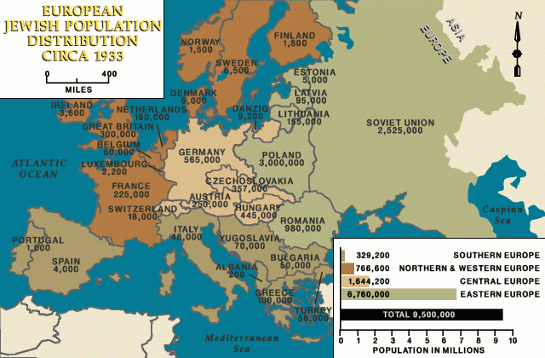

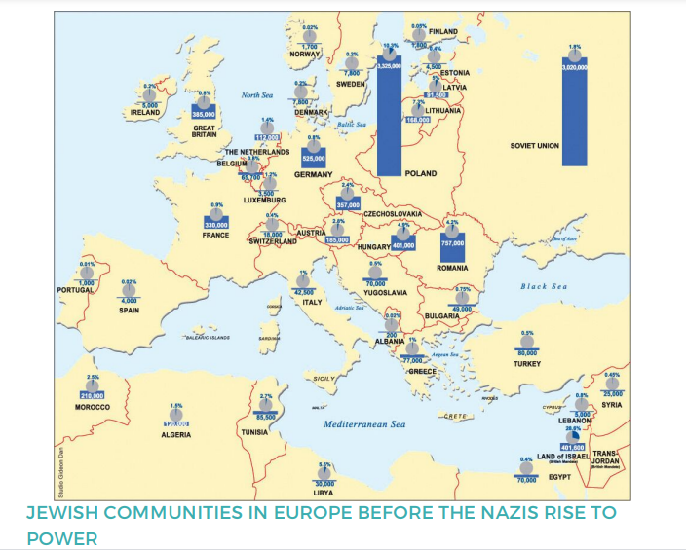

Key:
Bar Graph = Overall Jewish population in the nation
Pie Chart: Percentage of the overall population that identified as Jewish

Attachment B: Biography of Margaret Lambert
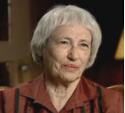
Margaret Lambert was born to Edwin and Paula Bergmann on April 12, 1914, in Laupheim, Germany. She had two brothers, Rudolph and Walter. Margaret’s father was in a manufacturing business along with his brothers and cousins. Margaret recalls that she was a strong-willed, independent child who had many friends, both Jewish and non-Jewish.

Margaret first attended a Jewish school, then a public high school followed by preparatory school. Margaret’s love and mastery of sports, which included skiing, skating, running, and climbing, led to her acceptance to study physical education at a German university in 1933. However, due to the rapidly changing political climate, she was advised to postpone her studies. Soon after came a devastating chain of events for Margaret: the anti-Jewish legislation, a dramatic change in her non-Jewish friends’ behavior and attitudes, and her exclusion from sports clubs.

In the fall of 1933, Margaret accepted an opportunity to study in London, England, where she again excelled in sports by winning a British track and field championship in the summer of 1934. Immediately afterwards, coerced by threats to her family, Margaret returned to Germany to train and compete on the German national team. She was the only Jewish athlete on the team, selected so that other nations wouldn’t boycott the 1936 Berlin Olympics. As soon as other Olympic teams were en route to Berlin, Margaret was dropped from the team.

In 1937, due in part to a wealthy friend of her father, Margaret obtained an affidavit to immigrate to the United States, following her older brother who had arrived in America five months earlier. Denied permission to leave, Margaret’s father and the rest of her family stayed in Germany until 1940 when they were allowed to immigrate to England.

After arriving in the United States, Margaret won a national championship in track and field in 1937 but retired from the sport shortly thereafter. She then sponsored the immigration of fellow athlete Bruno Lambert, whom she had met and fallen in love with before she left Germany. In 1938 they married. During the war years, Margaret was an army bride, moving from base to base until 1946 when she and Bruno, a physician, moved back to New York, where they had two sons, Gary and Glenn. The rest of her family eventually emigrated from England to the United States and settled in Queens, New York. In 1980, Margaret was inducted into the Jewish Sports Hall of Fame. At the time of Margaret’s interview in 1995, she and Bruno had three grandchildren: Jake, Ben, and Moli.

Attachment C: Definition of Antisemitism

Antisemitism is the term for hatred of Jews as a group or a concept. Hatred of Jews has existed since ancient times, and in the nineteenth century it was being influenced by modern scientific ways of thinking. The word “antisemitism” was coined in Germany by political activist Wilhelm Marr to represent this newer way of thinking. “Semitism” supposedly expressed all things Jewish, since at the time national groups were frequently defined by their language and the traditional language of Jews is Hebrew, which is a Semitic language. Of course there is no such thing as “Semitism” and all speakers of Semitic languages never belonged to the same national or ethnic groups.

Antisemitism may take the form of religious teachings that proclaim the inferiority of Jews, their supposedly evil nature, or other negative ideas about Jews. It may include political efforts to isolate, oppress, or otherwise injure them. It may also include prejudiced or other stereotyped views about Jews derived from racial or other ideologies.

Attachment D: USHMM Holocaust Encyclopedia Article on Antisemitism
The term antisemitism was coined only in the nineteenth century, but anti-Jewish hatred and Judeophobia (fear of Jews) date back to ancient times and have a variety of causes.

Origin and Meaning of the Term
The word antisemitism means prejudice against or hatred of Jews. The Holocaust, the state-sponsored persecution and murder of European Jews by Nazi Germany and its collaborators between 1933 and 1945, is history’s most extreme example of antisemitism.

In 1879, German journalist Wilhelm Marr originated the term antisemitism, denoting the hatred of Jews, and also hatred of various liberal, cosmopolitan, and international political trends of the eighteenth and nineteenth centuries often associated with Jews. The trends under attack included equal civil rights, constitutional democracy, free trade, socialism, finance capitalism, and pacifism.

Antisemitism in History
The specific hatred of Jews, however, preceded the modern era and the coining of the term antisemitism. Among the most common manifestations of antisemitism throughout history were pogroms, violent riots launched against Jews and frequently encouraged by government authorities. Pogroms were often incited by blood libels—false rumors that Jews used the blood of Christian children for ritual purposes.

In the modern era, anti-Semites added a political dimension to their ideology of hatred. In the last third of the nineteenth century, anti-Semitic political parties were formed in Germany, France, and Austria. Publications such as the Protocols of the Elders of Zion generated or provided support for fraudulent theories of an international Jewish conspiracy. A potent component of political antisemitism was nationalism, whose adherents often falsely denounced Jews as disloyal citizens.

The nineteenth century xenophobic "voelkisch movement" (folk or people’s movement)—made up of German philosophers, scholars, and artists who viewed the Jewish spirit as alien to Germandom—shaped a notion of the Jew as "non-German." Theorists of racial anthropology provided pseudoscientific backing for this idea.

The Beginnings of Nazi Antisemitism
The Nazi Party, founded in 1919 and led by Adolf Hitler, gave political expression to theories of racism. In part, the Nazi Party gained popularity by disseminating anti-Jewish propaganda. Millions bought Hitler's book Mein Kampf (My Struggle), which called for the removal of Jews from Germany.

With the Nazi rise to power in 1933, the party ordered anti-Jewish economic boycotts, staged book burnings, and enacted discriminatory anti-Jewish legislation. In 1935, the Nuremberg Laws racially defined Jews by “blood” and ordered the total separation of so-called "Aryans" and "non-Aryans,” thereby legalizing a racist hierarchy.
On the night of November 9, 1938, the Nazis destroyed synagogues and the shop windows of Jewish-owned stores throughout Germany and Austria (an event now known as the Kristallnacht pogrom or Night of Broken Glass). This event marked a transition to an era of destruction, in which genocide would become the singular focus of Nazi antisemitism.

Attachment E: Pyramid of Hate

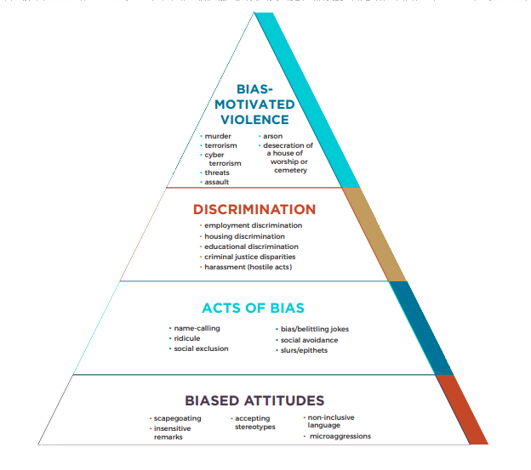

An Inquiry Approach: Performance Tasks, Assessment and Taking Action
(Blueprint adapted from C3 Teachers)
(Inquiry developed by Virginia Inquiry Collaborative and C3 Teachers)

Inquiry Description
This inquiry focuses on the effects of dehumanizing a segment of the population to create an environment that allows the dominant population to justify gradual marginalization that ultimately results in the attempted or actual genocide of the defined segment of the population.
The questions, tasks, and sources in this inquiry asks students to examine primary source documents, victim testimonies, geographic map comparisons, art, and timelines to develop an understanding of the effects of dehumanization. The students are further asked to construct claims and arguments that demonstrate an understanding of the dehumanizing of the Jews in the time leading up to and during the Second World War that resulted in the Holocaust
This inquiry highlights the following Virginia social studies standards.
- locating and describing the major events and turning points of the war in Europe and the Pacific by examining the dehumanizing components of the Holocaust perpetrated by Nazi Germany on segments of society that the ruling class found undesirable.

This inquiry is expected to take four 50-minute class periods. The inquiry time frame could expand if teachers think their students need additional instructional experiences (e.g., supporting questions, formative performance tasks, featured sources, writing). Teachers are encouraged to adapt the inquiry to meet the needs and interests of their particular students. This inquiry lends itself to differentiation and modeling of historical thinking skills while assisting students in reading the variety of sources.

Structure of the Inquiry
In addressing the compelling question, “What conditions and ideas made the Holocaust possible?” students will examine the concept of genocide as it applies to the European Jewish population and other so called undesirable parts of the population during the 1930s and 1940s. Students will use prior knowledge to identify previous events of genocide in American history and compare those events to the experiences of the victims of the Holocaust. Next the students will examine anti-Semitic propaganda to identify visual representations that justify the adverse treatment of European Jews. The students will then go on to identify differences and similarities of treatment depending on location and ethnic background. Lastly the students will look into the dehumanizing events that had cultural and economic consequences on the Jewish population and why this discrimination was allowed to spread.
The formative performance tasks will follow the progression of genocide from low level exclusion of the Jewish population from social and cultural activities to the ultimate attempted extermination of the Jews from the continent of Europe. The students will start out by creating a historical point of reference based on American history. Students will then examine and annotate propaganda material to highlight the treatment that led to the singling out of the Jews. Next, the students will complete a geographic comparison of the Jewish population and differences in treatment. Lastly the students will create an annotated timeline of events that led to the genocide of the Jews in Europe.
Ultimately, students make an argument in response to the compelling question about the effects of dehumanizing people that evaluates the need to study, understand, and remember the events of the Holocaust, the effects of dehumanizing people, and the realities of genocide on history.

What conditions and ideas made the Holocaust Possible?

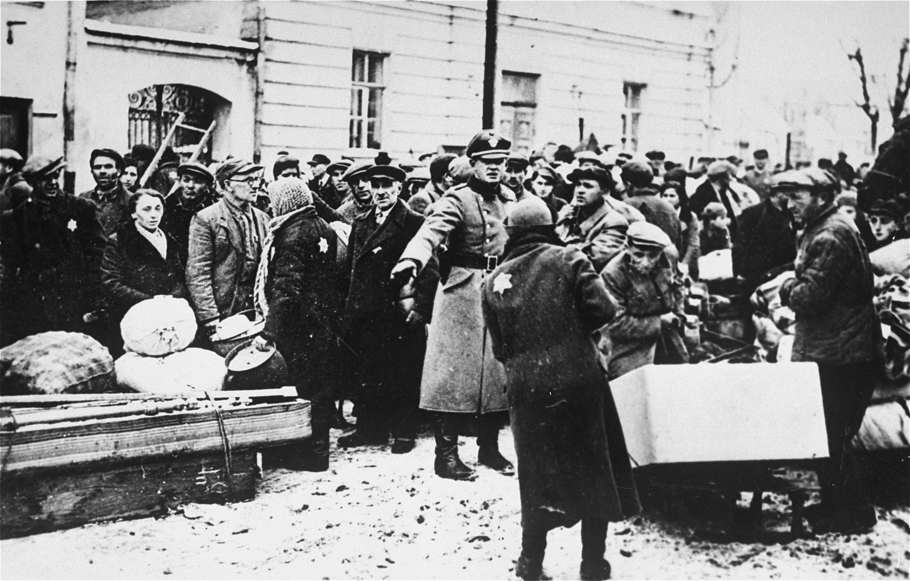

Jews move their belongings into the Grodno ghetto.
https://collections.ushmm.org/search/catalog/pa413
United States Holocaust Memorial Museum

Supporting Questions
- Describe an event from American history that you previously studied that could be categorized as a genocide?
- How did the Nazi government use the European Jewish population as a scapegoat for social, economic, and political problems in Germany?
- How did the location impact the experience of the Jews in Nazi-occupied Europe?
- What are 5 most critical dehumanizing events that led to economic obstructions in the lives of Jews and why?

Topic | Compelling question?
Virginia Social Studies Standards | USII.7: The student will apply social science skills to understand the major causes and effects of American involvement in World War II by  b) locating and describing the major events and turning points of the war in Europe and the Pacific;  JU.6-8.12: I can recognize and describe unfairness and injustice in many forms including attitudes, speech, behaviors, practices, and laws.
Staging the Compelling Question | Using 10 words or less, how would you define the Holocaust?

Supporting Question | Formative Performance Task | Featured Sources
1. Describe an event from American history that you previously studied that could be categorized as a genocide? | Construct a claim  Identifying a genocide from previously studied history. | Source A: What is genocide? USC Shoah Foundation video segment  Source B: 10 Stages of Genocide  Source C: Testimonies from the Trail of Tears and Wounded Knee
2. How did the Nazi government use the European Jewish population as a scapegoat for social, economic, and political problems in Germany? | Examine and annotate print propaganda in order to identify manifestations of the spread of antisemitism. | Source A: Source packet on print propaganda (5 parts).  Source B: Definition of Antisemitism.
3. How did the location impact the experience of the Jews in Nazi-occupied Europe? | Develop a chart comparing sources that illustrate the impact of geography on the experience of dehumanization during the Holocaust. | Source A: Map Set  Source B: Testimonies  Source C: Poetry paired reading.
4. What are 5 most critical dehumanizing events that led to economic obstructions in the lives of Jews and why? | Create an annotated timeline that sequences the economic events that led to destruction in the lives of Jews. | Source A: Curated Timeline of Events of the Holocaust

Topic | Summative Performance Task
ARGUMENT | Construct an argument (e.g., detailed outline, poster, essay) that supports the need to stand up against hate using specific claims and relevant evidence from sources while acknowledging competing views.
EXTENSION | Use information provided in this lesson and the information you learned when studying the American Indians and the Trail of Tears. Identify similarities and differences among and between the marginalized populations in both events.

Topic | Taking Informed Action
UNDERSTAND | Show your understanding that every person on the earth is valued as a unique part of a world civilization without regard for their race, gender, ability, age, income, or any other arbitrary classification.
ASSESS | Consider your community and look to identify groups of people who are limited or denied the respect and value that they are entitled to as a part of a world community.
ACT | Speak out for anyone who is not given the respect and inclusion they deserve.
*Featured sources are suggested and links are provided. It may be that these links are broken and we apologize in advance for the inconvenience. This inquiry was developed by

Staging the Compelling Question
In staging the compelling question, students will use 10 words of less to define the Holocaust?

The staging task is not designed to delve too far into the specific content of the compelling question. Instead, it’s intended to provide a frame of reference and context for the inquiry. Specifically, by determining students prior knowledge of the events of the holocaust.

This task may be completed in a brief period of time, depending on how much overall time is available for the inquiry. If following the guidelines described in the inquiry overview (three or five 50-minute class periods), then this staging task would likely only last 10-15 minutes.

Supporting Question 1
The first supporting question asks, "Describe an event from American history that you previously studied that could be categorized as a genocide?” The idea of genocide has been a part of the world since the early years of recorded history. As history has gone by, dominant cultures have at times decided that they were superior to another part of the population and felt that they were justified in eliminating their opponents. Unfortunately, the enlightenment of the modern era has not been civilized enough to put an end to genocide. The early history of the United States had several examples of genocide against the native people of North America and worldwide this unspeakable practice continues.
The featured sources include What is Genocide? USC Shoah Foundation video segment, 10 Stages of Genocide, and Trail of Tears victim testimonies.
The formative performance task is to “Construct a claim identifying a genocide from previously studied history”.
The following procedures may be used to support students as they complete this task.
- Provide a graphic organizer that supports student organization of main ideas.
- Provide sentence stems to help students clarify content understanding.
- Include digital links to prior curriculum learning sources.
Work on the formative performance task provides students an opportunity to gather information they will need in responding to the compelling question.
Featured Source | Information on Source
Source A: Genocide Video | This source is created by the USC-Shoah Foundation and is available through the link below. This video provides a definition and overview of what genocide is and how it has occurred throughout time.  Link to USC-Shoah Foundation Genocide Video
Source B: 10 Stages of Genocide | This source is a Google document that defines the 10 stages of Genocide and provides an area for students to state their understanding and is available online at:  10 Stages of Genocide
Source C: American Indian Genocide Testimony from the Trail of Tears and Wounded Knee | This source is historical witness testimony from the events known as the Trail of Tears, and is available online at:  Digital History  Sequoyah Research Center  This source is historical witness testimony and information from the event known as “Wounded Knee and is available online at:  PBS New Perspectives on the West  EyeWitness to History

Supporting Question 2
The second supporting question asks, "How did the Nazi government use the European Jewish population as a scapegoat for social, economic, and political problems in Germany?” From the selection of Adolph Hitler to the position of Chancellor of Germany in 1933 until his death at the end of the Second World War the control of information was very important to the Nazi Party. One of the most potent weapons in the German arsenal against the idea of truth was their use of propaganda. Propaganda is the use of information in a biased and misleading manner with the intent of influencing people's beliefs. The Nazis used words, music, books and art as part of their propaganda against the Jewish people and anyone else they considered undesirable. Propaganda posters were found all over Germany and their occupied lands giving everyone who saw them the same idea about the Jews; Jews were bad and could not be trusted. The German government under Hitler wanted all of the blame for their bad conditions to be on one group and they used propaganda to do this to great effect.
The featured sources include a Source packet on print propaganda (6 parts), and the Definition of Antisemitism.
The formative performance task is to examine and annotate print propaganda in order to identify manifestations of the spread of antisemitism.
The following procedure may be used to support students as they complete this task.
- Copies of Propaganda can be provided with audio descriptions to aid with visual interpretation.
- Digital copies of the propaganda posters can be provided for student annotation.
Work on the formative performance task provides students an opportunity to gather information they will need in responding to the compelling question.
Featured Source | Information on Source
Source A: Source packet on print propaganda (5 parts). | This source includes 5 examples of propaganda from Nazi Germany from the children’s books The Poisonous Mushroom and Never Trust a Fox on the Green Heath and Never Trust a Jew by His Oath, and is available online at:  Propaganda Sources
Source B: Definition of Antisemitism. | This handout briefly describes the history of antisemitism including the ways it has been manifested throughout time, and is available online at:  Definition of Antisemitism

Supporting Question 3
The third supporting question asks, "How did the location impact the experience of the Jews in Nazi-occupied Europe?” When the Nazi party first took control of Germany their first order of business was to set up the scapegoat for their poor conditions. As they started to oppress the Jews they also built their military might to a level that could compete with the other nations of Europe. At first Germany took over countries with threat and intimidation, but it was not long before the Germans used military force. As they took over European nations the German propaganda program quickly followed to spread their hate for the Jews. The experiences for Jews throughout Europe were different depending on where they lived. For some the mistreatment was a slow progression of increasing pressure, for others the time between blame and death was very short. Many victims of the Holocaust who were fortunate enough to survive the mistreatment were able to record their experiences through statements or art.
The featured sources include Map Set (Pre-War Jewish Life & Ghettos in Nazi-occupied Europe), Testimonies of Margaret Lambert & Itka Zygmuntowicz, and Poetry paired reading I Never Saw Another Butterfly Poem & Clipped Wings Poem.
The formative performance task is to develop a chart comparing sources that illustrate the impact of geography on the experience of dehumanization during the Holocaust
The following procedure may be used to support students as they complete this task.
- Printed copies of the testimony can be provided to allow students to take notes
- A graphic organizer (Venn diagram) can be provided for a compare and contrast.

Work on the formative performance task provides students an opportunity to gather information they will need in responding to the compelling question.

Featured Source | Information on Source
Source A: Map Pairing | This source includes a map of pre-1933 Jewish Life in Europe and a map of Ghettos in Nazi-occupied Europe. The map is available online at:  Map link
Source B: Testimony Pairing | This source includes a pairing of testimonies between a German-Jewish young woman, Margaret Lambert, and a Polish-Jewish young woman, Itka Zygmuntowicz.and is available online at:  Testimony
Source C: Poem Pairings | This source is I Never Saw Another Butterfly will be paired with Clipped Wings to illustrate the different experience between the camps and ghettos, and is available online at:  Poetry Pair

Supporting Question 4
The third supporting question asks, "What are 5 most critical dehumanizing events that led to economic obstructions in the lives of Jews and why?” The events of the Holocaust started out a gradual pressures that were easy for the German government to justify without a level of complaints from the German population. As time went on the level of discrimination increased and the areas there this discrimination was felt grew in size. German Jews in some cases did not recognize that a real problem was starting until it was too late to react. Many mainstream Germans were also unaware or unconcerned until the pressure spilled out into the streets. By the time the mistreatment of the Jews was obvious to all, it was too dangerous and too late to do anything about it.
The featured sources include a Curated Timeline of Events of the Holocaust
The formative performance task is to create an annotated timeline that sequences the economic events that led to destruction in the lives of Jews.
The following procedure may be used to support students as they complete this task.
- A graphic organizer with a column for priority (severity) can be provided to allow students to identify the most critical five.
- A visual timeline can be provided with locations for notes.
- Provide a copy of Reverend Niemoller's poem “First They Came”

Work on the formative performance task provides students an opportunity to gather information they will need in responding to the compelling question.
Featured Source | Information on Source
Source A: Timeline of the Holocaust | This source is a timeline of 13 events from which they would be asked to analyze and select 5 that they feel effected the economic livelihood of Jews in Nazi-occupied Europe, and is available online at:  Timeline

Summative Performance Task
At this point in the inquiry students have examined the effects of dehumanizing a segment of the population and the resulting attempted genocide of the Jewish population in Europe. Students should be able to demonstrate the breadth of their understanding and their ability to use evidence from multiple sources to support their claims. In this summative performance task, students are asked to construct an evidence-based argument responding to the compelling question “What conditions and ideas made the Holocaust Possible?” The students will construct an argument (e.g., detailed outline, poster, essay) that supports the need to stand up against hate using specific claims and relevant evidence from sources while acknowledging competing views.
It is important to note that students’ arguments could take a variety of forms, including a detailed outline, poster, or essay.
Students’ arguments likely will vary, but could include any of the following.
- Academic intervention that includes writing articles or speaking out publicly against genocide.
- Artistic intervention that includes art, music or poetry that speaks out against genocide
- Activist intervention that includes taking personal risks to stop injustice and protect a targeted part of the population.
- Passive intervention that includes not following anti-population persecution, but taking no risks.

To extend this inquiry, students will use information provided in this lesson and the information you learned when studying the American Indians and the Trail of Tears, identifying similarities and differences among and between the marginalized populations in both events.
To take informed action students complete the following steps.
- Students demonstrate that they understand that every person on the earth is valued as a unique part of a world civilization without regard for their race, gender, ability, age, income, or any other arbitrary classification.
- Students assess by identifying groups of people who are limited or denied the respect and value that they are entitled to as a part of a world community.
- Students act by speaking out for anyone who is not given the respect and inclusion they deserve.

SECTION III: Division-level Curriculum Map for Teaching the Holocaust in World History 1500 to Present
The Virginia Department of Education does not provide or prescribe content for this chart. The Division-level Curriculum Map should be aligned to the History and Social Science Standards of Learning and reflect the division pacing and needs of students and teachers.

Topic and/or Unit Title | Skills and Content Standard(s) | Pacing | Assessment Title and Type | Local Connections | Necessary Professional Development

Learning In Place

Instruction Type | Description
Schoolhouse Instruction | Traditional (Face-to-Face) teaching (also known as in-person, F2F) focuses on several elements, including lectures, capstones, team projects, labs, studios, and so forth. Teaching is conducted synchronously in a physical learning environment (utilizing appropriate safety measures), meaning that “traditionally,” the students are in the same place simultaneously. The traditional classroom has the significant advantage of face-to-face interaction between the student and educator and the students themselves. Students derive motivation from the teacher as well as from the other students.
Interdisciplinary Instruction | Interdisciplinary teaching is an approach that integrates different aspects of more than one academic discipline to examine a theme, issue, question, or topic.  Interdisciplinary learning empowers students to explore different perspectives and views.  And research shows that interdisciplinary approaches to teaching help students learn how to solve problems and answer questions by:  - Recognizing biases  - Thinking critically  - Embracing ambiguity  - Analyzing ethical concerns
Home-based Instruction | The asynchronous modality affords students time to work on their learning on their own schedule. The teacher has designed a sequence of activities for students to work independently, and therefore this work may not be completed in tandem with other students. Asynchronous learning is often completed outside of regular class time. Examples of asynchronous assignments might include reading, watching videos, taking assessments, completing projects, completing homework, or answering questions. Students may need extra support in how to structure their time to complete work within the parameters set by the teacher. Students may also be given options to make choices about how they prioritize their time, which can provide practice in time management. Considerations for instructors include the student’s age, maturity, and evidence of prior success in working on asynchronous assignments, as well as the types of support available at home.
Online Instruction | Virtual learning has become an integral part of our educational system. Virtual learning can aid in  - Increasing student engagement and choice,  - Supporting personalized learning experiences for students, and  - Increasing equity in access to high quality learning experiences.  Virtual learning programs offer flexibility to students while providing instruction aligned with the Standards of Learning. A number of Virginia school divisions provide opportunities for their students to take online courses as a part of their regular course offerings.

Organizing Topic

World History & Geography: 1500 to Present

Related Standard(s) of Learning
WHII.1 The student will demonstrate skills for historical thinking, geographical analysis, economic decision making, and responsible citizenship by
- analyzing and interpreting artifacts and primary and secondary sources to understand events in United States history;
b) analyzing and interpreting geographic information to determine patterns and trends in United States history;
c) interpreting charts, graphs, and pictures to determine characteristics of people, places, or events in United States history;
d) using evidence to draw conclusions and make generalizations;
e) comparing and contrasting historical, cultural, and political perspectives in United States history;
f) determining relationships with multiple causes or effects in United States history;
g) explaining connections across time and place;
h) using a decision-making model to identify the costs and benefits of a specific choice made;
i) identifying the rights and responsibilities of citizenship and the ethical use of material or intellectual property; and
j) investigating and researching to develop products orally and in writing.

WHII.10 The student will apply social science skills to understand World War I and its
worldwide impact by
a) explaining economic and political causes and identifying major leaders of the war,
with emphasis on Woodrow Wilson and Kaiser Wilhelm II;
b) describing the location of major battles and the role of new technologies;
c) analyzing and explaining the terms of the Treaty of Versailles and the actions of the
League of Nations, with emphasis on the mandate system;
d) citing causes and consequences of the Russian Revolution;
e) explaining the causes and assessing the impact of worldwide depression in the
1930s; and
f) examining the rise of totalitarianism.

WHII.11 The student will apply social science skills to understand World War II and its
worldwide impact by
a) explaining the major causes of the war;
b) describing the leaders of the war, with emphasis on Franklin D. Roosevelt, Harry
Truman, Dwight D. Eisenhower, Douglas MacArthur, George C. Marshall, Winston
Churchill, Joseph Stalin, Adolf Hitler, Hideki Tojo, and Hirohito;
c) describing the major events, including major battles and the role of new
technologies;
d) examining the Holocaust and other examples of genocide in the twentieth century;
and
e) examining the effects of the war, with emphasis on the terms of the peace, the war
crimes trials, the division of Europe, plans to rebuild Germany and Japan, and the
creation of international cooperative organizations and the Universal Declaration of
Human Rights (1948).

Essential Understandings
- The First World War transformed European and American life, wrecked the economies of Europe, and planted the seeds for a second world war.
- A period of uneven prosperity in the decade following World War I (the 1920s) was followed by worldwide depression in the 1930s that had an impact on many European societies.
- Depression weakened Western democracies, making it difficult for them to challenge the threat of totalitarianism.
- There had been a climate of hatred against Jews in Europe and Russia for centuries.
- Despite the lessons learned from the Holocaust, other instances of genocide have occurred in the second half of the twentieth century and into the twenty-first century.
- The outcomes of World War II included the war crimes trials, the division of Europe, plans to rebuild Germany and Japan, and the establishment of international cooperative organizations.
- The Universal Declaration of Human Rights was issued in 1948 to protect the “inherent dignity and…the equal and inalienable rights of all members of the human family….”

Sample Resources
Below is an annotated list of Internet resources for this organizing topic. Copyright restrictions may exist for the material on some Web sites. Please note and abide by any such restrictions.
“Holocaust Encyclopedia.” United States Holocaust Memorial Museum
“Echoes & Reflections” Echoes & Reflections. This site offers lesson plans and correlated primary and secondary sources to teach this topic to secondary students.
“Teach” United States Holocaust Memorial Museum. This site offers lesson plans to educators across a variety of interconnected topics.
“Facing History and Ourselves.” Facing History. This site offers lesson plans to educators across a variety of interconnected topics.
“IWitness.” USC Shoah Foundation. This site allows access to testimonies related to the Holocaust and other world genocides, as well as student activities to learn more deeply about these events and other themes.
“What We Carry” The Holocaust Commission of the United Jewish Federation of Tidewater. These developed lessons allow students to learn from a Virginia-affiliated witness to the Holocaust. Lessons are aligned to specific Virginia Social Studies Standards of Learning Outcomes and include ideas for differentiation. For World History II students, the story of Dame Mary Baracco may be of particular interest.
“Resources for Teachers” Virginia Holocaust Museum. This site contains a variety of resources to aid teachers in instructing about the Holocaust and other world genocides including connections to Virginia survivors of these atrocities.

Other collections, series and links in eMediaVASM that you might find helpful:

Holocaust:
- Echoes and Reflections (A Series of 22 assets)
- What We Carry Collection | The Holocaust Commission
- Primary Source Set: Elie Wiesel’s Night and the Holocaust
- You Have to Speak Up: Lessons from the Holocaust | PBS NewsHour

Cambodian Genocide:
- Cambodia Teaches New Generation about Khmer Rouge Atrocities
- Khmer Rouge Leaders Found Guilty | NPR (Article)

Rwanda:
- Clinton: Crises in Somalia and Rwanda

Learning Experience: The Seeds of the Second World War
The First World War transformed European and American life, wrecked the economies of Europe, and planted the seeds for a second world war. A period of uneven prosperity in the decade following World War I (the 1920s) was followed by worldwide depression in the 1930s that had an impact on many European societies. Depression weakened Western democracies, making it difficult for them to challenge the threat of totalitarianism. There had been a climate of hatred against Jews in Europe and Russia for centuries.

Materials
- Handout: The Weimar Republic and the Rise of the Nazi Party
- Handout: Graphic Organizer - The Weimar Republic and the Rise of the Nazi Party
- Timeline of the Holocaust (Note: Can be downloaded in non-illustrated PDF Form)
- Google Slides or Google Jamboard or Paper

Instructional Activities
- Ask students to define the term “Democracy.” When they think of our democracy, what comes to mind? What about democracies in other countries? Did students know that Germany was a democracy at the time that Adolf Hitler came to power? Next, ask students what types of things can make a democracy fragile? Let students know that while the Weimar Republic was a democracy, it was a new form of government in Germany at that time. It was also structured a bit differently than our democracy in the United States; however, all democracies can be susceptible to the things that led to its overthrow by Hitler and the Nazi Party.
- Distribute the handout, The Weimar Republic and the Rise of the Nazi Party, and the accompanying graphic organizer. Ask students to complete in small groups or individually, then share answers. The following questions can be used to help guide the discussion:
  - What political, economic, social, or cultural factors do you think were most pivotal in setting the stage for the rise of the Nazi Party?
  - What were the conditions under which the Weimar Republic was formed? How do you think ordinary German citizens felt about this government?
  - What principles in the platform do you think appealed to German people in the 1930s? Why did Nazi ideology engender support even though it went against democratic values?
- Set the stage for the next activity by explaining to students that they will be reviewing primary and secondary source materials via a pre-curated Timeline of the Holocaust. From there, they will be asked to select the 5 most critical events on the Timeline that illustrate the path of the Nazi rise to power. They should note the name and date of the event, write a brief description for each event in their own words and choose at least one primary source to accompany their brief description. This can be curated into an online resource such as Google Slides or Google Jamboard OR on paper.
Allow students to explore each other’s timelines. As students are exploring, they should jot down content they can use in their final task, creating an exit ticket that illustrates, in their opinion, to how Hitler and the Nazi party were able to seize power due to the fragility of Germany’s democracy in the 1920s and 1930s.

Learning Experience: Examining the Holocaust - Focus on Concentration Camps
The era of the Holocaust would fundamentally change how the world viewed human rights violations. Between 1933 and 1945, Adolf Hitler and the Nazi party chipped away at the rights of Jews and others they deemed undesirable to building a strong Aryan nation. One of the ways in which they revoked the rights of individuals was through internment in concentration camps that existed throughout Nazi-occupied Europe.

Materials
- Google Earth - Concentration Camps of Nazi Germany Shell (Link)
- Google Earth Tutorial: Intro to Creation Tools (Link)
- Flipgrid (Link)

Instructional Activities – Part I
- Provide students with Google Earth - Concentration Camps of Nazi Germany Shell (Attachment A):
  - Ask students to make their own copy of the shell
  - Direct students through how to use Google Earth or use the provided link for the playlist from Google Earth (Attachment B)
- Have students work individually or in pairs to complete the Google Earth presentation.
  - Determine which of the camps you would like for students to focus on prior to distributing the project. (More than what is on the SOLs has been provided.)
  - Students should be answering the following questions while completing their research and projects:
    - Who: What groups of people were sent to this camp? What was the estimated number of prisoners at the camp (if this can be provided)?
    - What: What type of camp was this?
    - When: When was this camp active? When was this camp liberated?
    - Where: Where was the camp located? (Image should be provided from students)
- Presentation of materials
  - This can be done either by the whole group or individual. You could also have students create their own Flipgrid (Attachment C) presentation on their project.
  - Have students reflect on their projects and answer the following questions:
    - What does the Holocaust teach us about the process of genocide?
    - How is the Holocaust is an example of prejudice, discrimination, and genocide taken to the extreme?

Checking for Understanding
- Monitor student responses during class work time.
- What are some of the lessons of that we have learned from the atrocities of the Holocaust? Would these same atrocities be seen in other parts of the world in the 20th century?
- What else?

Learning Experience: America & the Holocaust
The Holocaust not only had a profound effect on Europe but impacted other areas of the world as well, including America. This time period has created significant discussion of what Americans knew and how America as a nation reacted to these events. Newspapers have provided some of our most important knowledge on this topic.

Materials
- Teacher Lesson Plan (for additional support if required)
- Student Research Packet
- Handout: How Americans Got Their News
- History Unfolded Site
- Activity Rubric
- Access to a Newspaper Archive (1933-1946)

Instructional Activities
1. Ask students, what do you think Americans knew about the events of the Holocaust as they were happening? Why do you think this? Discuss these concepts with students then distribute the handout: How Americans Got Their News. Allow students to read and discuss as a large group.
2. Next, distribute the Student Research Packets. Have students establish roles, then ask students to visit the History Unfolded site and click on the event modules. They should select 3 events to learn more about and make predictions as to whether or not the newspaper they will be reviewing covered the event at the time of its occurrence.
3. Guide students in establishing a research path for their final chosen topic. Demonstrate how to access your archives of choice and then allow students time to research their chosen pieces.
4. When students are done, have them analyze their chosen pieces and enter the information into the History Unfolded Database. They should then perform their final analysis and share their findings with the class.

Note: This activity can be expanded to include newspapers from around the world if desired. The USHMM database only seeks American articles; however, the other pieces can be brought in for the class as a point of comparison.

Learning Experience: Examining Genocide: Genocide in the 20th Century
Genocide pre-dated the Holocaust and also continued afterwards. Each genocide was unique in its manifestation and impacted human beings, some who survived and far too many who did not. Understanding these incidents of genocide can help us work towards preventing their occurrence in the future.

Materials
● Google Earth - Genocides of the 20th Century Shell (Link)
● Google Earth Tutorial: Intro to Creation Tools (Link)
● USC Shoah Foundation - What is Genocide? (Link)
● USC Shoah Foundation - What is the Genocide against the Tutsi in Rwanda? (Link)
● Attachment A: USHMM Encyclopedia - The Armenian Genocide
● Attachment B: USHMM Encyclopedia - The Rwanda Genocide
● USHMM - Cambodia (Link)
● USHMM - Bosnia (Link)
● Attachment C: Handout on the Genocide in Ukraine
● Attachment D: USHMM Encyclopedia - Darfur
● Flipgrid (Link)

Instructional Activities – Part I
- Review with students the definition of genocide. ‘What is Genocide?’ (Attachment C) can also be shown as a supplement to spark discussion.
- Provide students with Google Earth - Genocides of the 20th Century Shell (Attachment A):
- Ask students to make their own copy of the shell
- Direct students through how to use Google Earth or use the provided link for the playlist from Google Earth (Attachment B)
- Have students work individually or in pairs to complete the Google Earth presentation.
- Students should work from the locations that have been provided: Armenia (Attachment E), Cambodia (Attachment G), Rwanda (Attachment D and F), Bosnia (Attachment H), Ukraine (Attachment I), and Darfur (Attachment J)
- Students should be answering the following questions while completing their research and
projects:
- Who: Who were the people(s) involved in the conflict? Who were the leaders? How many people(s) have been impacted by this event(s)?
- What: What is the background information about this genocide? What has become a result of this genocide?
- When: When was this event(s)?
- Where: Where was the genocide located? (In many cases students can identify specific cities that were involved, not just the countries)
- Presentation of materials: This can be done either by the whole group or individual. You could also have students create their own Flipgrid (Attachment K) presentation on their project.
- Have students reflect on their projects and answer the following question: What have we learned about the risk factors and warning signs of genocide?

Note: To further extend student learning related to these genocides, please check out the Virginia Holocaust Museum’s oral histories at this link.

Checking for Understanding
- Monitor student responses during class work time.
- What are some of the lessons that we have learned from the atrocities of the genocides of the 20th century? Did we, as a global society, react to “newer” genocides faster after the delayed response to the Holocaust?
- What else?

Attachment A: USHMM Holocaust Encyclopedia Article on the Armenian Genocide
Sometimes called the first genocide of the twentieth century, the Armenian genocide refers to the physical annihilation of Armenian Christian people living in the Ottoman Empire from spring 1915 through autumn 1916. There were approximately 1.5 million Armenians living in the multiethnic Ottoman Empire in 1915. At least 664,000 and possibly as many as 1.2 million died during the genocide, either in massacres and individual killings, or from systematic ill treatment, exposure, and starvation.

The origin of the term genocide and its codification in international law have their roots in the mass murder of Armenians in 1915–16. Lawyer Raphael Lemkin, the coiner of the word and later its champion at the United Nations, repeatedly stated that early exposure to newspaper stories about Ottoman crimes against Armenians was key to his beliefs about the need for legal protection of groups (a core element in the UN Genocide Convention of 1948).

Ottoman authorities, supported by auxiliary troops and at times by civilians, perpetrated most of the persecution and mass killing. The Ottoman government, controlled by the Committee of Union and Progress (CUP; also called the Young Turks), aimed to solidify Muslim Turkish dominance in the regions of central and eastern Anatolia by eliminating the sizeable Armenian presence there.

Mass atrocities and genocide are often perpetrated within the context of war. The destruction of the Armenians was closely linked to the events of World War I. Fearing that invading enemy troops would induce Armenians to join them, in spring 1915 the Ottoman government began the deportation of the Armenian population from its northeastern border regions. In the months that followed, the Ottomans expanded deportations from almost all provinces regardless of distance from combat zones.

The victims of the Armenian genocide include people killed in local massacres that began in spring 1915; others who died during deportations, under conditions of starvation, dehydration, exposure, and disease; and Armenians who died in or en route to the desert regions of the southern Empire [today: northern and eastern Syria, northern Saudi Arabia, and Iraq]. In addition, tens of thousands of Armenian children were forcibly removed from their families and converted to Islam.

US Ambassador to Constantinople Henry Morgenthau Sr. was deeply troubled by the atrocities committed against the Armenians and was among those who sought to rouse the world's conscience in response. The plight of the Armenians triggered an unprecedented public philanthropic response in the United States, involving President Woodrow Wilson, Hollywood celebrities, and many thousands of Americans at the grassroots level who volunteered both domestically and abroad and raised over $110 million (over $1 billion adjusted for inflation) to assist Armenian refugees and orphans.

The Armenian genocide cast a long shadow into the Holocaust era. Ambassador Morgenthau's son, Henry Morgenthau Jr., was secretary of the treasury in the administration of Franklin D. Roosevelt. In part due to his memories of the Armenian genocide, Morgenthau Jr. was a key advocate for the establishment of the War Refugee Board which rescued as many as 200,000 Jews from Nazi Europe. Perhaps most hauntingly, a novel about Armenian self-defense (Franz Werfel's The Forty Days of Musa Dagh) was secretly passed from hand-to-hand among Jews imprisoned in ghettos during the Holocaust, who saw in it an inspirational analogy to their plight and a call to resistance.

Attachment B: USHMM Holocaust Encyclopedia Article on the Rwandan Genocide
Genocides have continued to happen since the Holocaust, for example in Rwanda in 1994. In 100 days, from April to July 1994, as many as one million people, mostly Tutsis, were massacred when a Hutu extremist-led government launched a plan to wipe out the country’s entire Tutsi minority and any others who opposed its policies.
-----------------------------------------------------------------------------------------------------------------------------------------
On the evening of April 6, 1994, a surface-to-air missile shot down the plane carrying Rwanda’s president, Juvenal Habyarimana, a Hutu, as it was landing in Kigali, the Rwandan capital. It is still not known who fired the missile, but the assassination was taken by extremist leaders of Rwanda’s Hutu majority as the signal to launch a carefully planned campaign to wipe out the country’s Tutsi minority, as well as moderate Hutu leaders who might oppose this program of genocide. Political and other high profile leaders who might have been able to take charge of the situation were killed immediately.
Under the cover of war, Hutu extremists launched their plans to destroy the entire Tutsi civilian population. Violence spread through the capital and into the rest of the country, and continued for roughly three months. As many as one million people, mostly Tutsis, were slaughtered in 100 days. Hutu militias, backed, trained and equipped by Rwandan government forces, were responsible for the majority of the killing.

As the level of violence became clear, groups of Tutsi—and Hutu who feared they might be targeted—fled to places that in previous times of turmoil had provided safety: churches, schools, and government buildings. Many of these refuges became the sites of major massacres. In addition to mass killings, thousands and thousands of Tutsis and people suspected of being Tutsis were killed in their homes and in the street, especially at roadblocks set up across the country by militias to prevent them from escaping. Entire families were killed at a time. Women were systematically and brutally raped. Sometimes, Tutsis were murdered or attacked by their neighbors.

The genocide ended when the Tutsi-dominated rebel movement, the Rwandan Patriotic Front (RPF), captured Kigali, overthrowing the Hutu government and seizing power.

Attachment C: Handout on the Genocide in the Ukraine

Holodomor

The Ukrainian Genocide
"In the case of the Holodomor, this was the first genocide that was methodically planned out and perpetrated by depriving the very people who were producers of food of their nourishment (for survival). What is especially horrific is that the withholding of food was used as a weapon of genocide and that it was done in a region of the world known as the ‘breadbasket of Europe’.” – Prof. Andrea Graziosi, University of Naples.

An Introduction
In 1932 and 1933, millions of Ukrainians were killed in the Holodomor, a man-made famine engineered by the Soviet government of Joseph Stalin. The primary victims of the Holodomor (literally "death inflicted by starvation") were rural farmers and villagers, who made up roughly 80 percent of Ukraine's population in the 1930s. While it is impossible to determine the precise number of victims of the Ukrainian genocide, most estimates by scholars range from roughly 3.5 million to 7 million (with some estimates going higher). The most detailed demographic studies estimate the death toll at 3.9 million. Historians agree that, as with other genocides, the precise number will never be known.
Through a study of the Holodomor (which has been referred to as the Great Famine), students can come to understand that the Holodomor is an example of how prejudice and a desire to dominate and control a particular ethnic group can lead to the misuse of power, mass oppression, and genocide.

Ukraine Before the Holodomor
Beginning in the 18th century, Ukrainian territories were divided between the Austrian and Russian Empires. In the aftermath of World War I and the overthrow of the Russian monarchy in February 1917, Ukraine set up a provisional government, declaring itself the independent Ukrainian People's Republic in January 1918. The Ukrainian People's Republic fought the Bolshevik Red Army for three years (1918-1921) but lost its fight for independence.
The bulk of Ukrainian territory was forcibly incorporated into the Soviet Union, or USSR (Union of Soviet Socialist Republics), and by 1922 Ukraine became the Ukrainian Soviet Socialist Republic (UkrSSR). Then the USSR sanctioned the requisition of all surplus agricultural products from the rural population, resulting in economic collapse.
Discontent among the farmers forced Lenin to halt the requisitions and bring in the New Economic Policy (NEP) in March of 1921. The NEP was intended to provide greater economic freedom and permit private enterprise, mainly for independent farms and small businesses. Beginning in 1923, the Soviet authorities also pursued a policy of indigenization, which in the Ukrainian SSR took the form of Ukrainization, a policy of national and cultural liberalization that promoted Ukrainian language use in education, mass media, and government. The goal for the introduction of both NEP and Ukrainization was to increase support for the Soviet regime in Ukraine. Video: Timothy Snyder: Ukrainian History as World History: 1917-2017
By the end of the 1920s, Soviet leader Joseph Stalin consolidated his control over the Communist Party of the Soviet Union. Feeling threatened by Ukraine's strengthening cultural autonomy, Stalin took measures to destroy the Ukrainian peasantry and the Ukrainian intellectual and cultural elites to prevent them from seeking independence for Ukraine.
To prevent "Ukrainian national counterrevolution," Stalin initiated mass-scale political repressions through widespread intimidation, arrests, and imprisonment. Thousands of Ukrainian intellectuals, church leaders, and Ukrainian Communist Party functionaries who had supported pro-Ukrainian policies were executed by the Soviet regime.
At the same time, Stalin decreed the First Five Year Plan, which included the collectivization of agriculture, effectively ending the NEP. Collectivization gave the Soviet state direct control over Ukraine's rich agricultural resources and allowed the state to control the supply of grain for export. Grain exports would be used to fund the USSR's transformation into an industrial power.
The majority of rural Ukrainians, who were independent small-scale or subsistence farmers, resisted collectivization. They were forced to surrender their land, livestock and farming tools, and work on government collective farms (kolhosps) as laborers. Historians have recorded about 4,000 local rebellions against collectivization, taxation, terror, and violence by Soviet authorities in the early 1930s. The Soviet secret police (GPU) and the Red Army ruthlessly suppressed these protests. Tens of thousands of farmers were arrested for participating in anti-Soviet activities, shot, or deported to labor camps.
The wealthy and successful farmers who opposed collectivization were labeled "kulaks" by Soviet propaganda ("kulak" literally means "a fist"). They were declared enemies of the state, to be eliminated as a class. The elimination of the so-called "kulaks" was an integral part of collectivization. It served three purposes: as a warning to those who opposed collectivization, as a means to transfer confiscated land to the collective farms, and as a means to eliminate village leadership. Thus, the secret police and the militia brutally stripped "kulaks" not only of their lands but also their homes and personal belongings, systematically deporting them to the far regions of the USSR or executing them.
These mass repressions, along with manipulation of state-controlled grain purchases and collectivization through the destruction of Ukrainian rural community life, set the stage for the total terror – a terror by hunger, the Holodomor.

The Holodomor
Ukraine, with its history of resistance to the Soviet rule, was a threat to the Soviet regime. Fearing that opposition to his policies in Ukraine could intensify and possibly lead to Ukraine's secession from the Soviet Union, Stalin set unrealistically high grain procurement quotas. Those quotas were accompanied by other Draconian measures intended to wipe out a significant part of the Ukrainian nation.
In August of 1932, the decree of "Five Stalks of Grain," stated that anyone, even a child, caught taking any produce from a collective field, could be shot or imprisoned for stealing "socialist property." At the beginning of 1933, about 54,645 people were tried and sentenced; of those, 2,000 were executed.
As famine escalated, growing numbers of farmers left their villages in search of food outside of Ukraine. Directives sent by Stalin and Molotov (Stalin's closest collaborator) in January of 1933 prevented them from leaving, effectively sealing the borders of Ukraine.
To further ensure that Ukrainian farmers did not leave their villages to seek food in the cities, the Soviet government started a system of internal passports, which were denied to farmers so they could not travel or obtain a train ticket without official permission. These same restrictions applied to the Kuban region of Russia, which borders Ukraine, and in which Ukrainians made up the largest portion of the Kuban population - 67 percent.
At the time of the Holodomor, over one-third of the villages in Ukraine were put on "blacklists" for failing to meet grain quotas. Blacklisted villages were encircled by troops and residents were blockaded from leaving or receiving any supplies; it was essentially a collective death sentence.
To ensure these new laws were strictly enforced, groups of "activists" organized by the Communist Party were dispatched to the countryside. As described by historian Clarence Manning:
"The work of these special 'commissions' and 'brigades' was marked by the utmost severity. They entered the villages and made the most thorough searches of the houses and barns of every peasant. They dug up the earth and broke into the walls of buildings and stoves in which the peasants tried to hide their last handfuls of food."
To escape death by starvation, people in the villages ate anything that was edible: grass, acorns, even cats and dogs. Contemporary Soviet police archives contain descriptions of the immense suffering and despair of Ukrainian farmers, including instances of lawlessness, theft, lynching, and even cannibalism.
This Famine, the Holodomor, resulted in widespread deaths and mass graves dug across the countryside. The official registers did not give a full accounting of what was happening across Ukraine - deaths often remained unregistered, cause of death was missing - to conceal the true situation.
At the height of the Holodomor in June of 1933, Ukrainians were dying at a rate of 28,000 people per day. Around 3.9 million Ukrainians died during the Holodomor of 1932-33 (as established in a 2015 study by a team of demographers from the Ukrainian Institute of Demographic and Social Studies, and the University of North Carolina-Chapel Hill).
While Ukrainians were dying, the Soviet state extracted 4.27 million tons of grain from Ukraine in 1932, enough to feed at least 12 million people for an entire year. Soviet records show that in January of 1933, there were enough grain reserves in the USSR to feed well over 10 million people. The government could have organized famine relief and could have accepted help from outside of the USSR. Moscow rejected foreign aid and denounced those who offered it, instead exporting Ukraine's grain and other foodstuffs abroad for cash.
Most historians, who have studied this period in Ukrainian history, have concluded that the Famine was deliberate and linked to a broader Soviet policy to subjugate the Ukrainian people. With the fall of the Soviet Union and the opening of Soviet government archives (including archives of the security services), researchers have been able to demonstrate that Soviet authorities undertook measures specifically in Ukraine with the knowledge that the result would be the deaths of millions of Ukrainians by starvation.
"The Terror-Famine of 1932-33 was a dual-purpose by-product of collectivization, designed to suppress Ukrainian nationalism and the most important concentration of prosperous peasants at one throw." –Norman Davies, Europe, A History.

The Holodomor as Genocide
Raphael Lemkin (1900-1959), an expert in international criminal law (with a particular interest in the prevention of mass human extermination), who coined and promoted the term "genocide," identified the Holodomor as "the classic example of Soviet genocide."
Lemkin's ideas on genocide served as the basis of the United Nations Convention on the Prevention and Punishment of Genocide in 1948. The Convention defines genocide as acts "having intent to destroy, in whole or in part, a national, ethnic, racial or religious group, as such."
In a speech given in 1953, as well as in articles written in the 1950s, Lemkin applied the term genocide to the Holodomor and the attempt to destroy the Ukrainian nation.
Lemkin identified four integral components in the genocidal process in Ukraine:
- The decimation of the Ukrainian national elites (political and cultural leaders),
- The destruction of the Ukrainian Autocephalous (independent) Orthodox Church (its clergy and hierarchy),
- The starvation of the Ukrainian farming population (the Holodomor), and
- Its replacement with non-Ukrainians from the RSFSR and elsewhere.
Leading historians and other scholars, such as James Mace, Robert Conquest, Timothy Snyder, Norman Naimark, Anne Applebaum, who have devoted significant time to studying the Holodomor and have published extensively on the subject have all concluded that it was genocide.
"Is the Ukrainian Holodomor genocide? Yes, in my view, it is. It meets the criteria of the law of genocide of 1948, the Convention – it meets the ideas that Raphael Lemkin laid down." –Timothy Snyder (Richard C. Levin Professor of History at Yale University and a Permanent Fellow at the Institute for Human Sciences in Vienna), 15th Annual Arsham and Charlotte Ohanessian Lecture and Center for Holocaust and Genocide Studies Symposium.

Holodomor Denial
At the time of the Holodomor, the Soviet government and the Communist Party denied that a famine was taking place and refused any outside relief efforts. A succession of Soviet governments maintained formal denial that the Holodomor had occurred. In Ukraine, it was impossible to speak publicly, discuss openly, or teach about the Holodomor until the late 1980s. Information about the Famine was only available in the West, mostly from eyewitness testimonies of refugees who had survived the event and escaped from the Soviet Union after World War II.
Even today, authorities of the Russian Federation admit that there were famines in the 1930s in the USSR, but refuse to acknowledge the deliberate nature of the Famine in 1932–1933 in Ukraine.
In addition to Soviet denial at the time of the Holodomor, foreign journalists stationed in the USSR largely ignored it, while most governments, whose countries were going through the Great Depression, knew about it but did nothing. Journalist Walter Duranty of The New York Times, who was awarded a Pulitzer Prize for his articles about the USSR, wrote: "There is no actual starvation or deaths from starvation, but there is widespread mortality from disease due to malnutrition… conditions are bad. But there is no famine." Recently, Duranty was discredited for his cover-up of the Famine in Ukraine.
There were a few journalists who wrote about starvation in Ukraine, such as Gareth Jones, who wrote for the New York American and Los Angeles Examiner, and Malcolm Muggeridge, a British foreign correspondent. More on Holodomor Denial.

Legacy and Aftermath
The Holodomor ended in 1933. Collectivization was complete with all farmland becoming a socialist property and all farmers working for the state. According to recent demographic studies, 13.3 percent of Ukraine's population died at the time of the Holodomor. In some regions of Ukraine, the percentage of deaths due to the Famine were higher; for example, the rate was 19 percent in Kyiv and 29 percent in Kharkiv oblasts. The Holodomor wiped out millions of Ukrainians. Promotion of a 'new Soviet identity' and official pressure on Ukrainians to use the Russian language intensified. Even when the Holodomor ended, Ukrainians didn't really stop suffering. The families of Holodomor victims feared hunger and further repressions for the rest of their lives, and this fear was passed onto future generations. They were soon to experience new traumas: Stalin's purges of 1937-38, World War II, Nazi occupation and the Holocaust, and the 1946-47 famine.
Another consequence of the Holodomor in Ukraine was a loss of collective memory. In Soviet Ukraine, the Holodomor was kept out of official public discourse until shortly before Ukraine won its independence in 1991. We now know that explicit instructions were issued throughout the Soviet Union banning the use of the word famine, not only in party and military documents but also in medical records and statistical accounts. Irena Chalupa, the director of RFE/RL's Ukrainian Service, stated:
"The creative engine of a people was destroyed, slowing down and distorting nation-building for decades. The Soviet regime prevented families and individuals from processing both personal and national grief. For more than 50 years, Ukraine could not address this trauma openly."
In the 1980s, with the publication of the report of the US Commission on the Ukraine Famine and the findings of the International Commission of Inquiry into the 1932–33 Famine in Ukraine, as well as the release of an eye-opening documentary "Harvest of Despair," greater world attention finally came to bear on the Holodomor.
On November 28, 2006, the Verkhovna Rada (Parliament of Ukraine) passed a decree defining the Holodomor as a deliberate act of genocide. The Holodomor has been recognized as genocide by 16 nations and 22 US states, including Minnesota.

Attachment D: USHMM Encyclopedia Entry on Darfur

Introduction
Darfur is a region in northwest Sudan, covering an area approximately the size of Spain. It is a multi-ethnic country with a dictatorial government dominated by an Arab and Islamist elite who are based in Khartoum, the country's capital. Since early 2003, Sudanese government soldiers and their proxy militia, known as Janjaweed, have fought rebel groups in Darfur.

Between 2003 and 2005, an estimated 200,000 civilians died from violence, disease, and starvation as a result of the conflict, and 2 million were displaced from their homes. The violence has continued, claiming over 100,000 additional lives.

In 2004, the US Secretary of State termed the Sudanese government's campaign of violence in Darfur a genocide.

Violence
From 2003 to 2005, Sudanese forces, in cooperation with the Janjaweed, engaged in a scorched earth campaign characterized by the intentional burning of homes, villages, and crops and the systematic destruction of food stores. Government and Janjaweed forces systematically depopulated land inhabited by Fur, Masalit, and Zaghawa communities through forced displacement and violent attacks on civilians amounting to ethnic cleansing and genocide. Additionally, refugee and displaced persons settlements have long been targets of further violence by government and Janjaweed forces, including looting relief supplies, killing, and widespread rape. Between 2003 and 2005, these measures resulted in the deaths of 200,000 and forced displacement of two million people.

In the course of Khartoum’s genocidal campaign in Darfur, a pattern of government-sponsored actions included:
- Backing Janjaweed militias in systematic attacks against civilians from the same ethnic groups as rebel forces, primarily the Fur, Zaghawa, and Masalit;
- Bombing civilians from aircrafts; committing massive human rights abuses including murder, rape, and persecution based on race, ethnicity, and religion;
- Impeding international humanitarian access, resulting in deadly conditions of life for displaced people; and harassing internally displaced persons;
- The use of rape as a tool of social control and a weapon of war.

Although large-scale government attacks against civilians have declined since 2005, millions remain at risk as the fighting continues. Most of those displaced have not returned home for fear that their villages will be attacked again.

International Intervention
The violence in Darfur received enormous public and international attention. Partially in response to pressure from human rights advocates, members of the United States government were some of the first international figures to label the violence in Darfur a genocide. In 2004 and 2005, respectively, Secretary of State Colin Powell and President George W. Bush issued statements condemning the ongoing genocide for which the Janjaweed and Sudanese government were considered responsible. While the UN, the African Union (AU), and the European Union disagreed that genocide had occurred, they all accused the Sudanese government and its allied militias of committing crimes against humanity.
In 2004, the African Union Mission in Darfur (AMIS) was established to monitor the Humanitarian Ceasefire Agreement signed earlier that year. African Union and UN efforts to negotiate a permanent settlement expanded in the years following the initial AMIS deployment, resulting in the short-lived Darfur Peace Agreement (DPA) in 2006. In 2007, the United Nations Security Council authorized a hybrid United Nations-African Union peacekeeping force to oversee the implementation of the DPA. Since its inception, the force has been underfunded, understaffed, and vulnerable to attacks from Sudanese government forces and rebel groups alike.
While UNAMID was the largest peacekeeping force in the world from 2007 to 2014, with roughly 27,000 military and police personnel, its force has since been decreased to just over 17,000 personnel in 2016.

In March 2005, the UN Security Council referred the case of Sudan to the International Criminal Court (ICC) for investigation of war crimes, crimes against humanity, and genocide. In July 2008, ICC prosecutor Luis Moreno-Ocampo requested the court issue an arrest warrant for Sudanese President Omar Hassan al-Bashir, charging him with crimes against humanity and war crimes for the government's role in orchestrating violence in Darfur. In 2010, three counts of genocide were added to the list of charges. However, in 2014, ICC prosecutor Fatou Bensouda announced that the case against Bashir would be suspended because of lack of enforcement by international actors, which was then demonstrated in 2015, when the government of South Africa failed to arrest President Bashir when he visited for an African Union conference.

An Inquiry Approach: Performance Tasks, Assessment and Taking Action
(Blueprint adapted from C3 Teachers) (Inquiry developed by 10 Grade North Carolina Hub/Stephanie Boyne and Vandna Gill)

Inquiry Description
The purpose of this inquiry is to draw connections in the hopes of discovering possible factors, not proven causes, for genocide. This inquiry focuses on five different instances of genocide as well as more generally with concepts of genocide and war crimes, war and ethnic conflict, demographics, GDP, political centralization, and changes of power.
Introduce the idea of genocide and its history. Give a brief overview of the Armenian genocide, the Holocaust, the Cambodian genocide, the Rwandan genocide, and the Bosnian genocide. Explain that, while each of these genocides is different and has its own unique causes, there are some similarities among the circumstances surrounding the genocides. While many countries have groups of people who are prejudiced against other groups, this prejudice only culminates in genocide in a few extreme cases. Then, tell them they are going to look at the populations, economics, and politics of five countries before the genocides to see if they can find any patterns that might help explain why genocide occurred. These five countries include: Ottoman Empire (present-day Turkey), Germany, Cambodia, Rwanda, and Yugoslavia (present-day Bosnia and Herzegovina). Introduce or review necessary vocabulary, such as terms like demographics, majority, minority, simple majority, absolute majority, GDP, and centralization.

Structure of the Inquiry
The formative tasks in this inquiry deal with the demographic, economic, and political contexts of genocide. In the first formative task, students will be presented with the concept of demographics and the nature of demographic minorities. They will explore whether the size of minority populations correlates with the persecution of those minorities. The second formative task will ask students to examine more advanced economic data and look at the concept of economic instability. The data will require students to draw on economic concepts like GDP to evaluate the economic stability of the five countries. They will evaluate the potential of economic instability to influence ethnic tensions. Finally, in the third formative task, students will evaluate the political stability of the five countries. After completing the formative tasks, students will have a body of evidence and some initial analysis to prepare them to do the summative work of building that evidence into an argument about common factors of genocide.

Are there common circumstances underlying genocides?
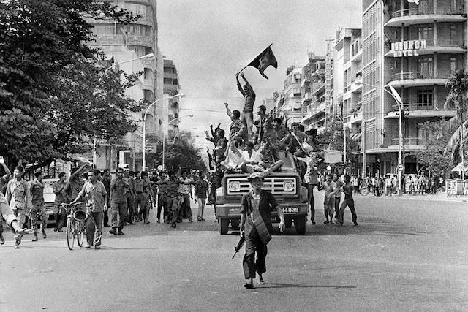

https://www.flickr.com/photos/13476480@N07/1610550..

Supporting Questions

- Who were the groups targeted in five major genocides in the 20th century, and what were the relative sizes of those groups within their country?
- What were the economic conditions in each of the five countries where genocide occurred in the 20th century?
- What were the political contexts in each of the five countries leading up to the genocides?

Inquiry Standard
WH2.11d: The student will apply social science skills to understand World War II and its worldwide impact by examining the Holocaust and other examples of genocide in the twentieth century.

Staging the Compelling Question
Brainstorm different times when large groups of people have been prejudiced against others.

Supporting Question | Formative Performance Task | Featured Source
1. Who were the groups targeted in five major genocides in the 20th century, and what were the relative sizes of those groups within their country? | List the groups targeted in the five major genocides in the 20th century, the perpetrating groups, and the sizes of those groups. | - Source A: Past Genocides and Mass Atrocities  - Source B: Late Ottoman Population and its Ethnic Distribution  - Source C: Jewish Population of Europe in 1933  - Source D: Ethnic Groups of Cambodia (1967)  - Source E: Genocide in Rwanda  - Source F: Ethnic Groups in Yugoslavia (1991)
2. What were the economic conditions in each of the five countries where genocide occurred in the 20th century? | Create a chart comparing and rating the economic stability of the five countries. Discuss your ratings with the class | - Source A: GDP Graphs of the Five Countries Where Genocide Occurred in the 20th Century
3. What were the political contexts in each of the five countries leading up to the genocides? | Create a timeline for each country that includes 3-5 political events or changes. | - Source A: Political context in the Ottoman Empire preceding the Armenian genocide  - Source B: Political context in Germany preceding the Holocaust  - Source C: Political context in Cambodia preceding genocide  - Source D: Political context in Yugoslavia preceding the Bosnian genocide  - Source E: Political context in Rwanda preceding genocide

Topic | Summative Performance
ARGUMENT | Construct an argument in the form of an essay that addresses the compelling question Are there common circumstances underlying genocides? Using specific claims and relevant evidence from the featured sources while acknowledging competing views.
EXTENSION | Create a visual representation of the contexts of genocide using evidence from the formative tasks.

Topic | Taking Informed Action
UNDERSTAND | Research a country currently experiencing ethnic conflict.
ASSESS | Compare the demographic, economic, and political status of that country to those of the countries featured in this inquiry, and determine whether there are common circumstances.
ACTION | Write a letter to the U.S. State Department about the country you researched, advising whether you think the ethnic conflict is likely to escalate based on the country's demographic, economic, and political context.

Staging the Compelling Question

Compelling Question
Are there common circumstances underlying genocides?

Staging the Compelling Question
Students will brainstorm instances of large-scale (sometimes even government-sanctioned) prejudice and discrimination, which may also lead into discussion of mass violence, ethnic cleansing, and genocide. The purpose of this staging task is to initiate discussion among students in a manner that is accessible and relevant, while also getting a sense of what they already know or do not know about genocides throughout history.

Supporting Question 1

Overview

Supporting Question
Who were the groups targeted in five major genocides in the 20th century, and what were the relative sizes of those groups within their country?

Formative Performance Task
List the groups targeted in the five major genocides in the 20th century, the perpetrating groups, and the sizes of those groups.

Featured Sources
- Source A: Past Genocides and Mass Atrocities
- Source B: Late Ottoman Population and its Ethnic Distribution
- Source C: Jewish Population of Europe in 1933
- Source D: Ethnic Groups of Cambodia (1967)
- Source E: Genocide in Rwanda
- Source F: Ethnic Groups in Yugoslavia (1991)

Supporting Question 1
This supporting question discusses the topic of demographics, emphasizing the concepts of majorities and minorities. Students will analyze population data for the five different countries of interest. This will give students the opportunity to learn more about these countries and demographics in general, while also allowing them to develop and practice the skills of data and demographic analysis.

Formative Performance Task
In this formative task, students will analyze demographic data for all five countries as presented in sources B- F and list the groups targeted, the perpetrating group, and the sizes of those groups. They may also work collaboratively to generate graphs/maps representing the populations, or they may create a chart/table either individually, in small groups, or as a class. The first source presents background information on the five countries being investigated, and it may be helpful for students who need an introduction to the groups involved in these genocides.

Featured Sources

Featured Source A: Past Genocides and Mass Atrocities

Excerpt
This website provides an overview of genocides in Armenia, Germany, Cambodia, Rwanda, and Bosnia: http://endgenocide.org/learn/past-genocides/

Source:
United to End Genocide - http://endgenocide.org/

Featured Source B: Late Ottoman Population and its Ethnic Distribution

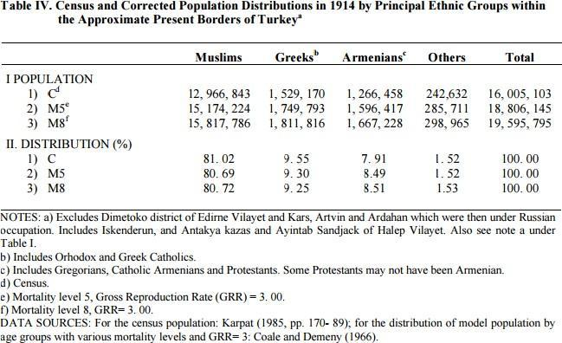

Source: Servet Mutlu, Turkish Journal of Population Studies -http://www.hips.hacettepe.edu.tr/nbd_cilt25/mutlu.pdf

Featured Source C: Jewish Population of Europe in 1933

Excerpt
"In 1933, approximately 9.5 million Jews lived in Europe, comprising 1.7% of the total European population. This number represented more than 60 percent of the world's Jewish population at that time, estimated at 15.3 million...In prewar central Europe, the largest Jewish community was in Germany, with about 525,000 members (0.75% of the total German population). This was followed by Hungary with 445,000 (5.1%), Czechoslovakia with 357,000 (2.4%), and Austria with 191,000, most of whom resided in the capital city of Vienna (2.8%)."

Source:
United States Holocaust Memorial Museum - https://www.ushmm.org/wlc/en/article.php?ModuleId=..

Featured Source D: Ethnic Groups of Cambodia (1967)

Table 25: Classification of Ethnic Groups by Kunstadter (1967)

No. | Name | Alternative Name(s) | Population
1 | Khmer | Cambodian, Kampuchean | 3,500,000
2 | Chinese | Han, Sino-Kampuchean | 435,000
3 | Vietnamese | Annamite, Annamese, Yuch, Kinh | 400,000
4 | Stieng | Xtieng, Sa Tieng, Ta Mun, Steang | 30,000
5 | French |  | 6,000
6 | Brao | Brau, Brou, Proue, Love, Lave, Laveh | 3,000
7 | Saoch | Sa’och, Sauch, Saotch | 172
8 | Cham | Tjam, Chiem, Cam, Khmer Islnm | na
9 | Chong | Chawng, Shong, Xong, Jan, Chhung | na
10 | Jarai | Jorai, Gia Rai, Gio Rai, Zrai, Cho Rai | na
11 | Kui | Kuy, Kuoy, Suai, Suoi, Soai, Souei, Suei | na
12 | Pear | Babr, Pohr, Porr, Por, Puar, Pushr | na
13 | Rhade | Ede, Edeh, Radeh, Rade, Anak | na
14 | Thai | Central Thai, Siamese, Thai Noi | na

Joachim Schliesinger - Ethnic Groups of Cambodia Vol 1: Introduction and Overview

Featured Source E: Genocide in Rwanda

Excerpt
"In 1994, Rwanda’s population of seven million was composed of three ethnic groups: Hutu (approximately 85%), Tutsi (14%) and Twa (1%). In the early 1990s, Hutu extremists within Rwanda’s political elite blamed the entire Tutsi minority population for the country’s increasing social, economic, and political pressures. Tutsi civilians were also accused of supporting a Tutsi-dominated rebel group, the Rwandan Patriotic Front (RPF). Through the use of propaganda and constant political maneuvering, Habyarimana, who was the president at the time, and his group increased divisions between Hutu and Tutsi by the end of 1992. The Hutu remembered past years of oppressive Tutsi rule, and many of them not only resented but also feared the minority."
Source:
United Human Rights Council - http://www.unitedhumanrights.org/genocide/genocide..

Featured Source F: Ethnic Groups in Yugoslavia (1991)

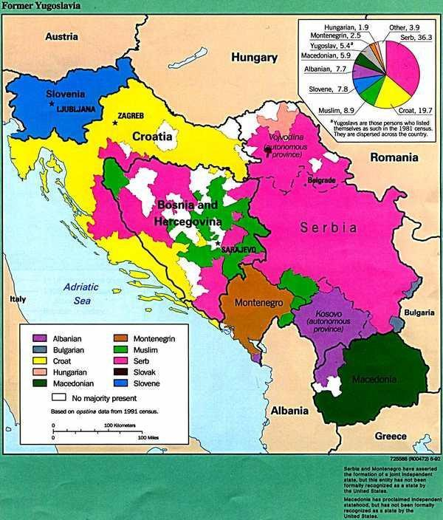
This map shows ethnic groups in the former Yugoslavia based on data from the 1991 census. Focus on the central province of Bosnia and the pie chart in analyzing demographic data for the formative task.
Central Intelligence Agency, "Ethnic Groups in Yugoslavia," Making the History of 1989, Item #170, https://chnm.gmu.edu/1989/items/show/170 (accessed December 12 2016, 4:39 pm)

Supporting Question 2

Overview
This supporting question introduces the topic of economic instability by presenting the economic conditions in the five countries before the genocides. Students will develop their understanding of GDP and practice analyzing it as a marker of economic stability or instability. The question also introduces possible motives that can lead groups of people to become perpetrators of genocide.

Supporting Question
What were the economic conditions in each of the five countries where genocide occurred in the 20th century?

Formative Performance Task
Create a chart comparing and rating the economic stability of the five countries. Discuss your ratings with the class.

Featured Sources
Source A: GDP Graphs of the Five Countries Where Genocide Occurred in the 20th Century

Formative Performance Task
In this formative task, students will analyze the economic data of the five countries being investigated (using the GDP graphs in the featured source). They will create a chart that includes the name of the country, the date(s) of genocide, as well as the Gross Domestic Product (GDP) of the countries before, during, and after the genocide. Lastly, the chart should also include student ratings of the economic stability of the countries on a scale of 1-5 with 1 being the least stable. Students will share their ratings with the class.

Featured Sources

Featured Source A: GDP Graphs of the Five Countries Where Genocide Occurred in the 20th Century

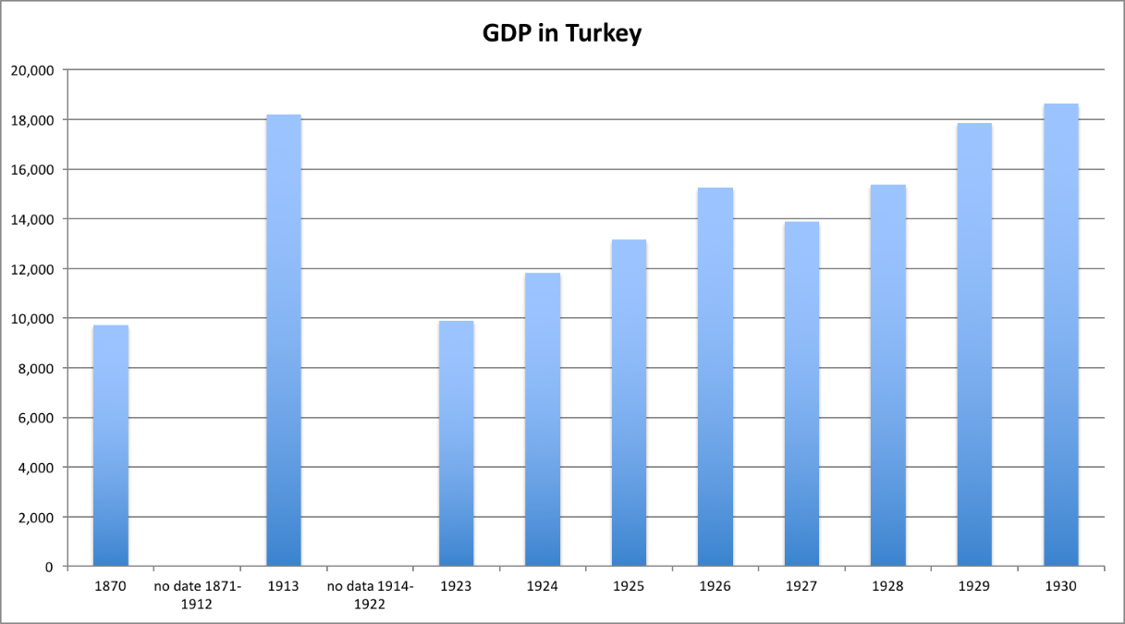

This graph depicts the GDP of Turkey before and after the Armenian genocide. Note that there is no GDP data available for 1871-1912 as well as 1914-1922 (during the genocide). The x-axis displays the year and the y-axis displays the number of 1990 International Geary-Khamis dollars in millions. The Geary-Khamis dollar (international dollar) is "a hypothetical unit of currency that has the same purchasing power parity that the U.S. dollar had in the United States at a given point in time. It is widely used in economics" (Wikipedia entry on Geary- Khamis dollar).

The full data set is available at this website: http://www.worldeconomics.com/Data/MadisonHistoric

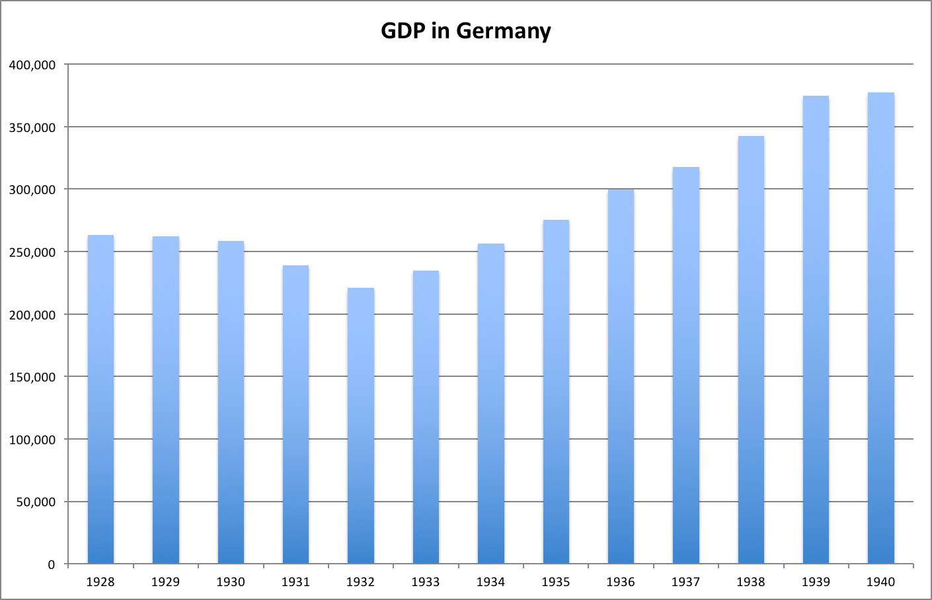

This graph depicts the GDP of Germany before, during, and after the Holocaust.
The x-axis displays the year and the y-axis displays the number of 1990 International Geary-Khamis dollars in millions.

The Geary-Khamis dollar (international dollar) is "a hypothetical unit of currency that has the same purchasing power parity that the U.S. dollar had in the United States at a given point in time. It is widely used in economics" (Wikipedia entry on Geary- Khamis dollar).

The full data set is available at this website: http://www.worldeconomics.com/Data/MadisonHistoric

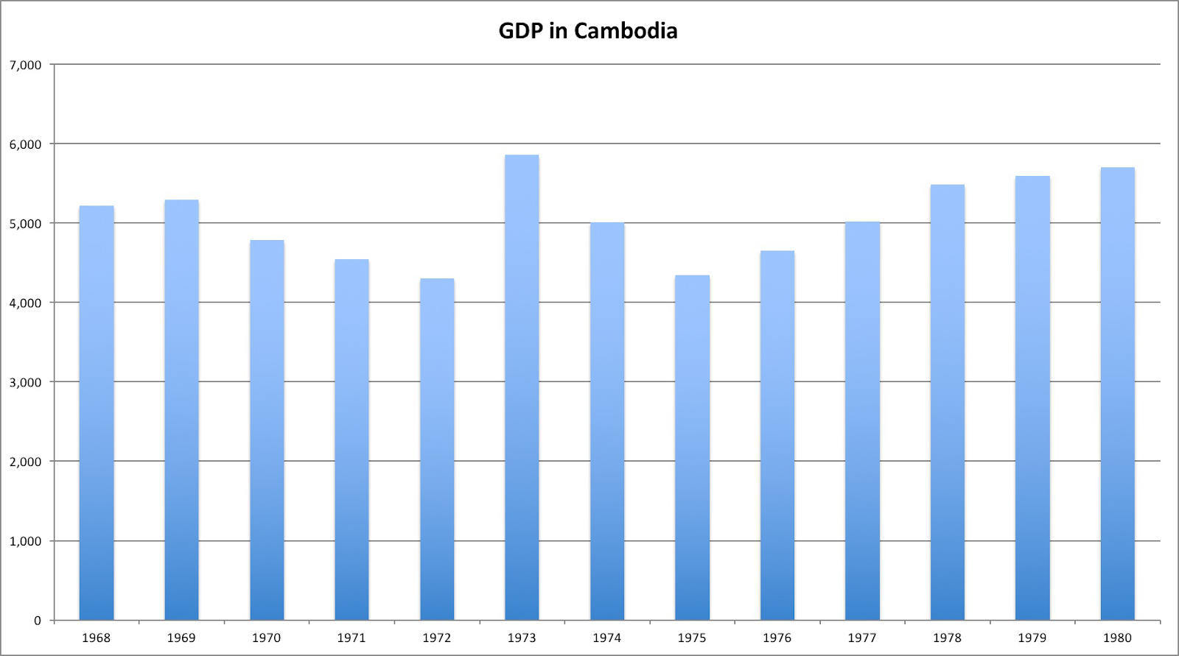

This graph depicts the GDP of Cambodia before, during, and after the genocide.
The x-axis displays the year and the y-axis displays the number of 1990 International Geary-Khamis dollars in millions.
The Geary-Khamis dollar (international dollar) is "a hypothetical unit of currency that has the same purchasing power parity that the U.S. dollar had in the United States at a given point in time. It is widely used in economics" (Wikipedia entry on Geary- Khamis dollar).

The full data set is available at this website: http://www.worldeconomics.com/Data/Madison=Historic
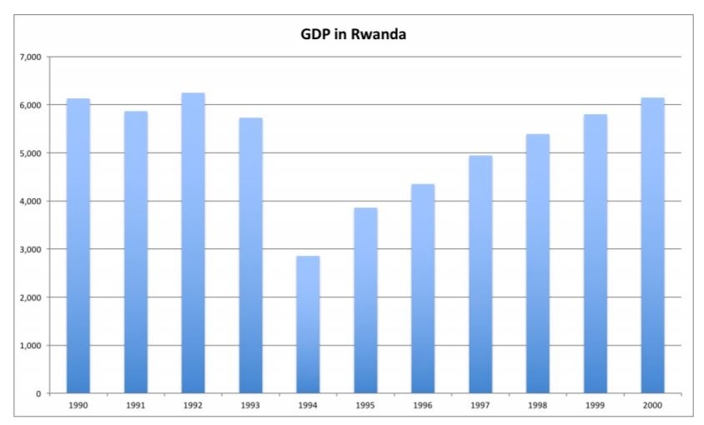

This graph depicts the GDP of Rwanda before, during, and after the genocide.
The x-axis displays the year and the y-axis displays the number of 1990 International Geary-Khamis dollars in millions. The Geary-Khamis dollar (international dollar) is "a hypothetical unit of currency that has the same purchasing power parity that the U.S. dollar had in the United States at a given point in time. It is widely used in economics" (Wikipedia entry on Geary- Khamis dollar).

The full data set is available at this website: http://www.worldeconomics.com/Data/MadisonHistoric

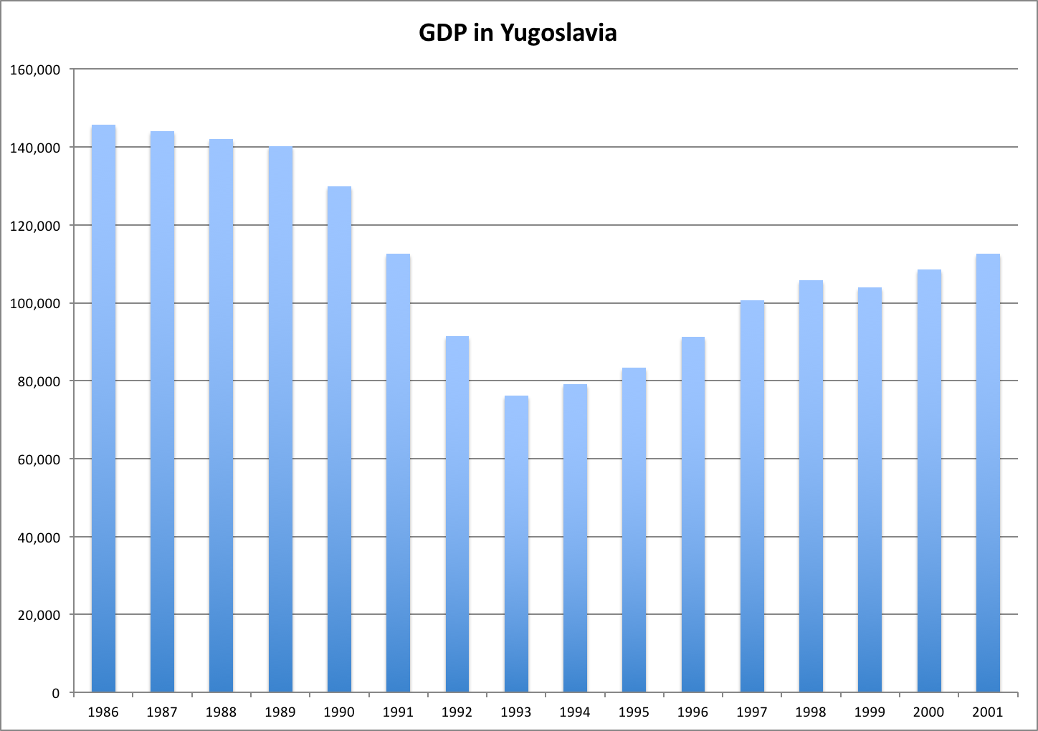

This graph depicts the GDP of Yugoslavia before, during, and after the genocide in Bosnia. The data included after 1991 likely represents the combined GDP of the former Yugoslavian provinces (after they became independent countries).
The x-axis displays the year and the y-axis displays the number of 1990 International Geary-Khamis dollars in millions.

The Geary-Khamis dollar (international dollar) is "a hypothetical unit of currency that has the same purchasing power parity that the U.S. dollar had in the United States at a given point in time. It is widely used in economics" (Wikipedia entry on Geary- Khamis dollar).

The full data set is available at this website: http://www.worldeconomics.com/Data/MadisonHistoric

Supporting Question 3

Overview

This supporting question explores the concept of political instability as it applies to the five countries in this inquiry. Students will read about the political situation of each of the five countries leading up to the genocides, and they will become familiar with the concepts of political centralization and changes of power

Supporting Question
What were the political contexts in each of the five countries leading up to the genocides?

Formative Performance Task

Create a timeline for each country that includes 3-5 political events or changes.

Featured Sources
Source A: Political context in the Ottoman Empire preceding the Armenian genocide
Source B: Political context in Germany preceding the Holocaust
Source C: Political context in Cambodia preceding genocide
Source D: Political context in Yugoslavia preceding the Bosnian genocide
Source E: Political context in Rwanda preceding genocide

Formative Performance Task
In this formative task, students will create timelines of 3-5 political events in each of the five countries. To support students in creating the timelines, they should read the information presented in the sources discussing the political situation of the five countries before the genocides. In small groups or as a whole class, students may then explain why each of the five countries was politically stable or unstable before the genocide.

Featured Source A
Political context in the Ottoman Empire preceding the Armenian genocide

Excerpt
This website gives a brief overview of the fall of the Ottoman Empire and the political context surrounding the Armenian genocide:
http://worldwithoutgenocide.org/genocides-and-conf..

Source:
World Without Genocide - http://worldwithoutgenocide.org/

Featured Source B
Political context in Germany preceding the Holocaust

Excerpt
This website gives a brief overview of the political context in Germany in the years leading up to the Holocaust:
http://www.history.co.uk/study-topics/history-of-w..

Source:
The History Channel (UK) - http://www.history.co.uk/

Featured Source C
Political context in Cambodia preceding genocide

Excerpt
This website provides a brief overview of the political situation in Cambodia in the years leading up to the genocide:
http://worldwithoutgenocide.org/genocides-and-conf..

Source:
World Without Genocide - http://worldwithoutgenocide.org/

Featured Source D
Political context in Yugoslavia preceding the Bosnian genocide

Excerpt
This website provides a brief overview of the political context of Bosnia (in former Yugoslavia) in the years leading up to the genocide:
http://worldwithoutgenocide.org/genocides-and-conf..

Source:
World Without Genocide - http://worldwithoutgenocide.org/

Featured Source E
Political context in Rwanda preceding genocide

Excerpt
This website provides a brief overview of the political context in Rwanda in the years leading up to the genocide:
http://worldwithoutgenocide.org/genocides-and-conf..

Source:
World Without Genocide - http://worldwithoutgenocide.org/

Summative Performance Task

Overview

Compelling Question
Are there common circumstances underlying genocides?

Argument
Construct an argument in the form of an essay that addresses the compelling question Are there common circumstances underlying genocides? Using specific claims and relevant evidence from the featured sources while acknowledging competing views.

Extension
Create a visual representation of the contexts of genocide using evidence from the formative tasks.

Argument
Students will write an argumentative essay about possible common factors for genocide. They will argue whether or not there are common demographic, economic, and political contexts among the genocides presented in this inquiry. Students will use their work from the three formative tasks as evidence. The essay should conclude with an explanation of whether or not these contexts contribute to the escalation of prejudice into genocide. For demographic contexts, students may argue that target populations are usually the same size because most of the genocides discussed targeted small minorities. Other students may argue that population size does not affect whether a group becomes a target because in some cases the target population was not a minority or was not always a small minority. For economic contexts, students may argue that economic instability is a common link because of declining GDP in most of the countries. Others may argue that economic instability is not necessarily a precursor to genocide since not all the countries suffered dramatic losses in GDP. For political contexts, students may argue that political instability is a common precursor to genocide. Other students may argue that political instability is not a common factor because the political situation in each of the countries was so different. Students may have a number of other arguments and may use any combination of the above arguments to make their larger argument about possible common circumstances underlying genocide. In terms of evaluation, any number of interpretations can earn a perfect score as long as the interpretation is supported with evidence from the formative tasks. If students are trained in proper citation, this should be included in scoring. For students less experienced with citations, they should be guided in this process and citation should play a smaller part in grading if it factors in at all. The bulk of scoring should center on constructing an argument, supporting it with evidence, and organizing it clearly.
Extension
Students will create a visual representation of the contexts of genocide, which should have three sections, including one for the demographic contexts, one for the economic contexts, and one for the political contexts. They may include maps, charts, and/or pictures with evidence from the three formative tasks.

Taking Informed Action

Overview
The purpose of this taking informed action task is to connect the study of genocides throughout history to instances of modern-day ethnic conflict and genocide. This helps students understand the purpose and usefulness of the inquiry as a whole as they come to recognize the issues presented in the inquiry are enduring. Since the inquiry already spans about 80 years of history, it is a logical conclusion to extend the study to the modern day. Additionally, analyzing a modern-day conflict for potential risk factors will help students to see possible applications for what they learned in the inquiry.

Understand
Research a country currently experiencing ethnic conflict.

Assess
Compare the demographic, economic, and political status of that country to those of the countries featured in this inquiry, and determine whether there are common circumstances.

Action
Write a letter to the U.S. State Department about the country you researched, advising whether you think the ethnic conflict is likely to escalate based on the country's demographic, economic, and political context.

SECTION IV: Division-level Curriculum Map for Teaching the Holocaust in Virginia & United States History
The Virginia Department of Education does not provide or prescribe content for this chart. The Division-level Curriculum Map should be aligned to the History and Social Science Standards of Learning and reflect the division pacing and needs of students and teachers.

Topic and/or Unit Title | Skills and Content Standard(s) | Pacing | Assessment Title and Type | Local Connections | Necessary Professional Development

Learning In Place

Instruction Type | Description
Schoolhouse Instruction | Traditional (Face-to-Face) teaching (also known as in-person, F2F) focuses on several elements, including lectures, capstones, team projects, labs, studios, and so forth. Teaching is conducted synchronously in a physical learning environment (utilizing appropriate safety measures), meaning that “traditionally,” the students are in the same place simultaneously. The traditional classroom has the significant advantage of face-to-face interaction between the student and educator and the students themselves. Students derive motivation from the teacher as well as from the other students.
Interdisciplinary Instruction | Interdisciplinary teaching is an approach that integrates different aspects of more than one academic discipline to examine a theme, issue, question, or topic.  Interdisciplinary learning empowers students to explore different perspectives and views.  And research shows that interdisciplinary approaches to teaching help students learn how to solve problems and answer questions by:  - Recognizing biases  - Thinking critically  - Embracing ambiguity  - Analyzing ethical concerns
Home-based Instruction | The asynchronous modality affords students time to work on their learning on their own schedule. The teacher has designed a sequence of activities for students to work independently, and therefore this work may not be completed in tandem with other students. Asynchronous learning is often completed outside of regular class time. Examples of asynchronous assignments might include reading, watching videos, taking assessments, completing projects, completing homework, or answering questions. Students may need extra support in how to structure their time to complete work within the parameters set by the teacher. Students may also be given options to make choices about how they prioritize their time, which can provide practice in time management. Considerations for instructors include the student’s age, maturity, and evidence of prior success in working on asynchronous assignments, as well as the types of support available at home.
Online Instruction | Virtual learning has become an integral part of our educational system. Virtual learning can aid in  - Increasing student engagement and choice,  - Supporting personalized learning experiences for students, and  - Increasing equity in access to high quality learning experiences.  Virtual learning programs offer flexibility to students while providing instruction aligned with the Standards of Learning. A number of Virginia school divisions provide opportunities for their students to take online courses as a part of their regular course offerings.

Organizing Topic

Virginia and United States History

Related Standard(s) of Learning
VUS.1 The student will demonstrate skills for historical thinking, geographical analysis, economic decision making, and responsible citizenship by
- analyzing and interpreting artifacts and primary and secondary sources to understand events in United States history;
b) analyzing and interpreting geographic information to determine patterns and trends in United States history;
c) interpreting charts, graphs, and pictures to determine characteristics of people, places, or events in United States history;
d) using evidence to draw conclusions and make generalizations;
e) comparing and contrasting historical, cultural, and political perspectives in United States history;
f) determining relationships with multiple causes or effects in United States history;
g) explaining connections across time and place;
h) using a decision-making model to identify the costs and benefits of a specific choice made;
i) identifying the rights and responsibilities of citizenship and the ethical use of material or intellectual property; and
j) investigating and researching to develop products orally and in writing.

VUS.11 The student will apply social science skills to understand World War II by
a) analyzing the causes and events that led to American involvement in the war, including the
Japanese attack on Pearl Harbor and the American response;
b) describing and locating the major battles and key leaders of the European theater;
d) evaluating and explaining how the United States mobilized its economic and military
resources, including the role of all-minority military units (the Tuskegee Airmen and Nisei
regiments) and the contributions of media, minorities, and women to the war effort;
e) analyzing the Holocaust (Hitler’s “final solution”), its impact on Jews and other groups, and the
postwar trials of war criminals; and
f) evaluating and explaining the treatment of prisoners of war and civilians by the Allied and Axis
powers.

Essential Understandings
- The United States policy of neutrality in World War II was no longer a viable option following the events of Pearl Harbor.
- Military miscalculations by the leadership of the Axis powers led to a strategic Allied victory in World War II.
- World War II was a total war in which all of America’s economic and human resources had to be mobilized to their greatest capacity.
- The Nazis targeted specific groups for genocide to create a “master race.”
- The savagery of war and indecencies against humanity were prevalent during World War II.

Sample Resources
Below is an annotated list of Internet resources for this organizing topic. Copyright restrictions may exist for the material on some Web sites. Please note and abide by any such restrictions.
“Holocaust Encyclopedia.” United States Holocaust Memorial Museum
“Echoes & Reflections” Echoes & Reflections. This site offers lesson plans and correlated primary and secondary sources to teach this topic to secondary students.
“Teach” United States Holocaust Memorial Museum. This site offers lesson plans to educators across a variety of interconnected topics.
“Facing History and Ourselves.” Facing History. This site offers lesson plans to educators across a variety of interconnected topics.
“IWitness.” USC Shoah Foundation. This site allows access to testimonies related to the Holocaust and other world genocides, as well as student activities to learn more deeply about these events and other themes.
“What We Carry” The Holocaust Commission of the United Jewish Federation of Tidewater. These developed lessons allow students to learn from a Virginia-affiliated witness to the Holocaust. Lessons are aligned to specific Virginia Social Studies Standards of Learning Outcomes and include ideas for differentiation.
“Resources for Teachers” Virginia Holocaust Museum. This site contains a variety of resources to aid teach instructing about the Holocaust and other world genocides including connections to Virginia survivors of these atrocities.

Other collections, series and links in eMediaVASM that you might find helpful:

Holocaust:
- Echoes and Reflections (A Series of 22 assets)
- What We Carry Collection | The Holocaust Commission
- Primary Source Set: Elie Wiesel’s Night and the Holocaust
- You Have to Speak Up: Lessons from the Holocaust | PBS NewsHour

Cambodian Genocide:
- Cambodia Teaches New Generation about Khmer Rouge Atrocities
- Khmer Rouge Leaders Found Guilty | NPR (Article)

Rwanda:
- Clinton: Crises in Somalia and Rwanda

Session 1: Establishing a Context for the Holocaust

Materials
- Attachment A: Starburst Identity Worksheet
- The Bear Who Wasn’t
- Google Slides: The Rise of the Nazi Party
- The Path to Nazi Genocide
- Attachment B: Considering the Path to Nazi Genocide

Instructional Activities Part I
- Introduce the lesson by telling students that the essential question will be, ““What is the effect of believing that you are more important than your neighbor?”
- Have students fill out the Starburst Identity Worksheet. For the arrows that are pointing ‘outward’, these are the qualifiers that they feel make up their identity, how they see themselves. For the arrows that are pointing ‘inward,’ these will represent how they perceive society’s view of them.
- Students will be asked to view the animated video, “The Bear Who Wasn’t a Bear.” The students will be asked how does identity impact how people see themselves. How does society’s view of identity impact how they see themselves?
- Next, have students create a K-W-L chart, working in pairs to focus on the K & L sections - consider 3-5 things they already know about the Holocaust and then 1-3 things that they want to know about the Holocaust.
- Next, the students will use their existing knowledge to address two essential questions to create a working definition of the Holocaust.
a) What was the Holocaust?
b) How and why did the Holocaust happen?
- Provide the following USHMM definition of the Holocaust to provide context and to see if the student's definition matches with the USHMM’s. “The Holocaust was the systematic, state-sponsored persecution and murder of approximately six million European Jews by the Nazi regime and its collaborators in years leading up to and during World War Two. During the era of the Holocaust - (1933-1945), German authorities also targeted other groups because of their perceived “racial inferiority”: Roma (Gypsies), disabled persons, and some of the Slavic Peoples (Poles, Russians, and others). Other groups were persecuted on political, ideological, and behavioral grounds, among them Communists, Socialists, Jehovah’s Witnesses, and homosexuals.”

Instructional Activities Part II
- Share notes/concepts with students on the Rise of the Nazi Party using this Google Slides presentation.
- Then, ask students to view The Path to Nazi Genocide - completing the questions on Attachment C: Considering the Nazi Path to Genocide.
- Ask students to discuss/debrief their answers to these questions in Pair-Share format.

Attachment A: Starburst Identity Worksheet

Directions: Write your name (or the name of a person or character) in the circle. At the ends of the arrows pointing outward, write words or phrases that describe what you consider to be key aspects of your identity. At the ends of the arrows pointing inward, write labels others might use to describe you. Add more arrows as needed.

Attachment B: Considering the Path to Nazi Genocide

The Path to Nazi Genocide
Student Name: ________________________________________________________

Chapter 1: Prologue
What is it about the prologue that will help you better understand how and why the Holocaust happened?

Chapter 2: Aftermath of WWI and the Rise of Nazism
What details in this section of the film helps you understand in more depth how and why the Holocaust happened?

How did the Treaty of Versailles set up an environment where the German people would be drawn to nationalism?

What are the competing forces that tried to solve the problems of German society?

What personal motivation did German citizens have to overlook the Nazis’ policies of persecution?

Building a National Community
During this time period, how did the Nazis build a national community?

What was the significance of the loyalty oath?

What personal motivation did German citizens have to overlook the Nazis’ policies of persecution?

From Citizens to Outcasts
What are the factors pushing Jews under the Third Reich to emigrate?

WWII and the Holocaust
What examples from 1939-1945 show that the Holocaust was systematic?

How does World War II contribute to the acceleration of the Holocaust?

How did people react to the evidence of the atrocities of the Holocaust?

Session 2: The Rise of the Nazi Party

Materials
- Handout: What Rights Are Most Important to Me?”
- Handout: Examples of Anti-Jewish Policy in Nazi Germany, 1933-1938
- United States Holocaust Memorial Museum Individual Profile Cards

Instructional Activities - Part I
- Introduce the lesson by telling students that the essential question will be, “What factors lead to the erosion of rights in a democracy?”
- Distribute the handout, “Attachment A: What Rights Are Most Important to Me?” Ask students to review and rank their choices in order of importance from 1(important) to 11(least important).
- In groups, ask students to discuss their choices. Then, within their groups, have students create a T-Chart with the left column labeled, “How Rights in a Democracy Are Protected?” and the right column labeled, “Factors That Can Lead to the Loss of Rights.” Students should discuss and consider the following questions:
a. What systems or mechanisms exist in democracies to protect people’s rights?
b. How easy or hard is it to lose rights in a democracy? What are some ways this might occur?
c. What might allow an extreme party or group to undermine rights in a democracy and even take over?
d. Can you think of any examples of rights being taken from a group of peoples in a democracy?
Personally?

Instructional Activities - Part II

Note: The following components could be done as stations or in sequential order.
- Share the handout, “Attachment B: Examples of Anti-Jewish Policy in Nazi Germany, 1933-1938.” Ask them to discuss and examine this handout in groups and create a visual display of how these events affected one of the individuals from the United States Holocaust Memorial Museum’s Individual Profile Cards. (Note: USHMM has a larger timeline activity available for incorporation at this link)
- Ask students to review one or multiple opportunities from Google Arts & Culture and select an image or images to analyze using the aligned handouts:
a. “State of Deception: The Power of Nazi Propaganda” Picture Analysis Worksheet, Written Document Analysis Worksheet - National Archives |
b. “Der Ewige Jude-‘The Eternal Jew’: Images of Persecution” Photo Analysis Worksheet - National Archives |, Picture Analysis Worksheet
c. “Stories of hope and survival against all odds.” Written Document Analysis Worksheet - National Archives |, Text-to-Text, Text-to-Self, Text-to-World Handout - Facing History ...
- Have students complete the (L)earned column of the K-W-L sheet and then ask students to consider, “Over the course of the past several days, you have learned about the Holocaust. How has these activities deepened your understanding of the actions that the Nazis and their collaborators took to initiate persecution of the Jews of Europe?” Students can share their answers out loud or via a technology such as Flipgrid.

Session 3: The Final Solution to the Jewish Question

Materials
- Attachment A: K-W-L Chart
- Handout: How Should We Study the Final Solution
- Handout: The Final Solution
- What We Carry: Bill Jucksch

Instructional Activities
1. Ask students to complete the K(now) & (W)ant to Know Columns of the K-W-L chart regarding the topic of the Final Solution. Allow students to share their answers in a class discussion.
2. Distribute the How Should We Study the Final Solution handout. Allow students time to analyze and reflect, then lead a class discussion related to student perspectives on these approaches.
3. Next, distribute The Final Solution handout. Allow students time to read or read aloud - then ask students what approach this handout takes. Is it a primary or secondary source? Does it focus on broad history or the story of an individual? What facts did they learn in this handout that might be important to consider when studying an individual account?
4. Lastly, guide students through the EMediaVA Activity - What We Carry - The Story of Bill Jucksch.

Attachment A: K-W-L Chart

K-W-L Chart

Assess what you know about a particular topic before and after you have engaged with it. Fill in the columns below with what you Know about the topic, what you Want to know, and what you have Learned.

What do you Know about the topic? | What do you Want to know? | What did you Learn?

Session 4: America & the Holocaust

Materials
- Teacher Lesson Plan (for additional support if required)
- Student Research Packet
- Handout: How Americans Got Their News
- History Unfolded Site
- Activity Rubric
- Access to a Newspaper Archive (1933-1946)

Instructional Activities
1. Ask students, what do you think Americans knew about the events of the Holocaust as they were happening? Why do you think this? Discuss these concepts with students then distribute the handout: How Americans Got Their News. Allow students to read and discuss as a large group.
2. Next, distribute the Student Research Packets. Have students establish roles, then ask students to visit the History Unfolded site and click on the event modules. They should select 3 events to learn more about and make predictions as to whether or not the newspaper they will be reviewing covered the event at the time of its occurrence.
3. Guide students in establishing a research path for their final chosen topic. Demonstrate how to access your archives of choice and then allow students time to research their chosen pieces.
4. When students are done, have them analyze their chosen pieces and enter the information into the History Unfolded Database. They should then perform their final analysis and share their findings with the class.

An Inquiry Approach: Performance Tasks, Assessment and Taking Action
(Blueprint adapted from C3 Teachers)(Inquiry developed by the Holocaust Memorial Center - Zekelman Family Campus)

Inquiry Description
Georgetown University law professor Gary D. Solis writes,
“I was only following orders!” This phrase has been used so often, in so many circumstances, that today it is its own parody. The legal, moral, and personal implications of those words are rooted in man’s wartime conduct, as well as being his appeal for understanding and absolution. It is a plea mouthed by both the relatively innocent junior soldier and the duplicitous battlefield murderer. Does the phrase merit serious legal consideration? Is it a legitimate defense to war crimes today? Was it ever a legitimate defense to war crimes?
This inquiry asks students to explore issues of individual responsibility and moral choice by investigating the compelling question, “I was only following orders! Is this an acceptable defense?” Students will consider Dr. Solis’s questions and more as they study the history of the “superior orders” defense from its first known use in 1474, through the Nuremberg trials following World War II, to its appearance in our own times. The final summative assignment then asks students to make an argument answering the Compelling Question and support it with evidence from their inquiry.
An extension activity asks students to take informed action by writing an editorial response to an article describing a recent use of the superior orders defense.
NOTE: This inquiry is expected to take four to six 60-minute class periods.
The inquiry time frame could expand if teachers think their students need additional instructional experiences (i.e., supporting questions, formative performance tasks, and featured sources). Teachers are encouraged to adapt the inquiry​ in order to meet the needs and interests of their particular students. Resources can also be modified as necessary to meet individualized education plans (IEPs) or Section 504 Plans for students with disabilities.

Content Background
Much of this inquiry deals with issues of responsibility that arose during the Nuremberg war crimes trials following the Holocaust. Before teaching this inquiry, it is important that teachers and students have a strong grasp of the historical context surrounding it. Fortunately, there are many resources available to teachers that provide reliable historical information on these subjects. One excellent resource is the Holocaust Encyclopedia created by the United States Holocaust Memorial Museum. For information on the Nuremberg trials, try the USHMM Holocaust Encyclopedia’s series “International War Crimes Tribunal.” An excellent “classroom-ready” resource is titled War Crimes Trials, provided by Echoes & Reflections.

For an overview of the Holocaust itself, the United States Holocaust Memorial Museum’s 38-minute film “The Path to Nazi Genocide,” is another excellent resource.

Additional standards may be emphasized through this inquiry, including the following.

Virginia Social Studies Standards (2015):
VUS.11.e The student will apply social science skills to understand World War II by analyzing the Holocaust (Hitler’s “final solution”), its impact on Jews and other groups, and the postwar trials of war criminals; and

C3 Inquiry standards (2013):
D2.His.3.9-12 - Use questions generated about individuals and groups to assess how the significance of their action changes over time and is shaped by the historical context.
D2.His.16.9-12 - Integrate evidence from multiple relevant historical sources and interpretations into a reasoned argument about the past.
D4.1.9-12 - Construct arguments using precise and knowledgeable claims, with evidence from multiple sources, while acknowledging counterclaims and evidentiary weaknesses.

The Superior Orders Defense
The superior orders defense is the claim by a person accused of war crimes that “he did what he did because he was ordered to do so by a superior officer (or by his Government) and that his refusal to obey the order would have brought dire consequences upon him.” Levie, 1991.
This defense was first used in the what is considered history’s first international war crimes tribunal: the 1474 trial of the knight Peter von Hagenbach, who claimed he ordered the rape and pillage of the German town of Breisach under orders from the Duke of Burgundy. On trial before an ad hoc tribunal of the Holy Roman Empire, von Hagenbach asked the court, “Is it not known that soldiers owe absolute obedience to their superiors?” Ruling that he had no responsibility to obey orders so obviously “against the laws of God and Man,” the court found von Hagenbach guilty and sentenced him to be drawn and quartered.
Nearly a half-millennium later, Nazi commanders on trial before the International Military Tribunal (IMT) at Nuremberg following World War II also tried to claim they were “only following orders.” Their plea was met with similar results. The IMT refused to consider the defense of superior orders citing Article 8 of its charter: “The fact that the Defendant acted pursuant to order of his Government or of a superior shall not free him from responsibility.” Ever since, this justification that “I was only following orders” has been popularly known as the “Nuremberg Defense.”
As students will discover in this inquiry, while the war crimes tribunals of 1474 and 1945 may have agreed that acting under orders is no defense for committing atrocities, this was not always the case in the intervening five centuries, nor is it always the case today.

Why teach the “soldier’s dilemma” of superior orders?
In her lecture “What the rule of law should mean in civics education: from the ‘Following Orders’ defence to the classroom,” legal scholar Martha Minow makes a strong case for why we should teach middle and high school students the “soldier’s dilemma” of having to both obey orders and disobey illegal orders. While the issue may seem a world away from the lives of students, Minow argues, the obedience dilemma of soldiers is analogous to issues students face with peers and groups at school, and that they will face as adults.
Should the corporate lawyer follow the directions of the CEO even if that means breaking or sneaking around the law? Should morality trump the demands of economic or political competition? The pervasiveness of these issues makes the topic vital; the starkness of the soldier’s dilemma makes it a terrific avenue for thinking through what we should think about teaching young people about the rule of law …Pondering the dilemma of the soldier who must, for her own safety, obey orders but also know when to disobey them, may prompt the kind of conflict that produces advances in personal moral development...
The situation of the soldier needing to follow orders and also needing to resist unlawful ones would provide a valuable topic for instruction in the independent thinking crucial to preventing future atrocities, to strengthen democracies and to pursue human dignity.

A Note on Terminology
While this inquiry is about issues of responsibility and moral decision making, its main topic, the superior orders defense, is a complex issue of international and military law. As such, most of the writing about this topic is authored by legal scholars, judges, and lawyers. As an authentic exploration of this complex issue, many of the sources in this inquiry come from those legal scholars, judges, and lawyers. While these sources have been edited for brevity and clarity, their vocabulary and structure may still prove challenging for some students. It is recommended that teachers follow best practices for teaching challenging content by previewing key terms and concepts. To help teachers do this, we have provided a glossary of Key Terms for each of the Featured Sources.

“I was only following orders!”Is this an acceptable defense?
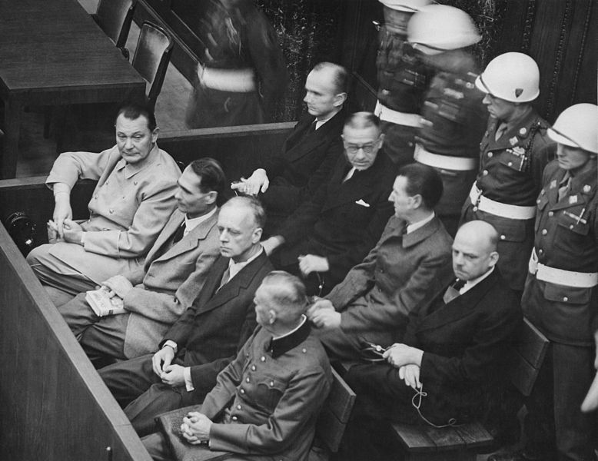
Nuremberg Trials. Defendants in their dock, circa 1945-1946. (in front row, from left to right): Hermann Göring, Rudolf Heß, Joachim von Ribbentrop, Wilhelm Keitel (in second row, from left to right): Karl Dönitz, Erich Raeder, Baldur von Schirach, Fritz Sauckel. https://commons.wikimedia.org/w/index.php?curid=12435756.

Supporting Questions
- How was the “superior orders” defense used prior to World War II?
- How did German officers use the superior orders defense at their trials?
- Did German military personnel have a “moral choice” available to them? Why did they choose to follow orders?
- What are today’s laws about following orders in the military?

Standards and Practices
Michigan Social Studies Standards (2007):
USHG 7.2.4 RESPONSES TO GENOCIDE - Investigate development and enactment of Hitler’s “final solution” policy, and the responses to genocide by the Allies, the U.S. government, international organizations, and individuals (e.g. liberation of concentration camps, Nuremberg war crimes tribunals, establishment of state of Israel).

Staging the Question
Discuss why it is necessary for soldiers to follow orders. Ask, “What if it is an illegal order?”

Supporting Question | Formative Performance Task | Featured Sources
How was the “superior orders” defense used prior to World War II? | Students complete a timeline illustrating how the standard for judging the superior orders defense changed over time. | Source A: Excerpt of article describing the first international war crimes trial in 1474.  Source B: 19th-century American and English cases.  Source C: Excerpts from “Obedience of Orders and the Law of War.”
How did German officers use the superior orders defense at their trials? | Jigsaw Activity: Groups summarize readings then present their summaries to each other while listeners take notes. | Source A: Summary of the trial of Wilhelm Keitel.  Source B: Summary of the trial of Alfred Jodl.  Source C: Summary of the trial of Rudolf Hoess.  Source D: Excerpt from Adolf Eichmann’s final plea at his war crimes trial.
Did German military personnel have a “moral choice” available to them? Why did they choose to follow orders? | Use a graphic organizer to compile evidence of what choices German military personnel had and why they chose to follow orders, then summarize findings. | Source A: Ways soldiers could avoid carrying out orders to commit murder.  Source B: Why they carried out orders to murder.  Source C: Excerpt from “Reserve Police Battalion 101.”  Source D: Excerpt of testimony by perpetrator.
What are today’s laws about following orders in the military? | Students write a summary of the current legal and military consensus on the acceptability of the superior orders defense. | Source A: The Nuremberg principles.  Source B: Article 33 of the Rome Statute of the ICC, 1998.  Source C: Article, “When can a soldier disobey an order?”  Source D: Article, “Why German soldiers don’t have to obey orders.”

Topic | Summative Performance Task
ARGUMENT | “I was only following orders” an acceptable defense? Construct an argument (e.g., detailed outline, poster, essay) that discusses the compelling question using specific claims and relevant evidence from historical sources while acknowledging competing views.
EXTENSION | While the Rome Statute is clear that soldiers have an obligation to disobey a “manifestly unlawful” order, it does not state what makes an order “manifestly unlawful.” Work in teams to rewrite the Rome Statute so that it offers a clear statement of what makes an order “manifestly unlawful” so that it is less confusing to officers and soldiers.

Topic | Taking Informed Action
UNDERSTAND | Research a recent case in which someone accused of committing atrocities has used the superior orders defense: “Washington Breaks Out the ‘Just Following Orders’ Nazi Defense for CIA Director-Designate Gina Haspel,” The Intercept, 15 March 2018.
ASSESS | Evaluate the circumstances of the case and determine whether the “superior orders” defense is acceptable in this case.
ACT | Write an editorial response to the publisher expressing agreement or disagreement with the article’s argument. Use evidence from this inquiry to support your argument.

Staging the Compelling Question - Overview for the Teacher

Compelling Question
“I was only following orders!” Is this an acceptable defense?

Featured Sources
- Featured Source A: Excerpt from Rogers, A. P. V. (1996) Law on the battlefield (Manchester and New York, Manchester University Press).
- Featured Source B: Scene from the film A Few Good Men (1992).

Setting the Stage
To set the stage for students to explore the Compelling Question, “I was only following orders! Is this an acceptable defense?”, begin by discussing the following prompt: “What would happen if we all decided not to follow orders?” Ask students to consider:
- What personal consequences might you face for disobedience at school? At home? At work? In public?
- What would be the effect on how the school functions? How would it affect behavior? How would it affect safety? What would be the effect on your ability to learn?
- What would be the effect on how you and your classmates get along? How would it affect how our community functions? Could it function? What are the potential consequences for public safety? How would it affect our ability to be a self-governing society?
Follow up by asking why it’s necessary for people in the military to follow orders.
To illustrate the necessity of following orders in the military you can share the following Featured Sources.
Featured Source A is an excerpt from the book, Law on the battlefield in which British military legal scholar A.P.V. Rogers explains the life-and-death importance of obeying orders in the military.
Featured Source B is a clip from the 1992 film, A Few Good Men in which Jack Nicholson’s character says, “We follow orders or people die.” Show the clip from the beginning until the 1:05 mark, when the Navy prosecutor, played by Tom Cruise, replies, “Crystal.”
After discussing the need for obedience in the military, pose the questions: “But what if it is an unlawful order?” and “What if the order is against your personal beliefs?”
Explain that this inquiry will explore the Compelling Question, “I was only following orders! Is this an acceptable defense?”

Featured Source A

"Military effectiveness depends on the prompt and unquestioning obedience of orders to such an extent that soldiers are prepared to put their lives at risk in executing those orders. During military operations decisions, actions and instructions often have to be instantaneous and do not allow time for discussion or attention by committees. It is vital to the cohesion and control of a military force in dangerous and intolerable circumstances that commanders should be able to give orders and expect their subordinates to carry them out."
—Rogers, A. P. V. (1996) Law on the battlefield (Manchester and New York, Manchester University Press)
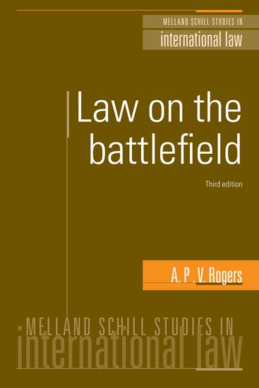

Excerpt from Rogers, A. P. V. (1996) Law on the battlefield (Manchester and New York, Manchester University Press), quoted in Minow, Martha. What the rule of law should mean in civics education: from the ‘Following Orders’ defence to the classroom, Journal of Moral Education Vol. 35, No. 2, June 2006, pp. 137–162.

Featured Source B

In the first featured source, A.V.P. Taylor explained why military “commanders should be able to give orders and expect their subordinates to carry them out.” While Taylor’s explanation is clear, it is worded in the cold, precise language of a military academic. Featured Source B provides a much more vivid explanation that should be instantly clear to students in a way that Taylor’s quote might not. Featured Source B is a clip from the 1992 film, “A Few Good Men” in which Jack Nicholson’s character states emphatically, “We follow orders or people die.”
Show the clip from the beginning until the 1:05 mark, when the Navy prosecutor, played by Tom Cruise, replies, “Crystal.”
After discussing the need for obedience in the military, pose the questions: “But what if it is an unlawful order?” and “What if the order is against your personal beliefs?” Explain that this inquiry will explore the Compelling Question, “I was only following orders!” Is this an acceptable defense?
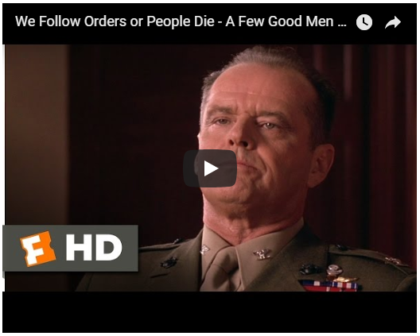
Scene from the film “A Few Good Men” (1992).
Accessed from: https://www.youtube.com/watch?v=nyKJeXDoqnw

Supporting Question 1 - Overview for the Teacher

Supporting Question
How was the “superior orders” defense used prior to World War II?

Formative Performance Task
Use a graphic organizer to gather key facts of pre-WWII cases involving the superior orders defense.

Featured Sources
Source A: Excerpt of article describing the first international war crimes trial in 1474.
Source B: 19th-century American and English cases.
Source C: Excerpts from “Obedience of Orders and the Law of War.”

Overview
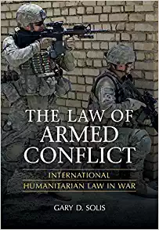
“Is the individual soldier immune from punishment because he carried out his duties pursuant to the orders of a superior? It was not until World War II,” writes Georgetown University law professor Gary D. Solis, “that the question of personal responsibility appeared resolved, bringing about significant change to this ancient defense.”
To answer the compelling question, “I was only following orders! Is this an acceptable defense?” students will need to understand what the superior orders defense is and how the standards for judging this “ancient defense” have changed over time. Supporting Question 1 asks students “How was the ‘superior orders’ defense used prior to World War II?”
The Formative Performance Task calls on students to gather information on the evolution of the superior orders defense from its first known use in the 15th century through its appearance as a defense at the Nuremberg trials. As they study the Featured Sources, students use a graphic organizer to create a timeline that tracks how the standard for judging the superior orders defense changed over time.
Featured Source A is a Harvard Law Review article that describes the 15th-century trial of Peter von Hagenbach, considered history’s first international war crimes tribunal. Foreshadowing the Nuremberg trials nearly 500 years later, von Hagenbach used as his defense that he was simply following orders. The court rejected von Hagenbach’s defense and sentenced him to death.
Featured Source B is an excerpt from a 1944 pamphlet titled, “What Shall Be Done with the War Criminals,” written by Harvard law professor Sheldon Glueck for the “G.I. Roundtable Series,” published by the American Historical Association for the U.S. Army to help win the war and prepare for the transition to a postwar world. This excerpt from the section titled, “Are Superior Orders a Legitimate Defense,” describes three 19th-century cases—two American and one British—involving the superior orders defense. Upon analysis of these three cases, students will discover that, while the courts did not all reach the same verdict, in each case the same standard was applied to the superior orders defense: a soldier is protected by the superior orders defense, unless the orders are “so manifestly illegal that he must or ought to have known they were unlawful.”
Featured Source C is an excerpt from “Obedience of Orders and the Law of War: Judicial Application in American Forums,” by Georgetown University law professor Gary D. Solis. In this excerpt, Solis describes the evolution of the military and legal standards for judging the superior orders defense from the late 19th-century through Nuremberg trials. Students will discover that while the standard applied by Imperial Germany [1871-1918] remained consistent in its rejection of the defense, American and British military law took a 30-year “legal detour” from this position, accepting the superior orders defense as an absolute shield from war crimes charges in the early decades of the 20th century, only to come full-circle to the “new old standard” of the late 19th-century found in Featured Source A.

Supporting Question 1 - Featured Source A

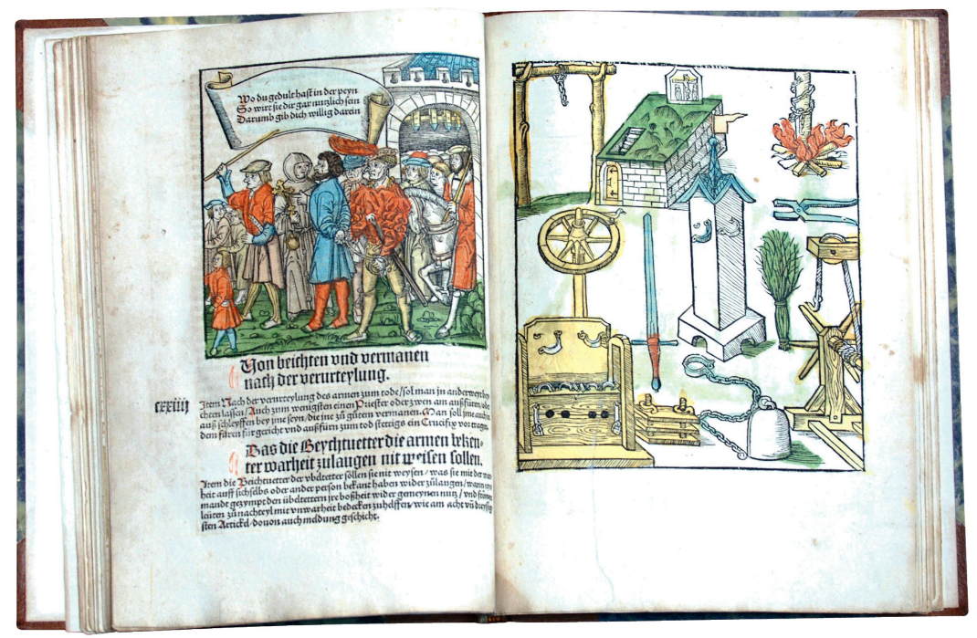
Included in a recent Harvard Law School library exhibit, these illustrations from a 16th-century book show instruments of torture and a criminal on the way to execution during the late 1400s. This was the period when the first international criminal tribunal tried and convicted an individual for "violating the laws of God and man." Image credit: Gustav Freedman
The following is an excerpt from “Exhibit highlights the first international war crimes tribunal,” written by Linda Grant, published in the Harvard Law Review on April 1, 2006.
As the marshal shouted “Let justice be done,” Peter von Hagenbach was beheaded in 1474, after being tried and convicted by the first international criminal tribunal. Created by the Archduke of Austria, the tribunal consisted of 28 judges from different states in the Holy Roman Empire. Von Hagenbach, appointed governor by Charles the Bold, Duke of Burgundy, was told to keep order in Austria’s territories on the upper Rhine. In fulfilling the duke’s directive, von Hagenbach terrorized the population.
Charged with violation of “the laws of God and man,” specifically murder, rape and perjury, among other crimes, von Hagenbach used as his defense that he was simply following orders. “Is it not known that soldiers owe absolute obedience to their superiors?” he asked.
By setting up a court to handle von Hagenbach’s case, rather than holding a summary execution, the Archduke of Austria laid the groundwork for the Nuremberg Trials, the international criminal tribunals for the former Yugoslavia and Rwanda, and the International Criminal Court, says Professor Martha Minow.
“Von Hagenbach’s defense, ‘just following orders,’ was raised by several defendants at the Nuremberg Trials” … said Minow.
Excerpt from Grant, Linda, “Exhibit highlights the first international war crimes tribunal,” Harvard Law Review, April 1, 2006.
Accessed from: https://today.law.harvard.edu/exhibit-highlights-the-first-international-war-crimes-tribunal/

Supporting Question 1 - Featured Source B

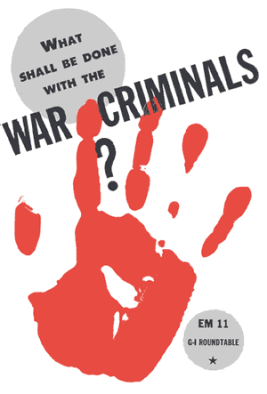

The American View
A famous American case is that of Mitchell v. Harmony, 54 U.S. 13 How. 115 115 (1851), a civil suit growing out of the Mexican War [1846 - 1848]. An American Army officer in Mexico illegally seized the goods of a trader in occupied territory. When later sued for the price of the goods, he claimed to have acted under orders of a superior officer. The court refused to consider this plea. Chief Justice Taney of the United States Supreme Court declared: “It can never be maintained that a military officer can justify himself for doing an unlawful act by producing the order of his superior. The order may palliate, but it cannot justify” the deed.

In another well-known American case, United States v. John Jones, 36 Fed. Cas. 653 (No. 15494) (C.C.D. Pa. 1813), some members of the crew of an American privateer were tried because, during the War of 1812, they stopped and searched a neutral Portuguese vessel on the high seas, assaulted the captain and crew, and stole valuables. They were held guilty of the act. With reference to the defense of Jones and the others that they had only obeyed their captain’s orders, the justice said: “This doctrine [that the defendant is innocent because he was following orders], ... alarming and unfounded, is repugnant to reason, and to the positive law of the land. No military or civil officer can command an inferior to violate the laws of his country; nor will such command excuse, much less justify the act. Can it be for a moment pretended, that the general of an army, or the commander of a ship of war, can order one of his men to commit murder or felony? Certainly not.”

The English View
A leading case in English legal history is that of Regina v. Smith, 17 Cape Reports 561 (South Africa, 1900) (p. 130). During the Boer War [1899 - 1902] a patrol of British soldiers, sent out on a dangerous mission, had an argument with a [South African] native who hesitated to find a bridle for them. Smith, one of the soldiers, under orders of his superiors, killed the [South African] native on the spot. After the war, a special court tried Smith for murder and acquitted him. The court said, “I think it is a safe rule to lay down that if a soldier believes he is doing his duty in obeying commands of his superior, and if the orders are not so manifestly illegal that he must or ought to have known they were unlawful, the private soldier would be protected by the orders of his superior officer.”

Examples of 19th-century American and English cases involving the superior orders defense. Excerpted from AHA article, “Are Superior Orders a Legitimate Defense?” (1944).
Accessed from: https://www.historians.org/about-aha-and-membership/aha-history-and-archives/gi-roundtable-series/pamphlets/em-11-what-shall-be-done-with-the-war-criminals-(1944)/are-superior-orders-a-legitimate-defense

Supporting Question 1 - Featured Source C

Featured Source C is an excerpt from “Obedience of Orders and the Law of War: Judicial Application in American Forums,” by Georgetown University law professor Gary D. Solis. In this excerpt, Solis describes the evolution of the military and legal standards for judging the superior orders defense from the late 19th-century through Nuremberg trials. Students will discover that while the standard applied by Imperial Germany [1871-1918] remained consistent in its rejection of the defense, American and British military law took a 30-year “legal detour” from this position, accepting the superior orders defense as an absolute shield from war crimes charges in the early decades of the 20th century, only to come full-circle to the “new old standard” of the late 19th-century found in Featured Source A.
In the first section, “THE TWENTIETH CENTURY: AN EVOLVING STANDARD,” students will find that after centuries of consensus that superior orders provided no protection for war crimes, the United States and Great Britain’s rules of warfare began to change.
In 1906, prominent British law professor and publicist, Lassa Oppenheim asserted that “If members of the armed forces commit violations by order of their government, they are not war criminals and cannot be punished by the enemy.” Over the next decade, British and American military field manuals followed Oppenheim’s pronouncement nearly word-for-word, “making a subordinate’s obedience to orders a complete legal defense, setting aside American military and civilian case history of the past 110 years.” As the second world war approached, the American field manual diverged even farther from centuries-old standard by stating in 1934 that a soldier is always exempt from prosecution for crimes committed under orders, and that there is no requirement that an order must be lawful in order to be obeyed.
In the second section, “THE TWENTIETH CENTURY: AN EVOLVING STANDARD [Imperial Germany],” students will be surprised to discover that while those they view as the “good guys” in World War II—Great Britain and the United States—were becoming more accepting of the superior orders defense, Imperial Germany remained steadfast in its rejection of it.
This excerpt provides brief overviews of two cases from the First World War in which German U-boat officers claimed they were not liable for committing war crimes because they were ordered to do so by superior officers. In the first case, the commander of a German U-boat was accused of sinking the British hospital ship Dover Castle, in violation of the rules of war. The court ruled since the U-boat commander believed that he was acting under lawful orders, he was not responsible for the sinking of the Dover Castle.
In the second example, German U-boat officers were tried for machine-gunning the survivors of the torpedoed hospital ship Llandovery Castle as they floated helplessly in lifeboats or in the water. As in the Dover Castle case, the officers claimed they were not liable because they acted under superior orders. In this case, however, the court ruled that the officers were responsible because, though they acted under superior orders, shooting survivors was so manifestly contrary to the law, the officers must have known or should have known that they were committing war crimes.
Since the German high court reached different verdicts in these two cases—not guilty in Dover Castle; guilty in Llandovery Castle—students might mistakenly concluded that these two cases represent different interpretations of the superior orders defense. Therefore it is important to help students to recognize that while the verdicts differed, the standard they were based on is the same: “[T]he Imperial Court applied the more strict German military code’s standard, not the revised standard of the American and British victors. It was ironic in that the German standard was similar to the one … which the American victors had [abandoned]. The German standard was that subordinates were liable for carrying out orders they knew to be illegal, or should have known to be illegal. Likewise, officers issuing orders that they knew, or should have known, to be illegal, were personally liable.”
In the third excerpt, “WORLD WAR II: AN OLD NEW STANDARD,” students will learn that by the end of World War II, the Great Britain and the United States had returned to the rejection of superior orders that they had abandoned decades earlier: “[t]he plea of superior orders shall not constitute a defense ... if the order was so manifestly contrary to the laws of war that a person of ordinary sense and understanding would know or should know ... that an order was illegal.”
Why the reversal? As the end of the war approached, the Allies were determined to hold Germans accountable for their crimes. Article 8 of the charter of the International Military Tribunal, created to punish war crimes, stated that “[t]he fact that the defendant acted pursuant to order of his Government or of a superior shall not free him from responsibility …” The IMT intended to hold the Nazis criminally responsible for war crimes they committed, and for war crimes they ordered. Obedience to superior orders would be no shield…”
As Solis explains:
The IMT intended to hold the Nazis criminally responsible for war crimes they committed, and for war crimes they ordered. Obedience to superior orders would be no shield …
In anticipation of the trial of the Nazis, the Allies had reverted their law regarding the superior orders defense to the pre-1914 standard, which had applied all along in German courts-martial … The Anglo-American legal detour had lasted thirty years, but the IMT seemingly brought the soldiers’ legal defense full circle: a [war crime] pursuant to a superior’s manifestly illegal order remained a war crime.
Excerpt from Solis, Gary D. “Obedience of Orders and the Law of War: Judicial Application in American Forums.” American University International Law Review 15, no. 2 (1999): 481-526.
Accessed from: https://digitalcommons.wcl.american.edu/cgi/viewcontent.cgi?referer=https://www.google.com/&httpsredir=1&article=1268&context=auilr

THE TWENTIETH CENTURY: AN EVOLVING STANDARD
… For the United States and Great Britain, the mid-Nineteenth Century standard remained fixed: an officer was criminally responsible for the issuance or execution of orders he knew, or should have known to be illegal. Subordinates, in turn, were not liable for illegal orders they carried out, unless the illegality of those orders was clear …
In 1906, Lassa Oppenheim, a prominent British international law professor and publicist, postulated that obedience to superior orders constituted a complete and absolute defense to criminal prosecution. “If members of the armed forces commit violations by order of their Government, they are not war criminals and cannot be punished by the enemy ... In case members of forces commit violations ordered by their commanders, the members cannot be punished, for the commanders are alone responsible …”
Oppenheim was instrumental in bringing about a sea change to the soldiers’ obedience defense. There was no personal responsibility, Oppenheim held, when superiors ordered criminal acts. Oppenheim later wrote Great Britain’s 1912 handbook on the rules of land warfare … The new handbook incorporated Oppenheim’s dicta that, for subordinates, obedience to orders constituted a complete defense to violations of the law of war ...
Looking to Great Britain's example … in 1914 [the United States] published its first manual relating to the law of war … [T]he Rules of Land Warfare read: “[I]ndividuals of the armed forces will not be punished for [war crimes if] they are committed under the orders or sanction of their government or commanders ...” With this paragraph, the United States’ published policy joined Britain’s revised manual in making a subordinate’s obedience to orders a complete legal defense, setting aside American military and civilian case law of the previous 110 years …
As World War II approached, the United States and United Kingdom continued to view superior orders as a complete defense to subordinate’s war crimes. In the 1929 edition of her land warfare manual, the United Kingdom baldly stated:
… members of the armed forces who commit such violations of the recognized rules of warfare as are ordered by their Government or by their commander are not war criminals and cannot therefore be punished …
In 1934, the United States published a new edition of the Rules of Land Warfare ... which … did not vary from the original … [A soldier] remained fully exempt from prosecution if the soldier committed the crime pursuant to the order of a superior. There was no [requirement] that the order must have been [lawful].THE TWENTIETH CENTURY: AN EVOLVING STANDARD [Imperial Germany]
Curiously, Imperial Germany [1871 - 1918], where obedience was … thought to be absolute, employed a different and less forgiving rule [than the United Kingdom and the United States]. Imperial courts punished subordinates if they executed an order knowing that it “related to an act which obviously aimed at a crime.” Such a ruling is comparable to ... the pre-1914 United States military standard...
There were two … notable [German] cases that involved the defense of superior orders. Lieutenant Karl Neumann, commander of a German submarine [during World War I], admitted that he had torpedoed and sunk the British hospital ship, Dover Castle, but pleaded that he did so only in obedience to orders issued by the Admiralty. Indeed, the German Government had asserted that the enemy was using hospital ships for military purposes, in violation of customary international law, and declared on March 19, 1917 that German submarines would attack hospital ships not complying with several German conditions. The Imperial Court held that Neumann believed the order to be [lawful] and therefore was not personally responsible for the sinking of the Dover Castle … [T]he Court applied the German obedience to orders standard delineated in Section 47 of the German Military Penal Code, which stated that a subordinate acting in conformity with superior orders is liable to punishment only when he knows his orders [are illegal]. Applying the German standard, the Imperial Court acquitted Neumann.
A similar case, however, saw a different result and actually set a standard for obedience to orders. The Allies charged Lieutenants Ludwig Dithmar and Johann Boldt, of the submarine U-86, for the sinking of a Canadian hospital ship, the Llandovery Castle. At trial, the evidence revealed that, just after the sinking, Captain Helmuth Patzig sought to conceal the sinking of the hospital ship and ordered the two accused subordinates to help kill the survivors. Patzig and another officer machine-gunned the survivors in lifeboats in the water, assisted by Dithmar and Boldt who spotted targets and maintained a lookout. The officers sunk at least two lifeboats. The Imperial Court was unable to determine a precise number of casualties from the gunfire because many of the survivors drowned or were victims of shark attacks...
[S]ince [Patzig] had taken refuge in the then-independent state of Danzig, he [could not be brought to trial]. Like Neumann in the Dover Castle case, Dithmar and Boldt pleaded “not guilty” on the basis of superior orders from the German naval high command. Also like Neumann, the Court found that Dithmar and Boldt were not guilty of sinking the hospital ship by reason of obedience to superior orders. The Imperial Court found them guilty as accessories to homicide, however, due to their help with machine-gunning of the survivors. In explaining its ruling, the Court stated:
According to the Military Penal Code, if the execution of an order ... involves … a violation of law…, the superior officer issuing such an order is alone responsible. However, the subordinate obeying such an order is liable to punishment if it was known to him that the order ... involved the infringement of civil or military law.
[S]hooting survivors in the water was manifestly contrary to customary international law ... [T]he judges found that Dithmar and Boldt had knowledge or should have had knowledge that their actions were against the law of war …
[T]he Imperial Court applied the more strict German military code’s standard, not the revised standard of the American and British victors. It was ironic in that the German standard was similar to the one … which the American victors had [abandoned]. The German standard was that subordinates were liable for carrying out orders they knew to be illegal, or should have known to be illegal. Likewise, officers issuing orders that they knew, or should have known, to be illegal, were personally liable.
Excerpt from Solis, Gary D. “Obedience of Orders and the Law of War: Judicial Application in American Forums.” American University International Law Review 15, no. 2 (1999): 481-526.
Accessed from: https://digitalcommons.wcl.american.edu/cgi/viewcontent.cgi?referer=https://www.google.com/&httpsredir=1&article=1268&context=auilr

SQ1: Graphic Organizer

Supporting Question 1:
How was the “superior orders” defense used prior to World War II?

Formative Performance Task:
Use the graphic organizer to gather key facts of pre-WWII cases involving the superior orders defense.

Featured Source A  Questions | Answers
In his defense, what question did Peter von Hagenbach ask the court?
Why do you think the court rejected this defense?

Featured Source B  Court Cases | Questions and Written Answers for each Court Case
Mitchell v. Harmony | What was the court’s verdict in Mitchell v. Harmony? (circle one) Guilty / Not Guilty  What did Chief Justice Taney of the U.S. Supreme Court declare in response to the defendant’s claim that he was only following the orders of his superior officer? Use your own words to explain Taney’s reasoning.
The United States  v.  John Jones | What was the court’s verdict in The United States v. John Jones? Guilty / Not Guilty  What did the justice (judge) say in response to the defense of Jones and the others that they had only obeyed their captain’s orders? Use your own words to explain the justice’s reasoning.
Regina v. Smith | What was the court’s verdict in Regina v. Smith? Guilty / Not Guilty  According to the court’s statement, under what circumstances should a soldier not obey a superior’s order? Use your own words to explain the court’s reasoning.

Featured Source B | Written Answer
Although they did not all come to the same verdict, the courts in these three 19th-century cases used similar reasoning in making their decisions. Based on these three cases, what would you say was the 19th-century standard for judging cases involving the superior orders defense?

Featured Source C

INSTRUCTIONS:
Featured Source C describes how the standard for judging the superior orders defense changed over the course of the 20th century. Complete the timeline below to track this evolution.

THE TWENTIETH CENTURY: AN EVOLVING STANDARD [Imperial Germany]

Date: | Standard for the Superior Orders Defense:
19th Century | British and American standard:
1906 | Lassa Oppenheim (British):
1912 | British handbook on the rules of land warfare:
1914 | The United States Rules of Land Warfare:
1929 | US and UK standard:
1934 | New edition of United States Rules of Land Warfare:
1917 | Dover Castle case:
1921 | Llandovery Castle case:

WORLD WAR II: AN OLD NEW STANDARD

Date: | Standard for the Superior Orders Defense:
January 1944 | United Nations War Crimes Commission:
April 1944 | United Kingdom’s military field manual:
1947 | Article 8 of the IMT Charter:

According to the article, “The Anglo-American legal detour had lasted thirty years, but the IMT seemingly brought the soldiers’ legal defense full circle.” To come “full circle” means to start in one place, go to a different place, then return to where you started. Label the diagram below to illustrate how the English and American legal standard came “full circle.” At the top, write the standard that they left in 1914 and returned to in 1947. At the bottom, write the standard they adopted during their 30-year “detour.”

Supporting Question 2 - Overview for the Teacher

Supporting Question
How did German officers use the superior orders defense at their trials?

Formative Performance Task
Jigsaw Activity: Groups read German officer statements defending their decisions and actions. Groups summarize the readings then present their summaries to each other while listeners take notes.

Featured Sources
Source A: Summary of the trial of Wilhelm Keitel.
Source B: Summary of the trial of Alfred Jodl.
Source C: Summary of the trial of Rudolf Hoess.
Source D: Excerpt from Adolf Eichmann’s final plea at his war crimes trial.

The most famous use of the superior orders defense is, without a doubt, the claim by Nazi leaders and military commanders that in committing the murder of two-thirds of the Jews of Europe, they had been following orders and were thereby innocent of war crimes. Supporting Question 2 asks, “How did German officers use the superior orders defense at their trials?”
The Formative Performance Task helps students answer this question by working collaboratively in a jigsaw activity to quickly gather information on the trials and verdicts of four war criminals.
Divide the class into four groups and assign each group one of the four Featured Sources. Each group should use the graphic organizer to collect information about the war criminal described in their assigned source. Once the teams have completed their graphic organizers, they should report their findings to their classmates, as their listeners take notes.
Students will discover that, applying the standard set by Article 8 of the International Military Tribunal (p. 288) (“The fact that the Defendant acted pursuant to order of his Government or of a superior shall not free him from responsibility”), the courts in all four cases rejected the pleas of the Nazi commanders, sentencing them to death by hanging.
Featured Sources A, B, and C are succinct summaries of the International Military Tribunal’s postwar trials of three Nazi military leaders: Wilhelm Keitel, Supreme Commander of the Wehrmacht; Alfred Jodl, Chief of Staff for war operations in the Wehrmacht; and Rudolf Hoess, commandant of Auschwitz. All three claimed they were only following orders.
Featured Source D is the final plea of Adolf Eichmann, one of the key organizers of the Holocaust. Unlike, Keitel, Jodl, and Hoess, Eichmann was not tried by the International Military Tribunal at Nuremberg. Having eluded the Allies at the end of World War II, Eichmann escaped to South America where he was captured by the Israeli intelligence services (the Mossad) in 1960. Like the others, Eichmann claimed that he was only following orders, even going so far to say that he was a victim. The Israeli court rejected Eichmann’s plea and sentenced him to death.
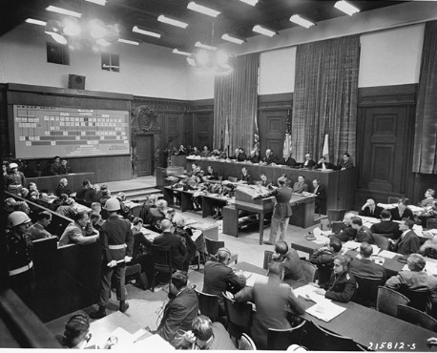
A large chart showing Nazi "Chain of Command" (in the background at left) was displayed during the afternoon of the third day of the Nuremberg War Crimes Trials in Germany. At the same session, Major Frank B. Wallis (standing at desk near center), a member of trial counsel and trial preparation legal staff, presents further items of the prosecution's case. Defendants Hermann Goering (first in box at left), Rudolph Hess, and Joachim von Ribbentrop are visible in the defendants' box. November 22, 1945.
https://www.trumanlibrary.org/photographs/view.php?id=11286

Featured Source A:

Summary of the trial of Wilhelm Keitel, Chief of the Armed Forces High Command in Nazi Germany.
Accessed from: https://trialinternational.org/latest-post/wilhelm-keitel/
Wilhelm Keitel was named Supreme Commander of the Wehrmacht (German armed forces)… in 1938. Following Hitler’s orders to the letter, he covered up the atrocities committed during the Russian campaign (Jewish massacres, execution of Red Army political commissioners…). After the failed attempt on Hitler’s life, in July 1944, he allowed the execution of hundreds of officers of the German army to go ahead.
It was Keitel who signed the attack orders, or who was present at the meetings during which attacks were decided against Czechoslovakia, Denmark, Norway, Poland, The Netherlands, Greece, Yugoslavia, and the USSR. Furthermore, he signed numerous decrees authorizing, for example, the execution of striking workers or the killing of captured underground fighters …

Charged with counts 1 (concerted plan or conspiracy), 2 (crimes against peace), 3 (war crimes) and 4 (crimes against humanity), he pleaded not guilty.

Keitel’s signature… appeared on the notorious decree “Nacht und Nebel” (“Night and Fog”) passed on 7 December 1941, whereby civilians in the occupied territories, suspected of being in the resistance would only be tried if the death penalty was the probable outcome. Failing this they would be turned over to the Gestapo which had them disappear without trace in Germany …

Faced with the evidence, Keitel did not deny the essential facts. However in his defense, he indicated that, as a soldier, he had only been following orders from his superiors and that he was not in a position to make decisions in his own right. The Tribunal did not follow this line of reasoning. In consideration of Article 8 of the Charter of the Tribunal [which states “The fact that the Defendant acted pursuant to order of his Government or of a superior shall not free him from responsibility, but may be considered in mitigation of punishment if the Tribunal determines that justice so requires.”], the concept of “superior orders” was not admitted as excusing him from his criminal responsibility.

As a result, the Tribunal found Keitel guilty on all of the charges, and sentenced him to death on 1 October 1946.
His appeal to the Control Council was rejected on 10 October 1946.
Wilhelm Keitel was executed by hanging on 16 October 1946.
Photo: https://commons.wikimedia.org/wiki/File:KeitelDetentionReport.jpg
Supporting Question 2

Featured Source B:

Summary of the trial of Alfred Jodl, Chief of the Operations Staff of the Armed Forces High Command in Nazi Germany.
Accessed from: https://trialinternational.org/latest-post/alfred-jodl/
Alfred Jodl was born on 10 May 1890 in Bavaria into a family of army officers and embarked upon a military career ... Being a staunch supporter of the Nazi party, he was nominated, in 1939, to the position of Chief of Staff for war operations of the Oberkommando der Wehrmacht [High Command of the Armed Forces] …

Jodl participated in the military planning and in the preparation of the Nazi conspiracy aimed at waging wars of aggression ... He authorized, directed and took part in acts constituting war crimes … and in crimes against humanity …

Charged with counts 1 (common plan or conspiracy), 2 (crimes against peace), 3 (war crimes) and 4 (crimes against humanity), he pleaded not guilty.

In his defense Jodl insisted on his military status and thus on the absolute duty wherever he was to carry out any orders received. He pointed out that whenever he gave out or signed orders, memorandums or letters, he did so in the name of Hitler and very often in place of Keitel [Supreme Commander of the Armed Forces]. Furthermore he tried to demonstrate in his defense that even if, as a matter of principle, he had to carry out orders received, he frequently tried to resist the more evil measures ordered, notably by delaying their implementation …

According to the Tribunal, the participation in such crimes as those demonstrated had never been … required of any soldier and Jodl could not therefore hide behind the “mythical” requirement of blind obedience of a soldier...
The Tribunal as a result, found Alfred Jodl guilty on all four counts and condemned him to death on 1 October 1946.

His appeal to the Control Council was rejected on 10 October 1946.

Alfred Jodl was executed by hanging on 16 October 1946.

Photo: https://commons.wikimedia.org/wiki/File:Alfred-jodl-72-926.jpg
2

Featured Source C:

Summary of the trial of Rudolf Hoess, commandant of Auschwitz extermination camp.
Accessed from: https://trialinternational.org/latest-post/rudolf-franz-ferdinand-hoess/
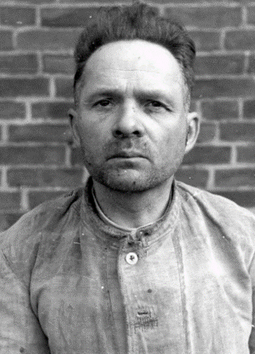
In 1933 Rudolf Hoess joined the SS ... He was appointed commander in the concentration camp Auschwitz in 1940.
In the following years Rudolf Hoess established, according to the visions of Himmler [Commander of the SS], the biggest extermination facility for humans of all time. In March 1941 … he contributed to the construction of the [extermination camp] Auschwitz-Birkenau. After [Himmler] informed him about the Final Solution of the Jewish Question, he ordered to construct four big crematoria with gas chambers and he used, for the first time, the gas Cyclone B [more commonly known by its German name, “Zyklon B”], a highly poisonous form of cyanhydric acid, to exterminate Jews, as he deemed the execution by gun to be ineffective and costly. The introduction of gas chambers in the showers in order to ensure gasification without a rebellion is also attributed to Rudolf Hoess.
On average death through gasification occurred after approximately three to ten minutes, whereupon Zyklon B caused severe pain … It is estimated that up to 10,000 human beings were killed like this on a daily basis...
After the end of WWII, Hoess [evaded arrest by using a false name]. In 1946 he was recognized and detained in Flensburg [Germany] by the British Military Police. After being tortured, he revealed his true identity...
Under the British custody he was interrogated various times about the incidents in Auschwitz. He never denied that he had committed the criminal action that [he] was accused of but he claimed that he had merely executed orders...
The trial started on 11 March 1947 in the auditorium of the Union of Polish Teachers in the district Powiśle in Warsaw. During the hearing [Hoess] repeated a couple of times that he merely had executed orders and justified his actions with the compulsion to obey orders. The highest Polish Public Court sentenced him to death to be hanged on 2 April 1947.
Rudolf Hoess was hanged in front of his former house in the concentration camp Auschwitz on 16 April 1947.

Photo: https://vi.wikipedia.org/wiki/T%E1%BA%ADp_tin:H%C3%B6ss,_Rudolf.jpg

Featured Source D:
Excerpt from Adolf Eichmann’s final statement at his war crimes trial in Jerusalem, 1961.
Accessed from: http://remember.org/eichmann/ownwords
About this source: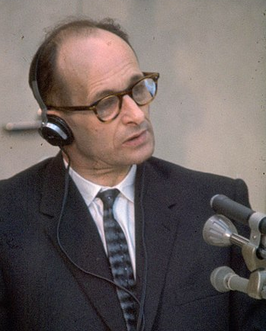
Adolf Eichmann was one of the most pivotal actors in the implementation of the “Final Solution.” Charged with managing and facilitating the mass deportation of Jews to ghettos and killing centers in the German-occupied East, he was among the major organizers of the Holocaust … At war’s end, Eichmann found himself in U.S. custody, but escaped in 1946… fleeing to Argentina. There he lived under a number of aliases ... In 1960, agents of the Israeli Security Service (Mossad) abducted Eichmann and brought him to Israel to stand trial ...In December 1961, Eichmann was found guilty of crimes against the Jewish people. He was hanged at midnight between May 31 and June 1, 1962. Jewish authorities cremated his remains and scattered his ashes in the sea beyond Israeli boundary waters. —https://encyclopedia.ushmm.org/content/en/article/adolf-eichmann
Photo: https://commons.wikimedia.org/wiki/File:Adolf_Eichmann_at_Trial1961.jpg
The following is an excerpt from Eichmann’s final plea after receiving the court’s verdict.
I have heard the Court’s severe verdict of guilty. I see myself disappointed in my hopes for justice. I cannot recognize the verdict of guilty. I understand the demand for atonement for the crimes which were perpetrated against the Jews. The witnesses’ statements here in the Court made my limbs go numb once again, just as they went numb when once, acting on orders, I had to look at the atrocities. It was my misfortune to become entangled in these atrocities. But these misdeeds did not happen according to my wishes. It was not my wish to slay people. The guilt for the mass murder is solely that of the political leaders.
I did try to leave my position, to leave for the front, for honest battle. But I was held fast in those dark duties. Once again I would stress that I am guilty of having been obedient, having subordinated myself to my official duties and the obligations of war service and my oath of allegiance and my oath of office, and in addition, once the war started, there was also martial law.
This obedience was not easy. And again, anyone who has to give orders and has to obey orders knows what one can demand of people. I did not persecute Jews with avidity and passion. That is what the government did. Nor could the persecution be carried out other than by a government … I accuse the leaders of abusing my obedience. At that time obedience was demanded, just as in the future it will also be demanded of the subordinate. Obedience is commended as a virtue.
May I therefore ask that consideration be given to the fact that I obeyed, and not whom I obeyed.
I have already said that the top echelons, to which I did not belong, gave the orders, and they rightly, in my opinion, deserved punishment for the atrocities which were perpetrated on the victims on their orders. But the subordinates are now also victims. I am one of such victims.

SQ2: Graphic Organizer

Supporting Question 2:
How did German officers use the superior orders defense at their trials?

Formative Performance Task:
Jigsaw Activity: Groups read German officer statements defending their decisions and actions. Groups summarize the readings then present their summaries to each other while listeners take notes.

Instructions:
With your partner(s), carefully read the summary of your assigned trial. Use the chart below to record key facts.

Name of Defendant:

Defendant’s role in the Holocaust:

Charges against the defendant:

How the defendant pleaded:

Explanation of defense:

Tribunal’s ruling:

Verdict:

Sentence:

Supporting Question 3 - Overview for the Teacher

Supporting Question
Did German military personnel have a “moral choice” available to them? Why did they choose to follow orders?

Formative Performance Task
Use a graphic organizer, compile evidence to determine what choices did German military personnel had and why they choose to follow orders. Summarize findings.

Featured Sources
Source A: Ways soldiers could avoid carrying out orders to commit murder.
Source B: Why they carried out orders to murder.
Source C: Excerpt from “Reserve Police Battalion 101.”
Source D: Excerpt of testimony by perpetrator Werner Schwenker.

According to the Nuremberg tribunal, “That a soldier was ordered to kill or torture in violation of the international law of war has never been recognized as a defense to such acts of brutality … The true test … is not the existence of the order, but whether moral choice was in fact possible.”
Was a moral choice in fact possible for the perpetrators of war crimes? Could they have chosen not to commit atrocities, or would they have been killed if they disobeyed the orders to commit war crimes?
One of the most common assumptions about the Holocaust is that if the perpetrators had refused to take part in mass killings, they would have been killed themselves. Students are given the opportunity to investigate the truth of this assumption as they answer Supporting Question 3: “Did German military personnel have a ‘moral choice’ available to them? Why did they choose to follow orders?”
To answer this question, students will complete the Formative Performance Task of using a graphic organizer to compile evidence of whether a moral choice was available to the perpetrators of the Holocaust. The SQ3 handout guides students through their analysis of the documents and asks students to summarize their findings by responding to the prompt: “Based on the Featured Sources, did perpetrators have a ‘moral choice’ available to them? Use evidence from the sources to support your argument.”
Featured Source A is an excerpt from the book, The Eichmann Kommandos, by Justice Michael Musmanno, the presiding judge at the Einsatzgruppen Trial in U.S. military court at Nuremberg. In this excerpt, Justice Musmanno recounts testimony from several Einsatzgruppen commanders who described the many ways that men who were “too soft” to participate in murder could be assigned to other duties. Contrary to the assumption that refusing to participate would result in instant execution for the soldier, one SS general testified, “I do not know a single case in which a man who refused to take part was shot.”
In Featured Source B, also from The Eichmann Kommandos, Musmanno explains the reasons why officers did not take the moral choices available to them: “Vanity, arrogance and greed were the vehicles in which the Nazi leaders travelled the highway of criminality and inhumanity.” Musmanno continues, “The Einsatzgruppen officers had an additional reason for preferring their assignments: it saved them from hazardous combat service.”
Featured Source C presents a passage from historian Christopher Browning’s Ordinary Men: Reserve Police Battalion 101 and the Final Solution in Poland. Browning describes an incident in which, on their first “killing action” in Poland, an Einsatzgruppen commander presented his men with an extraordinary offer: anyone who was “not up to the task before them” could step out. Despite this offer, with very few exceptions, the men of Reserve Police Battalion 101 killed the Jews they had been told to kill. Years later, some men admitted that they hadn’t taken up their commander’s offer because they were afraid of looking cowardly in front of their comrades.
Featured Source D presents the testimony of war criminal Werner Schwenker, who explains that he obeyed orders not because he feared punishment—“I knew of no case and still know of no case today where one of us was sentenced to death because he did not want to take part in the execution of Jews”—but because he feared he would be seen as weak or “my chances of promotion would be spoilt.

Featured Source A
Excerpts on the ways that men in the Einsatzgruppen could avoid carrying out orders to commit murder. Musmanno, Michael A., The Eichmann Kommandos. Peter Davies, 1962.
Accessed from: https://archive.org/stream/in.ernet.dli.2015.149016/2015.149016.The-Eichmann-Kommandos_djvu.txt
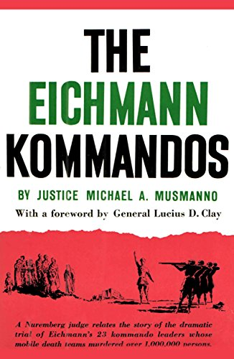
General Walter Schellenberg who ... had frequent dealings with Eichmann in connection with the Einsatzgruppen ... told me: “The Nazi leaders couldn’t be accused of great human sympathy, but they were men of efficiency, and if a man couldn’t go along with this type of an order [to commit war crimes], then he [would] be sent back home. And many were sent back home.”... (pg. 123)

Albert Hartel, who served with the German Security Police in [the city of Kiev in the Ukraine region of the Soviet Union] … testified that SS-General Thomas, commanding Einsatzgruppe C at the time, “passed on an order that all those people who could not … carry out such orders, that is, people who were too soft, as he said, to carry out these orders, should be sent back to Germany or should be assigned to other tasks. Thus at the time a number of people, also commanders, were sent back by Thomas to [Germany] just because they were too soft to carry out orders” … (pg. 229)

[T]hroughout the seven months’ trial there was no evidence that a failure to obey the [order to murder Jews] precipitated any major penalty. On the contrary, several instances came to light showing that disobedience or evasion of the Fuhrer-Order invoked no grievous punishment.
[SS-Colonel Gustav Nosske] testified to the following episode. On duty in Germany he was assigned to [the city of] Dusseldorf, where his higher SS and Police Leader ordered him to round up all Jews and half-Jews in that area for executions. Nosske said that he protested against the order and that, finally, it was revoked, or at any rate not enforced. Nosske’s protest was probably due mostly to the fact that many of the intended victims had one German parent. Nonetheless, his categorical refusal to obey the order demonstrated … that a member of the German Armed Forces could protest against a superior order and not be shot in consequence …
SS-General Erich von dem Bach Zelewski, whom I interviewed in Nuremberg after the war, told me that in all his years as a professional soldier he never heard that any German soldier had ever been shot for asking to be relieved of an assignment to shoot unoffending civilians. As recently as March 1961, he confirmed this statement before a Munich court, where he said: “I know people who did not want to take part in shootings and who did not do so. But I do not know a single case in which a man who refused to take part was shot.” (pgs. 232-233)

Featured Source B:
Excerpt on why the men of the Einsatzgruppen carried out their orders to commit murder. Musmanno, Michael A., The Eichmann Kommandos. Peter Davies, 1962.
Accessed from: https://archive.org/stream/in.ernet.dli.2015.149016/2015.149016.The-Eichmann-Kommandos_djvu.txt
Eichmann would not have had too much trouble in being released from his command post if he had really wanted to be released. All he would have had to do was to engage in a heart-to-heart talk with his superior Kaltenbrunner — who was his fellow-townsman and had befriended him since his early days in the SS — and ask him for a transfer to another assignment, and it would have been done. But the fact is that, as Rudolf Hoess, the commandant of Auschwitz, said, Eichmann was obsessed with the desire to exterminate Jews.
In fulfilling Hitler’s programme Eichmann and every Nazi official saw for himself increased authority, an easier and more lucrative post, a gaudier uniform, a bigger and shinier car, a longer strut and a more numerous group of underlings to tremble before his greatness. Vanity, arrogance and greed were the vehicles in which the Nazi leaders travelled the highway of criminality and inhumanity. Equipped with the goggles of glory and gore, they saw nothing wrong in mass murder, pillage, thievery, kidnapping, torture and diabolical instruction...
The Einsatzgruppen officers had an additional reason for preferring their assignments: it saved them from hazardous combat service. In the front lines one faced an armed and aggressive opponent; in a foxhole one could expect any moment a fragmentising artillery shell. But on the Einsatzgruppen field there were no foxholes. There were only long ditches in front of which one’s adversaries helplessly stood to await the fire which they could not return. (pgs. 231-232)

Featured Source C:
Excerpt from Facing History and Ourselves article, “Reserve Police Battalion 101.”
Accessed from: https://www.facinghistory.org/holocaust-and-human-behavior/chapter-9/reserve-police-battalion-101

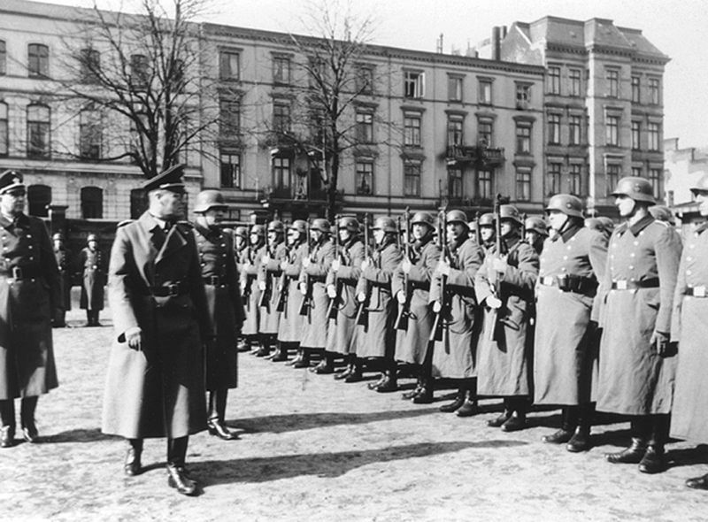

Inspection of Reserve Police Battalion 101 of the Nazi German Ordnungspolizei (Order Police) at Łódź (Litzmannstadt) in occupied Poland; late November of 1940 or spring 1941.
Image: http://tinyurl.com/yyf4watm
What kind of person kills civilians, including old people and even babies, all day long? To find answers to such questions, historian Christopher Browning studied courtroom testimony made in the 1960s and 1970s by 210 men who served in the German Reserve Police Battalion 101 [under the command of the SS during the war] and were later charged with war crimes ...
The battalion’s first killing mission took place on July 13, 1942. Browning reports:
Just as daylight was breaking, the men arrived at the village [of Jozefow, Poland] and assembled in a half-circle around Major Trapp, who proceeded to give a short speech. With choking voice and tears in his eyes, he visibly fought to control himself as he informed his men that they had received orders to perform a very unpleasant task. These orders were not to his liking either, but they came from above … Trapp then explained to the men that the Jews in Jozefow would have to be rounded up, whereupon the young males were to be selected out for labor and the others shot.
Trapp then made an extraordinary offer to his battalion: if any of the older men among them did not feel up to the task that lay before him, he could step out. Trapp paused, and after some moments, one man stepped forward. The captain of 3rd company … began to berate the man. The major told the captain to hold his tongue. Then ten or twelve other men stepped forward as well. They turned in their rifles and were told to await a further assignment from the major...

[Years later,] a few who admitted that they had been given the choice and yet failed to opt out were quite blunt. One said that he had not wanted to be considered a coward by his comrades. Another—more aware of what truly required courage—said quite simply: “I was cowardly.” A few others also made the attempt to confront the question of choice but failed to find the words. It was a different time and place, as if they had been on another political planet, and the political vocabulary and values of the 1960s were helpless to explain the situation in which they found themselves in 1942. As one man admitted, it was not until years later that he began to consider that what he had done had not been right. He had not given it a thought at the time...
Was the incident at Jozefow typical? Certainly not. I know of no other case in which a commander so openly invited and sanctioned the nonparticipation of his men in a killing action. But in the end the most important fact is not that the experience of Reserve Police Battalion 101 was untypical, but rather that Trapp’s extraordinary offer did not matter. Like any other unit, Reserve Police Battalion 101 killed the Jews they had been told to kill.

Featured Source D:
Excerpt of testimony by perpetrator Werner Schwenker.
Accessed from: http://www.70voices.org.uk/content/day39
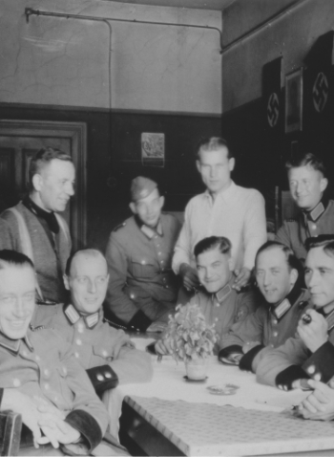
The majority of those who murdered Jews were regular German policemen, such as those shown in the photograph. After the war, many claimed that they would have been shot if they had refused to take part. However, this was not true. As the following post-war testimony from Werner Schwenker, a low-ranking detective who took part in the shooting of Jews in Kołomyja in Poland, makes clear, other factors influenced their decision to become murderers.

The reason I did not say to Leideritz [his senior officer] that I could not take part in these things was that I was afraid that Leideritz and others would think I was a coward. I was worried that I would be affected adversely in some way in the future if I allowed myself to be seen as too weak. I did not want Leideritz or other people to get the impression that I was not as hard as an SS man ought to have been...

I carried out orders not because I was afraid I would be punished by death if I didn’t. I knew of no case and still know of no case today where one of us was sentenced to death because he did not want to take part in the execution of Jews ... I thought that I ought not to say anything to Leideritz because I did not want to be seen in a bad light, and I thought that if I asked him to release me from having to take part in the executions it would be over for me as far as he was concerned and my chances of promotion would be spoilt or I would not be promoted at all.

Schwenker’s testimony is one of many which reminds us that the perpetrators had choices and illustrates how eminently human motives, such as ambition and peer pressure, could lead someone to become a murderer.

Photo: German policemen in Poland, 1941; United States Holocaust Memorial Museum, courtesy of Michael O’Hara/Bernhardt Colberg.
Testimony: Ernst Klee et al. (eds.), “The Good Old Days”: The Holocaust as Seen by Its Perpetrators and Bystanders (Konecky & Konecky, (1991)

SQ3: Graphic Organizer

Supporting Question 3:
Did German military personnel have a “moral choice” available to them? Why did they choose to follow orders??

Formative Performance Task:
Use a graphic organizer to compile evidence to determine what choices did German military personnel had and why they choose to follow orders. Summarize findings.

Instructions:
According to the Nuremberg tribunal, “That a soldier was ordered to kill or torture in violation of the international law of war has never been recognized as a defense to such acts of brutality … The true test, … is not the existence of the order, but whether moral choice was in fact possible.”
Was a moral choice in fact possible for the perpetrators of war crimes? Could they have chosen not to commit atrocities, or would they have been killed if they disobeyed orders?
Study the documents to determine whether moral choices were available to the Nazi perpetrators, what choices they made, and why.

Featured Source A
Excerpt on the ways that men in the Einsatzgruppen could avoid carrying out orders to commit murder. Musmanno, Michael A., The Eichmann Kommandos.

According to General Walter Schellenberg, was a moral choice available to men who were ordered to murder?

What did Schellenberg say would happen to a man who “couldn’t go along with this type of an order”?

Why?

According to Albert Hartel, what would happen to those who were “too soft” to carry out orders to murder?

What happened when S.S. Colonel Gustav Nosske objected to an order to murder Jews?

According to S.S. General Erich von dem Bach Zelewski, how many men were killed for refusing to take part in shooting?

Featured Source B

Excerpt on why the men of the Einsatzgruppen carried out their orders to commit murder. Musmanno, Michael A., The Eichmann Kommandos.

According to Musmanno, was there a moral choice available to Eichmann?

How could Eichmann have been released from his role in the Holocaust?

According to Musmanno, why didn’t Eichmann and every Nazi official refuse to fulfill Hitler’s programme?

What was the “additional reason” that Einsatzgruppen officers preferred to keep their assignments as murderers?

Featured Source C
Excerpt from Facing History and Ourselves article, “Reserve Police Battalion 101.”

What extraordinary offer did Major Trapp make for his battalion?

How did Major Trapp feel about the orders the battalion had received?

What statements support your conclusion?

According to their testimony years later, why didn’t more men take Major Trapp’s offer?

What other reasons may explain the soldiers’ choice to kill the Jews they had been told to kill?

Featured Source D
Excerpt of testimony by perpetrator Werner Schwenker.

What did Werner Schwenker say he was afraid might happen to him if he refused to murder Jews?

According to Schwenker, how often were men sentenced to death for refusing to murder Jews?

Based on Schwenker’s testimony, did perpetrators have a “moral choice” available to them? Explain.

SQ3: Summary

Supporting Question 3:
Did German military personnel have a “moral choice” available to them? Why did they choose to follow orders?

Formative Performance Task:
Use a graphic organizer, compile evidence to determine what choices did German military personnel had and why they choose to follow orders. Summarize findings.

Summary
Based on the Featured Sources, did perpetrators have a “moral choice” available to them? Use evidence from the sources to support your argument.

Supporting Question 4 - Overview for the Teacher

Supporting Question
What are today’s laws about following orders in the military?

Formative Performance Task
Write a summary of the current legal and military consensus on the acceptability of the superior orders defense.

Featured Sources
Source A: The Nuremberg principles.
Source B: Article 33 of the Rome Statute of the International Criminal Court, 1998.
Source C: Article, “When can a soldier disobey an order?”
Source D: Article, “Why German soldiers don’t have to obey orders.”

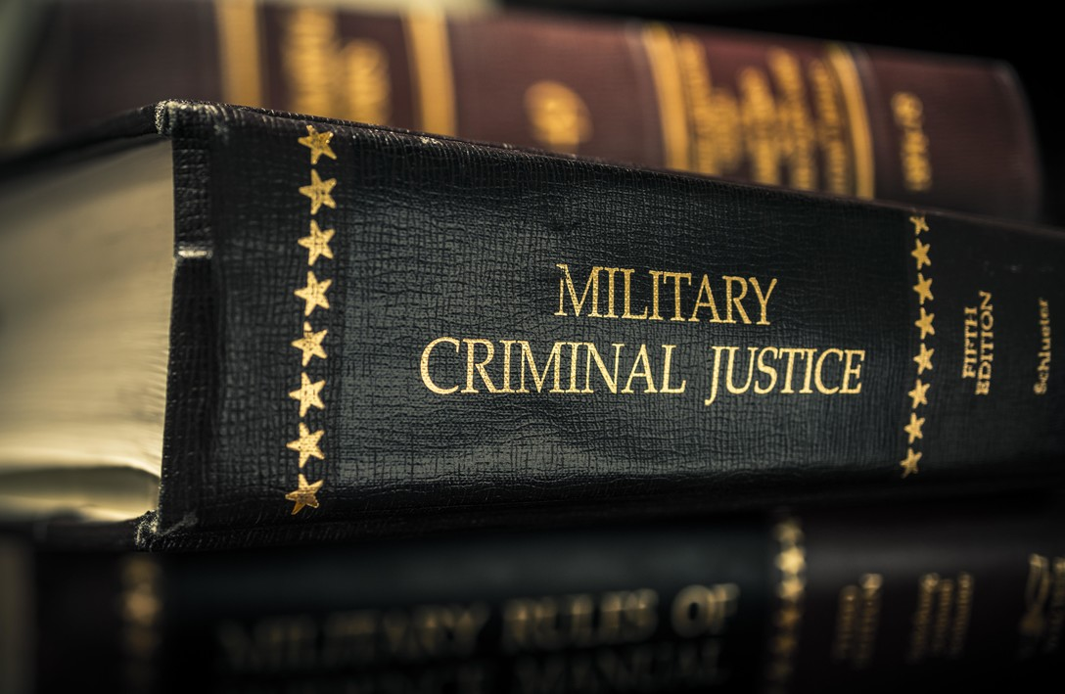
Image: https://www.af.mil/About-Us/The-Book/Enlisted-Ranks/igphoto/2001043985/
The final Supporting Question asks students, “What are today’s laws about following orders in the military?”
Students will answer this question by completing the Formative Performance Task of writing a summary of the current legal and military consensus on the acceptability of the superior orders defense. This final Formative Performance Task is intentionally less structured than the preceding three. Having practiced the skills of gathering and summarizing relevant evidence with the help of guiding questions and graphic organizers, students are now asked to practice these skills on their own.
Featured Source A is the “Principles of International Law Recognized in the Charter of the Nüremberg Tribunal and in the Judgment of the Tribunal, 1950.” By now, students should recognize two key principles they have encountered in varying forms in the previous Featured Sources:
Principle III
The fact that a person who committed an act which constitutes a crime under international law acted as Head of State or responsible Government official does not relieve him from responsibility under international law.

Principle IV
The fact that a person acted pursuant to order of his Government or of a superior does not relieve him from responsibility under international law, provided a moral choice was in fact possible to him.

Featured Source B is Article 33 of the 1998 Rome Statute of the International Criminal Court. The Rome Statute is the treaty that established the International Criminal Court. It established four principal international crimes: genocide, crimes against humanity, war crimes, and the crime of aggression. The ICC has authority to investigate and prosecute these crimes in cases where states are unable or unwilling to do so themselves. Article 33 specifically rejects the superior orders defense unless:
  - The person was under a legal obligation to obey orders of the Government or the superior in question;
  - The person did not know that the order was unlawful; and
  - The order was not manifestly unlawful.
The key word in the above passage is “and.” Superior orders is only a defense if the conditions in a., b., AND c. are met.
NOTE: Article 33 of the Rome Statute contains the terms “genocide” and “crimes against humanity.” For the statute’s definition of these terms, see Appendix A.
Featured Source C is an article titled, “When Can a Soldier Disobey an Order?” in which former military prosecutor and current U.S. Army Judge Advocate John Ford explains the circumstances under which a member of the American armed forces is permitted and, in fact, obligated to disobey a superior order. Ford provides examples from American history, including the massacre at My Lai in Vietnam and the torture of detainees at Abu Ghraib prison in Iraq. Ford explains that the Nuremberg standard—that a soldier must disobey manifestly illegal order—is the standard the U.S. service members must follow.
NOTE: The second-to-last paragraph of Featured Source C contains the following description of the abuses at Abu Ghraib:
Further, most of what went on at Abu Ghraib went far beyond anything authorized in any memo or order. Guards urinated on detainees, forced them to simulate oral sex on each other, forced them to remove their clothes and lie naked in piles together, and sodomized them with broomsticks. There were even instances of U.S. soldiers raping female inmates.
While this description is accurate without being graphic, it may be difficult or problematic for some students. As always, teachers should use their discretion and follow best practices when presenting sensitive historical content such as this. Teachers may want to edit this passage by rewording or inserting ellipses in a way that provides a less explicit description without changing the author’s point. If, on the other hand, teachers choose to present the article as written, they should be prepared to answer students’ questions about the content.
Featured Source D is a History.com article titled, “Why German Soldiers Don’t Have to Obey Orders,” in which journalist Erin Blakemore writes that “the brutal legacy of two world wars and the Holocaust explains Germany’s reticence to make its soldiers obey orders no matter what.” This reticence, Blakemore explains, has led to a duty to disobey not just an unlawful order (as in the Nuremberg principles and American military law) but any order that “is not ‘of any use for service,’ or cannot reasonably be executed. In fact, if the order denies human dignity to the armed forces member or the order’s target.”

Featured Source A:
Principles of International Law Recognized in the Charter of the Nüremberg Tribunal and in the Judgment of the Tribunal, 1950.
Accessed from: https://bit.ly/2MDN2sP

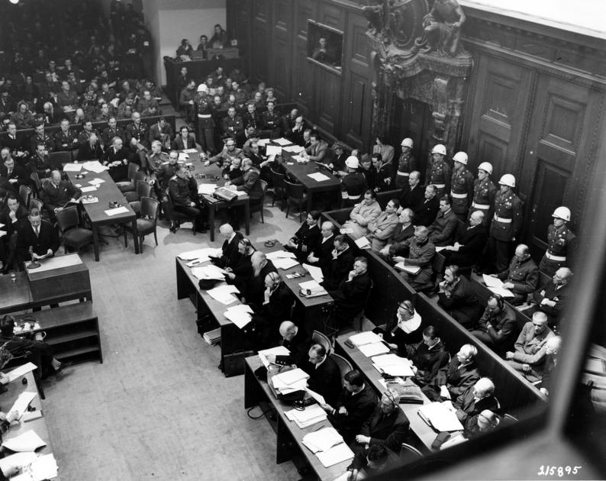
View of a packed courtroom at the Palace of Justice, Nuremberg, Germany, during the war crimes trials,
circa November 1945. Image: https://www.trumanlibrary.org/photographs/printRecord.php?id=11273

Principles of International Law Recognized in the Charter of the Nüremberg Tribunal and in the Judgment of the Tribunal, 1950.

Principle I
Any person who commits an act which constitutes a crime under international law is responsible therefor and liable to punishment.

Principle II
The fact that internal law does not impose a penalty for an act which constitutes a crime under international law does not relieve the person who committed the act from responsibility under international law.

Principle III
The fact that a person who committed an act which constitutes a crime under international law acted as Head of State or responsible Government official does not relieve him from responsibility under international law.

Principle IV
The fact that a person acted pursuant to order of his Government or of a superior does not relieve him from responsibility under international law, provided a moral choice was in fact possible to him.

Principle V
Any person charged with a crime under international law has the right to a fair trial on the facts and law.

Principle VI
The crimes hereinafter set out are punishable as crimes under international law:
  - Crimes against peace:
    - Planning, preparation, initiation or waging of a war of aggression or a war in violation of international treaties, agreements or assurances;
    - Participation in a common plan or conspiracy for the accomplishment of any of the acts mentioned under (i).
  - War crimes:
Violations of the laws or customs of war include, but are not limited to, murder, ill-treatment or deportation to slave-labour or for any other purpose of civilian population of or in occupied territory, murder or ill-treatment of prisoners of war, of persons on the seas, killing of hostages, plunder of public or private property, wanton destruction of cities, towns, or villages, or devastation not justified by military necessity.
  - Crimes against humanity:
Murder, extermination, enslavement, deportation and other inhumane acts done against any civilian population, or persecutions on political, racial or religious grounds, when such acts are done or such persecutions are carried on in execution of or in connection with any crime against peace or any war crime.

Principle VII
Complicity in the commission of a crime against peace, a war crime, or a crime against humanity as set forth in Principle VI is a crime under international law.

A person, any person involved in the military or head of state can be charged with a war crime and held responsible before criminal court.
4

Featured Source B:
Article 33 of the Rome Statute of the International Criminal Court, 1998.
Accessed from: https://www.icc-cpi.int/nr/rdonlyres/ea9aeff7-5752-4f84-be94-0a655eb30e16/0/rome_statute_english.pdf (p. 21)

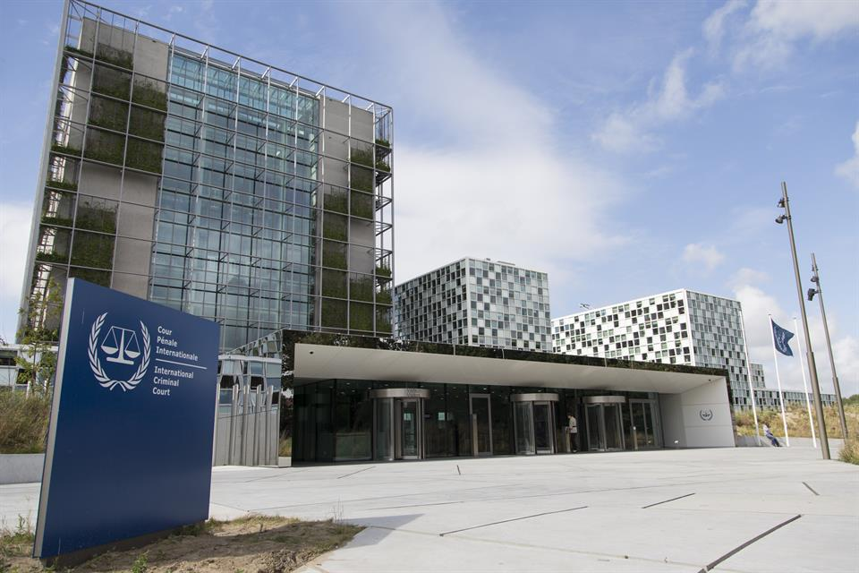
Image: https://www.icc-cpi.int/Pages/item.aspx?name=ma229

Article 33
Superior orders and prescription of law
- The fact that a crime within the jurisdiction of the Court has been committed by a person pursuant to an order of a Government or of a superior, whether military or civilian, shall not relieve that person of criminal responsibility unless:
  - The person was under a legal obligation to obey orders of the Government or the superior in question;
  - The person did not know that the order was unlawful; and
  - The order was not manifestly unlawful.
- For the purposes of this article, orders to commit genocide or crimes against humanity are manifestly unlawful.
A person, any person involved in the military or head of state can be charged with a war crime and held responsible before criminal court. Any orders of genocide or crimes against humanity are illegal and unlawful.

Featured Source C:
Ford, John. “When can a soldier disobey an order?” War on the Rocks. https://warontherocks.com/2017/07/when-can-a-soldier-disobey-an-order/. July 24, 2017. Accessed 5 October 2018.

WHEN CAN A SOLDIER DISOBEY AN ORDER?
JOHN FORD
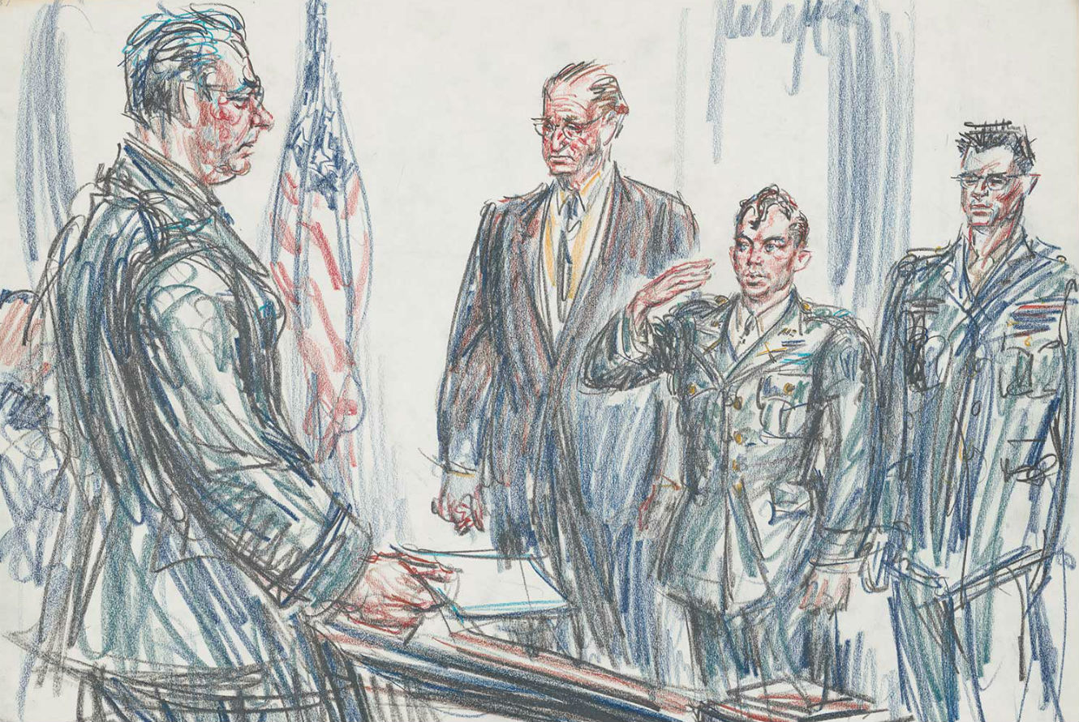
In March 1968, a U.S. infantry platoon under the command of 2nd Lt. William “Rusty” Calley conducted a raid of a hamlet called My Lai in Quang Ngai Province of South Vietnam. After taking the hamlet, Calley ordered his men to round up the remaining civilians, herd them into a ditch, and gun them down. Somewhere between 350 and 500 civilians were killed on Calley’s instruction.
Calley was court-martialed for his actions and charged with 22 counts of murder. At his trial, he testified that his company commander, Capt. Ernest Medina, had ordered him to kill “every living thing” in My Lai, telling him there were no civilians there, only Viet Cong. When Calley radioed back to Medina that the platoon had rounded up a large number of unarmed civilians, he claimed Medina told him to “waste them.” Essentially, Calley defended gunning down hundreds of civilians by saying he was just following orders from his superiors (It should be noted that Medina denied giving these orders).
But Calley was unable to hide behind this defense. Every military officer swears an oath upon commissioning. That oath is not to obey all orders. It is to “preserve, protect, and defend the Constitution of the United States against all enemies, foreign and domestic.” It is simply wrong to say Calley had an obligation to follow any order no matter what. His first obligation was to obey the law, and the law prohibits the deliberate killing of unarmed civilians.
But it’s not enough to assert that soldiers must follow all lawful orders and disobey unlawful ones. Not every case is clear-cut. Soldiers taking orders in combat must act quickly and don’t always have time to calmly deliberate on every decision. Asking soldiers to make fine legal distinctions in combat or else face court-martial is akin to asking them to sail between Scylla and Charybdis.
This tension is resolved by rules contained in the Manual for Courts Martial. The manual is an executive order that augments the Uniform Code of Military Justice by setting forth procedural rules and providing guidance based on case law for interpreting the code. Rule 916(d) of the Manual for Courts Martial says:
It is a defense to any offense that the accused was acting pursuant to orders unless the accused knew the orders to be unlawful or a person of ordinary sense and understanding would have known the orders to be unlawful.
Calley was convicted under this rule. The court found that “whether Calley was the most ignorant person in the United States Army in Vietnam or the most intelligent,” he would have to have known that it was illegal to slaughter civilians who were “demonstrably unable to defend themselves” and that the order was “palpably illegal.” The court noted that, “For 100 years, it has been a settled rule of American law that even in war the summary killing of an enemy who has submitted … is murder.”
So the order Calley tried to use as a shield against criminal liability ­– the order to slaughter civilians – was so clearly illegal that any reasonable person would have known it was illegal …
As My Lai shows ... there are cases where an order would clearly violate the law. An order to torture a detainee would be one. Every soldier is trained to know that torture is illegal. The U.N. Convention Against Torture, to which the United States is a party, prohibits cruel, inhumane, or degrading treatment of detainees. Army Field Manual 2-22.3, which governs human intelligence collection, also bans torture. It permits 19 types of interrogation techniques, none of which could be considered torture, and two of which require special authorization to use. Under the McCain amendment to the 2006 National Defense Authorization Act, no Department of Defense employee may use any interrogation technique not authorized under the Army Field Manual. Torture is also explicitly prohibited by DoD Directive 3115.09.
It would be palpably illegal to give an order to torture a prisoner. There is no defensible legal argument that interrogation techniques such as waterboarding are permitted. No soldier, sailor, or airman would be in a position to plead ignorance of the law. Any member of the military who received such an order would not just be allowed to disobey it – they would be required to do so. Otherwise, they would face the threat of criminal charges under Article 92 of the UCMJ, for dereliction of duty in failing to follow lawful regulations and for cruelty and maltreatment, and Article 134, for general misconduct to the prejudice of good order and discipline. The officer would also be at risk of being charged for conduct unbecoming under Article 133.
This is exactly what happened after the conditions at Abu Ghraib prison were made public in 2004. The lurid details of widespread abuse of prisoners, including sexual abuse and humiliation, are by now well-known. Eleven soldiers were found guilty of various charges at court-martial for their involvement in prisoner abuse. Two senior officers who had overseen the prison, Lt. Col. Steven Jordan and Col. Thomas Pappas, also faced disciplinary action for their dereliction in supervising the facility.
Some of the soldiers involved in the abuse tried to assert superior orders as a defense, though none were successful. It was true that Lt. Gen. Ricardo Sanchez, the commander of U.S. forces in Iraq, had authorized the use of dogs, sleep deprivation, and extreme temperature exposure as interrogation techniques. None of these were permitted by the Army Field Manual in place at the time, FM 34-52. They should not have been authorized and Sanchez’s memo was an illegal order, though he ultimately faced no disciplinary action for it. Because the soldiers involved in the scandal were assigned to detainee operations, they would have been expected to know what techniques were and were not authorized by the manual. The only way they could defend themselves from the charge of dereliction in knowingly failing to follow the rules would be to admit they committed the crime of dereliction by not bothering to learn the rules.
Further, most of what went on at Abu Ghraib went far beyond anything authorized in any memo or order. Guards urinated on detainees, forced them to simulate oral sex on each other, forced them to remove their clothes and lie naked in piles together, and sodomized them with broomsticks. There were even instances of U.S. soldiers raping female inmates. None of this was authorized at any level, nor could it have been authorized. Any soldier who was ordered to do any of this should have immediately understood that the order was illegal and would have been obligated to disobey and report the abuse...
The military is a hierarchical organization. Some degree of obedience to the orders of superior officers is required for the organization to function. But those who serve in the U.S. military are not automatons, and they are not asked to surrender all independent moral judgment when they sign their enlistment papers. American service members are defending a nation of laws, not of men. Their obligation to obey the orders of their superiors does not include orders that are palpably illegal.

John Ford is a former military prosecutor and a current reserve U.S. Army Judge Advocate. He now practices law in California. You can follow him on twitter at @johndouglasford.
Image: Howard Brodie/Library of Congress

Featured Source D:
Blakemore, Erin. “Why German soldiers don’t have to obey orders.” History. https://www.history.com/news/why-german-soldiers-dont-have-to-obey-orders. Nov. 7, 2017. Accessed 5 October 2018.

Why German Soldiers Don’t Have to Obey Orders
ERIN BLAKEMORE

Consider, if you will, a fraught military standoff. A soldier from the German army receives an order from a superior to fire his gun, but he puts it down and walks away. In the United States, he would have just committed the unforgivable and illegal act of insubordination, even if the superior officer weren’t from the same service branch.
But in this scenario, the German soldier didn’t break the rules—he followed them. Military disobedience is actually baked into the German Bundeswehr, or armed forces. And the reasons why can be found in the country’s sinister past.
American military law states that an order can only be disobeyed if it is unlawful. However, the German military manual states that a military order is not binding if it is not “of any use for service,” or cannot reasonably be executed. In fact, if the order denies human dignity to the armed forces member or the order’s target, it must not be obeyed.
In practice, that means that a soldier or armed forces administrator can ignore a superior officer’s order—even if it’s in the midst of combat or is given by a high-ranking official.
That’s not how it used to be. Unconditional obedience to military orders was once a norm going back to the kingdoms that preceded Germany before it became a nation state in 1871. During World War I, Germany executed 48 soldiers for insubordination, and its basic training regimen—designed around unconditional submission to higher officers—was known as one of Europe’s most brutal.
After World War I, this discipline softened thanks to the Allied forces, which blamed the country’s strict military hierarchy for the ruthlessness of World War I. Under the Treaty of Versailles, Germany was forced to admit guilt for the war and to restrict its military’s numbers and weapons. The country’s military was effectively dismantled, with officer schools shut down and the number of troops reduced to just 100,000.
However, Germany had no intention of following the treaty’s military provisions. Soon after the treaty was signed, German general Hans von Seeckt began to reorganize and secretly rebuild the military with the help of Russia. German companies began producing forbidden arms on Russian soil and German troops trained with Russian soldiers—all in secret.
By the time Adolf Hitler came into power in 1933 with promises to revive the country’s former might, the German public was ready for it. Hitler immediately began to openly flout the treaty. As he brought Germany’s secretive postwar military into the open, they began pledging their loyalty directly to him. From 1934 on, the German military oath was sworn to Hitler himself—and it contained a clause that promised “unconditional obedience.”
That rule was taken seriously during the lead up to World War II and the conflict itself. At least 15,000 German soldiers were executed for desertion alone, and up to 50,000 were killed for often minor acts of insubordination. An unknown number were summarily executed, often in the moment, by their officers or comrades when they refused to follow commands.
This wasn’t always the case. Historian David H. Kitterman’s research on a group of 135 German soldiers who refused orders to kill Jews, POWs or hostages shows they suffered beatings and death threats for defying their superiors, but none were executed. Although insubordination was taken seriously, excuses that soldiers had “just been obeying orders” when they participated in Holocaust atrocities weren’t entirely true.
When the war ended, the Allies assumed control of Germany and decommissioned its entire military. It took a decade for Germany—now split in two—to regain a military, and in 1955 a new Bundeswehr was created.
The new German armed forces were a different beast than their predecessors. German law forbids the use of its military to do anything other than defend Germany itself, though the military does participate in some humanitarian and NATO coalition missions. Instead of blind obedience, the military emphasizes Innere Führung, a hard-to-translate concept that centers the military experience around the inner conscience of each individual.
As a result, many German soldiers refuse combat assignments or disobey orders—with no consequence. Their ability to do so has been repeatedly held up in civil courts (Germany has no military courts) and in the federal government. In 2007, the German federal government even went so far as to state that German law means unconditional authority or loyalty to superiors can’t exist. Soldiers must not obey unconditionally, the government wrote, but carry out “an obedience which is thinking.” However, the policy statement added, soldiers can’t disobey an order merely because their personal views conflict with those of their superior.
Nowhere is that conception of conscientious military service more apparent than at the Benderblock, a Berlin building where participants of a failed attempt to assassinate Hitler were executed in 1944. Today, the building is a museum to German resistance—and every year, it’s the place where new German soldiers are traditionally sworn to their duties.
It’s intentional that their oaths to defend Germany are sworn in a place not of military obedience, but of military resistance. The brutal legacy of two world wars and the Holocaust explains Germany’s reticence to make its soldiers obey orders no matter what.

Summative Performance Task - Overview for the Teacher

Summative Performance Task

ARGUMENT
Is “I was only following orders” an acceptable defense? Construct an argument (e.g., detailed outline, poster, essay) that discusses the compelling question using specific claims and relevant evidence from historical sources while acknowledging competing views.

EXTENSION
While the Rome Statute is clear that soldiers have an obligation to disobey a “manifestly unlawful” order, it does not state what makes an order “manifestly unlawful.” Work in teams to rewrite the Rome Statute so that it offers a clear statement of what makes an order “manifestly unlawful” so that it is less confusing to officers and soldiers.

Constructing an Argument

At this point in the inquiry, students have examined the historic uses of the superior orders defense from its first known appearance in the 15th century, to the Nuremberg trials, and to the present. They have seen that at times the superior orders defense has provided an absolute shield against charges of war crimes, but at other times it has afforded no protection at all. Students have learned that while the superior orders defense is generally rejected by international law since the Nuremberg trials, the soldier’s responsibility to follow or reject orders is interpreted differently in different nations and under different circumstances.

What should be the standard applied to the superior orders defense? In this task, students construct and extended, evidence-based argument responding to the Compelling Question, “I was only following orders! Is this an acceptable defense?”

This response may take the form or forms that the teacher deems most appropriate for their students. For example, the argument could be in the form of a detailed outline, a poster, an essay, a video, or any other creative format the teacher and student may decide is best for constructing their argument and supporting it with evidence.

Extension
Professor Gary D. Solis writes,
What can be said with some assurance is that military defendants will raise the defense of superior orders, ancient as it is, in the future. Moreover, subordinates will obey illegal orders, given the overwhelming influence of the military hierarchical structure—particularly in the lower ranks and in combat.
The defense has seldom prevailed in the past, while its application, more important than ever, has not grown clearer in today's world. Finally, those who devote their energies to military justice and to international law will continue to wrestle with definitions, intent, and the accused’s understanding. As one United States Army commander said after a recent training exercise, “I know that if I ever go to war again, the first person I’m taking is my lawyer,” indicating that commanders require the counsel of their judge advocates more than ever.

As the students learned in Supporting Question 4, Article 33 of the Rome Statute of the International Criminal Court establishes that the fact that a crime was committed pursuant to superior orders does not relieve the perpetrator of criminal responsibility if the order was “manifestly unlawful.” The statute adds that, “for the purposes of this article, orders to commit genocide or crimes against humanity are manifestly unlawful.”

How could this standard be made clearer? What kind of conduct should be considered “manifestly unlawful?” Are there universal standards of behavior that exist even in war? If so, can this behavior be clearly defined so that an Army commander does not feel the need to take a lawyer with them to war?

In this extension activity, students work in teams to rewrite the Rome Statute so that it offers a clearer statement of what makes an order “manifestly unlawful” so that it is less confusing to officers and soldiers.

Taking Informed Action

Overview for the Teacher

Now it’s time for students to take what they’ve learned and put it into action in today’s world.

Today, as in 1474, international law and the military law of most nations rejects the superior orders defense in cases where the accused obeyed orders that are manifestly unlawful. This however, has not stopped its use as a defense.

In this activity, students civically engage this issue by understanding, assessing, and acting in response to a recent case in which “just following orders” is raised by those at the highest levels of the United States government in defense of the acts of CIA director Gina Haspel.

UNDERSTAND
Research a recent case in which someone accused of committing atrocities has used the superior orders defense: “Washington Breaks Out the ‘Just Following Orders’ Nazi Defense for CIA Director-Designate Gina Haspel,” The Intercept, 15 March 2018.

ASSESS
Evaluate the circumstances of the case and determine whether the “superior orders” defense is acceptable in this case.

ACT
Write an editorial response to the publisher expressing agreement or disagreement with the article’s argument. Use evidence from this inquiry to support your argument.

The Featured Source is an article titled “Washington breaks out the “just following orders” Nazi defense for CIA director-designate Gina Haspel,” published just prior to the Senate confirmation hearings for Gina Haspel, who was nominated by President Donald Trump to be Director of Central Intelligence. Haspel was a controversial choice for CIA director because she “oversaw a secret ‘black site’ in Thailand, at which prisoners were waterboarded and subjected to other severe forms of abuse. Haspel later participated in the destruction of the CIA’s videotapes of some of its torture sessions.” The Senate confirmed Haspel’s nomination.
After a brief description of the Nuremberg defense, the author states that the United Nations’ rejection of the defense
...is likely the most famous declaration in the history of international law and is as settled as anything possibly can be.
However, many members of the Washington, D.C. elite are now stating that it, in fact, is a legitimate defense for American officials who violate international law to claim they were just following orders.
Specifically, they say Gina Haspel, a top CIA officer whom President Donald Trump has designated to be the agency’s next director, bears no responsibility for the torture she supervised during George W. Bush’s administration.

Practicing the Historian Skill of “Sourcing”
The piece was written by journalist Jon Schwartz for The Intercept, a news website dedicated to what it calls “adversarial journalism.” The Intercept states that it “gives its journalists the editorial freedom and legal support they need to pursue investigations that expose corruption and injustice wherever they find it and hold the powerful accountable.”
As you might have guessed from that description, The Intercept is not a news organization that is afraid to take a position on issues. While journalist Jon Schwartz quotes members of both political parties who both support and oppose Ms. Haspel’s nomination, the author clearly takes a position in opposition to her confirmation as Director of Central Intelligence. The fact that Mr. Schwartz takes a position, rather than striving for some a sort of “he said, she said” neutrality in reporting the debate, makes this article provocative for the student, and gives them the opportunity to respond to Schwartz’s argument and take a position of their own.
As a pre-reading reading activity, ask your students to practice the historian skill of sourcing by reading The Intercept’s “About Us” page, which is the source of the description in the previous paragraph. Ask the students to consider what kind of position they predict the article will take, based on the information they have from the “About Us” page and the title of the article. Follow up during and after the reading by asking students what position the author took, and how the author supported their argument. Did they use evidence to support their claims, or just assert their opinion? Who did they quote for the article? Did they only quote people they agree with, or did they acknowledge opposing claims? Did they quote only people from one political party?

Assessing the Case
This article presents students with many opportunities to apply what they have learned about the history of the superior orders defense and its current standing in international and military law.
Schwartz reports that Michael Hayden, former director of both the CIA and the National Security Agency, who served under Presidents Clinton, Bush, and Obama, endorsed Haspel as head of the CIA in an op-ed, writing that “Haspel did nothing more and nothing less than what the nation and the agency asked her to do, and she did it well.”
Schwartz continues:
Hayden later said on Twitter that Haspel’s actions were “consistent with U.S. law as interpreted by the department of justice.” This is true: In 2002, the Office of Legal Counsel at the Justice Department declared in a series of notorious memos that it was legal for the U.S. to engage in “enhanced interrogation techniques” that were obviously torture. Of course, the actions of the Nuremberg defendants had also been “legal” under German law.
This is an opportunity to ask students to refer to their research in this unit. If it was “obviously torture,” does it matter that the government said it was legal? What does the Rome Statute say about laws that are “manifestly illegal”?
Texas Republican Rep. Will Hurd, a member of the House Intelligence Committee and a former CIA operative, defended Haspel by arguing, “You have to remember where we were at that moment, thinking that another attack was going to happen.”
Schwartz responds:
This is another defense that is explicitly illegitimate under international law. The U.N. Convention Against Torture, which was transmitted to the Senate by Ronald Reagan in 1988, states that “no exceptional circumstances whatsoever, whether a state of war or a threat or war, internal political instability or any other public emergency, may be invoked as a justification of torture.”
This provides another opportunity for students to apply their learning: Does the 1988 convention mean that Ms. Haspel should have known that her orders to torture were unlawful and therefore should not have been obeyed? What have courts ruled on cases when a perpetrator “should have known” that an order was unlawful, even though it was in fact legal according to their superiors?
Samantha Winograd, who served on President Obama’s National Security Council and now is an analyst for CNN, likewise used Nuremberg defense language in an appearance on the network. Haspel, she said, “was implementing the lawful orders of the president… You could argue she should have quit because the program was so abhorrent. But she was following orders.”
Should she have quit? What does Winograd imply when she says “but she was following orders?” Is she saying that it was good or that it was bad?
Schwartz concludes the article with a statement from Senator Rand Paul:
Remarkably, this perspective has even seeped into the viewpoint of regular journalists. At a recent press conference at which Kentucky Republican Sen. Rand Paul criticized Haspel, a reporter asked him to respond to “the counterargument” that “these policies were signed off by the Bush administration… They were considered lawful at the time.”
It fell to Paul to make the obvious observation that appears to have eluded almost everyone else in official Washington: “This has been historically a question we’ve asked in every war: Is there a point at which soldiers say ‘no’? … Horrendous things happened in World War II, and people said, well, the German soldiers were just obeying orders … I think there’s a point at which, even suffering repercussions, that if someone asks you to torture someone that you should say no.”
Once again, does it matter that Haspel’s actions were “considered lawful at the time?” Who “considered” these acts lawful? What do the cases and laws you have studied say about this?

Featured Source
Schwartz, Jon. “Washington Breaks Out the ‘Just Following Orders’ Nazi Defense for CIA Director-Designate Gina Haspel,” The Intercept. https://theintercept.com/2018/03/15/washington-breaks-out-the-just-following-orders-nazi-defense-for-cia-director-designate-gina-haspel/. 15 March 2018. Accessed 5 October 2017.

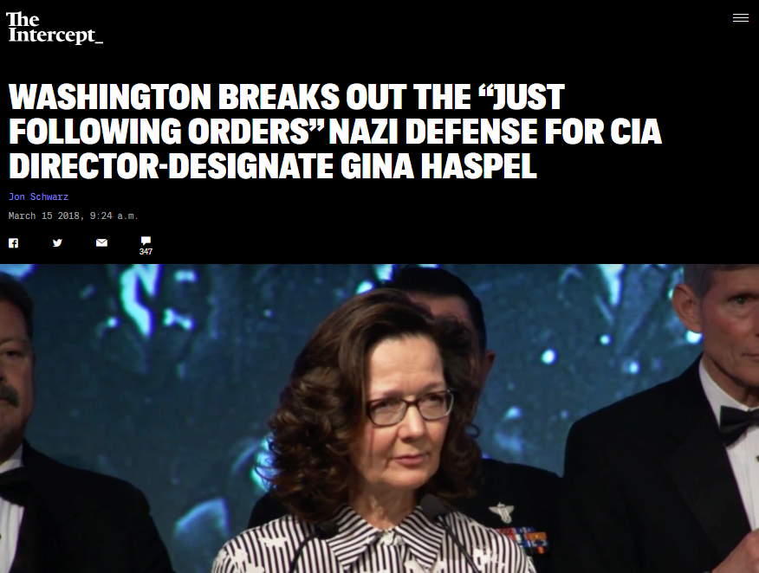
DURING THE NUREMBERG TRIALS after World War II, several Nazis, including top German generals Alfred Jodl and Wilhelm Keitel, claimed they were not guilty of the tribunal’s charges because they had been acting at the directive of their superiors.
Ever since, this justification has been popularly known as the “Nuremberg defense,” in which the accused states they were “only following orders.”
The Nuremberg judges rejected the Nuremberg defense, and both Jodl and Keitel were hanged. The United Nations International Law Commission later codified the underlying principle from Nuremberg as “the fact that a person acted pursuant to order of his Government or of a superior does not relieve him from responsibility under international law, provided a moral choice was in fact possible to him.”
This is likely the most famous declaration in the history of international law and is as settled as anything possibly can be.
However, many members of the Washington, D.C. elite are now stating that it, in fact, is a legitimate defense for American officials who violate international law to claim they were just following orders.
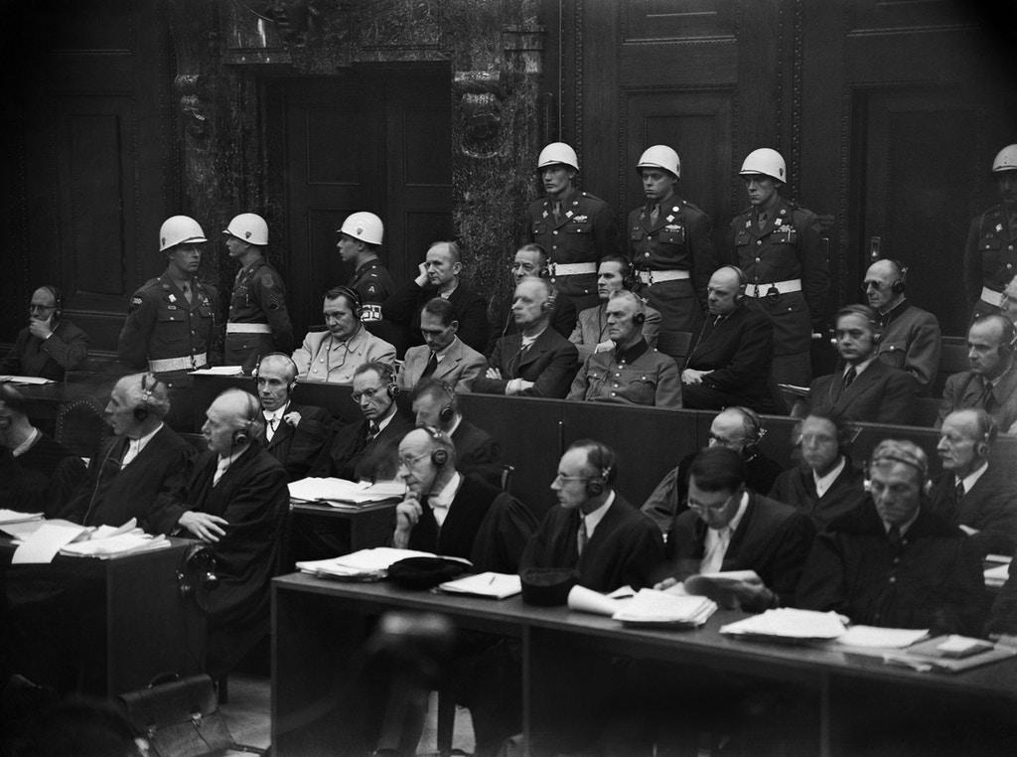
View of some of the Nazi leaders accused of war crimes during World War II during the war crimes trial at Nuremberg International Military Tribunal court, held between Nov. 20, 1945 and Oct. 1, 1946. Photo: Stringer/AFP/Getty Images.
Specifically, they say Gina Haspel, a top CIA officer whom President Donald Trump has designated to be the agency’s next director, bears no responsibility for the torture she supervised during George W. Bush’s administration.
Haspel oversaw a secret “black site” in Thailand, at which prisoners were waterboarded and subjected to other severe forms of abuse. Haspel later participated in the destruction of the CIA’s videotapes of some of its torture sessions. There is informed speculation that part of the CIA’s motivation for destroying these records may have been that they showed operatives employing torture to generate false “intelligence” used to justify the invasion of Iraq.
John Kiriakou, a former CIA operative who helped capture many Al Qaeda prisoners, recently said that Haspel was known to some at the agency as “Bloody Gina” and that “Gina and people like Gina did it, I think, because they enjoyed doing it. They tortured just for the sake of torture, not for the sake of gathering information.” (In 2012, in a convoluted case, Kiriakou pleaded guilty to leaking the identity of a covert CIA officer to the press and spent a year in prison.)
Some of Haspel’s champions have used the exact language of the popular version of the Nuremberg defense, while others have paraphrased it.
One who paraphrased it is Michael Hayden, former director of both the CIA and the National Security Agency. In a Wednesday op-ed, Hayden endorsed Haspel as head of the CIA, writing that “Haspel did nothing more and nothing less than what the nation and the agency asked her to do, and she did it well.”
Hayden later said on Twitter that Haspel’s actions were “consistent with U.S. law as interpreted by the department of justice.” This is true: In 2002, the Office of Legal Counsel at the Justice Department declared in a series of notorious memos that it was legal for the U.S. to engage in “enhanced interrogation techniques” that were obviously torture. Of course, the actions of the Nuremberg defendants had also been “legal” under German law.
John Brennan, who ran the CIA under President Barack Obama, made similar remarks on Tuesday when asked about Haspel. The Bush administration had decided that its torture program was legal, said Brennan, and Haspel “tried to carry out her duties at CIA to the best of her ability, even when the CIA was asked to do some very difficult things.”
Texas Republican Rep. Will Hurd used the precise language of the Nuremberg defense during a Tuesday appearance on CNN when Wolf Blitzer asked him to respond to a statement from Sen. John McCain, R-Ariz.: “The Senate must do its job in scrutinizing the record and involvement of Gina Haspel in this disgraceful program.”
Hurd, a member of the House Intelligence Committee and a former CIA operative as well, told Blitzer that “this wasn’t Gina’s idea. She was following orders ... She implemented orders and was doing her job.”
Hurd also told Blitzer, “You have to remember where we were at that moment, thinking that another attack was going to happen.”
This is another defense that is explicitly illegitimate under international law. The U.N. Convention Against Torture, which was transmitted to the Senate by Ronald Reagan in 1988, states that “no exceptional circumstances whatsoever, whether a state of war or a threat or war, internal political instability or any other public emergency, may be invoked as a justification of torture.”
Notably, Blitzer did not have any follow-up questions for Hurd about his jarring comments.
Samantha Winograd, who served on President Obama’s National Security Council and now is an analyst for CNN, likewise used Nuremberg defense language in an appearance on the network. Haspel, she said, “was implementing the lawful orders of the president… You could argue she should have quit because the program was so abhorrent. But she was following orders.”
Last but not least there’s Rich Lowry, editor of National Review, who issued a ringing defense of Haspel in Politico, claiming she was merely acting “in response to what she was told were lawful orders.”
Remarkably, this perspective has even seeped into the viewpoint of regular journalists. At a recent press conference at which Kentucky Republican Sen. Rand Paul criticized Haspel, a reporter asked him to respond to “the counterargument” that “these policies were signed off by the Bush administration… They were considered lawful at the time.”
It fell to Paul to make the obvious observation that appears to have eluded almost everyone else in official Washington: “This has been historically a question we’ve asked in every war: Is there a point at which soldiers say ‘no’? … Horrendous things happened in World War II, and people said, well, the German soldiers were just obeying orders … I think there’s a point at which, even suffering repercussions, that if someone asks you to torture someone that you should say no.”
(Thank you to @jeanbilly545 and Scott Horton for telling me about Hurd and Paul’s remarks, respectively.)
Top photo: Gina Haspel speaks at the 2017 William J. Donovan Award Dinner.

Appendix A: Definitions of “Genocide” and “Crimes Against Humanity” from the Rome Statute of the International Criminal Court.
Accessed from: Rome Statute of the International Criminal Court (https://www.icc-cpi.int/nr/rdonlyres/ea9aeff7-5752-4f84-be94-0a655eb30e16/0/rome_statute_english.pdf)

Article 6

Genocide
For the purpose of this Statute, "genocide" means any of the following acts committed with intent to destroy, in whole or in part, a national, ethnical, racial or religious group, as such:
  - Killing members of the group;
  - Causing serious bodily or mental harm to members of the group;
  - Deliberately inflicting on the group conditions of life calculated to bring about its physical destruction in whole or in part;
  - Imposing measures intended to prevent births within the group;
  - Forcibly transferring children of the group to another group.

Article 7
Crimes against humanity
- For the purpose of this Statute, "crime against humanity" means any of the following acts when committed as part of a widespread or systematic attack directed against any civilian population, with knowledge of the attack:
  - Murder;
  - Extermination;
  - Enslavement;
  - Deportation or forcible transfer of population;
  - Imprisonment or other severe deprivation of physical liberty in violation of fundamental rules of international law;
  - Torture;
  - Rape, sexual slavery, enforced prostitution, forced pregnancy, enforced sterilization, or any other form of sexual violence of comparable gravity;
  - Persecution against any identifiable group or collectivity on political, racial, national, ethnic, cultural, religious, gender as defined in paragraph 3, or other grounds that are universally recognized as impermissible under international law, in connection with any act referred to in this paragraph or any crime within the jurisdiction of the Court;
  - Enforced disappearance of persons;
  - The crime of apartheid;
  - Other inhumane acts of a similar character intentionally causing great suffering, or serious injury to body or to mental or physical health.
- For the purpose of paragraph 1:
  - "Attack directed against any civilian population" means a course of conduct involving the multiple commission of acts referred to in paragraph 1 against any civilian population, pursuant to or in furtherance of a State or organizational policy to commit such attack;
  - "Extermination" includes the intentional infliction of conditions of life, inter alia the deprivation of access to food and medicine, calculated to bring about the destruction of part of a population;
  - "Enslavement" means the exercise of any or all of the powers attaching to the right of ownership over a person and includes the exercise of such power in the course of trafficking in persons, in particular women and children;
  - "Deportation or forcible transfer of population" means forced displacement of the persons concerned by expulsion or other coercive acts from the area in which they are lawfully present, without grounds permitted under international law;
  - "Torture" means the intentional infliction of severe pain or suffering, whether physical or mental, upon a person in the custody or under the control of the accused; except that torture shall not include pain or suffering arising only from, inherent in or incidental to, lawful sanctions;
  - "Forced pregnancy" means the unlawful confinement of a woman forcibly made pregnant, with the intent of affecting the ethnic composition of any population or carrying out other grave violations of international law. This definition shall not in any way be interpreted as affecting national laws relating to pregnancy;
  - "Persecution" means the intentional and severe deprivation of fundamental rights contrary to international law by reason of the identity of the group or collectivity;
  - "The crime of apartheid" means inhumane acts of a character similar to those referred to in paragraph 1, committed in the context of an institutionalized regime of systematic oppression and domination by one racial group over any other racial group or groups and committed with the intention of maintaining that regime;
  - "Enforced disappearance of persons" means the arrest, detention or abduction of persons by, or with the authorization, support or acquiescence of, a State or a political organization, followed by a refusal to acknowledge that deprivation of freedom or to give information on the fate or whereabouts of those persons, with the intention of removing them from the protection of the law for a prolonged period of time.
- For the purpose of this Statute, it is understood that the term "gender" refers to the two sexes, male and female, within the context of society. The term "gender" does not indicate any meaning different from the above.

Sample Resources
Below is an annotated list of Internet resources for this organizing topic. Copyright restrictions may exist for the material on some Web sites. Please note and abide by any such restrictions.
“Holocaust Encyclopedia.” United States Holocaust Memorial Museum
“Echoes & Reflections” Echoes & Reflections. This site offers lesson plans and correlated primary and secondary sources to teach this topic to secondary students.
“IWitness” USC-Shoah Foundation. This interactive platform has activities, pre-curated clips and other materials to teach the Holocaust and other world genocides.
“Teach” United States Holocaust Memorial Museum. This site offers lesson plans to educators across a variety of interconnected topics.
“Facing History and Ourselves.” Facing History. This site offers lesson plans to educators across a variety of interconnected topics.“What We Carry” The Holocaust Commission of the United Jewish Federation of Tidewater. These developed lessons allow students to learn from a Virginia-affiliated witness to the Holocaust. Lessons are aligned to specific Virginia Social Studies Standards of Learning Outcomes and include ideas for differentiation.
“Resources for Teachers” Virginia Holocaust Museum. This site contains a variety of resources to aid teachers in instructing about the Holocaust and other world genocides including connections to Virginia survivors of these atrocities.

Other Compelling Questions to Consider . . . .

- Were American Indians the Victims of Genocide?
  - TEN STAGES OF AMERICAN INDIAN GENOCIDE
  - Indian Removal Act: The Genocide of Native Americans
  - Removing Native Americans from their Land
  - “Cultural Genocide” and Native American Children
- What conditions foster genocide?
  - What is genocide? (USHMM Simon-Skojdt Center)
  - County Case Studies (USHMM Simon-Skojdt Center)
  - Early Warning Project (USHMM Simon Skojdt Center)
- What areas of the world are at risk for genocide today?
  - County Case Studies (USHMM Simon-Skojdt Center)

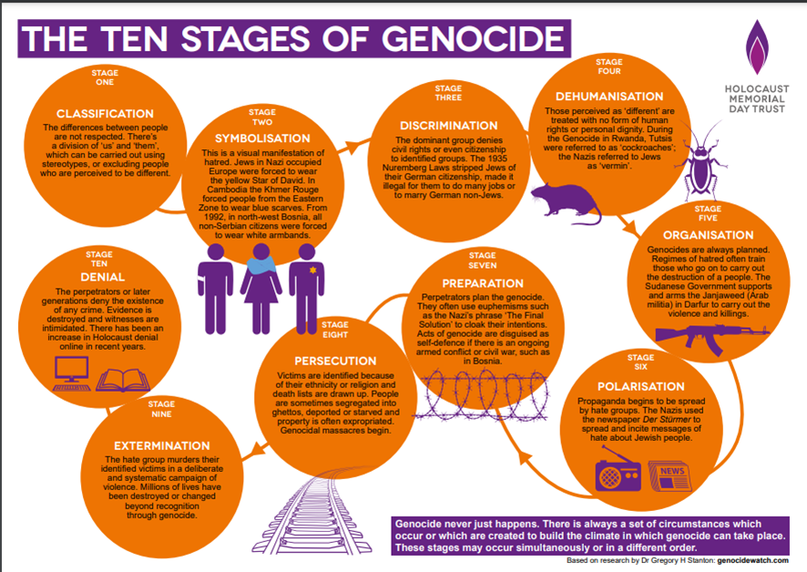
Early Warning Project (USHMM Simon Skojdt Center)Ten Stages of Genocide

We would sincerely appreciate your feedback on this resource guide.
Please click here to take a short survey.

Echoes & Reflections Definitions can be found at https://echoesandreflections.org/audio_glossary/
These questions are adapted from Echoes & Reflections Unit 3: Nazi Germany, located at https://echoesandreflections.org/unit-3/?state=open#content
Biography courtesy of Echoes & Reflections at https://echoesandreflections.org/wp-content/uploads/2017/07/03-01-02-01-Caro.Alfred_Biography.pdf
Biography courtesy of Echoes & Reflections at https://echoesandreflections.org/wp-content/uploads/2017/07/03-01-02-02-Shurman.Frank_Biography.pdf
Handout courtesy of the United States Memorial Museum found at: https://encyclopedia.ushmm.org/content/en/article/the-nazi-rise-to-power
Map courtesy of the United States Holocaust Memorial Museum at https://encyclopedia.ushmm.org/content/en/map/european-jewish-population-distribution-ca-1933?parent=en%2F11150
Map courtesy of Echoes & Reflections at https://echoesandreflections.org/wp-content/uploads/2020/12/02-02-02_Map_JewishCommunitiesEurope_BeforeNaziRise.pdf
Biography courtesy of Echoes & Reflections https://echoesandreflections.org/wp-content/uploads/2017/07/02-01-03-03-Lambert.Margaret_Biography.pdf
Definition courtesy of Echoes & Reflections at https://echoesandreflections.org/wp-content/themes/twentysixteenechoes/fileview.php?source=1&file_nm=2017/07/02-01-09_StudentHandout_AntisemitismDefinition.pdf
The USHMM Holocaust Encyclopedia Entry on Antisemitism can be found at: https://encyclopedia.ushmm.org/content/en/article/antisemitism
Pyramid of Hate courtesy of Echoes & Reflections at: https://echoesandreflections.org/wp-content/themes/twentysixteenechoes/fileview.php?source=1&file_nm=2018/12/ERPyramid-Final12.2018.pdf
The USHMM Holocaust Encyclopedia Entry on the Armenian Genocide can be found at: https://encyclopedia.ushmm.org/content/en/article/the-armenian-genocide-1915-16-overview
The USHMM Holocaust Encyclopedia Entry on the Rwandan Genocide can be found at: https://encyclopedia.ushmm.org/content/en/article/the-rwanda-genocide
This handout is adapted from University of Minnesota’s Holocaust & Genocide Studies site: https://cla.umn.edu/chgs/holocaust-genocide-education/resource-guides/holodomor
The USHMM Holocaust Encyclopedia Entry on Darfur can be found at: https://encyclopedia.ushmm.org/content/en/article/darfur
Adapted from Facing History & Ourselves at https://www.facinghistory.org/sites/default/files/Starburst_Identity_Chart.pdf
This handout originated from the United States Holocaust Memorial Museum lesson plan for The Path to Nazi Genocide at https://www.ushmm.org/m/pdfs/20171019_Introduction_to_the_Holocaust_Combined.pdf
Source: https://www.facinghistory.org/sites/default/files/KWL_Chart_handout_v.final_.pdf

