Green Link

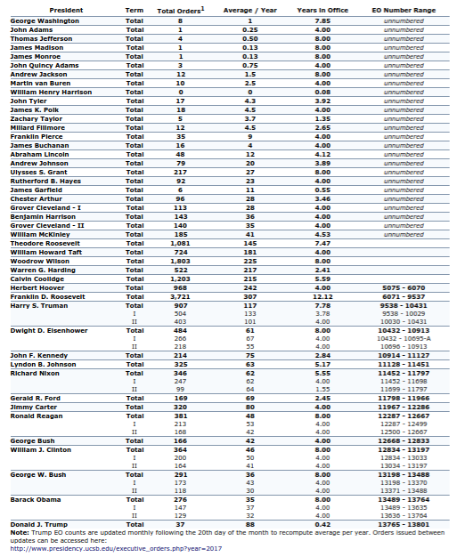
Last Update: Data through June 20, 2017.

Citation: Gerhard Peters and John T. Woolley, "Executive Orders." The American Presidency Project. Ed. John T. Woolley and Gerhard Peters. Santa Barbara, CA. 1999-2017. Available from the World Wide Web: http://www.presidency.ucsb.edu/data/orders.php.
Notes:
¹ 1789 to 1945 (Roosevelt) data includes "numbered" and "unnumbered" executive orders. 1945 (Truman) & 1967 (Johnson) data includes only numbered executive orders including those with letter designations (ex. Executive Order 9577-A).
Data Sources:
• 1789 - 1945 (Roosevelt) data from Lyn Ragsdale, "Vital Statisitcs on the Presidency: Washington to Clinton." rev. ed. (Washington, D.C.: CQ Press, 1998); data compiled by John Woolley, The American Presidency Project; and figures from the National Archives and Records Administration.
• 1945 (Truman) - present data compiled by Gerhard Peters, The American Presidency Project, from documents contained in the Federal Register.

"Executive Orders Washington-Trump." Executive Orders. The American Presidency Project, n.d. Web. 30 June 2017.

