Yellow Link
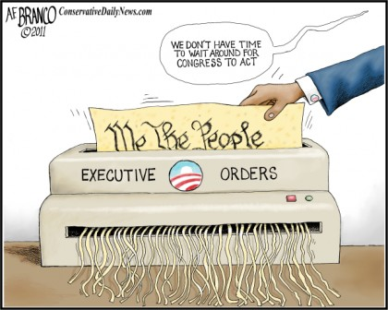
Bronco, A. F. Conservative Daily News, 2011. Web. 20 June 2017.

Yellow Link
Bronco, A. F. Conservative Daily News, 2011. Web. 20 June 2017.

