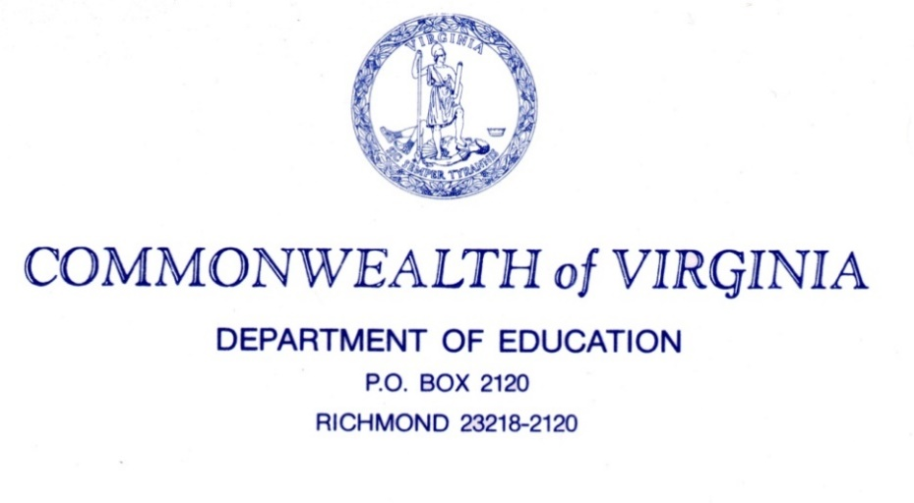

SNP Memo #2018-2019-07
TO: Directors, Supervisors, and Contact Persons Addressed
FROM: Sandy C. Curwood, PhD, RDN, Sandy
Director, School Nutrition Programs
DATE: July 27, 2018

SUBJECT: Updated School Meal Programs Menu Production Record and Instructions
The purpose of this memo is to provide School Food Authorities (SFAs) who operate the National School Lunch Program (NSLP) and School Breakfast Program (SBP) with updated tools for compliance with program requirements. This includes the menu production record worksheet and instructions.
Production records are a hands-on tool used to document the menu, meal components, and component portion size offered, served, and track leftovers each day. This is a tool to be used in the production area by staff preparing and serving meals, and not to be maintained in a pristine state, filed away in the manager’s office. This information must support the total number of meals claimed for reimbursement. SFAs must keep documentation, of compliance, with breakfast and lunch meal pattern requirements through completion of production records. The menu production record worksheet can also be used to document food temperatures and incorporated into the SFA’s HACCP plan. SFAs may use the newly updated Menu Production Record template attached or may choose to use the previous template for the 2018-2019 school year to support compliance with meal pattern requirements. The instructions page will assist you with navigation and accurate completion of the menu production record.
The attached forms will also be available in SNPweb, in the application tab, under download forms section.
Please contact the regional specialist assigned to your division.
SCC/an/cc
Attachments
- Menu Production Record Instructions – a.
- Menu Production Record 2018-19 – b.

