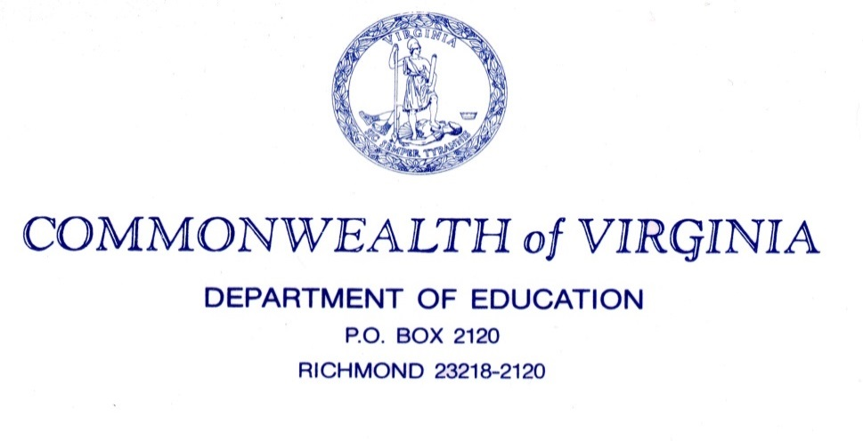

SNP Memo # 2017-18-02

TO: Directors. Supervisors, and Contact Persons, Addressed

FROM: Sandra C. Curwood, PhD, RDN, Sandy

DATE: July 21, 2017

SUBJECT: Eligibility Manual for School Year 2017-2018

The Virginia Department of Education (VDOE) Office of School Nutrition Programs (SNP) is excited to share the 2017 edition of the Eligibility Manual for School Meals. (Attached) This edition replaces the 2016 edition of the Eligibility Manual for School Meals, released in July 2016.

The Eligibility Manual for School Meals

The manual provides comprehensive information on federal requirements, policies, and procedures, and is intended to help state agencies and local education agencies (LEAs) accurately determine, certify, and verify children’s eligibility for free or reduced price school meals and milk.

Revisions and Highlights

This edition incorporates clarifications requested by state agencies and Food and Nutrition Services (FNS) Regional Offices, as well as applicable guidance issued since the last revision in July 2016. Notable changes are highlighted in yellow throughout the manual. Formatting changes and minor changes to the language are not highlighted, as they do not represent a change in policy.

New this year, regulatory citations, FNS policy memoranda citations, and links to the School Programs Policy Page were added throughout the manual. Also, “Questions and Answers” (Q&As) were added to the end of each section of the manual. These Q&As provide guidance on eligibility-related issues that have raised questions in the past. The Q&As will be updated in future editions of the manual to address new questions from state agencies and LEAs.

Important Updates to Note

Throughout the manual there are some common themes to note: Addition of the Food Distribution Program on Indian Reservations (FDPIR) as another household program case number eligible for direct certification, protecting student privacy, improving the meal application and direct certification process, and, additional guidance on web-based/electronic applications.

Specific areas of note include:
- The added question and answer section at the end of each chapter provide guidance to current issues. Please read these sections.
- Providing timely meal application approval and notice within 10 operating days of receiving the application is referenced several places in the manual.
- Ensuring students are receiving the proper carryover eligibility within the first 30 operating days when transferring from one school to another within the same (pg. 14) or a different LEA are discussed and highlighted.
- There is also a section of note, on page 47, to ensure that students transitioning from a Provision school receive the proper eligibility and no gap in meal access.
- If using a web-based application, there is guidance to promote integrity of the application if fields are left blank (page 25).
- Language in the new manual encourages LEAs to gain an understanding of the local foster care system and partnering with homeless liaisons to ensure children in these situations are promptly provided benefits.
- On page 55, there is a section to encourage LEAs to notify parents and guardians about the end of the year carryover period to reduce the risk of unpaid meal charges. This was addressed in Superintendent’s Memo No. 070-17, dated March 10, 2017.
- Pages 79-81 should be reviewed for the information required on the application and other clarifying language for “no income” reported on the application. A total of household members reporting field and a placement of social security number reporting field are now mandatory on the SY 2017-2018 application.
- Please review Section 6 on verification. Definitions, regulatory citations, additional guidance, and clarifying language have been added to improve communication with families as well as the verification for cause and required information on the letter to the household. Also, improving the verification process is highlighted and strategies are outlined in SP 43-2016 (v.)2.

Training for the meal application verification process will be provided at a later date. If you have any questions about these resources, please email SNPPolicy@doe.virginia.gov.

SCC/ag
Attachment
Eligibility for School Meals

