Unit I – Behind the Wheel

Introduction
The behind-the-wheel curriculum guide is to provide the basis for the development of operational skills by prospective school bus drivers. This instruction should follow the classroom phase of the pre-service instruction that relates specifically to the skills being practiced behind the wheel. References from the pre-service units have been included to allow instructors to reemphasize certain principles and procedures during driving practice sessions. Materials that could be taught effectively in the classroom should not be introduced during behind-the-wheel training. Instruction should be devoted to observation, re-emphasis of principles and procedures, actual driving, and evaluation.
This section consists of several units. Proficiency in all units is considered the minimum behind-the-wheel instruction needed by new drivers.
An instruction permit is required for anyone learning to drive a school bus. The trainee must pass the Commercial Driver’s License General Knowledge test, Passenger Bus test, School Bus test, Air brake test (if you are going to drive a bus with air brakes) and the skills test for the school bus.
A properly endorsed and licensed school bus trainer must accompany the school bus driver trainee, who has an instruction permit.
Practice of advanced skills should occur in an area, suitable by size and condition of surface. The practice area should allow trainees to practice all of the maneuvers necessary to obtain a school bus driver’s license.
Units in this section provide a logical sequence of behind-the-wheel instruction for a new trainee. Teaching the units in sequence is recommended; however, some trainees may have had experience and may not require practice in all of the suggested drills.

Virginia School Bus Driver Training
Success of the instructional program rests with the instructor. The trainer's knowledge, understanding and attitude toward the total program determine the effectiveness of such a program.
The trainer must become involved in the learning process. Experiences in the controlled environment should be integrated with classroom and on-road instruction. This provides the student an opportunity to put into practice those concepts introduced in the classroom.
The following suggestions may aid in establishing a more effective learning situation:
- Clarify what is to be taught.
- Be prepared.
- Know the subject.
- Be enthusiastic and believe in what is taught.
- Organize materials in a meaningful way.
- Have objectives in mind for each presentation.
- Plan each presentation carefully to make the best use of time and available facilities.
- Limit the number of ideas presented in each instructional period.
- Make sure the presentation fits the length of the class period.
- Use a variety of methods to evaluate the progress of each student.
- Review previous lesson. If it is the first lesson, review the applicable classroom lesson to ensure smooth transition to behind-the-wheel instruction.
- State objectives for the day and how they will be accomplished.
- Have comments at the end of the lesson.
- Have trainees comment on their performance.
- Assess the daily performance of each trainee.
- Summarize the lesson.
- Discuss the plans for the next lesson.
- Trainees may be evaluated with the following:
- Written check list (daily evaluation of skills)
- Through "commentary" driving (can assess scope of understanding)
- Question/answer
- Through observation

Planning Considerations
There should be maximum participation by each driver trainee. The more a trainee participates by observing, asking and answering questions, taking notes, and engaging in actual driving, the better he or she will achieve the needed skills.

Evaluation
The trainee should be evaluated on all behind-the-wheel exercises. Information gathered from each evaluation should be used in determining the trainee's proficiency in each instructional area.

Defensive Driving
As defensive drivers, school bus drivers should adopt the crash prevention formula shown below. A defensive driver is a person who is always alert and takes every precaution to prevent traffic mishaps. Because the movement of a large school bus can affect the normal flow of traffic on the highway, the driver must develop a positive attitude toward safe driving. Defensive driving involves maintaining a positive attitude toward crash prevention. A defensive driver must anticipate potential crash situations by evaluating constantly changing situations and planning preventive measures.
Preventable incident or crash: Any incident or crash involving a school bus which results in death, injury, or property damage in which the school bus driver failed to take all reasonable measures to prevent its occurrence.
Crash Prevention Formula
- See the Hazard. Think about what is going to happen or what might happen as far ahead of encountering the situation as possible. Never assume everything is “all right.”
- Understand the Defense. There are special ways of handling specific situations. Learn these ways and be prepared to apply them when the need arises.
- Act in Time. Once you have perceived the hazard and determined the defense, act immediately. Never take a “wait and see” attitude.
SIPDE discussed in the lesson on "Detecting Hazards" is one of the most important strategies to develop in all of the driving skills.
Driving skills must be taught that involve decision making, reaction, and evasive maneuvers. It does not matter how fast the reflexes are, if the wrong decision is made.
Performing or executing the skills in time is the final step. Making a good decision won't help if reaction time has been hampered by medications, inattentiveness, alcohol/drugs, etc.
Drivers must have knowledge, be alert, use foresight and good judgment, and have skills to control the school bus in any situation.
According to the National Safety Council, "85 percent of all accidents happen when the light, road, weather, traffic and vehicle conditions are good."

A variety of studies have indicated that accidents resulting from human error range from 75-80 percent to a high of 97 percent.
Of more than 150 driving errors, the top 10 involve judgment, clearance, and emotional habits.
- Failure to yield right-of-way
- Turning maneuvers
- Intersections
- Driving too fast for conditions
- Distractions
- Following a vehicle too closely
- Poor condition of the vehicle
- Improper signaling
- Inattention
- Backing

Commentary Driving
This is a technique to assist the trainer in determining certain aspects of the lesson(s) that need to be reinforced or reemphasized. If the trainee does not mention certain elements, then he or she has not determined those elements to be important.
Except for pre-trip, commentary technique should not be used until the trainee has had a few lessons. Then, the trainee should begin with simple comments until he or she is able to give a complete commentary, including roadway environment (trees, buses, animals, culverts, etc.), traffic control devices (signs, signals, and pavement markings), and other traffic (cars behind, in front, to side on adjacent roads). While in the controlled environment, have the trainee comment on what he or she is doing: “I am positioning my hands at 9 o’clock and 3 o’clock for the best position for control”; “I am directing my line of vision toward a reference point 100 yards ahead. This will help me position the bus where I want it to go”; “I am checking my mirrors for traffic around me,” etc.
The pre-trip DMV/third party test is a good example of commentary techniques, for example, “I am looking at the tires to determine if there are cuts, or if the tire pressure is appropriate.” In addition, “These could cause me to have difficulty controlling the position of the bus or the possible loss of a tire.”
Note: The trainer should observe the following:
- Trainees’ comments on what they are observing.
- Trainees’ comments on what they need to do as a driver based on the observation.
- Trainees’ comments on why their observations are important to driving decisions.
Most people applying for a school bus driver’s position have never had an instructor to teach them to drive. Some applicants have never been inside a school bus. Others may be familiar with large trucks, but not school buses. The purpose of this unit is to provide an opportunity for the instructor to familiarize the trainee with the bus. Also, this unit is intended to provide an opportunity for the trainee to observe the instructor, prepare for and perform a daily trip with students on the bus.

Getting Acquainted with the School Bus
In cases where the classroom instructor and the behind-the-wheel instructor are not the same person, use this time to introduce the behind-the-wheel instructor to the trainee. The instructor and trainee also should take a few moments to discuss driving experiences, such as the number of years of driving experience, the types of vehicles driven or driving conditions encountered. This procedure will enable the instructor to pick practice drills in accordance with the trainee’s experience.
In an effort to relax the trainee, the instructor should allow the trainee time to become familiar with the operation of the vehicle. The instructor should stress special features of the school bus, including the length and size of the vehicle, dual rear wheels, the operation and location of the emergency exits, the entrance door, the location of mirrors, instruments, etc.

Observing Instructor Prepare for and Perform Daily Trip
Allow the trainee an opportunity to observe the instructor conduct the pre-trip inspection, fasten seat belt, greet and interact with students, perform loading and unloading procedures, and operate the bus under actual road and traffic conditions.

Discussion of Daily Trip
During the observation period, the trainee should record questions concerning the operation of the vehicle. At the completion of the trip, the instructor should allow time to discuss questions the trainee might ask. The trainee should be asked his opinion of the daily performance.

Review
Following the completion of the trip, the trainer should recap the highlights of the lesson and provide appropriate feedback. The trainer should also mention what the next lesson will encompass.
Instructor Should Observe the Following:
- Did trainee appear receptive to instruction?
- Did trainee appear to know everything due to previous experience?
- Was trainee appropriately dressed?
- Did trainee appear to understand the operation of the bus based upon classroom instruction?
- Did trainee appear relaxed?
Note: Some nervousness is expected; if a trainee becomes too relaxed, he or she is apt to become complacent.
- Is the trainee prepared for basic skills of driving a school bus in a controlled area?
- Comments

Driving Practice in a Controlled Environment
The exercises provide a guide for the instructor to follow in demonstrating proper driving procedures and in evaluating the trainee.
Driving in a controlled environment, free of traffic and persons, provides an opportunity for the trainee to gain experience under conditions of maximum safety. The various aspects of instruction will assist the trainee in developing the skills necessary to operate a school bus safely.
Skills are refined by continued practice. This experience is in preparation for those to be gained in “on road” operation. Situations resulting from the many different road and traffic conditions must be mastered before the driver is confronted with the additional responsibilities with children on the bus.

Site Selection and Preparation
The ideal controlled environment site is a large, level, paved area, free of curbing and obstacles. A school parking lot, playground, or driving range might be available. If possible, the driving area should be constructed of high-quality paving material, such as asphalt or concrete. Because of the weight of a school bus, attention should be directed to surface strength to prevent the bus from cracking the pavement.
Before positioning cones for marking the area for practice sessions, a scale diagram should be made of the area to determine the position of each exercise and to make maximum use of available space.
The site for the practice exercises should be inspected for safety hazards before it is used. Spaces required for the exercise should be measured and carefully marked the day before the exercise is given. When each exercise is laid out correctly, reference points can be marked for later use. The equipment then can be stored and set up quickly on the day of the exercise.
A suggested sequence for planning and completing the physical layout of the exercises follows:
- Make preliminary measurements of each exercise or group exercise.
- Maintain a safe distance between each exercise.
- Lay out the entire site area into individual exercise blocks.
- Return to each exercise block and mark the respective position of the cones with chalk (temporarily).
- Position the cones on the chalk and drive vehicle through the course.
- Make any necessary adjustments and mark permanent cone position with spray paint, if permitted to do so. Spray paint of different colors should be used for marking cone location of various exercises in the same area.

Suggested Equipment
A review of the diagrams for drills should indicate the amount and type of equipment needed. Adequate equipment should be acquired in advance to reduce the possibility of last minute improving at the site. Suggested items:
- School bus – largest bus the trainee will be expected to operate
- Traffic cones – different sizes
- Caution flags – for mounting on poles with weighted base
- Various highway signs – for mounting on poles with weighted base
- Traffic barricades
- Sign – student driver
- Tape measure – 100-feet
- Spray paint
- Chalk
- Fire extinguishers
- Reflective triangles – all types used in fleet

Exercises
The exercises have been divided into the following:
- Pre-trip/Post Inspection
- Starting and Stopping
- Controlled Braking
- Straight Line Forward Tracking
- Stop Line
- Straight Line Backward Tracking
- Serpentine
- Perception of Distance/Time
- Managing Space
- Diminishing Clearance
- Right and Left Turns
- Intersections
- Lane Changing/Passing
- Driving in a Restricted Space
- Starting and Stopping on Grades
- Backup Turnaround
- Cul-de-sac Turnaround
- Loading and Unloading
- Railroad Crossing
- Bus Evacuation
- Position of Reflective Triangles
- Sudden Loss of Visibility
- Steering Failure
- Brake loss, Fade or Failure
- Power Failure
- Tire Blowout/Loss of Wheel
- Off Road Recovery
- Loss of Traction
- Dealing with Disruptive Behavior
Note: Set up course according to space. Do not put participants on the road unless you are sure they can safely handle the bus.

Preparing Trainee for Obtaining License
The trainee should be oriented to requirements for obtaining a CDL with appropriate endorsements and instruction permit from the Department of Motor Vehicles (DMV). Each trainee should be given a current copy of the DMV Commercial Driver’s Manual to use in preparing for the examination. Review various components of the manual, including the school bus supplement. Solicit and answer questions from the trainee about the examination, and arrange a suitable time for the instructor and trainee to go to DMV for the test. If the trainee has a problem with any portion of the DMV Manual, the classroom or behind-the-wheel instructor should provide remedial training in that area.
Notes: Oral Test may be requested.
Suggested Sequence
Instruction Permit
- General Knowledge
- Endorsements Tests
- Air brakes
- School bus
- Passengers
- Vision Test
- Road Test (includes pre-trip and driving)
For drivers of school buses designed to carry fewer than 16 passengers, including driver, no CDL is required but the driver must have school bus endorsement and must take knowledge and road test.
For drivers of school buses designed to carry 16 or more passengers, including the driver, a CDL is required with either class B or C vehicle.
Licensing Process
- General knowledge test
- Endorsement test
- Passengers
- School Bus
- Air brakes
- Vision Requirements
- Pre-Trip
- An inspection of various vehicle components to ensure safe operation is required prior to taking the road test.
- Road Test-A prescribed route incorporating various driving environments and skills
Pre-trip/Post Trip
Objectives
- To be able to locate and name all components.
- To be able to explain the function of all components.
- To be able to explain potential problems.
Many accidents and breakdowns can be avoided by proper pre-trip inspections. As required by local and state regulations, each driver must inspect the bus daily before transporting students and record the inspection.
Using a pre-trip inspection form, demonstrate the proper way to make the inspection. Allow each trainee sufficient time to practice this procedure, and ask questions about the various components of the bus to be inspected.
Evaluate the trainees on how well they perform the inspection. Ask questions to determine how well they know whether certain components of the bus are in good operating condition and how they are checked. Follow eye and hand movements to help determine which items are being checked by the trainee.
The instructor should observe the following:
- Locates all items on checklist
- Identifies all items and functions
- Identifies trouble spots with each item
- Follows suggested sequence
- Locates all defects
- Comments
Adjustment of Mirrors
Objectives
- The trainee must be able to adjust all mirrors to give view of areas required by FMVSS 111.
- The trainee must be able to identify blind spots.
- Adjust the inside mirrors.
Note: Drivers may need to request assistance with the adjustment of all other mirrors so they can be used without moving the head. Garage personnel may need to reposition mirror brackets if proper adjustment cannot be achieved.
Blind spots
- Between windshield and door and driver window
- An open door
- Front tires turned all the way to the left
- Extended stop-arm
- Mirrors

Types of mirrors and intended use
Inside rearview – mounted on inside header above windshield and in front of driver’s seat. Adjust to view the top of the rear window, all students including the top of the student’s right behind the driver. The driver should be able to see somewhat outside the right side window.
(1) (2) Cross view Mirrors – mounted on fender. Adjust to see the entire area in front of the bus as well as the front bumper.
(4)(5)Outside Upper Left and Right Flat Mirrors – Adjusted to see 200 feet or 4 bus lengths behind the bus, the side of the bus and the rear tires touching the ground. Note: On older buses, it may be impossible to see the tire touching the ground but you should see the rubber skirting around the wheel well.
(3)(6)Outside Convex Mirrors – Mounted below the outside flat mirrors. Adjust to see the entire area to the rear of the mirror along the side of the bus and at least one traffic lane on either side of the bus.
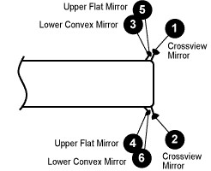

Starting and Stopping
Objective
To be able to demonstrate correct starting and stopping procedures in a bus with air or hydraulic brakes.
Demonstrate and allow the trainee to practice the proper methods of starting, using a clutch, changing gears, accelerating, steering, stopping, and parking a school bus to prevent it from moving.
On manual transmission, trainee should place gear lever in first and simply practice getting the bus moving; then bringing the bus to a stop. Continue this practice of starting and stopping until the trainee is able to perform the task smoothly. Practice the procedures using an automatic transmission.
Evaluate trainee’s ability to follow instructions and apply techniques in a reasonable amount of time.
The instructor should observe the following characteristics of a trainee:
- Follows instructions
- Makes good use of observation time
- Checks parking brake
- Adjusts seat
- Checks mirrors
- Fastens seat belt
- Places gear shift in neutral
- Disengages clutch, if appropriate
- Inserts key and starts engine
- Does not “rev” engine
- Recognizes proper gear and gauge locations
- Checks gauges
- Places foot on brake pedal
- Releases parking brake
- Places bus in appropriate gear
- Uses proper hand position in steering
- Observes conditions before moving
- Releases clutch and accelerates without allowing the bus to roll backwards (manual)
- Downshifts gears adequately
- Brakes smoothly
- Maintains appropriate speed
- Checks surrounding traffic
- Gives stop signal (brake lights)
- Tests brakes
- Stops smoothly
- Parks bus properly to prevent moving
- Engages parking brake
- Places in first or reverse gear (manual)

Controlled Braking
Objective
To be able to bring the bus to a stop without causing the bus to skid.
The school bus driver should be trained in applying brakes and the effect the brakes have on the vehicle.
Controlled braking is the process in which the pressure on the brake is increased until the wheels start to lock. The brake is then released to let the wheels roll. It gives maximum braking, alternated with rolling wheels, to permit steering control.
Remember, in an emergency, to release the brake when it becomes necessary to steer.
When the brake is released, the front wheels should be heading in the desired direction. The driver, in this case, usually has to fight the natural urge to keep pressing hard on the brake. Such action usually results in a continuous skid and lack of steering control.
ABS systems prevent this from happening by automatically pulsating brake action to wheels regardless of how hard the driver's foot depresses the brake pedal. Thus, steering control is maintained.
The controlled braking maneuver is designed to force the trainee to utilize braking capabilities of a vehicle to the maximum extent possible before lockup and skidding occur.
Most drivers do not know how to brake correctly in an emergency. The closer the hazard, the harder they press on the brakes. Correct braking is the key to vehicle control. "Snub" method for braking is recommended for down-grades. Rather than applying hard braking, then letting up from time to time, the driver should use intermittent, moderate applications (snub). Appropriate gear selection, to govern engine speed, also will help slow the vehicle.
Procedure
Place traffic cones in parallel lines to form a lane within which the trainee should drive. Demonstrate proper braking and stopping procedures. The trainee should be instructed to drive in the lane at a predetermined speed. At a given point, the trainee should be instructed to stop the bus.
Evaluate the trainee's ability to stop the bus smoothly and safely, without sliding the tires or locking the brakes, while maintaining proper position in the lane.
Evaluate the trainee on the following:
- Uses proper hand positions in steering
- Uses good visual skills
- Smoothness
- Avoids locking brakes
- Avoids sliding tires
- Maintains proper lane position
Controlled Braking
A: Length to Brake Cue, 100 ft.
B: Width, 14 ft. (expert 12 ft.)
C: End Barrier, 50 ft. from Brake Cue
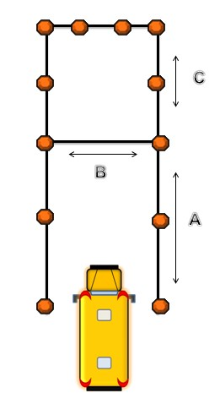

Straight Line – Forward Tracking
Objective
To be able to operate the bus in a straight line and maintain proper position in the traffic lane.
Procedure
Place traffic cones in parallel lines, forming a lane for the trainee to drive along. Demonstrate technique for maintaining the position of the bus in the traffic lane (use mirrors and point of reference ahead). Allow trainees time to practice these techniques under various traffic lane sizes.
Evaluate the trainee’s ability to maneuver the bus through a straight path of given width.
The instructor should observe the following:
- Trainee’s position related to steering
- Use of proper hand positions
- Use of eye movement
- Use of mirrors
- Use of reference point(s)
- Excessive speed
- Sudden stops and starts
- Braking late
- Braking and accelerating at same time
- Tracking improperly
- Too much play/movement of steering wheel
- Wrong gear
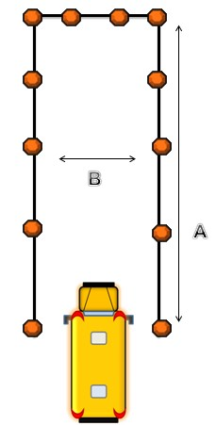
Straight Line Tracking
A: Length to End Barrier, 100 ft.
B: Width, 14 ft. (expert 12 ft.)

Stop Line
Objective
To be able to avoid rear-end collisions by having school bus drivers accurately judge the distance between the bus and vehicles or objects ahead.

Procedure
Place traffic cones in a line across the end of a traffic lane. Demonstrate the appropriate techniques for judging the distance ahead of the bus by maneuvering the bus in the traffic lane and stopping as close to the cones as possible without touching them. A board or painted line may be substituted for the cones in later practice to refine the trainee’s perceptual skills.

Have trainee attempt to stop within six inches of lines or cones and center bus between cones.

Reference points – Since lines painted on pavement are more difficult to see than three foot cones, the trainee should be instructed to select points adjacent to lines to assist in aligning with designated point, i.e., mailboxes, poles, trees, bushes, etc.
Evaluate trainee’s ability to perceive distance accurately.
The instructor should observe the following:
- Makes smooth, complete stops
- Has adequate depth perception
- Uses cross-view mirrors
- Uses reference points

Straight Line – Backward Tracking
Objective
To be able to make appropriate checks before backing and be able to move vehicle backward in a straight line, using mirrors appropriately. Trainee should be able to center bus and position rear bumper within a specific distance from the cones.
A large percentage of school bus accidents occur while the vehicles are being operated in reverse.
Procedure
Place traffic cones in two parallel lines (14 feet apart) to form a traffic lane for the trainee to practice backing the bus. Discuss when to back the vehicle and demonstrate proper practices for backing, such as steering and use of mirrors.
Allow trainees time to practice these techniques on traffic lanes of various widths.
Evaluate trainees on their ability to maneuver the bus through a straight path while backing.
Instructional Strategies
Trainee should observe both sides of bus when backing and when pulling forward to leave the parking space.
Many drivers sideswipe or scrape sides and fenders because they begin turning wheels too soon when leaving the space.

Serpentine
Objectives
- To teach the necessity of proper hand position on the wheel throughout the maneuver. Hand-over-hand steering will provide the maximum turning capability in either direction.
- To develop ability to judge distances between the vehicle’s perimeter and obstacles.
- To develop rhythm and timing in steering.
- To develop coordination in the use of hand and foot control.
The school bus driver should be properly trained in the importance of proper position of hands on steering wheel, correct use of mirrors, and maintaining proper speed. The driver also must be prepared for the effects of sudden weight changes, under-steering, and over-steering to maintain proper control and position of the vehicle. This exercise is designed to give the trainee an opportunity to practice steering skills that will be needed later in some of the more complicated maneuvers. Also, it will help the trainee get a feel for the turning radius and characteristics of the vehicle.
To steer properly, hold the steering wheel firmly on each side in a position that feels comfortable. Imagine that the steering wheel is the face of a clock. One of the more comfortable and safest hand positions for steering control is the 9 o’clock and 3 o’clock position. The steering wheel should be held with the knuckles of the hand outside the rim of the wheel. This position will keep the spokes from hitting the hands and thus allow full control in turning the wheel.
Hand-over-hand steering makes turning easier and smoother in some maneuvers and is the technique to be used with straight trucks and tractor trailers. Start to turn with the hand that is located on the side opposite to the way planning to turn. Place this hand near the top of the steering wheel and pull down almost to the bottom. The other hand reaches over the first hand to get a new grip and pull down again. Continue this procedure until the vehicle has turned the corner. Most vehicles will straighten out after a turn if grip is relaxed. At slow speeds and with certain vehicles, the driver may have to use hand-over-hand or push-pull steering to straighten the vehicle.
Push-pull steering is an acceptable method, especially for the steering wheels typically found in transit-style buses.
Procedure
Place traffic cones in a straight line and at measured distance apart. Have the driver enter the course with the first cone on the left side of the vehicle, the second cone on the right side of the vehicle, and the third cone on the left side.
Instructional points
- Driver should assume proper hand-over-hand steering position.
- Arms should be extended comfortably, with elbows slightly bent for flexibility.
- Driver should enter course at proper speed.
- Driver should approach first cone on left.
- Driver should maintain speed while passing second cone on right, third cone on left, etc.
- Driver should pass each cone as close as possible.
- Smooth steering and proper vehicle position will allow successful maneuver completion.
- If range dictates, suggested speeds are 15 mph minimum, 30 mph maximum.
Common Mistakes
- Turn wheels too little and hits cone.
- Turn wheels too much, which causes continuous widening of the vehicle’s movement, and misses the last cone.
- Fails to maintain speed.
- Early or late steering inputs that result in positioning the vehicle improperly.
- Grasps inside spokes of steering wheel, at bottom or top or uses one hand for steering.
- Does not keep both hands on the steering wheel.
- Releases steering wheel or uses one hand while executing the turn and following the turn.
The instructor should observe the following:
- Over-steer or under-steer
- Appropriate hand position on wheel
- Maintains speed
- Proper use of mirrors
- Proper use of clutch
- Good visual skills

Serpentine
A: Width, 14 ft. (expert 12 ft.)
B: 55 ft. (expert 40 ft.)
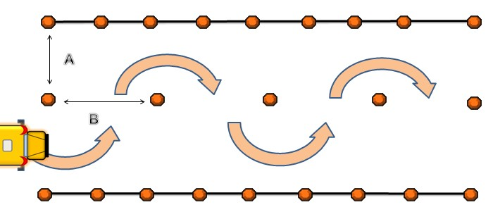

Perception of Distance
Objective
To be able to practice techniques to improve judgment of distance and develop strategies to assist in determining selected distances critical to school bus operation.
Judging distance correctly is very important when operating a vehicle as large as a school bus. The school bus driver trainee should be trained properly to identify prescribed distances and to react appropriately in each situation.
Procedure
Place traffic cones along a straight line at intervals of 50 feet, and place two cones at the end of the line to indicate a stopping or turning point. Demonstrate the proper distances for following, stopping, signaling, and activating traffic warning lights. Allow the trainee time to practice estimating these distances. Practice first with the use of cones, then without the use of cones.
Evaluate the trainee's ability to perceive distances and react appropriately.
The instructor should observe the following:
Appropriate judgment for:
- Signaling
- Traffic Warning Lights
- Following
- Stopping
- Turning
- Diminishing Clearances
- Intersections

Perception of Time
Objective
To be able to practice techniques to improve judgment of time and develop strategies to assist in determining selected times critical to school bus operation.
The following questions are critical to crash avoidance/defensive driving.
- Do I have enough time to cross the intersection?
- Am I looking far enough ahead?
- Can I stop in time if the vehicle ahead of me stops suddenly?
Many drivers do perform visual checks at various points; however, most do not know how to judge the time and space needed for certain maneuvers.
Vision and Perception Requirements
Emphasize the importance of directed attention, maintaining an open line of sight, searching skills, and targeting a line to maintain a safe path of travel. It is critical that students understand how an inadequate or improper visual search, or lack of understanding of vehicle dynamics, failure to respond, or delayed response to a threatening object or condition contributes to driver crash involvement.

Referencing Vehicle to Path of Travel
Visual Functions
- Focus Vision is used to read and identify distinct objects, and covers about three percent of one’s visual field.
- Central (Inner Fringe) Vision is used to judge depth and position.
- Peripheral (Outer Fringe) Vision is conical in shape around the other vision fields.
- Using visual references and turning points when making turns allows the driver to recognize the point to enter the intersection for steering. Drivers should remember that each bus is different and that the driver will need to adjust driving and turning with respect to the size, height, length and wheelbase of that particular vehicle.
- Targeted line of sight and path of travel allows the driver to maintain a visual lead while moving on the roadway. It allows the driver to see far ahead and judge lane position. Any restrictions to Line of sight/Path of travel need to have a speed reduction or lane position adjustment to re-establish the path of travel.
- Referencing vehicle to paths of travel allows the driver to determine lane position when making low risk decisions about the amount of space to leave between them and other drivers.
The instructor should observe the following:
- Judges following distance
- Judges on-coming traffic
- Judges traffic at intersections

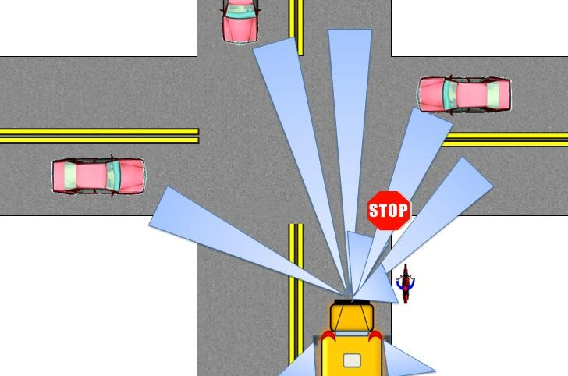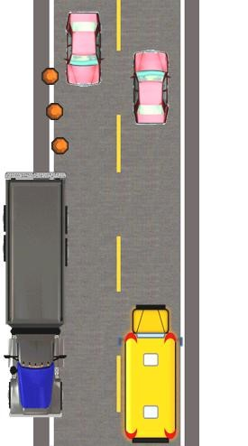

Managing Space
Objective
To be able to practice techniques to improve judgment of vehicle spacing, following distances and defensive driving.
To be a safe driver, you need space all around your vehicle. When something goes wrong, space gives you time to think and to take action. While this is true for all vehicles, it is very important for large vehicles. Large vehicles require more space for stopping and turning.
Space Ahead
You need space in front of you in case you must stop suddenly. In crashes, trucks and buses most often hit the vehicle in front of them. This is because they were following too closely. If the vehicle ahead of you is smaller than your vehicle, it can probably stop faster than you can. If you follow too closely, you could hit it if the driver stops suddenly.
The rule of seconds
If you are driving below 40 mph, maintain at least one second for each 10 feet of vehicle length. At speeds over 40 mph, add an extra second for safety.
Procedure
Watch the vehicle ahead pass a fixed point, such as an overpass, sign, fence, corner or other marker. Begin counting off the seconds it takes you to reach the same place in the road. If you reach the mark before you have counted off the correct number of seconds, you’re following too closely. Slow down and increase your following distance.
Remember, the rule of seconds applies only in good weather and depends on the condition of your vehicle and the road. In bad weather, heavy traffic, poor pavement or if your vehicle is in poor condition, add extra seconds to your following distance.
The instructor should observe the following:
- Judges following distance
- Judges weather conditions and road type
- Judges traffic conditions

Diminishing Clearance
Objective
To be able to develop skills to recognize a change in size of an area and to maneuver the vehicle within the reduced area.
Accidents frequently occur on highways where the width of the pavement is suddenly reduced: for example, from two lanes to one lane, at approaches to narrow bridges, and road construction sites. In such circumstances, the reaction of the driver may determine whether an accident occurs.
Procedure
Place several pairs of traffic cones opposite each other to form a traffic lane with a diminishing width. Demonstrate the proper driving technique and allow the trainee time to practice driving along the traffic lane until he or she becomes proficient under these conditions.
Evaluate the trainee's ability to perceive a change in the width of the traffic lane and make appropriate adjustments in driving.
The instructor should observe:
- Recognizes change in width of traffic lane
- Checks traffic
- Uses mirrors properly
- Adjusts speed
- Uses proper hand position on wheel
- Smoothness of operation
- Selects reference points
Diminishing Clearance
A :(8 ft. 8 in.) , B :(8 ft. 6 in.”), C:(8 ft. 4 in.), D:(8 ft. 2 in.) E :(25 ft.)

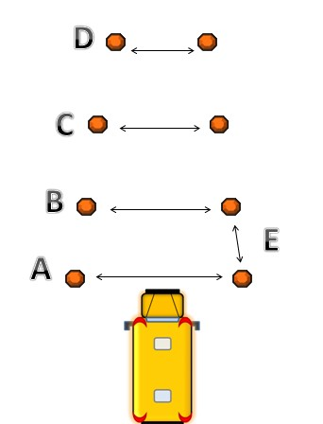

Right and Left Turn
Objectives
- To position bus appropriately and legally to negotiate turn.
- To be able to negotiate right turns and left turns according to curriculum guide.
- To be able to develop and practice the use of appropriate visual skills and scanning techniques.
Drivers need to be aware of the difference in turning a school bus and turning a smaller vehicle. Drivers must allow enough room for both the front and the back wheels to complete the turn.
Procedure
Place traffic cones in two intersecting lines to form a corner for executing a right turn. Place several traffic cones along the center traffic line to form the left-side boundary for making both a right and left turn. Demonstrate the proper turning techniques and have the trainee practice them.
Evaluate the trainee’s ability to perceive distances and apply proper turning techniques.
The instructor should observe the following:
- Checks surrounding traffic
- Checks mirrors
- Gives appropriate turn signal
- Moves to correct lane
- Observes traffic
- Reduces speed
- Checks for pedestrians/check blind spots
- Uses reference points
- Turns when clear
- Selects correct lane following turn
- Deactivates turn signal
- Uses hand-over-hand or push-pull method when turning

Right Turns: If you must cross into an oncoming lane to make a turn, watch out for vehicles coming towards you. Give them room to pass or stop. However, don’t back up for them. You could hit the vehicle behind you.

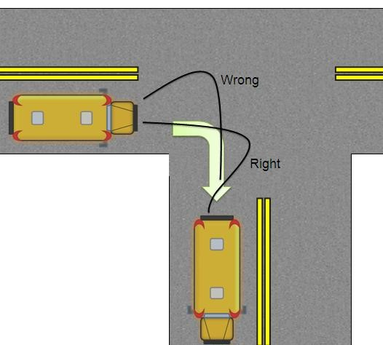

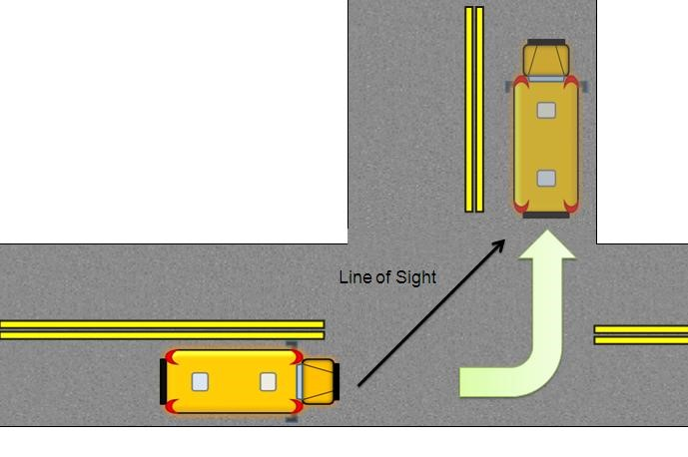
Left Turns: Reach the center of the intersection before you begin your turn. If you turn too soon, your vehicle could hit another because of off-tracking.

Intersections
Objectives
- To be able to identify potential conflicts occurring at an intersection.
- To be able to distinguish between controlled and uncontrolled intersections.
- To be able to define right of way rules.
- To be able to explain different types of traffic control devices and distinguishing characteristics.
School bus drivers should exercise extreme caution at intersections. Approximately 25 percent of accidents involving school buses occur at intersections each year. The school bus trainee must be taught the proper procedures and defensive driving techniques when approaching, crossing, or turning at an intersection.
The trainee must be instructed about the importance of judging time and space. Drivers sometimes take advantage of a bus by darting in front or taking the right of way.
Note: Most collisions at intersections occur when a vehicle leaving a stop sign is struck from the right. If it takes a car about four seconds to cross a street 24 – 30 feet wide, calculate the bus time.
Commentary Driving
- “I am approaching an intersection.”
- “I notice the light is green and has been green awhile.”
- “I prepare for light to change by covering the brake.”
- “I prepare for a lane change, if necessary.”
- “I check mirrors for traffic.”
- “I scan and notice a car with left signal on.”
Procedure
Place traffic cones around each of the four corners of the intersection and place traffic control devices at three of the four corners. If space is limited, the three traffic control devices can be alternately used at the same corner of the intersection. Demonstrate proper procedures. Allow the trainee time to practice safe procedures to use at various types of intersections.
Evaluate how well the trainee is able to use proper procedures.
The instructor should observe the following:
- Approaches at a safe speed, covers brake
- Observes surrounding traffic and pedestrians
- Gives right of way to pedestrians
- Observes traffic signals and signs
- Crosses at a safe speed
- Prepares to take defensive measures, if necessary

Lane Changing
Objectives
- To be able to demonstrate a safe and legal change.
- To be able to explain conflicts that might arise during a lane change or pass.
- To be able to explain how to determine if it’s safe to pass or change lanes.
Passing other vehicles, while driving a school bus, increases the risk of an accident and should be avoided. However, the school bus trainee should be taught proper procedures to use when it is necessary to pass other vehicles. If it takes about 10 seconds for a passenger car to pass another car, imagine the time needed for a bus to pass.
Procedure
Place traffic cones in parallel lines to mark the edges of a two-lane road. With other traffic cones, form the outline of a parked vehicle and a vehicle in the right traffic lane. Discuss when to pass and demonstrate techniques for executing a safe passing maneuver. Allow the trainee time to practice passing parked vehicles and vehicles in the right traffic lane.
To practice, have trainee suggest when he or she believes it is safe to pass – begin counting “one-thousand-one”. Continue until this vehicle reaches the bus – “How much time did you have?” During the practice in a controlled area, have trainee count to determine how long it takes to complete the maneuver.
Evaluate the trainee’s ability to overtake other vehicles smoothly and safely in a traffic lane.
The instructor should observe the following:
- Checks traffic
- Signals intention
- Checks blind spots
- Moves into lane quickly/cancels signal
- Clears other vehicles
- Steers into lane and adjusts speed
- Signals right – for passing
- Checks traffic – for passing
- Returns to right-hand lane – for passing
- Cancels turn signal – for passing

Driving in a Restricted Space
Objective
To develop skills to recognize a change in the size of a driving area and to maneuver the vehicle within the reduced area. Drivers should be able to maneuver the bus around obstructions in the traffic lane.
Procedure
Using several traffic cones, form an "offset alley" for the trainee to guide the bus through. Demonstrate and allow the trainee to enter the lane in a forward motion, proceed through the lane, and come to a stop at the end. Then place the transmission in reverse and back the bus out of the lane, using proper backing procedures.
Evaluate the trainee's ability to perceive distances and maneuver the bus properly.
The trainee should observe the following:
- Proper hand positions in steering
- Use of eye movement
- Use of mirrors
- Adjust speed
- Smoothness of operation (forward & reverse)
- Selects reference points
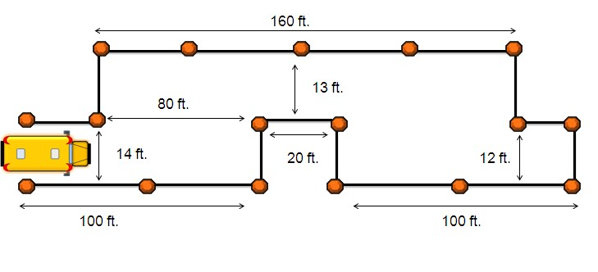

Starting and Stopping on Grades
Objectives
- To be able to move the bus forward (uphill) from a stopped position without stalling or rolling backward more than one or two feet.
- To be able to park bus at the side of the road by turning front wheels appropriately and securing the bus properly.
School bus accidents may occur when a bus, starting on a grade, rolls back into another vehicle. The school bus driver trainee should be taught to use the proper techniques for stopping and starting the bus on a grade. Demonstrate the proper procedures for starting and stopping on a grade. Have the trainee practice on a grade or simulate the procedures on a flat surface.
A key to smooth shifting is to develop a sense for the "friction point".
Trainee should turn wheels accordingly. If parked on level or upgrade, shift to low gear and turn front wheels away from curb. On a downgrade, shift gear to reverse and turn front wheels toward the curb.
Evaluate the trainee's ability to apply procedures, prevent "roll backs" and make smooth starts and stops on grades.
The instructor should observe the following:
- Uses parking brake
- Use of clutch
- Chooses appropriate gear (loaded, empty, partial)
- Smoothness
- Turns front wheel to correct position, if parking

Back-up Turnaround
Objectives
- To be able to execute a turnaround that is performed safely and legally.
- To be able to use mirrors appropriately while backing and moving forward after completing the maneuver.
Turnarounds that require backing are not recommended; however, there are certain circumstances, such as dead-end roads and cul-de-sacs, where it is necessary to operate the bus in reverse. The trainee must consider position of front of bus when turning the wheels (front end swings out). Commentary driving is important. “I have visually scanned for culverts, mailboxes, parked cars, trees, bushes, children, animals, etc.” “I noticed a car parked which will prevent me from turning as usual.”
Procedure
Using several traffic cones, outline a dead-end street and a space, such as a driveway, into which the bus can back. Demonstrate proper techniques for executing a back-up turnaround on different streets and driveways of varying widths. Allow the trainee time to practice the maneuver with and without another person observing the area behind the bus. Trainee should align bus two or three feet from the curb on edge of roadway, with rear of bus just past driveway. Position of rear wheels relevant to driveway is the key. If backing into the driveway on the right, the right rear wheel should barely clear the edge of the driveway.
Evaluate the trainee’s ability to maneuver the school bus at turnaround points.
The instructor should observe:
- Checks surrounding traffic
- Gives stop signal and test brakes by light application
- Stops smoothly
- Stops bus in proper position
- Gives turn signal
- Checks all traffic
- Foot remains on the brake
- Places transmission in reverse
- Checks mirrors
- Backs slowly and smoothly (sometimes no acceleration is necessary)
- Uses proper hand positions in steering
- Uses proper eye movement (continues to look left and right for position)
- Backs into designated area correctly
- Checks surrounding traffic before moving forward
- Gives signal to enter traffic
- Enters traffic smoothly
- Continues to check sides as bus leaves space
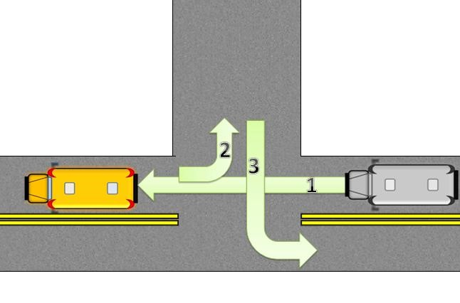

Cul-de-sac Turnaround
Objectives
- To be able to execute a turnaround performed both safely and legally.
- To be able to use mirrors appropriately while backing and moving the bus forward after completing the maneuver.
Visual scanning by trainee (visually sight the entire maneuver) can be very helpful to the trainee. Approach is a critical skill in executing the maneuver correctly.
Procedure
Use traffic cones to form a cul-de-sac. Demonstrate proper techniques for executing the turnaround by avoiding unnecessary backing. Stress the special precautions that must be exercised if backing in the cul-de-sac is necessary. Allow the trainee time to practice until he or she can perform the maneuver proficiently.
The instructor should observe the following:
- Checks traffic
- Checks mirrors
- Scans the environment for potential obstructions
- Uses appropriate signal
- Uses proper hand positions in steering
- Uses of eye movement
- Reduces speed
- Checks for pedestrians
- Avoids unnecessary backing
- Backs cautiously
- Smoothness of operation
Cul De Sac
A: 90 ft. (Expert 60 ft.), B: 16 ft. (Expert 11 ft.)
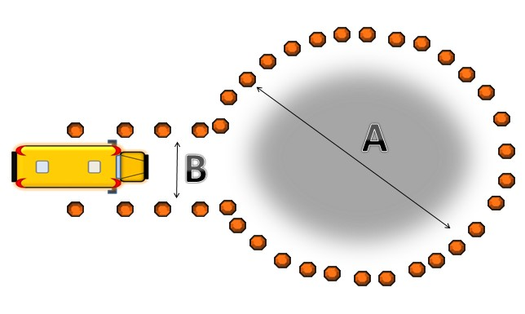

Loading and Unloading
Objectives
- To be able to demonstrate appropriate and legal techniques for slowing for a stop, stopping, loading/unloading, and proceeding.
- To be able to explain appropriate action if an emergency vehicle approaches during any phase of the loading and unloading process.
Each year students are injured or killed as they enter and leave school bus loading zones. Most of these injuries and fatalities are preventable, if the school bus driver knows and enforces the proper loading and unloading procedures. The driver should count the number of students, check for emergency vehicles nearby, and signal for students to cross the road with clear and precise directions.
Students should know what to do in the event of an emergency vehicle approaching while either preparing to load or unload or in the process of loading or unloading.
Note: Door should not be opened or crossing and stop arms extended until bus has stopped completely.
Demonstrate proper procedures for approaching stops and loading and unloading students with and without a patrol or flag person. Place traffic cones around a stopped school bus to indicate the danger area around the bus. Have trainee practice these procedures by role-playing the part of the bus driver, patrol, and students. Do this first with traffic cones; then without the cones.
Evaluate the trainee's ability to perceive distances and use proper safety procedures.
The trainer should observe the following:
- Stops only at designated points, approaching and leaving with extreme caution
- Stops in right travel lane
- Gives proper warning/brake lights, traffic warning lights
- Checks traffic (mirrors and blind spot check)
- Places transmission in neutral with foot on brake
- Does not open door until bus has stopped
- Has students follow proper procedure
- Counts the number of children
- Gives signals for students to cross
- Counts number who board
- Closes entrance door and secures warning signs
- Has children seated
- Checks danger area by observing pedestrian mirrors
- Accelerates smoothly
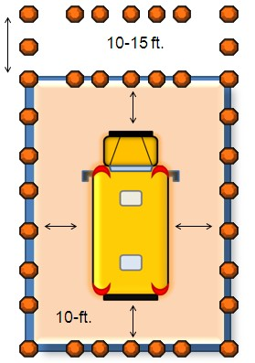

Railroad Crossing
Objective
- To be able to demonstrate appropriate and legal techniques for approaching, crossing, and leaving a railroad crossing.
The most tragic school bus accident is one involving a school bus and a moving train. The potential for this type of tragedy is always present; therefore, the school bus driver must understand and apply all necessary safety practices to protect the children they transport each day.
Even if there are no railroad crossings within the jurisdiction, field trips might include these crossings.
Procedure
Simulate a railroad grade crossing by using boards or painted lines. Place one traffic cone 15 feet and another cone 50 feet from the nearest rail to indicate the stopping zone for a school bus at a railroad crossing. Demonstrate the proper safety procedures to be used at railroad crossings and have the trainee practice them, first with the aid of traffic cones as markers and then without their use.
Evaluate the trainee’s ability to perceive distances and use proper safety procedures.
The trainer should observe the following:
- Checks mirrors, taps brakes
- Gives proper warning (brake lights and 4-way hazard lights)
- Stops bus within 15 to 30 feet of crossing
- Has inside of bus quiet, turns off accessories
- Shifts to sufficient gear
- Checks tracks – through door and side window
- Proceeds with door closed and 4-way hazard lights off
- Does not shift gears until bus is off tracks
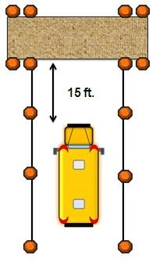

Bus Evacuation
Objectives
- To be able to demonstrate through practices the proper procedures for evacuating a bus.
- To be able to explain the differences between buses with different types and locations of exits.
- To be able to explain local procedures to follow.
Usually, the safest place for students to be after a bus accident or breakdown is on the school bus. However, in certain situations, such as a breakdown on a railroad track or an accident where there is the potential for a fire, the school bus should be evacuated.
Demonstrate the proper procedures for evacuating the bus, and have the trainee practice evacuation drills for students using the front exit only, the rear exit only, side exit combinations. Have the trainee role play to assume the role of the driver, safety patrol and student.
Evaluate the trainee’s ability to follow procedures.
The trainee should observe the following:
- Secures the bus
- Instructs students
- Directs students’ action
- Uses student assistance according to policy
- Checks inside of bus

Positioning Reflective Triangles
Objectives
- Trainee will demonstrate the legal positioning of reflective triangles.
- Trainee will demonstrate how to assemble the triangles.
All school buses must be equipped with bi-directional reflective triangles. In case of an accident or breakdown, these devices are to be positioned to warn traffic. Reflective triangles not placed properly on the roadway may result in an accident.
Procedure
Demonstrate the proper procedures for positioning triangles. Have trainee practice procedures to be used on a curved road, straight road and at locations where there are physical obstructions.
Evaluate the trainee’s ability to perceive distances and apply procedures.
The trainer should observe the following:
- Secures bus
- Activates hazard warning lights
- Places reflective triangles correctly – straight road
- Places reflective triangles correctly – curved road or physical obstruction

Two-lane Roadway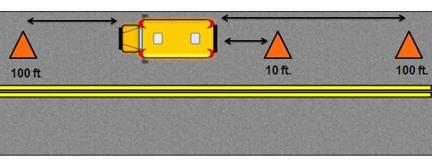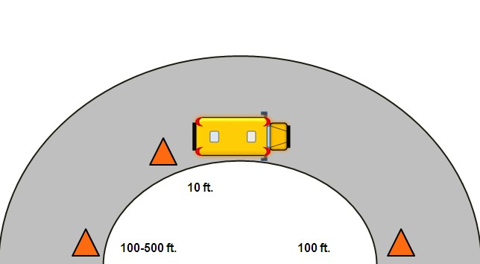

Hills and Curves

Sudden Loss of Visibility
Objective
- To be able to demonstrate proper vehicle handling during simulated loss of visibility.
Sudden loss of visibility can happen at any time. Loss of visibility may result from water splashing on the windshield, failure of the headlights, or the hood of the vehicle flying up. When loss of visibility occurs, trainee should imagine the area ahead and this should allow trainee time to maneuver bus to safety.
The school bus driver trainee must develop the skills needed to control the vehicle until normal visibility returns.
Procedure
Evaluate the trainee’s ability to maneuver the bus, maintain position in the traffic lane, and apply safety procedures.
The trainer should observe the following:
- Uses proper hand position in steering
- Grips the steering wheel firmly
- Decreases speed
- Seeks available visibility
- Applies brakes
- Activates hazard warning lights

Steering Failure
Objective
- To be able to demonstrate vehicle handling during simulated steering failure.
The trainee must develop the skills needed to handle the bus if a loss of power steering occurs.
Procedure
Evaluate the trainee’s ability to maneuver the bus, maintain its position in the traffic lane and use proper safety procedures.
The trainer should observe the following:
- Uses proper hand positions in steering
- Grips steering wheel firmly
- Uses appropriate eye movement
- Avoids over and under steering
- Uses mirrors
- Smoothness

Power Failure
Objective
- To be able to demonstrate proper vehicle handling during power failure.
This exercise is to provide demonstration, practice, and evaluation for the school bus driver trainee in using proper procedures and developing skills needed to deal with a power failure on the bus.
Procedure
Evaluate the trainee on ability to maneuver the bus, maintain its position in the traffic lane, stop the bus, and apply proper safety procedures.
The trainer should observe the following:
- Uses proper hand positions in steering
- Uses appropriate eye movement
- Avoids over-steer and under-steer
- Uses mirrors
- Smoothness

Tire Blowout/Loss of Wheel
Objective
- To be able to demonstrate proper vehicle handling during simulated tire blowout/loss of wheel.
The sudden loss of tire pressure is one of the emergencies that might confront a school bus driver. Maintaining adequate tire pressure may prevent tire blowout. During pre-trip inspection, check for cuts, bulges, under/over inflation, loose nuts or rust around nuts.
Procedure
Evaluate trainee’s ability to maneuver the bus, maintain its position in the traffic lane, and use safety procedures.
The trainer should observe the following:
- Maintains proper hand position in steering
- Maintains firm grip in steering
- Uses appropriate eye movement
- Releases accelerator
- Waits before applying brakes
- Stops bus

Off Road Recovery
Objective
- To be able to demonstrate proper vehicle handling during off-road recovery.
When the right rear wheels slip off the pavement, the problems that occur are often the result of the driver trying to return to the pavement too soon or “over compensating” in steering the bus. This may force the bus across the street into the path of on-coming vehicles.
The school bus driver trainee must develop the skills needed to deal with this type of emergency.
Procedure
Evaluate the trainee’s ability to maneuver the bus and apply proper procedures.
The trainer should observe the following:
- Uses proper hand positions in steering
- Uses good visual skills
- Decreases speed
- Centers bus over pavement
- Avoids over and under steering
- Resumes normal speed

Loss of Traction
Objective
- To be able to demonstrate proper vehicle handling during loss of traction.
Skidding affects steering, braking, decelerating and accelerating. The driver trainee must be able to detect the loss of traction in time to maintain or regain control of the bus.
Evaluate the trainee’s ability to respond appropriately, maintain or regain control, and prevent additional skids.
The trainer should observe the following:
- Decreases speed
- Uses proper hand positions in steering
- Uses appropriate eye movement
- Steers in direction of skid
- Avoids additional skids

Dealing with Disruptive Behavior
Objectives
- To be able to explain the school division’s policy for dealing with disruptive behavior.
- To be able to demonstrate through simulated practice the appropriate procedures to follow if a disturbance erupts.
Disruptive behavior by pupils can contribute to a school bus accident; however, developing strategies and controlling driver’s reaction to these disturbances is the key factor in whether accidents occur.
Many school divisions use video cameras for monitoring behavior; however local policy must be adhered to.
Simulate a disturbance and demonstrate proper procedures, such as stopping the bus in a safe place to deal with the disturbance, and have the trainee practice these procedures. Have the trainee(s) role play by assuming the roles of the driver, patrol, and students.
The trainer should observe the following:
- Stops bus in a safe place
- Secures bus
- Activates hazard warning lights
- Deals with disruptions according to local policy.

