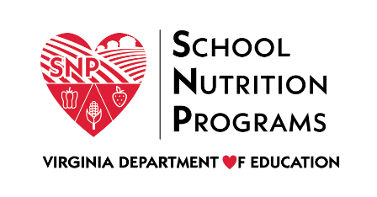

FEDERAL PROGRAM ADMINISTRATIVE REVIEW
SCHOOL NUTRITION PROGRAM SUMMARY
Section 207 of the Healthy Hunger Free Kids Act 2010, amended section 22 of the National School Lunch Act (42 U.S.C. 1769c) requires the Virginia Department of Education, Office of School Nutrition Programs (VDOE SNP), to report the final results of the administrative review to the public in an accessible, easily understood manner in accordance with guidelines promulgated by the Secretary.
Local Educational Agency: Restorative Youth Services
Report Publication Date: June 5, 2020
Administrative Review Dates: November 20-22, 2020
Review Month and Year: September 2019
Participating Programs: NSLP, SBP, ASP
Participates in Special Provisions? N/A

Findings Identified during the Administrative Review:

Table 1: Program Access and Reimbursement
Category | Findings
Certification and Benefit Issuance | FINDINGS IDENTIFIED
Details: | Errors were identified on the Point of Service benefit issuance document.
Verification | FINDINGS IDENTIFIED
Details: | The verification process was not completed by the November 15 deadline.
Meal Counting and Claiming | FINDINGS IDENTIFIED
Details: | Meals were claimed at the free rate for students that did not have approved applications on file.

Table 2: Meal Patterns and Nutritional Quality
Category | Findings
Meal Components and Quantities | NO FINDINGS
Details:
Offer versus Serve | NO FINDINGS
Details:
Dietary Specifications and Nutrient Analysis | NO FINDINGS
Details:

Table 3: School Nutrition Environment and Civil Rights
Category | Findings
Food Safety |  | FINDINGS IDENTIFIED
Details: |  | A copy of the written food safety plan was not available onsite.  The SFA did not request two food safety inspection from the responsible agency.  The most recent food safety inspection report was not posted in a publicly visible location.
Local School Wellness Policy |  | FINDINGS IDENTIFIED
Details: |  | The SFA did not complete an assessment of the LSWP.
Competitive Foods |  | NO FINDINGS
Details:
Civil Rights |  | FINDINGS IDENTIFIED
Details: |  | The SFA did not annually train all program staff on Civil Rights requirements.
USDA is an Equal Opportunity Provider, Employer and Lender.

